**Title**

**A MINOR PROJECT REPORT**

*submitted by*

**Name of Students**

**Register No**

*Under the supervision of*

**Guide’s Name**

**Designation**

**Department of Computer Science and IT**

*in partial fulfilment of the requirement of*

**AMRITA VISHWA VIDYAPEETHAM**

*for the award of the degree of*

**BACHELOR OF COMPUTER APPLICATIONS IN DATA SCIENCE**



**AMRITA VISHWA VIDYAPEETHAM, KOCHI CAMPUS**

**November 2024**

**AMRITA VISHWA VIDYAPEETHAM**



**BONAFIDE CERTIFICATE**

This is to certify that the project report entitled **TITLE** submitted by **NAME WITH ROLL NO** in partial fulfilment of the requirements for the award of the **DEGREE OF BACHELOR OF COMPUTER APPLICATIONS** in **DATA SCIENCE** is a bonafide record of the work carried out under my guidance and supervision at School of Computing, Amrita Vishwa Vidyapeetham, Kochi Campus.

|  |  |
| --- | --- |
| **Name of Guide**  Project Advisor  Designation  Department of Computer Science  School of Computing  Amrita Vishwa Vidyapeetham  Kochi Campus | **Name of HOD**  Head of the Department  Department of Computer Science  School of Computing  Amrita Vishwa Vidyapeetham  Kochi Campus |

The project was evaluated as on: ________________________________________________

**Internal Examiner External Examiner**

**DECLARATION**

I affirm that the project work entitled **“Title”** being submitted in partial fulfilment for the award of the **DEGREE OF BACHELOR OF COMPUTER APPLICATIONS** in **DATA SCIENCE** is the original work carried out by me. It has not formed the part of any other project work submitted for the award of any degree or diploma, either in this or any other University.

Place: Kochi Name of Students

Date: Register No

**DEDICATION**

To

My parents, all my teachers and the eternal God.

Thank you for believing in me and encouraging me throughout.

1. **INTRODUCTION**

**1.1 ABOUT THE SYSTEM**

Our website will function as a travel guide matching site, improving the experience of traveling because it will bring tourists directly into contact with verified local guides. In this way, it will be offering an easy-to-use interface through which travellers can discover and choose their preferred guides according to their language or interest and, thus, tailor their journey. Travellers these days are in fact becoming more interested to have meaningful, personal experiences instead of the more traditional packages nowadays. This website tries to provide a unique, personalized travel experience by linking travellers with guides from local areas based on language, location, and preferences, and to make high translation tools possible for easy communication. In addition, the website aims at demolishing language barriers and provides more efficient interaction options with in-app messaging, text, voice, and image translation. It connects travellers with guides who speak the same language and share the same interests, hence bringing a collaborative experience into travel and minimizes the standardized tour package.

It also lets for a peer-to-peer coordination experience of travellers. It gives an innovative dimension of interlinking travel makers with guides by offering travel options in highly customized and interactive ways. It broke the rigid framework of traditional tours. In this regard, it creates a very interesting, accessible, and personal travel experience. In fact, the system is at an excellent position to answer the changing needs of modern travellers-to attract to an authentic and enriching journey.

**2.0 NEED FOR THE SYSTEM**

This app has a multi-function goal, designed to perfect user experience when traveling by giving personalized connections with local guides, frictionless communication across languages, cultural exchange, and the increasing of revenues in the local economies. With an ever-increasing demand for personalization in travel experiences, this app bridges huge gaps left by traditional tour packages and what a modern traveller seeks. Communication Barriers According to the needs of the local population, it resolves local guides and traveller communication problems since it facilitates translation of their language, and it includes a chatbot for any kind of communication. Match of traveller with the guide according to specific needs of communications followed with an efficient feedback mechanism bring out a platform where users can make informed choices which in turn enhances trust and satisfaction.

**3.0 BACKGROUND STUDY**

**3.1 EXISTING SYSTEM**

A Website that connects tourists and local guides exists but does not offer the facility of translation services and user reviews. The Website that connects you on the basis of language spoken is hard to find. At present, traditional travel platforms mainly operate with pre-set tour packages, not preferring individual choices, and are bound by fixed itineraries. While some platforms do have interaction by the traveller with a local guide, they do not have a rather advanced mechanism for matching guides and travellers by language, location, and availability. Secondly, the mechanisms usually lack multilingual and multimodal features, such as text, voice, and image translation, and therefore communication is restricted to just text.

Stiff Itineraries: Packages have stiff itineraries, not helpful if you really crave very personalized experiences.

Limited Communication Tools: The incumbent platforms lack sophisticated translation tools that would make it easier for harmonious communication between a traveller who is linguistically different from the other and the guide.

Lack of Integration Feedback: Most of the systems do not offer immediate response options; this creates boundaries concerning the scope- mainly focusing on quality control and adaptability.

Restricted Matchmaking Process: The matching systems have mostly been based on simple filters instead of offering optimal matchmaking processes, leaving a chance to mismatch.

**3.2 DRAWBACKS**

**Resource-Intensive Development:** Advanced translation and real time match capabilities are resource-intensive for development. That means to take longer development time and costs.

**Risk of Guide Verification Stalling:** Manual verification of guide certifications by processes may act like a pinch-point, thereby potentially delaying the recruitment cycle for more guides.

**Database Maintenance Needs:** The platform requires constant monitoring and updating of the database, which may increase administrative workload.

**3.3 PROPOSED SYSTEM**

The proposed website focuses on an efficient matchmaking system that connects travellers with local guides based on language, location, and other preferences. The platform offers advanced text, voice, and image translation services to foster communication, a chatbot to assist users with platform features, and a sophisticated feedback system that lets travellers and guides rate each other. Both travellers and guides have distinct homepages with trending locations, notification areas, and profile editing options. The system offers numerous merits:

• Customized Experience: Visitors can select guides to travel with, ensuring a unique experience for all.

• Secure Guide Verification: Each guide must provide authentication to ensure authenticity.

• Dynamic and Customized Matchmaking: The algorithm selects travellers dynamically according to place, language, and interests.  
• Real-time Translation Features: Enables fluent multi-lingual conversation. Provides text, voice, and image translation to visitors' preferred language.  
• Real-Time Notifications and Response Tracking: Bookings, matches, and updates are received by the guides as well as the travellers.  
• User-friendly Interface with Trending Destinations: Both the home pages hold popular destinations as well as recommendations based on the personalized choice of travellers.  
• Feedback and Review System: Travelers can comment on guides so that they can eventually decide on quality. So that next traveller can enjoy a better experience.  
• Flexible Admin Control Panel: The robust dashboard the admin has to manage user data as well as check guide credentials for authenticity.

**4.0 Problem Formulation**

**4.1 Main Objective**

The primary objective of the travel guide matchmaking project is to connect tourists with local guides who best match their preferences and interests, enhancing personalized travel experiences. This platform allows users to find verified guides by filtering based on various criteria like language, specialty, and region. It incorporates a matchmaking algorithm that pairs tourists and guides for a tailored experience. Additionally, the platform facilitates communication between tourists and matched guides via a chat interface for trip planning and support. With features like reviews, ratings, and real-time support, the project aims to build culture and provide an enriching travel experience for users.

**4.2 Specific Objectives**

The travel guide matchmaking project aims to verify guides, ensuring they are qualified and trustworthy for tourists. It includes a matchmaking algorithm that pairs tourists with guides based on language, locations, and preferences, allowing for personalized travel experiences. To overcome language barriers, it offers multilingual support within an in-app chat feature, fostering clear communication between users and guides. A review and rating system allows tourists to leave feedback, helping future users choose guides confidently. The platform is designed with scalability in mind, allowing for future enhancements like payment integration and loyalty programs.

**4.3 Methodology**

The methodology of this website begins with requirements gathering, where user preferences and guide verification standards are defined. Next, a relational database is designed to store profiles, preferences, and reviews, which results in a smooth retrieval and matching. The matchmaking algorithm is then developed, to match tourists and guides based on criteria like language and region. Following this, a chat interface with multilingual support is implemented for real-time communication between users and guides. Additionally, we have developed a language translation page using APIs for real-time translation of voice, text and images.

**4.4 Platform Selection**

The travel guide matchmaking project is developed with HTML, CSS, and JavaScript for the front end, creating an intuitive and responsive interface. AJAX and JSON frameworks are employed to manage asynchronous data communication between the client and server, enabling real-time updates. For the back end, we are using a combination of JavaScript and Python to help with server-side logic, data processing, real-time language translation and matchmaking functionality. MySQL is used as the database to store user profiles, preferences, chat data, and reviews efficiently. This streamlined tech stack is designed to provide an effective and responsive platform. As for the Operating System, we are using Windows OS.

**5.0 SYSTEM ANALYSIS AND DESIGN**

**5.1 System Analysis**

System analysis is a systematic approach to understanding and breaking down complex problems into smaller, manageable components. It involves studying various operations and processes within a system to identify areas for improvement and potential solutions.

Key aspects of system analysis include:

* Defining System Boundaries: Clearly delineating the scope of the system, including its inputs, outputs, and interactions with other systems.
* Identifying System Requirements: Determining the functional and non-functional requirements that the system must meet.
* Analysing Existing Systems: Evaluating the current system's strengths, weaknesses, and opportunities for improvement.
* Modelling System Behaviour: Creating visual representations, such as data flow diagrams or use case diagrams, to understand the system's dynamics.

By conducting a thorough system analysis, organizations can gain valuable insights into their processes, identify inefficiencies, and make informed decisions about system design and implementation.

**5.2 Feasibility**

Feasibility analysis is a critical step in the system development process. It involves evaluating a proposed system's viability to determine if it's worth pursuing. By conducting a feasibility study early on, organizations can avoid investing significant resources in projects that may not be feasible.

Key aspects of a feasibility study include:

* Identification and Description: Clearly defining the problem or opportunity that the system aims to address.
* Evaluation of Alternatives: Assessing different system options, considering factors like cost, performance, and risk.
* Selection of the Best System: Choosing the most suitable system based on the evaluation criteria.

To ensure the proposed system is practical and aligns with organizational goals, the following factors should be considered:

* Technical Feasibility
* Economic Feasibility
* Performance Analysis

**5.2.1 Technical Analysis**

Technical feasibility assesses a system's practicality based on its technological viability. It considers factors such as:

* Hardware and Software Requirements: The availability and compatibility of necessary hardware and software components.
* Technical Expertise: The organization's in-house technical capabilities and the ability to acquire external expertise.
* Technical Limitations: Potential challenges like scalability, performance, and security risks.

A thorough technical feasibility analysis helps determine whether the proposed system can be implemented effectively within the organization's technological constraints. It ensures that the system is not only theoretically possible but also realistically achievable.

**5.2.2 Economical Analysis**

Economic analysis is a crucial part of a feasibility study. It helps determine a project's financial viability.

Key Considerations:

* Cost-Benefit Analysis: Weighs the project's costs (development, operation, maintenance) against its benefits (increased revenue, cost savings, improved efficiency).
* Cash Flow Analysis: Tracks the project's inflow and outflow of cash over time.
* Return on Investment (ROI): Measures the profitability of the project.
* Payback Period: Determines how long it takes to recover the initial investment.
* Sensitivity Analysis: Evaluates the impact of changes in key variables on the project's financial performance.

By carefully analysing these factors, organizations can make informed decisions about resource allocation and project prioritization.

**5.2.3 Performance Analysis**

Performance feasibility assesses a system's ability to meet specific performance requirements, such as response time, throughput, and resource utilization.

Key Considerations:

* Response Time**:** How quickly the system can respond to user inputs and generate outputs.
* Throughput: The maximum amount of work a system can process in a given period.
* Resource Utilization**:** The efficient use of system resources like CPU, memory, and disk space.
* Scalability**:** The system's ability to handle increased workload and data volume.
* Reliability**:** The system's ability to operate without failures.

**6.0 SYSTEM DESIGN**

Systems Design is the process of defining the architecture, components, modules, interfaces, and data for a system to satisfy specified requirements. The system design shows how to approach a system. This is composed of several steps. It emphasises on translation of the performance requirements of our system into design specification. Design goes through logical and physical stage of development. In the design phase, the physical design produces the working system by defining a particular specification that helps to know what the new system must do. The logical design determines the information flow in and out of the system and required databases. Design is a multi-step process that focuses on data structure, software, architecture, procedural details, and interface between modules. The design process converts the requirements into a representation of the software. Computer software design is subjected to change continually as a result of new methods, better analysis and broader understanding of evolving technology. The system design is the last phase that indicates the final system.

**6.1 Input Design**

Input design emphasises on how the information collected from the users is entered into the system to ensure accuracy, efficiency, and ease of use. The input design involves determining what the input is, how the data should be utilized, how to validate data, how to minimize data entry and how to provide a multi user facility. Inaccurate input data are the most common cause of errors in data processing. Errors entered by data entry operator can be controlled by input design. Input design is the process of converting user originated input to a computer-based format. Input data are collected and organized into groups of similar data. Once identified, appropriate input media are selected for processing. All the input data are validated. If the data violates any conditions, the user gets an alert message. If the data satisfies all the conditions, then it is recorded into the appropriate table in the database. A user-friendly input form is designed for users to enter details so that even users with minimal knowledge can enter the data. The form is designed using tools like text boxes, labels, option buttons, combo boxes and others.

**6.2 Output Design**

Output design is a key concept in developing the system. Without reliable output, the user will find the process baseless. A proper and valid output design is important for any system as it facilitates effective decision making. The output design of this system includes various pages and reports. The output requirements are formulated during system analysis. An application is successful only when it can provide efficient and effective reports. The goal of the output design is to capture the output and get the data into a format suitable

for the computer. A major form of the output is the harder copy from the pointer and screen reports. Printouts are designed around the output requirements of the user. Allowing the user to view the sample screen is important because the user is the ultimate judge of the quality of output.

**System Architecture**

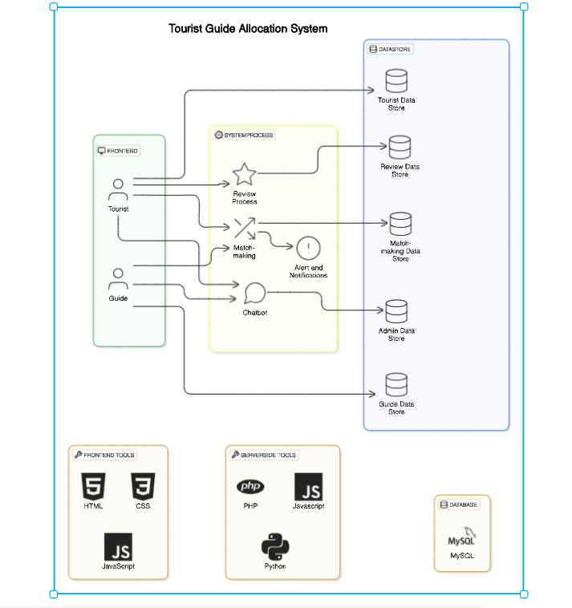

**Input Design**

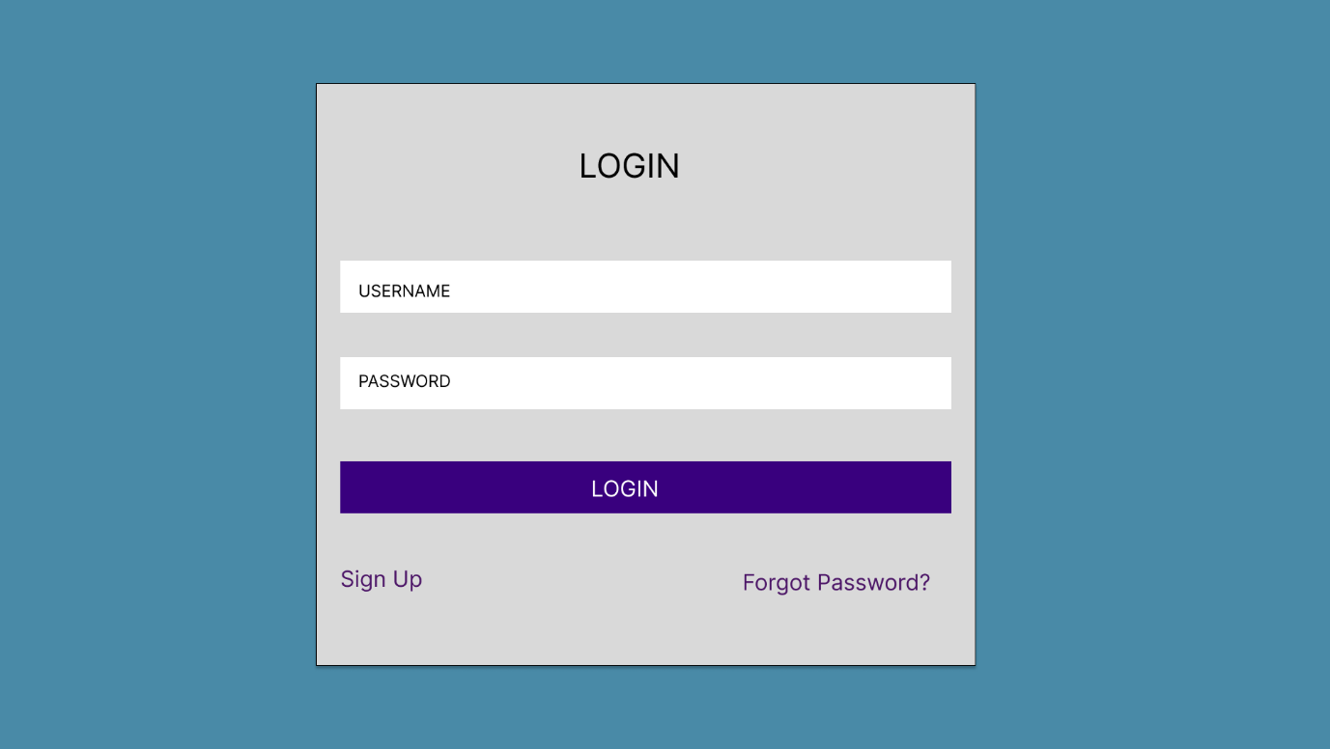

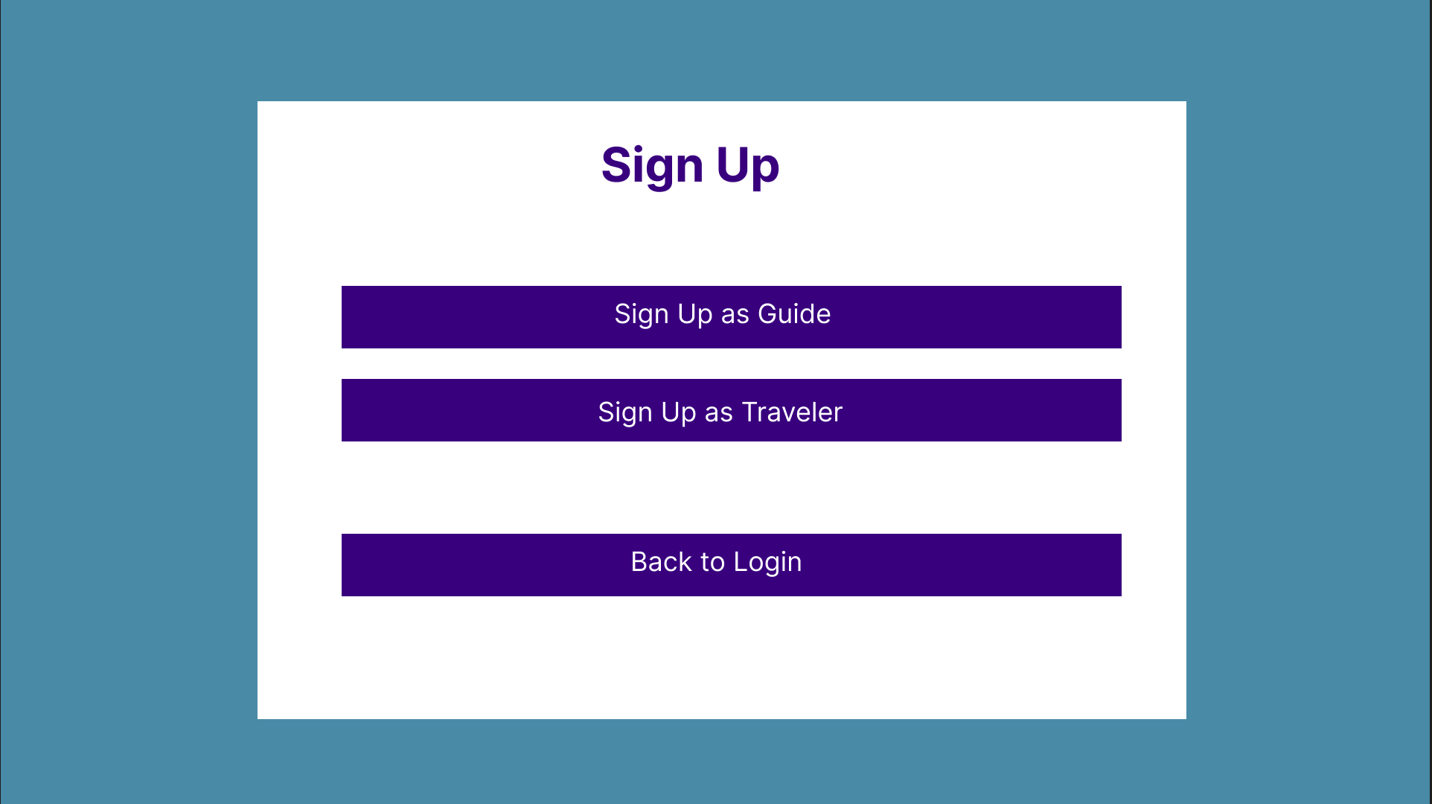

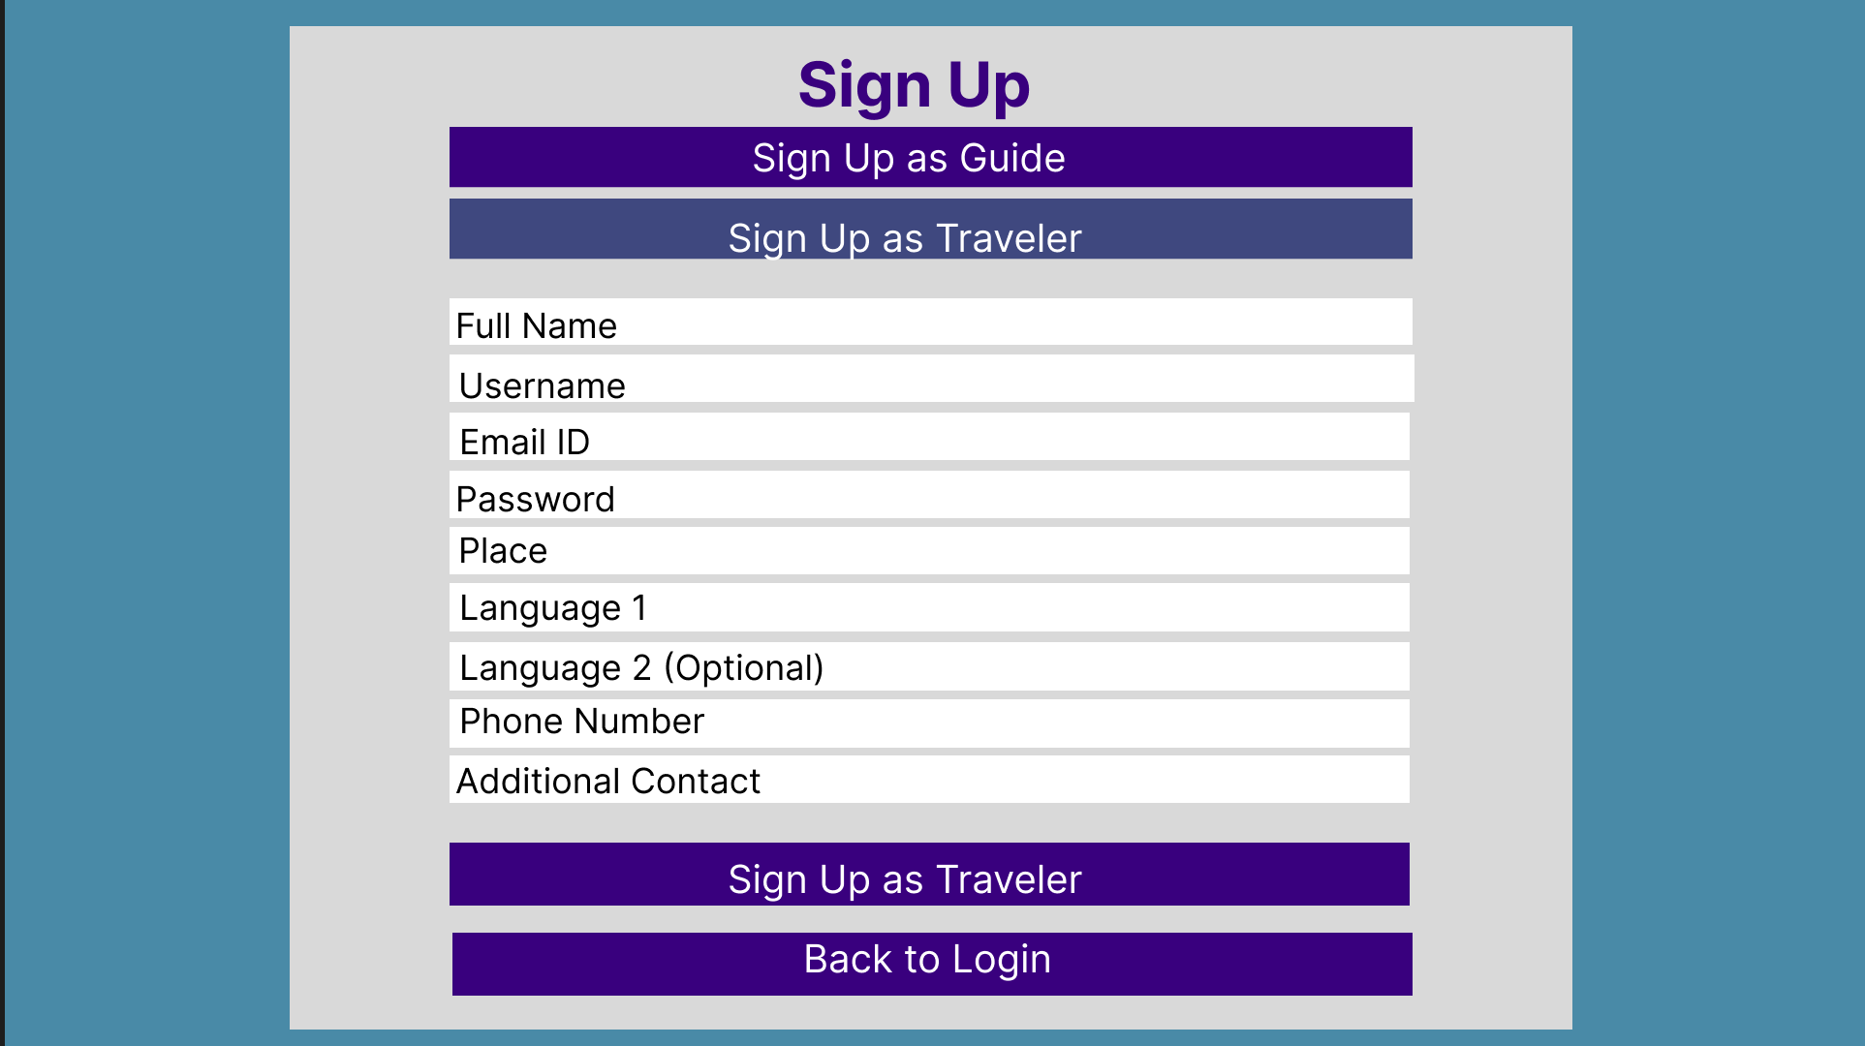

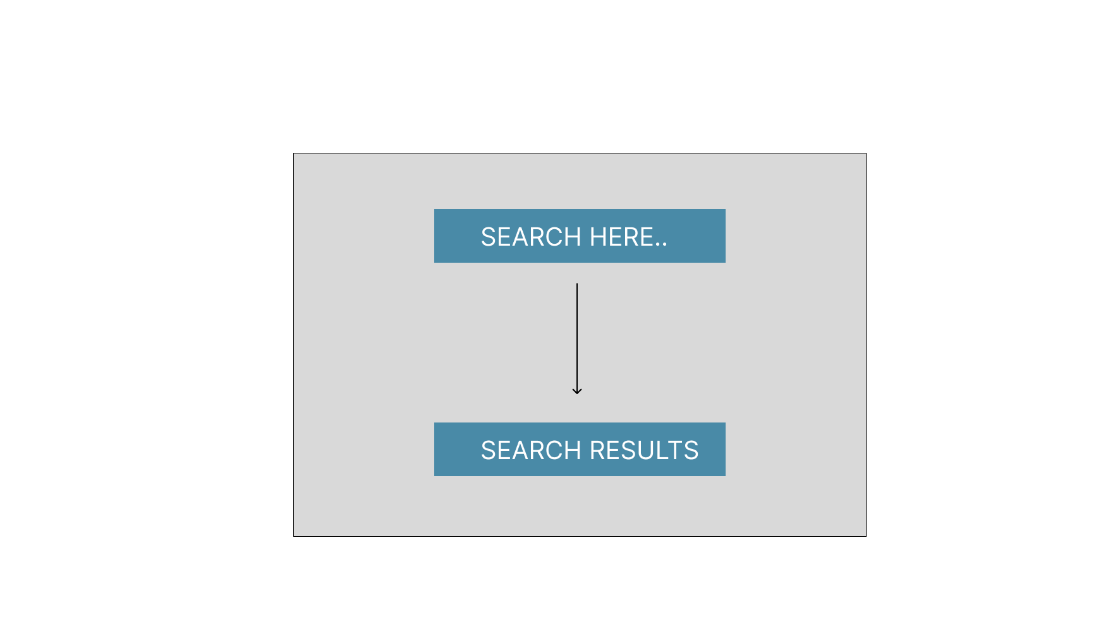

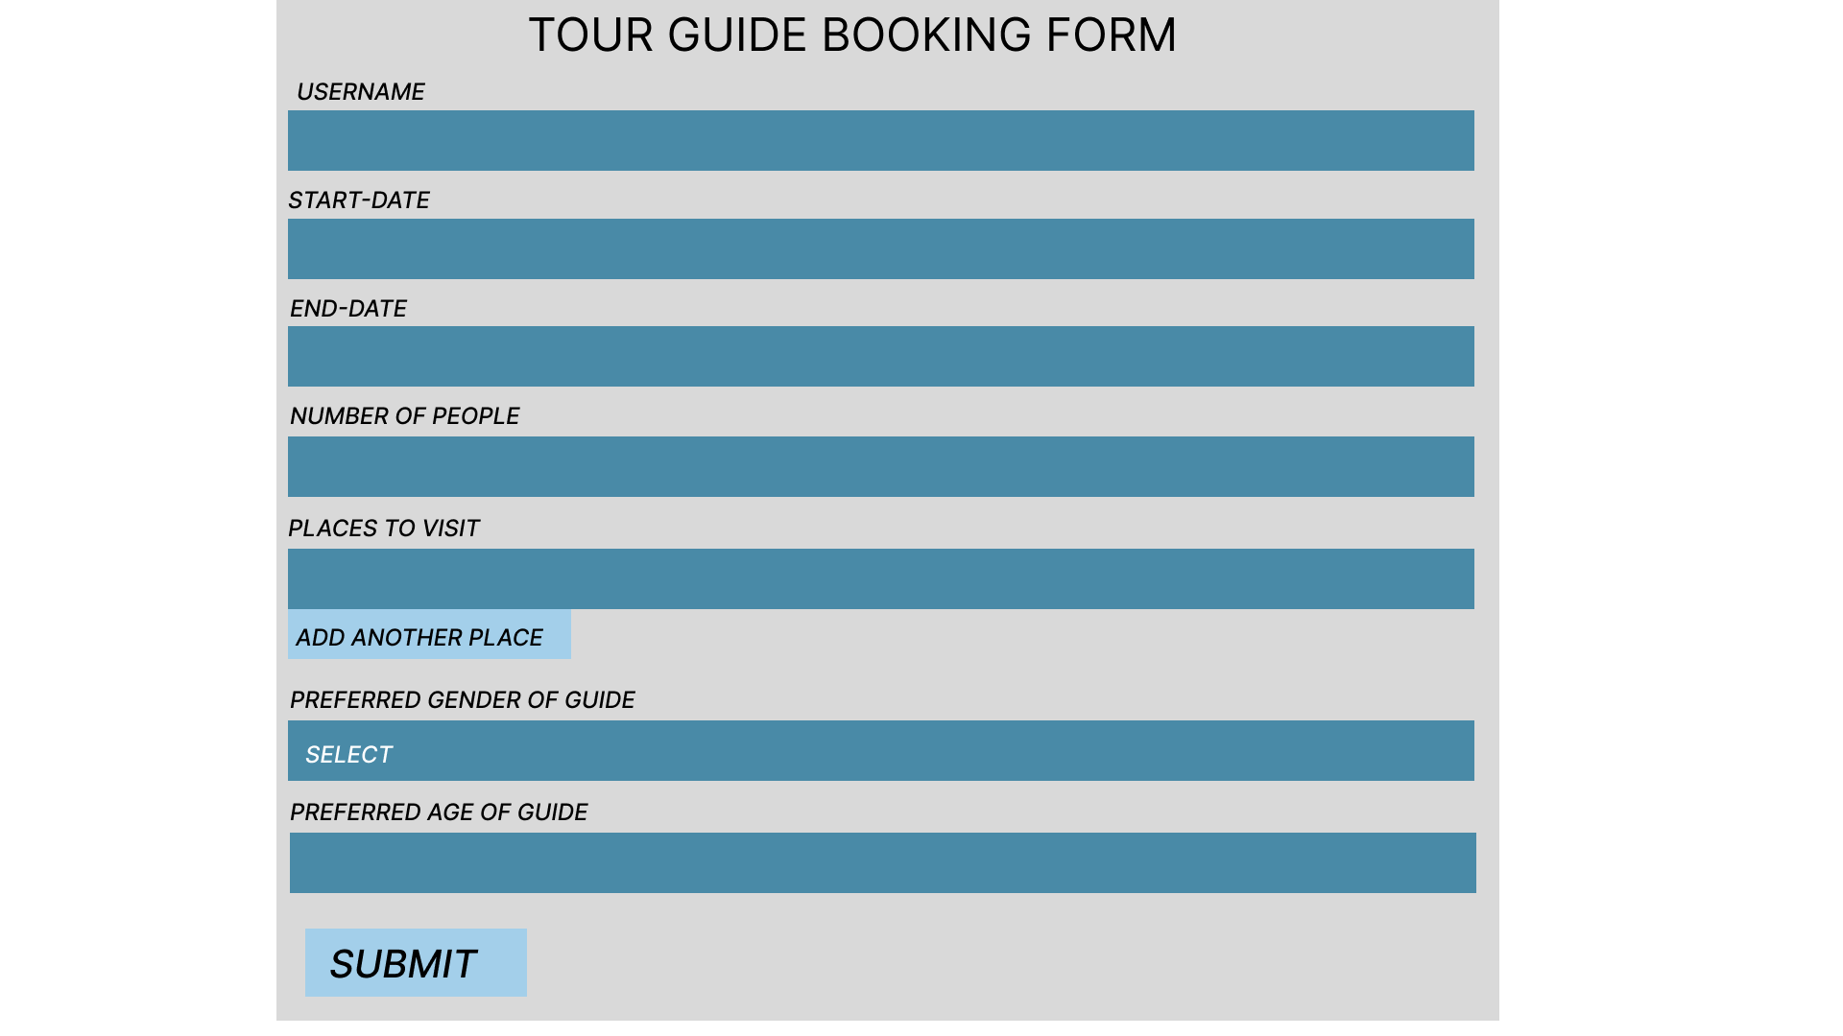

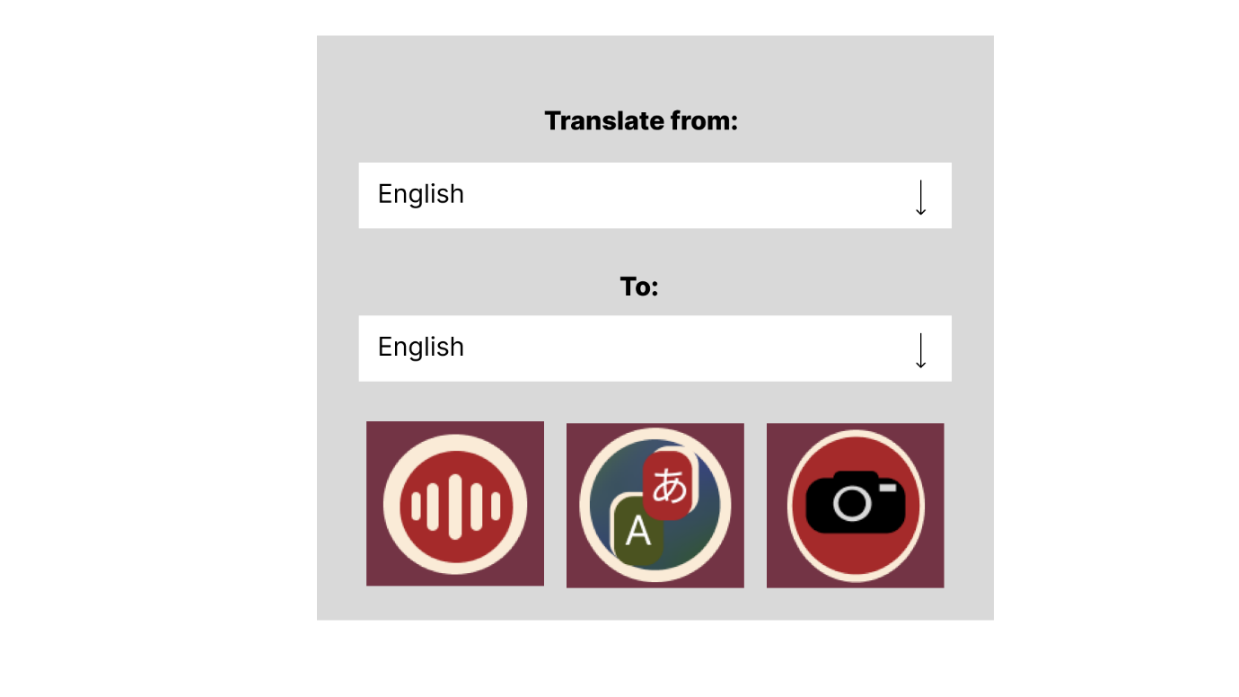

**Output Design**

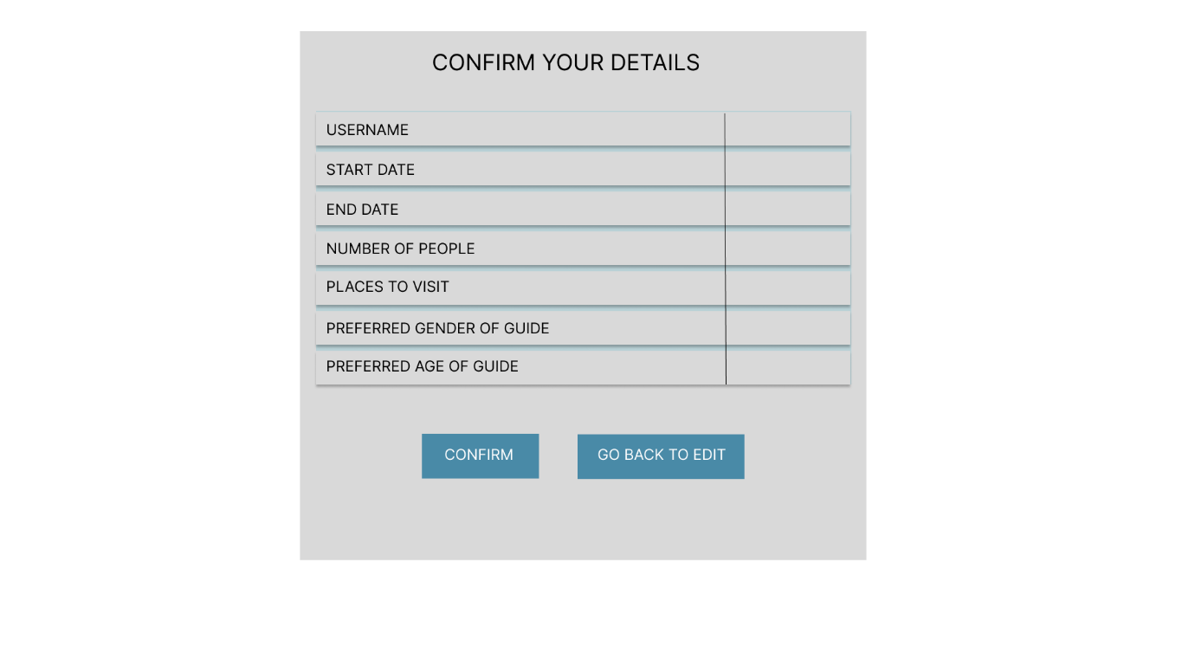

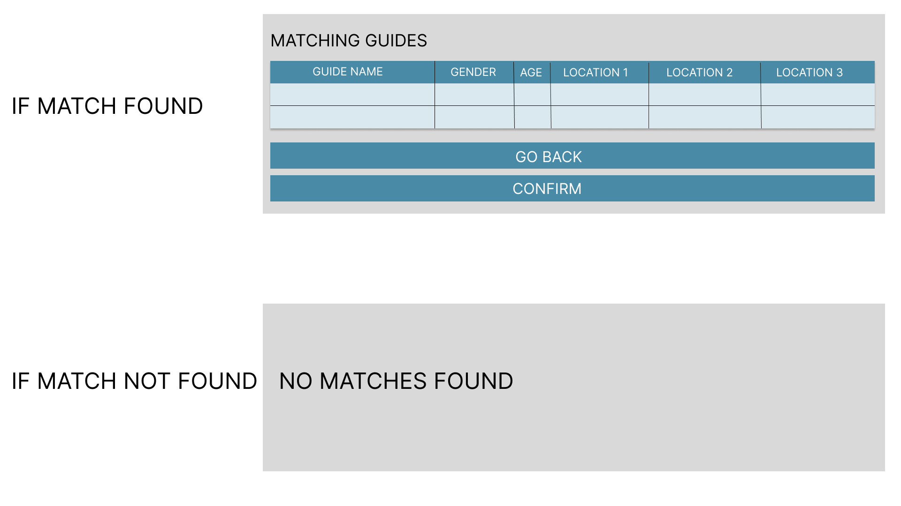

**6.3.1 DATAFLOW DIAGRAM**

**LELVEL 0**

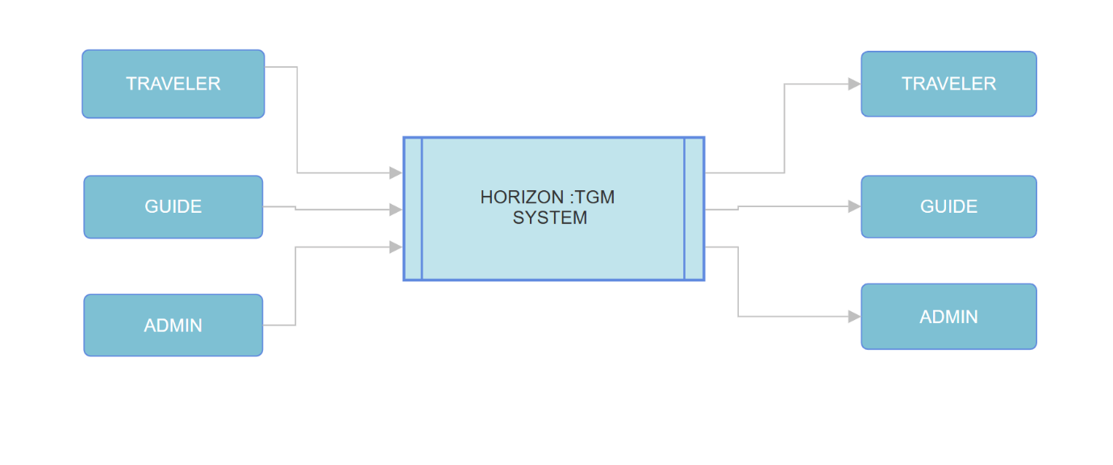

**LEVEL 1**

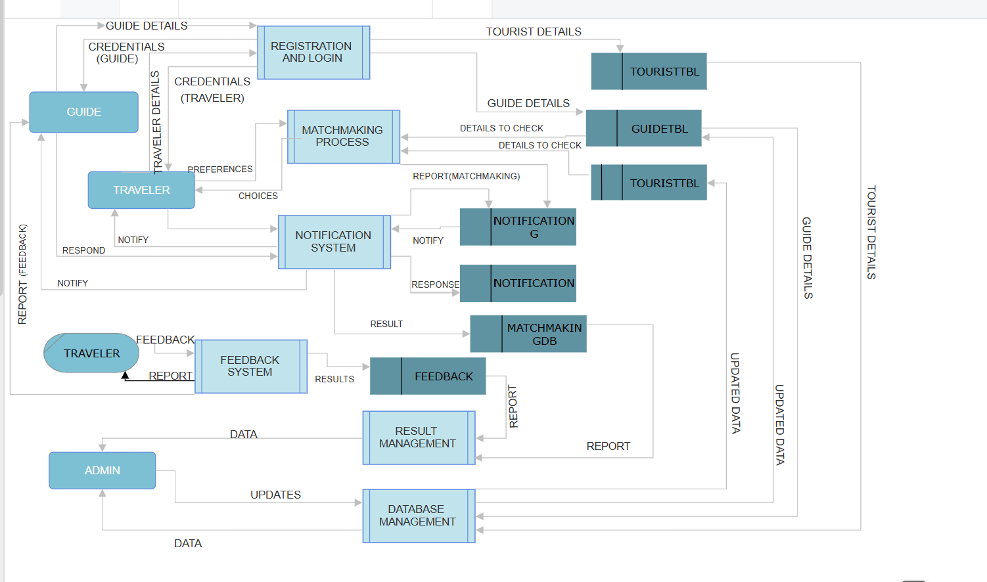

**6.3.2 ERD**

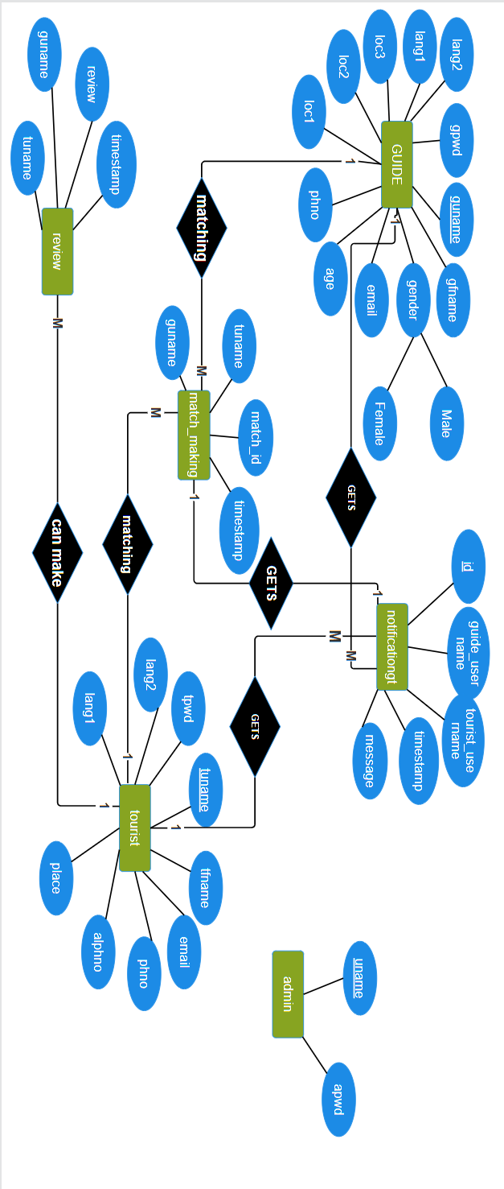

**6.3.3 TABLE DESIGN**