CAN Node Spec v0.4
Bobcat Baja DAQ. What every node sends on the CAN bus and how it connects. v0 frozen Oct 19, 2026. v0.2 follows the car topology approved there: corner nodes, cockpit node and powertrain temps. v0.3 (Oct 20, 2026) retires the diff nodes: the car moves to mechanical diff control. v0.4 (Oct 26, 2026) drops the node ID byte from the heartbeat. Owner: Toph Jones. Changes to existing IDs or signals are agreed at the Monday meeting first. Machine-readable version: dbc/baja_daq.dbc in Bobcat-BAJA/can-spec.

What changed in v0.4
- Heartbeat: byte 0 (node ID) removed. The heartbeat ID is already 0x700 + node ID, so the byte repeated it. Every field moves down one byte and the heartbeat is now 7 bytes: state, error flags, firmware major/minor, uptime. Hub and node firmware must update together.
- Unchanged: every ID, node ID and data message. Bus load stays at 17.7%.

What changed in v0.3
- Retired: front diff (node 0x03, DiffF_Fault 0x020, DiffF_Status 0x210) and rear diff (node 0x08, DiffR_Fault 0x021, DiffR_Status 0x211). The diff boards are scrapped; the car moves to mechanical diff control. These IDs are not reused, and corners stay on 0x320–0x323.
- Unchanged: every other ID and signal. Bus load falls from 18.9% to 17.7%.

What changed in v0.2
- Added: corner nodes 0x09–0x0C on 0x320–0x323 (wheel speed, shock travel, tie-rod strain, 200 Hz); cockpit node 0x0D on 0x120 (steering wheel, throttle, brake switch, marker) and 0x121 (front/rear brake pressure); PT_Temps 0x201 (CVT, head, gearbox temps, 10 Hz).
- Retired: SensorBoardV2 (node 0x05, 0x300/0x310); it must also lose its 120 Ω (R8). Fuel gauge (node 0x04, 0x500): a sensor in the tank is not feasible.
- Termination: moved from the harness end plugs onto the hub and rear-steer boards, the two ends of the trunk.
- Unchanged: every other ID and signal.

1. Bus basics
- Protocol: classic CAN 2.0A, 11-bit IDs, 1 Mbit/s. No CAN FD and no remote frames.
- Transceiver: TI SN65HVD230DR on 3.3 V, RS pin to GND (high-speed mode).
- Termination: 120 Ω on the two end boards only: the hub (DAQ) and rear-steer (R11 fitted). The bus measures 60 Ω. No terminator on any other node or in the harness.
- Priority: lower ID wins the bus, so faults get the lowest IDs and slow data the highest.

2. Car topology
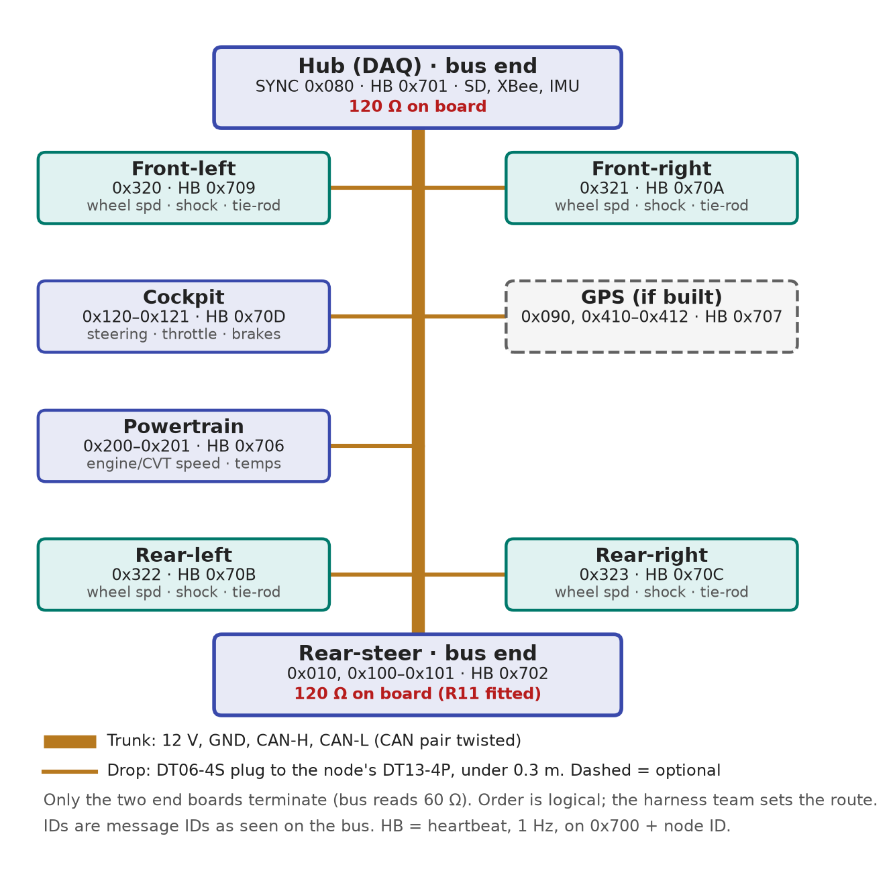
- Trunk: one continuous run from the hub to rear-steer, the two terminated ends. CAN-H/CAN-L twisted, kept away from the ignition lead and rear-steer motor wires.
- Drops: each node sits on the frame beside its corner or system, stub under 0.3 m. Longer sensor cables (DTM) run from the node, not the bus.
- Order between the ends is logical; the harness team sets the physical route.

3. Node hardware
Item | Standard
Node MCU | Seeed XIAO ESP32-C3 (113991054). The hub is a XIAO ESP32-S3.
CAN pins | TX = D7 (GPIO20), RX = D10 (GPIO10), each through a 0 Ω series resistor. 10 kΩ pull-up on TX keeps the bus quiet during boot.
Boot pins | D0, D8, D9 (GPIO2, 8, 9) are sampled at reset. Never pull them low at power-up.
Analog inputs | D1, D2 (ADC1). D3 is ADC2: use it as digital.
Firmware | Arduino "USB CDC On Boot" = Enabled, so Serial uses USB and not D7. Use D-pin names, not GPIO numbers.
Connector | One Deutsch DT13-4P per node (12 V, GND, CAN-H, CAN-L), mating with the DT06-4S drop plug. Pin order per the harness standards doc.
Power | 12 V in → B340A reverse-polarity diode → SMBJ15A TVS → LM1084-5.0 → 1N5819 → XIAO 5V pin.
Protection | ESD2CAN24-Q1 on CAN-H/CAN-L at the connector.
Design start | Club Altium project template plus the CAN Node Core reuse block.

4. What every node must send

Heartbeat: once per second on 0x700 + node ID (no header)
Byte | Field | Type | Meaning
0 | State | u8 | 0 booting, 1 OK, 2 warning, 3 fault
1–2 | Error flags | u16 | Bits 0–7 node library: 0 no SYNC seen, 1 CAN error-passive, 2 TX queue overflow, 3 brownout/watchdog reset. Bits 8–15 node-specific
3–4 | Firmware version | u8, u8 | Major, minor
5–6 | Uptime | u16 | Seconds since power-up

Data frames: 3-byte header + up to 5 data bytes
Byte | Field | Type | Meaning
0 | Sequence counter | u8 | +1 per message on this ID, wraps 255 → 0. A gap means a dropped frame
1–2 | Time since SYNC | u16 | µs since the node last saw SYNC (0x080). 0xFFFF = no SYNC yet
3–7 | Data | — | Per message, below
The hub sends SYNC on 0x080 every 50 ms. Each node zeroes its µs counter on SYNC. On the bench model nodes may send 0xFFFF and rely on the hub timestamp.

5. Data rules
- Integers only, little-endian. No floats on the bus.
- Scaled: real value = raw × factor + offset, as listed in the DBC.
- Signed types for anything that can go negative.
- Not available: all ones (0xFF, 0xFFFF; 0x7FFF signed). Never 0.
- Fixed rates: periodic messages on a steady schedule. Faults go out on change, then 10 Hz while active.
- Stay in your slice: a node only sends on IDs assigned to it in the registry.

6. CAN ID map
IDs | Block
0x000–0x07F | Faults
0x080–0x0FF | Timing (SYNC 0x080, GPS time 0x090)
0x100–0x1FF | Steering and driver inputs (cockpit 0x120–0x121)
0x200–0x2FF | Powertrain
0x300–0x3FF | Suspension and wheels (corners 0x320–0x323)
0x400–0x4FF | Vehicle dynamics
0x500–0x5FF | Electrical
0x600–0x6FF | Spare
0x700–0x77F | Heartbeats (0x700 + node ID)

Node IDs
Node ID | Node | Heartbeat | Built by
0x01 | Hub | 0x701 | DAQ
0x02 | Rear-steer | 0x702 | Toph
0x03 | Retired (was front diff). Do not reuse | — | —
0x04 | Retired (was fuel gauge). Do not reuse | — | —
0x05 | Retired (was SensorBoardV2). Do not reuse | — | —
0x06 | Powertrain | 0x706 | Unassigned
0x07 | GPS | 0x707 | DAQ, if built
0x08 | Retired (was rear diff). Do not reuse | — | —
0x09–0x0C | Corners: FL, FR, RL, RR | 0x709–0x70C | Shock team
0x0D | Cockpit | 0x70D | Unassigned
0x10–0x7F | New nodes, claimed in the registry | 0x710–0x77F | —

7. Messages
Generated from dbc/baja_daq.dbc. Hub-internal messages are logged under these IDs but never sent on the wire.
ID | Message | Sent by | Rate | Header | Data bytes: signal, type, factor, unit
0x010 | RS_Fault | REARSTEER | On change; 10 Hz while active | Yes | 3: FaultCode, u8, 1  4: Severity, u8, 1
0x080 | SYNC | HUB | 20 Hz | No | 0: SyncCounter, u8, 1
0x090 | GPS_Time | GPS | 1 Hz | No | 0–3: UtcTimeOfDay, u32, 1 ms
0x100 | RS_SteerAngles | REARSTEER | 100 Hz | Yes | 3–4: FrontAngle, i16, 0.01 deg  5–6: RearAngle, i16, 0.01 deg
0x101 | RS_SteerMotor | REARSTEER | 100 Hz | Yes | 3–4: MotorCurrent, i16, 0.01 A  5: Mode, u8, 1
0x120 | CP_Driver | COCKPIT | 100 Hz | Yes | 3–4: SteeringWheelAngle, i16, 0.1 deg  5: Throttle, u8, 0.5 %  6.0: BrakeSwitch, bit  6.1: MarkerButton, bit
0x121 | CP_Brakes | COCKPIT | 100 Hz | Yes | 3–4: FrontBrakePressure, u16, 0.1 bar  5–6: RearBrakePressure, u16, 0.1 bar
0x200 | PT_EngineCVT | POWERTRAIN | 100 Hz | Yes | 3–4: EngineSpeed, u16, 1 rpm  5–6: CvtSecondarySpeed, u16, 1 rpm
0x201 | PT_Temps | POWERTRAIN | 10 Hz | Yes | 3: CvtPrimaryTemp, u8, 1 °C, offset −40  4: CvtSecondaryTemp, u8, 1 °C, offset −40  5: HeadTemp, u8, 2 °C  6: GearboxTemp, u8, 1 °C, offset −40
0x320 | CornerFL | CORNER_FL | 200 Hz | Yes | 3: WheelSpeed, u8, 0.5 km/h  4–5: ShockTravel, u16, 0.01 mm  6–7: TieRodStrain, i16, 1 µε
0x321 | CornerFR | CORNER_FR | 200 Hz | Yes | 3: WheelSpeed, u8, 0.5 km/h  4–5: ShockTravel, u16, 0.01 mm  6–7: TieRodStrain, i16, 1 µε
0x322 | CornerRL | CORNER_RL | 200 Hz | Yes | 3: WheelSpeed, u8, 0.5 km/h  4–5: ShockTravel, u16, 0.01 mm  6–7: TieRodStrain, i16, 1 µε
0x323 | CornerRR | CORNER_RR | 200 Hz | Yes | 3: WheelSpeed, u8, 0.5 km/h  4–5: ShockTravel, u16, 0.01 mm  6–7: TieRodStrain, i16, 1 µε
0x400 | HUB_IMU_Accel | HUB (hub-internal) | 500 Hz | No | 0–1: AccelX, i16, 0.001 g  2–3: AccelY, i16, 0.001 g  4–5: AccelZ, i16, 0.001 g
0x401 | HUB_IMU_Gyro | HUB (hub-internal) | 500 Hz | No | 0–1: GyroX, i16, 0.1 deg/s  2–3: GyroY, i16, 0.1 deg/s  4–5: GyroZ, i16, 0.1 deg/s
0x410 | GPS_Lat | GPS | 10 Hz | Yes | 3–6: Latitude, i32, 1e-07 deg
0x411 | GPS_Lon | GPS | 10 Hz | Yes | 3–6: Longitude, i32, 1e-07 deg
0x412 | GPS_SpeedHeading | GPS | 10 Hz | Yes | 3–4: GroundSpeed, u16, 0.01 m/s  5–6: Heading, u16, 0.01 deg
0x510 | HUB_Battery | HUB (hub-internal) | 10 Hz | No | 0–1: BatteryVoltage, u16, 0.01 V

8. Bus load
All periodic on-bus messages total about 1,370 frames/s, or 17.7% of 1 Mbit/s worst case with bit stuffing. The limit is 50%. tools/check_dbc.py recomputes this on every DBC change.

9. Adding a new sensor
- Claim a node ID and an ID slice in the CAN ID registry (Wrigley).
- Add every signal to the DBC: bytes, type, factor, offset, unit, rate.
- Run tools/check_dbc.py until it prints PASS. Toph reviews.
- Build the board from the club template and CAN Node Core block; build firmware on the node library.
- Bench test: plug in, see the heartbeat on the dashboard, check values decode in real units.

