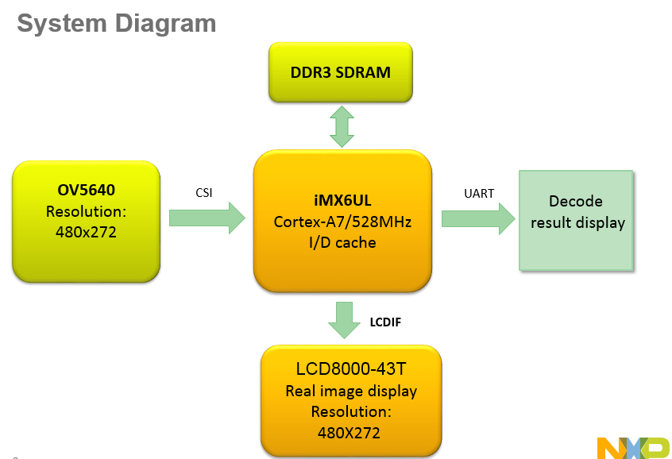

|  |  |  |  |  |
| --- | --- | --- | --- | --- |
| Qrdecoder_yuv.c | | | | |
| CSI | PXP | | Qrdecoder | LCD |
| input pixel format: YUV422 | IN(psbuffer) | OUT(outputbuffer) | Require Y input,  8 lines process and decoder;  Convert all the Y data to R/G/B to LCD display, | Pixel format : RGB888 |
| Bytes per pixel: 2 bytes(YUYVYUYV…) | Pixel format: UYVY1P422 | Pixel format:  8-bit monochrome pixels (1-plane Y luma output) | Data bus : 24bit |
| Interace: HSYNC/HREF, VSYNC, and PIXCLK used | pitchBytes:  CAMERA_WIDTH * 2 bytes | pitchBytes:  CAMERA_WIDTH * 1 bytes |  |
|  | Csc1 bypassed, the output pixels will be in the YUV/YCbCr color space | | LCD output monochrome picture |
|  |  | |  |  |

|  |  |  |  |  |
| --- | --- | --- | --- | --- |
| Qrdecoder_rgb.c | | | | |
| CSI | PXP | | Qrdecoder | LCD |
| input pixel format: RGB565 | IN(psbuffer) | OUT(outputbuffer) | Require Y input,  8 lines process and decoder;  LCD display the camera input directly(not through PXP) | Pixel format : RGB565 |
| Bytes per pixel: 2 bytes(YUYVYUYV…) | Pixel format: RGB565 | Pixel format:  8-bit monochrome pixels (1-plane Y luma output) | Data bus : 24bit |
| Interace: HSYNC/HREF, VSYNC, and PIXCLK used | pitchBytes:  CAMERA_WIDTH * 2 bytes | pitchBytes:  CAMERA_WIDTH * 1 bytes |  |
|  | Csc1 bypassed, the output pixels will be in the YUV/YCbCr color space | | LCD output color picture |
|  | Csc2 enabled, operations occur on the pixels, RGB to YUV | |  |  |

Notes:

1. Build the zxing library with Cortex A7

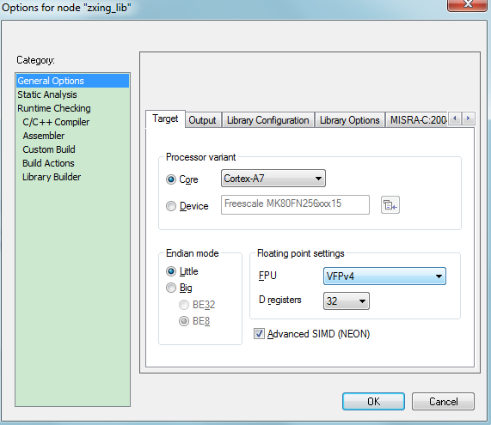

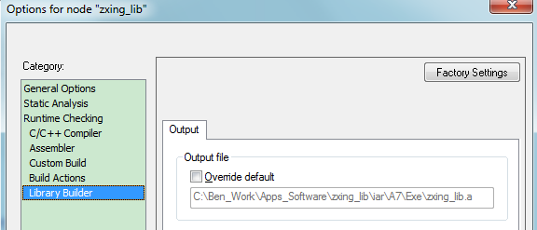

1. Allocate the enough stack and heap size in the decoder project

