A-Life Complete Organism and Intelligence Architecture
  - Version 2.0 CONTROLLING - Permanent Controlling Source of Truth and Compliance Standard
24 August 2026
Contents
Document status
Executive summary
Part I - Normative foundation
– 1. Requirement language and precedence
– 2. Project objectives
– 3. Global invariants
– 4. Whole-system authority model
– 5. Time, cadence, and causal scheduling
Part II - World, body, and physiology
– 6. World and ecology
– 7. Body and physiology
Part III - Genetics, development, and heritable priors
– 8. Genetics as a construction program
– 9. Development
– 10. Germline neural-prior assets
Part IV - Sparse evolvable biochemistry
– 11. Biochemical purpose and boundary
Part V - Brain and cognitive memory
– 12. Cognitive brain scope
– 13. Neural substrate
– 14. Nine founder developmental regions
– 15. Sensory grounding and attention
– 16. Cognitive context and interoception
– 17. Episodic, semantic, and social memory
– 18. Concepts, causal topology, and unresolved gaps
– 19. Prediction, world modelling, and bounded planning
– 20. Neural learning and credit assignment
– 21. Structural plasticity and dendritic allocation
– 22. Action, planning, and motor intentions
– 23. Embodiment adapters and body schema
Part VI - Sleep, growth, and identity
– 24. Sleep and consolidation
– 25. Cognitive identity and graph epochs
– 26. Function-preserving brain growth and augmentation
Part VII - Founder training, teachers, SLMs, and culture
– 27. Founder pretraining and nested meta-training
– 28. Shared semantic-prior service
– 29. Teacher system
– 30. Culture and curricula
Part VIII - Reproduction, assimilation, and evolution
– 31. Reproduction and ordinary inheritance
– 32. Genetic assimilation
– 33. Evolution and selection
Part IX - Portability and external use
– 34. Portable cognitive core
Part X - Game and community architecture
– 35. Core game loops
– 36. Community artifact types
Part XI - Compute, persistence, observability, and failure handling
– 37. Compute architecture and work accounting
– 38. Persistence and exact continuity
– 39. Observability and presentation
– 40. Failure, recovery, and transaction safety
Part XII - Compliance grading and scientific evaluation
– 41. Compliance reports
– 42. Required capability families
– 43. Test and evidence strategy
Part XIII - Migration, supersession, and deferred research
– 44. Migration from existing implementations
– 45. Deferred and research capabilities
Appendix A - Canonical interface catalogue
– A.1 Organism genotype package
– A.2 Grounded perception frame
– A.3 Cognitive context frame
– A.4 Motor intent bundle
– A.5 Physical outcome
– A.6 Experience transaction
– A.7 Neural receptor frame
– A.8 Neural emission frame
– A.9 Portable cognitive core
Appendix B - Reference formulas and policies
– B.1 Region allocation
– B.2 Sparse synaptogenesis bound
– B.3 Multi-dimensional three-factor learning
– B.4 Function-preserving recurrent growth
– B.5 Inherited complexity pressure
Appendix C - Prohibited shortcuts
Appendix D - Compliance report template
Appendix E - Glossary
Appendix F - Design lineage and superseded material

Document status
Status: CONTROLLING. This document is the single normative architecture for A-Life. Ratification changed only its status and publication name; all stable requirement IDs and normative requirements remain unchanged.
Authority: This document is intended to supersede every earlier A-Life architecture, brain, runtime, biochemical, genetic, memory, teacher, evolution, and integration specification. Earlier documents remain historical design lineage only. They may explain how the project arrived here, but they do not override this document.
Implementation status: This document defines the target and the grading standard. It deliberately does not state whether the current code satisfies any requirement. Current status belongs in separate dated compliance reports that cite the stable requirement IDs defined here.
Scope: The complete simulation-and-organism architecture: genetics, development, body and physiology, biochemistry, brain, memory, embodiment, world and ecology, reproduction, evolution, teaching, culture, shared semantic priors, persistence, portability, community artifacts, compute architecture, observability, and codebase grading. Renderer internals, editor layout, deployment tooling, and platform-specific UI are replaceable implementation details unless they cross an interface defined here.

Executive summary
A-Life is a persistent artificial-life simulation game and an artificial-animal intelligence research platform. Its central object is not a neural network, a reinforcement-learning policy, or a chemistry toy. Its central object is an organism whose body, biochemistry, nervous system, genetics, individual memory, culture, and environment form one causal life.
The project takes Creatures 3 as an architectural ancestor, not a source-code template. It retains the valuable organism-level ideas: a genome that constructs the creature; evolvable chemistry with reactions, receptors, emitters, and neuroemitters; bidirectional brain-body coupling; developmental expression; lifetime learning; persistent individuals; reproduction; and culture. It replaces the limitations of that system with sparse GPU-accelerated recurrent cognition, modern predictive and self-supervised learning, episodic and semantic memory, nonlinear dendritic computation, structural plasticity, explicit attention, richer motor control, modern training methods, portable cognitive cores, and rigorous capability-per-compute evaluation.
The architecture makes four biological simulation systems distinct but tightly coupled:
- Genetics and development construct the organism and define heritable variation.
- Body and physiology own morphology, organs, tissues, mechanics, and viability.
- Biochemistry owns chemicals, metabolism, regulatory signalling, and neuroendocrine coupling.
- Brain and cognitive memory own adaptive information processing, prediction, memory, concepts, action choice, and learning.
These systems communicate through explicit interfaces. None may silently duplicate another system’s authoritative state. The world reports physical facts, never an externally authored reward. Biochemistry reports physiological and neuromodulatory signals, never a finished cognitive policy. The brain chooses and learns, but does not calculate heartbeat-equivalent or servo-control housekeeping. Genetics constructs and biases; it does not own current memories, current chemistry, or acquired adult weights.
The founder species begins with nine conserved developmental brain homologues, minimum functional floors, proportional allocation of remaining neurons, and a deliberately pretrained germline neural foundation. Region function is induced by inputs, outputs, dynamics, chemistry, plasticity, development, and experience - not by handwritten lobe algorithms. Evolution may create bounded derived regions by duplication, subdivision, reserve recruitment, specialization, fusion, and pruning.
Individual learning, cultural inheritance, and genetic inheritance remain separate. Personal episodic and semantic memory is never inherited. Generalized neural skills may become heritable only through sanitized, compressed, newborn-compatible germline-prior assets. Communities may train cohorts, assimilate shared transferable competence into new breed revisions, and distribute culture as separate curricula taught through grounded interaction.
A mature creature’s cognitive core can be scaled upward without destroying its learned abilities and can later be transplanted into another game, software environment, or embodied robot through explicit sensory, motor, and viability adapters.
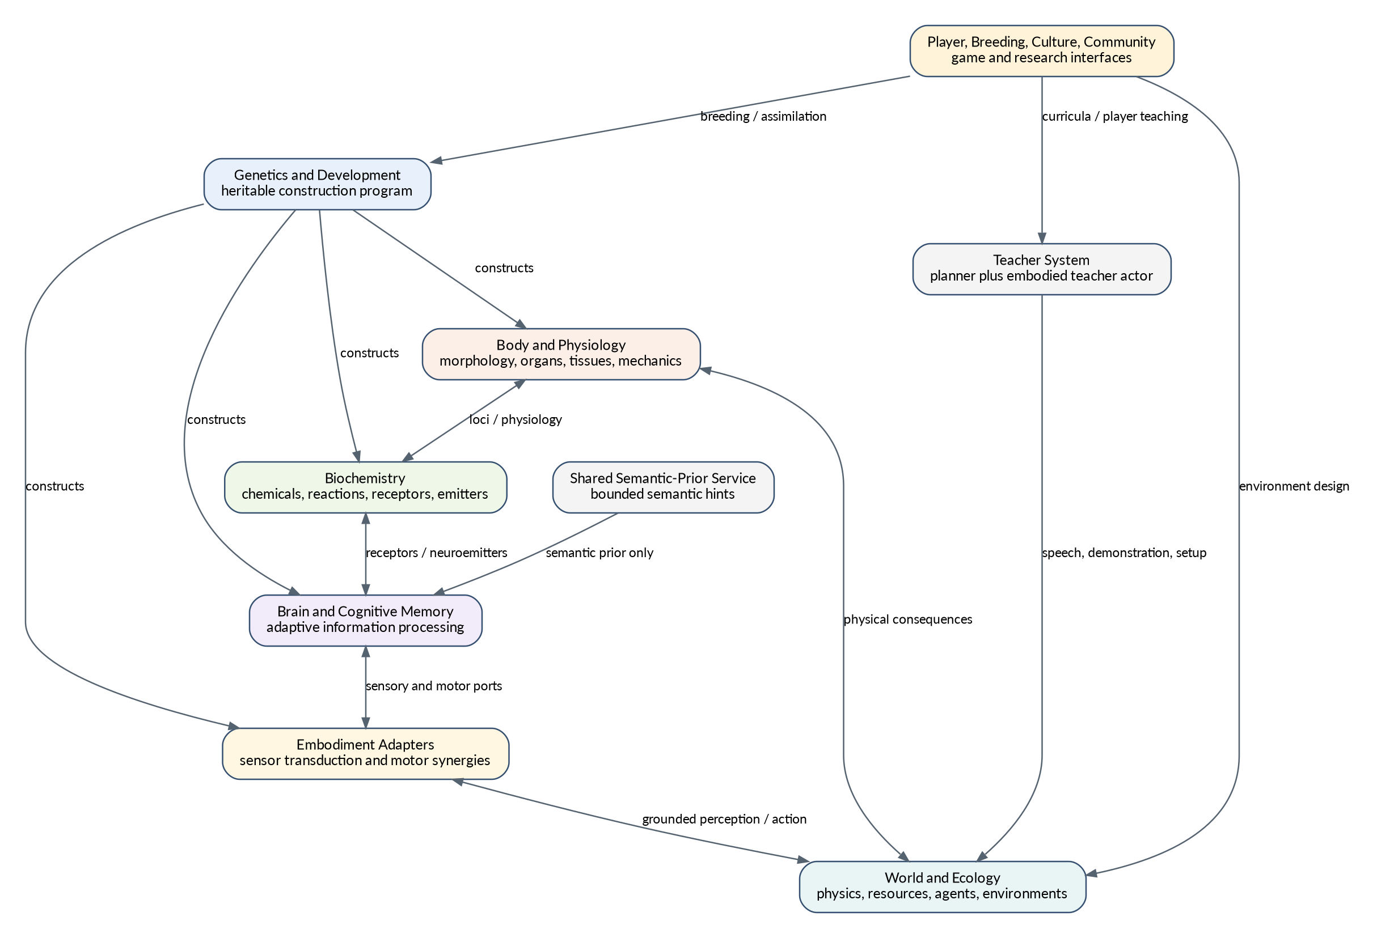
Whole-system architecture
Figure 1. The organism-centred system and its external semantic-prior, teacher, player, and community services.

Part I - Normative foundation

1. Requirement language and precedence
Each normative statement has a stable ID and one category:
Category | Meaning
LOCKED GOAL | Optimization objective or project purpose. Implementations are judged by whether they advance it.
LOCKED CAPABILITY | Observable ability the system must possess. The mechanism may change.
LOCKED INVARIANT | Rule no compliant implementation may violate.
LOCKED INTERFACE | Semantic boundary between subsystems. Concrete data structures may change while meaning remains stable.
REFERENCE MECHANISM | Favoured current design that may be replaced by evidence-backed alternatives satisfying the same locked requirements.
TUNABLE DEFAULT | Initial numeric or policy value expected to change through profiling, training, evolution, or experimentation.
DEFERRED CAPABILITY | Required destination that is not necessarily an immediate implementation gate.
RESEARCH | Promising optional mechanism not required for compliance.
When requirements conflict, precedence is:
- locked invariants;
- locked interfaces;
- locked capabilities;
- locked goals;
- reference mechanisms;
- tunable defaults;
- deferred and research items.
A lower-precedence item may never be used to narrow or reinterpret a higher-precedence item. Implementation inconvenience does not amend architecture.
[AOA-ADM-001 | LOCKED INVARIANT] This document is self-contained. A compliant implementation or reviewer must not need an earlier architecture document to determine intended subsystem behaviour.
[AOA-ADM-002 | LOCKED INVARIANT] Earlier architecture documents are historical only after ratification. When they conflict with this document, this document controls.
[AOA-ADM-003 | LOCKED INTERFACE] Current codebase compliance is recorded in separate dated reports that cite requirement IDs. Implementation status is never embedded in this permanent architecture.
[AOA-ADM-004 | LOCKED INVARIANT] Requirement IDs are never reused for a different meaning. Removed requirements remain reserved and are marked deprecated in later revisions.
[AOA-ADM-005 | LOCKED INVARIANT] An implementation limitation remains a limitation. It must not become a new architectural rule unless this document is explicitly revised.
[AOA-ADM-006 | LOCKED INVARIANT] A type, field, counter, diagnostic, test fixture, or interface declaration does not by itself satisfy a capability. Required mechanisms must participate causally through production paths.
[AOA-ADM-007 | LOCKED INVARIANT] Current languages, engines, libraries, processor placement, GPU layouts, brain-size classes, constants, adapters, and test fixtures are implementation mechanisms unless this document explicitly locks their semantics.

2. Project objectives
[AOA-GOAL-001 | LOCKED GOAL] Develop artificial animals capable of increasingly general lifelong learning, grounded prediction, memory, concept formation, social learning, planning, communication, and transfer.
[AOA-GOAL-002 | LOCKED GOAL] Maximize behavioural capability per unit of neural compute, memory, latency, biochemical work, teacher/SLM cost, and simulated energy.
[AOA-GOAL-003 | LOCKED GOAL] Preserve evolvability: the organism must remain capable of useful genetic, developmental, biochemical, neural, and cultural adaptation rather than becoming one frozen engineered policy.
[AOA-GOAL-004 | LOCKED GOAL] Remain a fun, legible persistent simulation game built around individual creatures, relationships, communities, teaching, breeding, culture, ecology, and visible behavioural change.
[AOA-GOAL-005 | LOCKED GOAL] Use biologically inspired mechanisms when they improve intelligence, efficiency, robustness, evolvability, individuality, or game value; biological resemblance is never an end in itself.
[AOA-GOAL-006 | LOCKED GOAL] Support extraction, enlargement, transplantation, and reuse of mature cognitive cores in other games, software environments, and embodied robots.
[AOA-GOAL-007 | LOCKED GOAL] Keep the architecture inspectable and falsifiable so that apparent intelligence can be attributed to the creature rather than hidden host code, teachers, SLMs, or benchmark leakage.

3. Global invariants
[AOA-INV-001 | LOCKED INVARIANT] All creature cognition is grounded in causal world, body, biochemical, memory, social, and teacher interactions. No privileged semantic truth may silently enter the brain.
[AOA-INV-002 | LOCKED INVARIANT] The world reports physical and transactional facts, not reward, desirability, task success, or what the creature ought to do.
[AOA-INV-003 | LOCKED INVARIANT] Every mutable fact has one authoritative owner. Other representations are explicitly derived views and cannot advance independently.
[AOA-INV-004 | LOCKED INVARIANT] Genetics/development, body/physiology, biochemistry, and brain/cognitive memory are separate mechanisms with explicit interfaces and no duplicated ownership.
[AOA-INV-005 | LOCKED INVARIANT] Computation and storage are bounded by explicit phenotype, world, or platform budgets. Unbounded all-pairs search, unbounded graph growth, and unbounded external-model calls are prohibited.
[AOA-INV-006 | LOCKED INVARIANT] No hidden host policy may choose creature actions, fabricate learning credit, inject concepts or memories, or solve semantic tasks outside the creature.
[AOA-INV-007 | LOCKED INVARIANT] Personal episodic memories, individual semantic propositions, current activations, current chemistry, pending eligibility, and autobiographical identity are not inherited biologically.
[AOA-INV-008 | LOCKED INVARIANT] Teacher and semantic-prior services may accelerate learning but may not substitute for the creature brain. Competence must be separately measurable with each service removed.
[AOA-INV-009 | LOCKED INVARIANT] The ordinary game, training/evaluation hosts, school system, and research scenarios must use the same semantic causal organism step. Reduced evaluators may exist only when explicitly labelled and may not certify full-organism capabilities.
[AOA-INV-010 | LOCKED INVARIANT] Failure must be explicit. Missing assets, incompatible schemas, invalid causal transactions, and partial multi-system commits may not silently fall back to plausible defaults.
[AOA-INV-011 | LOCKED INVARIANT] Brain, body, biochemistry, world, memory, persistence, lifecycle, and presentation must describe the same individual organism and causal sequence.
[AOA-INV-012 | LOCKED INVARIANT] Architectural success is behavioural and causal, not ornamental. A biological mechanism that adds cost without measurable capability, robustness, game value, or evolvability must be replaceable or removable.

4. Whole-system authority model
The organism is the unit of authority. The simulation may store components in different crates, processes, GPU buffers, databases, or content-addressed assets, but those storage choices do not change ownership.
Authoritative owner | Mutable state owned
World/ecology | geometry, physics, resources, object state, environmental fields, social opportunities
Body/physiology | morphology, tissues, organs, physical injury, energy stores, actuator and proprioceptive state
Biochemistry | chemical concentrations, reactions, receptor/emitter state, endocrine and metabolic regulation
Brain | neural state, acquired weights, learned structure, attention, prediction, concepts, action selection
Cognitive memory | personal episodic, semantic, relationship, procedural-index, and cultural-learning records
Genome/development | heritable instructions, germline references, developmental stage and expression state
Teacher/culture infrastructure | curriculum and lesson records, never learner-owned cognition
Semantic-prior infrastructure | shared pretrained semantic model and cache, never organism truth
[AOA-AUTH-001 | LOCKED INTERFACE] The canonical organism record binds organism identity to its genome/development state, body, biochemistry, brain ownership, memories, lifecycle, persistence dependencies, and presentation identity.
[AOA-AUTH-002 | LOCKED INVARIANT] A subsystem may cache another subsystem’s state only as a versioned read-only view tied to a causal tick or transaction ID.
[AOA-AUTH-003 | LOCKED INVARIANT] No evaluator, UI, teacher, trainer, or adapter may maintain an independently advancing copy of canonical body, biochemical, developmental, neural, or memory state.
[AOA-AUTH-004 | LOCKED INTERFACE] Every action/outcome cycle has a stable organism ID, causal sequence ID, pre-action state reference, decision reference, measured joint outcome, and commit status.
[AOA-AUTH-005 | LOCKED INVARIANT] A transaction touching several authoritative systems either commits all required state transitions or rolls back all of them.

5. Time, cadence, and causal scheduling
A-Life is a multirate simulation. Neural cognition, fast neurochemistry, metabolism, organ regulation, ecology, development, reproduction, structural plasticity, sleep, and external teacher calls operate at different rates.
The scheduler advances each due subsystem exactly once for the current causal interval according to that subsystem’s configured cadence. A single rendering frame may contain zero, one, or several simulation substeps. A creature that is asleep, inactive, distant, or low-priority may be updated less frequently only if the scheduler preserves equivalent causal semantics within declared approximation bounds.
[AOA-TIME-001 | LOCKED INVARIANT] Causal sequence order is explicit and deterministic for identical initial state, inputs, configuration, and randomness seeds.
[AOA-TIME-002 | LOCKED INVARIANT] Neural, biochemical, metabolic, ecological, developmental, reproductive, and presentation cadences are not forced to one universal tick rate.
[AOA-TIME-003 | LOCKED INTERFACE] Each derived view records the authoritative tick or interval from which it was derived. Stale views are rejected when semantic freshness matters.
[AOA-TIME-004 | LOCKED INVARIANT] Catch-up processing is bounded. Large time jumps use capped substeps, analytically equivalent integration, or explicit approximation receipts rather than unbounded loops.
[AOA-TIME-005 | LOCKED CAPABILITY] The simulation supports accelerated time while preserving births, deaths, learning, chemical dynamics, sleep, culture, and ecology within declared fidelity limits.
[AOA-TIME-006 | REFERENCE MECHANISM] High-bandwidth neural updates normally run on the GPU; sparse irregular memory, concept, structural proposal, persistence, teacher, and world operations normally run on the CPU or service best suited to them. Placement is determined by measured efficiency, not authority ideology.
Canonical causal loop
Figure 2. The ordinary multirate organism loop. Every training and evaluation host that claims full-organism evidence must traverse this semantic sequence.

Part II - World, body, and physiology

6. World and ecology
The world is a causal environment, not a reward wrapper. It owns physical resources, spatial structure, environmental fields, objects, other organisms, and opportunities for interaction. It may expose physically grounded properties and legal low-level affordances required to operate a body, but it may not expose designer-authored value or task labels as creature policy.
[AOA-WORLD-001 | LOCKED INTERFACE] World sensing exposes grounded observables: geometry, motion, material/chemical cues, sound, light, contact, temperature, object persistence, social signals, and other physically or socially instantiated properties.
[AOA-WORLD-002 | LOCKED INVARIANT] The world may expose that an effector can contact, grip, ingest, emit sound, or apply force. It may not expose that an entity is food, an enemy, a tool, desirable, dangerous, or the correct task target unless that information is itself communicated through a grounded world channel.
[AOA-WORLD-003 | LOCKED INTERFACE] World action execution returns a measured joint physical outcome for the complete factorized motor bundle, including contacts, transfers, movement, damage, energy/material exchange, and failures.
[AOA-WORLD-004 | LOCKED CAPABILITY] Ecologies support resource scarcity, niches, hazards, social interaction, construction or manipulation, reproduction, and persistent environmental consequences sufficient for selection and culture.
[AOA-WORLD-005 | LOCKED INVARIANT] Natural selection operates through survival, reproduction, resource access, and ecological consequence. The runtime brain is not trained by a hidden world fitness scalar.
[AOA-WORLD-006 | REFERENCE MECHANISM] Environmental complexity is introduced progressively so that founders can survive, but later worlds vary enough to prevent one fixed engineered policy from dominating all niches.

7. Body and physiology
The body is a simulated physical organism. It includes morphology, tissues, organs, proprioception, effectors, injury, energetic reserves, and body-specific constraints. Routine deterministic regulation belongs here or in biochemistry, not in the expensive adaptive cognitive brain.

7.1 Functions outside the cognitive neural budget
The following are normally noncognitive:
- heartbeat and circulation equivalents;
- respiration and gas exchange;
- digestion and absorption;
- basal metabolism;
- thermoregulation;
- immune maintenance;
- tissue repair;
- reproductive physiology;
- actuator stabilization, inverse dynamics, and joint safety;
- catastrophic protective cut-outs.
The brain may influence autonomic setpoints and may learn when to invoke behaviours that affect these systems. It does not numerically integrate them.
[AOA-BODY-001 | LOCKED INVARIANT] Body and physiology own physical morphology, tissue and organ state, energy reserves, injury, temperature, proprioception, actuator limits, and viability.
[AOA-BODY-002 | LOCKED INVARIANT] The body never stores reward, learned value, concepts, intentions, or semantic action preferences.
[AOA-BODY-003 | LOCKED CAPABILITY] Organisms may differ genetically and developmentally in size, morphology, sensors, effectors, metabolism, resilience, lifespan, fertility, and physiological trade-offs.
[AOA-BODY-004 | LOCKED CAPABILITY] Local organ or tissue dysfunction may alter behaviour and survival without immediately collapsing every other subsystem.
[AOA-BODY-005 | LOCKED INTERFACE] Body events report physical facts such as tissue damage, nutrient intake, material transfer, temperature change, force, displacement, social contact, and actuator effort.
[AOA-BODY-006 | LOCKED INVARIANT] A body event never contains a field whose semantics are equivalent to reward, punishment, task success, or preferred action.
[AOA-BODY-007 | LOCKED CAPABILITY] Simple withdrawal, balance, actuator protection, and life-preserving reflexes may bypass deliberative cognition, but their stimuli and outcomes remain available to the brain for learning.
[AOA-BODY-008 | LOCKED INVARIANT] A reflex may prevent catastrophic harm; it may not silently solve a semantic or strategic task that the creature is expected to learn.
[AOA-BODY-009 | REFERENCE MECHANISM] Physiology is represented as typed organs and tissues with local cadence, energetic cost, damage, repair, and exposed loci, rather than one undifferentiated health scalar.
[AOA-BODY-010 | TUNABLE DEFAULT] Initial founder bodies use a manageable early-animal or early-mammal reference morphology; the architecture does not lock one species body plan.

Part III - Genetics, development, and heritable priors

8. Genetics as a construction program
Genetics answers: what kind of organism is built? It does not continuously micromanage an adult mind.
The complete heritable genotype consists of a compact recombining genome plus exact references to immutable germline assets. The genome encodes developmental rules and low-dimensional parameters. Large pretrained neural priors are stored out-of-line in content-addressed regional blocks.
[AOA-GEN-001 | LOCKED INVARIANT] The genome contains only heritable construction, development, mutation, recombination, and prior-reference information. It does not contain current acquired state.
[AOA-GEN-002 | LOCKED CAPABILITY] The genome can alter body, organ, biochemical, neural, developmental, reproductive, temperament, plasticity, and learning characteristics.
[AOA-GEN-003 | LOCKED INTERFACE] The genome expresses separate body, biochemical, neural, and embodiment phenotypes. Shared traits may influence several phenotypes only through explicit compiler rules.
[AOA-GEN-004 | LOCKED INVARIANT] Biochemical parameters are not duplicated as independently authoritative brain constants. Neural receptor genes may refer to biochemical species or receptor classes without transferring ownership of chemistry into the brain genome.
[AOA-GEN-005 | LOCKED CAPABILITY] Ordinary reproduction supports diploid or otherwise explicitly modelled recombination, mutation, dominance/codominance where used, lineage provenance, and compatibility checks.
[AOA-GEN-006 | LOCKED CAPABILITY] Structural genetic variation may alter region allocation, create or suppress derived-region alleles, change biochemical graph topology, and change developmental timing within viability bounds.
[AOA-GEN-007 | LOCKED INVARIANT] A child receives new organism, brain, neuron, synapse, memory, and runtime identities. Parent runtime IDs are never inherited literally.
[AOA-GEN-008 | LOCKED INVARIANT] Genetic and germline prior dependencies are content-addressed and versioned. Fragile filesystem paths and silent fallback assets are prohibited.
[AOA-GEN-009 | LOCKED CAPABILITY] Genetic complexity and inherited neural information are measurable so evolution and breed design can trade innate structure against lifetime learning.
[AOA-GEN-010 | REFERENCE MECHANISM] The compact genome stores region floors and shares, connectivity-generator parameters, receptor profiles, plasticity parameters, developmental schedules, biochemical graph genes, mutation policy, and germline-prior manifests.

9. Development
Development compiles the genotype into a viable organism over time. It controls growth, gene expression, sensor and effector activation, region maturation, critical periods, biochemical changes, and reproduction readiness.
Development is not a one-time constructor. It is an explicit state machine or continuous process whose due transitions are part of the organism’s causal life.
[AOA-DEV-001 | LOCKED CAPABILITY] Development supports staged growth from newborn through mature life, including body growth, organ maturation, biochemical expression, neural growth, critical periods, puberty, senescence, and other species-specific stages.
[AOA-DEV-002 | LOCKED INTERFACE] Development receives authoritative biological age, genotype, current body and biochemical context, and previous developmental state; it outputs due expression and growth operations.
[AOA-DEV-003 | LOCKED INVARIANT] World time and biological age are distinct. A newborn created late in world history begins at biological age zero unless a specific reproductive mechanism says otherwise.
[AOA-DEV-004 | LOCKED INVARIANT] Biochemical signals may gate or modulate development, but biochemistry does not directly rewrite cognitive policy. It triggers genetically defined developmental responses.
[AOA-DEV-005 | LOCKED CAPABILITY] Natural developmental brain growth and deliberate mature-brain augmentation use the same function-preserving graph-migration substrate with different policies.
[AOA-DEV-006 | LOCKED CAPABILITY] Critical periods may alter plasticity, structural growth, receptor expression, teacher responsiveness, or region recruitment without making mature learning impossible by default.
[AOA-DEV-007 | LOCKED INVARIANT] Developmental operations that change graph topology occur at explicit transaction boundaries with checkpoint, provenance, and rollback support.
[AOA-DEV-008 | REFERENCE MECHANISM] Developmental regions are generated by compact regional and connectivity programs rather than by storing every neuron and synapse in the genome.

10. Germline neural-prior assets
The compact genome cannot efficiently carry every pretrained neural parameter inline. Heritable neural capability therefore uses immutable content-addressed germline prior blocks.
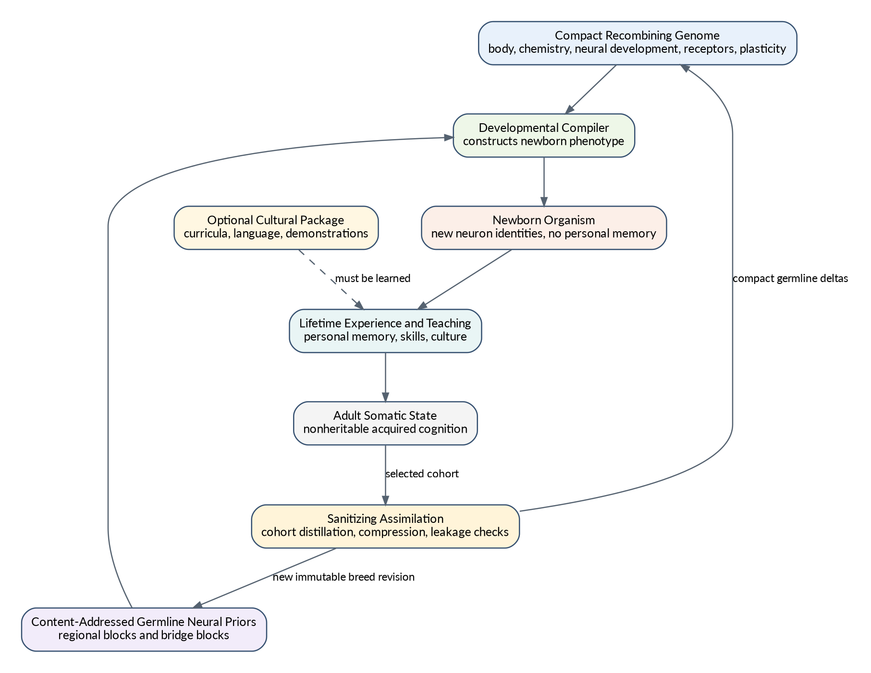
Genotype, germline priors, culture, and lifetime learning
Figure 3. The physical split between compact recombining genome, large germline neural priors, separate culture, and nonheritable adult state.
[AOA-PRIOR-001 | LOCKED INTERFACE] A germline prior manifest names exact regional blocks, bridge blocks, schemas, compatibility families, source provenance, sanitization receipts, and inherited-information cost.
[AOA-PRIOR-002 | LOCKED INVARIANT] Germline prior blocks are immutable and content-addressed. A new breed revision creates new blocks or a new manifest; it never mutates an existing published block in place.
[AOA-PRIOR-003 | LOCKED INVARIANT] A germline prior is a sanitized newborn-compatible template, not a saved adult checkpoint with a memory table removed.
[AOA-PRIOR-004 | LOCKED CAPABILITY] Prior blocks are region-addressable and may be recombined or selected independently when compatibility and bridge requirements are satisfied.
[AOA-PRIOR-005 | LOCKED CAPABILITY] Bridge blocks or deterministic developmental bridge rules describe cross-region priors without requiring one monolithic whole-brain asset.
[AOA-PRIOR-006 | LOCKED INVARIANT] Personal episodes, named individuals, exact locations, private conversations, current body schema, current chemistry, current activation, pending eligibility, and unresolved action credit are excluded from germline priors.
[AOA-PRIOR-007 | LOCKED CAPABILITY] Generic reusable representations and skills may be inherited after sanitization: object persistence, containment, affordance structure, generic navigation, manipulation priors, social prediction, and language-grounding priors.
[AOA-PRIOR-008 | LOCKED INVARIANT] Missing or incompatible germline assets cause explicit construction failure or an explicitly requested migration path. Silent substitution is prohibited.

Part IV - Sparse evolvable biochemistry

11. Biochemical purpose and boundary
Biochemistry is a persistent, evolvable signalling and metabolic system between body, organs, development, and brain. It is inspired by the useful architecture of Creatures 3 but modernized with typed loci, bounded active graphs, safe persistence, sparse execution, and explicit separation from neural policy.
Biochemistry answers: what physiological state is the organism in, what chemical transformations occur, and what regulatory signals result?
It does not answer: what should the creature attend to, believe, remember, or do?
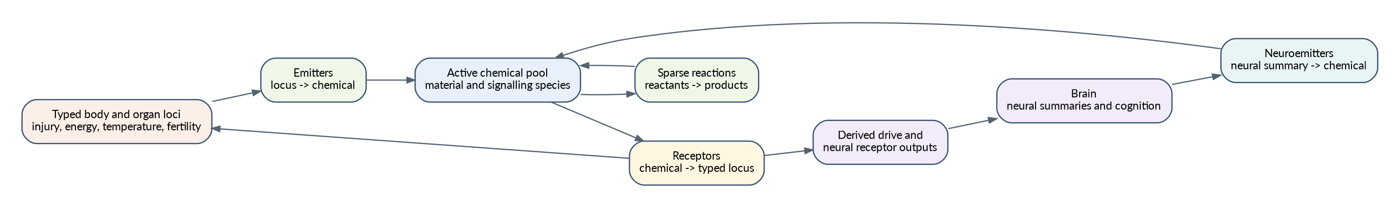
Sparse biochemical nervous system
Figure 4. Typed loci, emitters, active chemical species, sparse reactions, receptors, derived drives, and neural emitters.
[AOA-BIO-001 | LOCKED INVARIANT] Biochemistry owns chemical concentrations, reaction state, receptor/emitter state, endocrine regulation, metabolic intermediates, and biochemical developmental signals.
[AOA-BIO-002 | LOCKED INVARIANT] Biochemistry does not own final neural threshold, attention, salience, motor confidence, learning-rate, planning, or action policy values. It supplies signals; neural receptor phenotypes determine cognitive effects.
[AOA-BIO-003 | LOCKED CAPABILITY] The biochemical phenotype contains a bounded sparse active set of chemical species with per-species baseline, decay, range, type, and compartment information.
[AOA-BIO-004 | TUNABLE DEFAULT] The address space may support up to 256 species for compatibility and experimentation, while each phenotype instantiates a smaller active subset such as 32-64 species unless its budget permits more.
[AOA-BIO-005 | LOCKED CAPABILITY] The biochemical phenotype supports sparse reactions with bounded reactants, products, stoichiometry, rates, compartments, and optional rate-control loci.
[AOA-BIO-006 | LOCKED CAPABILITY] The biochemical phenotype supports emitters that map typed source loci to chemical release using bounded cadence, threshold, gain, analogue/digital response, inversion, and optional source reset.
[AOA-BIO-007 | LOCKED CAPABILITY] The biochemical phenotype supports receptors that map chemical concentrations to typed body, organ, drive, developmental, autonomic, or neural loci.
[AOA-BIO-008 | LOCKED CAPABILITY] The biochemical phenotype supports neuroemitters that map bounded neural summaries or learned assembly activity to chemical release.
[AOA-BIO-009 | LOCKED INVARIANT] Receptor and emitter destinations are typed and validated. Untyped raw pointers or arbitrary memory addresses are prohibited.
[AOA-BIO-010 | LOCKED CAPABILITY] Different organisms may respond differently to the same chemical concentration because receptor expression, thresholds, gains, target loci, and neural receptor profiles are heritable and evolvable.

11.1 Reference chemical dynamics
For a species concentration vector (c), a simple decay step is:
c_i(t + Δt) = b_i + (c_i(t) - b_i) · λ_i^(Δt)
where (b_i) is a baseline and (_i) is a bounded decay factor. A material reaction with up to two reactants uses the available limiting amount:
a = min_k(c_Rk / p_Rk); Δ = k · a
and applies stoichiometric reductions and products. Numerical integrators may differ if they preserve non-negativity, declared conservation, boundedness, and cadence semantics.
[AOA-BIO-011 | LOCKED INVARIANT] Material and energetic biochemical pathways obey declared conservation and resource accounting. Regulatory signalling chemicals may be produced and decay non-conservatively only through explicit emitters and costs.
[AOA-BIO-012 | LOCKED INVARIANT] Biochemical execution cost scales with active reactions, receptors, emitters, organs, and species, not the square of all possible chemical IDs.
[AOA-BIO-013 | LOCKED CAPABILITY] Chemicals may act on different natural timescales, providing transient arousal, medium-duration reinforcement, slow developmental regulation, persistent toxins, and other temporal roles.
[AOA-BIO-014 | LOCKED CAPABILITY] Compartmentalization may model blood, organ-local chemistry, extracellular signalling, gut contents, neural modulators, or other species-specific compartments without requiring every organism to instantiate every compartment.

11.2 Drives and interoception
Drives are brain-facing summaries of viability-relevant state, not the primary biochemical substrate. Hunger, fatigue, pain, fear, social need, curiosity, reproductive motivation, temperature stress, and brain-energy availability may be reference drive channels, but their values are derived by biochemical/body receptor networks.
[AOA-BIO-015 | LOCKED INTERFACE] A drive frame is a bounded derived view tied to authoritative body and biochemical state. It cannot advance independently.
[AOA-BIO-016 | LOCKED CAPABILITY] Evolution can change what raises, lowers, suppresses, stores, or restores a drive by changing body, chemical, reaction, emitter, and receptor pathways while preserving the brain-facing ABI where required.
[AOA-BIO-017 | LOCKED CAPABILITY] Emergency chemistry may suppress or transform lower-priority drive signals without hardcoding a complete cognitive decision tree.
[AOA-BIO-018 | LOCKED INVARIANT] A drive is not itself a reward. A high drive changes internal state and salience; the brain must still learn or infer which grounded actions affect it.

11.3 Neural receptor and neuroemitter interfaces
The biochemical-to-brain interface is a compact receptor frame plus direct interoceptive inputs. The brain-to-biochemistry interface is a compact neural-emission frame built from GPU-friendly summaries rather than full neuron readback.
Reference neural-emission sources include regional mean/max activity, tile or assembly activation, prediction residuals, selected motor channels, unresolved-gap voltage, and sustained executive or social state.
[AOA-BIO-019 | LOCKED INTERFACE] The neural receptor frame exposes bounded chemical/receptor activations with stable semantics, source chemistry version, target neural receptor class, and causal tick.
[AOA-BIO-020 | LOCKED INTERFACE] The neural-emission frame exposes bounded neural summaries to biochemistry without giving chemistry arbitrary access to raw neural state.
[AOA-BIO-021 | LOCKED CAPABILITY] Neural receptor effects may modulate interoceptive input, regional excitability, projection gain, local threshold, attention gating, plasticity receptor classes, structural growth, sleep, and consolidation.
[AOA-BIO-022 | LOCKED INVARIANT] Those effects are computed by the neural phenotype from biochemical signals. Biochemistry does not publish one universal finished NeuralModulation policy object.
[AOA-BIO-023 | LOCKED CAPABILITY] Neuroemitters allow learned cognition to influence autonomic, endocrine, developmental, social, and metabolic state without directly mutating body variables.

11.4 Homeostatic value and neuromodulation
Physical outcome, homeostatic change, neural prediction error, and teacher/social evidence are distinct.
A reference biological value function may estimate viability improvement:
ΔH = H(b_(t+1), c_(t+1), o_(t+1)) - H(b_t, c_t, o_t)
but this value is derived from the organism’s before/after state, not supplied by the world.
A bounded neuromodulatory frame may contain appetitive, aversive, novelty, arousal, social, consolidation, metabolic-availability, and developmental lanes. The exact lane count is replaceable.
[AOA-BIO-024 | LOCKED INVARIANT] Reward valence, biological value change, and neural reward-prediction error remain separately represented and inspectable.
[AOA-BIO-025 | LOCKED INTERFACE] Every sealed experience transaction includes measured before/after body and biochemical references sufficient to compute actual homeostatic change.
[AOA-BIO-026 | LOCKED INVARIANT] A production outcome may not substitute a zero or default homeostatic delta when canonical biology changed.
[AOA-BIO-027 | REFERENCE MECHANISM] Use a small multidimensional neuromodulatory vector rather than one universal scalar. Synapse or projection receptor profiles project that vector into a local third factor.
[AOA-BIO-028 | LOCKED CAPABILITY] The organism can learn different things from the same physical event depending on its current physiology, expectations, receptor genetics, memory, and social context.

Part V - Brain and cognitive memory

12. Cognitive brain scope
The adaptive brain receives grounded sensory and interoceptive evidence, remembers, predicts, forms concepts, allocates attention, chooses factorized motor intentions, learns, and reorganizes. It does not perform routine autonomic integration or deterministic actuator control.
[AOA-BRAIN-001 | LOCKED INVARIANT] Adaptive neural compute is reserved for functions that materially benefit from learning, prediction, memory, context, generalization, arbitration, communication, or flexible control.
[AOA-BRAIN-002 | LOCKED CAPABILITY] The brain supports sparse recurrent dynamics, nonlinear dendritic computation, local plasticity, predictive learning, attention, memory interfaces, semantic topology, factorized action selection, and structural plasticity.
[AOA-BRAIN-003 | LOCKED INVARIANT] No region name dispatches a handwritten cognitive algorithm. Region function emerges from connectivity, ports, dynamics, chemistry, plasticity, development, training, and experience.
[AOA-BRAIN-004 | LOCKED INVARIANT] The brain never receives game-specific commands such as find food, attack target, solve task, or an equivalent high-level policy shortcut as a sensory input or motor primitive.
[AOA-BRAIN-005 | LOCKED INTERFACE] The portable cognitive core has stable sensory, interoceptive, memory, semantic-prior, teacher/social, motor-intent, neural-emission, persistence, and inspection ports.

13. Neural substrate
The reference substrate is a sparse multirate recurrent neural system. Each neuron has bounded intrinsic state, activation dynamics, metabolic state, optional dendritic subunits, and membership in one developmental region. Synapses separate inherited, lifetime-consolidated, and fast acquired contributions.
A reference effective weight is:
W_eff(i,j) = W_genetic(i,j) + W_lifetime(i,j) + α(i,j) · W_fast(i,j)
where () is susceptibility or mixing, not a fourth additive memory.
[AOA-BRAIN-006 | LOCKED CAPABILITY] Neural state is recurrent and can preserve context, attractors, oscillations, working memory, and temporally extended competence.
[AOA-BRAIN-007 | LOCKED CAPABILITY] Synaptic state has distinct inherited, lifetime-consolidated, and fast acquired components with explicit update, persistence, and inheritance semantics.
[AOA-BRAIN-008 | LOCKED INVARIANT] Lifetime and fast acquired weights are somatic. They do not enter offspring except through explicit sanitizing assimilation.
[AOA-BRAIN-009 | LOCKED CAPABILITY] Neurons or projections may use different intrinsic time constants, update cadences, receptor profiles, plasticity classes, and metabolic costs.
[AOA-BRAIN-010 | LOCKED CAPABILITY] Selected neurons support nonlinear within-neuron conjunction computation through bounded dendritic branches or an evidence-backed equivalent.
[AOA-BRAIN-011 | LOCKED INVARIANT] Dendritic execution is indexed by target or another sparse equivalent. It may not scan every branch for every neuron.
[AOA-BRAIN-012 | LOCKED CAPABILITY] The neural substrate exposes enough bounded state for persistence, migration, debugging, work accounting, and capability attribution without placing identity indirection in the hot path.
[AOA-BRAIN-013 | REFERENCE MECHANISM] High-volume recurrent projections, dendritic evaluation, local learning, and prediction heads are batch-executed on the GPU using sparse target-major or tile-major layouts.
[AOA-BRAIN-014 | LOCKED INVARIANT] Quantization, sparsity, batching, and accelerator-specific kernels may alter numerical precision only within declared behavioural and dynamical tolerances.

14. Nine founder developmental regions
The founder brain uses nine conserved homologues. Their names state ancestral input/output and training roles, not fixed algorithms.
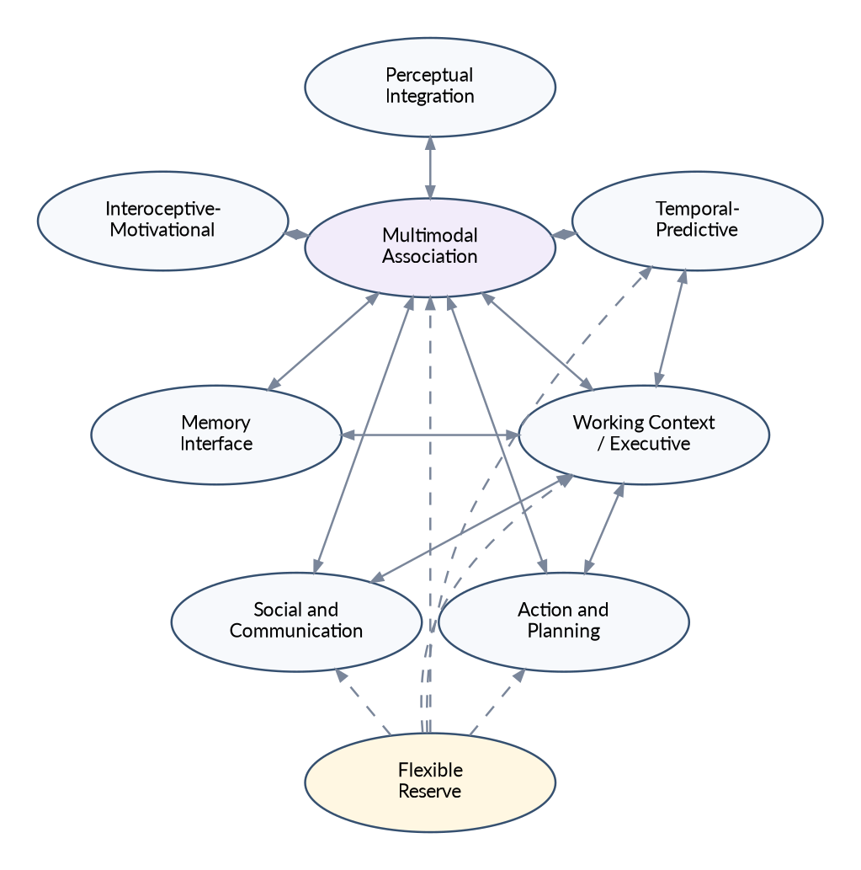
Nine founder developmental regions
Figure 5. The nine conserved founder homologues and broad recurrent communication. Dashed links from Flexible Reserve indicate potential recruitment.
Founder homologue | Ancestral role and bias
Perceptual Integration | Stable representations from body-neutral sensory adapters; cross-sensory local structure
Interoceptive-Motivational | Biochemical receptor signals, viability state, motivational context, autonomic intent
Multimodal Association | Cross-modal concepts, affordances, relations, abstraction, broad integration
Temporal-Predictive | Sequence modelling, action-conditioned prediction, temporal context, world-model state
Working Context / Executive | Active state, conflict resolution, bounded deliberation, goal competition
Memory Interface | Retrieval/storage control and memory-to-cognition translation
Action and Planning | Goal/action proposals, candidate evaluation, factorized motor intentions
Social and Communication | Other-agent modelling, imitation, language grounding, SLM interface
Flexible Reserve | Initially undercommitted capacity for growth, specialization, duplication, or innovation
Founder sizes use minimum functional floors plus proportional allocation of the remaining neurons:
N_r = N_r,min + α_r · (N - Σ_k N_k,min); Σ_r α_r = 1
[AOA-REG-001 | LOCKED INVARIANT] The nine founder homologues are permanent developmental and compatibility anchors. They cannot be deleted, although their mature functions and sizes may change above functional floors.
[AOA-REG-002 | LOCKED INVARIANT] Founder region labels never authorize special handwritten cognitive code.
[AOA-REG-003 | LOCKED CAPABILITY] Region size, recurrence, cell mix, dendritic capacity, connectivity, receptor expression, plasticity, cadence, and developmental timing are phenotype-controlled and evolvable.
[AOA-REG-004 | LOCKED CAPABILITY] Founder allocation uses minimum floors plus proportional remainder so small brains preserve essential interfaces while larger brains devote most added capacity to flexible cognition.
[AOA-REG-005 | TUNABLE DEFAULT] Reference remainder shares are: Perceptual 16%, Interoceptive 6%, Association 23%, Temporal 13%, Executive 10%, Memory Interface 7%, Action/Planning 10%, Social/Communication 8%, Flexible Reserve 7%.
[AOA-REG-006 | LOCKED CAPABILITY] Evolution and development may create derived regions by reserve recruitment, subdivision, duplication and divergence, assembly specialization, bounded fusion, and pruning.
[AOA-REG-007 | LOCKED INTERFACE] Every derived region records parent homology, creation mechanism, interface ports, prior dependencies, receptor/plasticity profile, capacity requirements, and compatibility family.
[AOA-REG-008 | LOCKED INVARIANT] Derived-region count and capacity are bounded by brain class, developmental viability, inherited-information cost, and runtime work budgets.
[AOA-REG-009 | LOCKED CAPABILITY] Crossbreeding uses homology-aware bounded recombination. Matched derived regions recombine; unmatched regions are optional structural alleles expressed only when dependencies and budgets are satisfied.
[AOA-REG-010 | LOCKED INVARIANT] New or unmatched bridges begin silent, zero-gain, low-gain, or in developmental acclimation. They may not immediately destabilize the child brain.

15. Sensory grounding and attention
Sensory adapters perform transduction and bounded nonsemantic preprocessing. The brain learns meaning. Attention is a compute-allocation architecture, not merely a ranking annotation.
The reference perception path has two tiers:
- a broad, cheap peripheral pass over bounded candidates or regions;
- a small, phenotype- and budget-controlled focal pass that obtains richer information for selected targets.
A reference salience score may combine novelty, drive relevance, episodic expectancy, concept relevance, unresolved-gap relevance, prediction error, social relevance, urgency, and persistence/hysteresis:
S_i = Σ_k w_k · f_i,k + h_i
[AOA-SENSE-001 | LOCKED INTERFACE] Sensory adapters expose grounded modality features, confidence, spatial/temporal reference, and provenance. They do not expose designer semantic categories as truth.
[AOA-SENSE-002 | LOCKED INVARIANT] A body-neutral sensor ABI may normalize or compress raw signals, but must not secretly perform the semantic recognition, planning, or value judgement assigned to cognition.
[AOA-ATT-001 | LOCKED CAPABILITY] Attention performs broad peripheral processing followed by bounded expensive focal processing or an equivalent mechanism that materially reallocates compute.
[AOA-ATT-002 | LOCKED CAPABILITY] Focal selection depends on current physiology, memory, concepts, uncertainty, prediction residuals, social state, novelty, and learned neural influence.
[AOA-ATT-003 | LOCKED CAPABILITY] Focal capacity is a function of brain class, phenotype, current state, and available compute rather than a universal fixed constant.
[AOA-ATT-004 | LOCKED INVARIANT] Changing attention while holding the world constant must be capable of changing downstream neural evidence or action, not only a diagnostic label.
[AOA-ATT-005 | LOCKED CAPABILITY] Attention includes hysteresis and persistence so noisy small salience changes do not cause pathological target thrashing.
[AOA-ATT-006 | REFERENCE MECHANISM] The peripheral pass is usually world/CPU efficient; focal sensory encoding and neural processing may be batched on the GPU. Exact placement is replaceable.

16. Cognitive context and interoception
A bounded cognitive context integrates focal perception, peripheral summaries, canonical interoception, memory expectancies, active concepts, unresolved gaps, prediction state, social context, and current compute budget.
[AOA-CTX-001 | LOCKED INTERFACE] The cognitive context is bound to one organism, causal sequence, world tick, perception frame, and canonical body/biochemical view.
[AOA-CTX-002 | LOCKED INVARIANT] The context interoceptive view is populated from canonical biology. A default or stale internal-state vector may not coexist with a different authoritative state in the same decision.
[AOA-CTX-003 | LOCKED INVARIANT] Canonical digests are identity and integrity evidence. They are not semantic embeddings and may not be used as geometry for learning or generalization.
[AOA-CTX-004 | LOCKED CAPABILITY] The context supports bounded explicit uncertainty, source confidence, recency, and provenance so cognition can distinguish observation, memory, semantic prior, and teacher communication.

17. Episodic, semantic, and social memory
Memory is not action replay. It supplies grounded evidence, expectancies, causal context, trust, familiarity, and retrieval of relevant experience.

17.1 Episodic memory
An episode records a bounded grounded event sequence: perceptual context, internal state, attention, action bundle, physical outcome, biochemical consequence, prediction error, social participants, and temporal references.

17.2 Individual semantic memory
Semantic memory stores concepts and relations inferred during this individual’s life, including confidence, source, temporal validity, and grounding links. It may contain world knowledge, language grounding, relationships, social trust, and learned facts. It remains personal and nonheritable.

17.3 Distributed skill
Procedural skill and generalized representations may also reside in neural weights and structure. They are somatic unless explicitly distilled through assimilation.
[AOA-MEM-001 | LOCKED CAPABILITY] The organism supports delayed episodic recall, context-sensitive retrieval, memory confidence, source/provenance, and forgetting or compression.
[AOA-MEM-002 | LOCKED INVARIANT] Memory retrieval provides evidence and expectancy; it does not force an action or bypass neural arbitration.
[AOA-MEM-003 | LOCKED CAPABILITY] Candidate-specific episodic evidence may alter attention, prediction, neural state, or action preference through a real production path.
[AOA-MEM-004 | LOCKED CAPABILITY] Individual semantic memory stores grounded concepts, relations, confidence, source, temporal validity, and contradiction history.
[AOA-MEM-005 | LOCKED INVARIANT] Personal semantic propositions and autobiographical episodes are not written into the germline by ordinary sleep or reproduction.
[AOA-MEM-006 | LOCKED INTERFACE] The Memory Interface region controls queries, retrieval, storage, and neural translation while the memory store remains an explicit bounded subsystem.
[AOA-MEM-007 | LOCKED CAPABILITY] Memory can represent individuals and relationships persistently across time, save/load, sleep, separation, and reunion.
[AOA-MEM-008 | LOCKED CAPABILITY] Memory consolidation balances retention, compression, interference control, and generalization without forcing all stable memories into neural weights.
[AOA-MEM-009 | REFERENCE MECHANISM] Episodic memory is usually sparse irregular CPU-side storage with bounded GPU uploads for selected retrievals; alternative placements require measured benefit.

18. Concepts, causal topology, and unresolved gaps
A concept is a grounded reusable abstraction that improves prediction, affordance understanding, memory compression, communication, social reasoning, or drive-relevant action. An unresolved gap is a persistent representation of contradiction, uncertainty, missing causal structure, or failed prediction that can guide attention and exploration.
A broad reference utility for concept (C) is:
U(C) = ΔL_prediction + λ_a·ΔL_affordance + λ_m·ΔL_memory + λ_s·ΔL_social + λ_d·ΔL_drive - λ_c·Complexity(C) - λ_r·ResidualContradiction(C)
[AOA-CON-001 | LOCKED CAPABILITY] Concepts can form, strengthen, weaken, split, merge, decay, and be re-grounded from experience.
[AOA-CON-002 | LOCKED CAPABILITY] Concept induction is organized by predictive and cognitive utility, not only perceptual clustering.
[AOA-CON-003 | LOCKED CAPABILITY] Systematic contradiction may create or raise an unresolved gap and may trigger concept splitting, relation revision, targeted attention, or exploration.
[AOA-CON-004 | LOCKED CAPABILITY] Concept and gap state can alter neural context, attention, prediction, memory retrieval, communication, or action through explicit causal paths.
[AOA-CON-005 | LOCKED INVARIANT] Global diagnostic maxima alone do not satisfy target-grounded concept or gap influence. Evidence must be linked to relevant objects, relations, actions, or contexts.
[AOA-CON-006 | LOCKED INVARIANT] Concept induction and neural structural growth are separate learning processes. They may exchange bounded evidence, but concept edges are not automatically synapses and strong synapses are not automatically concepts.
[AOA-CON-007 | LOCKED INVARIANT] External semantic-prior suggestions remain hypotheses until grounded. They cannot create authoritative concepts by declaration.

19. Prediction, world modelling, and bounded planning
Prediction learns stable semantic successor representations conditioned on current grounded state and the complete joint motor intention. Its representations must preserve meaningful differences and must not collapse to constants or action-insensitive outputs.
A reference predictor estimates:
z_hat_(t+1) = P(z_t, A_t, c_t)
where (z_t) is a compact semantic state, (A_t) is the complete factorized motor bundle, and (c_t) is relevant context. A small nonlinear or low-rank interaction model is preferred over a purely additive linear map when state-action interactions matter.
[AOA-PRED-001 | LOCKED CAPABILITY] The brain predicts grounded successor features including sensory change, contact, motion, drive/chemical change, success/failure, concepts, social response, and other phenotype-supported targets.
[AOA-PRED-002 | LOCKED INVARIANT] Source and successor vectors use explicitly versioned semantically corresponding features or an explicit cross-schema mapping.
[AOA-PRED-003 | LOCKED INVARIANT] Prediction conditions on the full joint motor bundle, not only one primary action ID when multiple channels execute together.
[AOA-PRED-004 | LOCKED INVARIANT] Categorical motor identities use one-hot, learned, structured, or otherwise semantically valid encodings. Arbitrary integer or bit geometry is not treated as meaningful distance.
[AOA-PRED-005 | LOCKED INVARIANT] The predictive objective includes information-preserving constraints or grounded target construction that makes constant and action-insensitive representations non-optimal.
[AOA-PRED-006 | LOCKED CAPABILITY] Different materially distinct successor states remain separable; different actions can predict different outcomes; passive observation can improve later prediction or behaviour.
[AOA-PRED-007 | LOCKED CAPABILITY] Prediction is used before action to estimate candidate consequences, uncertainty, or information gain, not only updated after the fact.
[AOA-PRED-008 | LOCKED CAPABILITY] Prediction residuals influence unresolved gaps, attention, curiosity, memory prioritization, learning, and structural proposals through bounded interfaces.
[AOA-PRED-009 | REFERENCE MECHANISM] Stable targets may use EMA teachers, stop-gradient encoders, fixed projections, variance/covariance constraints, contrastive structure, grounded observables, or evidence-backed combinations. No one self-supervised family is locked.
[AOA-PRED-010 | DEFERRED CAPABILITY] The brain supports bounded counterfactual rollout or deliberation using its learned world model, initially at small depth and candidate count rather than exhaustive tree search.

20. Neural learning and credit assignment
Learning combines local eligibility, measured biological and physical consequences, prediction error, neuromodulatory receptor profiles, normalization, and consolidation.
A reference three-factor update is:
ΔW_fast(i,j) = η_i,j · e_i,j · (r_i,j^T m_t + β_i,j · ε_t) - λ_i,j · N_i,j
where (e_{ij}) is eligibility, (r_{ij}) a heritable receptor vector, (m_t) the biochemical neuromodulatory frame, (t) local predictive error, and (N{ij}) a bounded normalization/homeostatic term.
[AOA-LEARN-001 | LOCKED CAPABILITY] The brain supports fast online learning that can alter behaviour after a small number of relevant experiences.
[AOA-LEARN-002 | LOCKED INVARIANT] Eligibility is bound to the exact organism, phenotype/graph epoch, perception/context, selected joint motor output, and causal outcome transaction.
[AOA-LEARN-003 | LOCKED CAPABILITY] Every active motor channel can receive causally supportable credit through joint eligibility or channel-aware traces without fabricated channel reward labels.
[AOA-LEARN-004 | LOCKED INVARIANT] Experience preserves individual channel commands and the joint physical outcome. It need not invent separable rewards for channels whose effects are inseparable.
[AOA-LEARN-005 | LOCKED INVARIANT] Immediate plasticity and slower normalization/consolidation have distinguishable semantics, schedules, and evidence.
[AOA-LEARN-006 | LOCKED CAPABILITY] Negative physical/biochemical experience can produce an appropriate aversive learning signal and change later action preference through the ordinary production path.
[AOA-LEARN-007 | LOCKED CAPABILITY] Positive homeostatic improvement, novelty, social consequence, and prediction surprise can shape different receptor classes rather than collapsing into one universal reward.
[AOA-LEARN-008 | LOCKED INVARIANT] Current hormone names may be reference species channels, but the architecture does not assume one universal mammalian mapping for every breed or transplanted brain.
[AOA-LEARN-009 | LOCKED CAPABILITY] Metaplasticity and local learning-rule parameters are heritable and can be optimized through founder meta-training and evolution.
[AOA-LEARN-010 | LOCKED INVARIANT] A teacher, evaluation harness, or world script cannot directly set the neuromodulatory third factor as an answer key.

21. Structural plasticity and dendritic allocation
Experience-dependent neural structure may grow, prune, duplicate, specialize, and reorganize. Candidate discovery must remain sparse and bounded.
A reference growth score for a proposed edge or branch is:
G_i,j = C_i,j · P_i,j · U_i,j · R_i,j - λ_red · Redundancy_i,j - λ_cost · Cost_i,j
but the exact formula is replaceable. The locked requirement is sparse candidate generation and causal structural change.
[AOA-STR-001 | LOCKED CAPABILITY] The lifetime brain supports experience-dependent synaptogenesis, pruning, dendritic branch allocation, and accepted structural changes that alter later computation.
[AOA-STR-002 | LOCKED INVARIANT] Structural candidate discovery never enumerates all absent neuron pairs. Its complexity is approximately proportional to active structure times a bounded candidate budget, such as O(NK), O(BK), or better.
[AOA-STR-003 | LOCKED CAPABILITY] Candidate evidence may include coactivation, eligibility, prediction residuals, shared concept/gap support, local activity sketches, spatial/developmental affinity, and bounded stochastic exploration.
[AOA-STR-004 | LOCKED INVARIANT] Candidate storage granularity is replaceable: neuron, branch, route, tile, sketch, or hybrid. No per-neuron reservoir is locked as universal architecture.
[AOA-STR-005 | LOCKED CAPABILITY] Dendritic conjunction capacity is allocated by phenotype, development, experience, and capability-per-compute evidence rather than uniformly or decoratively.
[AOA-STR-006 | LOCKED INVARIANT] A structural counter, proposal object, or pruning-only path does not satisfy synaptogenesis. Accepted growth must change live sparse computation.
[AOA-STR-007 | LOCKED CAPABILITY] Structural changes are persisted, versioned by graph epoch, included in work accounting, and compatible with brain growth and rollback.

22. Action, planning, and motor intentions
The cognitive brain outputs simultaneous bounded intentions across factorized channels. It does not choose one mutually exclusive whole-body symbolic action and does not directly control every actuator.
Reference channels include locomotion, orientation/gaze, manipulation, grip, posture, vocalization, and social signalling. Species and embodiments may expose different compatible channels.
[AOA-MOTOR-001 | LOCKED CAPABILITY] The brain can issue simultaneous bounded commands on multiple motor channels.
[AOA-MOTOR-002 | LOCKED INTERFACE] A motor intent bundle records every active channel, primitive/parameterization, intensity, duration, direction or target reference, confidence, coordination group, and causal sequence.
[AOA-MOTOR-003 | LOCKED INVARIANT] Inhibition is primarily within channels; learned coordination operates across channels. The architecture does not force locomotion, gaze, posture, manipulation, and vocalization into one exclusive token.
[AOA-MOTOR-004 | LOCKED CAPABILITY] Orientation and sensor direction are real motor channels with production candidates, execution, outcome, learning, and persistence.
[AOA-MOTOR-005 | LOCKED INVARIANT] The motor ABI expresses body-neutral effectors and intentions, not game-specific semantic goals.
[AOA-MOTOR-006 | LOCKED CAPABILITY] The brain can learn novel combinations of existing primitives and can adapt motor intentions to changed embodiment through the peripheral body-schema layer.
[AOA-MOTOR-007 | REFERENCE MECHANISM] Parameterized motor primitives and learned synergies provide combinatorial behaviour without an explosion of discrete action IDs.

23. Embodiment adapters and body schema
The portable cognitive core is separated from embodiment-specific learning. Sensory and motor adapters may themselves contain small learned peripheral neural systems, but they are not allowed to become hidden semantic agents.
The control hierarchy is:
cognitive goal and factorized intention
-> learned embodiment-specific sensorimotor adapter
-> deterministic numerical controller
-> actuator and physics
[AOA-EMB-001 | LOCKED INVARIANT] Deterministic actuator stabilization, inverse dynamics, servo loops, and safety constraints do not consume the portable cognitive neural budget.
[AOA-EMB-002 | LOCKED CAPABILITY] The embodiment layer learns sensor calibration, effector controllability, proprioceptive body schema, motor synergies, and action-to-sensory consequences.
[AOA-EMB-003 | LOCKED INVARIANT] The embodiment adapter may not infer or choose semantic goals on behalf of the cognitive core.
[AOA-EMB-004 | LOCKED CAPABILITY] A transplanted brain can discover a new embodiment through exploration, prediction, teacher guidance, and safe calibration rather than requiring hardcoded assumptions such as two legs or a forward camera.
[AOA-EMB-005 | LOCKED INTERFACE] Sensor and motor port descriptors are stable, typed, capability-oriented, versioned, and discoverable by the organism.
[AOA-EMB-006 | LOCKED CAPABILITY] Embodiment-specific acquired state can be saved, replaced, retrained, or discarded independently of the portable cognitive core.

Part VI - Sleep, growth, and identity

24. Sleep and consolidation
Biochemistry and physiology determine sleep pressure and readiness. The cognitive system owns replay and neural consolidation. Sleep is a multi-system transaction rather than a sequence of loosely related side effects.
[AOA-SLEEP-001 | LOCKED CAPABILITY] Organisms can enter, maintain, and exit sleep through biological state, external conditions, or explicit safety/recovery mechanisms.
[AOA-SLEEP-002 | LOCKED CAPABILITY] Sleep may consolidate fast to lifetime weights, episodic and semantic memory, prediction, concepts/gaps, structural proposals, derived-region recruitment, and developmental neural growth.
[AOA-SLEEP-003 | LOCKED INVARIANT] All required sleep updates commit atomically for one cycle or roll back. Partial cross-system consolidation is prohibited.
[AOA-SLEEP-004 | LOCKED INVARIANT] Sleep does not directly mutate germline priors or offspring. Natural assimilation is a separate lineage process.
[AOA-SLEEP-005 | LOCKED CAPABILITY] Sleep and replay are bounded by phenotype and work budgets and may prioritize salient, surprising, unresolved, socially important, or unstable experiences.
[AOA-SLEEP-006 | LOCKED CAPABILITY] A completed sleep cycle can restore fatigue/energy state and can change later behaviour through actual consolidated cognition.
[AOA-SLEEP-007 | LOCKED INVARIANT] Replay identity, cycle identity, graph epoch, and persistence state prevent duplicate, stale, or out-of-order consolidation.

25. Cognitive identity and graph epochs
Identity is layered so logical continuity survives GPU recompaction without imposing permanent IDs on every synapse in the hot path.
Identity | Persistence
Brain, region, port, concept, memory, learned assembly | Persistent logical identity
Neuron | Persistent individual-local lineage identity outside the hot path
Synapse, dendritic branch, sparse route | Graph-epoch structural handle
GPU buffer offset or physical index | Valid only for one compiled layout
[AOA-ID-001 | LOCKED INVARIANT] Semantic and memory systems reference persistent concepts, memories, assemblies, regions, and ports; they do not depend on raw synapse handles or GPU indices.
[AOA-ID-002 | LOCKED CAPABILITY] Every neuron has an individual-local lineage identity sufficient to track preservation, duplication, specialization, migration, and assimilation provenance.
[AOA-ID-003 | LOCKED INVARIANT] Ordinary synapses, branches, and routes need not have permanent global IDs. They use deterministic graph-epoch handles and durable old-to-new migration manifests.
[AOA-ID-004 | LOCKED CAPABILITY] Structural recompaction, pruning, growth, expansion, and relocation can freely change physical indices while preserving logical identity and causal state.
[AOA-ID-005 | LOCKED INVARIANT] Offspring inherit developmental homologues and priors, never the parent’s runtime neuron or structural handles.

26. Function-preserving brain growth and augmentation
A trained individual may grow naturally during development or be deliberately enlarged offline without losing established competence.
Function-preserving growth and identity
Figure 6. Quiescent migration from one graph epoch to another with acclimation, continuity verification, and rollback.
The old brain dynamics are embedded in the expanded brain. If the old recurrent update is (F), the new update is (F’), the embedding is (P), and the reduction map is (R), then the continuity target is:
R·P = I; F'(P·x, u) ≈ P·F(x, u)
For a locally linear regime, the recurrent Jacobians should satisfy (J’P PJ). New transverse modes begin stable, silent, or contractive.
[AOA-GROW-001 | LOCKED CAPABILITY] Both gradual developmental growth and deliberate mature augmentation use one function-preserving migration engine with mode-specific scheduling and safety policy.
[AOA-GROW-002 | LOCKED INVARIANT] Expansion occurs at a quiescent cognitive transaction boundary after pending action credit, weight-bank transactions, and replay state are committed or explicitly discarded.
[AOA-GROW-003 | LOCKED INVARIANT] Existing trained neurons, routes, memory anchors, concepts, predictor state, and learned dynamics remain the anchored core. Expansion does not randomly rebuild the old brain.
[AOA-GROW-004 | LOCKED CAPABILITY] Allowed reference morphisms include silent neuron addition, neuron duplication with conserved contribution, common-mode-preserving recurrent blocks, zero-gain routes, dormant dendrites, residual identity paths, and self-distillation into new capacity.
[AOA-GROW-005 | LOCKED INVARIANT] Neuron duplication preserves aggregate downstream drive and recurrent common modes while newly introduced difference modes begin stable or contractive.
[AOA-GROW-006 | LOCKED CAPABILITY] Additional capacity is recruited gradually through prediction of old regional state, residual-error learning, local self-distillation, and staged release of plasticity.
[AOA-GROW-007 | LOCKED INVARIANT] The enlarged brain must approximate the original brain’s immediate behaviour and representative internal trajectories before new capacity is allowed to change policy substantially.
[AOA-GROW-008 | LOCKED CAPABILITY] Every growth operation produces a pre-migration checkpoint, logical/physical map, graph-epoch manifest, added-neuron provenance, continuity receipt, and rollback path.
[AOA-GROW-009 | LOCKED INVARIANT] Somatic augmentation does not alter offspring until explicit genetic assimilation creates a new germline prior or developmental allele.
[AOA-GROW-010 | REFERENCE MECHANISM] New capacity is preferentially allocated to Flexible Reserve, Association, Temporal-Predictive, Executive, Action/Planning, and Social/Communication unless profiling shows another bottleneck.

Part VII - Founder training, teachers, SLMs, and culture

27. Founder pretraining and nested meta-training
Natural selection cannot optimize sophisticated cognition if founders are unable to perceive, move, eat, learn, or reproduce. Generation zero therefore begins with a competent but generic pretrained foundation.
Privileged offline training may use gradients, labels, demonstrations, large teachers, contrastive objectives, privileged world state, evolutionary outer loops, and differentiable surrogates. These privileges may optimize the genotype, priors, development, receptor profiles, local learning rules, structural policy, and sleep. They may not survive as hidden runtime policy.
[AOA-FOUND-001 | LOCKED CAPABILITY] The founder species receives a viable pretrained neural and developmental foundation rather than random unusable cognition.
[AOA-FOUND-002 | LOCKED INVARIANT] The published founder runs only through ordinary organism interfaces. No oracle feature, hidden label, direct action trace, or privileged trainer remains attached.
[AOA-FOUND-003 | LOCKED CAPABILITY] Founder pretraining covers generic competencies: object persistence, action consequence, body schema, navigation, avoidance, homeostatic learning, manipulation, social attention, imitation, and communication grounding.
[AOA-FOUND-004 | LOCKED INVARIANT] Founder training varies worlds, object identities, curricula, embodiments, and sensor mappings enough to reduce benchmark or world memorization.
[AOA-FOUND-005 | LOCKED CAPABILITY] Training uses a nested outer loop that optimizes initial priors and how the creature learns during legal inner lifetimes.
[AOA-FOUND-006 | LOCKED INVARIANT] Inner lifetimes inside meta-training use the same causal organism step, local plasticity, memory, chemistry, motor, sleep, and structural mechanisms available after deployment.
[AOA-FOUND-007 | LOCKED CAPABILITY] A trainer-removed acclimation phase demonstrates retained competence, continued learning, resistance to catastrophic forgetting, and absence of hidden teacher dependence before a founder prior is published.
[AOA-FOUND-008 | LOCKED INVARIANT] Pretraining gives generic capabilities and priors, not game answers, fixed locations, private source-world facts, or a complete solved policy.

28. Shared semantic-prior service
The shared SLM supplies compressed general semantic relationships that small creature brains would otherwise spend excessive compute rediscovering. It is external infrastructure, not one of the biological systems and not the creature’s executive system.
[AOA-SLM-001 | LOCKED INTERFACE] Semantic-prior requests contain bounded language or symbol context, a small set of active grounded concepts, model/interface version, and budget metadata.
[AOA-SLM-002 | LOCKED INTERFACE] Semantic-prior responses contain candidate relations, embeddings, distinctions, confidence, and provenance. They contain no creature action, reward, memory write, or policy command.
[AOA-SLM-003 | LOCKED INVARIANT] The semantic-prior service cannot inspect the full private episodic history, raw synapses, pending actions, or broad internal state unless a later architecture revision explicitly creates a safe interface.
[AOA-SLM-004 | LOCKED INVARIANT] A semantic hint is nonauthoritative. The creature must ground, accept, reject, revise, or ignore it through its own cognition and experience.
[AOA-SLM-005 | LOCKED CAPABILITY] One shared service supports many organisms through caching, batching, event-triggering, and explicit token/latency budgets.
[AOA-SLM-006 | LOCKED CAPABILITY] A mature creature retains substantial nonlinguistic intelligence and grounded competence when the semantic-prior service is disabled.
[AOA-SLM-007 | LOCKED CAPABILITY] Breed genetics may evolve how much capacity and attention are allocated to semantic-prior integration without inheriting or duplicating the external model weights.

29. Teacher system
The teacher is distinct from the semantic prior. It is an active pedagogical system that selects lessons and interacts with the learner through grounded channels.
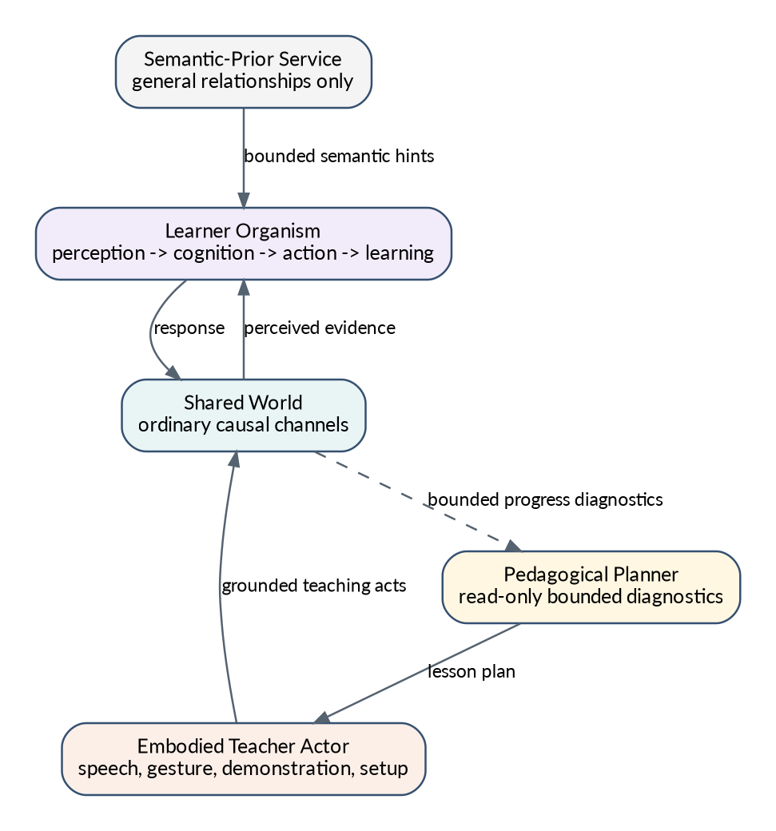
Semantic prior and split teacher authority
Figure 7. The semantic prior provides bounded hints; the pedagogical planner chooses lessons; only the embodied teacher actor influences the learner.
[AOA-TEACH-001 | LOCKED INTERFACE] The teacher has a read-only pedagogical planner and an embodied teacher actor with separate authority.
[AOA-TEACH-002 | LOCKED CAPABILITY] The planner may inspect bounded curriculum progress, observable success/failure, developmental stage, available interfaces, coarse safety/homeostasis, uncertainty summaries, lesson history, and world state needed to construct lessons.
[AOA-TEACH-003 | LOCKED INVARIANT] The planner cannot inspect raw synapses, neuron activations, eligibility traces, private episodic contents, hidden SLM state, pending action internals, or direct reward controls.
[AOA-TEACH-004 | LOCKED INVARIANT] Only the embodied teacher actor influences the learner, through speech, gesture, demonstration, objects, environment arrangement, social response, and other ordinary world channels.
[AOA-TEACH-005 | LOCKED INVARIANT] Teachers cannot directly write learner memories, concepts, weights, actions, rewards, neurochemistry, or declarations of understanding.
[AOA-TEACH-006 | LOCKED CAPABILITY] Teachers may be players, scripted agents, SLMs, larger LLMs, older creatures, or hybrids, provided they use the same grounded teaching interface.
[AOA-TEACH-007 | LOCKED CAPABILITY] Teaching episodes are auditable by curriculum ID, planner-visible diagnostics, teacher acts, learner-visible stimuli, learner response, physical/biochemical consequence, model provenance, and compute/token cost.
[AOA-TEACH-008 | LOCKED CAPABILITY] Learner competence is measured after the teacher is removed, not only while a capable external model is directing lessons.

30. Culture and curricula
Culture is a separate versioned artifact that must be learned. It is neither genome nor personal memory, although it becomes personal memory and skill after acquisition.
[AOA-CULT-001 | LOCKED INTERFACE] A cultural package may contain language conventions, curriculum graphs, prerequisites, demonstrations, environmental setup recipes, social norms, tool-use procedures, assessments, and teacher capability requirements.
[AOA-CULT-002 | LOCKED INVARIANT] A cultural package does not directly alter genotype, germline neural priors, personal memory, neural weights, or biochemical state.
[AOA-CULT-003 | LOCKED CAPABILITY] A breed may recommend or bundle a cultural package while remaining usable without it. Breed and culture dependencies are separately identifiable and removable.
[AOA-CULT-004 | LOCKED CAPABILITY] Genetically similar populations can diverge culturally through teaching, imitation, language, environment, and historical contingency.
[AOA-CULT-005 | LOCKED CAPABILITY] Research tooling can distinguish competence inherited genetically, acquired culturally, acquired individually without teaching, available only with the SLM, and available only while a teacher is active.

Part VIII - Reproduction, assimilation, and evolution

31. Reproduction and ordinary inheritance
Ordinary reproduction constructs a new organism. It recombines compact genetic instructions and compatible prior references; it does not clone an adult brain.
[AOA-REP-001 | LOCKED CAPABILITY] Reproduction uses canonical parent genotypes, physiological readiness, world interaction, and lifecycle authority to create a new child genotype and organism.
[AOA-REP-002 | LOCKED INVARIANT] A child receives a newly developed brain with new neuron identities and no parent personal memory.
[AOA-REP-003 | LOCKED CAPABILITY] Compatible regional prior blocks and bridge blocks may be selected, blended, or recombined through explicit bounded recipes.
[AOA-REP-004 | LOCKED INVARIANT] Ordinary births do not publish a new permanent large neural asset for every child. Child-specific compiled priors may be cached by content hash but remain derivable from genotype and dependencies.
[AOA-REP-005 | LOCKED CAPABILITY] Incompatible body, biochemical, neural, derived-region, or prior dependencies are detected before admission and either resolved through an explicit migration/crossing mechanism or rejected.
[AOA-REP-006 | LOCKED CAPABILITY] Parental investment, gestation/incubation, teaching opportunity, and social environment may influence development without becoming hardcoded inherited knowledge.

32. Genetic assimilation
Assimilation converts generalized stable somatic organization into heritable developmental priors while protecting personal memory and preventing genome bloat.
Two pathways are supported.

32.1 Natural assimilation
Rare, low-bandwidth lineage adaptation converts repeated useful patterns into compact germline deltas.

32.2 Breeder-directed assimilation
Players or researchers select a cohort, identify shared competence, sanitize and redistill it, and publish a new immutable breed revision.
[AOA-ASSIM-001 | LOCKED CAPABILITY] Natural assimilation can gradually alter developmental growth, receptor expression, connectivity affinities, plasticity, regional allocation, and small reusable motifs.
[AOA-ASSIM-002 | LOCKED INVARIANT] Natural assimilation is rare, lineage-level, information-budgeted, and does not publish a large new prior at every birth.
[AOA-ASSIM-003 | LOCKED CAPABILITY] Breeder assimilation accepts a selected cohort and target competence, compares individuals, and extracts shared generalized organization.
[AOA-ASSIM-004 | LOCKED INVARIANT] One exceptional individual alone is not normally sufficient to define a new heritable prior without additional evidence, redistillation, or explicit expert override and provenance.
[AOA-ASSIM-005 | LOCKED CAPABILITY] Assimilation uses cohort consensus, anonymization, compression bottlenecks, developmental redistillation, fresh-environment checks, and personal-memory leakage probes.
[AOA-ASSIM-006 | LOCKED INVARIANT] Assimilation excludes autobiographical episodes, individual identities, exact coordinates, private facts, current chemistry, current activation, pending eligibility, and body-specific calibration.
[AOA-ASSIM-007 | LOCKED CAPABILITY] Assimilation may preserve generalized regional weights, motifs, assembly templates, connectivity affinities, receptor/plasticity profiles, and learning priors.
[AOA-ASSIM-008 | LOCKED INVARIANT] Every assimilated bit or parameter is charged against an inherited-information and developmental-complexity budget.
[AOA-ASSIM-009 | LOCKED CAPABILITY] Published breed revisions are immutable, versioned, content-addressed, provenance-tracked, and independently testable from their source adults.

33. Evolution and selection
Evolution operates on complete organisms and lineages. It may alter body, chemistry, brain, development, learning, culture-learning ability, and reproductive strategy. It is not restricted to tuning neural weights.
[AOA-EVO-001 | LOCKED CAPABILITY] Evolution can alter morphology, metabolism, biochemical topology, developmental schedules, region allocation, derived regions, connectivity, receptors, plasticity, learning rules, temperament, and reproductive strategy.
[AOA-EVO-002 | LOCKED INVARIANT] Natural selection in game worlds is mediated by ecological survival and reproduction, not a hidden neural reward or externally assigned fitness during life.
[AOA-EVO-003 | LOCKED CAPABILITY] Offline founder and research outer loops may use explicit fitness or loss functions, but their privileged optimization is training infrastructure and is removed at deployment.
[AOA-EVO-004 | LOCKED GOAL] Evolution should discover compact priors and effective learners rather than serializing complete adult solutions genetically.
[AOA-EVO-005 | REFERENCE MECHANISM] A lineage objective may penalize inherited information, neural work, biochemical complexity, developmental fragility, and metabolic cost while rewarding survival and reproductive success.
[AOA-EVO-006 | LOCKED CAPABILITY] Niches may favour cheap reflexive brains, larger flexible brains, specialized biochemistry, strong cultural learning, or other legitimate strategies.
[AOA-EVO-007 | LOCKED INVARIANT] Evaluation environments must monitor degenerate strategies such as inactivity, sensor exploits, reproduction loopholes, reward leakage, parasitic use of teachers, or trivial niche collapse.

Part IX - Portability and external use

34. Portable cognitive core
The portable cognitive core contains acquired cognition that should survive a change of body or environment. It is distinct from body, biochemistry, and peripheral embodiment state.
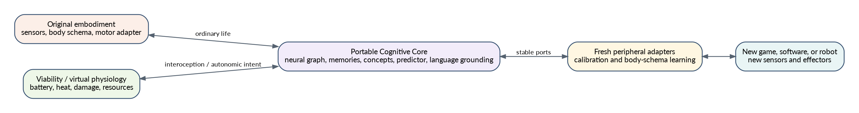
Portable cognitive core and a new embodiment
Figure 8. Cognitive transplantation preserves the mature core while replacing embodiment and viability interfaces.
[AOA-PORT-001 | LOCKED CAPABILITY] A mature cognitive core can be exported with neural graph, acquired weights, concepts, unresolved gaps, episodic and semantic memory, predictor, attention state, learned personality-like tendencies, and language grounding.
[AOA-PORT-002 | LOCKED INTERFACE] Portable exports include exact dependency, graph-epoch, schema, germline-prior, semantic-prior ABI, and adapter compatibility manifests.
[AOA-PORT-003 | LOCKED CAPABILITY] Full-organism transplantation may carry body and biochemistry; cognitive-core transplantation carries cognition plus an explicit receptor/viability interface but not the old transient chemistry by default.
[AOA-PORT-004 | LOCKED INVARIANT] A new game, software host, or robot supplies sensory, motor, and viability adapters. It may not replace the cognitive core with a host planner or arbitrary reward function.
[AOA-PORT-005 | LOCKED CAPABILITY] A transplanted brain can reacquire body schema, controls, and local semantics faster than a newborn when its learned abstractions are genuinely general.
[AOA-PORT-006 | LOCKED CAPABILITY] Transfer tests evaluate retention of object concepts, causal learning, social knowledge, language, planning habits, and learning speed across changed embodiment and environment.
[AOA-PORT-007 | LOCKED INVARIANT] Robot or software hosts may map battery, heat, damage, resource usage, and task constraints into a virtual physiology only through an explicit inspectable adapter. They may not inject hidden desirability labels.

Part X - Game and community architecture

35. Core game loops
The architecture must produce a compelling simulation game rather than hiding its depth behind developer tools.
[AOA-GAME-001 | LOCKED CAPABILITY] Players can raise persistent individuals with visible needs, learning, relationships, language, habits, development, and personality-like differences.
[AOA-GAME-002 | LOCKED CAPABILITY] Players can teach directly, construct schools and curricula, arrange environments, introduce cultures, and observe competence after teaching ends.
[AOA-GAME-003 | LOCKED CAPABILITY] Players can select cohorts, breed lineages, cross compatible breeds, stabilize traits, perform breeder assimilation, and compare descendants.
[AOA-GAME-004 | LOCKED CAPABILITY] Communities can exchange breeds, cultural packages, curricula, and exact individual exports as distinct artifact types.
[AOA-GAME-005 | LOCKED CAPABILITY] Ecological communities can form persistent social structures, traditions, cooperation, conflict, resource practices, and cultural divergence.
[AOA-GAME-006 | LOCKED CAPABILITY] Exceptional trained individuals may undergo deliberate brain augmentation or transplantation as a visible game/research process with risk, acclimation, and rollback.
[AOA-GAME-007 | LOCKED INVARIANT] The ordinary player interface emphasizes behavioural legibility and causal explanation. Raw synapse-level detail is reserved for expert inspection.
[AOA-GAME-008 | LOCKED CAPABILITY] The game distinguishes inherited, learned, culturally taught, SLM-assisted, and currently teacher-dependent behaviour in inspection and lineage records.
[AOA-GAME-009 | LOCKED INVARIANT] Game convenience features must not silently bypass the organism’s learning or causal systems when they are used as evidence of intelligence.

36. Community artifact types

36.1 Breed package
A breed package contains compact genome, germline-prior manifest, regional/bridge blocks or exact dependencies, body/chemistry compatibility, provenance, schemas, and inherited-information/work costs.

36.2 Cultural package
A cultural package contains curricula, language conventions, demonstrations, norms, tool-use procedures, assessments, and teacher requirements.

36.3 Individual export
An individual export contains exact current cognitive state, personal memories, learned structure, current graph epoch, and optionally body/chemistry for full-organism transfer.
[AOA-ART-001 | LOCKED INVARIANT] Breed, culture, and individual artifacts are semantically distinct and cannot be silently substituted for one another.
[AOA-ART-002 | LOCKED INVARIANT] Community artifacts contain no executable native code. Data, declarative curricula, validated model references, and sandboxed scripts use explicit trust and permission policies.
[AOA-ART-003 | LOCKED CAPABILITY] Artifacts are content-addressed, schema-versioned, dependency-complete or exactly resolvable, provenance-tracked, and reproducibly loadable.
[AOA-ART-004 | LOCKED CAPABILITY] Licensing, authorship, source cohort, training cost, model dependencies, and compatibility are recorded for shared artifacts.
[AOA-ART-005 | LOCKED INVARIANT] Missing dependencies and incompatible prior/adapter families fail explicitly rather than loading a superficially similar default.

Part XI - Compute, persistence, observability, and failure handling

37. Compute architecture and work accounting
The system targets many persistent organisms under limited hardware. It must spend adaptive neural compute where it increases intelligence and use deterministic simulation where learning provides little value.
Hardware-independent work units are recorded separately for:
- recurrent neural projection and activation;
- dendritic computation;
- local learning and structural change;
- prediction;
- memory and concept operations;
- attention and focal sensing;
- biochemical species, reactions, receptors, emitters, and organs;
- body/physics and embodiment adapters;
- SLM and teacher tokens/inference;
- sleep, development, reproduction, persistence, and migration.
[AOA-PERF-001 | LOCKED INVARIANT] All major subsystems expose deterministic hardware-independent work accounting sufficient for capability-per-compute comparison.
[AOA-PERF-002 | LOCKED INVARIANT] Conversion of cognitive or biochemical work to simulated metabolic cost is a configurable species/world policy, normally enabled in ecological/evolutionary worlds and optionally disabled in isolated benchmarks.
[AOA-PERF-003 | LOCKED INVARIANT] No neural, biochemical, attention, memory, teacher, or structural mechanism performs unbounded search or allocation.
[AOA-PERF-004 | LOCKED CAPABILITY] The runtime supports benchmark tiers of 1, 10, 30, 100, and 500 organisms or equivalent progressive population scales, with results reported by brain/body class and active cadence.
[AOA-PERF-005 | LOCKED INVARIANT] Population scaling claims require measured wall time, GPU time, CPU time, memory, buffer traffic, work units, sleep bursts, teacher/SLM cost, and behavioural fidelity.
[AOA-PERF-006 | REFERENCE MECHANISM] High-volume sparse recurrent and local-learning operations are GPU-batched; irregular sparse memory/topology/asset operations remain CPU-side until profiling supports relocation.
[AOA-PERF-007 | LOCKED CAPABILITY] Inactive, sleeping, offscreen, or distant organisms may use reduced cadence or lower fidelity only through declared policies that preserve causal state and do not fabricate outcomes.
[AOA-PERF-008 | LOCKED INVARIANT] Logical IDs, provenance, and migration maps remain off the accelerator hot path unless measured evidence justifies a different design.
[AOA-PERF-009 | LOCKED GOAL] A mechanism must justify its compute cost through capability, robustness, evolvability, game value, or compression of other costs.

38. Persistence and exact continuity
Persistence is part of organism identity. Saves and exports must retain the exact state required to continue the same individual rather than manufacture a plausible replacement.
[AOA-PERSIST-001 | LOCKED CAPABILITY] Exact saves contain world/ecology, body/organs, biochemistry, genotype and prior dependencies, developmental state, neural graph epoch, acquired weights/structure, memory, concepts, prediction, sleep, culture, adapters, and identity metadata.
[AOA-PERSIST-002 | LOCKED INVARIANT] Missing exact cognitive, biochemical, genetic, memory, or dependency state causes an explicit restore error or an explicit migration path, never silent default substitution.
[AOA-PERSIST-003 | LOCKED CAPABILITY] Schema migrations are deterministic, versioned, auditable, and produce receipts identifying transformed or discarded state.
[AOA-PERSIST-004 | LOCKED CAPABILITY] Save/load preserves later control behaviour and internal causal state within declared deterministic or numerical tolerance.
[AOA-PERSIST-005 | LOCKED CAPABILITY] Brain growth, derived regions, germline blocks, culture, teacher provenance, and portable-core exports are represented in persistence schemas from the moment they become production mechanisms.
[AOA-PERSIST-006 | LOCKED INVARIANT] A checkpoint never stores unresolved references to temporary local paths or mutable remote assets.

39. Observability and presentation
The architecture must be inspectable at several levels without letting diagnostic state become a second authority.
[AOA-OBS-001 | LOCKED CAPABILITY] Player-facing presentation exposes understandable needs, emotions, relationships, learning, development, sleep, culture, and lineage without requiring neural expertise.
[AOA-OBS-002 | LOCKED CAPABILITY] Expert inspection can trace stimulus -> attention -> neural state -> motor intent -> physical outcome -> biochemical consequence -> learning -> changed later response.
[AOA-OBS-003 | LOCKED CAPABILITY] Inspection distinguishes inherited prior, fast learning, lifetime consolidation, explicit memory, culture, SLM hints, teacher actions, and host/adapter effects.
[AOA-OBS-004 | LOCKED INVARIANT] Telemetry, presentation, reports, and debug snapshots are read-only derived views tied to authoritative versions and ticks.
[AOA-OBS-005 | LOCKED CAPABILITY] Every external SLM/teacher call, assimilation operation, migration, structural change, save migration, and evaluation run has provenance and cost receipts.
[AOA-OBS-006 | LOCKED INVARIANT] Comments and reports may not describe a live required mechanism as diagnostic-only, optional, or deferred unless the architecture itself says so.

40. Failure, recovery, and transaction safety
[AOA-FAIL-001 | LOCKED INVARIANT] Invalid IDs, stale causal sequences, incompatible graph epochs, malformed assets, nonfinite state, and impossible ownership relations fail explicitly.
[AOA-FAIL-002 | LOCKED INVARIANT] A failed multi-system action, sleep, reproduction, assimilation, migration, or restore transaction does not partially commit authoritative state.
[AOA-FAIL-003 | LOCKED CAPABILITY] Safe fallback states may protect the simulation from corruption or catastrophic body control, but they are observable and cannot masquerade as successful cognition.
[AOA-FAIL-004 | LOCKED CAPABILITY] Rollback checkpoints exist for brain augmentation, schema migration, breed publication, and other high-risk irreversible operations.
[AOA-FAIL-005 | LOCKED INVARIANT] Repeated diagnostic expansion is not a substitute for source-level tracing and repair. Observability remains bounded and purpose-driven.
[AOA-FAIL-006 | LOCKED CAPABILITY] Long-running simulations can detect and isolate corrupted individuals or assets without silently contaminating lineages or shared priors.

Part XII - Compliance grading and scientific evaluation

41. Compliance reports
Compliance reports are disposable dated artifacts generated against this permanent architecture. They include repository commit, configuration, hardware, model versions, seed sets, test versions, evidence locations, and uncertainty.

41.1 Per-requirement implementation grade
Grade | Meaning
VIOLATING | Production behaviour contradicts a locked invariant or interface.
ABSENT | No meaningful implementation exists.
STRUCTURAL | Types, interfaces, or storage exist but do not participate causally.
PARTIAL | A real path exists but required semantics are incomplete, bypassed, or limited to a reduced host.
CAUSAL | The production mechanism changes downstream authoritative organism state as required.
CAPABILITY-VALIDATED | The required observable ability is demonstrated through valid scenarios.
ROBUST-SCALED | Capability persists across seeds, time, populations, supported hardware, persistence, and relevant perturbations.
A report may attach independent evidence flags:
- ABLATION-ATTRIBUTED - removing or disabling the mechanism measurably changes the capability;
- COMPUTE-CHARACTERIZED - cost is measured and capability-per-compute is reported;
- PERSISTENCE-VERIFIED - save/load and migration preserve the mechanism;
- PORTABILITY-VERIFIED - capability survives a supported transplant or adapter change;
- EVOLUTION-VERIFIED - heritable variation creates meaningful selection gradients without leakage.
[AOA-GRADE-001 | LOCKED INTERFACE] Every compliance finding cites one or more stable architecture requirement IDs and exact source/evidence locations.
[AOA-GRADE-002 | LOCKED INVARIANT] A test written specifically around a stub or fixture cannot certify a production capability unless the same semantic path is used in ordinary gameplay.
[AOA-GRADE-003 | LOCKED INVARIANT] A passing causal test does not prove intelligence, usefulness, generalization, robustness, scale, or compute efficiency.
[AOA-GRADE-004 | LOCKED INVARIANT] Behavioural capability claims include appropriate controls, fresh environments, and service-off conditions where SLM or teacher dependence is possible.
[AOA-GRADE-005 | LOCKED INVARIANT] Mechanism attribution requires ablation or another credible causal comparison when multiple systems could explain the result.
[AOA-GRADE-006 | LOCKED INVARIANT] Performance claims identify brain class, body class, population composition, update cadence, sleep state, hardware, precision, and configuration.
[AOA-GRADE-007 | LOCKED CAPABILITY] Compliance tooling can produce a requirement matrix without modifying this architecture document.

42. Required capability families
The exact benchmark implementations may evolve, but the architecture must be graded against these capability families.
[AOA-EVAL-001 | LOCKED CAPABILITY] Few-shot avoidance: one or a few adverse grounded experiences reduce later selection of the relevant hazardous behaviour without a host rule.
[AOA-EVAL-002 | LOCKED CAPABILITY] Reversal learning: the creature updates when an earlier useful relation changes, without erasing unrelated knowledge.
[AOA-EVAL-003 | LOCKED CAPABILITY] Passive observational learning: watching another agent or event can improve later prediction or behaviour without direct action experience.
[AOA-EVAL-004 | LOCKED CAPABILITY] Delayed episodic recall: relevant past events influence behaviour after intervening time and context changes.
[AOA-EVAL-005 | LOCKED CAPABILITY] Concept generalization: learned structure transfers to novel instances while systematic contradiction can trigger refinement or splitting.
[AOA-EVAL-006 | LOCKED CAPABILITY] Targeted curiosity: unresolved gaps and prediction uncertainty cause information-seeking attention or action rather than indiscriminate novelty seeking.
[AOA-EVAL-007 | LOCKED CAPABILITY] Novel motor combination: the creature composes known factorized primitives in a useful new joint behaviour.
[AOA-EVAL-008 | LOCKED CAPABILITY] Continual-learning retention: new learning does not catastrophically erase earlier unrelated competence.
[AOA-EVAL-009 | LOCKED CAPABILITY] Experience-dependent structure: different life histories produce meaningfully different neural structure and behaviour.
[AOA-EVAL-010 | LOCKED CAPABILITY] Social learning and teaching: competence acquired through a teacher or peer remains after the teacher is removed.
[AOA-EVAL-011 | LOCKED CAPABILITY] Cultural transmission: a learned convention or skill can pass through teaching across generations without biological inheritance.
[AOA-EVAL-012 | LOCKED CAPABILITY] Genetic contribution: descendants inherit compact learning or skill priors without inheriting source adults’ personal memories.
[AOA-EVAL-013 | LOCKED CAPABILITY] Crossbreed viability: compatible regional priors and derived-region alleles recombine without destroying founder interfaces or causing silent dependency loss.
[AOA-EVAL-014 | LOCKED CAPABILITY] Memory leakage resistance: germline priors fail probes for source identities, private facts, exact locations, and autobiographical episodes while retaining generalized skill.
[AOA-EVAL-015 | LOCKED CAPABILITY] Brain expansion continuity: a trained individual preserves immediate and dynamical competence across upward scaling, then makes productive use of new capacity.
[AOA-EVAL-016 | LOCKED CAPABILITY] Transplantation: a mature cognitive core reacquires a new embodiment or environment faster or more effectively than an equivalent newborn.
[AOA-EVAL-017 | LOCKED CAPABILITY] SLM independence: disabling the semantic prior reduces only the capabilities legitimately dependent on it and does not erase grounded core intelligence.
[AOA-EVAL-018 | LOCKED CAPABILITY] Teacher independence: disabling the teacher after training preserves acquired competence and does not reveal hidden teacher-side policy execution.
[AOA-EVAL-019 | LOCKED CAPABILITY] Evolutionary usefulness: heritable variation in body, chemistry, development, cognition, or learning produces measurable, nontrivial selection gradients across generations.
[AOA-EVAL-020 | LOCKED CAPABILITY] Capability per compute: added neural, biochemical, memory, SLM, or teacher cost is justified by measurable capability, robustness, adaptability, or game value.

43. Test and evidence strategy
The preferred pyramid is:
many fast deterministic causal checks ≫ fewer focused accelerator integration tests ≫ very few full-game journeys and long evolutionary runs
Expensive experiments use progressive budgets, common seeds, content-addressed result caching, and early stopping. A failed small-scale prerequisite blocks larger runs until repaired.
[AOA-GRADE-008 | REFERENCE MECHANISM] Use layered fast checks for contracts and causal boundaries, focused GPU checks for accelerator semantics, milestone end-to-end journeys, and separate statistical capability/scaling campaigns.
[AOA-GRADE-009 | LOCKED INVARIANT] Full corpora, 500-organism profiles, long soaks, or evolution runs are not repeated against unchanged commits/configurations when exact valid receipts already exist.
[AOA-GRADE-010 | LOCKED INVARIANT] Expensive validation waits until known source-level defects in the measured path are repaired, unless the purpose is explicitly to measure the defective baseline.

Part XIII - Migration, supersession, and deferred research

44. Migration from existing implementations
The architecture is aspirational and controlling. The codebase may lag substantially. Migration must preserve working behaviour where possible while replacing blurred ownership and disconnected causal paths.
[AOA-MIG-001 | LOCKED INVARIANT] Code is graded against the target architecture even when migration is incomplete. Unimplemented target mechanisms remain gaps, not optional reinterpretations.
[AOA-MIG-002 | LOCKED CAPABILITY] Migration supports compatibility layers that reproduce current founder species behaviour while new genetics, biochemistry, neural receptors, priors, and adapters are introduced.
[AOA-MIG-003 | LOCKED INVARIANT] Compatibility layers are versioned and temporary. They may not become hidden permanent authorities that bypass the new subsystem boundaries.
[AOA-MIG-004 | LOCKED INVARIANT] The current fixed drive/hormone controller may serve as a reference breed phenotype during biochemical migration, but it is not the permanent biochemical architecture.
[AOA-MIG-005 | LOCKED INVARIANT] Current Rust types, Bevy entities, WGSL layouts, N512/N2048 assumptions, IDs, constants, and test fixtures do not define permanent architecture.
[AOA-MIG-006 | LOCKED CAPABILITY] Each migration phase produces a requirement-based compliance report, state/schema map, preserved capability list, unresolved gaps, and rollback plan.
[AOA-MIG-007 | LOCKED INVARIANT] Earlier architecture documents are archived with a notice that they are non-normative. Their requirement IDs, if any, may be mapped to new IDs for history but do not retain authority.

45. Deferred and research capabilities
These items are compatible with the architecture but are not immediate gates unless promoted by a later revision.
[AOA-DEF-001 | DEFERRED CAPABILITY] Bounded counterfactual planning with learned rollouts at greater depth and breadth.
[AOA-DEF-002 | DEFERRED CAPABILITY] Open-ended region duplication and specialization beyond initial bounded derived-region policies.
[AOA-DEF-003 | DEFERRED CAPABILITY] Large-scale robot deployment with real sensors, actuators, safety certification, and long-duration autonomous operation.
[AOA-DEF-004 | DEFERRED CAPABILITY] Cross-world software-agent embodiment with tools, files, and external services represented through grounded adapters and virtual physiology.
[AOA-RES-001 | RESEARCH] Evolved compact local plasticity programs or tiny meta-learned update networks, provided they remain bounded, inspectable, and accelerator-friendly.
[AOA-RES-002 | RESEARCH] Indirect developmental encodings such as CPPN-like generators, coordinate networks, or learned graph grammars for efficient neural and biochemical topology generation.
[AOA-RES-003 | RESEARCH] Neural and biochemical region duplication as an explicit evolutionary innovation mechanism with homology discovery.
[AOA-RES-004 | RESEARCH] Differentiable or surrogate models of organism development and lifetime learning for more efficient founder meta-training.
[AOA-RES-005 | RESEARCH] Shared community teacher ecosystems in which trained creatures teach younger creatures without an external LLM.

Appendix A - Canonical interface catalogue
This appendix specifies semantic data contracts. Concrete field names and serialization may change, but meanings remain stable.

A.1 Organism genotype package
Contains:
- compact recombining genome;
- germline prior manifest hash;
- body/chemistry/neural compatibility family;
- mutation and crossover policy;
- inherited-information budget;
- developmental compiler version;
- content provenance.

A.2 Grounded perception frame
Contains:
- organism and causal sequence IDs;
- authoritative world/body/biochemistry tick references;
- broad sensory features and confidence;
- bounded candidate/target references;
- canonical interoception;
- focal high-resolution features when selected;
- legal body-neutral effector affordances;
- no reward or semantic task labels.

A.3 Cognitive context frame
Contains:
- bound perception identity;
- attention state and focal targets;
- memory expectancies;
- active concepts and target-grounded relations;
- unresolved gaps and uncertainty;
- predictive state and candidate forecasts;
- social/teacher/semantic-prior provenance;
- compute budget and work used.

A.4 Motor intent bundle
Contains all active factorized channels and their bounded parameters, confidence, coordination, duration, and target references.

A.5 Physical outcome
Contains measured movement, contact, material/energy transfer, injury, temperature, effort, actuator failure, social signals, and other grounded consequences. It contains no reward.

A.6 Experience transaction
Binds pre-action state, decision evidence, complete motor bundle, physical outcome, before/after body and biochemical references, prediction target/error, eligibility identity, memory/topology observations, and commit status.

A.7 Neural receptor frame
Contains chemical/receptor activations and target receptor classes. It does not contain final attention, threshold, or policy values.

A.8 Neural emission frame
Contains bounded neural summaries used by neuroemitters, with graph epoch, region/assembly identity, causal tick, confidence, and work cost.

A.9 Portable cognitive core
Contains exact brain graph and acquired state, memories, concepts/gaps, predictor, language grounding, identity maps, dependencies, adapter ABI, and migration provenance.

Appendix B - Reference formulas and policies

B.1 Region allocation
N_r = N_r,min + α_r · (N - Σ_k N_k,min)

B.2 Sparse synaptogenesis bound
For active neural structure size (S) and bounded candidate budget (K):
C_growth = O(S·K), where K ≪ N
Global enumeration of absent pairs is noncompliant.

B.3 Multi-dimensional three-factor learning
Δw_i,j = η_i,j · e_i,j · (r_i,j^T m_t + β_i,j · ε_t) - λ_i,j · N_i,j

B.4 Function-preserving recurrent growth
R·P = I; F'(P·x, u) ≈ P·F(x, u); J'·P ≈ P·J

B.5 Inherited complexity pressure
A research or breed objective may include:
F = Capability + Survival + Reproduction - λ_g·C_genetic - λ_n·C_neural - λ_b·C_biochemical - λ_t·C_teacher/SLM
This is not a runtime reward signal.

Appendix C - Prohibited shortcuts
The following are explicitly noncompliant when used as claimed creature intelligence:
- world-supplied reward or task-success labels;
- high-level engine actions such as find food or solve task;
- concepts or memories written directly by teachers or SLMs;
- diagnostic-only topology presented as active cognition;
- attention that only reorders labels without changing expensive processing;
- prediction trained on cryptographic digest geometry;
- a predictor conditioned on one primary action while several channels execute;
- fabricated per-channel rewards for inseparable joint outcomes;
- zeroed homeostatic change when canonical biology changed;
- biochemistry computing finished universal attention or learning policy;
- brain genomes owning duplicate authoritative chemistry;
- evaluators with independently advancing body or biochemical state;
- all-pairs synaptogenesis candidate search;
- per-neuron scans of every dendritic branch;
- adult checkpoint cloning disguised as genetic memory;
- culture bundled as innate biological knowledge;
- external teachers or SLMs acting as hidden executive controllers;
- silent save/load fallback that replaces missing cognitive state;
- claiming capability from a type, counter, stub, or isolated fixture;
- claiming general intelligence while the creature fails when the SLM or teacher is removed.

Appendix D - Compliance report template
A dated report should include:
Architecture version:
Repository / artifact commit:
Reviewer and method:
Hardware and software environment:
Model and teacher versions:
Seed/configuration set:
Requirement ID:
Normative category:
Grade: VIOLATING | ABSENT | STRUCTURAL | PARTIAL | CAUSAL | CAPABILITY-VALIDATED | ROBUST-SCALED
Evidence flags:
Production source path:
Causal trace:
Behavioural evidence:
Ablation evidence:
Performance evidence:
Persistence evidence:
Known defects and uncertainty:
Required repair:

Appendix E - Glossary
Assimilation: Sanitizing conversion of stable generalized somatic competence into compact heritable developmental priors.
Biological value: Change in organism viability/homeostasis derived from actual before/after body and biochemical state.
Breed: A versioned genotype plus germline neural-prior dependencies, distinct from culture and individual state.
Causal organism step: The shared semantic sequence from authoritative state through perception, cognition, action, physical outcome, biochemical consequence, learning, and commit.
Concept: A grounded reusable abstraction with predictive or cognitive utility.
Culture: Nonbiological intergenerational information transmitted through teaching, imitation, language, and shared environment.
Derived region: An evolvable neural region created from founder homologues or Flexible Reserve with explicit developmental provenance.
Embodiment adapter: Sensor/motor calibration and body-schema system between portable cognition and a specific body or platform.
Founder homologue: One of the nine conserved developmental neural regions used as compatibility anchors.
Germline neural prior: Immutable content-addressed sanitized newborn-compatible neural template referenced by the genome.
Graph epoch: A committed version of the neural sparse topology and its physical layout.
Homeostatic change: Measured change in viability-relevant internal state, distinct from reward prediction error.
Neuroemitter: A genetically specified mapping from bounded neural summaries to chemical release.
Portable cognitive core: The acquired cognitive state intended to survive body or environment changes.
Semantic prior: Shared external SLM-derived semantic relationships supplied as nonauthoritative hints.
Teacher: Active pedagogical service or organism that teaches through grounded world interaction.
Unresolved gap: Persistent representation of contradiction, uncertainty, or missing causal structure that guides cognition and exploration.

Appendix F - Design lineage and superseded material
This document incorporates and replaces useful requirements from earlier A-Life architecture and review material, including the adaptive brain v1.1 design, sparse GPU runtime work, ExperiencePatch transaction design, main-branch architecture reviews, manual stimulus-to-response tracing, repair plans, and the new organism-level decisions developed in August 2026.
It also draws architectural inspiration from the released Creatures 3 engine, especially its separation and coupling of genome, organs, chemistry, receptors, emitters, neural emitters, drive loci, and neural plasticity. The source is design lineage only; this document defines the modern target.
No earlier document is normative under v2.0 CONTROLLING.

