- KYC – Know Your Customer
Scope and ownership – KYC is the system responsible for the decision whether the bank may trust a customer’s identity. That includes verification, evidence gathering, risk levels and review decisions. It works as it’s own separate service. It’s operated by compliance roles, because data collected by KYC has stricter retention policies and access rules. KYC works with CRM, AML, Notifications, the portal and console, also two external providers: IDV provider and Company registry.
1.1 Table of features
ID | Feature | Actor | Priority
KYC-01 | Document submission: ID, proof of address, registry extract, UBO declaration | Customer, SME representative | Must
KYC-02 | Automated identity verification (authenticity, liveness) via IDV provider | System | Must
KYC-03 | Sanctions / PEP screening requested from the AML module | System | Must
KYC-04 | Risk scoring LOW / MEDIUM / HIGH with configurable rules | System | Must
KYC-05 | Manual review queue; four-eyes approval for HIGH risk | Compliance officer | Must
KYC-06 | Information request to the customer and resubmission | Compliance officer, Customer | Should
KYC-07 | Periodic review, document-expiry handling, review after data change | System, Compliance officer | Should
KYC-08 | Legal entity verification: registry check and UBO identification | System, Compliance officer | Must
KYC-09 | Immutable KYC audit trail and retention control | Auditor, Compliance officer | Must

1.2 Integration with other modules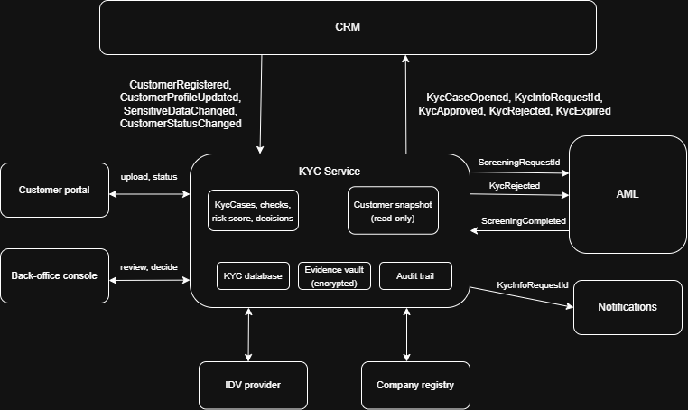
1.3 Case lifecycle business flow
Diagram sito veliau bus, noriu prasicheckinus tik daryt.
Flow 1: Onboarding case
- Actors: Customer, KYC Service, IDV provider, AML module, Compliance officer. Trigger: CustomerRegistered event from CRM.
- KYC takes CustomerRegistered, opens a KycCase ONBOARDING in DRAFT, stores a customer snapshot and publishes KycCaseOpened.
- The customer uploads documents (encrypted vault; the KYC database keeps a reference and a hash) and does a selfie liveness check. Later CustomerProfileUpdated events refresh the snapshot.
- KYC validates completeness, sets SUBMITTED, then CHECKS_IN_PROGRESS; it calls the IDV provider through the adapter, publishes ScreeningRequested to AML and, for a legal entity, queries the company registry and compares UBOs with the declared structure.
- IDV result and AML's ScreeningCompleted (CLEAR or HIT) are stored as VerificationCheck records, KYC calculates the risk score from nationality, residence country, customer type, structure complexity, PEP status and checks.
- LOW risk without a hit: auto approved. MEDIUM, HIGH or any hit: MANUAL_REVIEW by a Compliance office,; HIGH risk needs a second, different officer while following four eyes principle.
- KYC sets APPROVED, computes nextReviewDate (HIGH 1 year, MEDIUM 3, LOW 5; configurable) and publishes KycApproved. Its part ends here.
Alternative paths:
- IDV failed: PENDING_CUSTOMER with a reason code; max 3 attempts, then MANUAL_REVIEW. Officer requests information: REQUEST_INFO, PENDING_CUSTOMER and KycInfoRequested (Notification reminds the customer).
- Sanctions hit: a confirmed match gives REJECTED, KycRejected goes to CRM and AML, a false positive is cleared by the officer with a mandatory comment.
- Provider outage: no answer within 30 s, the adapter retries and after 24 h the case goes to MANUAL_REVIEW. No call blocks the customer.
Flow 2: Periodic review and change review\
The daily job opens a PERIODIC_REVIEW case when nextReviewDate or a document expiry day has reached 30 days left period. CRM's SensitiveDataChanged opens a CHANGE_REVIEW case. After the customer confirms or uploads documents, KYC re-runs IDV and AML screening and re-scores. For LOW/MEDIUM risk with no change in their risk level, they are auto-approved (KycApproved), otherwise manual review as in Flow 1. No response 30 days after the due date: EXPIRED and KycExpired. Adverse findings go to four-eyes review, blocking is done in CRM.
1.4 WireFrames
Veliau diagrama papaisysiu sita, vel jeifu praeis patikra.

# | Element (screen) | What happens when it is used
1 | Document type (K-W1) | Selects the required document class, the list depends on the customer type.
2 | Upload area (K-W1) | Uploads the file (PDF, JPG, PNG, max 10 MB) to the vault.
3 | Document list (K-W1) | Field per file (UPLOADED, VERIFIED, REJECTED), a rejected file shows the reason.
4 | Profile notice (K-W1) | Name, address and structure are edited in My profile. The link leaves KYC.
5 | Submit (K-W1) | Enabled when all required documents exist. Sets the case SUBMITTED.
6 | Queue filters (K-W2) | Filters the case queue by status, risk and type. search by case or customer code.
7 | Customer snapshot (K-W2) | Read-only data from CRM events. The link opens Customer 360 in CRM.
8 | Checks panel (K-W2) | Shows each VerificationCheck. A HIT is highlighted and expands to match details.
9 | Document viewer (K-W2) | Let’s the document be opened in the systems preview option or downloaded locally
10 | Decision buttons (K-W2) | Creates pop-up ReviewDecision (comment needed except for Approve). HIGH risk needs a second officer. The dedicated officer gets an e-mail.
1.5 Non-functional requirements
The requirements below refine the shared non-functional chapter for the KYC service (same baseline: TLS 1.3, AES-256, 99.9% availability).
ID | Area | Requirement
K-NFR-1 | Security and privacy | TLS 1.3 in transit; documents and personal data AES-256 at rest with keys in a key management service; role-based access (customer sees only own case, COMPLIANCE_OFFICER decides, AUDITOR read-only); every document view is audited; the four-eyes rule is enforced on the server.
K-NFR-2 | Availability and resilience | 99.9% availability per year for the KYC API. An IDV, registry or AML outage must not stop case intake: retries with backoff, circuit breaker, escalation to MANUAL_REVIEW after 24 h. Recovery targets: RPO 5 min, RTO 1 h (assumption).
K-NFR-3 | Performance | API response p95 below 500 ms (file upload excluded); upload of 10 MB below 5 s; automated checks (IDV and screening) finished within 60 s for 95% of cases; capacity of 100 new cases per minute at peak.
K-NFR-4 | Scalability and integration | Stateless service, scaled horizontally; events keyed by customerId (order per customer); at-least-once delivery with idempotent consumers (ProcessedEvent) and transactional outbox; event schemas versioned, only additive changes.
K-NFR-5 | Auditability and retention | KycAuditEvent is append-only and cannot be edited; evidence is kept 8 years after the end of the relationship, then deleted or anonymised (assumption: GDPR and AML rules); history can be exported as PDF.
K-NFR-6 | Compliance and localisation | GDPR data minimisation (only the snapshot fields KYC needs); EU AML directives (customer due diligence, periodic review); customer screens in LT and EN; all timestamps in UTC, ISO 8601.

1.6 High-level architecture
KYC is one deployable service with its own database and document vault. Dependencies point downwards (api, then application, then domain, persistence, integration, audit and messaging); the domain package has no dependency on infrastructure. Other modules are reached only through the API gateway or the event bus.
CIA BUS DIAGRAMA

Package | Responsibility
kyc.api | REST controllers for portal and console; validation and DTO mapping, no business logic.
kyc.security | Token and role check on every call; a customer reaches only their own case.
kyc.application | Use cases: case lifecycle, check orchestration, review queue, information requests, daily job.
kyc.domain | Entities and rules, no framework code: case state machine, four-eyes policy, risk rules.
kyc.persistence | Repositories for the KYC database and the client of the encrypted document vault.
kyc.integration | Adapters for the IDV provider and company registry: timeouts, retries, circuit breaker.
kyc.audit | Append-only KycAuditEvent for every state change and document view; PDF export.
kyc.messaging | Idempotent consumers of CRM and AML events; outbox relay publishes KYC events.

1.7 Data model
The KYC database is used only by KYC. customerId has no foreign key; SubjectSnapshot is KYC's own copy of CRM data (new version on every CustomerProfileUpdated), so KYC never reads CRM tables. Documents live in the encrypted vault (storageRef and sha256 in the database). SnapshotParty holds representatives and UBOs for comparison with the company registry. HIGH risk needs two APPROVE decisions by different officers (approvalOrder 1 and 2).
CIA BUS DIAGRAMA
Enumerations. CaseType: ONBOARDING, PERIODIC_REVIEW, CHANGE_REVIEW.
CaseStatus: DRAFT, SUBMITTED, CHECKS_IN_PROGRESS, PENDING_CUSTOMER, MANUAL_REVIEW, APPROVED, REJECTED, EXPIRED. RiskLevel: LOW, MEDIUM, HIGH.
SubjectType: INDIVIDUAL, LEGAL_ENTITY.
PartyRole: REPRESENTATIVE, UBO.
DocType: PASSPORT, ID_CARD, RESIDENCE_PERMIT, PROOF_OF_ADDRESS, REGISTRY_EXTRACT, UBO_DECLARATION.
DocStatus: UPLOADED, VERIFIED, REJECTED, EXPIRED.
CheckType: IDENTITY_DOC, LIVENESS, SANCTIONS, PEP, REGISTRY, UBO_MATCH.
CheckResult: PASS, FAIL, HIT, ERROR.
Decision: APPROVE, REJECT, REQUEST_INFO.
RequestStatus: OPEN, FULFILLED, EXPIRED.
RuleFactor: COUNTRY, SUBJECT_TYPE, STRUCTURE, PEP, CHECK_RESULT.
- CRM – Customer Relationship Management
Scope and ownership. CRM is the system of record for who the customer is: master data, legal-entity structure (representatives, beneficial owners), consents and lifecycle status. It has its own service and database. Every other module (CBS, Payments, Cards, Loans, Accounting, AML, Notification) treats a customer as an ID plus a small status replica fed by CRM events, so CRM is the single place where status is decided and published. KYC is one of its neighbours: CRM keeps only a read-only copy of the KYC outcome and applies its own rules to it
2.1 Table of features
ID | Feature | Actor | Priority
CRM-01 | Registration and profile creation (individual, legal entity) | Customer, SME representative | Must
CRM-02 | Profile maintenance; sensitive-data changes (name, ID code, address) flagged | Customer, Support agent | Must
CRM-03 | Legal entity structure: representatives with roles, UBOs (25% or more) | SME representative, Support agent | Must
CRM-04 | Lifecycle and status control (activate, restrict, block, close) with reason | Compliance officer, Operations | Must
CRM-05 | Contact preferences, GDPR consent, data export and erasure | Customer | Must
CRM-06 | Customer 360 and search (profile, KYC summary, products via module APIs) | Support agent, Relationship manager | Should
CRM-07 | Internal customer notes | Support agent | Could

2.2 Integration with other modules
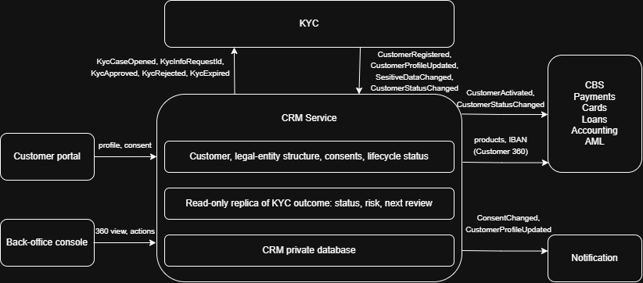

2.3 Customer lifecycle and business flows
Diagrama veliau

Flow 1: Registration to activation
Actors: Customer, SME representative, CRM Service. Precondition: the registration e-mail is not yet used.

- The customer registers (individual or legal entity, e-mail, phone). CRM creates the Customer as PROSPECT and publishes CustomerRegistered.
- The customer completes personal or company data, for a legal entity the SME representative adds representatives and UBOs (CRM-03). Each save publishes CustomerProfileUpdated; Notification keeps the contact details.
- CRM consumes KycCaseOpened and sets ONBOARDING. When it consumes KycApproved, it stores risk level and next review date, sets ACTIVE and publishes CustomerActivated.
- CBS, Payments, Cards and Loans now accept the customer, Accounting and AML register it, and Notification informs the customer.

Alternative paths. E-mail already used: registration is refused, nothing is published. KycRejected: the customer stays PROSPECT; a Compliance officer may BLOCK with a reason. KYC unavailable: CRM keeps working and the KYC chip shows the last known value.
Flow 2: Status control and data rights
- KycExpired makes CRM set RESTRICTED and publish CustomerStatusChanged; CBS and Cards then block outgoing payments and new products, while incoming funds are still accepted. A later KycApproved lifts the restriction.
- An officer uses Restrict, Block, Unblock or Close in Customer 360 (Compliance and Operations roles only). A reason is mandatory, a history entry is stored and CustomerStatusChanged is published to all modules.
- A change of name, ID code or address is saved with history and published as SensitiveDataChanged; KYC decides whether a re-check is needed.
- Consent changes are stored with a timestamp and published as ConsentChanged for Notification. Export and erasure cover CRM data only; other modules apply their own retention rules.

  - Wireframes
Diagrama veliau
# | Element (screen) | What happens when it is used
1 | Customer search (C-W1) | Finds customers by name, registration or personal code, e-mail or IBAN (IBAN resolved through CBS).
2 | Status header (C-W1) | Customer status comes from CRM, KYC status and risk are read-only replicas.
3 | Actions menu (C-W1) | Restrict, Block, Unblock, Close with a reason dialog, publishes CustomerStatusChanged.
4 | Tabs (C-W1) | Profile, Structure, Consents, KYC summary, Notes, products are loaded from other modules' APIs.
5 | Representatives and UBOs (C-W1) | Add or end a role with validity dates, each saved change publishes CustomerProfileUpdated.
6 | Profile form (C-W2) | The customer edits own master data, fields are validated and saved with history.
7 | Sensitive-data notice (C-W2) | Warns that a change may need re-verification, saving publishes SensitiveDataChanged.
8 | Consent toggles (C-W2) | Each change is stored with a timestamp and published as ConsentChanged.
9 | Data-rights buttons (C-W2) | Save, request a data export, or request erasure of CRM data.
2.5 Non-functional requirements
The requirements below refine the shared non-functional chapter for the CRM service (same baseline: TLS 1.3, AES-256, 99.9% availability).
ID | Area | Requirement
C-NFR-1 | Security and privacy | TLS 1.3 in transit; personal code, addresses and history values encrypted at field level (AES-256); status changes only by COMPLIANCE and OPERATIONS roles; every change is written to CustomerChangeLog; strong customer authentication is done by IAM at login.
C-NFR-2 | Availability and resilience | 99.9% availability per year. Other modules keep working from their own status replicas when CRM is down; CRM keeps working when KYC is down (last known KYC value is shown). Recovery targets: RPO 5 min, RTO 1 h (assumption).
C-NFR-3 | Performance | Profile read p95 below 300 ms; search p95 below 1 s on 5 million customers; a status change reaches all consumers within 5 s (p95); 200 requests per second sustained.
C-NFR-4 | Consistency and integration | Status change and its event are saved in one database transaction (outbox); events keyed by customerId; optimistic locking (version) prevents lost updates; consumers are idempotent (ProcessedEvent); event schemas versioned.
C-NFR-5 | Privacy rights and retention | Every consent change is timestamped; data export delivered within 24 h (legal limit 30 days); erasure only after closure and the retention period of 8 years (assumption); CRM covers its own data only.
C-NFR-6 | Localisation and data quality | Customer and back-office screens in LT and EN; e-mail and registration number unique; input checks for personal code, ISO country codes and ISO 8601 dates.

2.6 High-level architecture
CRM is one deployable service with its own database. Dependencies point downwards (api, then application, then domain, persistence, integration, audit and messaging); the domain package has no dependency on infrastructure. Other modules are reached only through the API gateway, the event bus or read-only query APIs.
CIA BUS DIAGRAMA
Package | Responsibility
crm.api | REST controllers for portal and back-office; validation and DTO mapping, no business logic.
crm.security | Token and role check on every call; only Compliance and Operations change a status.
crm.application | Use cases: registration, profile, structure, lifecycle, consents, data rights, search.
crm.domain | Customer aggregate and rules: status transitions, sensitive fields, UBO share (25% or more).
crm.persistence | Repositories for the CRM database and a search index over name, codes and e-mail.
crm.integration | Read-only product and IBAN lookups in CBS, Cards, Loans; a failure hides only that panel.
crm.audit | CustomerChangeLog for every status, profile and structure change; serves the history tab.
crm.messaging | Idempotent consumers of KYC events; outbox relay publishes customer events.

2.7 Data model
The CRM database is used only by CRM. KycReplica holds the last KYC outcome received from events (KYC stays the source of truth). CustomerChangeLog stores every status, profile and structure change; sensitive changes (name, personal code, address) are flagged and published as SensitiveDataChanged. Representative.personId points to an INDIVIDUAL customer. Other modules keep only customerId and a status replica.
CIA BUS DIAGRAMA
Enumerations. CustomerType: INDIVIDUAL, LEGAL_ENTITY.
CustomerStatus: PROSPECT, ONBOARDING, ACTIVE, RESTRICTED, BLOCKED, CLOSED.
Language: LT, EN.
AddressType: RESIDENCE, REGISTERED, MAILING.
RepRole: DIRECTOR, ACCOUNTANT, PROCURATOR.
ConsentPurpose: DATA_PROCESSING, MARKETING, E_STATEMENTS.
ChangeType: STATUS, PROFILE, STRUCTURE.
KycStatus: NONE, IN_PROGRESS, APPROVED, REJECTED, EXPIRED.
RiskLevel: LOW, MEDIUM, HIGH.
RequestType: EXPORT, ERASURE.
RequestStatus: OPEN, COMPLETED, REFUSED.

