Card management
Owner: dom1x

Scope
Cards manages card orders, status, limits, and approval or decline of card purchases. CRM owns customer status; CBS owns accounts, available funds, holds, and account transactions; AML owns screening. Loans assesses credit-card applications and sets credit limits.
Priority | Feature
Must | Order and activate a debit card linked to the customer's open EUR account, or a credit card with an approved credit limit.
Must | View cards and limits; change limits within bank maximums.
Must | Temporarily block/unblock a card or permanently block a lost/stolen card and order a replacement.
Must | Approve or decline a purchase using card/customer status, limits, AML result, and either CBS available funds or available card credit.
Must | Use a credit card within its approved limit and repay the used credit from a bank account.

Only ACTIVE cards belonging to an ACTIVE customer can be used. Debit cards spend from an OPEN EUR account; credit cards spend from an approved EUR credit limit. Each card also has a per-purchase and daily spending limit set within bank maximums. This version supports EUR purchases only.

Main flows
Order and activate. For a debit card, an authenticated customer chooses their own open EUR account; Cards checks ownership and CRM/CBS status. For a credit card, the customer applies and the bank's credit assessment returns an approval and limit or a rejection. An approved order creates an INACTIVE card. The customer enters a one-time confirmation code to activate it. A wrong or expired code leaves it inactive.
Debit card order and activation
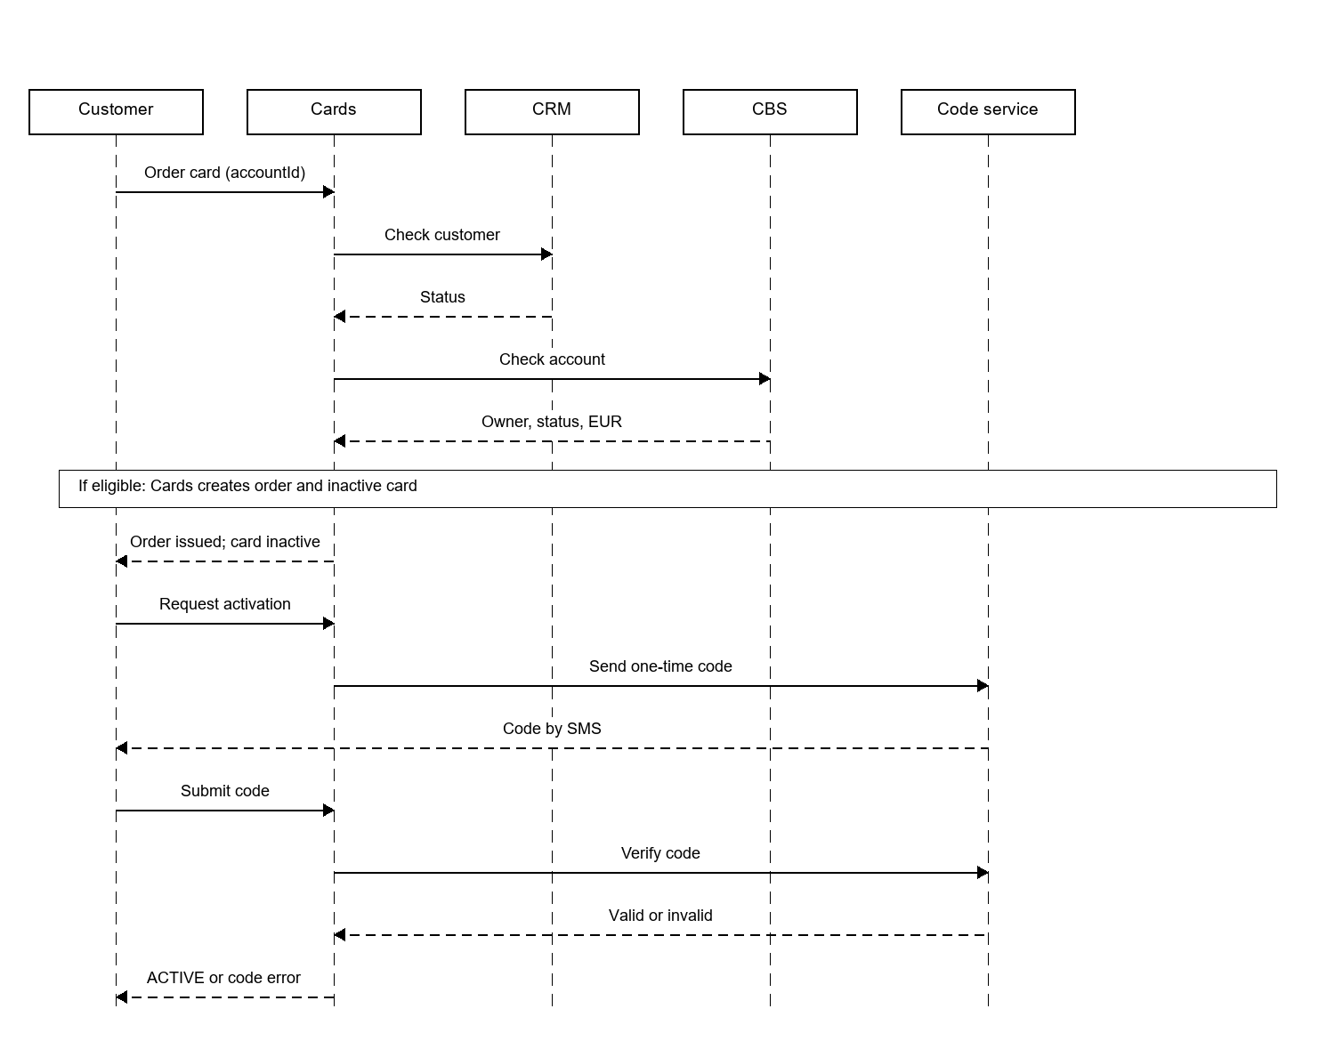
Block or replace. The owner can temporarily block an active card and later unblock it if the customer remains eligible (and, for debit, the linked account remains open). Reporting the card lost or stolen permanently blocks it; it cannot be unblocked. The owner can then order a replacement. A credit-card replacement keeps the same credit limit and outstanding balance. A saved block immediately stops new authorizations and publishes CARD_BLOCKED. Repeating the same block does not publish another event.
Authorize a purchase. The card network sends a unique networkRequestId. Cards first returns the saved answer if that ID was already processed. Otherwise, it checks card/customer status, currency, and spending limits, then asks AML to screen the attempt. For a debit card, CBS reserves available account funds. For a credit card, Cards reserves available credit (limit − outstanding balance − pending authorizations). A successful reservation produces APPROVED and CARD_TRANSACTION_AUTHORIZED; otherwise the attempt is DECLINED. An AML HOLD declines this attempt, not the card, and later AML release does not charge the customer automatically. On completion, a credit reservation becomes outstanding credit; on cancellation, it is released. CBS records the debit transaction and the account side of any credit repayment.
Debit card purchase authorization
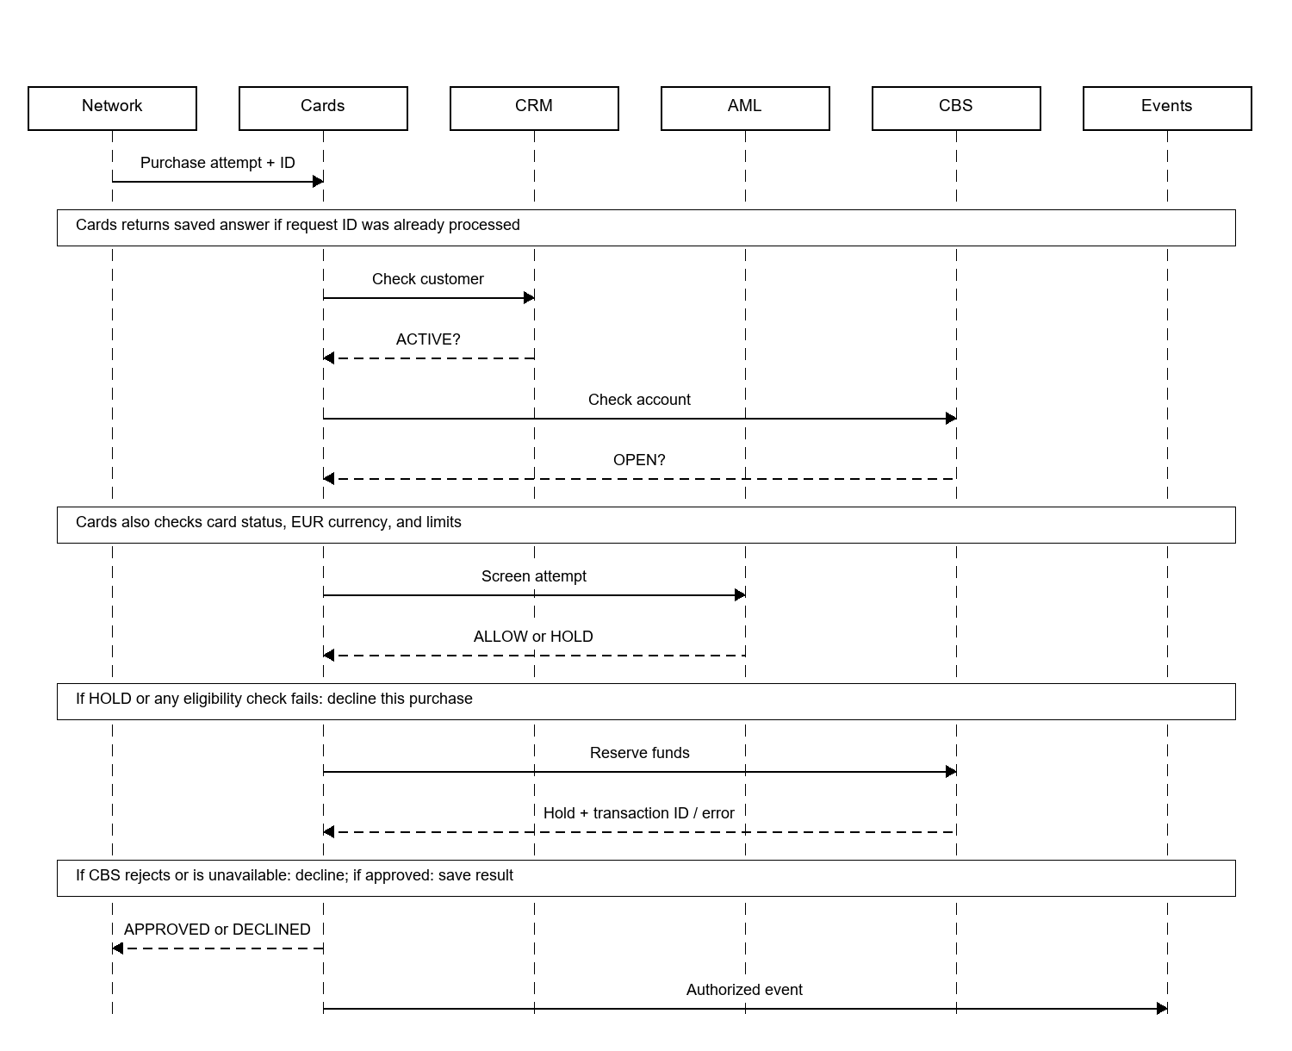
Repay used credit. The customer chooses a repayment amount from their own open EUR account. CBS records the repayment from that account; only after CBS confirms success does Cards reduce the outstanding credit by the same amount. The amount cannot exceed the outstanding balance. Repayment restores available credit. This system does not calculate interest or monthly bills.
Credit card purchase and repayment
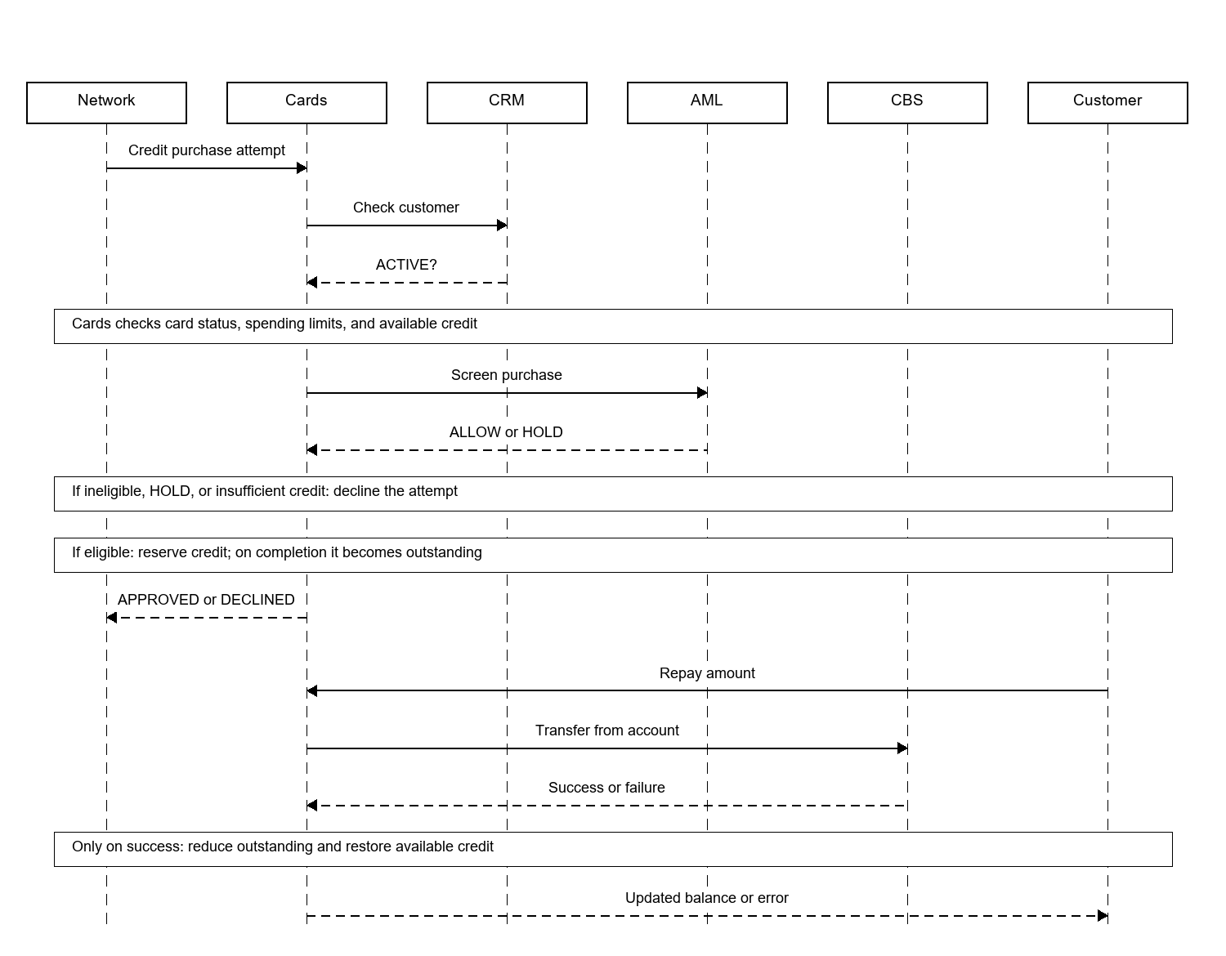
Credit-card approval. Loans assesses the application and returns either REJECTED or APPROVED with a creditLimit in EUR. Cards stores the approved limit, issues the card, and checks purchases against the remaining credit. Cards does not calculate or change the approved limit.

Card-owned data
These are Cards records. IDs for customers, accounts, and CBS transactions are references, not shared database tables. Decimal(18,2) means up to 18 digits in total, with two after the decimal point.
Entity | Fields
Card | id: UUID, customerId: UUID, accountId: UUID? (debit), creditId: UUID? (credit), orderId: UUID, replacesCardId: UUID?, last4: String(4), type: DEBIT/CREDIT, status: INACTIVE/ACTIVE/TEMP_BLOCKED/PERM_BLOCKED/EXPIRED/CANCELLED, expiresAt: Date, createdAt: DateTime, activatedAt: DateTime?, blockedAt: DateTime?
CardLimit | cardId: UUID, perTransactionAmount: Decimal(18,2), dailyAmount: Decimal(18,2), currency: EUR, updatedAt: DateTime
CardOrder | id: UUID, customerId: UUID, accountId: UUID?, type: DEBIT/CREDIT, approvedCreditLimit: Decimal(18,2)?, replacesCardId: UUID?, status: SUBMITTED/ISSUED/FAILED/CANCELLED, createdAt: DateTime, updatedAt: DateTime
CardCredit (credit only) | id: UUID, customerId: UUID, creditLimit: Decimal(18,2), outstandingAmount: Decimal(18,2), pendingAmount: Decimal(18,2), currency: EUR. Available credit is calculated as creditLimit − outstandingAmount − pendingAmount.
CardAuthorization | id: UUID, networkRequestId: String (unique), cardId: UUID, transactionId: UUID? (debit), holdId: UUID? (debit), amount: Decimal(18,2), currency: EUR, merchantName: String, merchantCountry: String(2), status: APPROVED/DECLINED/FAILED, reasonCode: String?, createdAt: DateTime

Card data model
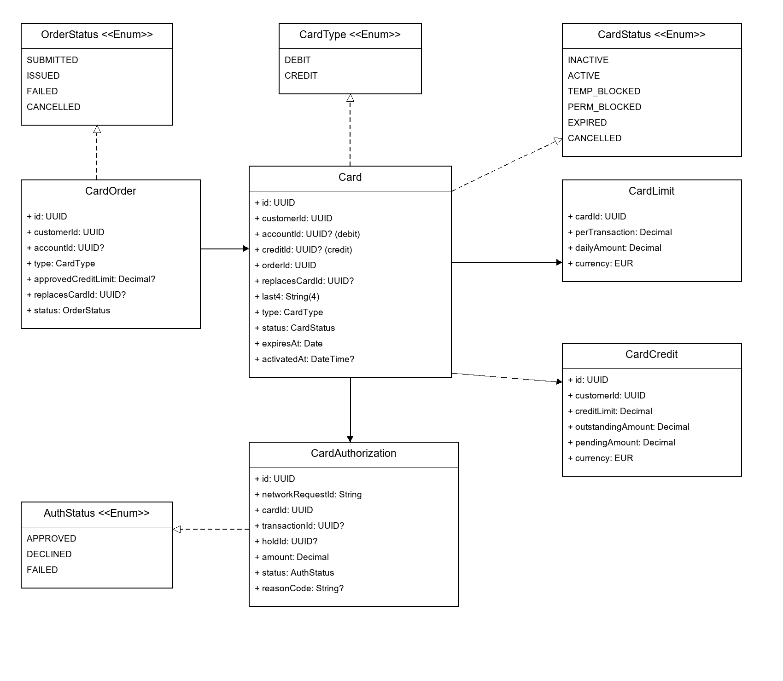
One customer may have many cards; one account may be linked to many debit cards. Each card has one spending-limit record and many authorization records. A credit card refers to one CardCredit record; a replacement refers to that same record. An order issues at most one card. Lists and events expose only last4, never a full card number, security code, or PIN.

Interfaces with other parts of the bank
Interaction | Information exchanged
Customer ↔ Cards | Card order, activation, limits, block/unblock, replacement; Cards returns the updated card or order status.
Card network ↔ Cards | Purchase request with a unique request ID, card, merchant and amount; Cards returns APPROVED or DECLINED. Repeating the same request ID returns the same result.
Cards ↔ CRM / Loans | CRM supplies customer status. Loans decides credit-card approval and the euro limit; Cards uses the returned result.
Cards ↔ AML / CBS | AML supplies a screening decision. CBS checks debit accounts, reserves debit funds, and records repayments from bank accounts. Cards stores the credit limit, outstanding credit, and pending card purchases.
Cards → Notifications / AML | CARD_BLOCKED and CARD_TRANSACTION_AUTHORIZED events contain the card ID, customer reference, safe display data and, for a purchase, the amount and transaction reference.

