**1.CTPN(水平文字检测)**

[**https://github.com/xiaofengShi/CHINESE-OCR**](https://github.com/xiaofengShi/CHINESE-OCR)

**https://github.com/AstarLight/Lets_OCR/tree/master/detector/ctpn**

**2.****SegLink（**CVPR2017**）**(**倾斜文字检测**)

**3.EASTCVPR**2017**）(倾斜文字检测)**

[**https://github.com/cs-chan/Total-Text-Dataset(cvpr2019**](https://github.com/cs-chan/Total-Text-Dataset(cvpr2019)**)**

**(Advanced EAST)**

**生成自己的样本:**

**https://github.com/YCG09/chinese_ocr**

**ocr dataset:**

**1.Chinese Text in the Wild(CTW)**

该数据集包含32285张图像，1018402个中文字符(来自于腾讯街景), 包含平面文本，凸起文本，城市文本，农村文本，低亮度文本，远处文本，部分遮挡文本。图像大小2048*2048，数据集大小为31GB。以(8:1:1)的比例将数据集分为训练集(25887张图像，812872个汉字)，测试集(3269张图像，103519个汉字)，验证集(3129张图像，103519个汉字)。

文献链接：https://arxiv.org/pdf/1803.00085.pdf

数据集下载地址：https://ctwdataset.github.io/

**2.Reading Chinese Text in the Wild(RCTW-17)**

该数据集包含12263张图像，训练集8034张，测试集4229张，共11.4GB。大部分图像由手机相机拍摄，含有少量的屏幕截图，图像中包含中文文本与少量英文文本。图像分辨率大小不等。

下载地址http://mclab.eic.hust.edu.cn/icdar2017chinese/dataset.html

文献：http://arxiv.org/pdf/1708.09585v2

3.ICPR MWI 2018 挑战赛

大赛提供20000张图像作为数据集，其中50%作为训练集，50%作为测试集。主要由合成图像，产品描述，网络广告构成。该数据集数据量充分，中英文混合，涵盖数十种字体，字体大小不一，多种版式，背景复杂。文件大小为2GB。

下载地址：

https://tianchi.aliyun.com/competition/information.htm?raceId=231651&_is_login_redirect=true&accounttraceid=595a06c3-7530-4b8a-ad3d-40165e22dbfe

**4.Google FSNS(谷歌街景文本数据集)**

该数据集是从谷歌法国街景图片上获得的一百多万张街道名字标志，每一张包含同一街道标志牌的不同视角，图像大小为600*150，训练集1044868张，验证集16150张，测试集20404张。

下载地址：http://rrc.cvc.uab.es/?ch=6&com=downloads

文献：http:// arxiv.org/pdf/1702.03970v1

**5.COCO-TEXT**

该数据集，包括63686幅图像，173589个文本实例，包括手写版和打印版，清晰版和非清晰版。文件大小12.58GB，训练集：43686张，测试集：10000张，验证集：10000张

文献: http://arxiv.org/pdf/1601.07140v2

下载地址：https://vision.cornell.edu/se3/coco-text-2/

**6.Synthetic Data for Text Localisation**

合成文本识别数据集，包含9百万张图像，涵盖了9万个英语单词。文件大小为10GB

下载地址：http://www.robots.ox.ac.uk/~vgg/data/text/

**7.Caffe-ocr中文合成数据**

数据利用中文语料库，通过字体、大小、灰度、模糊、透视、拉伸等变化随机生成，共360万张图片，图像分辨率为280x32，涵盖了汉字、标点、英文、数字共5990个字符。文件大小约为8.6GB

下载地址：<https://pan.baidu.com/s/1dFda6R3>

**OCR** 背景 **(2016-2017**蓬勃发展期**)**

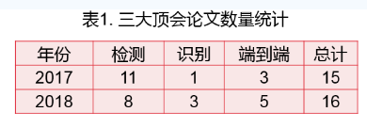

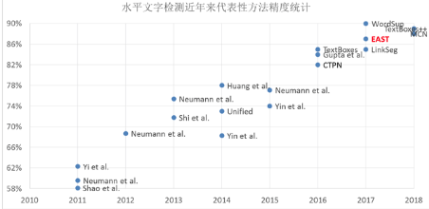

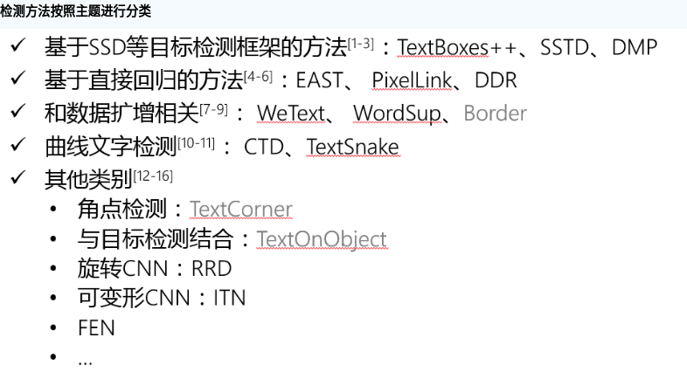

## **2. ECCV + CVPR + ICCV +AAAI**

### **检测**

* 水平文本

ctpn

* + Shangxuan Tian——【ICCV2017】WeText_Scene Text Detection under Weak Supervision
  + Shitala Prasad——【ECCV2018】Using Object Information for Spotting Text
  + XiangBai——【AAAI2017】TextBoxes_A Fast Text Detector with a Single Deep Neural Network
  + Sheng Zhang——【AAAI2018】Feature Enhancement Network_A Refined Scene Text Detector
* 倾斜文本
  + ChengLin Liu——【ICCV2017】Deep Direct Regression for Multi-Oriented Scene Text Detection
  + Chuhui Xue——【ECCV2018】Accurate Scene Text Detection through Border Semantics Awareness and Bootstrapping
  + Cong Yao——【CVPR2017】EAST_An Efficient and Accurate Scene Text Detector
  + Dafang He——【CVPR2017】Multi-Scale FCN With Cascaded Instance Aware Segmentation for Arbitrary Oriented Word Spotting in the Wild
  + Dan Deng——【AAAI2018】PixelLink_Detecting Scene Text via Instance Segmentation
  + Fangfang Wang——【CVPR2018】Geometry-Aware Scene Text Detection With Instance Transformation Network
  + Han Hu——【ICCV2017】WordSup_Exploiting Word Annotations for Character based Text Detection
  + Lianwen Jin——【CVPR2017】Deep Matching Prior Network_Toward Tighter Multi-oriented Text Detection
  + Pan He——【ICCV2017】Single Shot Text Detector With Regional Attention
  + XiangBai——【CVPR2017】Detecting Oriented Text in Natural Images by link Segments
  + XiangBai——【CVPR2018】Multi-Oriented Scene Text Detection via Corner Localization and Region Segmentation
  + XiangBai——【CVPR2018】Rotation-Sensitive Regression for Oriented Scene Text Detection
  + Yingli Tian——【CVPR2017】Unambiguous Text Localization and Retrieval for Cluttered Scenes
  + Yue Wu——【ICCV2017】Self-Organized Text Detection With Minimal Post-Processing via Border Learning
  + Zichuang Liu——【CVPR2018】Learning Markov Clustering Networks for Scene Text Detection
* 曲线文本
  + Shangbang Long——【ECCV2018】TextSnake_A Flexible Representation for Detecting Text of Arbitrary Shapes

### **识别**

* Wei Liu——【AAAI2018】Char-Net_A Character-Aware Neural Network for Distorted Scene Text Recognition
* Yang Liu——【ECCV2018】Synthetically Supervised Feature Learning for Scene Text Recognition
* Zhanzhan Cheng——【CVPR2018】AON Towards Arbitrarily-Oriented Text Recognition
* Zhanzhan Cheng——【CVPR2018】Edit Probability for Scene Text Recognition
* Zhanzhan Cheng——【ICCV2017】Focusing Attention_Towards Accurate Text Recognition in Natural Images
* Zichuan Liu——【AAAI2018】SqueezedText_A Real-time Scene Text Recognition by Binary Convolutional

### **检测+识别**

* Christian Bartz——【AAAI2018】SEE_Towards Semi-Supervised End-to-End Scene Text Recognition
* Chulmoo Kang——【AAAI2017】Detection and Recognition of Text Embedded in Online Images via Neural Context Models
* Chunhua Shen——【ICCV2017】Towards End-to-end Text Spotting with Convolutional Recurrent
* Fangneng Zhan——【ECCV2018】Verisimilar Image Synthesis for Accurate Detection and Recognition of Texts in Scenes
* Lluis Gomez——【ECCV2018】Single Shot Scene Text Retrieval
* Lukas Neumann——【ICCV2017】Deep TextSpotter_An End-to-End Trainable Scene Text Localization and Recognition Framework
* Weilin Huang——【CVPR2018】An End-to-End TextSpotter With Explicit Alignment and Attention
* XiangBai——【ECCV2018】Mask TextSpotter An End-to-End Trainable Neural Network for Spotting Text with Arbitrary Shapes
* XiangBai——【PAMI2018】ASTER_An Attentional Scene Text Recognizer with Flexible Rectification
* YuQiao——【CVPR2018】FOTS Fast Oriented Text Spotting With a Unified Network

## **3. 其他CV会议期刊**

### **2017年**

* Daitao Xing——【2017】ArbiText_Arbitrary-Oriented Text Detection in Unconstrained Scene
* Dena Bazazian——【2017】Improving Text Proposals for Scene Images with Fully Convolutional Networks
* Fan Jiang——【2017】Deep Scene Text Detection with Connected Component Proposals
* Jiaqi Ma——【2017】Arbitrary-Oriented Scene Text Detection via Rotation Proposals
* Lluis Gomez——【PR2017】TextProposals_A text-specific selective search algorithm for word spotting in the wild
* Siyang Qin——【2017】Cascaded Segmentation-Detection Networks for Word-Level TextSpotting
* Suman Ghosh——【2017】R-PHOC_Segmentation-Free Word Spotting using CNN
* Xiangyu Zhu——【ICDAR2017】Deep Residual Text Detection Network for Scene Text
* Yingying Jiang——【2017】R2CNN_Rotational Region CNN for Orientation Robust Scene Text Detection
* Yuchen Dai——【2017】Fused Text Segmentation Networks for Multi-Oriented Scene Text Detection
* Yuliang Liu——【2017】Detecting Curve Text in the Wild_New Dataset and New Solution(曲线文本)

### **2018年**

* Chunhua Shen——【2018】Correlation Propagation Networks for Scene Text Detection
* Dafang He——【2018】TextContourNet_a Flexible and Effective Framework for Improving Scene Text
* Jun Du——【ICPR2018】Sliding Line Point Regression for Shape Robust Scene Text Detection
* Qiangpeng Yang——【IJCAI2018】IncepText_A New Inception-Text Module with Deformable PSROI Pooling for Multi-Oriented Scene Text Detection
* QiYuan——【2018】A Single Shot Text Detector with Scale-adaptive Anchors
* **XiangBai——【2018TIP】TextBoxes++_A Single-Shot Oriented Scene Text Detector**
* XiangBai——【PAMI2018】ASTER_An Attentional Scene Text Recognizer with Flexible Rectification
* XiangLi——【2018】Shape Robust Text Detection with Progressive Scale Expansion Network
* Yu Qiao——【BMVC2018】Boosting up Scene Text Detectors with Guided CNN
* Zhuoyao Zhong——【2018】An Anchor-Free Region Proposal Network for Faster R-CNN based Text Detection Approaches

# SUMMARY:

# 最早的基于深度学习的文本检测方法,都是基于检测框回归的方法体系来做的,包括CTPN,seglinks,texrboxes++,RRPN等.但是这些基于检测框回归的方法在处理密集文本和倾斜文本的时候,往往表达的不够细致,也会出现回归边框不准确的问题

# 所以近期对于字符检测的研究都是基于检测的方向转向了基于分割的方法,往往是文本的区域分割+边框校准 的方法.以为对于文字的检测都需要较为精细的边界框,基于检测的方法已经往往只能确定一个四边形的文本框,后期的NMS算法也不太适合处理较为密集的文本区域筛选.

# 下面的文章基于分割+边界框校准的方法:

[EAST:An Efficient and Accurate Scene Text Detector（Advanced EAST）](https://arxiv.org/pdf/1704.03155.pdf)

* [PixelLink: Detecting Scene Text via Instance Segmentation](https://arxiv.org/pdf/1801.01315.pdf)
* [SOTD: Self-organized Text Detection with Minimal Post-processing via Border Learning](http://openaccess.thecvf.com/content_ICCV_2017/papers/Wu_Self-Organized_Text_Detection_ICCV_2017_paper.pdf)
* [Accurate Scene Text Detection through Border Semantics Awareness and Bootstrapping](https://arxiv.org/pdf/1807.03547.pdf)
* [MSR: Multi-Scale Shape Regression for Scene Text Detection](https://arxiv.org/abs/1901.02596)
* [TextField: Learning A Deep Direction Field for Irregular Scene Text Detection](https://arxiv.org/pdf/1812.01393v1.pdf)
* [TextMountain: Accurate Scene Text Detection via Instance Segmentation](https://arxiv.org/abs/1811.12786)