Model result record

Time | Model-Net | Data/aug | best_acc/top1 | test_loss/train_loss | 结果分析
20190710 | Teacher/resnet50 | Cifar100/  RandomResizedCrop32 | 70.82% | 1.082/0.702 | 采用初始lr 为0.1/0.02/0.004/0.0008有点过拟合,但又有训练不足的意思
20190710 | Student/squeezent | Cifar100/  RandomResizedCrop32 | 64.39% | 1.30/0.103 | 在训练loss中KD权重大,导致训练loss比较小远小于testloss,但模型性能很差
20190711 | Teacher/squeezent | Cifar100/  RandomResizedCrop32 | 66.08% | 1.207/1.277 | 单独用squeezent作为teacher模型比作为student模型好,那么student模型肯定有问题
20190711 | Student/squeezent | Cifar100/  RandomResizedCrop32 | 64.24% | 1.305/ | 设置参数T=10,adam训练方法优化,得到最低结果.现在只有一个原因,数据增强和原始不同,所以接下来改变数据增强方法
20190711 | Teacher/resnet18 | Cifar100/  RandomCrop(32, padding=4)  RandomRotation(15) | 72% | 1.209 | 无dropout 严重过拟合
20190711 | Teacher/resnet18 | Cifar100/  RandomCrop(32, padding=4)  RandomRotation(15) | 72.13 | 1.145 | 用了dropout,但是学习率设置太大,
20190712 | Teacher/resnet18 | Cifar100/  RandomCrop(32, padding=4) | 73.88% | 1.057/0.447 | 数据增强和dropout对结果影响很大(dropout=0.8)
20190712 | Teacher/resnet18 | Cifar100/  RandomCrop(32, padding=4) | 73.96% | 1.194/0.073 | (dropout=0.6)
20190712 | Teacher/resnet18 | Cifar100/  RandomCrop(32, padding=4) | 74.69% | 1.17/ | warmup_scheduler  (dropout=0.8)
20190710 表格第一行:
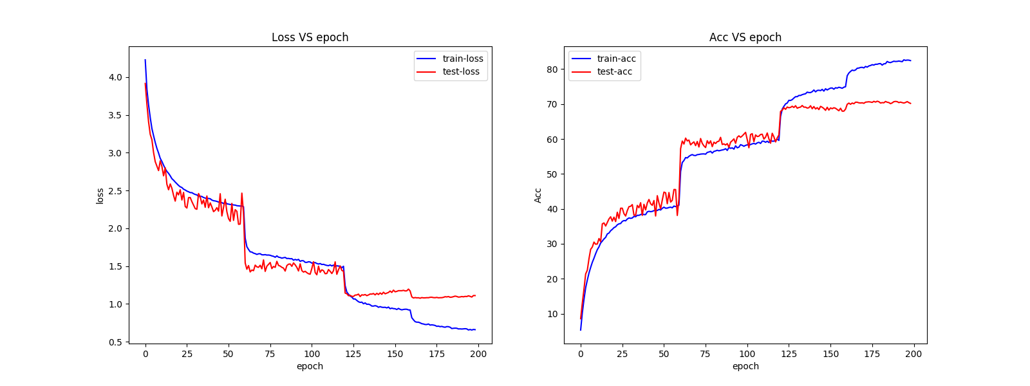
20190710 表格第二行:
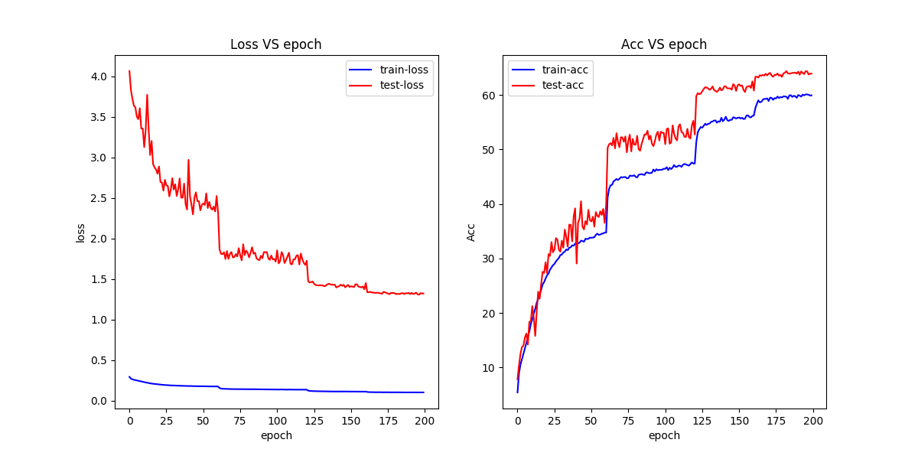

20190711 表格第三行:
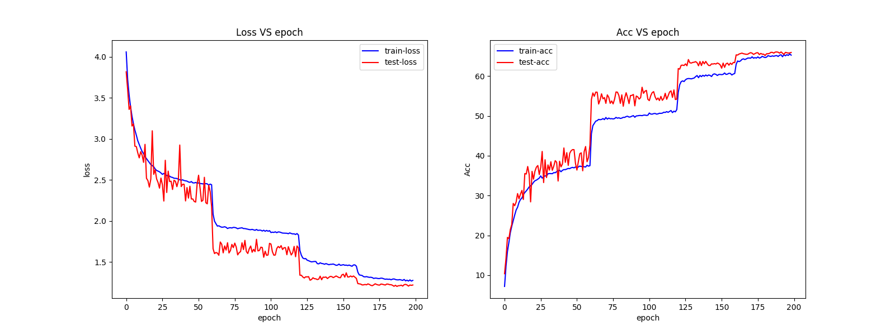
20190711 表格第四行:无必要放图

20190711 表格第7行:
