建立数据库
create database test；
use test；

- 版块表：
mysql> create table board(
-> boardId int not null auto_increment comment '版块编号',
-> parentId int not null comment '父版块编号',
-> boardName varchar(50) not null comment '版块标题',

-> primary key (boardId));
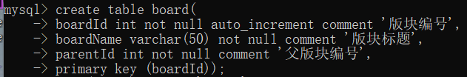

- 用户表：
mysql> create table user(
-> uId int not null auto_increment comment '用户编号',
-> uName varchar(50) not null comment '用户名',
-> uPwd varchar(10) not null comment '密码',
-> uSex smallint(6) not null comment '性别',

-> regTime timestamp not null default current_timestamp comment '注册时间',
-> head varchar(50) not null comment '头像',
-> primary key (uId));
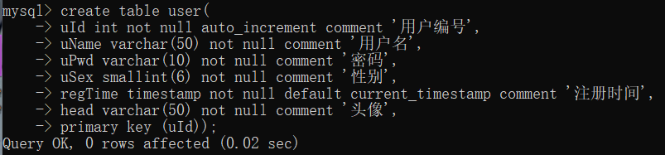

- 帖子表：
mysql> create table topic(
-> topicId int not null auto_increment comment '帖子编号',
-> title varchar(50) not null comment '帖子标题',

-> publishTime timestamp not null default current_timestamp comment '发帖时间',
-> modifyTime timestamp comment '修改时间',
-> uId int not null comment '用户编号',
-> boardId int not null comment '版块编号',
-> content varchar(1000) not null comment '帖子内容',
-> primary key (topicId),
-> foreign key fk_UId (uId) references user(uId),
-> foreign key fk_BId (boardId) references board (boardId));
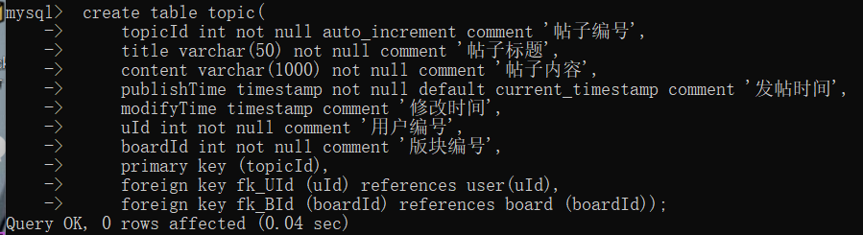

- 回帖表：
mysql> create table reply(
-> rId int not null auto_increment comment '回帖编号' ,
-> rName varchar(50) not null comment '帖子标题',
-> rText varchar(1000) not null comment '回帖内容',
-> rpublishTime timestamp not null default current_timestamp comment '回帖时间',
-> rmodifyTime timestamp comment '修改时间',
-> topicId int not null comment '帖子编号',
-> uId int not null comment '用户编号',
-> primary key(rId),
-> foreign key fk_Tid (topicId) references topic (topicId),
-> foreign key fk_UId (uId) references user(uId));
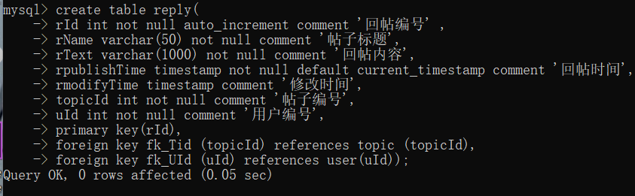

- PPT对应SQL语句
用户表（user）
- array findUser(string name)：
Select * from user where uName=name;

- array findUserById(int id)：
select * from user where uId=id;

- addUser(uName,uPass,head,gender="1")：
insert into user(uName,uPass,head,gender)
values (‘uname’,’upass’,’head’,’1’);

- updateUser(id,uName,uPass,head,gender)
upadte user set 字段名=值 where 筛选条件;

版块表（Board）
- findBoard(boardId)
select * from Board where boardId = boardId;

- findListBoard(parentId)
select * from Board where parentId= parentId;

帖子表（topic）
- addTopic(title,content,uId,boardId)
insert into topic(title,content,uId,boardId)
values (‘title’,’content’,’uId’,’boardId’);

- updateTopic(topicId,title, content)
upadte topic set 字段名=值 where 筛选条件;

- deleteTopic(topicId)
delete from topic where topicId = topicId;

- findTopicById(topicId)
select * from topic t,user u where t.uId=u.uId and topicId = topicId;

- int findCountTopic(boardId)
select count(*) as num from topic where boardId=boardId;

- findLastTopic(boardId)
select * from topic t,user u where t.uId =u.uId and boardId = boaardId
Order by publishTime desc limit 0,1;

- findListTopic(page,boardId)
select * from topic t,user u where t.uId =u.uId and boardId = boaardId
Order by publishTime desc limit page

回帖表
- addReply(title,content,uId,topicId)
insert into topic(title,content,uId,topicId)
values (‘title’,’content’,’uId’,’topicId’);

- updateReply(replyId,title, content)
upadte reply set 字段名=值 where 筛选条件;

- deleteReply(replyId)
delete from reply where replyId= replyId;

- findReplyById(replyId)
select * from reply r,user u where r.uId=u.uId and replyId= replyId;

- findCountReply(topicId)
select count(*) as num from reply where topicId=topicId;

- findListReply(page, topicId)
select * from reply r,user u where t.uId =u.uId and topicId= topicId
Order by rpublishTime desc limit page

