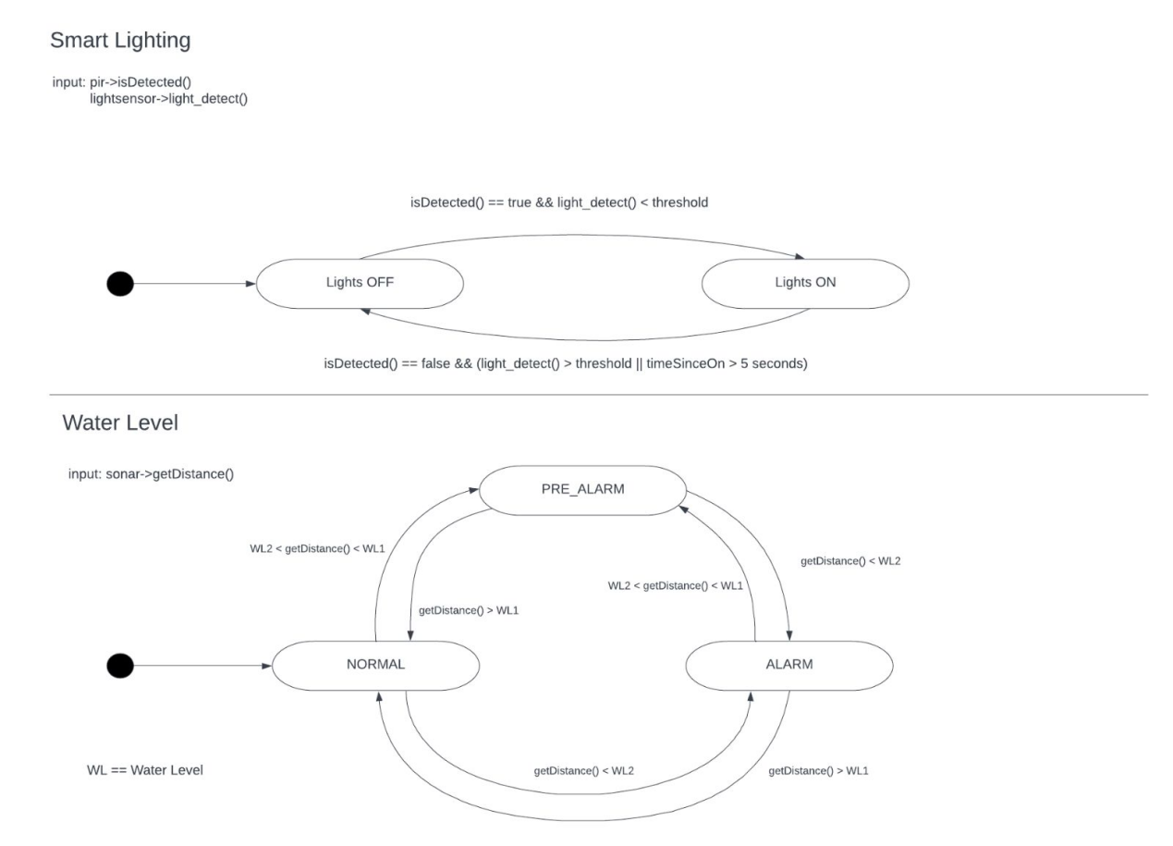

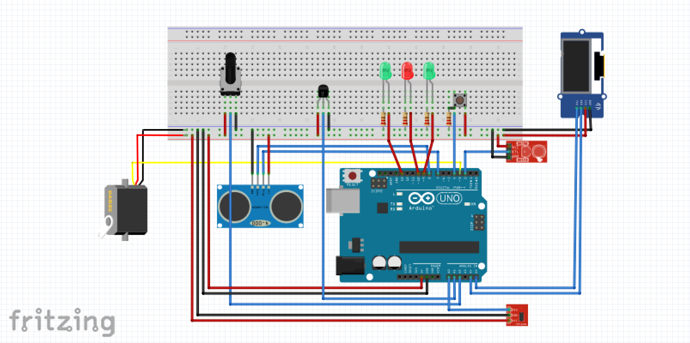

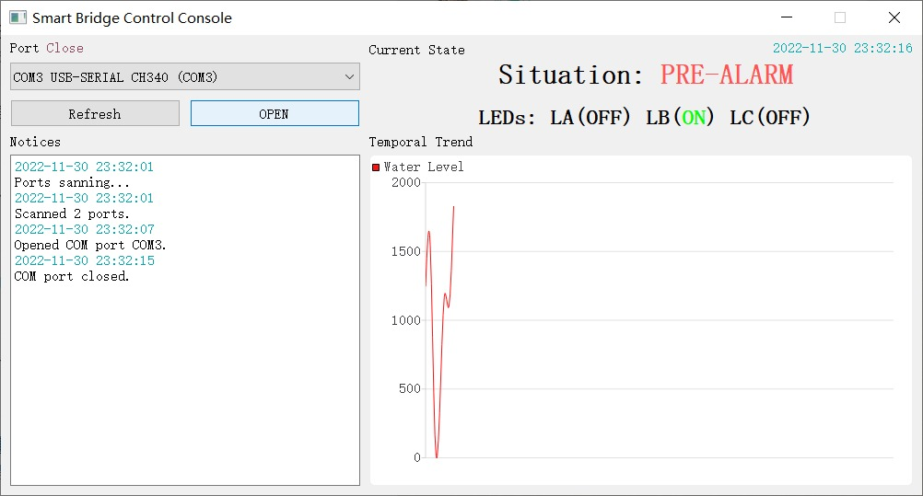

Video link:

https://liveunibo-my.sharepoint.com/personal/alexandru_vrabii_studio_unibo_it/_layouts/15/stream.aspx?id=%2Fpersonal%2Falexandru%5Fvrabii%5Fstudio%5Funibo%5Fit%2FDocuments%2FUniversit%C3%A0%2FIOT%20Personale%2FAssignment%5F2%5FVideo%2Emp4&ga=1