**The whole Smart Room system**

The video demonstrating the system: [[Click here to the link]](https://liveunibo-my.sharepoint.com/:v:/g/personal/siyu_chen3_studio_unibo_it/ETO2xYbGgqZBkklREkE8f5ABff_8XbFw_65ehyWu5NNQJw).

The whole Smart Room system is made up of 5 parts, as Figure 1 shows.

* Room Sensor-Board can detect the light intensity and people moving. It can send data to Azure IoT Hub via HTTP. Azure IoT Hub is a cloud service which can route messages between Room Sensor-Board, Room Dashboard, and Room Service.
* Room Service can receive data from Azure IoT Hub via HTTP, then send control commands to Room Controller via serial port.
* Room Dashboard provides a web page for users to monitor and control the system. It can communicate with Azure IoT Hub, receive some sensor data, and send control commands.
* Room Controller is the part to control actuator, it can receive commands from Room Service and then control the actual LED and roller blinder.
* Room Mobile App is an Android app, it can build connection with HC-05 Bluetooth module in Room Controller and can send manual control commands to it.

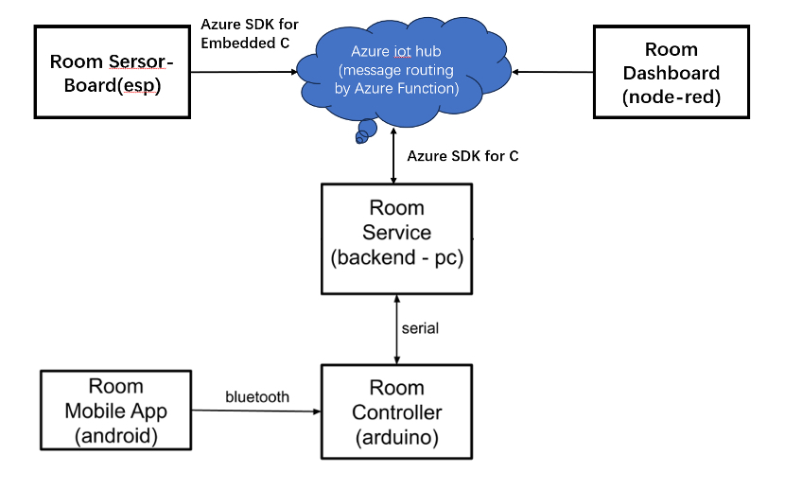

**Figure 1**  The diagram of the 5 parts of the Smart Room system

**Room Service**

The structure of program is from Assignment 2, which is done by using tasks(using thread should be better) and C++.

3 tasks in total: IoT task, Room task and serial task.

IoT task is to communicate with Azure IoT hub, both sending messages to the hub, and receiving, using 2 devices registered on IoT hub. The Azure Function is implemented on the cloud to route messages and sending C2D messages.

Serial task deal with the init of serial port, and receive new serial information to renew values of Arduino side. Serial communicates are implemented with an external lib called seriallib.

Room Task get information from other 2 tasks, and do specific control to the room, depending on different control states.

**Room Sensor Board**

Room sensor board is connected with Azure IoT hub, using Azure SDK for embedded C. The protocol is MQTT and the program is a superloop. The board gets the newest sensor value when sending messages to the cloud. The LED control is binded with reading PIR.

The schematic diagram is as Figure 2 shows.

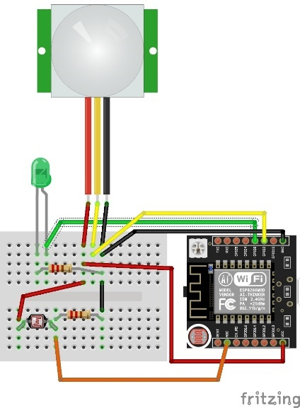

**Figure 2** The schematic diagram of Room Sensor Board

**Room Dashboard**

The Dashboard of the room is connected with Room Service and Room Sensor board, through message routing on the cloud using Azure services.

The dashboard is implemented using Node-RED. Through the dashboard we can control light and the roller manually. It shows the state of the LED(including ON/OFF and Light ON time) and the roller, also the room light value we get from sensor board. The screenshot is as Figure 3 shows.

The input of dashboard come from azure IoT hub node. It gets message in json format, then convert into object format, and then processed through 3 functions for 3 gauges, showing on ui site. Another function catch the time when light have been on. The output of dashboard is the controller on the dashboard sent to IoT hub. The diagram is as Figure 4 shows.

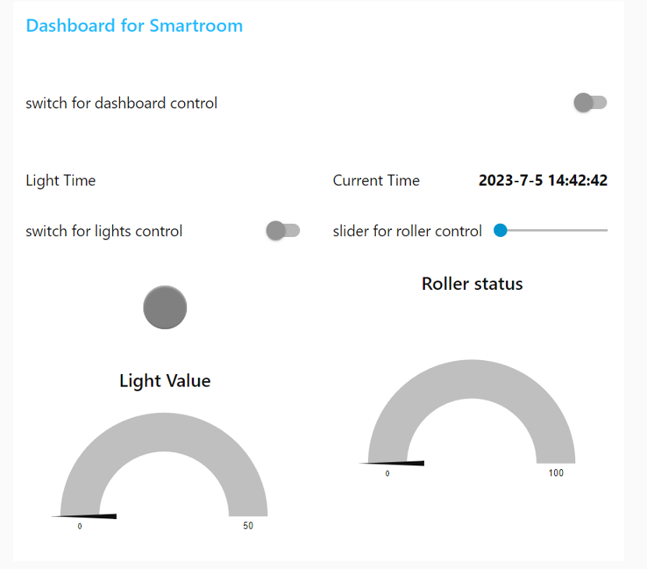

**Figure 3** The screenshot of the dashboard

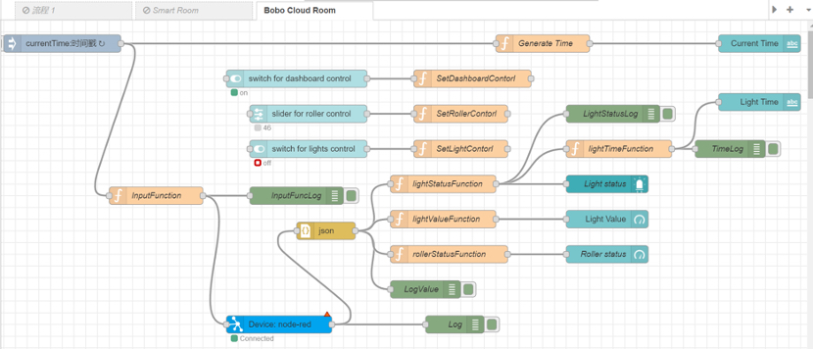

**Figure 4** The diagram of the dashboard

**Room Controller (Arduino)**

The schematic diagram is as Figure 5 shows.

**Figure 5** The schematic diagram of Room Controller

The Arduino will have connection with PC (via Serial) and Android Phone (via Bluetooth). So that it can receive commands from both Room Service and Room App, it can also send feedback to Room Service to tell whether it have received the command. The asynchronous FSM diagram is as Figure 6 shows.

**Figure 6** The asynchronous FSM diagram of Room Controller

We designed a specific data format for these three parts to communicate, the data format is as Figure 7 shows. For controlling the LED, recv_buf[] will be a string in the length of 4; For controlling the roller blind, the length will be 6.

**Figure 7** The format of the data

**Room App (Android - smartphone)**

Room App is an Android app running on a real Android phone. After connecting with HC-05, this app can be used to send commands to Room Controller. The code is based on AndroidExample04, we added a SeekBar and a Switch for users to send commands easily. The screenshot of the app is as Figure 8 shows.

**Figure 8** The screenshot of the Android App “Smart Room ESIoT”