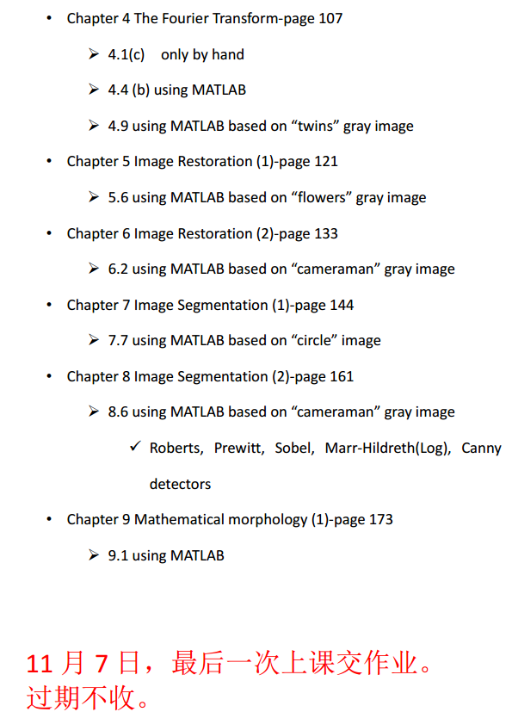

4.1(c) only by hand（）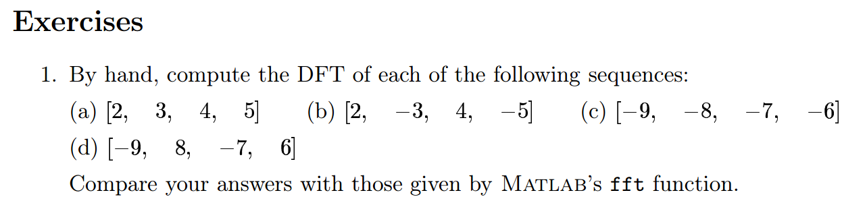

4.4(b) using MATLAB 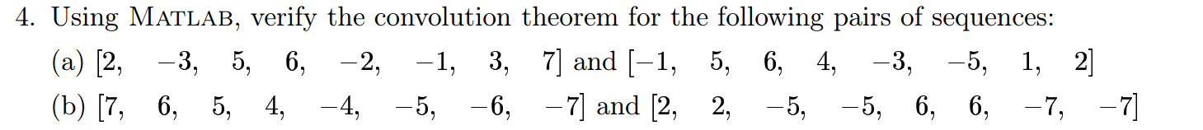

4.9 using MATLAB based on “twins” gray image

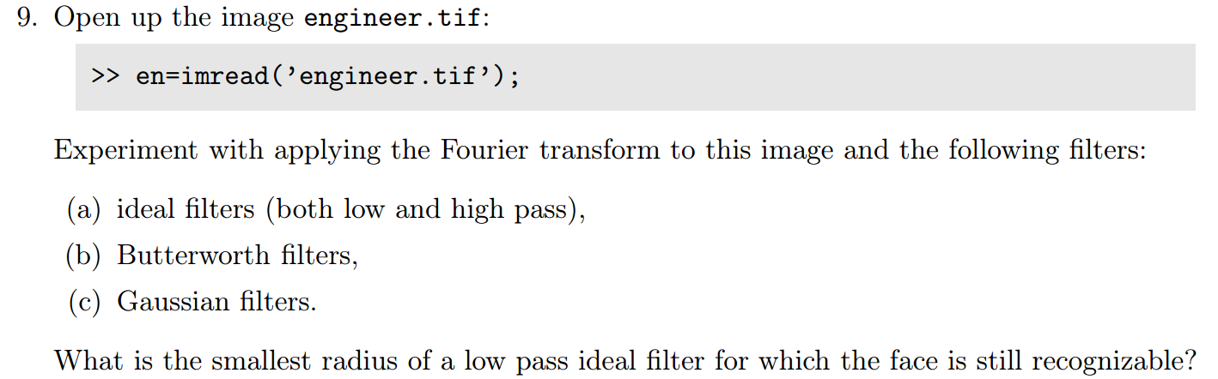

5.6 using MATLAB based on “flowers” gray imag

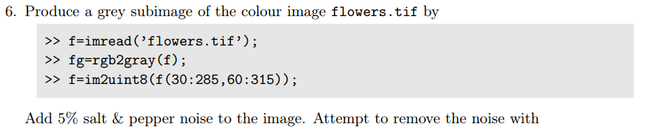

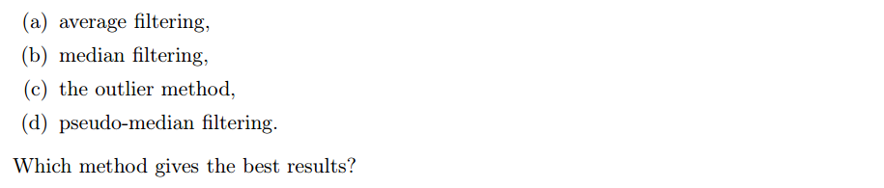

6.2

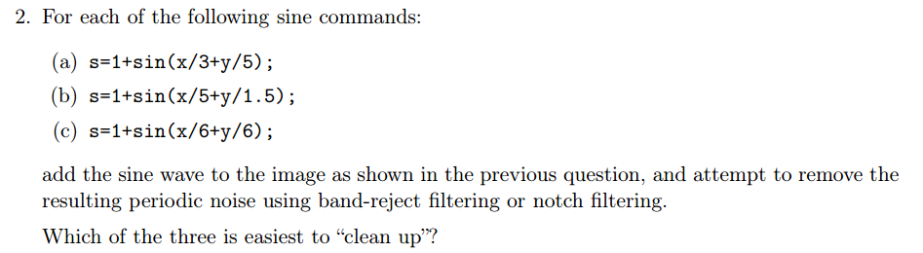

7.7

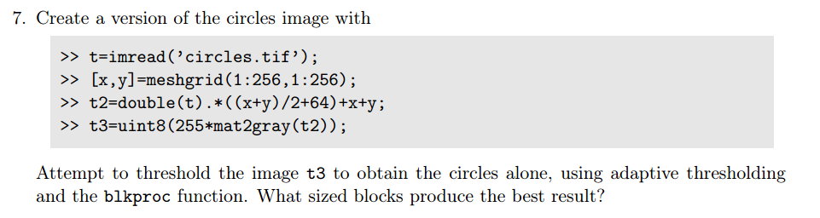

8.6

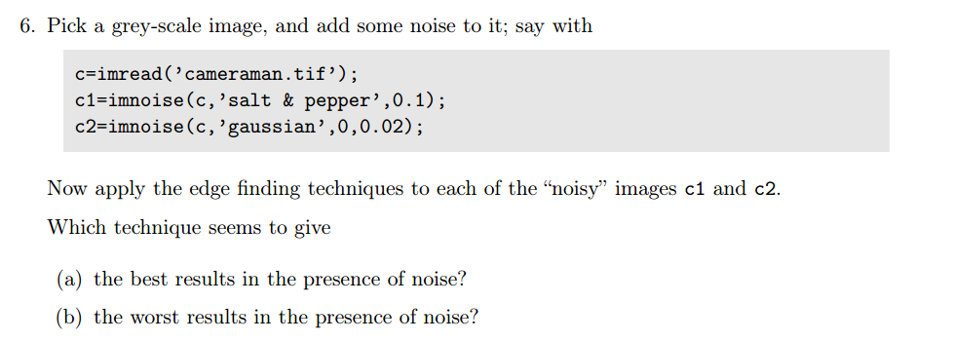

9.1

