Calculator.py
Code:
def add(a, b):
return a + b

def subtract(a, b):
return a - b

def multiply(a, b):
return a * b

def divide(a, b):
if b == 0:
print("Cannot divide by zero")
else:
return a / b

while True:
print("\nCalculator")
print("1. Add")
print("2. Subtract")
print("3. Multiply")
print("4. Divide")
print("5. Exit")

choice = input("Enter your choice: ")

if choice == "5":
print("Goodbye")
break

if choice == "1":
a = float(input("Enter first number: "))
b = float(input("Enter second number: "))
print("Answer:", add(a, b))

elif choice == "2":
a = float(input("Enter first number: "))
b = float(input("Enter second number: "))
print("Answer:", subtract(a, b))

elif choice == "3":
a = float(input("Enter first number: "))
b = float(input("Enter second number: "))
print("Answer:", multiply(a, b))

elif choice == "4":
a = float(input("Enter first number: "))
b = float(input("Enter second number: "))
answer = divide(a, b)

if answer is not None:
print("Answer:", answer)

else:
print("Invalid choice")

Output:
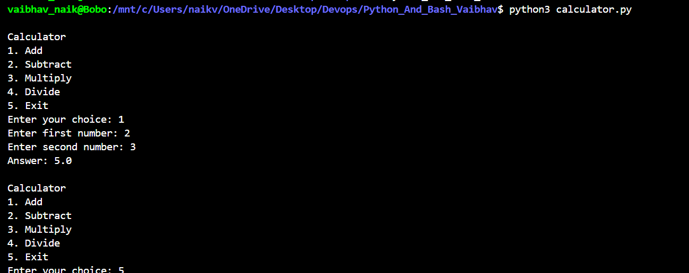

Explanation:
The project is a menu-driven calculator implemented using both Python and Bash. The Python program uses separate functions for addition, subtraction, multiplication, and division, while a loop and conditional statements allow the user to repeatedly select operations until exiting. It also handles errors such as division by zero and invalid number input without crashing. A separate Bash script provides the same calculator functionality, demonstrating the use of Bash scripting for system-level automation. The project is organized with the Python file, Bash file, README, and documentation containing screenshots of the working programs and error handling.

Calculator.sh
Code:
#!/bin/bash

while true
do
echo "Calculator"
echo "1. Add"
echo "2. Subtract"
echo "3. Multiply"
echo "4. Divide"
echo "5. Exit"

read -p "Enter your choice: " choice

if [ $choice -eq 5 ]
then
echo "Goodbye"
break
fi

read -p "Enter first number: " a
read -p "Enter second number: " b

if [ $choice -eq 1 ]
then
echo "Answer: $((a + b))"

elif [ $choice -eq 2 ]
then
echo "Answer: $((a - b))"

elif [ $choice -eq 3 ]
then
echo "Answer: $((a * b))"

elif [ $choice -eq 4 ]
then
if [ $b -eq 0 ]
then
echo "Cannot divide by zero"
else
echo "Answer: $((a / b))"
fi

else
echo "Invalid choice"
fi

echo ""
done

