
Python & Bash
DEVOPS | Assignment
SUBMISSION GUIDELINES
• Complete all tasks and document your work in a doc (Google Doc or Microsoft Word) with screenshots/commands and explanations.
• Create one folder named Python_and_Bash_YourName.
• Put your complete project source code and all files inside this folder.
• Add your documentation file (with screenshots and explanations) inside the same folder.
• Compress the folder into a .zip file (Python_and_Bash_YourName.zip).
• Upload the .zip file on the submission portal.
Zip File Must Contain
• Your complete project source code and all files
• Document with screenshots/commands and explanation for every task
• GitHub repository link (or code files)
⚠ Your full project code MUST be submitted inside this .zip file. Screenshots (terminal / commands / output) are mandatory. Also share your GitHub repository link.
Do NOT upload separate files.
Do NOT submit without compressing into a .zip file.

Objective: Practise core Python programming — conditionals, dictionaries, and file handling (reading and writing files).

1. Grade Checker
Take a score as input and print the grade based on the following:
90+ : “A”
80–89 : “B”
70–79 : “C”
60–69 : “D”
Below 60 : “F”
Use a basic if / else statement to determine the grade.
2. Student Grades
Create a dictionary where the keys are student names and the values are their grades. Allow the user to:
Add a new student and grade.
Update an existing student's grade.
Print all student grades.
Use a dictionary and basic operations with if / else.
3. Write to a File
Write a program to create a text file and write some content to it, using file functions like open() and write().
4. Read from a File
Open the file in read mode and use file.read() to read and display its content.

If you have any doubt, you can directly contact the Tutedude mentor.

Hello Ma’am/Sir,
I received the attached assignment under Python & Bash – DevOps Assignment, and according to the assignment I received, the tasks are Grade Checker, Student Grades using a dictionary, Write to a File, and Read from a File. These are the tasks I completed and submitted. I could not find any requirement for a calculator.py, calculator menu, mathematical operations, or Bash calculator component in the assignment I received.
I’m sorry for the trouble and confusion. Could you please confirm whether I received the correct assignment, or explain which assignment/version I should complete and submit? I want to make sure I follow the correct requirements before resubmitting.
Thank you.

Assignment 2
1. Grade Checker
Take a score as input and print the grade based on the following:
- 90+ : “A”
- 80–89 : “B”
- 70–79 : “C”
- 60–69 : “D”
- Below 60 : “F”
- Use a basic if / else statement to determine the grade.
Code:
score_input = input("Enter your score: ").strip().lower()

if score_input == "90+" or score_input.startswith("90"):
print("Grade: A")

elif score_input in ["80-89", "80-90"] or (score_input.isdigit() and 80 <= int(score_input) <= 89):
print("Grade: B")

elif score_input in ["70-79"] or (score_input.isdigit() and 70 <= int(score_input) <= 79):
print("Grade: C")

elif score_input in ["60-69"] or (score_input.isdigit() and 60 <= int(score_input) <= 69):
print("Grade: D")

elif score_input in ["below 60", "below60", "<60"] or (score_input.isdigit() and int(score_input) < 60):
print("Grade: F")

else:
# Try to treat it as a pure number
try:
score = int(score_input)
if score >= 90:
print("Grade: A")
elif score >= 80:
print("Grade: B")
elif score >= 70:
print("Grade: C")
elif score >= 60:
print("Grade: D")
else:
print("Grade: F")
except:
print("Invalid input! Please enter something like 90+, 80-89, 75, or 45")
Output: 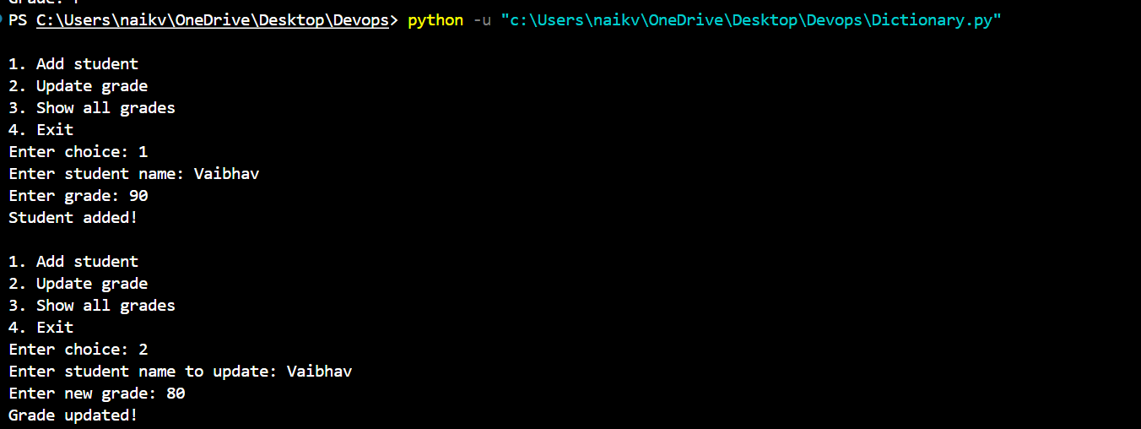
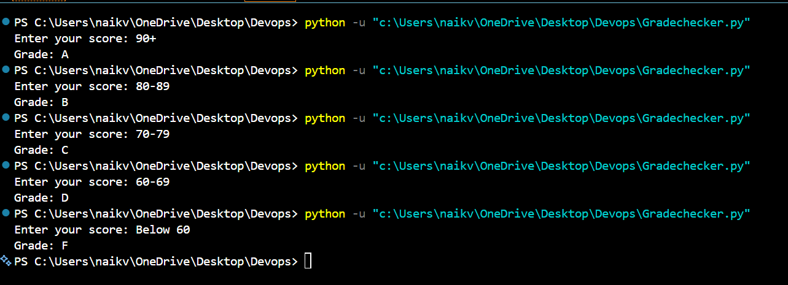
Explanation:
This program takes a student's score as input and checks it using if, elif, and else conditions. Based on the score, it prints the corresponding grade from A to F.

2. Student Grades
Create a dictionary where the keys are student names and the values are their grades. Allow the user to:
- Add a new student and grade.
- Update an existing student's grade.
- Print all student grades.
- Use a dictionary and basic operations with if / else.

Code:
students = {
"Rahul": "A",
"Priya": "B",
"Amit": "C"
}

name = input("Enter student name: ")
grade = input("Enter grade: ")

if name in students:
students[name] = grade
print("Student grade updated successfully.")
else:
students[name] = grade
print("New student added successfully.")

print("\nStudent Grades:")

for student, grade in students.items():
print(student, ":", grade)

Output: 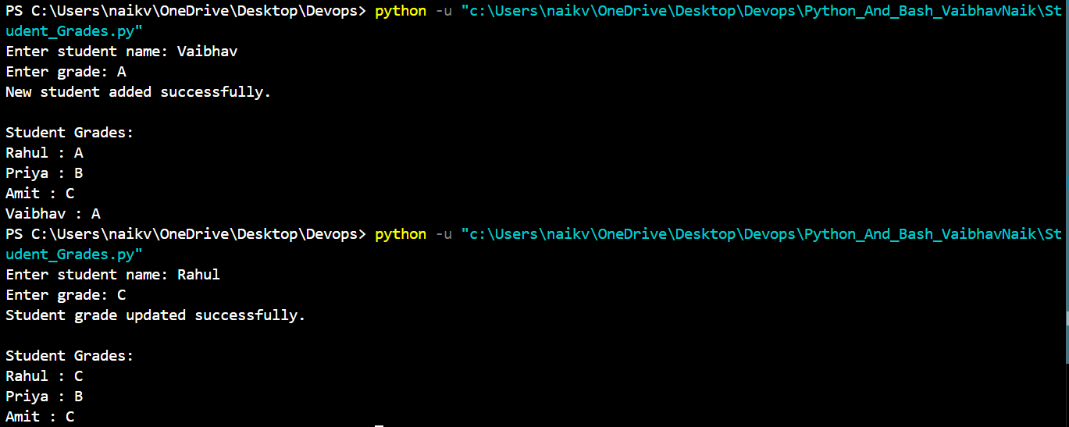
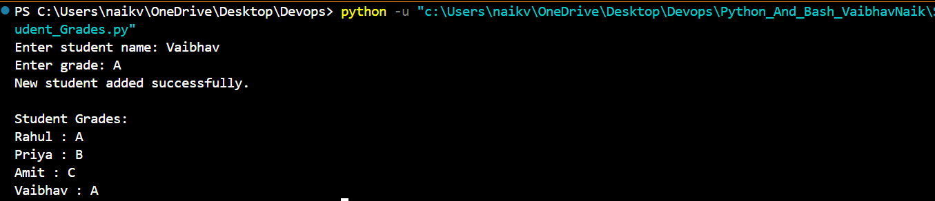

Explanation:
This program uses a dictionary to store student names and their grades. The user can enter a student name and grade. If the student already exists, their grade is updated. If the student is not present, a new student is added. Finally, the program displays all the student grades.

3. Write to a File
Write a program to create a text file and write some content to it, using file functions like open() and write().

Code:
file = open("student.txt", "w")

file.write("Student Name: Vaibhav\n")
file.write("Course: Computer Engineering\n")
file.write("This file was created using Python.")

file.close()

print("Content written to the file successfully.")

Output:
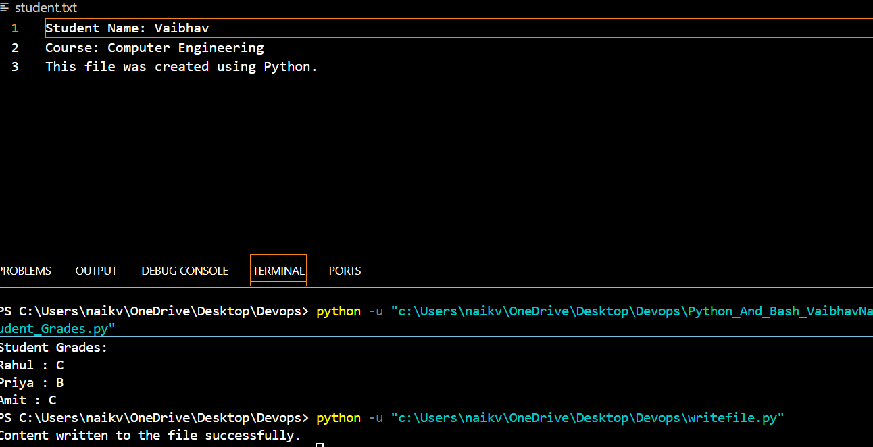
Explanation:
This program creates a text file named student.txt using open() in write mode. The write() function is used to add content to the file. Finally, close() is used to close the file.

4. Read from a File
Open the file in read mode and use file.read() to read and display its content.
Code:
file = open("student.txt", "r")

content = file.read()

print("File Content:")
print(content)

file.close()

Output:
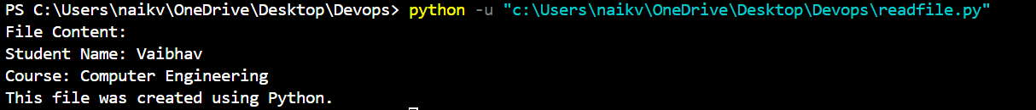

Explanation:
This program opens the student.txt file in read mode using "r". The read() function reads the complete content of the file and displays it on the screen. After reading the file, close() is used to close it.

Calculator.py
Code:
# Python Calculator

def add(num1, num2):
return num1 + num2

def subtract(num1, num2):
return num1 - num2

def multiply(num1, num2):
return num1 * num2

def divide(num1, num2):
if num2 == 0:
return "Error: Cannot divide by zero."
else:
return num1 / num2

while True:

print("\n===== Python Calculator =====")
print("1. Addition")
print("2. Subtraction")
print("3. Multiplication")
print("4. Division")
print("5. Exit")

choice = input("Enter your choice (1-5): ")

if choice == "5":
print("Calculator closed.")
break

if choice in ["1", "2", "3", "4"]:

num1 = float(input("Enter first number: "))
num2 = float(input("Enter second number: "))

if choice == "1":
print("Result:", add(num1, num2))

elif choice == "2":
print("Result:", subtract(num1, num2))

elif choice == "3":
print("Result:", multiply(num1, num2))

elif choice == "4":
print("Result:", divide(num1, num2))

else:
print("Invalid choice. Please select a number from 1 to 5.")

Output:
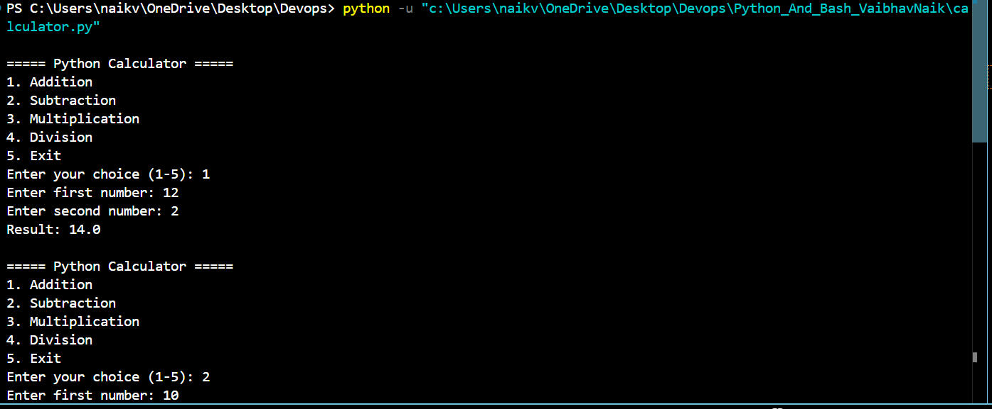
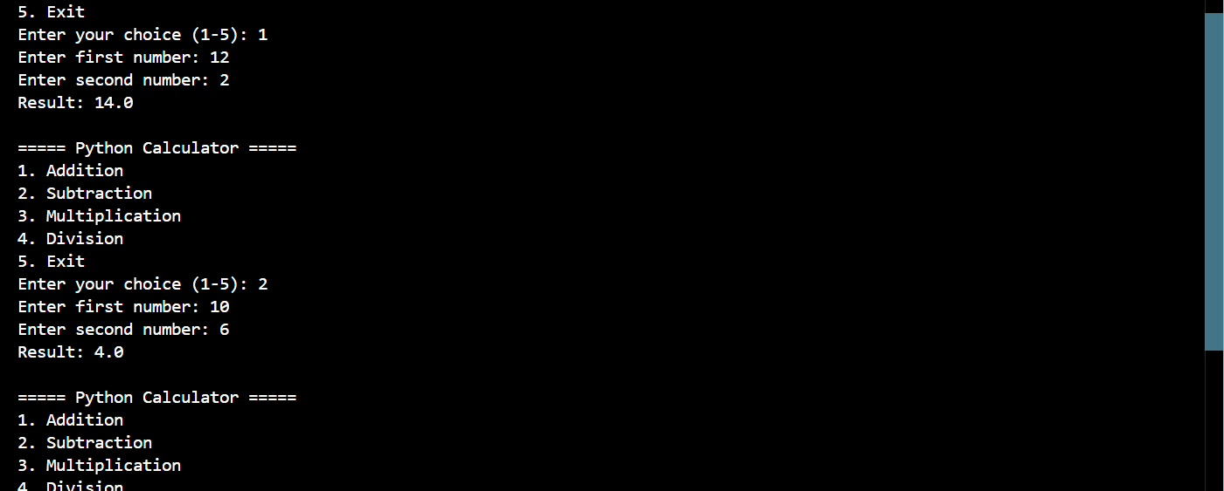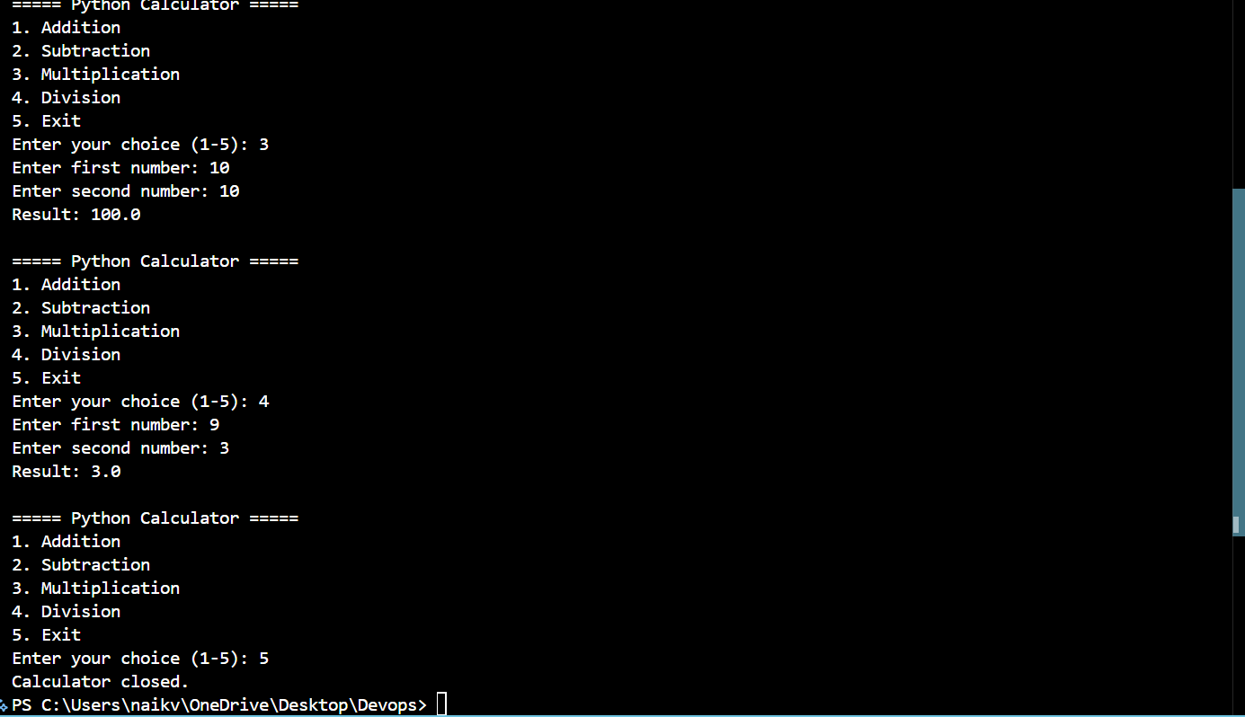
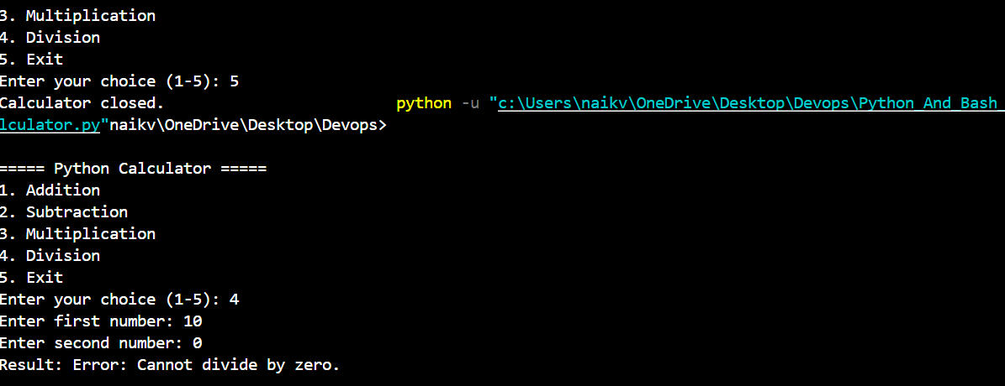
Explanation:
This program is a simple Python calculator where the user can choose between addition, subtraction, multiplication, and division. Each operation has its own function, and a while loop keeps showing the menu so the user can perform multiple calculations. The program takes two numbers as input and uses if/elif/else to perform the selected operation. It also checks for division by zero and shows an error message instead of crashing. Comments are added in the code to explain what each part does.

Github: https://github.com/Bobooo404/Devops.

