1. Creating and Renaming Files/Directories
Create a directory named test_dir using mkdir.
Inside test_dir, create an empty file called example.txt.
Rename example.txt to renamed_example.txt using mv

I created a directory named test_dir using the mkdir command. Inside this directory, I created an empty file named example.txt using the touch command. I then renamed the file to renamed_example.txt using the mv command.

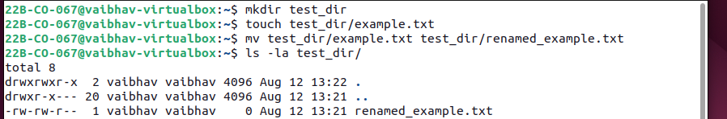

2. Viewing File Contents
Use cat to display the contents of /etc/passwd.
Display only the first 5 lines of /etc/passwd using head.
Display only the last 5 lines of /etc/passwd using tail.

I used the cat command to view the complete contents of the /etc/passwd file. I also used the head command to display only the first five lines and the tail command to display the last five lines of the file.
The /etc/passwd file contains information about the users available on the Linux system.
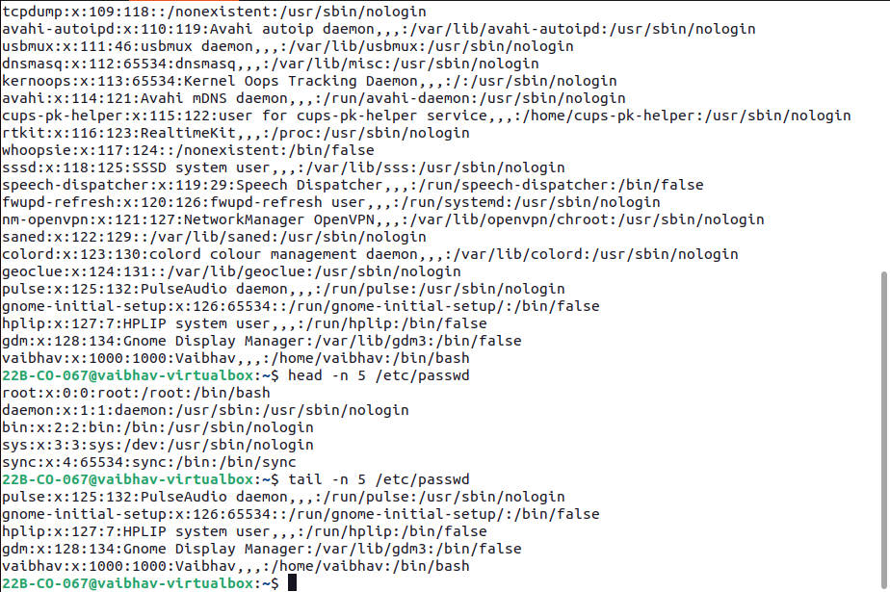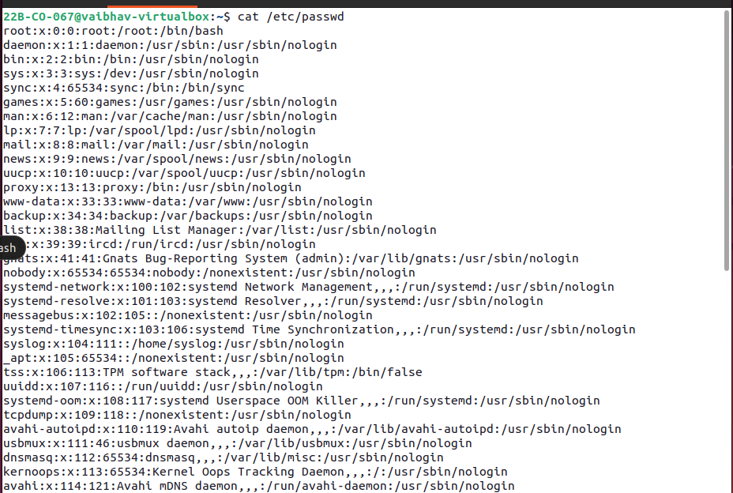

3.Searching for Patterns
Use grep to find all lines containing the word "root" in /etc/passwd.
I used the grep command to search for the word root in the /etc/passwd file. It displayed all the lines where the word root was present.
The grep command is useful when we need to find specific words or patterns inside a file.

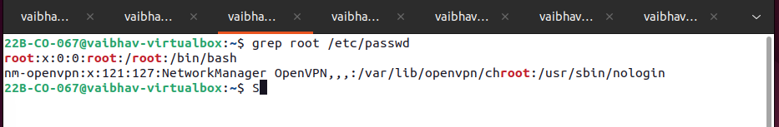

4. Zipping and Unzipping
Compress the test_dir directory into a file named test_dir.zip using zip.
Unzip test_dir.zip into a new directory named unzipped_dir.

I compressed the test_dir directory into a ZIP file named test_dir.zip. After that, I created a new directory named unzipped_dir and extracted the ZIP file into it.
This shows how Linux can be used to compress and extract files and directories.

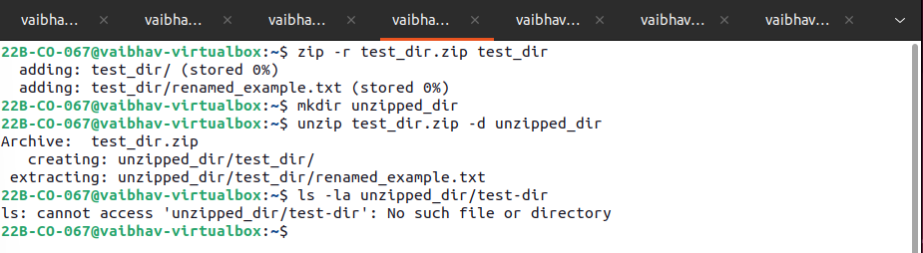

5. Downloading Files
Use wget to download a file from a URL (e.g., https://example.com/sample.txt).

I used the wget command to download a file from the internet using its URL. The downloaded file was saved in the current working directory.
The wget command is commonly used in Linux to download files directly from the command line.

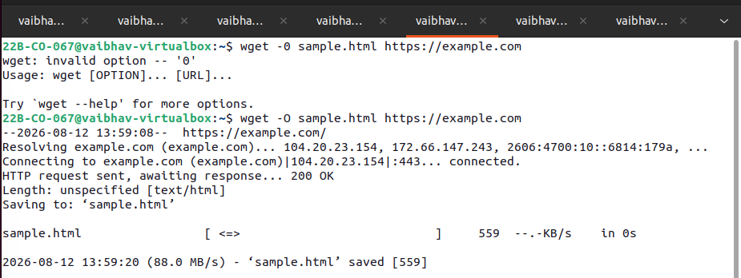

6. Changing Permissions
Create a file named secure.txt and change its permissions to read-only for everyone using chmod.

I created a file named secure.txt and changed its permissions to read-only for the owner, group, and other users.
The chmod command is used to change file permissions in Linux. By setting the permission to 444, the file can be read but cannot be modified or executed.

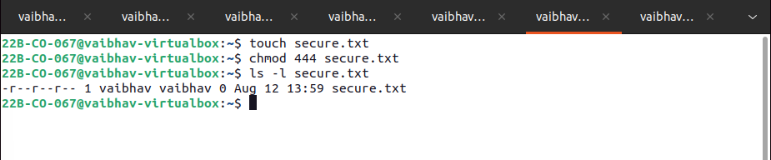

7. Working with Environment Variables
Use export to set a new environment variable called MY_VAR with the value "Hello, Linux!".

I created an environment variable named MY_VAR and assigned it the value Hello, Linux!. I then checked the variable to make sure the value was stored correctly.
Environment variables are used to store values that can be accessed by the shell and other programs running in the system.

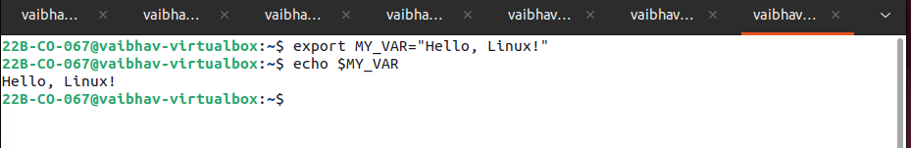

Github: https://github.com/Bobooo404/Devops.

