1. **Listening**

**Watch the video: How did tech become male dominated and summarise it in a few sentences (approximately 200 words):**

**Tech became dominated by male during the 80’ (before it was a field where women were more widespread, especially in programming) during the rise of the silicon valley. Men, very present in hardware engineering, switched to software engineering following Steve Jobs or Bill Gates’ example. Followed by the stereotypes given by the pop culture with nerds, the rise of the video games which was a gendered media which chose boys as a target. All those factors are things which have excluded women from IT. Social pressure, then, favored the “institutionalizationg” of this exclusion and probably demotivated or did not allow women to take an interest in tech.**

1. **Reading**

**Modern computer science is dominated by men. But it hasn't always been this way.**

A lot of computing pioneers — the people who programmed the first digital computers — were women. And for decades, the number of women studying computer science was growing faster than the number of men. But in 1984, something changed. The percentage of women in computer science flattened, and then plunged, even as the share of women in other technical and professional fields kept rising.

What happened? We spent the past few weeks trying to answer this question, and there's no clear, single answer.

But here's a good starting place: The share of women in computer science started falling at roughly the same moment when personal computers started showing up in U.S. homes in significant numbers. These early personal computers weren't much more than toys. You could play pong or simple shooting games, maybe do some word processing. And these toys were marketed almost entirely to men and boys. This idea that computers are for boys became a narrative. It became the story we told ourselves about the computing revolution. It helped define who geeks were, and it created techie culture. Movies like Weird Science, Revenge of the Nerds and War Games all came out in the '80s. And the plot summaries are almost interchangeable: awkward geek boy genius uses tech savvy to triumph over adversity and win the girl.

In the 1990s, researcher Jane Margolis interviewed hundreds of computer science students at Carnegie Mellon University, which had one of the top programs in the country. She found that families were much more likely to buy computers for boys than for girls — even when their girls were really interested in computers. This was a big deal when those kids got to college. As personal computers became more common, computer science professors increasingly assumed that their students had grown up playing with computers at home.

Patricia Ordóñez didn't have a computer at home, but she was a math wiz in school. "My teacher realized I was really good at solving problems, so she pulled me and this other boy out to do special math," she says. "We did math instead of recess!" So when Ordóñez got to Johns Hopkins University in the '80s, she figured she would study computer science or electrical engineering. Then she took her first intro class — and found that most of her male classmates were way ahead of her because they'd grown up playing with computers. "I remember this one time I asked a question and the professor stopped and looked at me and said, 'You should know that by now,' " she recalls. "And I thought 'I am never going to excel.' "

In the '70s, that never would have happened: Professors in intro classes assumed their students came in with no experience. But by the '80s, that had changed. Ordóñez got through the class but earned the first C of her life. She eventually dropped the program and majored in foreign languages. More than a decade later, though, she returned to computers. She found a mentor, and eventually got a Ph.D. in computer science. Now she's an assistant professor of computer science at the University of Puerto Rico.

**Decide whether the following statements are True (T) or False (F):**

* 1. Computer science was dominated by men. False,

In fact, computer science is dominated by men, by now, and for about thirty years or forty years.

* 1. In 1984, the percentage of women in computer science steadily increased. False. That’s the opposite, it was precisely from 1984 that percentage of women decreased.
  2. In the 1980s, personal computers targeted mainly a boys’ toys market. True. Personal computers targeted mainly a boy’s toys market which was gendered (with the geek cliché).
  3. Computer revolution went hand in hand with gender stereotypes. True.

As I said upper, sectors like video games are excessively gendered. Furthermore, when the new technologies like personal computers arrived, it was shown as a boy tech’.

* 1. Pop culture played a central role in excluding women from computer science. True. Of course, all pop culture works highlight nerds who are mostly boys.
  2. Researcher Jane Margolis found evidence that girls grew gradually less interested in playing computer games than boys. False. That’s not exactly that. Girls are not pushed to be interested in computer games so they play less than boys.
  3. Computer science professors reinforced the gender gap at the university. True. Because science professors consider that some things are supposed to be known by their students but those things are mostly known by male students because of the gender stereotypes.
  4. Patricia Ordóñez graduated in computer science. True. “She found a mentor, and eventually got a Ph.D. in computer science.”

**Match the words on the left with their synonyms/definitions on the right:**

|  |  |
| --- | --- |
| decade | ten years |
| plunge | abandon (school, college) |
| flatten | Crush |
| share |  |
| roughly | Approximately |
| plot | story |
| awkward | clumsy |
| wiz | Quota |
| recess | break (school) |
| ahead | In advance |
| drop | fall |
| major | Genius - Graduate |

1. **Grammar: Comparatives/Family words**

**Put the words in brackets into the right form (noun, adjective, adverb, comparative form, verbal forms).**

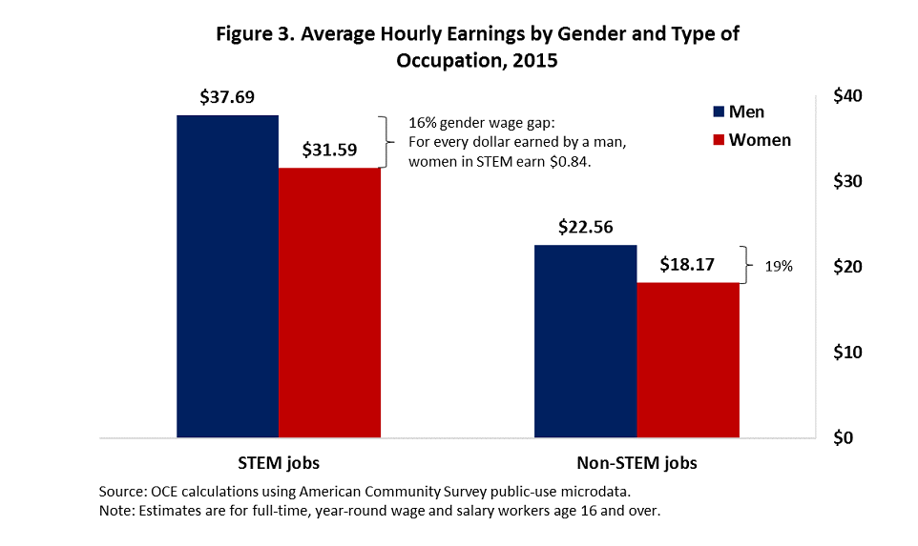

There is robust evidence across the economic literature of a gender wage gap—women earn **1.less** than men, even after controlling for a wide range of characteristics such as education and age. In our recent report, “STEM Jobs: 2017 Update,” we showed that STEM workers earn a **2. significant**  premium over their non-STEM counterparts. Figure 3 illustrates the intersection of these two **3. find** by showing the average **4. hour** earnings of full-time, year-round workers in STEM and non-STEM jobs. On average, men and women earn $37.69 and $31.59 per hour, **5. respectfully**, in STEM jobs—**6. higher** than the $22.56 and $18.17 that they earn, on average, in non-STEM occupations. For every dollar earned by a man in STEM, a woman in STEM earns 84 cents, a gender wage gap of 16 percent, **7. slightly** **8. larger** than the 14 percent wage gap we found using 2009 data but smaller than the 19 percent gender wage gap in non-STEM jobs. This STEM/non-STEM difference has narrowed from 7 percentage points in 2009 to 3 percentage points in 2015 because, while the gender gap in STEM jobs grew, the gender gap in non-STEM jobs shrank from 21 percent to 19 percent. This simple comparison of average **9. earning** can disguise other factors that affect worker income, especially age and educational attainment. We use a regression analysis to control for several demographic and geographic characteristics and attempt to get a **10. precise** measure of the gender earnings gap in STEM.

Source: **“STEM Jobs - Update 2017” Executive Summary**,

*U.S. Department of Commerce Economics and Statistics Administration*