**Use case Overview**

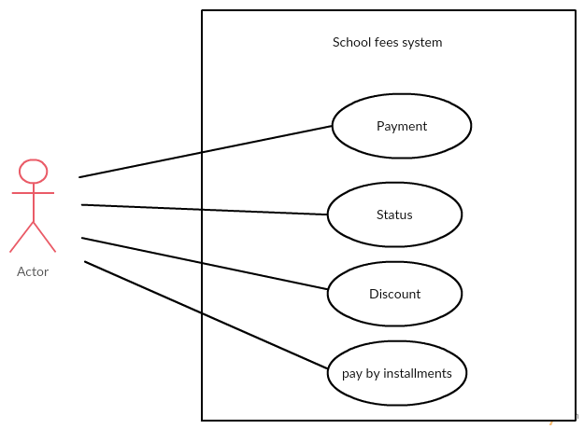

**System Structure**

**For example**:

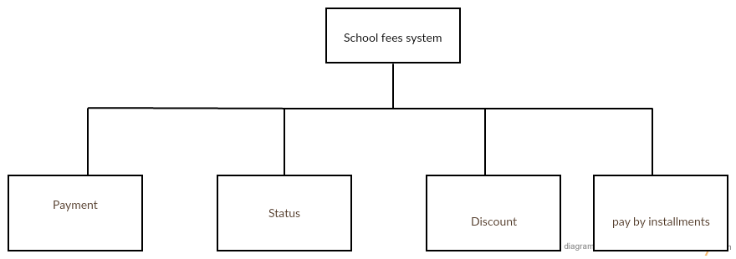

**Entity Class Model**

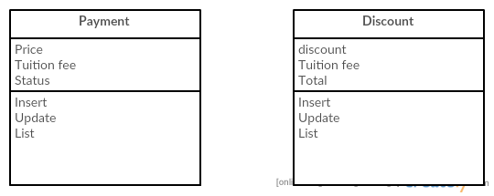

**Static Structure and Data Analysis**

**Model-View-Controller (MVC) Model**

mvc1.png

mvc2.png

**Sequence Diagram**

**1.Payment**

payment.png

**2.Status**

status.png

**3.Discount**

discount.png

**4.pay by installments**

pay by installments.png

**นาย อัครเดช สมบัติทิพย์ 5730213072 SE**