PLC learning Website Start Guide

URL: [*https://plc.csl.mtu.edu*](https://plc.csl.mtu.edu)

1. Create a user account
   1. Click on Register Here

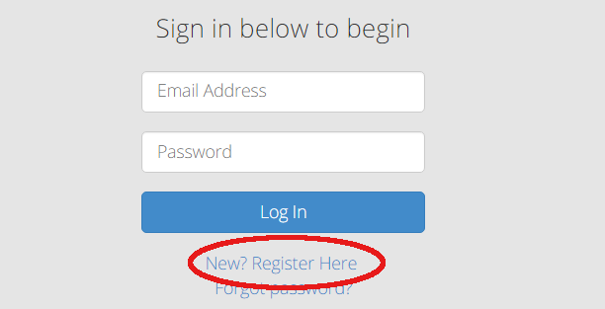

* 1. Use your Michigan Tech Email to register a **student** account with **Course Code left blank**, there is no benefit to register as an instructor.
  2. Go to your Michigan Tech Email, and click on the link of the confirmation email to activate your account.
  3. Go back to the website [*https://plc.csl.mtu.edu*](https://plc.csl.mtu.edu)*.* Login to your account.

1. Learning Modules
   1. To access each module, simply click on the module blocks.
   2. A module is divided into multiple sections. Each section page consists three areas:

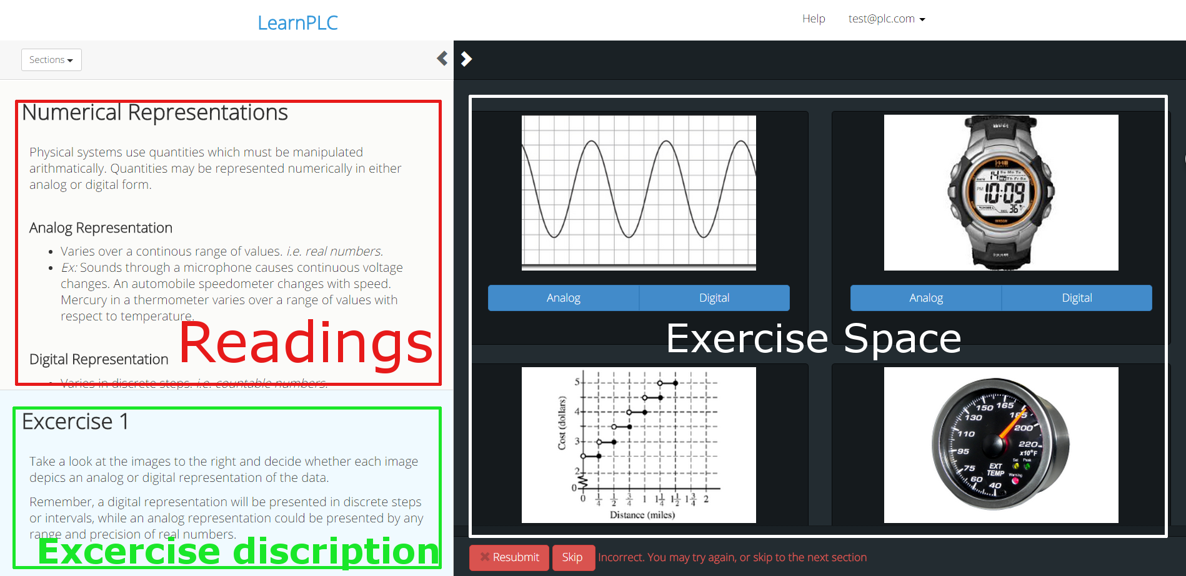

* 1. You can click on the small arrows to expand either **reading** area or the **exercise space.**

1. Go through modules and learn PLC.

If you are using this for a course, please follow the instruction of your course instructor.

Recommended learning steps are:

Follow modules and sections. For each section, do the reading first, and then read the exercise description and complete the exercise at the right side. If you encounter any trouble, click

**“Having Trouble”** buttons for hints.

1. Bug report.

If you find a bug or a typo. Please write down the **Module number**, **Section number, Exercise number, with a short description what happened (screenshot is the recommended),** and send them to [tewinn@mtu.edu](mailto:tewinn@mtu.edu) and [bochaol@mtu.edu](mailto:bochaol@mtu.edu). We will be greatly appreciate.