UNIVERSITI MALAYSIA SARAWAK
Faculty of Computer Science and Information Technology
TMA3084 Software Engineering Laboratory | Semester 1, 2026/2027
PROJECT PROPOSAL
(Product Requirements Document)
<Project Title (Short Name / Acronym)>
Group Number / Name | <e.g. Group 3 – TeamName>
Lab Group / Demonstrator | <Group 1 or 2 – demonstrator name>
Client / Organisation | <Client name, position, organisation>
Lecturer | Mdm. Nurfauza Jali
GitHub Repository | <https://github.com/...>
Version / Date | <v1.0 (original) | v1.1 (revised after presentation) – dd/mm/yyyy>

Team Members
No. | Name | Matric No. | TSPi Role | Signature
1
2
3
4
5

Declaration
By signing above, we certify that this proposal is our own work, that all external sources, libraries, APIs and AI-assisted content are acknowledged, and that we have not engaged in plagiarism or unauthorised collusion (Peraturan Akademik UNIMAS, Etika Akademik). AI tool usage is recorded in LOGAI.

How to Use This Template (delete this page before submission)
▸ Grey italic text (▸) and blue ‘PRD section’ bars are guidance. Replace them with your own content, then delete them.
▸ Target length: 10–15 pages excluding cover and appendices. Be concise: tables beat long paragraphs.
▸ Formatting: Times New Roman 12 pt, 1.5 line spacing, left aligned. Heading 1 = 14 pt bold, Heading 2 = 12 pt bold. Right-click the Table of Contents → Update Field before submitting.
▸ Every figure and table needs a numbered caption and must be referred to in the text. Add alt text to images.
▸ Keep IDs consistent: the FR-xx IDs you define here are reused in the SRS, GitHub Issues, test cases (LOGTEST) and LOGAI.

Proposal Checklist → PRD Mapping
Proposal checklist item | PRD equivalent | Key question it answers
Abstract | Executive Summary / TL;DR | What are we building, for whom, and why?
Introduction | Background & Context | Who is the client and who is the team?
Problem Statement | Problem & Opportunity | What pain exists today and what is the evidence?
Project Objectives | Goals & Success Metrics | How will we know the project succeeded?
Project Perspective | Users/Personas & System Context | Who uses it and how does it fit with other systems?
Project Scope | Scope, Features & Requirements | What is in, what is out, and what is the AI feature?
Task Allocation + Team Contribution | Team / Stakeholders (RACI) | Who owns what?
Team Goals | Team Working Agreement | How will the team work and measure itself?
Expected Result | Release Criteria / Deliverables | What will be handed over at the end?
Project Planning | Milestones, Timeline, Risks | When, in what order, and what could go wrong?
Table A: Mapping of proposal checklist to PRD sections
▸ Simplification: ‘Task Allocation’ and ‘Team Contribution’ are merged into one table; ‘Software Methodology’ and ‘System Environment’ are folded into Sections 9 and 5; placeholder writing tips from the old template were removed.

Table of Contents
Abstract 4
1. Introduction 4
1.1 Client Background 4
1.2 Team Background 4
2. Problem Statement 4
3. Project Objectives & Success Metrics 4
4. Project Perspective 5
4.1 Target Users 5
4.2 System Context and Architecture 5
5. Project Scope 5
5.1 In Scope / Out of Scope 5
5.2 Features and User Stories 5
5.3 AI Feature 6
5.4 Non-Functional Requirements and Constraints 6
5.5 System Environment 6
6. Task Allocation & Team Contribution 7
7. Team Goals 7
8. Expected Results 7
8.1 Working System 7
8.2 Documentation and Artefacts 7
9. Project Planning 8
9.1 Methodology 8
9.2 Submission Schedule 8
9.3 Development Milestones (GitHub) 8
9.4 Risks and Assumptions 9
10. References 9
Appendix A: Client Meeting Evidence 10
Appendix B: Revision History 10

▸ Right-click → Update Field to refresh page numbers. Add a List of Figures / List of Tables if you have more than three of each.

Abstract
PRD section: Executive Summary / TL;DR Rubric link: Clarity & presentation
▸ One paragraph, 150–250 words. Write it LAST. Cover: client and context → problem → proposed Flutter mobile app → the AI feature → main expected outcome.
<Write abstract here.>

1. Introduction
PRD section: Background & Context Rubric link: Background (Section A)
▸ 1–2 paragraphs introducing the project, the client and why a mobile app is the right fit.

1.1 Client Background
▸ Organisation name, year established, nature of business/operations, client contact person and role, number of intended users. Add a logo or site photo (with permission).

1.2 Team Background
▸ Team name, logo and motto; a one-line summary of the team’s relevant skills. Team photo optional.

2. Problem Statement
PRD section: Problem & Opportunity Rubric link: Objectives / constraints analysed
▸ Describe how the client works today and what goes wrong. Support each problem with evidence from the client meeting (numbers, quotes, examples). End with a one-sentence proposed solution.
ID | Current process / problem | Impact on client | Evidence (source)
P1 | e.g. Orders recorded on paper | Lost orders, slow reconciliation | Client interview, dd/mm
P2
P3
Table 1: Summary of client problems
▸ Proposed solution (1–2 sentences): “A Flutter mobile app that … using AI to …”.

3. Project Objectives & Success Metrics
PRD section: Goals & Success Metrics Rubric link: Objectives well defined and prioritised
▸ 3–4 objectives covering the lifecycle (study → design/develop → test/evaluate). Each must be measurable and linked to a problem (P-ID).
No. | Objective | Solves | Success metric (how we measure) | Priority
O1 | To study and analyse the client’s … process | P1, P2 | SRS signed off by client by M1 | High
O2 | To design and develop a Flutter app that … | P1 | All Must-have FRs pass acceptance tests | High
O3 | To integrate an AI feature that … | P3 | e.g. ≥80% correct classification on test set | High
O4 | To test and evaluate … with the client | All | ≥50 test cases, ≥60% coverage, UAT sign-off | Medium
Table 2: Project objectives and success metrics

4. Project Perspective
PRD section: Target Users & System Context Rubric link: Information obtained and analysed

4.1 Target Users
▸ List each user type (persona). Keep to 2–4 user types.
User type | Description | Main needs / goals | Device / tech level
e.g. Customer |  |  | Android phone, basic
e.g. Admin (client)
Table 3: Target users

4.2 System Context and Architecture
▸ Show how the app fits into the client’s environment: is it new, replacing, or extending an existing system? Include a high-level architecture diagram: Flutter app ↔ backend (Firebase / Supabase / REST) ↔ AI API ↔ external services (maps, payment, etc.). Explain the diagram in 1 paragraph.
[Insert Figure 1: High-level system architecture]

5. Project Scope
PRD section: Scope, Features & Requirements Rubric link: Design recommendations supported

5.1 In Scope / Out of Scope
▸ Draw a clear boundary. Out-of-scope items prevent scope creep and are just as important as in-scope items.
In scope (will deliver this semester) | Out of scope (will not deliver)
e.g. Android app for customers and admin | e.g. Online payment gateway
Table 4: Scope boundary

5.2 Features and User Stories
▸ Group features into modules. Write each as a user story. Prioritise with MoSCoW (Must / Should / Could / Won’t). These FR-IDs carry forward into the SRS and GitHub Issues.
FR-ID | Module | User story (As a … I want … so that …) | Priority
FR-01 | User Management | As a customer, I want to register and log in so that my orders are saved. | Must
FR-02
FR-03
FR-AI-01 | AI Feature |  | Must
Table 5: Features and user stories
[Insert Figure 2: System modules diagram]

5.3 AI Feature
▸ At least one AI feature is mandatory. In 1 short paragraph plus the table, explain what it does and why it adds real value (not a gimmick).
Item | Description
AI capability | e.g. chatbot, OCR, recommendation, classification, prediction
User value | Which problem (P-ID) it solves and for which user
Input → Output | What data goes in and what the user sees
AI service / API | e.g. Gemini, Claude, OpenAI, on-device ML Kit
Constraints | API key protection, cost, latency, offline fallback, data privacy
Table 6: AI feature summary

5.4 Non-Functional Requirements and Constraints
▸ List 4–6 key quality attributes and constraints with a measurable target (e.g. performance, usability, security, availability, compatibility, budget, client data policy).
NFR-ID | Category | Requirement / constraint | Target
NFR-01 | Performance | e.g. Main screens load quickly | < 2 s on mid-range phone
NFR-02 | Security | e.g. API keys never stored in source code | 0 secrets in repo
NFR-03
Table 7: Non-functional requirements and constraints

5.5 System Environment
Layer | Technology / tool | Justification
Mobile app | Flutter (Dart 3), Material 3 | Course requirement; cross-platform
State management | e.g. Provider / Riverpod
Backend / database | e.g. Firebase Auth + Cloud Firestore
AI service
Version control & CI | GitHub, GitHub Actions | Course requirement
Target devices | e.g. Android 8.0+ phones
Table 8: System environment

6. Task Allocation & Team Contribution
PRD section: Team & Stakeholders (RACI) Rubric link: Project breakdown; team work
▸ One row per member. Every member must have at least one technical task. Assign a TSPi role and a feature ownership (FR-IDs) to each.
Member | TSPi role | Owned features (FR-IDs) | Other responsibilities / contribution
 | Team Leader |  | e.g. weekly meetings, WEEK reports
 | Development Manager |  | e.g. architecture, code review
 | Planning Manager |  | e.g. TASK / SCHEDULE, GitHub board
 | Quality/Process Manager |  | e.g. LOGTEST, CI, coverage
 | Support Manager |  | e.g. repo setup, LOGAI, tools
 | Client Liaison / Developer |  | e.g. client meetings, UAT
Table 9: Task allocation and contribution

7. Team Goals
PRD section: Team Working Agreement Rubric link: Team work
▸ Maximum 4 goals. Each needs a measure so it can be checked at the weekly meeting (refer to the TSPi lecture on team goals).
No. | Team goal | Measure
G1 | e.g. Produce a quality product | e.g. All Must-have FRs pass; CI green on main
G2 | e.g. Run a productive, well-managed project | e.g. Every milestone delivered on time
G3 | e.g. Every member contributes fairly | e.g. Each member merges ≥1 PR per sprint
G4 | e.g. Keep the client engaged | e.g. Client meeting at least every 2 weeks
Table 10: Team goals

8. Expected Results
PRD section: Release Criteria / Deliverables Rubric link: Decisions supported by information

8.1 Working System
▸ 1 paragraph describing the final app from the user’s point of view, naming the key features and the AI feature. State the release criteria (e.g. signed release APK v1.0.0, client UAT sign-off).

8.2 Documentation and Artefacts
Deliverable | Submitted with
Project Proposal (original) | Proposal Submission (Week 4)
Revised Proposal and Software Requirements Specification (SRS) | Initial Report (Week 9)
Runnable prototype (4–5 screens), tagged release | Demo 1 (Week 9)
Software Design Specification (SDS), test plan and results (LOGTEST), user manual, maintenance plan, client acceptance form | Final Report (Week 13)
Release APK, demo video (5–10 min), presentation slides | Final Demo 2 (Week 14)
GitHub repository and complete project file | e-Archive (Week 15)
TSPi forms (LOGT, LOGD, LOGAI, SCHEDULE, SUMP, SUMQ, SUMS, SUMTASK, WEEK, PEER) and meeting minutes | Ongoing; compiled in Final Report
Table 11: Deliverables

9. Project Planning
PRD section: Milestones, Timeline & Risks Rubric link: Methodology to be followed

9.1 Methodology
The project follows Scrum with two-week sprints, run alongside the TSPi roles. Scrum suits this client because requirements are expected to change as the client sees each prototype, and a short sprint gives the client a chance to review working software every fortnight. Each sprint starts with a planning meeting where the Planning Manager moves the highest-priority Must-have user stories from the backlog into the sprint. Every story is a GitHub Issue with an FR-ID. A member takes an issue, creates a feature branch from develop (Git Flow), commits with the FR-ID in the message, and opens a pull request. A teammate reviews the pull request and GitHub Actions must pass (format, analysis, tests and at least 60% coverage) before it is merged. The team meets weekly, the Team Leader records the minutes and the WEEK report, and each sprint ends with a short review with the client. AI tools are used only after the requirement is written, every AI-assisted change is reviewed like any other code, and each use is recorded in LOGAI.

9.2 Submission Schedule
▸ Fixed course deadlines. Plan your sprints backwards from these dates.
Phase | Deliverable | Week | Due
Phase 1: Planning & Development | Proposal Submission (report + 10-minute pitch recording link) | 4 | 16 Oct 2026
 | Proposal Presentation | 5 | 19 – 23 Oct 2026
 | Initial Report | 9 | 16 Nov 2026
 | Demo 1 | 9 | 16 – 20 Nov 2026
Phase 2: Finalisation & Closure | Final Report | 13 | 24 Dec 2026
 | Final Demo 2 | 14 | 28 – 31 Dec 2026
 | e-Archive | 15 | By 2 Jan 2027, 10 PM
Table 12: Submission schedule

9.3 Development Milestones (GitHub)
Milestone | Week | Key output | Status
M1 – Scope & Requirements | 4 – 5 | GitHub repo, issue board, CI file; proposal and initial SRS in /docs | In progress
M2 – Design & Prototype | 9 | SDS draft, 4–5 screen prototype, green CI, v0.2.0 tag | Planned
M3 – Product & Verification | 13 | ≥50 tests, ≥60% coverage, AI feature working | Planned
M4 – Final Release & Acceptance | 15 | Release APK v1.0.0, client sign-off, e-Archive | Planned
Table 13: Development milestones
▸ Insert a Gantt chart (Figure 3) from Week 3 to Week 15 showing sprints, the seven submission dates and the four milestones. It should match your TSPi TASK and SCHEDULE worksheets.
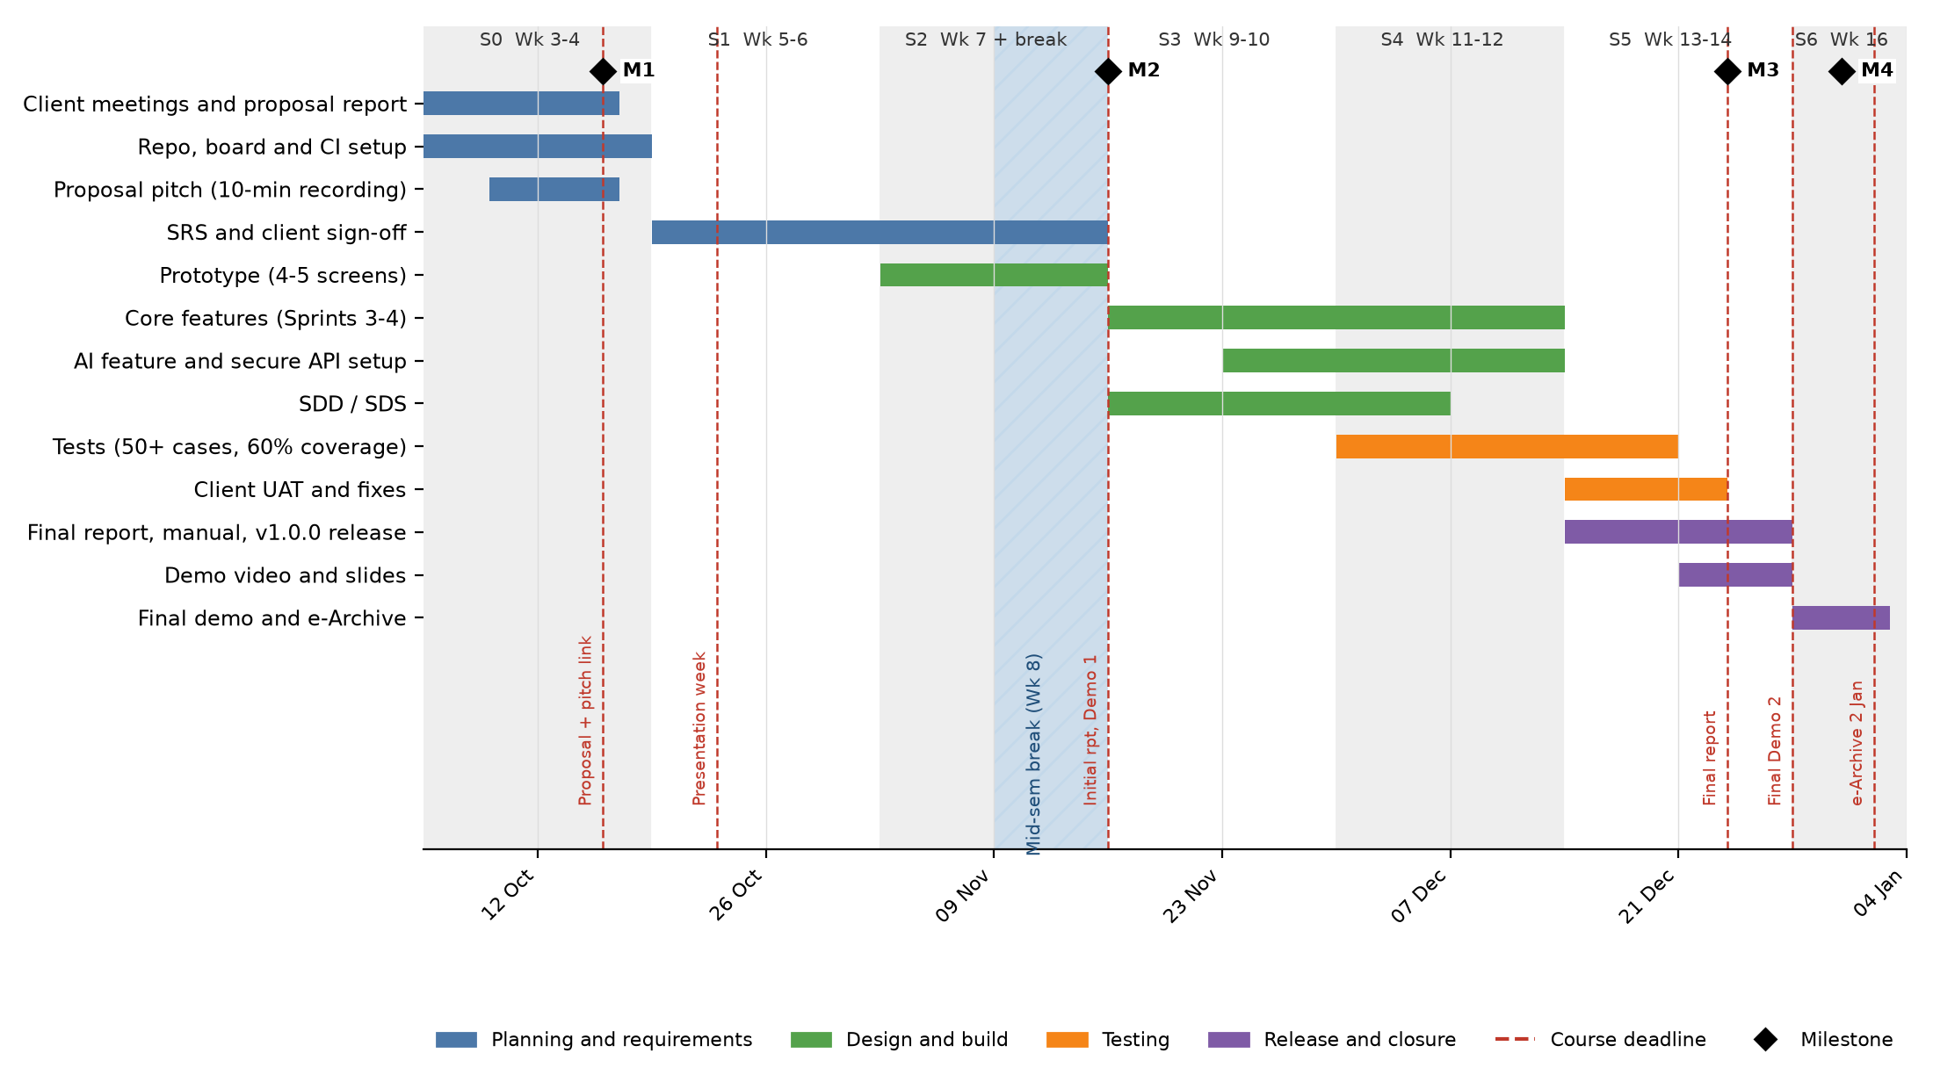
Figure 3: Gantt chart, Week 3 to Week 16 (two-week sprints S0 to S6). Alt text: thirteen tasks from 5 Oct 2026 to 2 Jan 2027 with sprint bands, the mid-semester break, milestones M1 to M4 and course deadlines.

9.4 Risks and Assumptions
▸ List the top 3–5 risks and at least one mitigation each. Include client availability, API cost/limits and skill gaps.
ID | Risk / assumption | Likelihood | Impact | Mitigation
R1 | Client is unavailable for meetings or slow to sign off | Medium | High | Agree a fixed fortnightly slot with an online fallback. Send sign-off requests at least 5 days before each deadline.
R2 | AI API free tier or rate limits are exceeded, or the key leaks | Medium | High | Call the AI through a backend that holds the key, cache repeated answers, cap requests per user, and show a manual fallback when the AI is unavailable.
R3 | Skill gaps in Flutter, testing or CI slow the team down | High | Medium | Pair on the first feature in each area, hold a short skills session in Sprint 1, and read the Flutter documentation before asking AI.
R4 | Scope grows beyond what the team can finish | Medium | High | Fix the Must-have list at M1, move new ideas to Could or Won't, and review the backlog at every weekly meeting.
R5 | A member is unavailable near a deadline | Medium | Medium | Every feature has a second reviewer who knows the code, and work is merged weekly so nothing sits on one laptop.
Table 14: Risks and assumptions

10. References
▸ APA 7th edition. Include client documents, libraries, packages and APIs used. Give enough detail for a reader to find each source.

Appendix A: Client Meeting Evidence
▸ Meeting minutes summary (date, attendees, key decisions) and, if allowed, a photo with the client.

Appendix B: Revision History
Version | Date | Changes (e.g. after proposal presentation feedback) | By
1.0 |  | Original submission
1.1

