**Ecommerce – SQL**

**Instructions**

* Coding Challenge submissions should be done through the partcipants’ Github repository, and the link should be shared with trainers and Hexavarsity.

**SQL Tables:**

1. **customers** table:
   * customer_id (Primary Key)
   * first_name
   * last_name
   * email
   * address

INSERT INTO customers VALUES

(1, 'John', 'Doe', 'johndoe@example.com', '123 Main St, City'),

(2, 'Jane', 'Smith', 'janesmith@example.com', '456 Elm St, Town'),

(3, 'Robert', 'Johnson', 'robert@example.com', '789 Oak St, Village'),

(4, 'Sarah', 'Brown', 'sarah@example.com', '101 Pine St, Suburb'),

(5, 'David', 'Lee', 'david@example.com', '234 Cedar St, District'),

(6, 'Laura', 'Hall', 'laura@example.com', '567 Birch St, County'),

(7, 'Michael', 'Davis', 'michael@example.com', '890 Maple St, State'),

(8, 'Emma', 'Wilson', 'emma@example.com', '321 Redwood St, Country'),

(9, 'William', 'Taylor', 'william@example.com', '432 Spruce St, Province'),

(10, 'Olivia', 'Adams', 'olivia@example.com', '765 Fir St, Territory');

1. **products** table:
   * product_id (Primary Key)
   * name
   * price
   * description
   * stockQuantity

INSERT INTO products VALUES

(1, 'Laptop', 'High-performance laptop', 800.00, 10),

(2, 'Smartphone', 'Latest smartphone', 600.00, 15),

(3, 'Tablet', 'Portable tablet', 300.00, 20),

(4, 'Headphones', 'Noise-canceling', 150.00, 30),

(5, 'TV', '4K Smart TV', 900.00, 5),

(6, 'Coffee Maker', 'Automatic coffee maker', 50.00, 25),

(7, 'Refrigerator', 'Energy-efficient', 700.00, 10),

(8, 'Microwave Oven', 'Countertop microwave', 80.00, 15),

(9, 'Blender', 'High-speed blender', 70.00, 20),

(10, 'Vacuum Cleaner', 'Bagless vacuum cleaner', 120.00, 10);

1. **cart** table:
   * cart_id (Primary Key)
   * customer_id (Foreign Key)
   * product_id (Foreign Key)
   * quantity

INSERT INTO cart VALUES

(1, 1, 1, 2),

(2, 1, 3, 1),

(3, 2, 2, 3),

(4, 3, 4, 4),

(5, 3, 5, 2),

(6, 4, 6, 1),

(7, 5, 1, 1),

(8, 6, 10, 2),

(9, 6, 9, 3),

(10, 7, 7, 2);

1. **orders** table:
   * order_id (Primary Key)
   * customer_id (Foreign Key)
   * order_date
   * total_price

INSERT INTO orders VALUES

(1, 1, '2023-01-05', 1200.00),

(2, 2, '2023-02-10', 900.00),

(3, 3, '2023-03-15', 300.00),

(4, 4, '2023-04-20', 150.00),

(5, 5, '2023-05-25', 1800.00),

(6, 6, '2023-06-30', 400.00),

(7, 7, '2023-07-05', 700.00),

(8, 8, '2023-08-10', 160.00),

(9, 9, '2023-09-15', 140.00),

(10, 10, '2023-10-20', 1400.00);

1. **order_items** table (to store order details):
   * order_item_id (Primary Key)
   * order_id (Foreign Key)
   * product_id (Foreign Key)
   * quantity
   * amount

INSERT INTO order_items VALUES

(1, 1, 1, 2, 1600.00),

(2, 1, 3, 1, 300.00),

(3, 2, 2, 3, 1800.00),

(4, 3, 5, 2, 1800.00),

(5, 4, 4, 4, 600.00),

(6, 4, 6, 1, 50.00),

(7, 5, 1, 1, 800.00),

(8, 5, 2, 2, 1200.00),

(9, 6, 10, 2, 240.00),

(10, 6, 9, 3, 210.00);

**Product Table**

|  |  |  |  |  |
| --- | --- | --- | --- | --- |
| **productID** | **name** | **Description** | **price** | **stockQuantity** |
| 1 | Laptop | High-performance laptop | 800.00 | 10 |
| 2 | Smartphone | Latest smartphone | 600.00 | 15 |
| 3 | Tablet | Portable tablet | 300.00 | 20 |
| 4 | Headphones | Noise-canceling | 150.00 | 30 |
| 5 | TV | 4K Smart TV | 900.00 | 5 |
| 6 | Coffee Maker | Automatic coffee maker | 50.00 | 25 |

|  |  |  |  |  |
| --- | --- | --- | --- | --- |
| **productID** | **name** | **Description** | **price** | **stockQuantity** |
| 7 | Refrigerator | Energy-efficient | 700.00 | 10 |
| 8 | Microwave Oven | Countertop microwave | 80.00 | 15 |
| 9 | Blender | High-speed blender | 70.00 | 20 |
| 10 | Vacuum Cleaner | Bagless vacuum cleaner | 120.00 | 10 |

**Customer Table**

|  |  |  |  |  |
| --- | --- | --- | --- | --- |
| **customerID** | **firstName** | **lastName** | **Email** | **address** |
| 1 | John | Doe | [johndoe@example.com](mailto:johndoe@example.com) | 123 Main St, City |
| 2 | Jane | Smith | [janesmith@example.com](mailto:janesmith@example.com) | 456 Elm St, Town |
| 3 | Robert | Johnson | [robert@example.com](mailto:robert@example.com) | 789 Oak St, Village |
| 4 | Sarah | Brown | [sarah@example.com](mailto:sarah@example.com) | 101 Pine St, Suburb |
| 5 | David | Lee | [david@example.com](mailto:david@example.com) | 234 Cedar St, District |
| 6 | Laura | Hall | [laura@example.com](mailto:laura@example.com) | 567 Birch St, County |
| 7 | Michael | Davis | [michael@example.com](mailto:michael@example.com) | 890 Maple St, State |
| 8 | Emma | Wilson | [emma@example.com](mailto:emma@example.com) | 321 Redwood St, Country |
| 9 | William | Taylor | [william@example.com](mailto:william@example.com) | 432 Spruce St, Province |
| 10 | Olivia | Adams | [olivia@example.com](mailto:olivia@example.com) | 765 Fir St, Territory |

**Order Table**

|  |  |  |  |
| --- | --- | --- | --- |
| **orderID** | **customerID** | **orderDate** | **totalAmount** |
| 1 | 1 | 2023-01-05 | 1200.00 |
| 2 | 2 | 2023-02-10 | 900.00 |
| 3 | 3 | 2023-03-15 | 300.00 |
| 4 | 4 | 2023-04-20 | 150.00 |
| 5 | 5 | 2023-05-25 | 1800.00 |
| 6 | 6 | 2023-06-30 | 400.00 |
| 7 | 7 | 2023-07-05 | 700.00 |
| 8 | 8 | 2023-08-10 | 160.00 |
| 9 | 9 | 2023-09-15 | 140.00 |
| 10 | 10 | 2023-10-20 | 1400.00 |

**OrderItem Table**

|  |  |  |  |  |
| --- | --- | --- | --- | --- |
| **orderItemID** | **orderID** | **productID** | **quantity** | **itemAmount** |
| 1 | 1 | 1 | 2 | 1600.00 |

|  |  |  |  |  |
| --- | --- | --- | --- | --- |
| **orderItemID** | **orderID** | **productID** | **quantity** | **itemAmount** |
| 2 | 1 | 3 | 1 | 300.00 |
| 3 | 2 | 2 | 3 | 1800.00 |
| 4 | 3 | 5 | 2 | 1800.00 |
| 5 | 4 | 4 | 4 | 600.00 |
| 6 | 4 | 6 | 1 | 50.00 |
| 7 | 5 | 1 | 1 | 800.00 |
| 8 | 5 | 2 | 2 | 1200.00 |
| 9 | 6 | 10 | 2 | 240.00 |
| 10 | 6 | 9 | 3 | 210.00 |

**Cart Table**

|  |  |  |  |
| --- | --- | --- | --- |
| **cartID** | **customerID** | **productid** | **quantity** |
| 1 | 1 | 1 | 2 |
| 2 | 1 | 3 | 1 |
| 3 | 2 | 2 | 3 |
| 4 | 3 | 4 | 4 |
| 5 | 3 | 5 | 2 |
| 6 | 4 | 6 | 1 |
| 7 | 5 | 1 | 1 |
| 8 | 6 | 10 | 2 |
| 9 | 6 | 9 | 3 |
| 10 | 7 | 7 | 2 |

1. Update refrigerator product price to 800.

UPDATE products

SET price = 800.00

WHERE name = 'Refrigerator';



1. Remove all cart items for a specific customer.

SELECT * FROM cart WHERE customer_id = 5;

DELETE FROM cart WHERE customer_id = 5;

SELECT * FROM cart WHERE customer_id = 5;



1. Retrieve Products Priced Below $100.

SELECT * FROM products

WHERE price < 100.00;

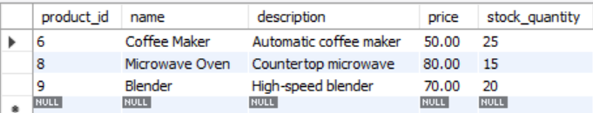

1. Find Products with Stock Quantity Greater Than 5.

SELECT * FROM products

WHERE stock_quantity > 5;

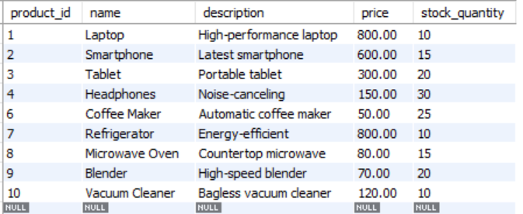

1. Retrieve Orders with Total Amount Between $500 and $1000.

SELECT * FROM orders

WHERE total_price BETWEEN 500.00 AND 1000.00;

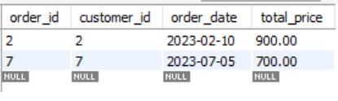

1. Find Products which name end with letter ‘r’.

SELECT * FROM products

WHERE name LIKE '%r';

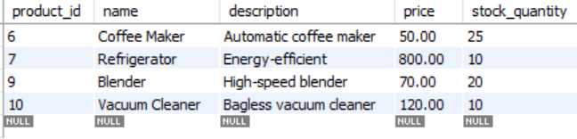

1. Retrieve Cart Items for Customer 5.

SELECT p.name, c.quantity, (p.price * c.quantity) AS total_price

FROM cart c

JOIN products p ON c.product_id = p.product_id

WHERE c.customer_id = 5;

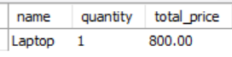

1. Find Customers Who Placed Orders in 2023.

SELECT DISTINCT c.customer_id, c.first_name, c.last_name

FROM customers c

JOIN orders o ON c.customer_id = o.customer_id

WHERE YEAR(o.order_date) = 2023;

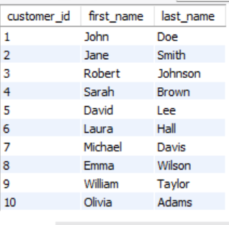

1. Determine the Minimum Stock Quantity for Each Product Category.

SELECT MIN(stock_quantity) AS min_stock

FROM products;

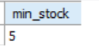

1. Calculate the Total Amount Spent by Each Customer.

SELECT c.customer_id, c.first_name, c.last_name, SUM(o.total_price) AS total_spent

FROM customers c

JOIN orders o ON c.customer_id = o.customer_id

GROUP BY c.customer_id, c.first_name, c.last_name;

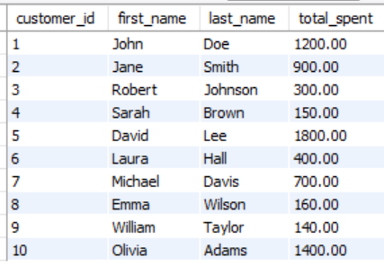

1. Find the Average Order Amount for Each Customer.

SELECT c.customer_id, c.first_name, c.last_name, AVG(o.total_price) AS avg_order_amount

FROM customers c

JOIN orders o ON c.customer_id = o.customer_id

GROUP BY c.customer_id, c.first_name, c.last_name;

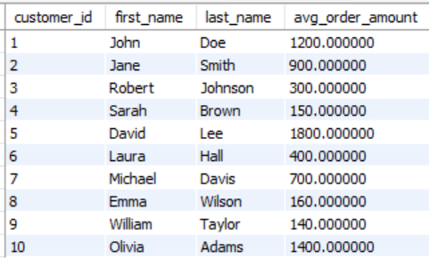

1. Count the Number of Orders Placed by Each Customer.

SELECT c.customer_id, c.first_name, c.last_name, COUNT(o.order_id) AS order_count

FROM customers c

LEFT JOIN orders o ON c.customer_id = o.customer_id

GROUP BY c.customer_id, c.first_name, c.last_name;

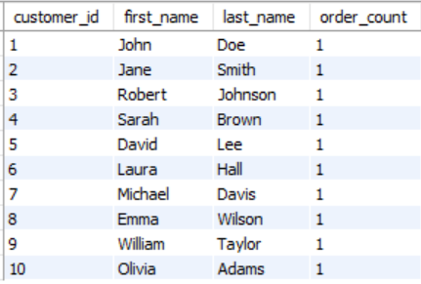

1. Find the Maximum Order Amount for Each Customer.

SELECT c.customer_id, c.first_name, c.last_name, MAX(o.total_price) AS max_order_amount

FROM customers c

JOIN orders o ON c.customer_id = o.customer_id

GROUP BY c.customer_id, c.first_name, c.last_name;

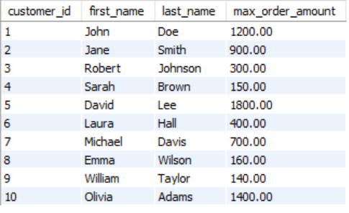

1. Get Customers Who Placed Orders Totaling Over $1000.

SELECT c.customer_id, c.first_name, c.last_name

FROM customers c

JOIN orders o ON c.customer_id = o.customer_id

WHERE o.total_price > 1000.00;

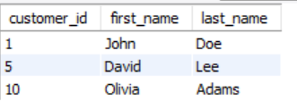

1. Subquery to Find Products Not in the Cart.

SELECT * FROM products

WHERE product_id NOT IN (SELECT DISTINCT product_id FROM cart);

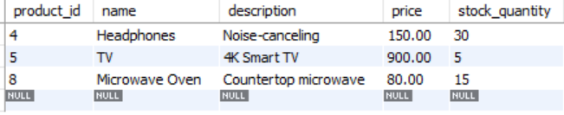

1. Subquery to Find Customers Who Haven't Placed Orders.

SELECT * FROM customers

WHERE customer_id NOT IN (SELECT DISTINCT customer_id FROM orders);

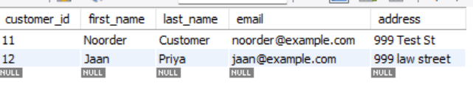

1. Subquery to Calculate the Percentage of Total Revenue for a Product.

SELECT

p.product_id,

p.name,

SUM(oi.item_amount) AS product_revenue,

(SUM(oi.item_amount) / (SELECT SUM(item_amount) FROM order_items)) * 100 AS revenue_percentage

FROM

products p

JOIN

order_items oi ON p.product_id = oi.product_id

GROUP BY

p.product_id, p.name;

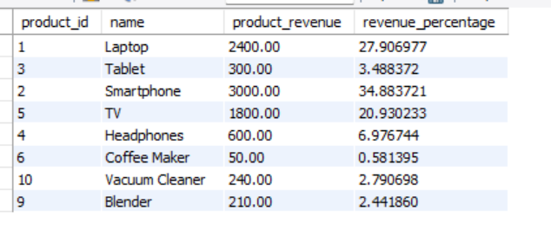

1. Subquery to Find Products with Low Stock.

SELECT * FROM products

WHERE stock_quantity < (SELECT AVG(stock_quantity) FROM products);

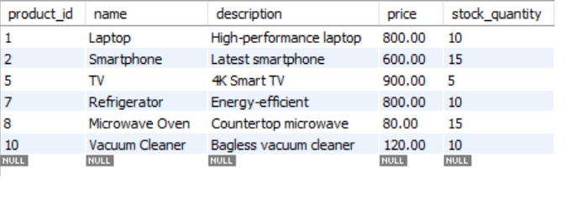

1. Subquery to Find Customers Who Placed High-Value Orders.

SELECT

c.customer_id,

c.first_name,

c.last_name,

o.total_price AS order_amount

FROM

customers c

JOIN

orders o ON c.customer_id = o.customer_id

WHERE

o.total_price > (SELECT AVG(total_price) FROM orders)

ORDER BY

o.total_price DESC;

