**DATE:18/06/25**

**Section A: List (3 Questions):**

**Section B: Tuple (2 Questions):**

**Section C: Dictionary (3 Questions):**

**Section D: Set (2 Questions):**

Q1. Write a Python program to remove all duplicates from a list without using the set() function. Input Example: [1, 2, 2, 3, 4, 4, 5]

Output: [1, 2, 3, 4, 5]

numbers = [1, 2, 2, 3, 4, 4, 5]

unique = []

for num in numbers:

if num not in unique:

unique.append(num)

print(unique)

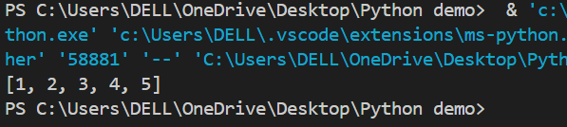

Q2. Given a list of integers, write a program to find the second highest unique number. Input Example: [12, 5, 9, 21, 21, 3]

Output: 12

numbers = [12, 5, 9, 21, 21, 3]

unique = []

for num in numbers:

if num not in unique:

unique.append(num)

unique.sort()

print(unique[-2])

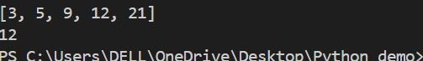

Q3. Rotate a list to the right by k positions. Input: List = [1, 2, 3, 4, 5], k = 2

Output: [4, 5, 1, 2, 3]

list = [1, 2, 3, 4, 5]

k = 2

rotated = list[-k:] + list[:-k]

print(rotated)



Q4. Write a Python program to multiply the elements of each tuple in a list of tuples and return a new list. Input: [(2, 4), (3, 5), (4, 6)]

Output: [8, 15, 24]

tuples = [(2, 4), (3, 5), (4, 6)]

result = []

for t in tuples:

result.append(t[0] * t[1])

print(result)



Q5. Given a tuple of integers, write a program to count how many times each element occurs. Input: (1, 2, 2, 3, 1, 4, 2)

Output: {1: 2, 2: 3, 3: 1, 4: 1}

tup = (1, 2, 2, 3, 1, 4, 2)

count = {}

for num in tup:

if num in count:

count[num] += 1

else:

count[num] = 1

print(count)



Q6. Write a Python program to count the frequency of each character in a string using a dictionary. Input: 'banana'

Output: {'b': 1, 'a': 3, 'n': 2}

word = 'banana'

freq = {}

for char in word:

if char in freq:

freq[char] += 1

else:

freq[char] = 1

print(freq)



Q7. Merge two dictionaries such that common keys have their values summed. Input: {'apple': 10, 'banana': 5}, {'banana': 3, 'orange': 7}

Output: {'apple': 10, 'banana': 8, 'orange': 7}

dict1 = {'apple': 10, 'banana': 5}

dict2 = {'banana': 3, 'orange': 7}

merged = dict1.copy()

for key in dict2:

if key in merged:

merged[key] += dict2[key]

else:

merged[key] = dict2[key]

print(merged)



Q8. Given a dictionary of student names and their marks, print the name(s) of the student(s) with the highest marks.

Input: {'Alice': 85, 'Bob': 92, 'Carol': 92} Output: ['Bob', 'Carol']

marks = {'Alice': 85, 'Bob': 92, 'Carol': 92}

max_mark = max(marks.values())

top_students = [name for name, score in marks.items() if score == max_mark]

print(top_students)



Q9. Write a Python program to find all common elements among three lists using set operations. Input: [1, 2, 3], [2, 3, 4], [3, 2, 5]

Output: {2, 3}

list1 = [1, 2, 3]

list2 = [2, 3, 4]

list3 = [3, 2, 5]

common = set(list1) & set(list2) & set(list3)

print(common)



Q10. From a sentence entered by the user, extract and display all unique words using a set. Input: 'this is a test this is fun'

Output: {'this', 'is', 'a', 'test', 'fun'}

sentence = 'this is a test this is fun'

words = sentence.split()

unique_words = set(words)

print(unique_words)

