# DATE:20/06/25

# Python Coding Task

Time: 30 Minutes

Level: Intermediate

## Q1. Understanding Access Specifiers

Create a class `Student` with the following properties:  
  
Class Requirements:  
1. `name` → Public attribute   
2. `_roll_number` → Protected attribute   
3. `__marks` → Private attribute   
  
Implement the following methods:  
- Constructor to initialize all attributes.  
- `display_details()` → Public method to display all attribute values.  
- `_update_roll_number(new_roll)` → Protected method to update roll number.  
- `__update_marks(new_marks)` → Private method to update marks.  
- `access_private_method(new_marks)` → Public method that uses the private method `__update_marks`.

**CODE:**

class Student:

    def __init__(self,name,roll_number,marks):

        self.name=name               # Public attribute

        self._roll_number=roll_number # Protected attribute

        self.__marks=marks           # Private attribute

    def details(self):

        print(f"STUDENT DETAILS:")

        print(f"Name: {self.name}")

        print(f"Roll_number: {self._roll_number}")

        print(f"Marks: {self.__marks}")

    def _update_roll_number(self,new_roll):

        self._roll_number= new_roll

    def __update_marks(self,new_marks):

        self.__marks = new_marks

    def access_private_method(self,new_marks):

        self.__update_marks(new_marks)

student = Student("Bindhu", "5001", 85)

student.details()

student._update_roll_number("5004")

student.access_private_method(90)

print("\nAfter updates:")

student.details()

**OUTPUT:**

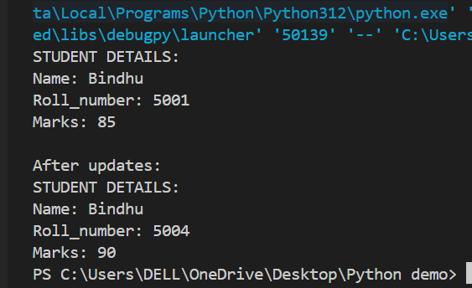

## Q2. Demonstrate Access

In the main section:  
- Create an object of the `Student` class.  
- Modify and print the `name` directly.  
- Modify and print the `_roll_number` directly.  
- Try accessing `__marks` directly and observe the result.

**CODE:**

student = Student("Rishi", "5002", 92)

#1

print("INITIAL STUDENT DETAILS:")

student.details()

print("\n")

#2

print("Accessing public name attribute:")

print(f"Original name: {student.name}")

student.name = "Ravi"

print(f"Modified name: {student.name}\n")

#3

print("Accessing protected _roll_number attribute:")

print(f"Original roll number: {student._roll_number}")

student._roll_number = "5003"

print(f"Modified roll number: {student._roll_number}\n")

#4

print("\nTrying to access marks directly:")

try:

    print(student.__marks)

except AttributeError:

    print("Failed! Can't access __marks directly")

# 5

print("\nFinal student details:")

student.details()

student.details()

**OUTPUT:**

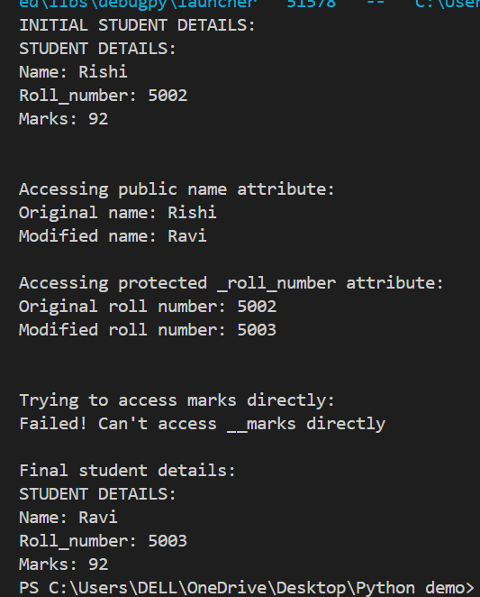

## Q3. Inheritance and Access Control

Create a subclass `Topper` that inherits from `Student` and includes:  
- A method `try_access()` that attempts to access `_roll_number` and `__marks` from the subclass.  
- Show what works and what doesn't.

**CODE:**

class Topper(Student):

    def try_access(self):

        print("\nTrying to access attributes from Topper subclass:")

        print(f"name: {self.name}")

        print(f"_roll_number: {self._roll_number}")

        try:

            print(f"__marks direct access: {self.__marks}")

        except AttributeError:

            print("Cannot access __marks directly")

topper = Topper("Anu", "5006", 92)

print("Initial details:")

topper.details()

topper.try_access()

**OUTPUT:**

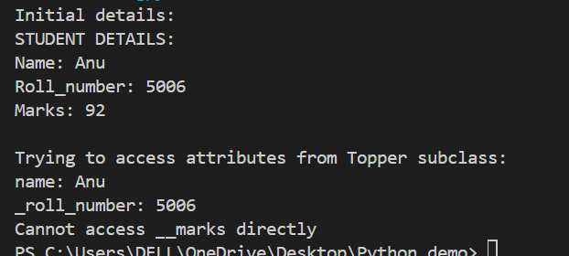

## Q4. Use of Name Mangling

Demonstrate how to access the private attribute `__marks` using name mangling technique from outside the class.

**CODE:**

s = Student("Sindhu", "5005", 85)

print("Tying to access private attribute using name mangling:")

print(f"Original marks: {s._Student__marks}")

s._Student__marks = 95

print(f"Modified marks: {s._Student__marks}")

print("\nVerifying through details():")

s.details()

**OUTPUT:**

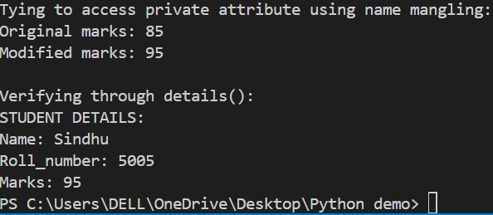

## Q5. Reflection

Answer the following short questions:  
1. Why can’t private members be accessed directly?

Private members can't be accessed directly because Python intentionally renames them (name mangling) to prevent accidental access from outside the class. This protects internal data that should only be modified by the class's own methods.

2. What is the purpose of using protected members in class design?

Protected members are meant to signal "use within this class or its subclasses only." They’re accessible but serve as a warning to developers to avoid misuse unless extending the class.

3. How does name mangling help with private members in Python?

Name mangling renames private attributes (like __marks to _Student__marks) to avoid naming conflicts in subclasses and discourage direct access. It’s Python’s way to enforce privacy (though not strictly, as you can still access them if needed).