ASSIGNMENT-2

#include<Servo.h>

Servo myservo;

int trigpin=6;

int echopin=5;

void setup()

{

pinMode(trigpin,OUTPUT);

pinMode(echopin,INPUT);

myservo.attach(2);

Serial.begin(9600);

}

void loop()

{

digitalWrite(trigpin,HIGH);

delay(1000);

digitalWrite(trigpin,LOW);

int duration=pulseIn(echopin,HIGH);

int distance=(duration\*0.034)/2;

Serial.println("the distance is");

Serial.println(distance);

if(distance<=50)

{

myservo.write(90);

delay(1000);

myservo.write(0);

delay(1000);

myservo.write(180);

delay(1000);

Serial.println("garage door opened");

}

else if(distance<=400&&distance>50)

{

Serial.println("garage doors not opened");

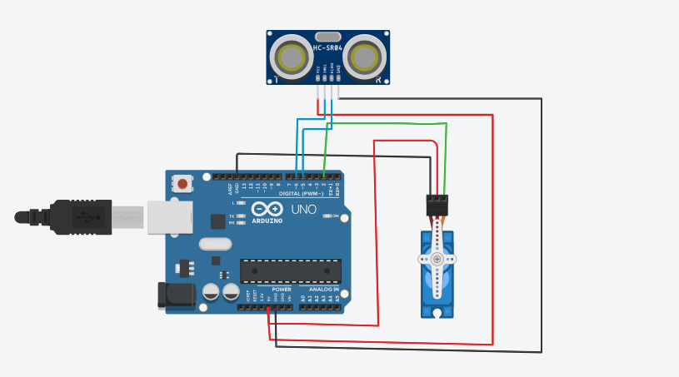 }

else

{

Serial.println("garage doors not opened");

delay(1000);

}

}