**Statistical Learning Lab**

Assignment - 4

Linear Regression Assignment

Anurag Singha | 22IM30007 

Show the code snippets and the corresponding output for the following:

Q1)Load the dataset “manufacturing.csv”. Display first few rows of the dataset. Take “Quality Rating” as response variable.

Ans:-

Code:-

**setwd('C:/Users/USER/OneDrive - iitkgp.ac.in/Desktop/Stat Lab/Validation and Bootstrating')**

**data <- read.csv("manufacturing.csv")**

**head(data)**

**target_variable <- data$Quality.Rating**

Output:-

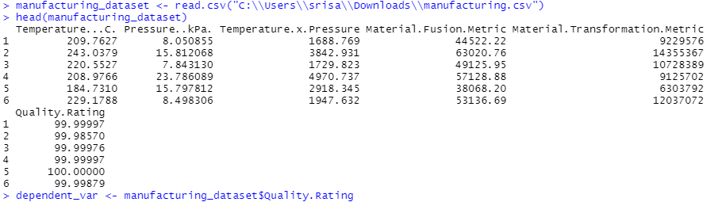

Q2)Fit polynomial models between Quality ~ Temp. Vary the degree of polynomial on temperature from 1 to 5 (temp, temp^2, temp^3 etc.). Perform LOOCV, k-fold CV for k=5 and 10 and compare the cross-validation MSE errors for different degrees of polynomials. Create a table showing the CV errors for different degree of polynomials and for different CV techniques. Plot the results. Discuss which degree of polynomial is preferable.

Ans:-

Code:-

**library(boot)**

**colnames(data)**

**poly_degrees <- 1:5**

**cv_results <- data.frame(Degree = poly_degrees, LOOCV_Error = NA, K5_Error = NA, K10_Error = NA)**

**kfold_cross_validation <- function(model_formula, dataset, num_folds) {**

**total_rows <- nrow(dataset)**

**split_size <- floor(total_rows / num_folds)**

**mse_accumulator <- 0**

**for (fold in 1:num_folds) {**

**test_idx <- ((fold - 1) * split_size + 1):(fold * split_size)**

**test_data <- dataset[test_idx, ]**

**train_data <- dataset[-test_idx, ]**

**fitted_model <- lm(model_formula, data = train_data)**

**predicted_vals <- predict(fitted_model, newdata = test_data)**

**actual_vals <- test_data$Quality.Rating**

**mse_accumulator <- mse_accumulator + mean((predicted_vals - actual_vals)^2)**

**}**

**return(mse_accumulator / num_folds)**

**}**

**for (deg in poly_degrees) {**

**poly_features <- paste("I(`Temperature...C.`^", 1:deg, ")", collapse = " + ")**

**model_formula <- as.formula(paste("Quality.Rating ~", poly_features))**

**print(paste("Training model for Degree", deg, ":", model_formula))**

**loocv_eval <- cv.glm(data, glm(model_formula, data = data), K = nrow(data))**

**print(paste("LOOCV Error for Degree", deg, ":", loocv_eval$delta[1]))**

**cv_results$LOOCV_Error[cv_results$Degree == deg] <- loocv_eval$delta[1]**

**k5_eval <- kfold_cross_validation(model_formula, data, 5)**

**k10_eval <- kfold_cross_validation(model_formula, data, 10)**

**print(paste("5-Fold CV Error for Degree", deg, ":", k5_eval))**

**print(paste("10-Fold CV Error for Degree", deg, ":", k10_eval))**

**cv_results$K5_Error[cv_results$Degree == deg] <- k5_eval**

**cv_results$K10_Error[cv_results$Degree == deg] <- k10_eval**

**}**

**print(cv_results)**

**library(ggplot2)**

**cv_results_long <- reshape(cv_results,**

**varying = c("LOOCV_Error", "K5_Error", "K10_Error"),**

**v.names = "MSE",**

**timevar = "CV_Method",**

**times = c("LOOCV", "K5CV", "K10CV"),**

**direction = "long")**

**ggplot(cv_results_long, aes(x = Degree, y = MSE, color = CV_Method)) +**

**geom_line() +**

**geom_point() +**

**theme_minimal() +**

**labs(title = "Cross-Validation MSE for Polynomial Degrees",**

**x = "Polynomial Degree", y = "Mean Squared Error") +**

**theme(legend.title = element_blank())**

Output:-

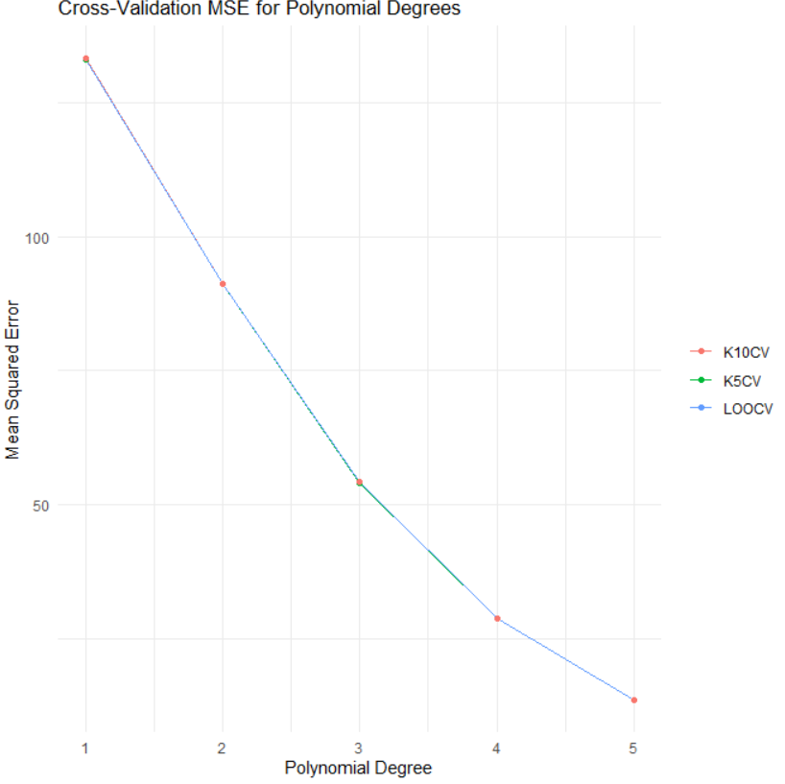

**Conclusion:Degrre 5 is Preferable as it has least MSE among them**

3.Perform the analysis in problem no. 2, but this time, fit linear models with different combination of X variables, without interaction. Discuss which model is most preferable based on the cross-validation results. Plot the results and on X-axis labels, provide the X-variable combinations used in the model, e.g. (temp, temp-press, temp-matfus, temp-matfus-mattr etc.)

Ans:-

Code:-

**feature_combinations <- list(**

**c("Temperature...C."),**

**c("Temperature...C.", "Pressure..kPa."),**

**c("Temperature...C.", "Material.Fusion.Metric"),**

**c("Temperature...C.", "Material.Transformation.Metric"),**

**c("Temperature...C.", "Pressure..kPa.", "Material.Fusion.Metric"),**

**c("Temperature...C.", "Pressure..kPa.", "Material.Transformation.Metric"),**

**c("Temperature...C.", "Material.Fusion.Metric", "Material.Transformation.Metric"),**

**c("Temperature...C.", "Pressure..kPa.", "Material.Fusion.Metric", "Material.Transformation.Metric")**

**)**

**cv_summary_results <- data.frame(Combination = character(0), LOOCV_Error = numeric(0), K5_Error = numeric(0), K10_Error = numeric(0))**

**for (features in feature_combinations) {**

**model_expression <- paste("Quality.Rating ~", paste(features, collapse = " + "))**

**model_formula <- as.formula(model_expression)**

**print(paste("Evaluating model with variables:", model_expression))**

**loocv_res <- cv.glm(data, glm(model_formula, data = data), K = nrow(data))**

**loocv_mse <- loocv_res$delta[1]**

**k5_mse <- kfold_cross_validation(model_formula, data, 5)**

**k10_mse <- kfold_cross_validation(model_formula, data, 10)**

**cv_summary_results <- rbind(cv_summary_results, data.frame(Combination = model_expression, LOOCV_Error = loocv_mse, K5_Error = k5_mse, K10_Error = k10_mse))**

**}**

**print(cv_summary_results)**

**library(reshape2)**

**cv_results_long <- reshape(cv_summary_results,**

**varying = c("LOOCV_Error", "K5_Error", "K10_Error"),**

**v.names = "MSE",**

**timevar = "CV_Method",**

**times = c("LOOCV", "K5CV", "K10CV"),**

**direction = "long")**

**ggplot(cv_results_long, aes(x = Combination, y = MSE, color = CV_Method, group = CV_Method)) +**

**geom_point() +**

**geom_line() +**

**theme_minimal() +**

**labs(title = "Cross-Validation MSE for Different Predictor Combinations",**

**x = "Predictor Combinations", y = "Mean Squared Error") +**

**theme(axis.text.x = element_text(angle = 45, hjust = 1), legend.title = element_blank())**

Output:-

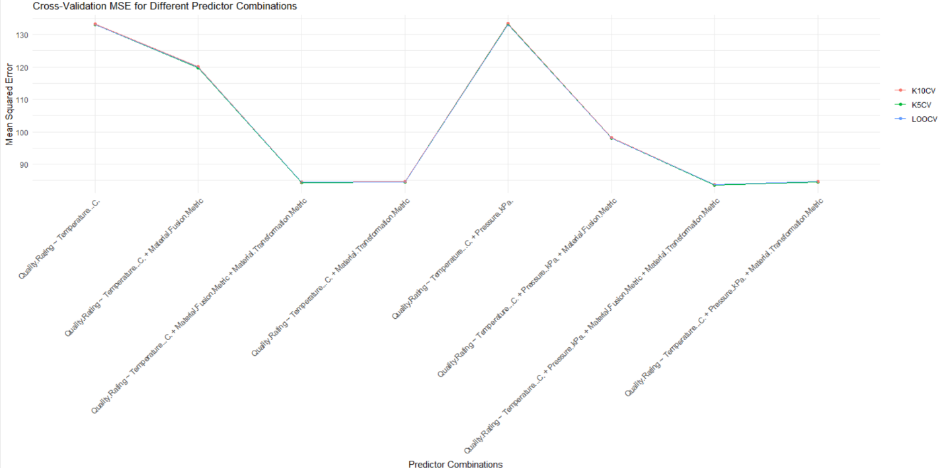

4)Generate 50 random numbers from Normal Distribution $N(μ=50, σ^{2}=2)$. Now create 100 bootstrap samples with 20 datapoints each, with replacement. Estimate the mean and variance of the population from the bootstrap samples.

Ans:-

Code:-

**set.seed(123)**

**random_population <- rnorm(50, mean = 50, sd = sqrt(2))**

**bootstrap_means <- numeric(100)**

**bootstrap_variances <- numeric(100)**

**for (iteration in 1:100) {**

**sample_subset <- sample(random_population, size = 20, replace = TRUE)**

**bootstrap_means[iteration] <- mean(sample_subset)**

**bootstrap_variances[iteration] <- var(sample_subset)**

**}**

**estimated_mean <- mean(bootstrap_means)**

**estimated_variance <- mean(bootstrap_variances)**

**estimated_mean**

**estimated_variance**

**Output:**

> estimated_mean

[1]50.05668

> estimated_variance

[1] 1.733931

**Conclusion:**

Estimated Population Mean from Bootstrap Samples: 50.05668

Estimated Population Variance from Bootstrap Samples: 1.733931