**Statistical Learning Lab**

Assignment - 9

**Artificial Neural Network**

Anurag Singha | 22IM30007 

1. Develop a binary classification model using ANN.

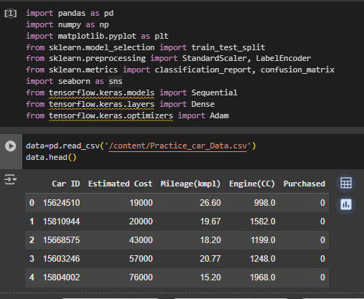

2. Perform the binary classification over the target variable – “Purchased”.

X=data.drop('Purchased',axis=1)

Y=data['Purchased']

scaler=StandardScaler()

X_scaled=scaler.fit_transform(X)

3. Split the data into train, test, and validation sets.

X_train, X_temp, Y_train, Y_temp = train_test_split(X_scaled, Y, test_size=0.3, random_state=55)

X_val, X_test, Y_val, Y_test = train_test_split(X_temp, Y_temp, test_size=0.5, random_state=55)

4. Show all the ANN layers, the number of neurons, and the activation function.

model = Sequential()

model.add(Dense(48, input_dim=X.shape[1], activation='relu'))

model.add(Dense(16, activation='relu'))

model.add(Dense(1, activation='sigmoid'))

model.summary()

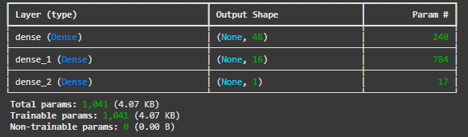

5. Fit the model with the relevant optimizer, loss function, and evaluation metric.

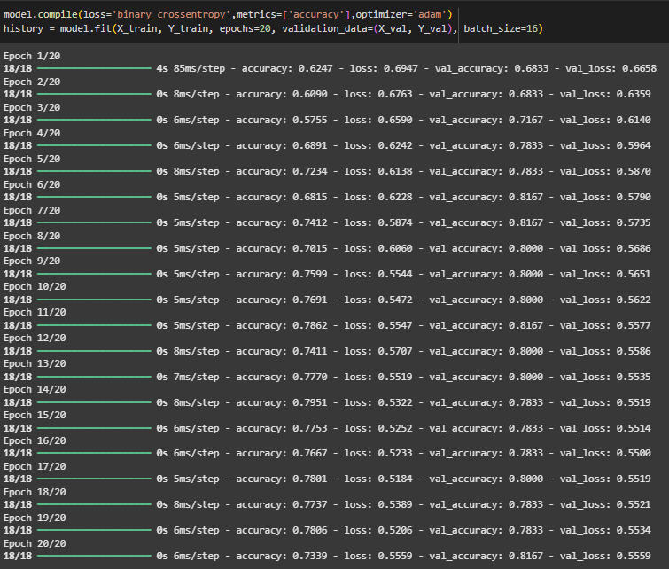

6. Plot the train set accuracy and validation set accuracy over epochs.

plt.figure(figsize=(10, 4))

plt.subplot(1, 2, 1)

plt.plot(history.history['accuracy'], label='Train Accuracy')

plt.plot(history.history['val_accuracy'], label='Validation Accuracy')

plt.title('Accuracy Over Epochs')

plt.legend()

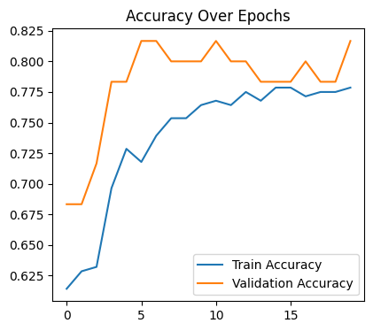

7. Plot the train set loss and validation set loss over epochs.

plt.subplot(1, 2, 2)

plt.plot(history.history['loss'], label='Train Loss')

plt.plot(history.history['val_loss'], label='Validation Loss')

plt.title('Loss Over Epochs')

plt.legend()

plt.tight_layout()

plt.show()

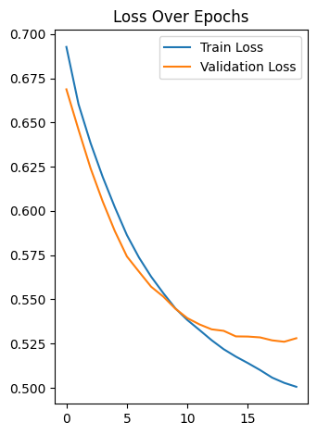

8. Calculate the model performance on the test set. [Test set accuracy should be at least 75%]

test_loss, test_accuracy = model.evaluate(X_test, Y_test)

print("Test Accuracy:",test_accuracy*100,"%")

**2/2** ━━━━━━━━━━━━━━━━━━━━ **1s** 290ms/step - accuracy: 0.7625 - loss: 0.5754

Test Accuracy: 80.0000011920929 %

9. Show the classification report and confusion matrix.

