Statistical Learning Lab
Assignment - 3
Linear Regression Assignment
Anurag Singha | 22IM30007
Show the code snippets and the corresponding output for the following:
- Load the dataset “diabetes.csv”. Display the first few rows of the dataset. A1. Loaded the data set using the read.csv command.
#Code
data <- read.csv("diabetes.csv")
head(data)

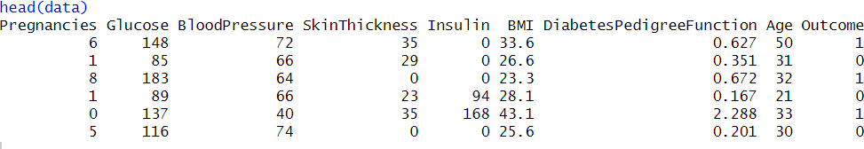

- Perform preliminary analysis to show how the variables are related. Use scatter plots, box plots, etc., to visualise how different variables impact the “Outcome” variable.
Checking for missing values:
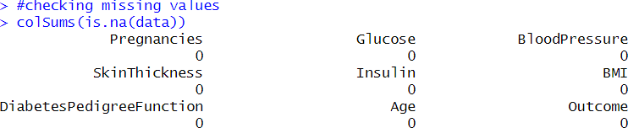

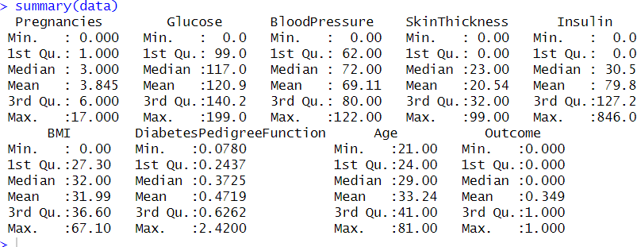
Used pairs(data, main = "Scatter Plot Matrix") to plot scatter Plot.
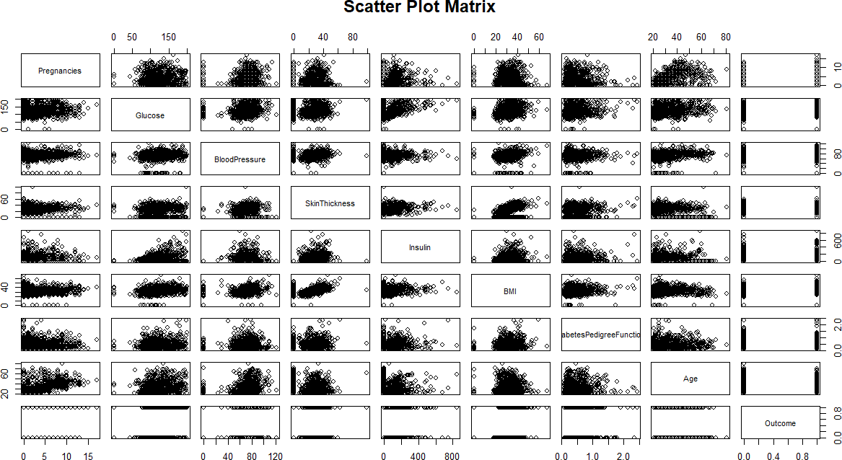

Code:
par(mfrow = c(1, 2))
for (col in colnames(data)[-ncol(data)]) { boxplot(data[[col]] ~ data$Outcome,
main = paste(col, "vs Outcome"), xlab = "Outcome",
ylab = col,
col = c("lightblue", "pink"))
}

Box Plots:
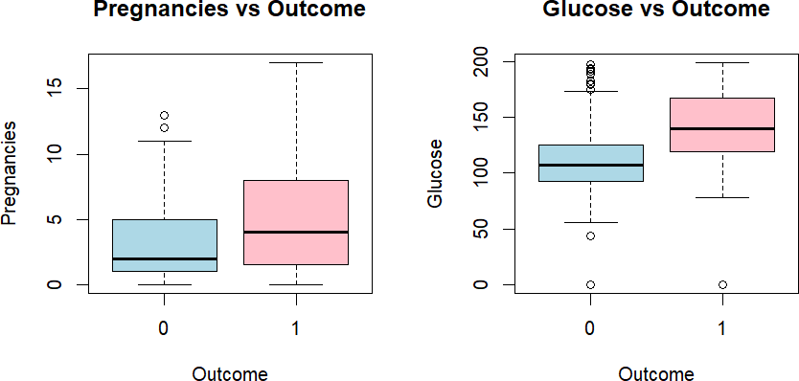
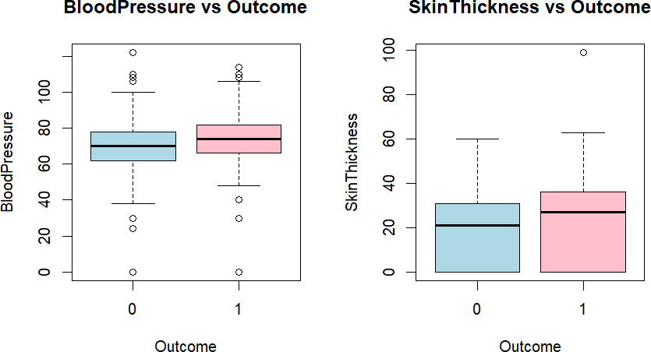

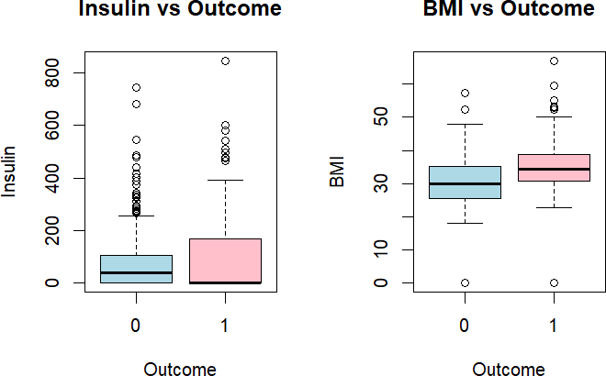
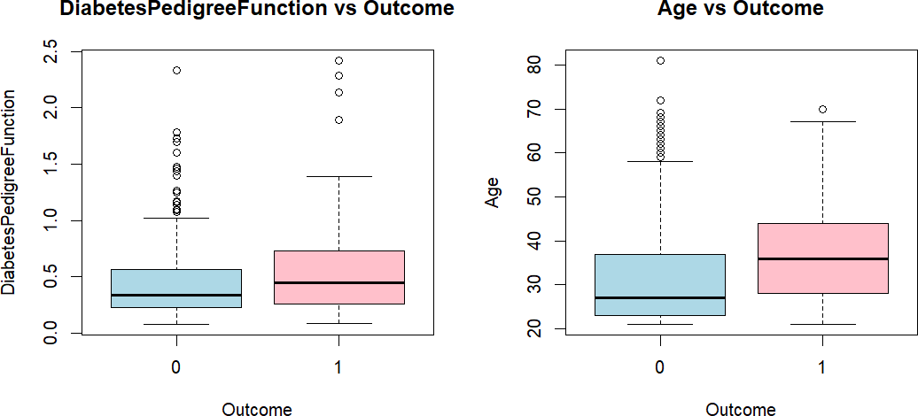

Syntax for correlation plot:
cor_matrix <- cor(data) print(cor_matrix) library(corrplot) mfrow(1,1)
corrplot(cor_matrix,method="color" ,type = "upper", tl.col = "black", tl.cex=0.8)

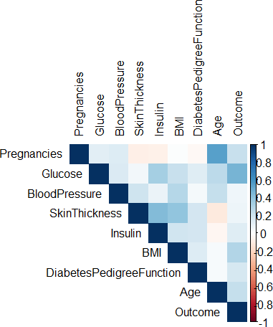

Outcome Correlations:

- Strong with Glucose (~0.46).
- Moderate with BMI (~0.29) and Pregnancies (~0.22).
- Weak with DiabetesPedigreeFunction (~0.17) and Age (~0.20).

Predictor Relationships:

- Strong: SkinThickness vs. BMI (~0.39).
- Moderate: Glucose vs. BMI (~0.22), Insulin vs. Glucose (~0.33), and Age vs.
Pregnancies (~0.54).

Q3) Randomly sample 80% of the data as training data and rest
as test data. Fit a LDA model and interpret the result.
Code:

Outcome:
Inferences:
- Glucose is a dominant predictor of diabetes, as it is much higher in diabetics.
- Genetics (Diabetes Pedigree Function) has a strong impact on predicting diabetes.
- Obesity (BMI) and Insulin levels also influence diabetes classification.
- Pregnancy history, age, and blood pressure contribute, but with less influence.
Q4) From the model fitted in problem 3, derive confusion
matrix, accuracy, and F1-score on test data.
Code:
Confusion Matrix:
Code:
Calculating accuracy
Code:
Result:
Q5) Fit QDA and KNN (K = 5) models on training data. Compare
the metrics in problem 4 for LDA, QDA and KNN models for
test data and discuss the results.
Code::

Inference & Comparison of Model Performance

Accuracy:
- LDA achieves the highest accuracy at 0.7792, making it the most effective model in terms of overall correct predictions on the test data.
- QDA follows closely with an accuracy of 0.7532, slightly lower than LDA.
- KNN has the lowest accuracy at 0.7338, suggesting that it may struggle in this scenario, potentially due to sensitivity to feature scaling or the choice of K.

F1 Score:
- LDA also outperforms the other models in terms of F1 score (0.6304), indicating a strong balance between precision and recall for the positive class.
- KNN follows with an F1 score of 0.5859, slightly higher than QDA (0.5778). This suggests that while KNN has the lowest accuracy, it maintains a better balance of precision and recall compared to QDA.
- QDA has the lowest F1 score, implying that while it correctly classifies a reasonable number of samples (as reflected in accuracy), it may struggle in balancing precision and recall effectively.

Conclusion:
- LDA emerges as the most effective model, achieving the highest accuracy and F1 score, making it a strong candidate for this problem.
- KNN, despite having the lowest accuracy, maintains a relatively balanced F1 score, indicating that it still captures some relevant patterns.
- QDA ranks lowest in terms of F1 score, suggesting it may not be as effective in distinguishing between positive and negative classes, even though its accuracy remains fairly competitive.
Overall, LDA appears to be the most reliable model, followed by KNN, with QDA performing the weakest based on these evaluation metrics.

Q6) Plot ROC curve for LDA and QDA models using the test
data.
->Code:
Plots:
Q7) Plot accuracy and f1-score by varying the neighbourhood
size from K=1 to K=20 and interpret the results.
Code:
Output:
Interpretation:
Accuracy and F1-Score Behavior:
At K=1, the accuracy is significantly high (around 0.7).
As K increases, accuracy drops sharply and remains close to zero for all larger K values.
The F1-score remains near zero for all K values, indicating poor classification performance.

