Health Ahead

Predicting your health for a better tomorrow

----------------------------------------------------------------------------------------------

**Problem Statement:**

* The challenge is to develop an innovative web app that leverages machine learning algorithms to accurately predict a patient's likelihood of developing various health conditions based on their medical history and lifestyle habits.
* The main goal is to create an accessible tool that can identify potential health risks early on and ultimately improve patient outcomes.

**Abstract:**

A multiple health prediction system is a software application that uses machine learning algorithms to predict the likelihood of an individual developing certain health conditions based on various factors. The system typically takes in a range of data, such as medical history, lifestyle, and genetic information, and uses this information to create a risk profile for the individual.

The system can be used to predict the likelihood of developing a range of health conditions, including cardiovascular disease, diabetes, cancer, and other chronic illnesses. By providing early warnings of potential health problems, the system can help individuals take preventative measures to reduce their risk of developing these conditions.

The multiple health prediction system is typically built using a combination of data analytics tools, machine learning algorithms, and big data technologies. The system may also incorporate artificial intelligence and natural language processing techniques to provide personalized health recommendations and advice.

Overall, the multiple health prediction system has the potential to revolutionize the way we approach healthcare by enabling early detection and preventative measures for a range of health conditions. By providing personalized and data-driven insights into an individual's health, the system can help reduce healthcare costs and improve overall health outcomes.

**To implement this app we will use:**

* 1.Anaconda
* 2.Streamlit
* 3.Jupiter notebook

**User Requirements:**

* Easy to use: The application should be user-friendly and easy to navigate.
* Symptom input: The user should be able to input their symptoms in a simple and clear way.
* Predictions: The application should provide accurate predictions of potential diseases based on the user's symptoms.
* Disease information: The application should provide information about the potential diseases including symptoms, causes, and treatment options.
* Confidentiality: The user's information should be kept confidential and not shared with any third party.
* Availability: The application should be available 24/7 to users.
* Accessibility: The application should be accessible to users with disabilities.

**Road map:**

**Week 1: Requirements Gathering**

* Conduct user research and gather requirements for the website.
* Define the scope and objectives of the project.
* Create a project plan and timeline.

**Week 2: Design and Prototyping**

* Research on what front-end tool suits our idea.
* Getting an idea about what we should use to develop the backend.
* Develop a prototype of the website's user interface using a prototyping tool.

**Week 3-4: Development**

* Develop the website's back-end using Jupyter notebook.
* Develop the website's front-end using a server-side language like PHP or Python.
* Using datasets gathered, data pre-processing, data testing and training should be done.

**Week 5: Integration and Testing**

* Integrate the website with the data using datasets.
* Test the website's functionality, performance, and security.
* Address any bugs or errors found during testing.

**Week 6: Deployment**

* Deploy the website to a web server or cloud platform.
* Configure the web server and set up domain and hosting.
* Make the website publicly accessible.

**Week 7-8: Maintenance and Updates**

* Monitor the website for errors or bugs.
* Update the website's content and features.
* Optimize the website's performance and security.

**Modules:**

* **User Authentication Module:** This module would allow users to register, log in, and authenticate themselves to access the health prediction system. and their personal information and health data would be protected.
* **Symptom Input Module:** The module would help users to select the symptoms that best describe their condition, and provide guidance on how to describe their symptoms accurately.
* **Disease Prediction Module:** This module would use machine learning algorithms to analyze the symptoms entered by the user, and predict whether they are likely to have a particular disease such as heart disease, Parkinson's disease, or diabetes. The algorithm could be trained on a dataset of known cases of these diseases, and use statistical analysis to identify the most likely diagnosis based on the user's symptoms.
* **User Data Management Module:** This module would be responsible for storing and managing user data, such as their personal information, medical history, and symptom data. The module would ensure that user data is stored securely and can be accessed quickly when needed.
* **Integration Module:** The module would ensure that the health prediction system can access the data it needs to make accurate predictions, and that other health systems can access the results of the health prediction system to provide better care for patients.

**Class diagram:**

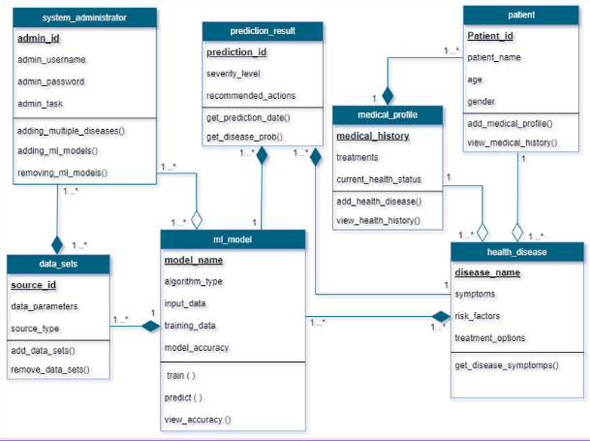

**Use case Diagram:**

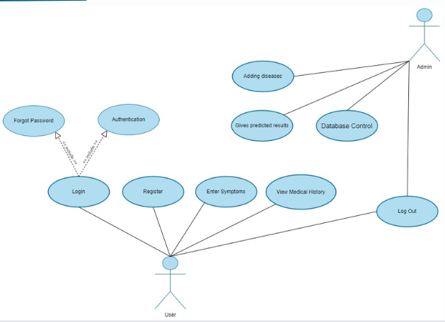

**ER Diagram:**

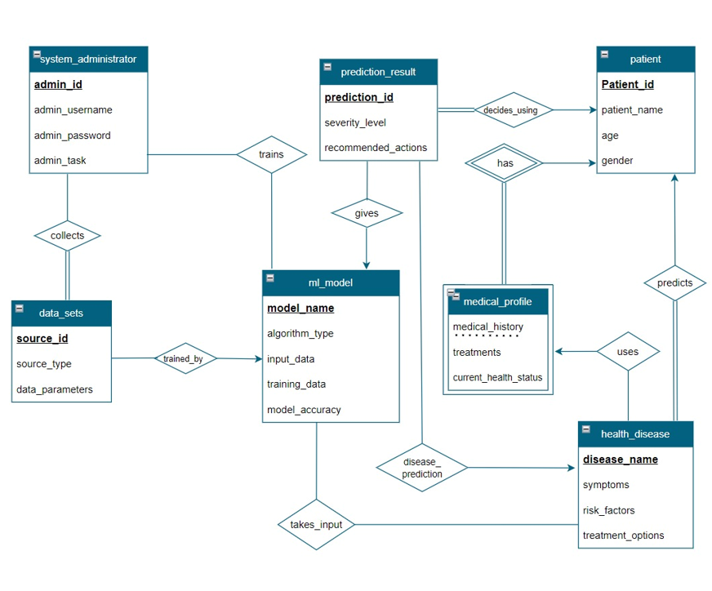

**CRC Model (Class Responsibility Collaborator):**

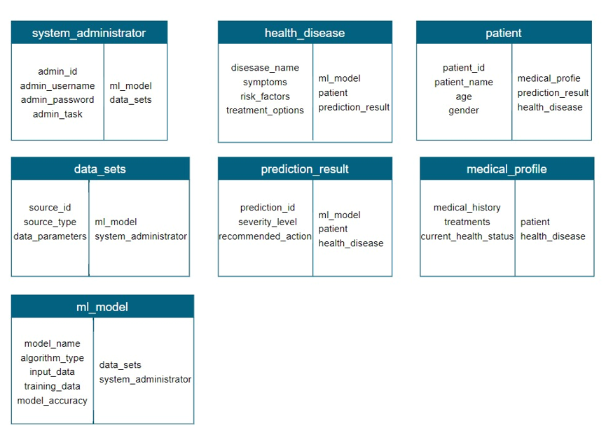

**Group Members:**

Group - 18

|  |  |
| --- | --- |
| **Name** | **Roll No** |
| T. Samhitha | AM.EN.U4CSE20072 |
| B. Sushma Chowdary | AM.EN.U4CSE20015 |
| K. Jahnavi | AM.EN.U4CSE20031 |