Create Virtual machine

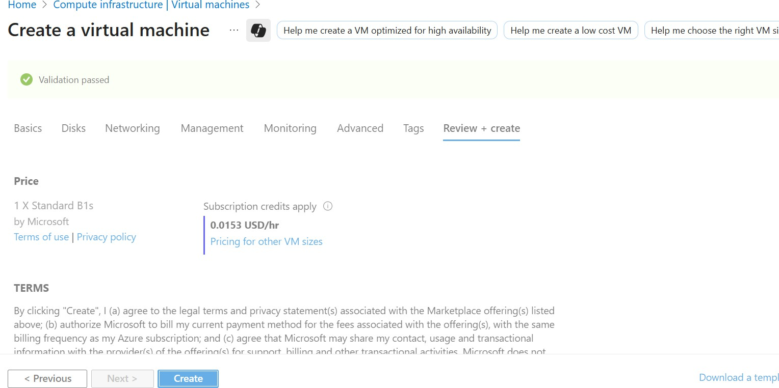

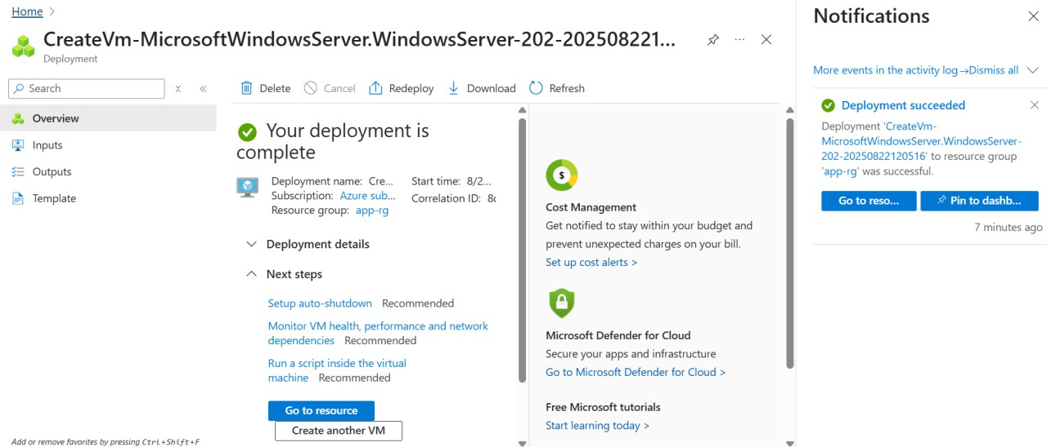

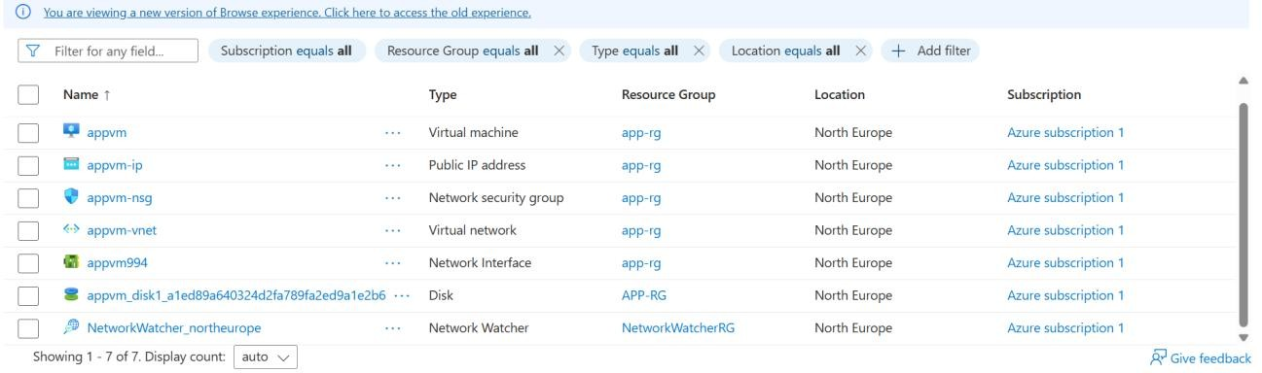

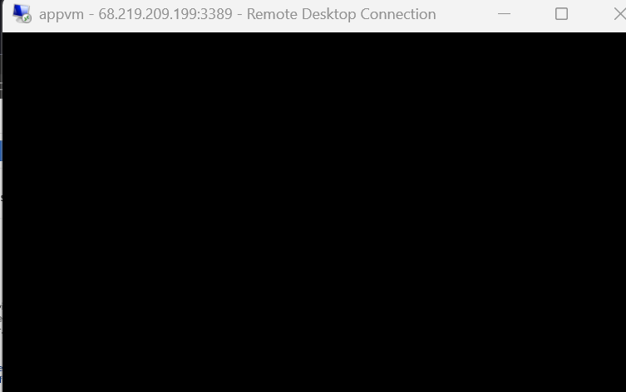

Resize vm

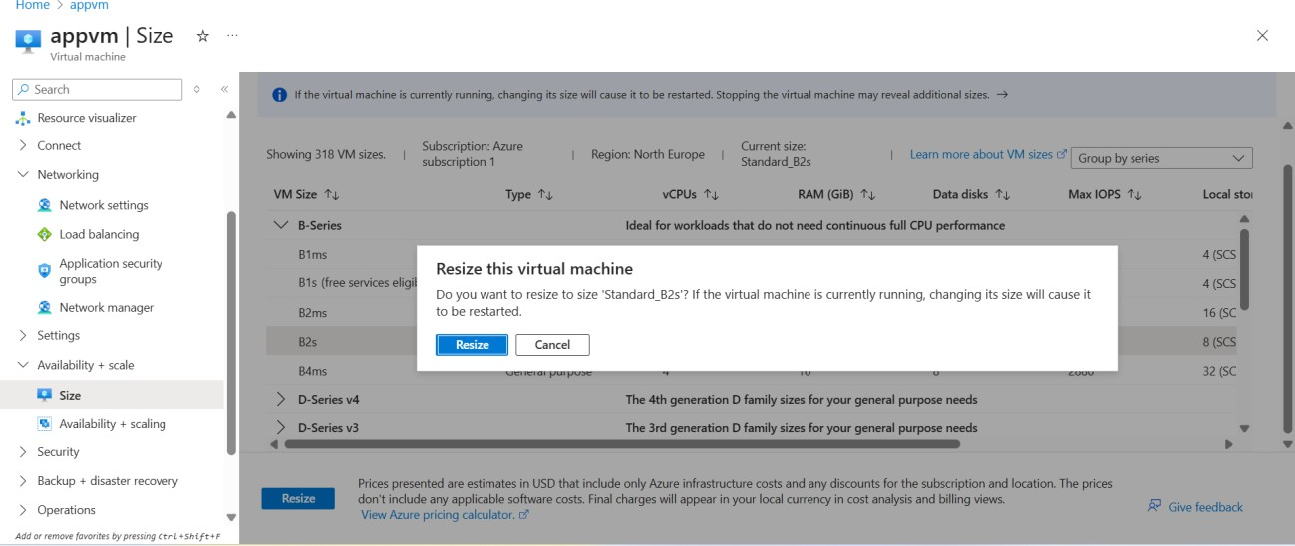

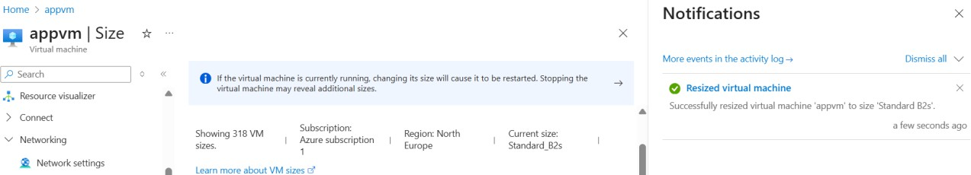

Install internet information on machine

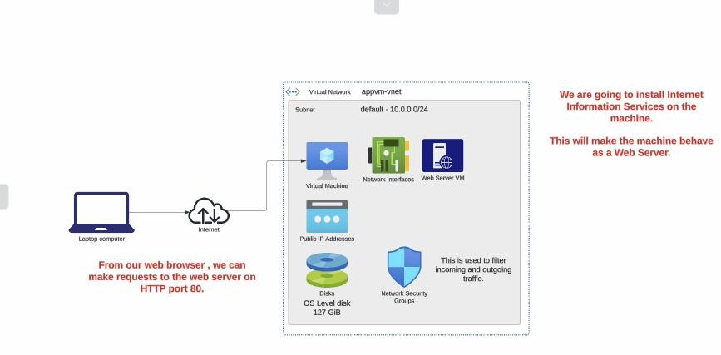

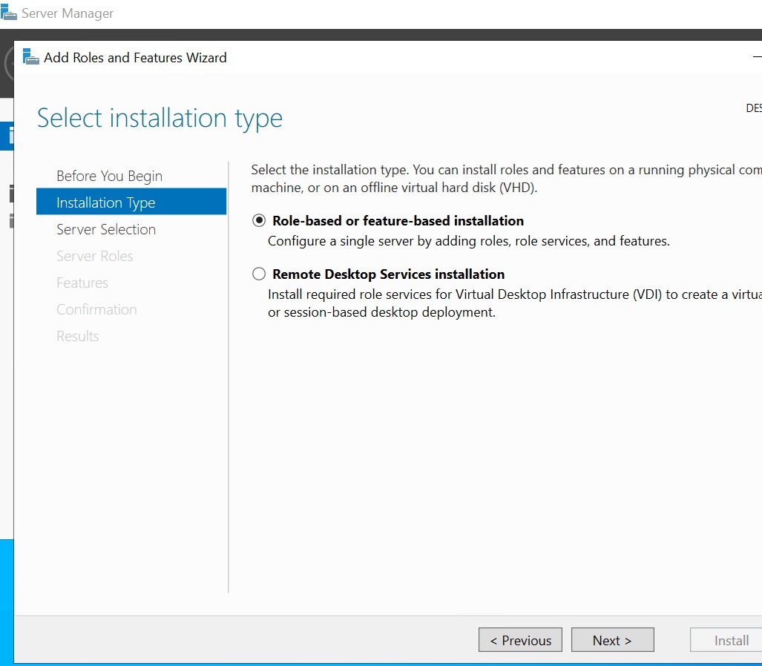

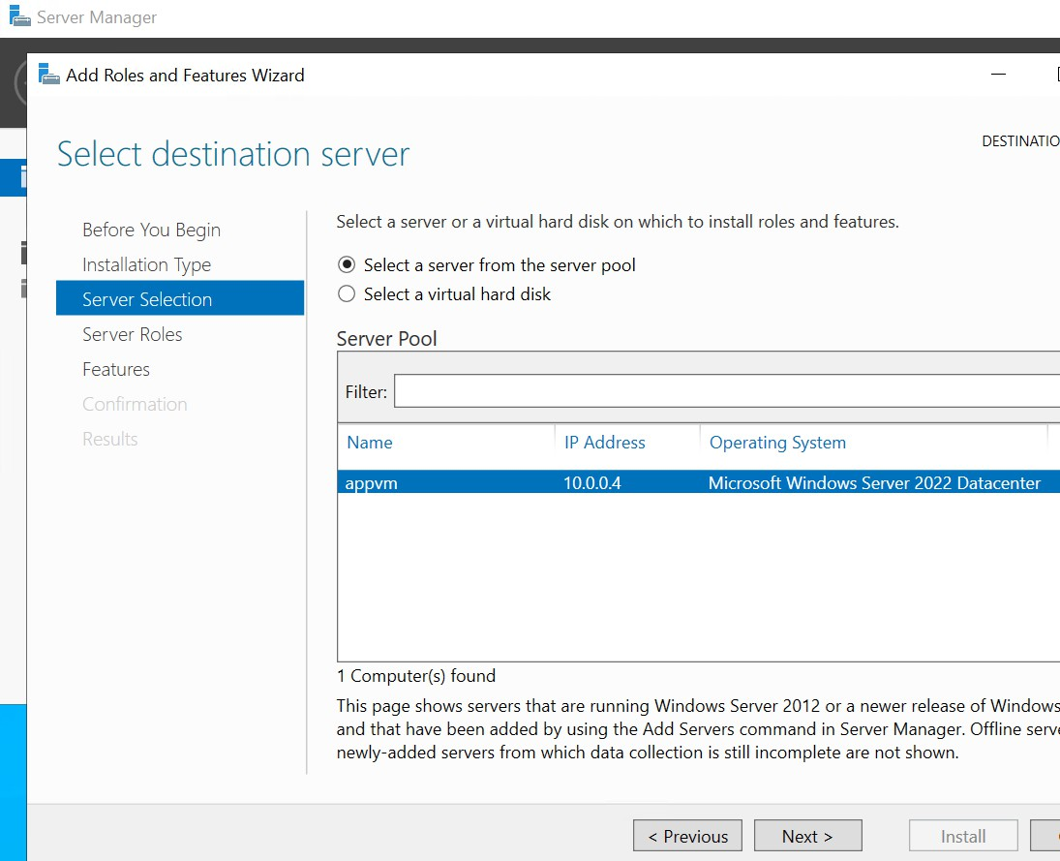

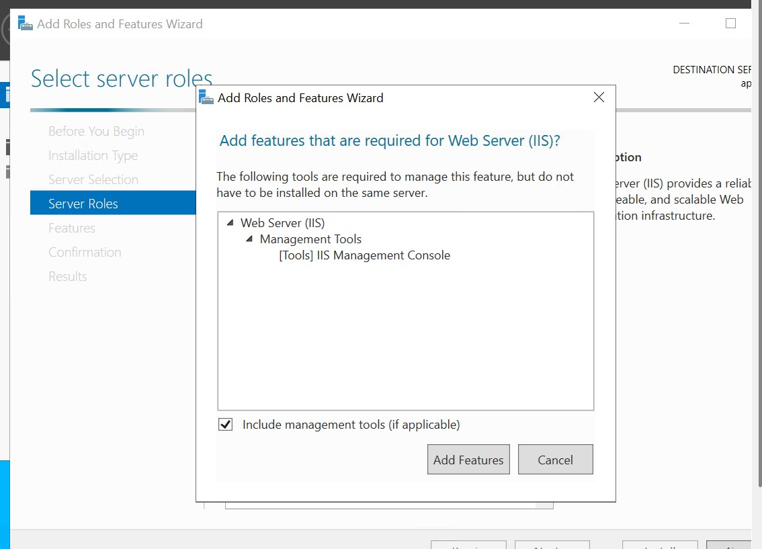

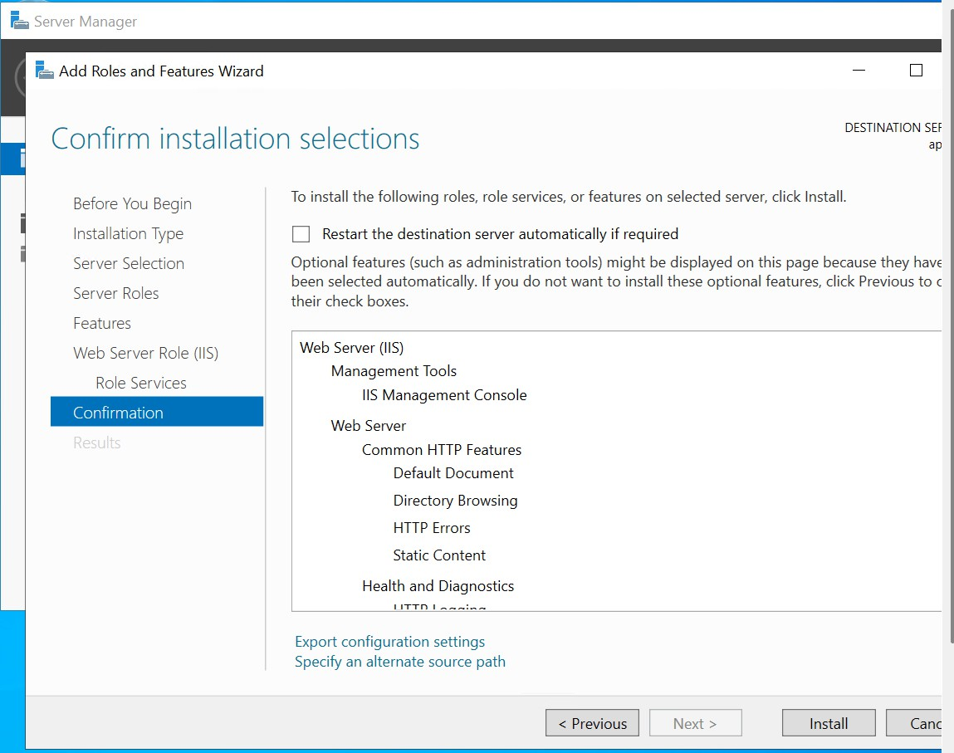

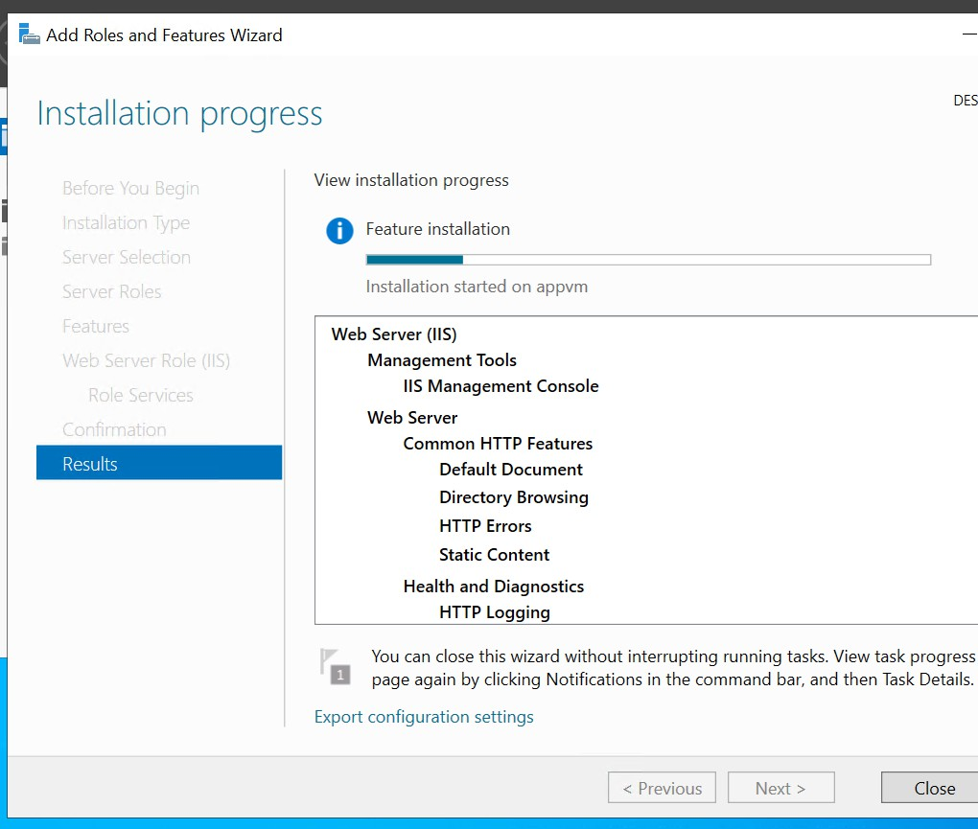

Site can’t reached

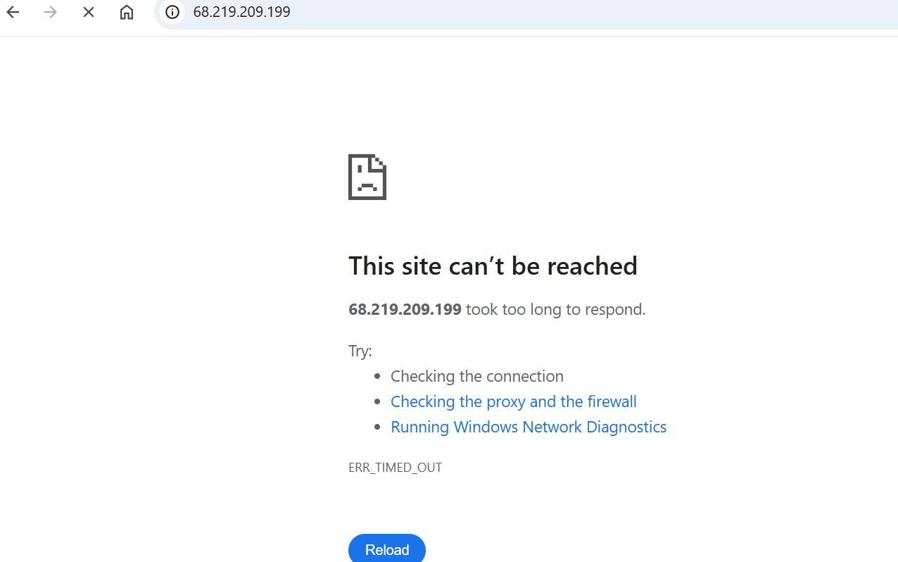

Add network inbound rule on machine

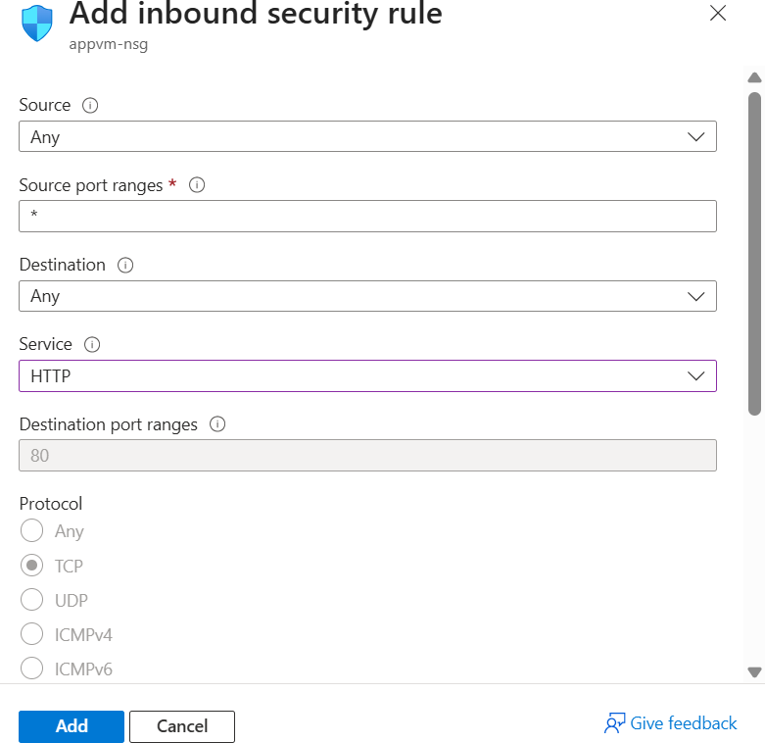

Refresh pages use public Ip of machine

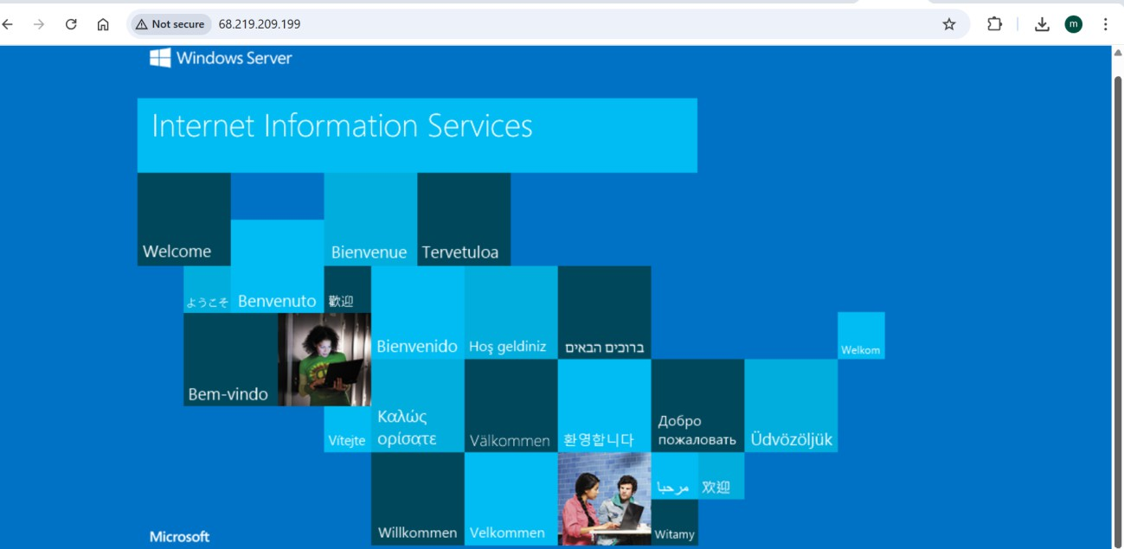

Azure region

Azure has data center’s location across in world.

Azure region has geographic location that has one or more data centers

When hosting a resource such as an azure virtual machine, it needs to be hosted on some physical infrastructure is a data center. These resources are made available to you via internet and azure portal is web interface that allows you to interact with the azure resources

Virtual sizes

[Virtual Machine series | Microsoft Azure](https://azure.microsoft.com/en-us/pricing/details/virtual-machines/series/)

create Linux VM

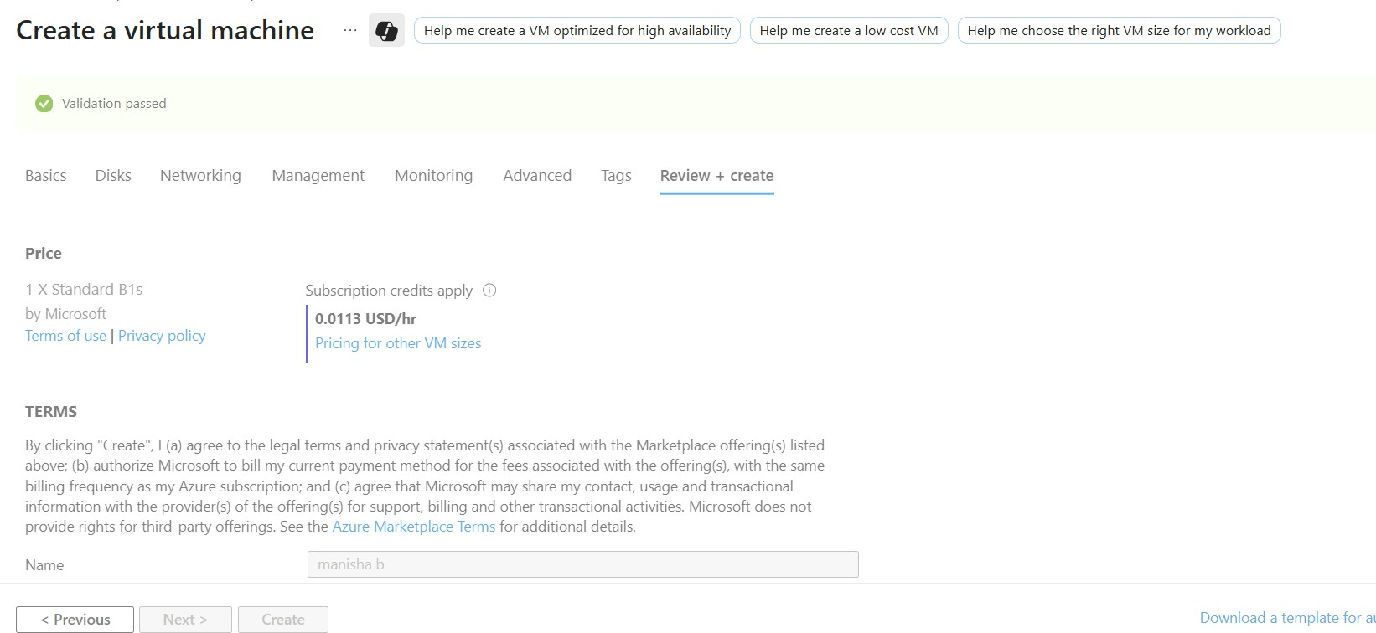

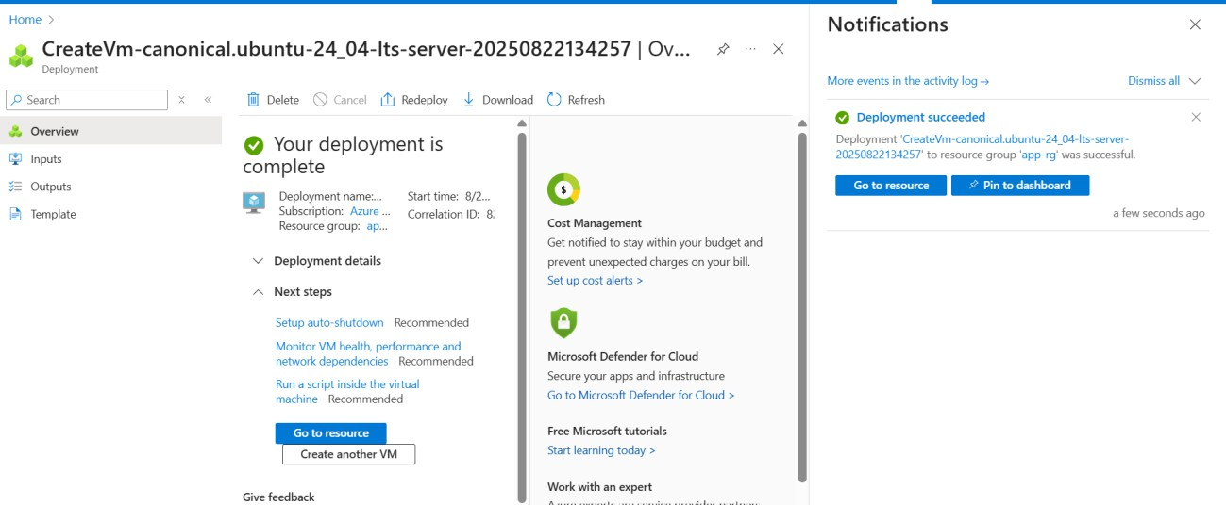

Connect to Linux

**Lab - Build a Linux Virtual Machine - Resources**

1> Connect with **Native SSH**

Deploy webserver on Linux VM

->Sudo apt update Sudo apt install nginx

Add inbound rule Http – 80 Got too public Ip -

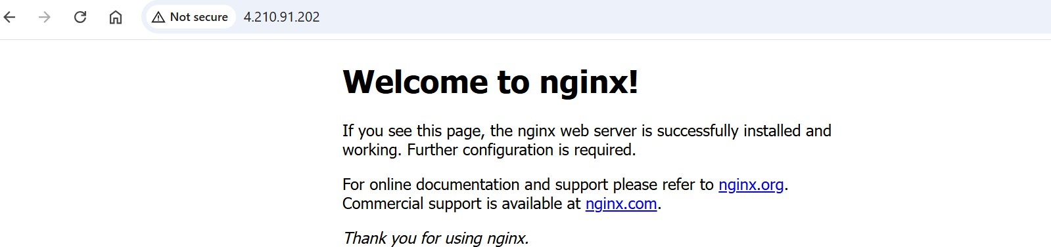

Lab - Deploying a Linux machine - SSH keys

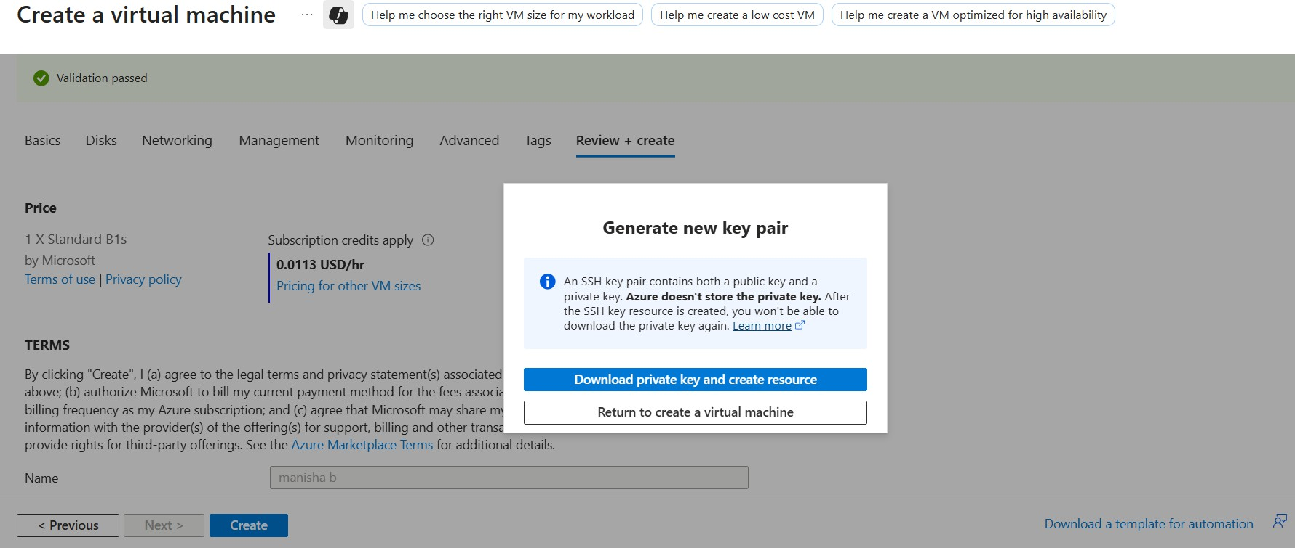

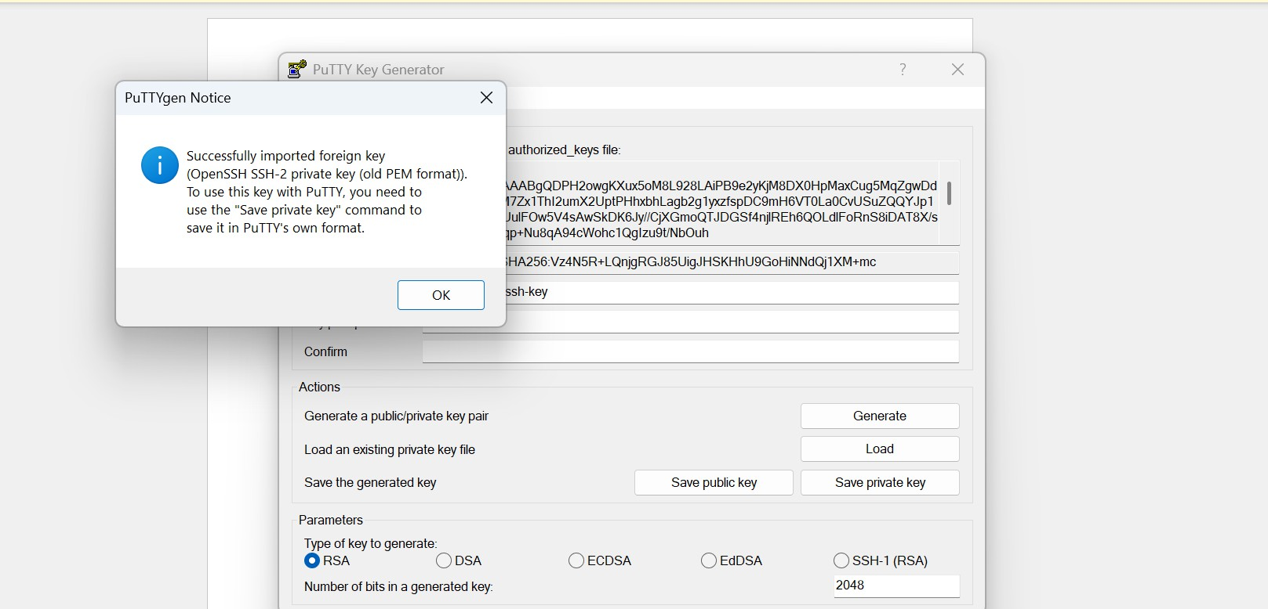

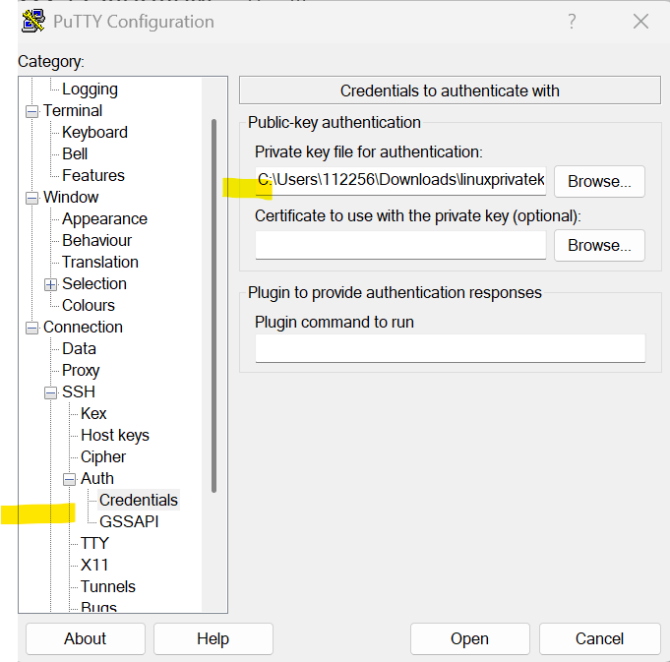

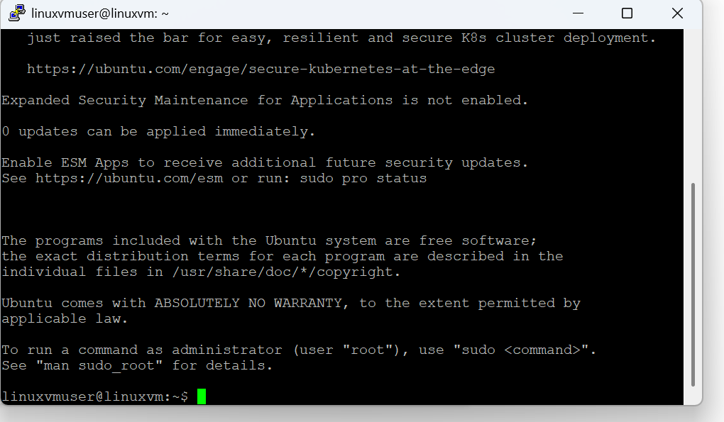

Azure disk –

Storage volume managed by azure Stard hdd – low cost, prformace issue

LUN -Logical unit number of the data disk. This value is used to identify data disks within the VM and therefore must be unique for each data disk attached to a VM.

Lab - Adding data disks

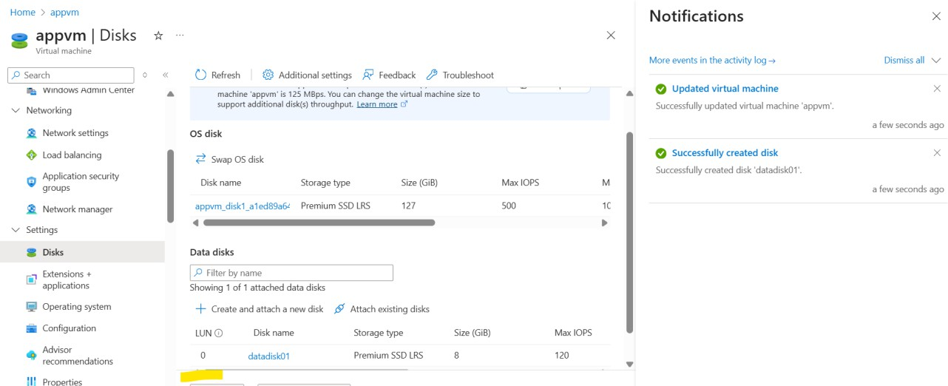

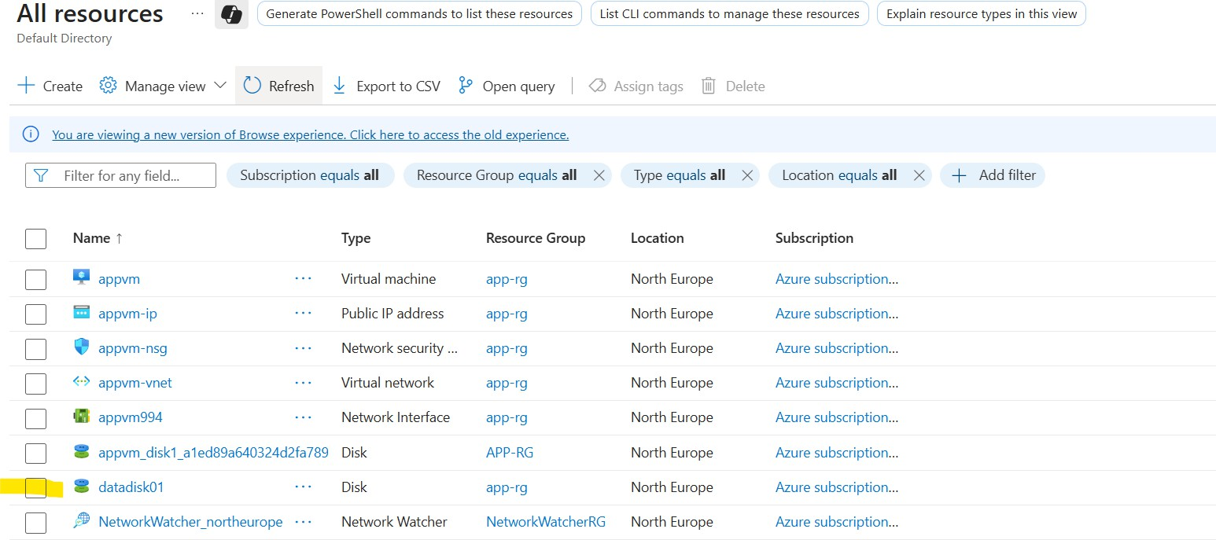

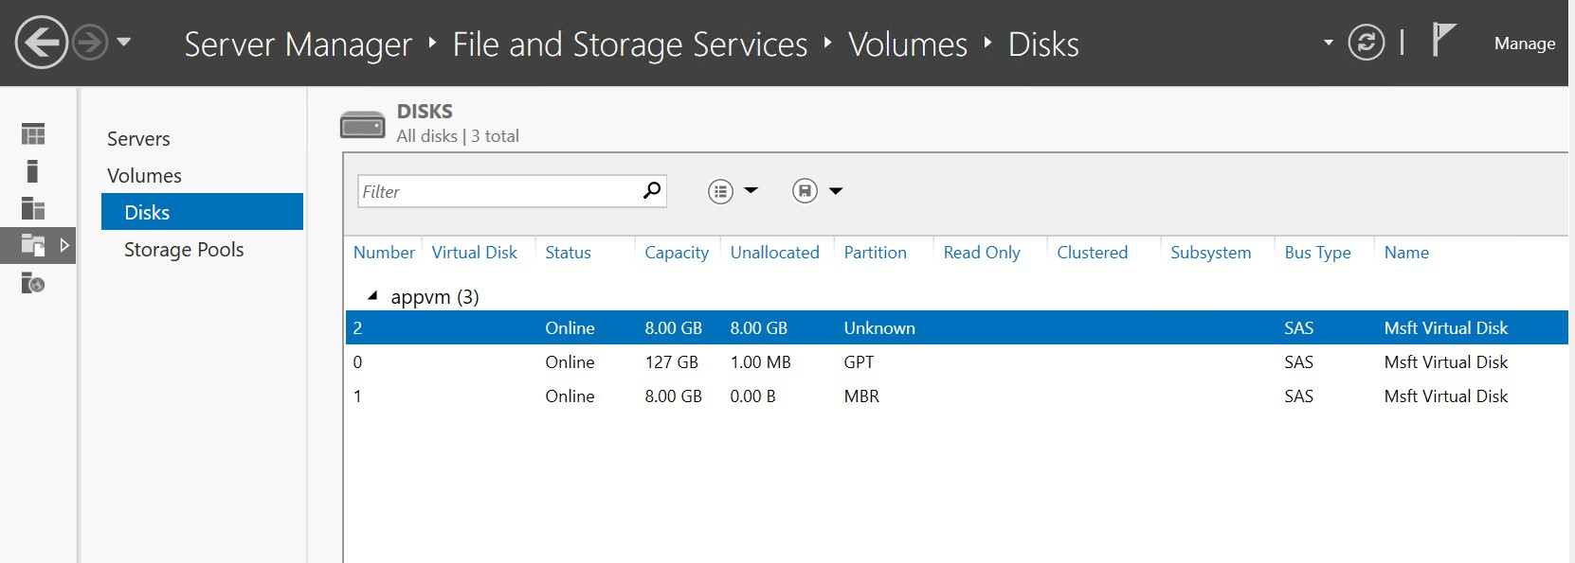

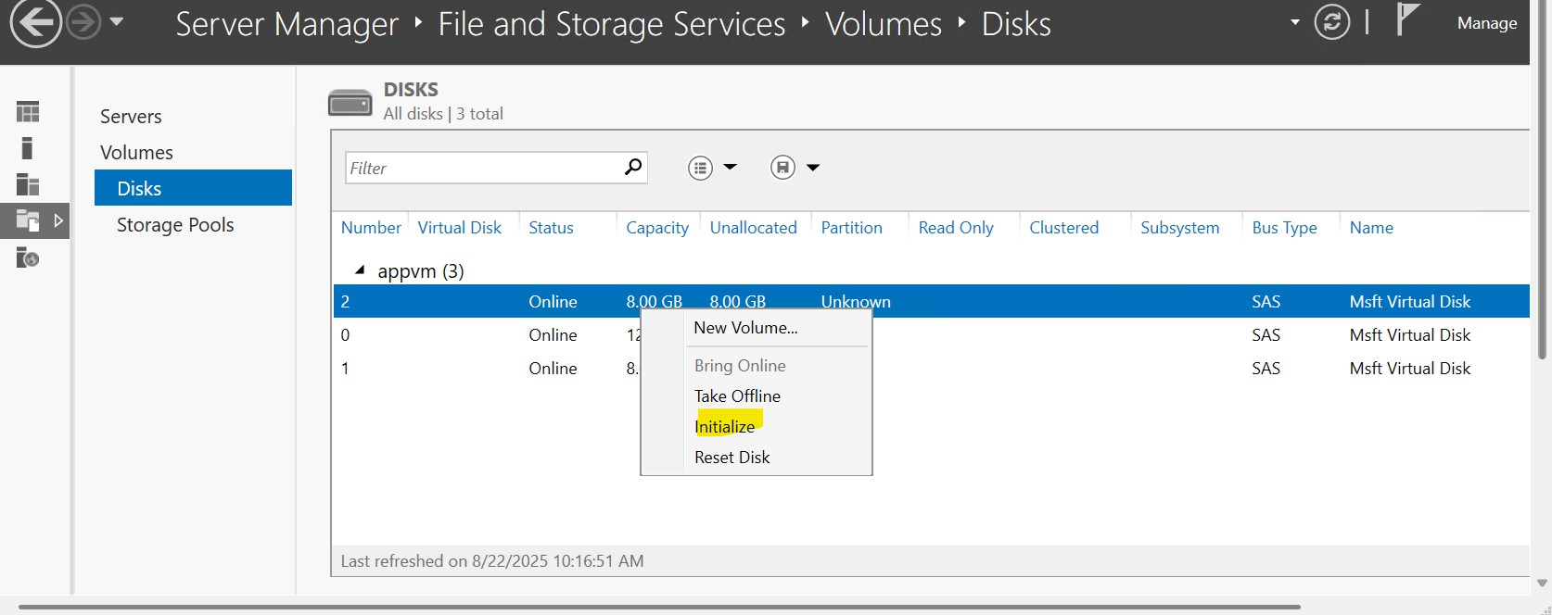

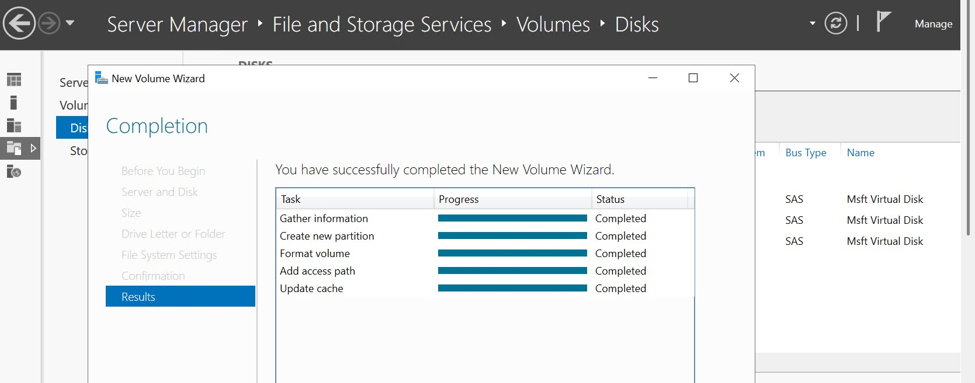

Added disk

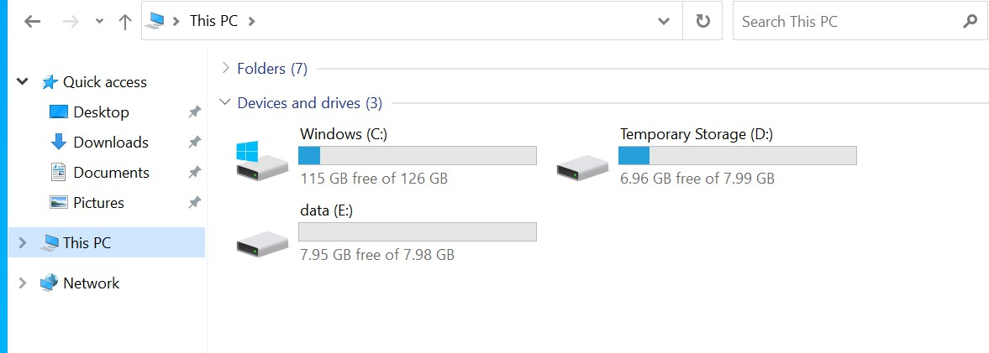

What happened we stop machin

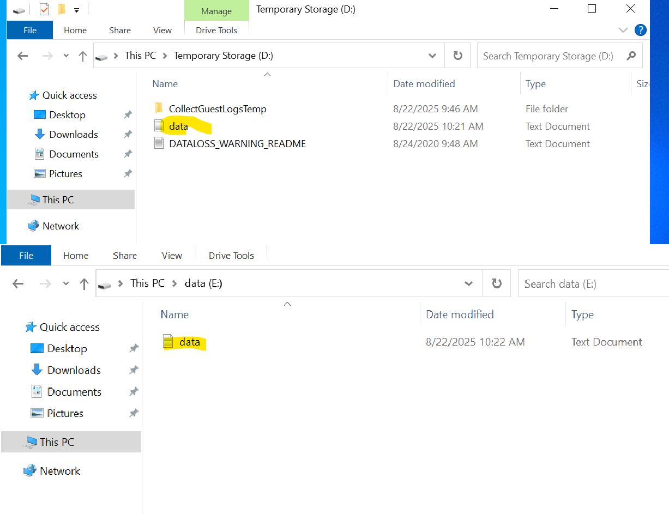1. Created notepad file save in D drive and E drive on machin

stop/deallocate vm and start vm again

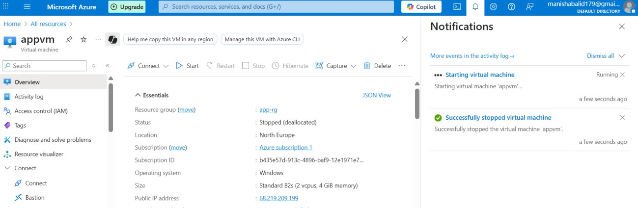

Connect to vm and verify drive D and E drive File available on E drive only

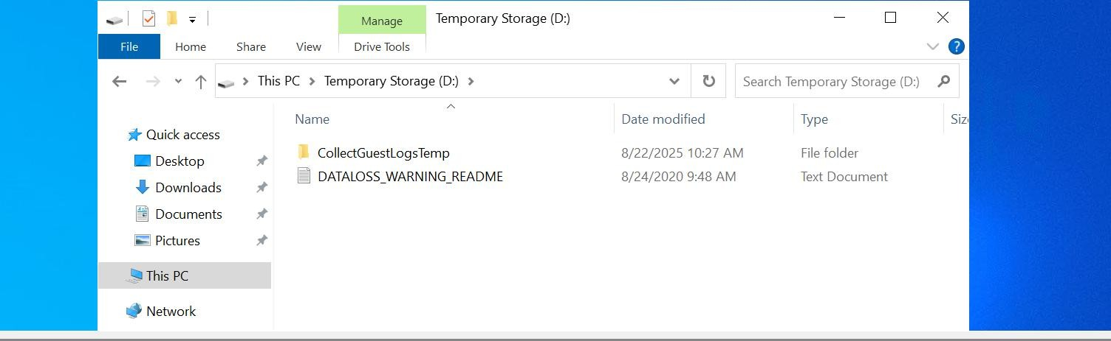

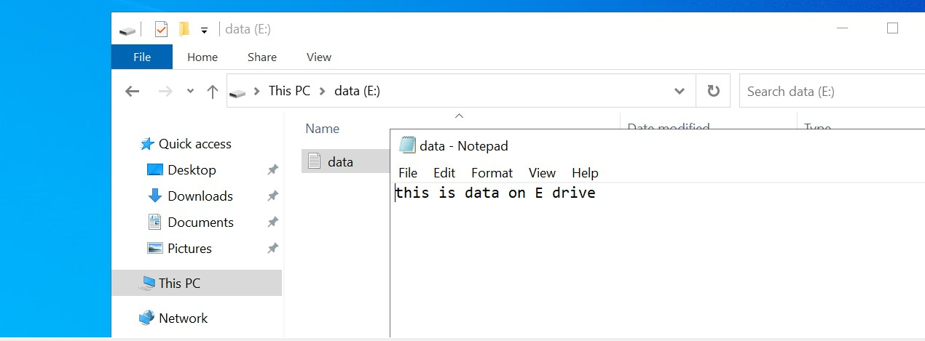

Lab - Data Disks Snapshot Read data copy of dick

1> Create 2 vm Appvm02

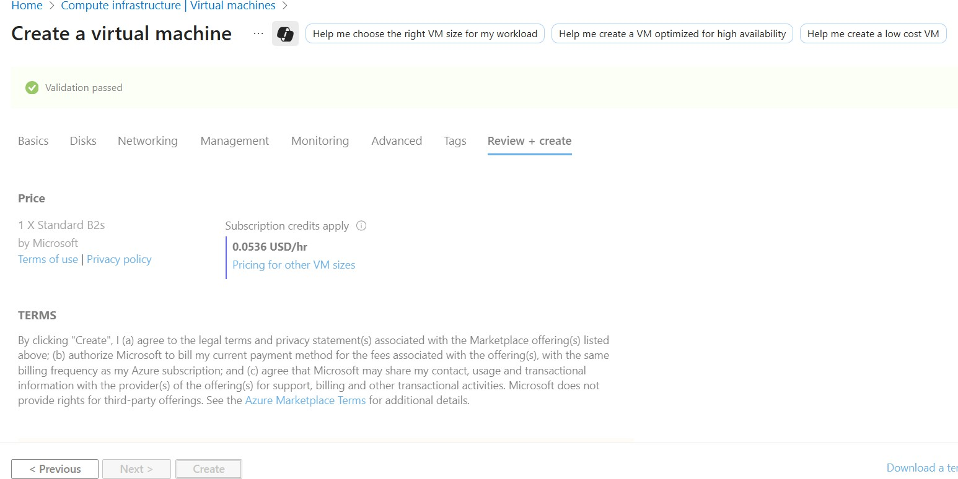

Create snapshot data disk

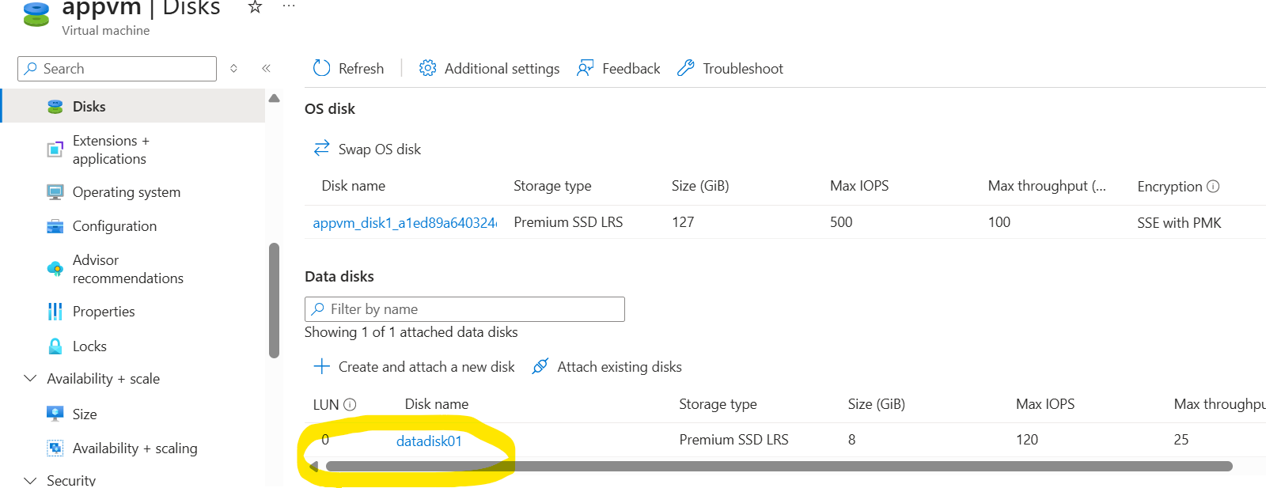

Click on disk and click on create snapshot

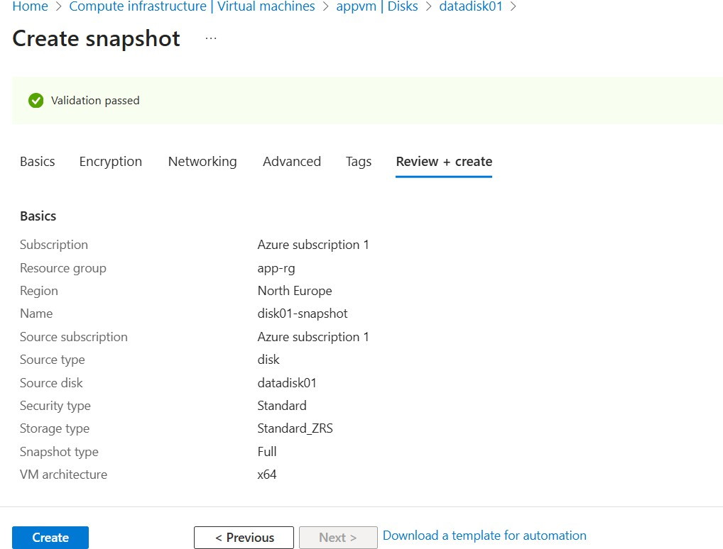

Login to 2vm

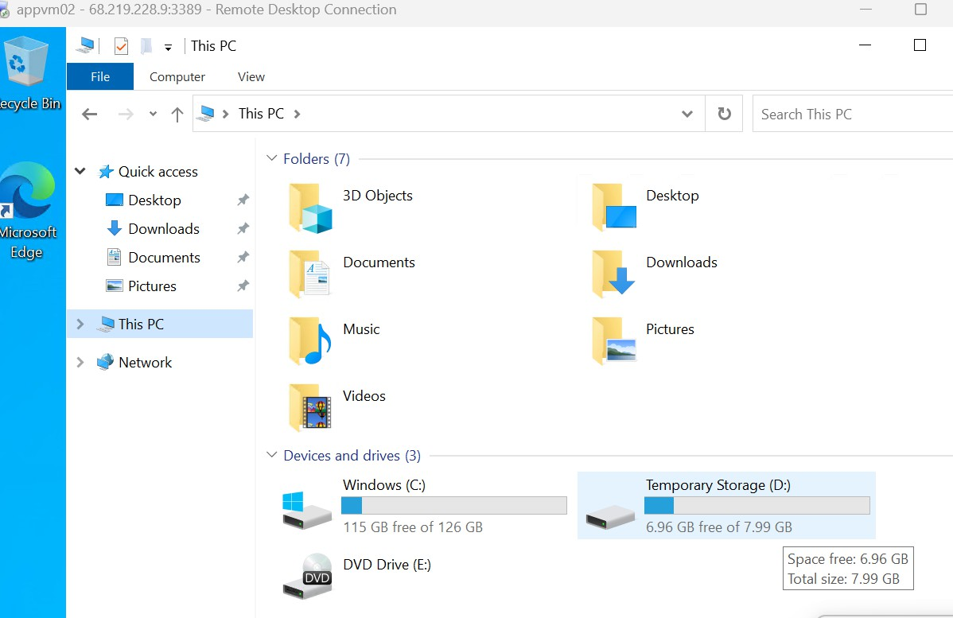

Goto snapshot disk

Goto snapshot disk and click on crete disk

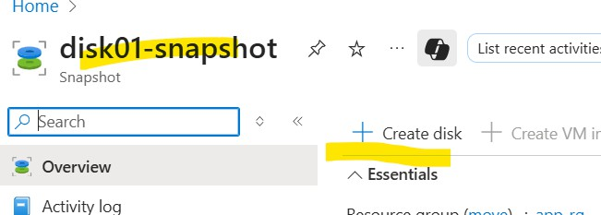

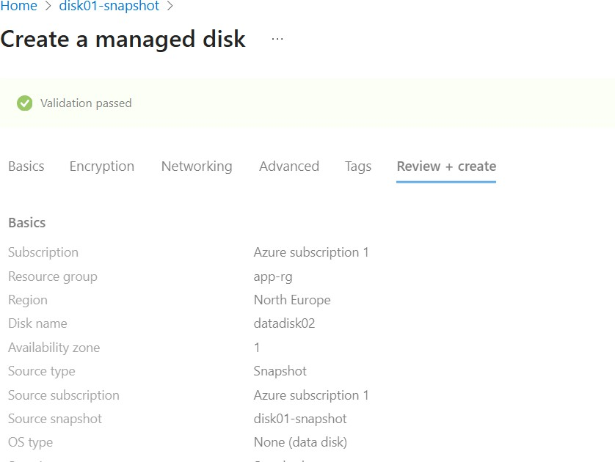

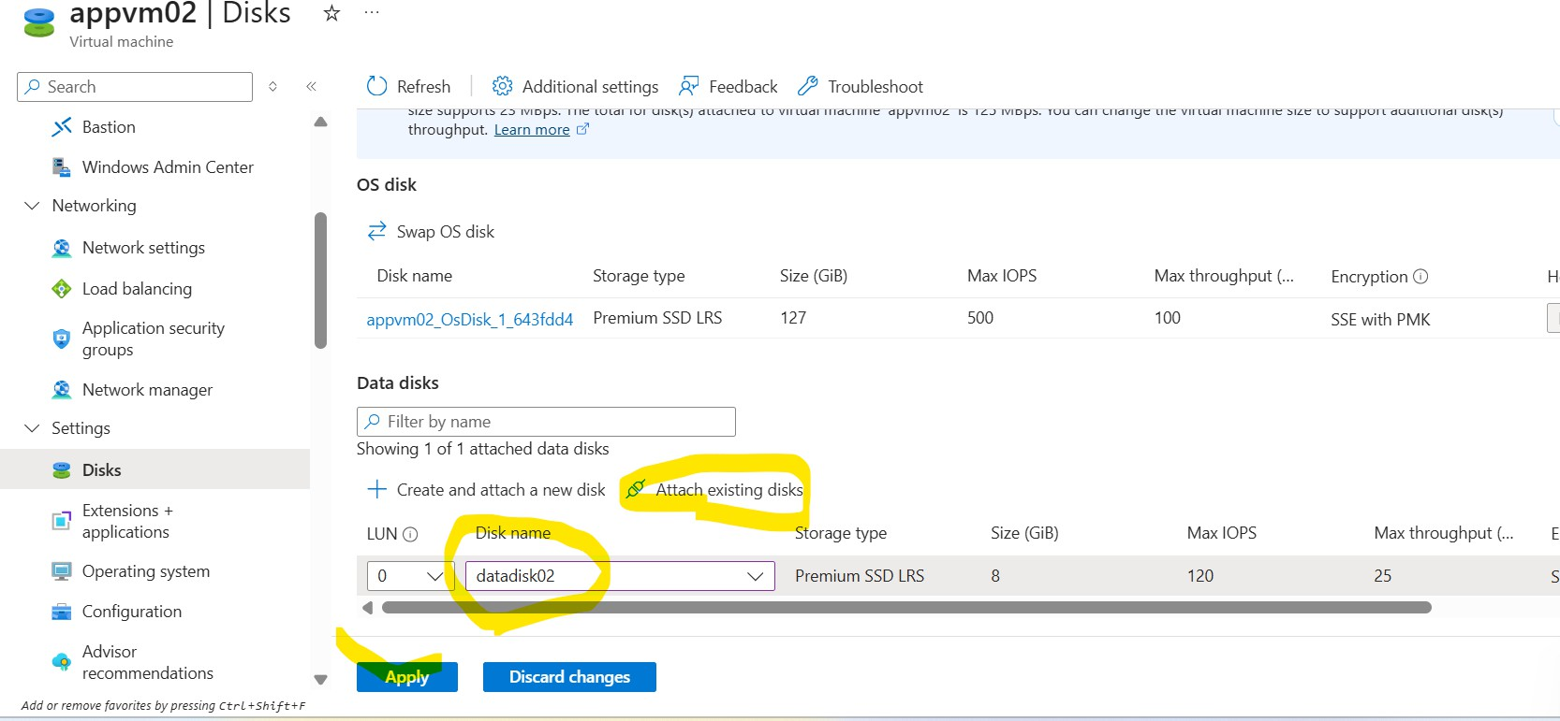Now go to appvm02 and attach disk02 as existing disk

