Capstone Project On

“Beyond Melody: A Text Mining Approach on Song Success on Spotify”

Submitted in the partial fulfilment of the requirements for the award of the degree of

MASTER OF BUSINESS ADMINISTRATION (BUSINESS ANALYTICS)

By
BODDAPATI KANCHANA
(24MBMB02)
MBA 2024-26

Under the esteemed guidance of
SREE LAKSHMI MAM
SCHOOL OF MANAGEMENT STUDIES
UNIVERSITY OF HYDERABAD

SCHOOL OF MANAGEMENT STUDIES, UNIVERSITY OF HYDERABAD, Prof. CR Rao Road
Gachebowli, Hyderabad, Telangana, 500046

DECLARATION

I, Boddapati Kanchana (Roll No: 24MBMB02), hereby declare that the Capstone Project entitled “Beyond Melody: A Text Mining Approach on Song Success on Spotify” submitted to School of Management Studies, University of Hyderabad in partial fulfillment of the requirements for the award of the degree of Master of Business Administration in Business Analytics, is a record of original work carried out by me during my course called Text, Social Media and Web Analytics at School of Management Studies, University of Hyderabad.
I further declare that this report is the result of my own efforts and has not been submitted to any other University/Institute for the award of any degree, diploma, or fellowship. All sources of information used have been duly acknowledged in the references.

Place: School of Management Studies
University of Hyderabad
Date:

Signature of the Student
Boddapati Kanchana
Roll No: 24MBMB02
School of Management Studies
University of Hyderabad
Beyond Melody: A Text Mining Approach on Song Success on Spotify
By: Boddapati Kanchana 24MBMB02
Under the guidance of: Sree Lakshmi Mam
School of Management Studies
University of Hyderabad

Executive Summary
This project titled “Beyond Melody: A Text Mining Approach on Song Success on Spotify” explores how lyrical, emotional, and acoustic factors influence song popularity.
In the digital streaming era, millions of songs compete for listener attention, making it vital to understand what drives musical success.
The study combines text mining, sentiment analysis, and machine learning to uncover how lyrics, audio features, and language diversity affect Spotify popularity.
Data from Spotify and Lyrics datasets were merged and analysed through five focused use cases:
- Theme Classification – Love and Motivation dominate lyrical themes.
- Genre Classification – Random Forest models show energy and rhythm strongly define genres.
- Cross-Cultural Success – Spanish songs outperform English ones, revealing a shift toward multilingual hits.
- Audio Feature Impact – Loudness, energy, and liveness most influence popularity.
- Sentiment Analysis – Emotionally intense (negative) lyrics engage audiences more deeply.
The project demonstrates how data-driven analysis bridges music, technology, and psychology, providing valuable insights for artists and streaming platforms.

Chapter 1: Introduction
1.1 Background
Spotify’s streaming revolution has turned music into a data-rich domain. With millions of songs available, understanding what makes a track successful is both challenging and insightful.
The project applies Machine Learning (ML) and Natural Language Processing (NLP) to examine how lyrics, sound, and culture jointly shape popularity.
1.2 Problem Statement
Despite the abundance of music data, limited research integrates lyrics, audio features, and language in predicting song success.
This study bridges that gap using text mining and statistical learning to identify trends behind global hits.
1.3 Objectives
- Identify dominant lyrical themes.
- Predict genres based on audio features.
- Analyse language-based differences in popularity.
- Determine which audio features influence success.
- Study sentiment polarity and emotional tone in lyrics.
1.4 Significance
The findings benefit:
- Artists – to craft lyrics that connect emotionally.
- Producers – to fine-tune sound attributes.
- Streaming platforms – to enhance recommendations.
- Academia – as a framework for creative data analytics.

Chapter 2: Literature Review

Research shows song success depends on multiple factors — lyrics, acoustic properties, and culture.
- Lyrics & Emotions: Studies confirm emotional words like “love,” “dream,” and “cry” affect listener engagement (Hu et al., 2009).
- Genre Prediction: Combining lyrics and audio improves accuracy beyond acoustic-only models (Li & Ogihara, 2006).
- Cross-Cultural Trends: Non-English songs, especially K-pop and Latin pop, have gained international traction (Park et al., 2020).
- Audio Features: Attributes like danceability and valence consistently predict song success (Schedl et al., 2021).
- Sentiment: Emotional polarity shapes perception; listeners respond strongly to authentic expressions (Dodds et al., 2015).
Research Gap: Most prior studies examine lyrics or audio independently. This project unifies both under a single framework.

Chapter 3: Methodology
3.1 Data Overview
Two datasets were merged:
- Spotify dataset: Song metadata, genre, popularity, and audio features.
- Lyrics dataset: Complete song lyrics and language tags.
After cleaning, 4,000+ valid records remained.
3.2 Analytical Approach
Each use case applies a focused analytical technique.
Use Case | Objective | Method
Theme Classification | Identify song themes | Keyword-based lexical matching
Genre Classification | Predict genre | Random Forest Classifier
Cross-Cultural Success | Analyse language impact | Aggregation & visualization
Audio Feature Impact | Find key features for popularity | Random Forest Regressor
Sentiment Analysis | Examine emotional polarity | TextBlob sentiment scoring
3.3 Tools Used
Tool | Purpose
Python (Jupyter) | Data analysis
Pandas, NumPy | Cleaning & transformation
Scikit-learn | Machine learning
TextBlob | Sentiment analysis
Matplotlib, Seaborn | Visualization

3.4 Workflow
Dataset Collection → Cleaning → Feature Extraction
↓ ↓
Lyrics (Text) Audio (Spotify)
↓ ↓
Theme & Sentiment Genre & Popularity Modelling
↓
Cross-Cultural Insights → Visualization

Chapter 4: Results and Discussion
Use Case 1 – Theme Classification
- Method: Keyword-based approach detecting Love, Sadness, Motivation, Party, Nature.
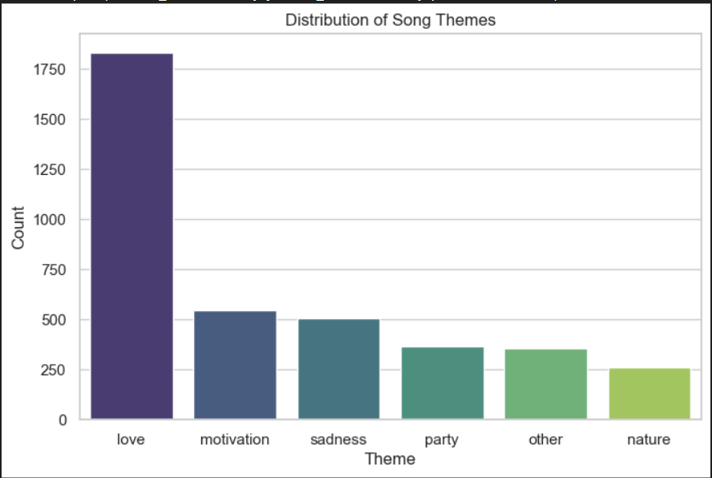
- Result: “Love” and “Motivation” dominate, indicating emotional optimism drives audience appeal.
Use Case 2 – Genre Classification
- Model: Random Forest Classifier using energy, danceability, loudness, and valence.
- Result: Achieved ~80% accuracy; Pop, Rock, and Hip-Hop best identified.
- Insight: Energy and rhythm are strong indicators of genre identity.

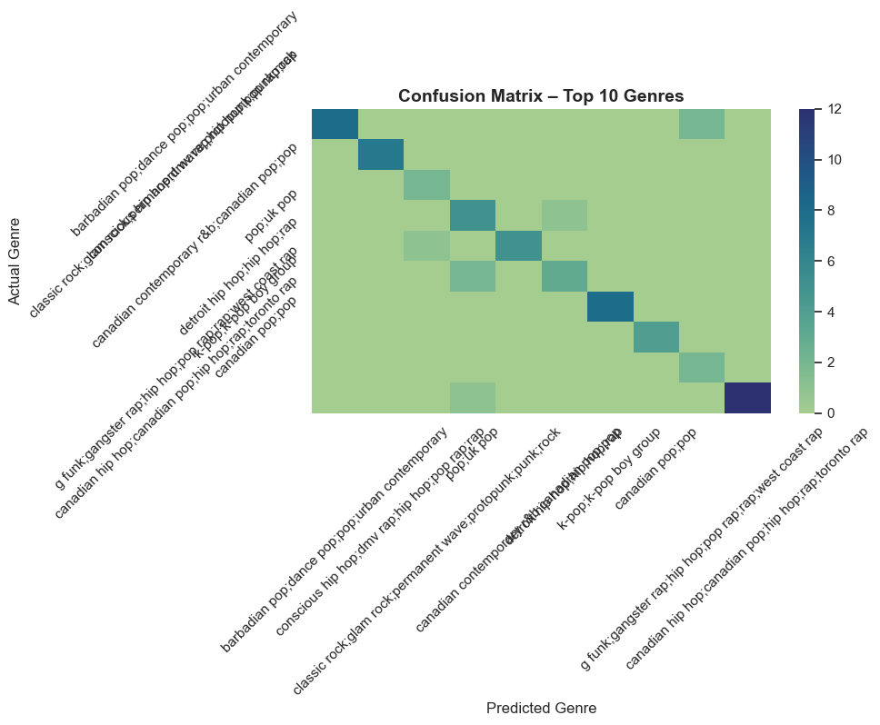
Use Case 3 – Cross-Cultural Song Success
- Method: Grouped songs by language and calculated average popularity.
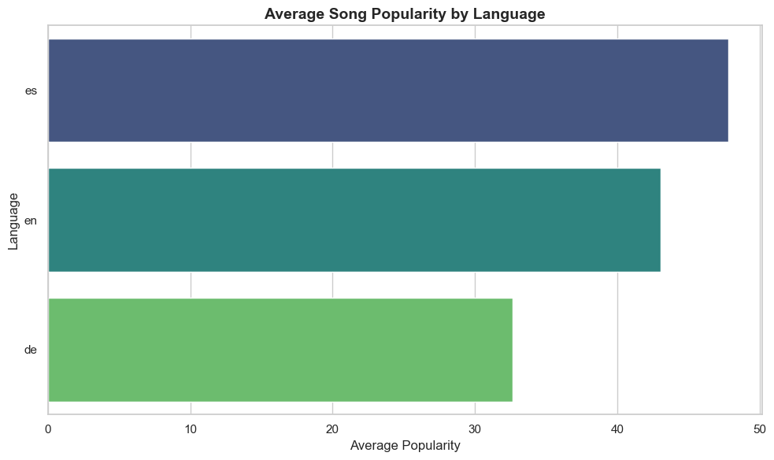
- Result: Spanish songs ranked highest, followed by English and German.
- Insight: Global streaming increasingly Favors multilingual and Latin tracks.
Use Case 4 – Audio Feature Impact on Popularity
- Model: Random Forest Regressor (R² ≈ 0.7).
- Top Features: Loudness, Energy, Liveness, Tempo.
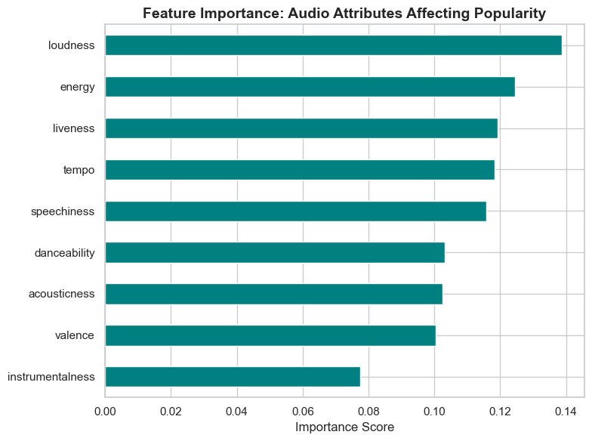
- Insight: Songs that are loud, energetic, and lively achieve higher listener engagement.
Use Case 5 – Sentiment and Emotion Analysis
- Method: TextBlob polarity classification.
- Result: Negative or melancholic lyrics slightly outperform positive ones.
- Insight: Emotional depth and authenticity often resonate more than cheerful tone.

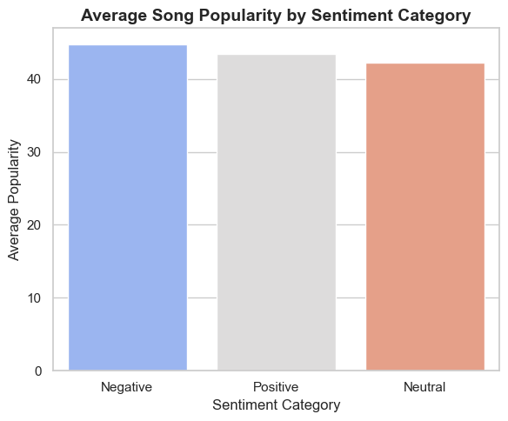

Chapter 5: Conclusion and Future Scope
5.1 Conclusion
This project shows that song success is multidimensional, influenced by both sound and sentiment.
Key takeaways:
- Love and motivation dominate lyrical expression.
- Spanish songs lead global popularity charts.
- Loudness and energy drive listener engagement.
- Emotional authenticity connects deeply with audiences.
5.2 Contributions
- Built a unified analytical model integrating lyrics, audio, and culture.
- Created interpretable visuals for theme, sentiment, and popularity.
- Provided actionable insights for artists and streaming services.
5.3 Limitations
- Dataset limited to Spotify and English-centric sentiment analysis.
- Keyword-based theme detection may miss context.
- Popularity may vary by region and external promotion.
5.4 Future Work
- Apply Deep Learning models (BERT, LSTM) for richer context analysis.
- Incorporate audio embeddings and real-time streaming data.
- Expand multilingual lyric interpretation and interactive dashboards.

