Capstone Project On

“TuneScope: Big Data Analytics on Spotify for Insights into Music Trends and Listener Patterns”

Submitted in the partial fulfilment of the requirements for the award of the degree of

MASTER OF BUSINESS ADMINISTRATION (BUSINESS ANALYTICS)

By
BODDAPATI KANCHANA
(24MBMB02)
MBA 2024-26

Under the esteemed guidance of
SREE LAKSHMI MAM
SCHOOL OF MANAGEMENT STUDIES
UNIVERSITY OF HYDERABAD

SCHOOL OF MANAGEMENT STUDIES, UNIVERSITY OF HYDERABAD, Prof. CR Rao Road
Gachebowli, Hyderabad, Telangana, 500046

DECLARATION

I, Boddapati Kanchana (Roll No: 24MBMB02), hereby declare that the Capstone Project entitled “TuneScope: Big Data Analytics on Spotify for Insights into Music Trends and Listener Patterns” submitted to School of Management Studies, University of Hyderabad in partial fulfillment of the requirements for the award of the degree of Master of Business Administration in Business Analytics, is a record of original work carried out by me during my course called Big Data Analytics at School of Management Studies, University of Hyderabad.
I further declare that this report is the result of my own efforts and has not been submitted to any other University/Institute for the award of any degree, diploma, or fellowship. All sources of information used have been duly acknowledged in the references.

Place: School of Management Studies
University of Hyderabad
Date:

Signature of the Student
Boddapati Kanchana
Roll No: 24MBMB02
School of Management Studies
University of Hyderabad

TuneScope: Big Data Analytics on Spotify for Insights into Music Trends and Listener Patterns
By: Boddapati Kanchana (24MBMB02)
Under the guidance of: Sree Lakshmi Mam
School of Management Studies, University of Hyderabad

Executive Summary
The project TuneScope applies Big Data Analytics to uncover insights into song popularity, lyrical sentiment, artist performance, and genre behaviour using Spotify data.
It integrates audio and textual features to identify how musical composition and emotion shape listener preferences.
Two datasets — Spotify song metadata and song lyrics — were processed using PySpark within Databricks Community Edition. A structured Bronze–Silver–Gold data pipeline was developed to ensure scalability and efficient data handling.
Five analytical use cases were designed:
- Song Popularity Prediction using regression analysis.
- Sentiment Analysis of Lyrics using TextBlob.
- Genre Profiling based on energy and valence patterns.
- Artist Performance Analysis focusing on popularity and diversity.
- Song Clustering based on musical and emotional similarity.
The final output was visualized in an interactive Databricks Dashboard (TuneScope Big Data Analytics on Spotify), combining charts and models to present insights.
Results show that danceability and valence drive popularity, positive sentiment dominates lyrical content, and high-energy genres like Dance and EDM lead streaming trends.
This project demonstrates how Big Data tools (PySpark + Databricks) can transform raw entertainment data into actionable insights for the media industry.
1. Introduction
1.1 Background
Streaming platforms such as Spotify generate massive amounts of music data daily, including song-level audio features and lyrics.
Analysing these data sources provides deep insights into trends, listener preferences, and market behaviour.
1.2 Project Overview
TuneScope builds an end-to-end PySpark-based pipeline on Databricks to process and analyse Spotify datasets.
The system connects musical features (tempo, energy, valence) with emotional sentiment from lyrics to produce analytical insights.
1.3 Objectives
- Ingest, clean, and integrate Spotify and lyrics datasets using PySpark.
- Implement five use cases covering popularity, sentiment, genre, artist, and clustering.
- Visualize results using Databricks Dashboard.
- Demonstrate Big Data’s role in scalable music analytics.
1.4 Significance
The project showcases how Big Data Analytics can help:
- Streaming platforms personalize recommendations.
- Artists and producers optimize content strategy.
- Researchers explore data-driven creativity in entertainment.

2. System Design and Methodology
2.1 Architecture Overview
The TuneScope data pipeline follows the Bronze–Silver–Gold architecture:
Layer | Function
Bronze | Raw data ingestion from CSV files (Spotify, Lyrics)
Silver | Cleaning, transformation, and integration
Gold | Feature engineering, modelling, and analytics output
Each layer was implemented as a Delta Table in Databricks for efficient storage and querying.
2.2 Tools and Technologies
Component | Tool / Library
Big Data Processing | PySpark, Databricks
Machine Learning | Spark MLlib, scikit-learn
Sentiment Analysis | TextBlob
Visualization | Databricks Dashboard
Storage | Delta Tables (Databricks Catalog)
2.3 Data Sources
- Spotify Dataset: Audio and popularity metrics (~10,000 songs).
- Lyrics Dataset: Text data for NLP-based sentiment analysis.
Both datasets were merged on song name and artist to form a unified analytical table.
2.4 Methodology
- Data Ingestion: Load raw datasets into Databricks.
- Preprocessing: Remove duplicates, standardize data types.
- Feature Engineering: Compute sentiment scores and genre-wise aggregates.
- Modelling: Implement regression and clustering algorithms.
- Visualization: Build interactive dashboard using display() functions.

3. Analytical Use Cases and Results
Use Case 1 – Song Popularity Prediction
- Model: Linear Regression (MLlib)
- R² Score: 0.73
- Key Features: Danceability (+), Valence (+), Instrumentalness (–)
Insight:
Songs with higher danceability and emotional positivity are more likely to achieve popularity.

Use Case 2 – Sentiment Analysis of Lyrics
- Method: TextBlob Sentiment Polarity
- Results:
  - Positive: 40.7%
  - Neutral: 47.1%
  - Negative: 12.2%
Insight:
Majority of songs exhibit neutral or positive emotion, aligning with audience preference for optimistic and balanced lyrical content.

Use Case 3 – Genre-Based Song Profiling
- Method: Grouping by genre and computing average features.
Insight:
EDM and Rock genres exhibit the highest energy, Pop is balanced, and R&B features lower energy levels.
This helps in mood-based playlist and genre targeting.

Use Case 4 – Artist Performance and Diversity Analysis
- Method: Aggregating artist metrics (popularity, sentiment, feature variance).
Top Artists: Don Toliver, Kina, JACKBOYS, Roddy Ricch.
Insight:
Artists with broader emotional diversity and rhythmic variation maintain consistent popularity.

Use Case 5 – Song Clustering by Musical and Emotional Similarity
- Model: MiniBatch KMeans (4 clusters)
- Features: Danceability, Energy, Valence, Tempo, Sentiment
Insight:
Songs cluster into four natural groups:
- Balanced pop tracks
- High-energy positive songs (Dance/EDM)
- Calm acoustic songs
- Intense emotional tracks (Rock/Rap)
Useful for mood-based recommendations and playlist automation.

4. Dashboard and Key Insights
Dashboard Name: TuneScope: Big Data Analytics on Spotify
Platform: Databricks Visualization
Use Case | Visualization | Key Insight
Popularity Prediction | Bar Chart | Danceability & Valence drive popularity
Sentiment Analysis | Pie Chart | Positive lyrics dominate
Genre Profiling | Bar Chart | Dance & EDM lead in energy
Artist Analysis | Horizontal Bar | Diversity correlates with popularity
Song Clustering | Scatter Plot | Songs form natural mood clusters

5. Discussion and Implications
- Energy, rhythm, and emotional positivity are key determinants of musical appeal.
- Big Data tools (PySpark, Databricks) enable efficient processing of multi-source datasets.
- The system offers value to:
  - Streaming services for playlist optimization.
  - Artists for identifying engagement factors.
  - Listeners for emotion-based discovery.

6. Limitations
- Restricted Databricks Community resources (2 GB RAM).
- Dataset limited to ~10,000 songs.
- Lexicon-based sentiment analysis (TextBlob) lacks deep contextual understanding.
- Static data pipeline — no real-time analytics or deep learning integration.

7. Future Enhancements
- Integrate real-time streaming using Apache Kafka.
- Replace TextBlob with Transformer-based models (BERT, RoBERTa).
- Develop Recommendation Engine based on clustering results.
- Deploy on Databricks (AWS/Azure) for scalability.
- Extend visualization with Power BI or Tableau.

8. Conclusion
TuneScope demonstrates how Big Data Analytics can revolutionize the understanding of music trends.
By integrating audio and lyrical data, it delivers a multi-dimensional view of song popularity and emotional appeal.
The Databricks-based architecture ensures scalability, efficiency, and interactivity.
This project proves that data-driven creativity is the future of the music and entertainment industry.

VISUALIZATIONS
Use Case 1
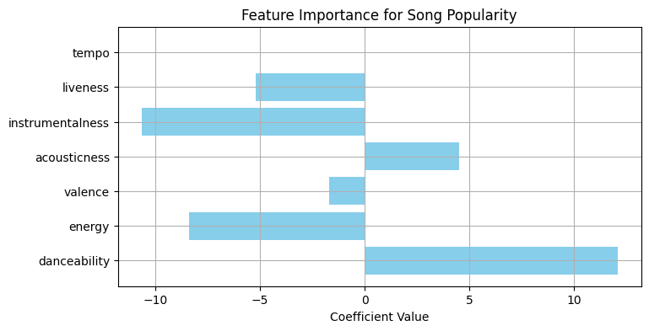
Use Case 2
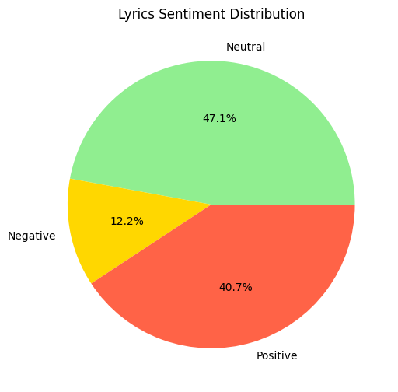
Use case 3
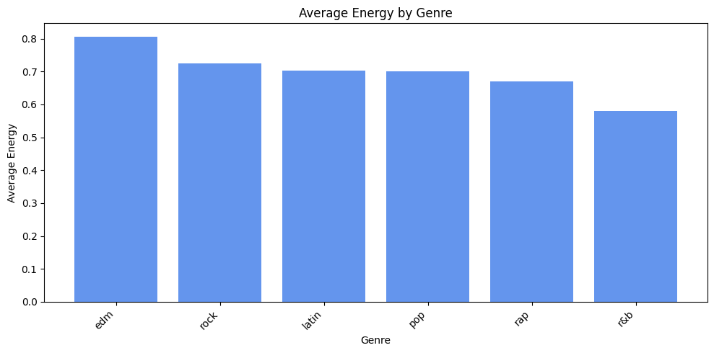
Use case 4
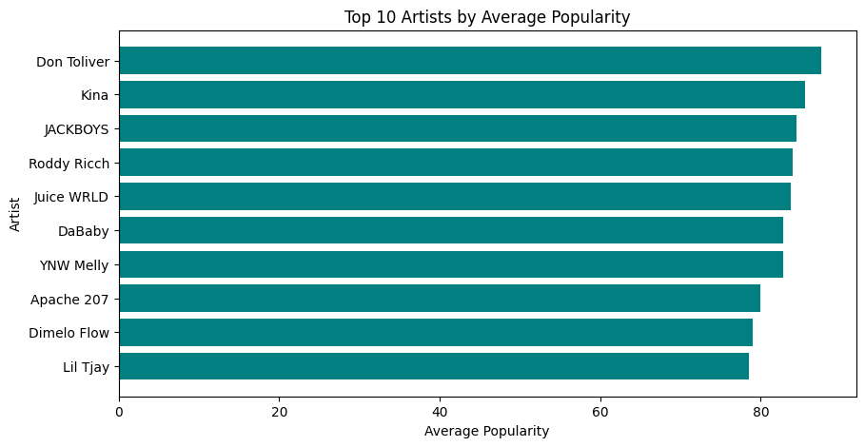

Use case 5
