**Exploratory Data Analysis insights**

**Summery Statistics**

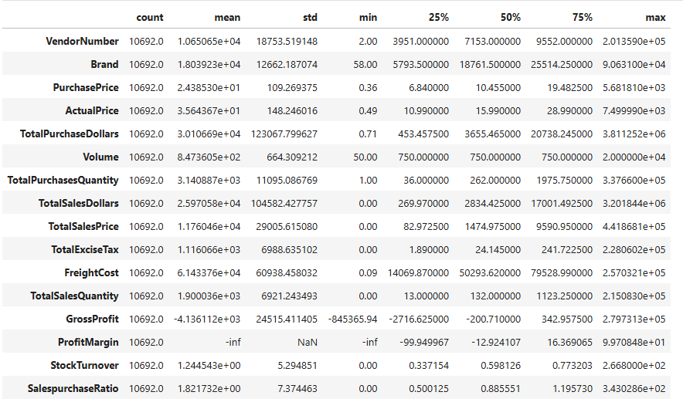

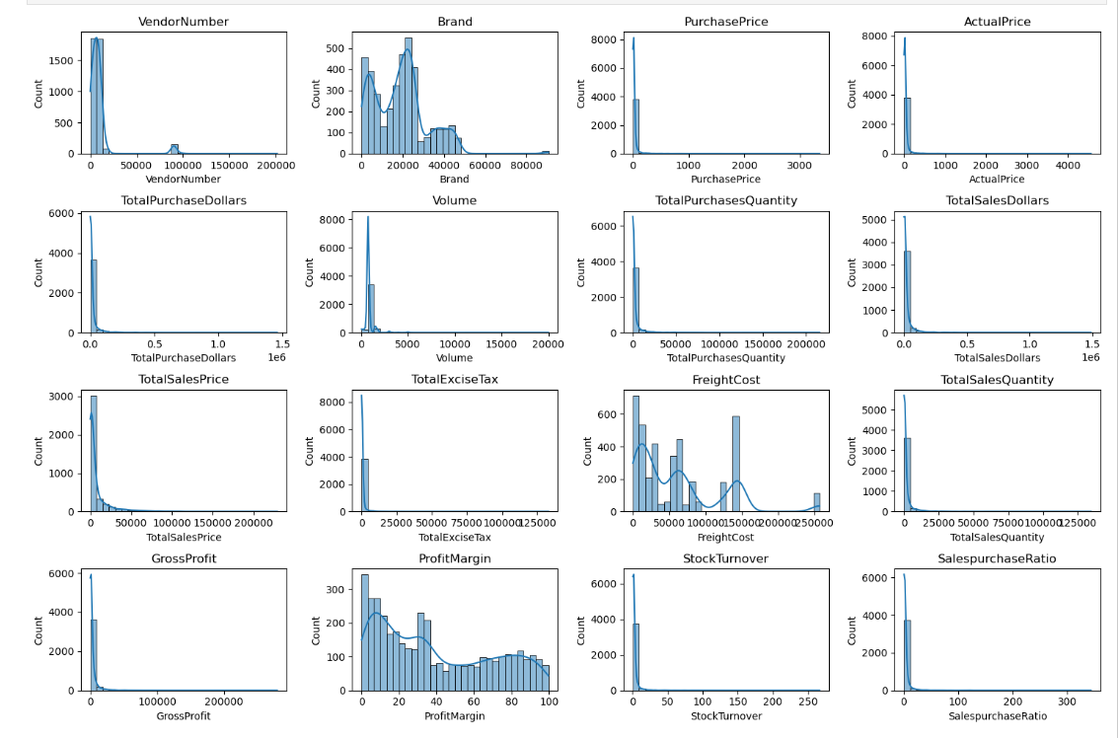

**Negative & Zero Values:**

• **Gross Profit:** Minimum value is -52,002.78, indicating losses. Some products or transactions may be selling at a loss due to high costs or selling at discounts lower than the purchase price.

• **Profit Margin:** Has a minimum of -∞, which suggests cases where revenue is zero or even lower than costs.

• **Total Sales Quantity & Sales Dollars:** Minimum values are 0, meaning some products were purchased but never sold. These could be slow-moving or obsolete stock.

**Outliers Indicated by High Standard Deviations:**

• **Purchase & Actual Prices:** The max values (5,681.81 & 7,499.99) are significantly higher than the mean (24.39 & 35.64), indicating potential premium products.

• **Freight Cost**: Huge variation, from 0.09 to 257,032.07, suggests logistics inefficiencies or bulk shipments.

• **Stock Turnover:** Ranges from 0 to 274.5, implying some products sell extremely fast while others remain in stock indefinitely. Value more than 1 indicates Sold quantity for that product is higher than purchased quantity due to either sales are being fulfilled from older stock. LUK IManes

**Data Filtering**

To enhance the reliability of the insights, we removed inconsistent data points where:

• Gross Profit ≤ 0 (to exclude transactions leading to losses).

• Profit Margin ≤ 0 (to ensure analysis focuses on profitable transactions).

• Total Sales Quantity = 0 (to eliminate inventory that was never sold).

**Correlation Insights**

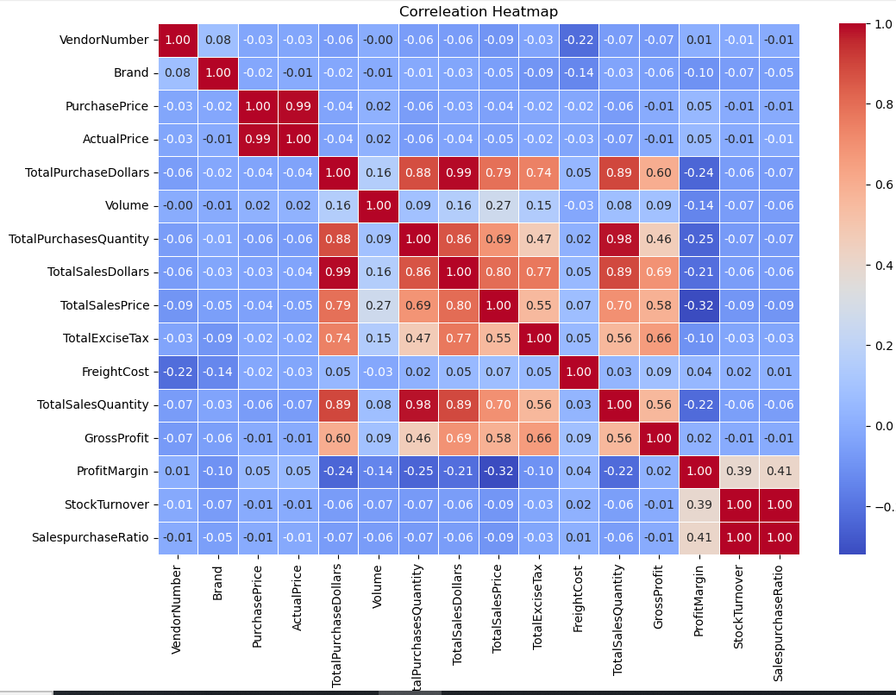

**Correlation Insights**

• PurchasePrice has weak correlations with TotalSales Dollars (-0.012) and Gross Profit (-0.016), suggesting that price variations do not significantly impact sales revenue or profit.

• Strong correlation between total purchase quantity and total sales quantity (0.999), confirming efficient inventory turnover.

• Negative correlation between profit margin & total sales price (-0.179) suggests that as sales price increases, margins decrease, possibly due to competitive pricing pressures.

• StockTurnover has weak negative correlations with both GrossProfit (-0.038) and ProfitMargin (-0.055), indicating that faster turnover does not necessarily result in higher profitability.

**Research Questions and Key Findings**

1. **Brands for Promotional or Pricing adjustments**

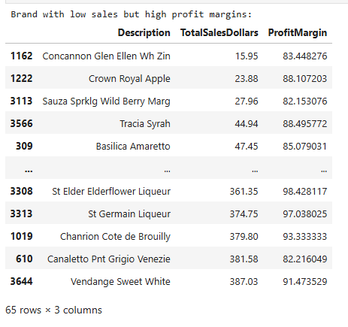

68 brands exhibit lower sales but higher profit margins, which could benefit from targeted marketing, promotions, or price optimizations to increase volume without compromising profitability.

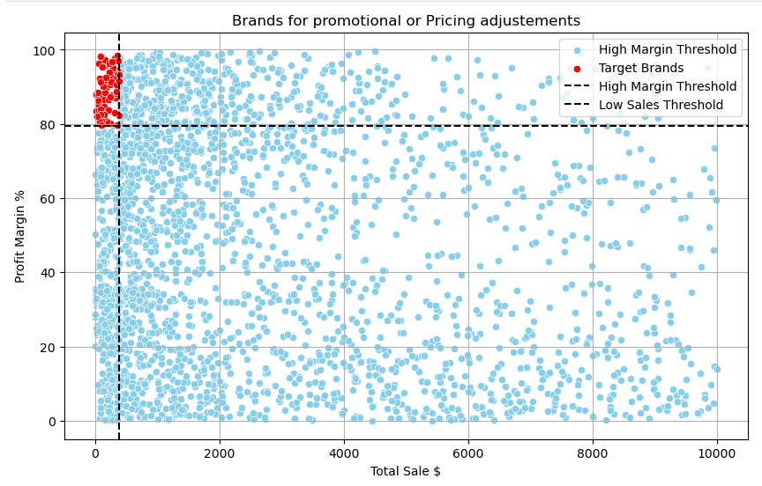

1. **Top Vendors by Sales and Purchase Contribution**

The top 10 vendors contribute 64.64% of total purchases, while the remaining vendors contribute only 34.36%. This over-reliance on a few vendors may introduce risks such as supply chain disruptions, indicating a need for diversification.

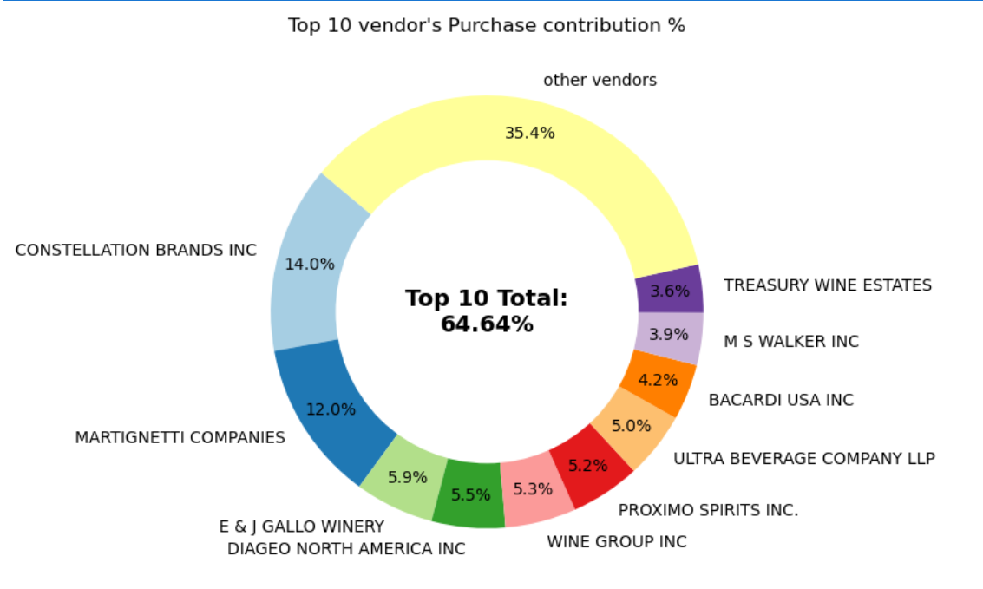

**3. Impact of Bulk Purchasing on Cost Savings**

Vendors buying in large quantities receive a 72% lower unit cost ($8.50 per unit vs. higher unit costs in smaller orders).

Bulk pricing strategies encourage larger orders, increasing total sales while maintaining profitability.

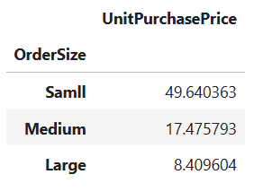

**4. Identifying Vendors with Low Inventory Turnover**

Total Unsold Inventory Capital: $12.63 M

Slow-moving inventory increases storage costs, reduces cash flow efficiency, and affects overall profitability.

Identifying vendors with low inventory turnover enables better stock management, minimizing financial strain.

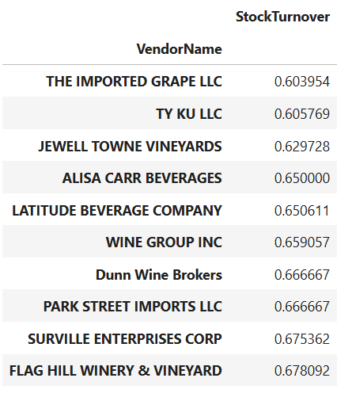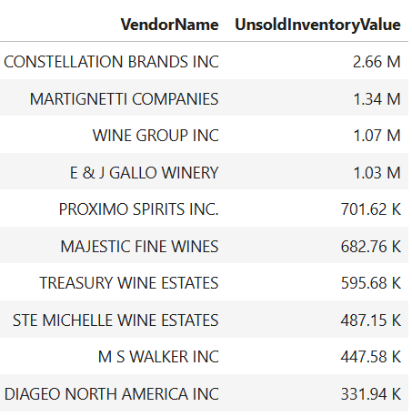

**5. Profit Margin Comparison: High vs. Low-Performing Vendors**

Top Vendors' Profit Margin (95% CI): (17.74% to 20.27%) Mean: 19.00%

Low Vendors' Profit Margin (95% CI): (44.92% to 48.25%), Mean: 46.59%

Low-performing vendors maintain higher margins but struggle with sales volumes, indicating potential pricing inefficiencies or market reach issues. Actionable Insights:

Actionable Insights:

* **Top-performing vendors:** Optimize profitability by adjusting pricing, reducing operational costs, or offering bundled promotions.
* **Low-performing vendors:** improve marketing efforts, optimize pricing strategies and enhance distribution networks.

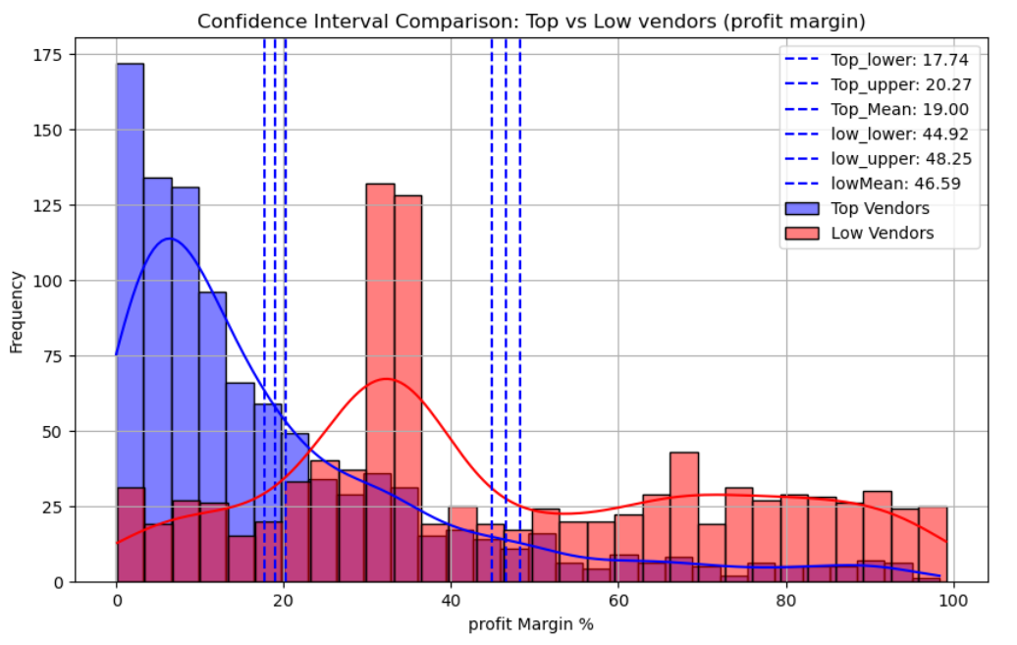

**6. statistical Validation of Profit Margin Differences**

**Hypothesis:**

**Ho (Null Hypothesis):** There is no significant difference in the mean profit margins of top-performing and low-performing vendors.

**H1 (Alternative Hypothesis):** The mean profit margins of top-performing and low-performing vendors are significantly different.

**Result:** the null hypothesis is rejected, confirming that the two groups operate under distinctly different profitability models

**Implication:** High-margin venders may benefit from better pricing strategies, while top-selling vendors could focus on cost efficiency.

**Final Recommendations**

• Re-evaluate pricing for low-sales, high-margin brands to boost sales volume without sacrificing profitability.

• Diversify vendor partnerships to reduce dependency on a few suppliers and mitigate supply chain risks.

• Leverage bulk purchasing advantages to maintain competitive pricing while optimizing inventory management.

• Optimize slow-moving inventory by adjusting purchase quantities, launching clearance sales, or revising storage strategies.

• Enhance marketing and distribution strategies for low-performing vendors to drive higher sales volumes without compromising profit margins.

• By implementing these recommendations, the company can achieve sustainable profitability, mitigate risks, and enhance overall operational efficiency.