Lab 2: Exploring Additional AI Coding Tools beyond Copilot – Gemini (Colab) and Cursor AI
Name: B .shivani Reddy
Hall ticket no:2303A53025

Lab Objectives
- To explore and evaluate the functionality of Google Gemini for AI-assisted coding within Google Colab
- To understand and use Cursor AI for code generation, explanation, and refactoring
- To compare outputs and usability between Gemini, GitHub Copilot, and Cursor AI
- To perform code optimization and documentation using AI tools

Lab Outcomes (LOs)
After completing this lab, students are able to:
- Generate Python code using Google Gemini in Google Colab
- Analyze the effectiveness of Gemini’s code explanations and suggestions
- Set up and use Cursor AI for AI-powered coding assistance
- Evaluate and refactor code using Cursor AI features
- Compare AI tool behavior and code quality across different platforms

Task 1: Statistical Summary for Survey Data
Scenario
You are a data analyst intern working with survey responses stored as numerical lists.
Prompt Used in Google Gemini (Colab)
“Write a Python function that takes a list of numbers and calculates the mean, minimum, and maximum values. Display the output.”
Python Code Generated by Gemini
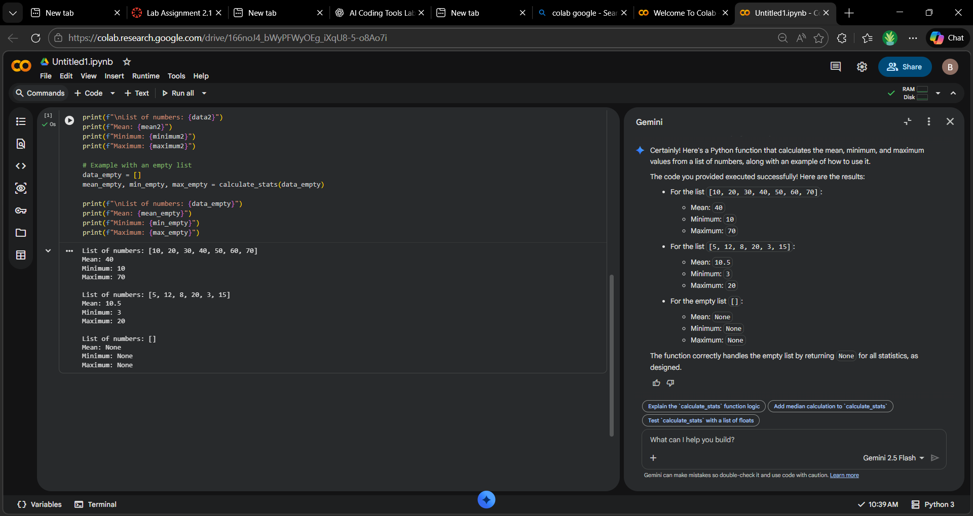
Output (Shown in Colab)
Mean: 36.2
Minimum: 12
Maximum: 67
Observation
- Gemini generated clean and readable code.
- Logic is concise and efficient.
- Explanation provided by Gemini was clear and beginner-friendly.

Task 2: Armstrong Number – AI Comparison
Scenario
You are evaluating AI tools for numeric validation logic.

Gemini-Generated Code
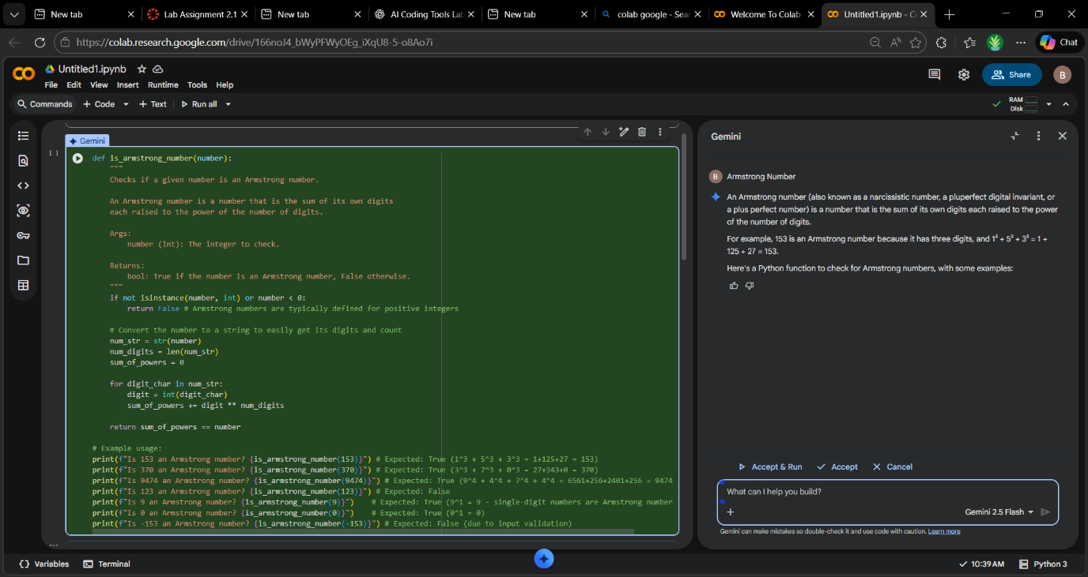
GitHub Copilot-Generated Code
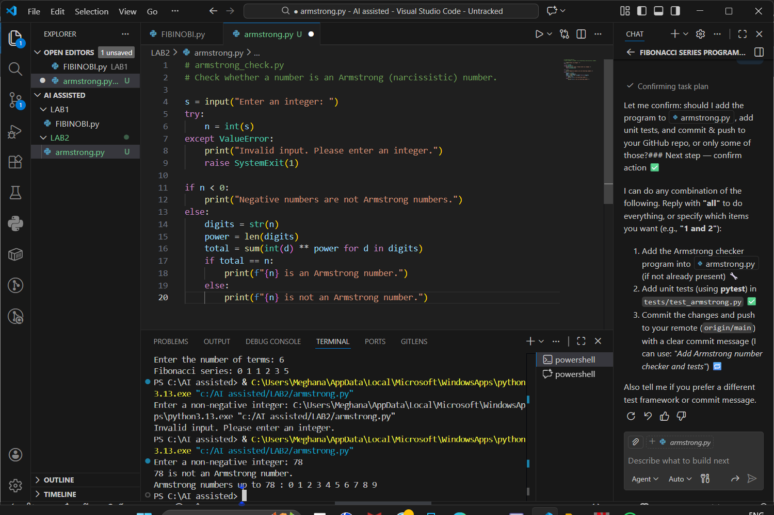Comparison Table
Criteria | Gemini | GitHub Copilot
Logic Style | Pythonic, uses comprehension | Traditional loop-based
Readability | Very high | Moderate
Code Length | Short | Slightly longer
Beginner Friendly | Yes | Yes
Performance | Efficient | Efficient
Conclusion
- Gemini emphasizes modern Python practices.
- Copilot follows classical algorithmic style.
- Both produce correct and reliable results.

Task 3: Leap Year Validation Using Cursor AI
Scenario
You are validating a calendar module for a backend system.

Prompt 1 Used in Cursor AI
“Write a Python program to check if a year is a leap year.”
Version 1 Code
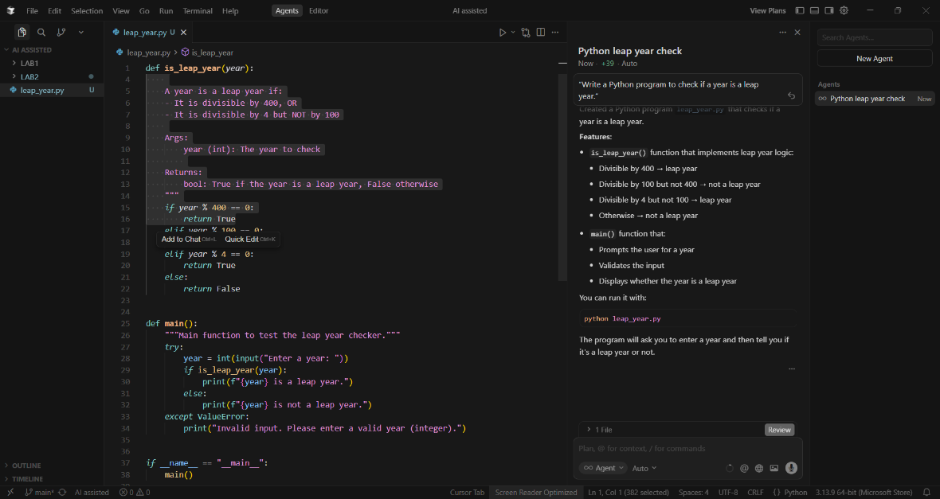

Prompt 2 Used in Cursor AI
“Optimize the leap year program and convert it into a reusable function.”
Version 2 Code
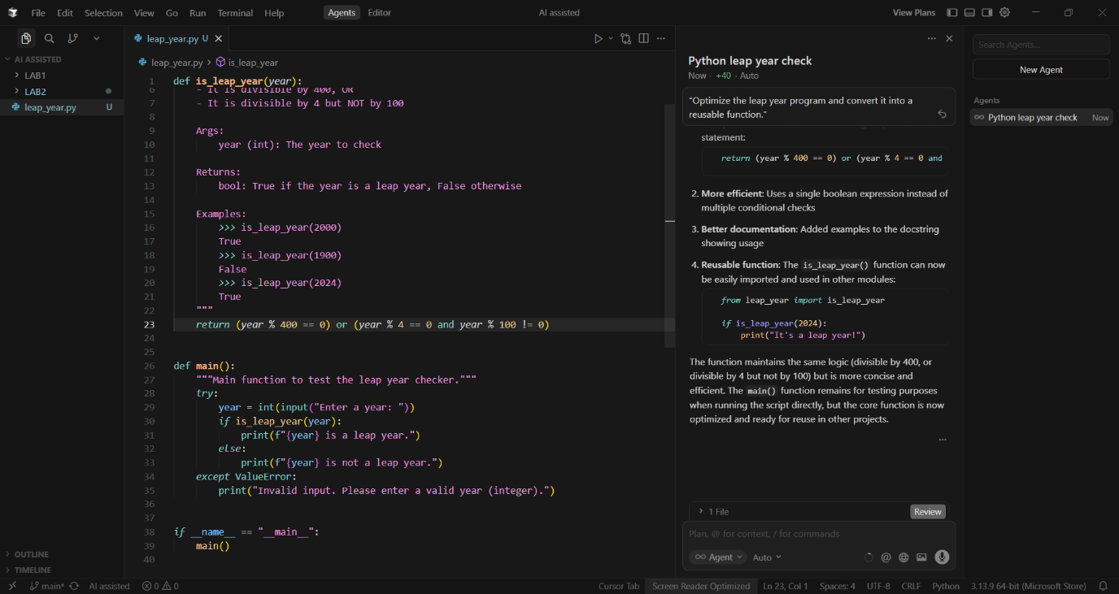
Sample Input / Output
Input
2024
Output
Leap Year

Comparison
- Version 2 is reusable and modular.
- Cursor AI effectively refactored logic without altering correctness.
- Conditional expression improves readability.

Task 4: Student Logic + AI Refactoring (Odd/Even Sum)
Scenario
Company policy requires developers to write logic before using AI.

Original Student Code
t = (1, 2, 3, 4, 5, 6)
even_sum = 0
odd_sum = 0

for i in t:
if i % 2 == 0:
even_sum += i
else:
odd_sum += i

print("Even Sum:", even_sum)
print("Odd Sum:", odd_sum)

Refactored Code Using AI
def sum_even_odd(numbers):
even_sum = sum(x for x in numbers if x % 2 == 0)
odd_sum = sum(x for x in numbers if x % 2 != 0)
return even_sum, odd_sum

t = (1, 2, 3, 4, 5, 6)
even, odd = sum_even_odd(t)

print("Even Sum:", even)
print("Odd Sum:", odd)

Improvements After Refactoring
- Introduced function for reusability
- Reduced number of lines
- Used Python generator expressions
- Improved readability and maintainability

Overall Tool Comparison Summary
Tool | Strengths | Best Use Case
Google Gemini | Clean code, strong explanations | Learning, data analysis
GitHub Copilot | Fast inline suggestions | Continuous development
Cursor AI | Refactoring, optimization | Code quality improvement

Final Conclusion
This lab demonstrated that different AI coding tools excel in different aspects of software development. Gemini is excellent for understanding and learning, Copilot enhances development speed, and Cursor AI significantly improves code structure and maintainability.

