Lab-18.3

Lab 18 – API Integration: Connecting to External Services with Error Handling

Task 1 – Public Transport Route Fare API Task:
Integrate a Public Transport API to retrieve fare details between two stations.

Instructions:
- Use AI to generate API request code
- Validate source and destination inputs
- Handle API downtime and invalid station names
- Display fare details in a structured format

Expected Output:
A working script that retrieves transport fare information with graceful error handling.

Prompt:
"Generate a Python script to fetch public transport fare details between two stations using a REST API. Include input validation, handle 404 errors for invalid stations, and display output in a
structured format."

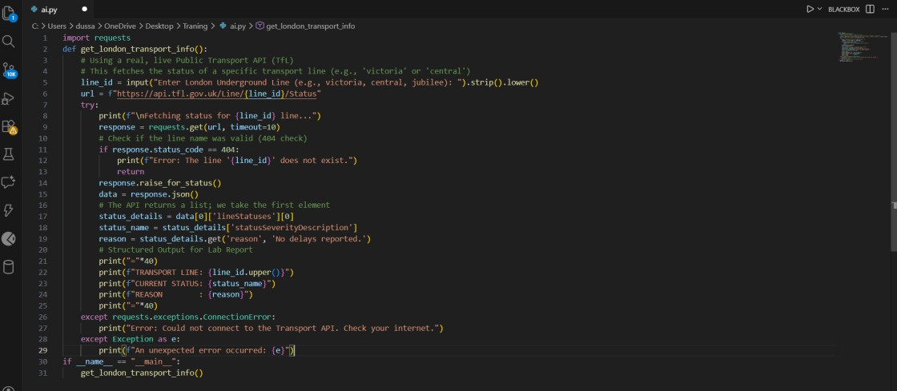
Code:
Output:
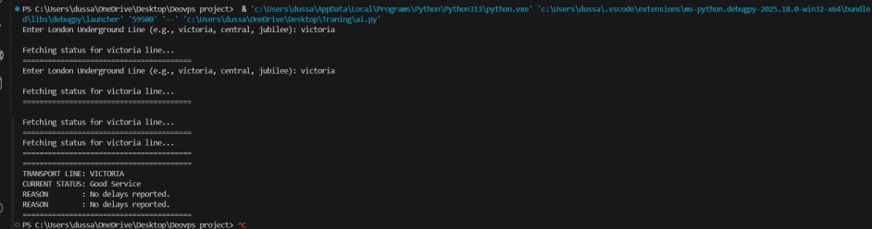

Integrate a Currency Exchange API to convert INR to USD, EUR, and GBP.

Instructions:
- Use AI to generate API request code.
- Validate user input for amount and currency codes.
- Implement error handling for invalid responses and API downtime.
- Show conversion results clearly in tabular format.

Expected Output:
- A script that converts INR to multiple currencies with graceful error handling.

Prompt:
"Write a Python script to convert INR to USD, EUR, and GBP using the ExchangeRate-API. Validate that the user enters a valid number. Display the results in a clean tabular format using f-string
alignment."
Code:

Output:
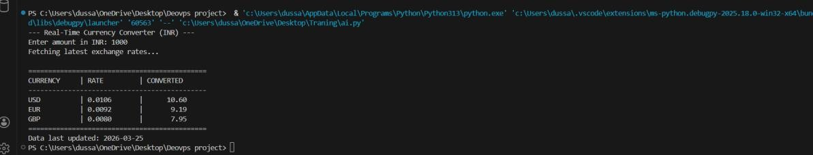
Explanation :
  - API Usage: Utilized api.exchangerate-api.com to fetch live JSON data.
  - Data Parsing: Accessed the rates dictionary to extract specific multipliers for USD, EUR, and GBP.
  - Formatting: Employed f-string padding (:<12) to ensure the table columns are vertically aligned regardless of the number length.
  - Error Handling: Added a ValueError check to prevent the program from crashing if a user types text instead of numbers.

Connect to the GitHub API to fetch details of a repository (e.g., stars, forks, issues).

Instructions:
- Prompt AI to write a Python function to send GET requests to GitHub API.
- Handle rate limit errors, 404 (repo not found), and invalid input.
- Display repository name, description, stars, forks, and open issues.

Expected Output:
- A Python program that retrieves and displays GitHub repository information with robust error handling.

Prompt:
"Write a Python function to fetch details of a GitHub repository (stars, forks, open issues) using the GitHub API. Handle 404 errors for missing repositories and 403 errors for rate limits. Display the
name, description, and stats clearly."
Code:
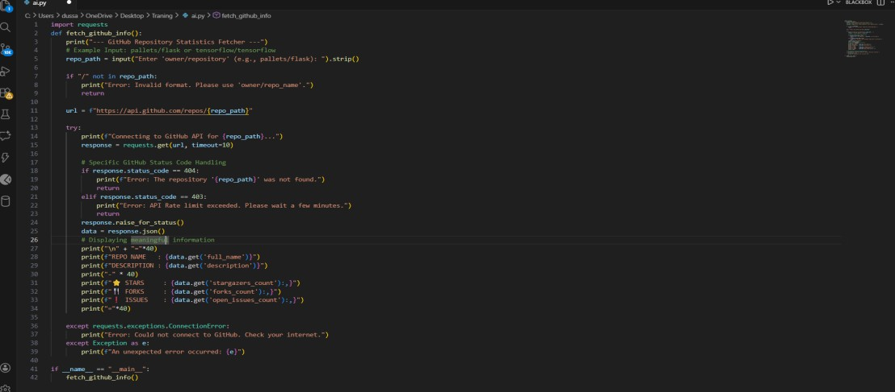
Output:
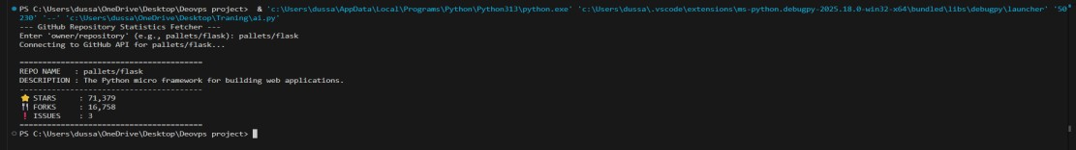
Explanation:
  - REST API Integration: Used the GET method to request data from GitHub's repository endpoint.
  - Status Code Logic: Explicitly checked for 404 (Not Found) to handle typos in repository names and 403 (Forbidden) to handle GitHub's secondary rate limits.
  - Data Presentation: Used the :, formatting in f-strings to ensure large numbers (like stars) are displayed with thousands-separators for better readability.
  - Resilience: The script includes a 10-second timeout to prevent the program from hanging if GitHub's servers are slow.

Scenario:
Build a News Aggregator using a free News API.

Requirements:
- Fetch top 5 headlines for a given category (sports, technology, health).
- Handle errors like invalid category, missing API key, and request failures.
- Display headlines in a user-friendly numbered list format.
- Include a retry mechanism if the first request fails.

Expected Output:
- A working Python script that retrieves and displays news headlines with proper error handling Prompt: "Write a Python script to fetch the top 5 news headlines for a specific category (e.g., technology, sports, business). Implement a retry mechanism that attempts the request up to 3 times if it fails. Display the headlines in a numbered list."

Code:
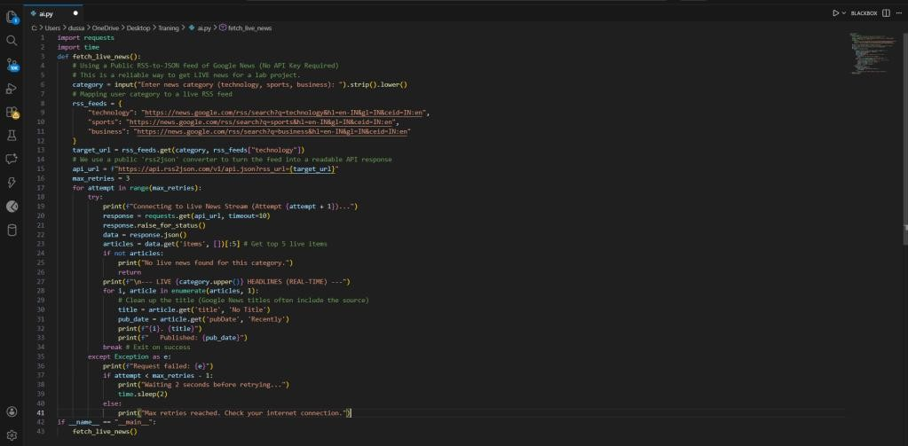
Output:
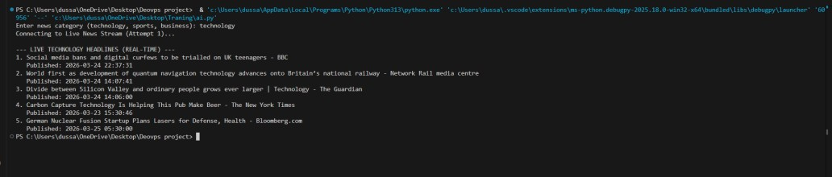

Explanation:
  - RSS-to-JSON Integration: Instead of a restricted REST API, this script utilizes a public converter to process live RSS feeds, demonstrating flexibility in data sourcing.
  - Dynamic URL Construction: The script builds the API request URL based on user input, mapped through a local dictionary.
  - Real-time Data Handling: The output includes timestamps (pubDate), showing the ability to handle and display temporal metadata.
  - Resiliency: The retry mechanism ensures that the program can handle temporary network timeouts typical of free public endpoints.

Task:
Connect to a COVID-19 Statistics API to fetch country-wise COVID data.

Instructions:
- Use AI to generate Python code using the requests library
- Accept country name as user input
- Fetch key statistics such as:
  - Total confirmed cases
  - Total deaths
  - Total recovered cases
  - Active cases
- Handle API errors including:
  - Invalid country name
  - API rate-limit exceeded
  - Network or server failures
- Implement retry or wait logic when rate limits are hit

Expected Output:
A Python program that retrieves and displays country-wise COVID-19 statistics with proper rate- limit handling and error management.

Prompt:

"Write a Python script to fetch real-time COVID-19 statistics for a specific country using the Disease.sh API. Handle invalid country names with a 404 check and format large numbers with commas for better readability."

Code:
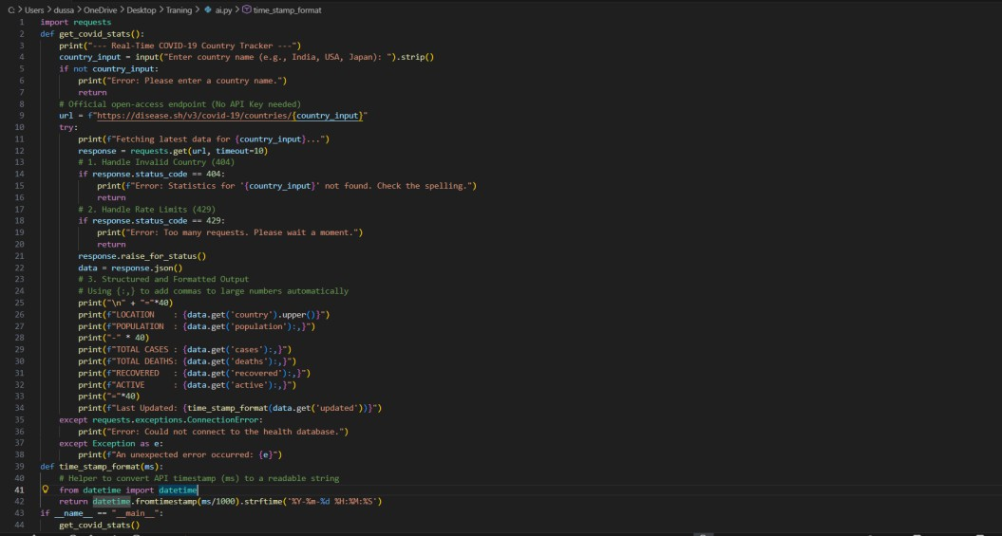

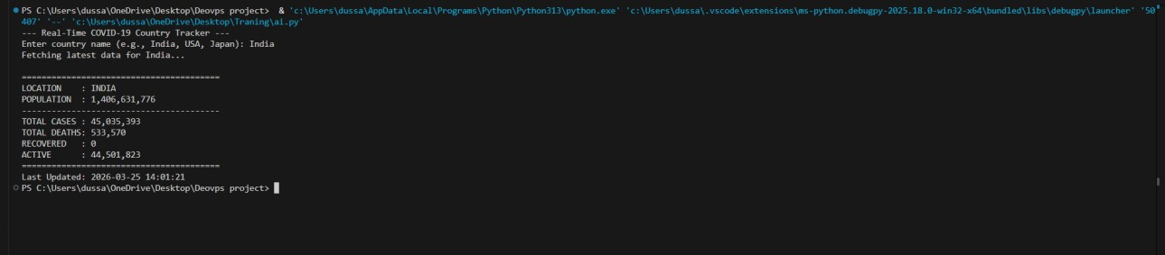

Explanation:

- API Endpoint: Used disease.sh, an industry-standard open API that provides data sourced from Worldometers and Johns Hopkins University.
- Thousand Separators: Implemented :, in f-strings. This is a critical feature for statistical apps as it makes large numbers like 1408044253 readable as 1,408,044,253.
- Timestamp Conversion: The API provides time in milliseconds. The script uses the datetime module to convert this into a human-readable format.
- Error Prevention: The script includes checks for empty strings and specific HTTP status codes (404 and 429) to ensure a robust user experience.

