A Technical Project Report

On

**GROCERY APP -USING KOTLIN**

**IN ANDROID STUDIO**

**SUBMITTED BY**

ANANTHA SAI TEJA BODDU

**SB20220248425**

**UNDER**



**DATE OF SUBMISSION: 15TH Sept 2022**

**INDEX**

**CHAPTER 1: Introduction**

**1.1 Abstract 1**

**1.2 Objective 1**

**CHAPTER 2: Background & Diagrams**

**2.1 Background 2**

**2.2 Studies 2**

**2.3 Challenges 2**

**2.4 Context Diagram 3**

**CHAPTER 3: Requirements**

**3.1 Software Requirements 4**

**3.2Hardware Requirements 4**

**CHAPTER 4: Implementation and Designing**

**4.1 Home Page 5**

**4.2 Pop Up 5**

**CHAPTER 5: Conclusion and Future Scope**

**5.1 Conclusion 6**

**5.2 Future Scope 6**

**5.3 Existed System 6**

**5.4 Proposed System 6**

**1**

**CHAPTER-I**

**1.1 Abstract:**

Now a days the whole world is adapting to the latest technologies where there is rapid development of applications which are very helpful.

Android studio is the free and open source software available for all types of systems which has different ways of applications development.

**1.2 Objective:**

The main theme of my project is able to order the daily grocery needs easily with help of this application.

* Ability to add items into cart along with name of item,quantity of items and price.
* Develop a database room which is used to store the user data which already added by the user in cart and user can also remove the previous added item in cart.
* User understandable manner.
* Best GUI components.

2

**CHAPTER 2**

**Background & Diagrams**

**2.1 Background:**

Grocery app consists of option to add an item in list.These items are sequentially maintained one by one where user can list out the items.

**\* UI design.**

**\* Android Application.**

**\* Database is maintained to store the data.**

**2.2 Studies:**

- Understandable manner.

- database is maintained.

- Create the vectors and Material Colours.

- Navigation of user action from one page to another page.

- user friendly.

**2.3 Challenges:**

Working with database friendly UI design for UX gradle and SDK settings.

**3**

**2.4 Context Diagram:**

Architecture of the user and admin.

Add item name

Order

Add item quantity

USER

4

**CHAPTER 3**

**REQUIREMENT OF COLLECTION ADN ANALYSIS:**

**3.1 SOFTWARE REQUIREMENTS:**

The Software Package is Developed Using Kotlin and Android Studio.basic Sql Commands Used to Store the Database

Operating System : Windows 11

Software : Kotlin and Java

Emulator : Pixel 4 (Api 30)

**3.2 HARDWAREREQUIREMENTRS:**

RAM : 8GB RAM

ROM : 20GB

**5**

**CHAPTER 4**

**4.1 HOME PAGE & LIST ITEMS**

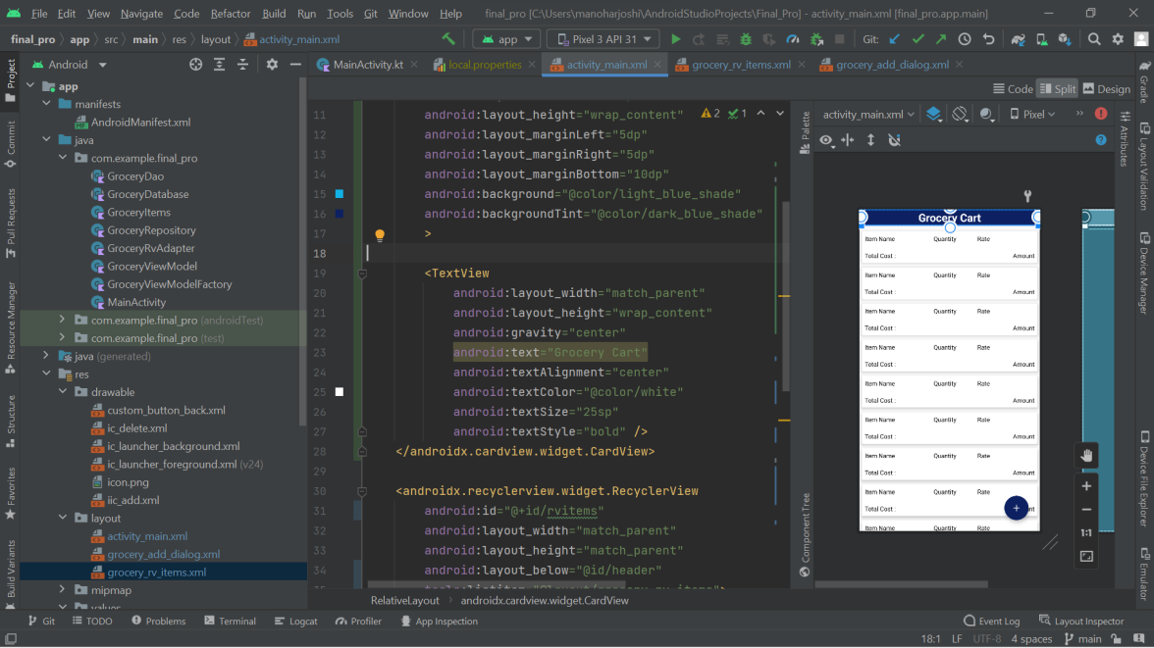

**4.2 POP UP PAGE**

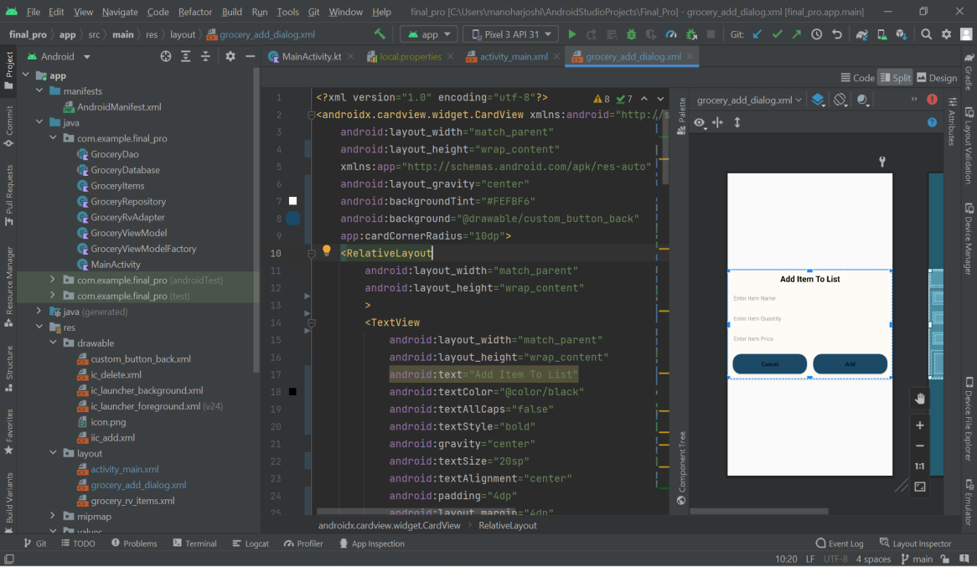

**6**

**CHAPTER 5**

**5.1 Conclusion:**

This APPLICATION is really helpful for users to order daily needs for home easily as per comfort.

I can conclude that using this Grocery app we can order daily needs.

**5.2 Future Scope:**

This application help to store the list of items by Admin . If required any items, those items can be added in future.

**5.3 Existed System:**

Mannually the people need to visit the grocery shops or any super markets daily to purchase the daily needs which consumes more time to purchase and it is a high time taken process.

**5.4 Proposed System:**

With this grocery app we can order the required items easily where it saves much time for purchase.

This application is really helpful to overcome the drawbacks of the manual process of purchasing.