**What is Kafka?**

* Apache Kafka is an open-source distributed event streaming platform.
* Event streaming means Creating Real-time stream & Process Real-time stream.

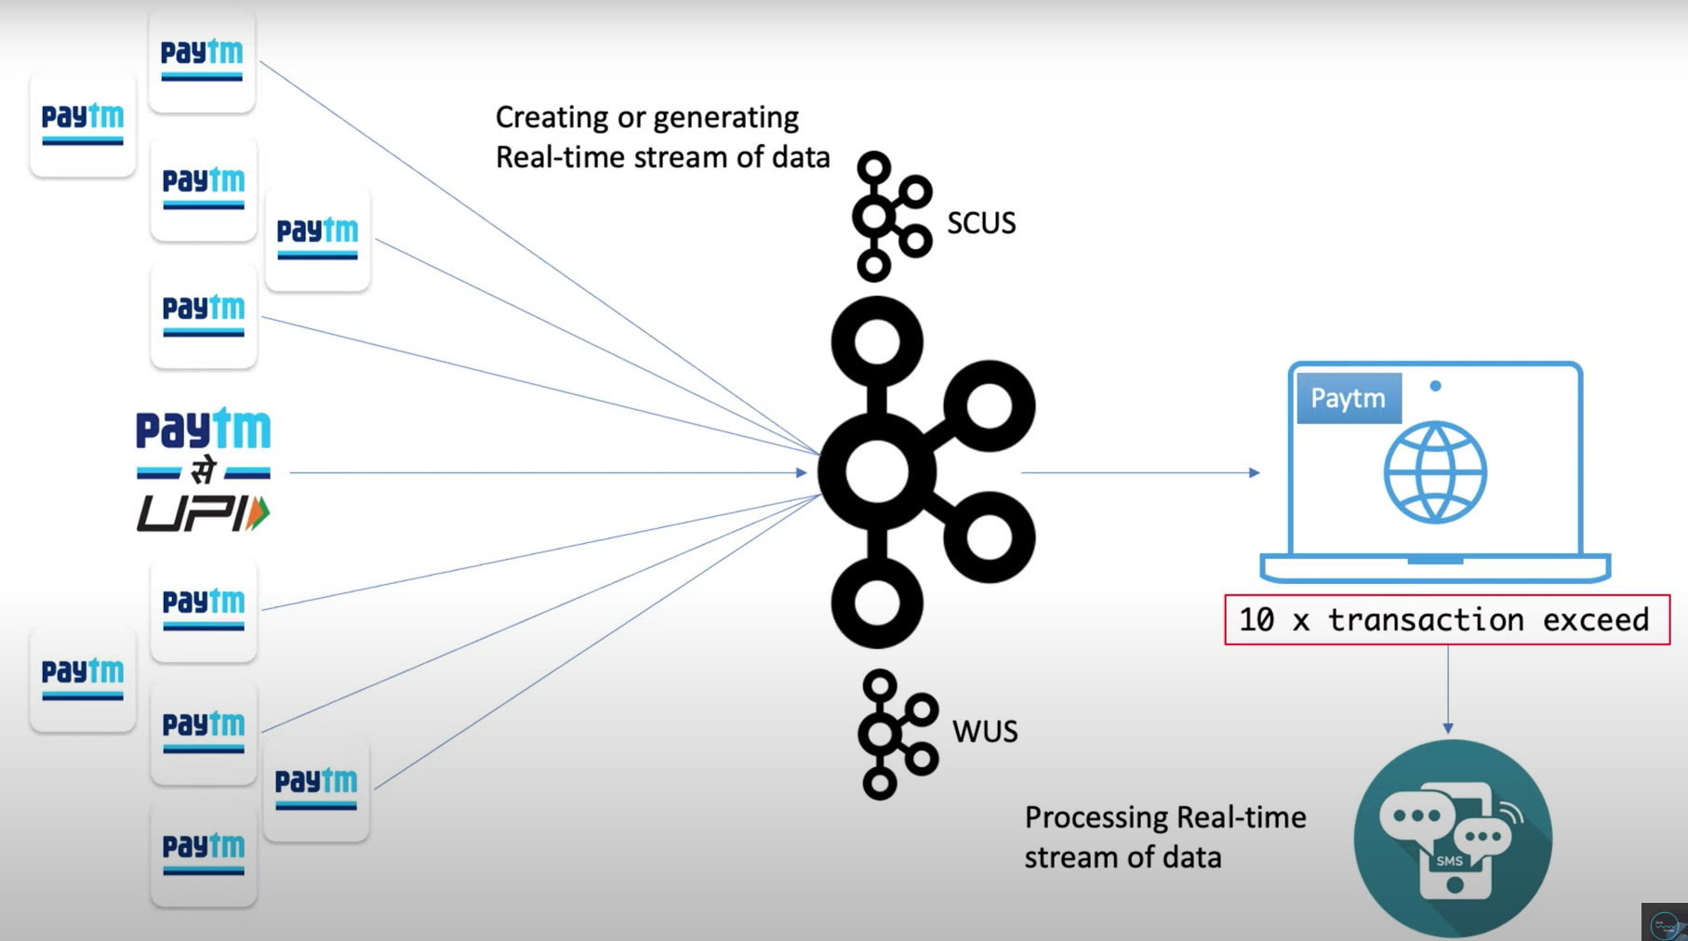

Where does Kafka come from?

* Kafka was originally developed at LinkedIn, and was subsequently open sourced in early 2011.

Why do we need Kafka?

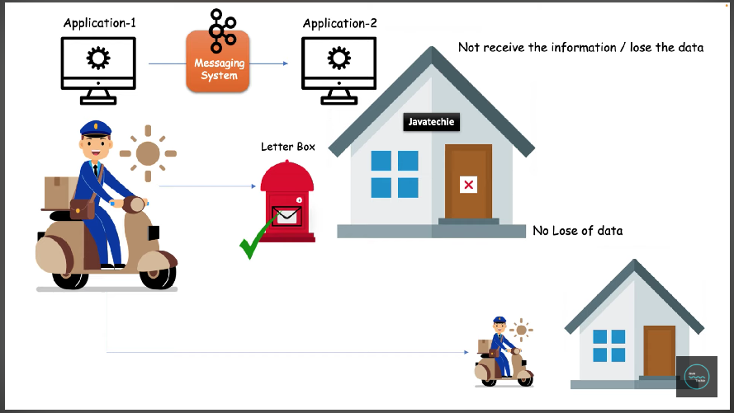

Here message system can be a Kafka / RabitMQ / Reddis. Now we focus on Kafka.

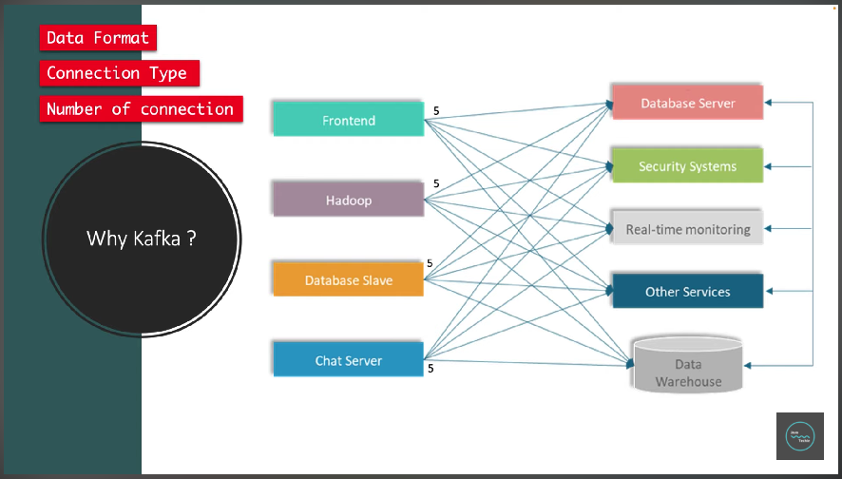

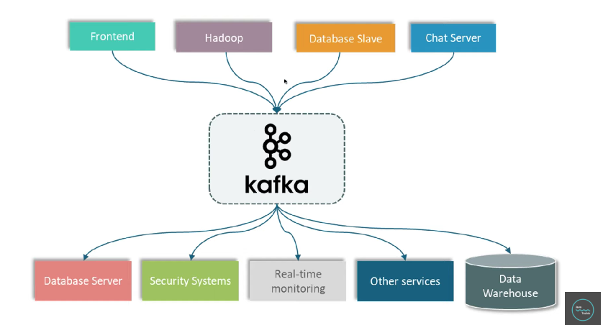

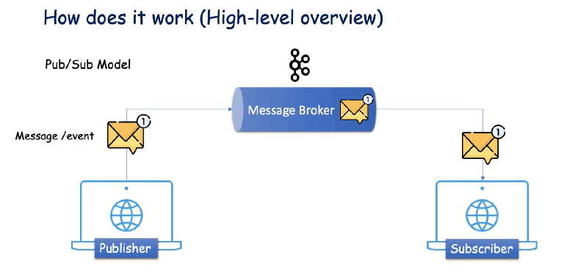

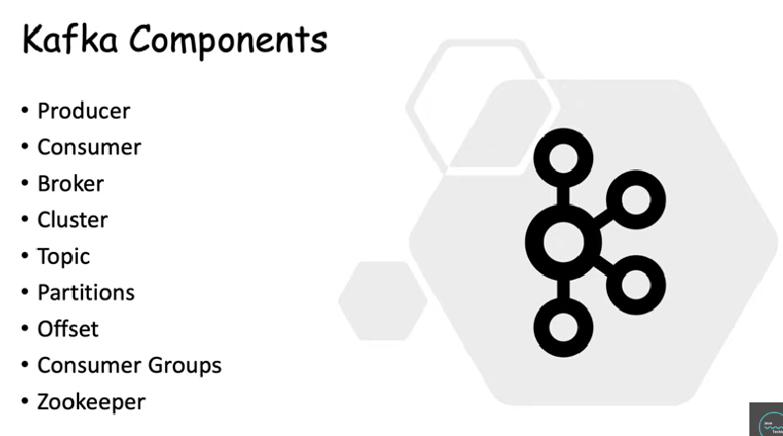

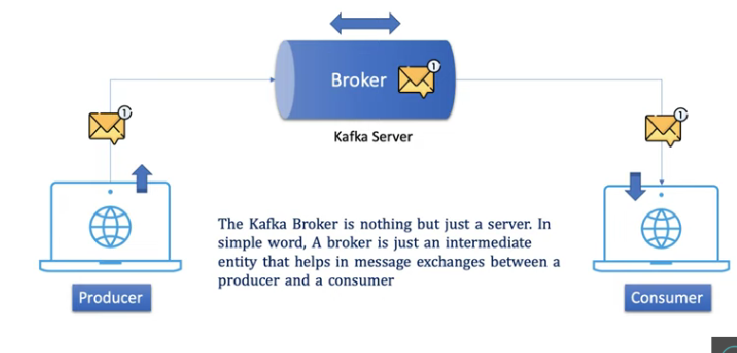

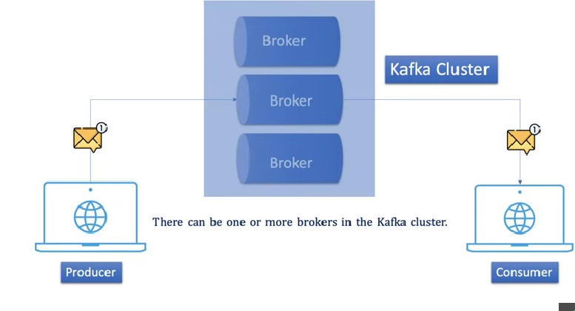

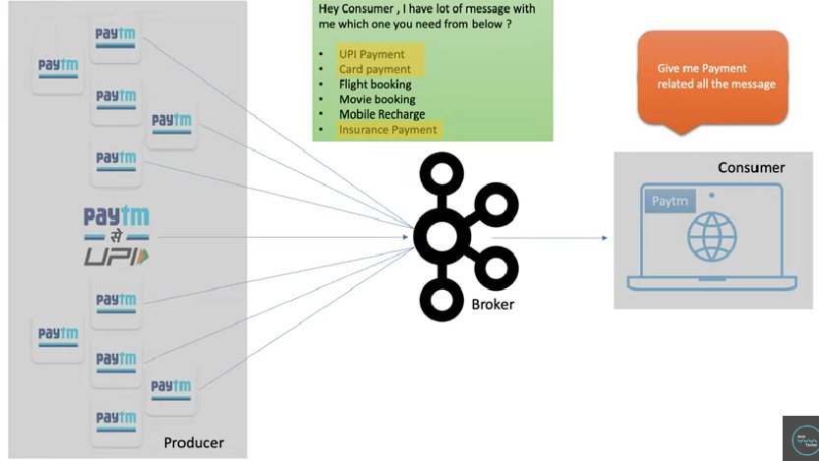

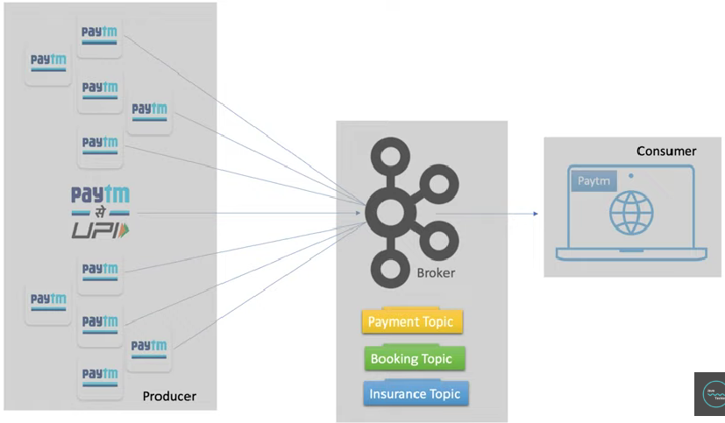

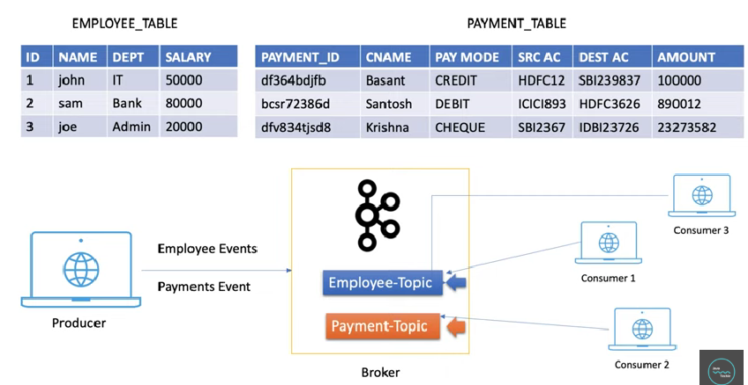

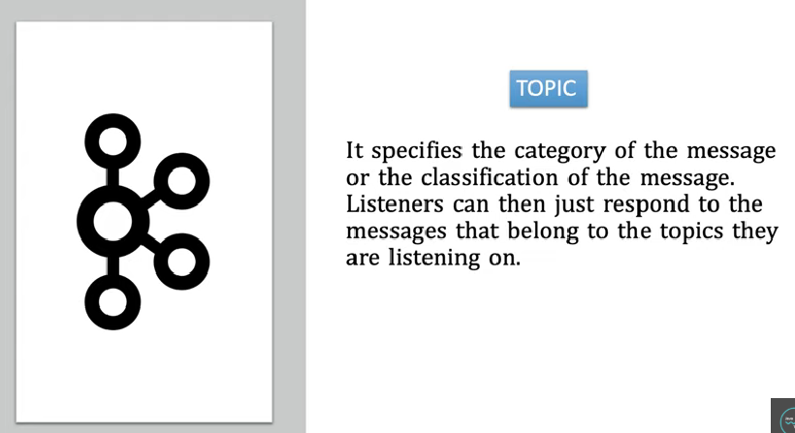

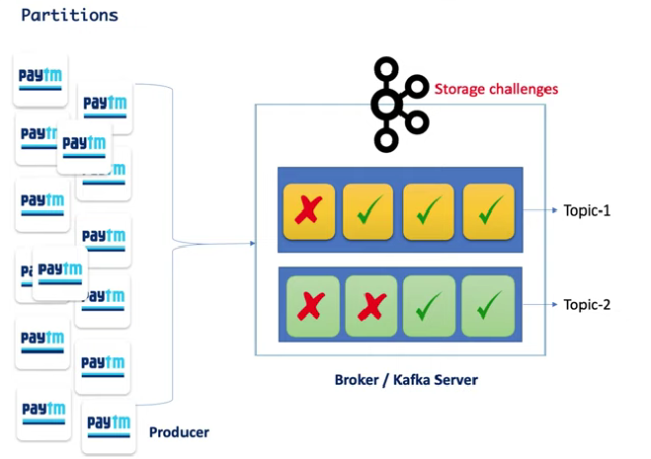

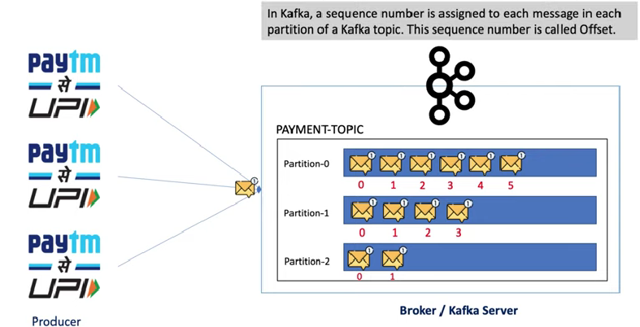

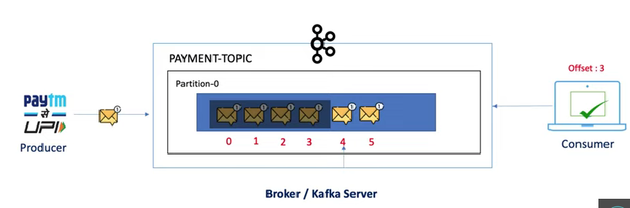

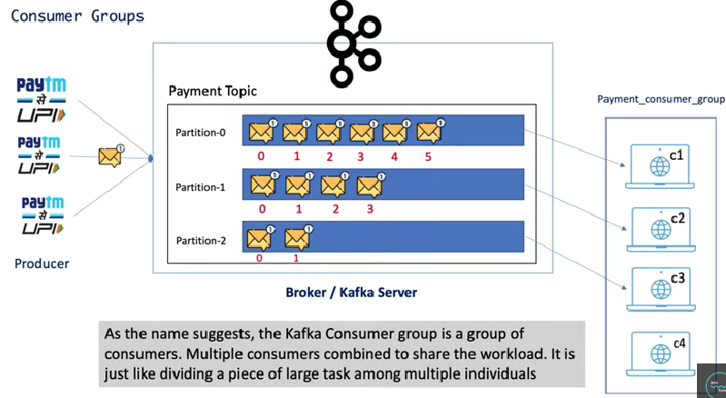

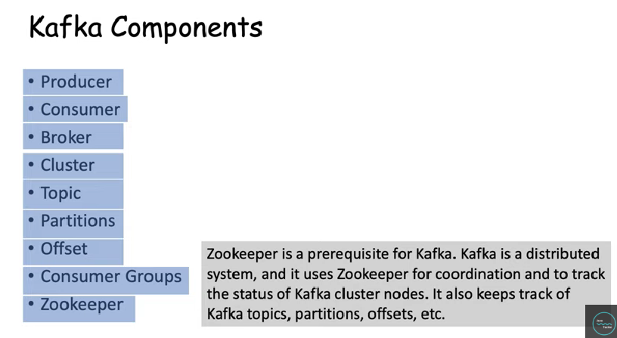

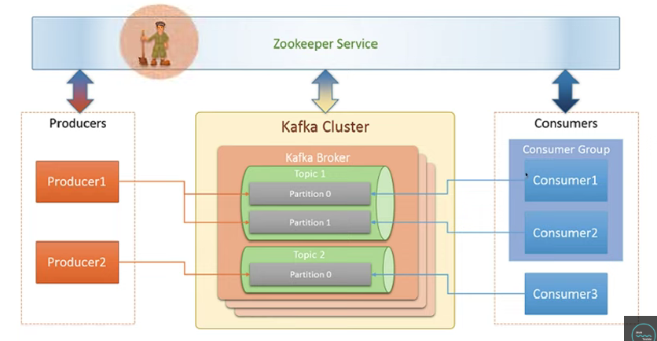

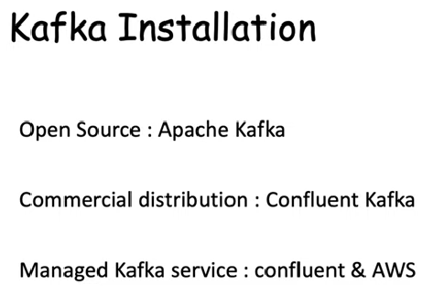

Open source – Apache Kafka

<https://kafka.apache.org/downloads>

Community edition of confluent Kafka

<https://www.confluent.io/installation/>

Kafka Offset Explorer

<https://offsetexplorer.com/download.html>

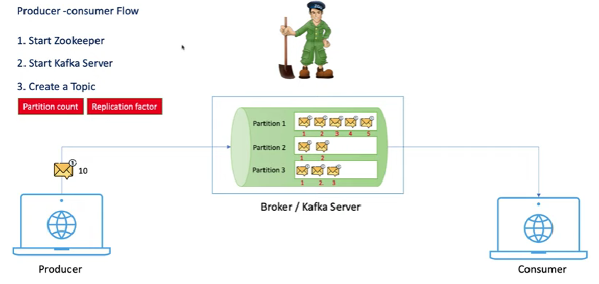

**Open-Source Kafka Startup in local**

**Windows OS:**

**1) Start Zookeeper**

*D:\softwares\kafka_2.12-3.5.1>.\bin\windows\zookeeper-server-start .\config\zookeeper.properties*

Zookeeper will start port: 2181

**2) Start Kafka Server**

Windows OS:

*D:\softwares\kafka_2.12-3.5.1>.\bin\windows\kafka-server-start.bat .\config\server.properties*

Kafka server will start port: 9092

**3) Create Topic:**

*D:\softwares\kafka_2.12-3.5.1>.\bin\windows\kafka-topics.bat --create --bootstrap-server localhost:9092 --partitions 3 --replication-factor 1 --topic user-tracking*

List All topics in kafka server / broker:

*D:\softwares\kafka_2.12-3.5.1>.\bin\windows\kafka-topics.bat --list --bootstrap-server localhost:9092*

*D:\softwares\kafka_2.12-3.5.1>.\bin\windows\kafka-topics.bat –describe –topic user-tracking --bootstrap-server localhost:9092*

**4) Start Producer**

*D:\softwares\kafka_2.12-3.5.1>.\bin\windows\kafka-console-producer.bat --broker-list localhost:9092 --topic user-tracking*

Send file:

*D:\softwares\kafka_2.12-3.5.1>.\bin\windows\kafka-console-producer.bat --broker-list localhost:9092 --topic user-tracking <C:\Users\satya\Downloads\organizations-100\organizations-100.csv*

**5) Start Consumer**

*D:\softwares\kafka_2.12-3.5.1>.\bin\windows\kafka-console-consumer.bat --bootstrap-server localhost:9092 --topic user-tracking --from-beginning*

**Linux / Mac OS:**

**1) Start Zookeeper Server**

*sh bin/zookeeper-server-start.sh config/zookeeper.properties*

**2) Start Kafka Server / Broker**

*sh bin/kafka-server-start.sh config/server.properties*

**3) Create topic**

*sh bin/kafka-topics.sh --bootstrap-server localhost:9092 --create --topic NewTopic --partitions 3 --replication-factor 1*

**4) list out all topic names**

*sh bin/kafka-topics.sh --bootstrap-server localhost:9092 --list*

**5) Describe topics**

*sh bin/kafka-topics.sh --bootstrap-server localhost:9092 --describe --topic NewTopic*

**6) Produce message**

*sh bin/kafka-console-producer.sh --broker-list localhost:9092 --topic NewTopic*

**7) consume message**

*sh bin/kafka-console-consumer.sh --bootstrap-server localhost:9092 --topic NewTopic --from-beginning*

## Confluent Kafka Community Edition in local

**Linux / Mac OS:**

**1) Start Zookeeper Server**

*bin/zookeeper-server-start etc/kafka/zookeeper.properties*

**2)Start Kafka Server / Broker**

*bin/kafka-server-start etc/kafka/server.properties*

**3)Create topic**

*bin/kafka-topics --bootstrap-server localhost:9092 --create --topic NewTopic1 --partitions 3 --replication-factor 1*

**4)list out all topic names**

*bin/kafka-topics --bootstrap-server localhost:9092 --list*

**5)Describe topics**

*bin/kafka-topics --bootstrap-server localhost:9092 --describe --topic NewTopic1*

**6)Produce message**

*bin/kafka-console-producer --broker-list localhost:9092 --topic NewTopic1*

**6)consume message**

*bin/kafka-console-consumer --bootstrap-server localhost:9092 --topic NewTopic1 --from-beginning*

**7)Send CSV File data to kafka**

*bin/kafka-console-producer --broker-list localhost:9092 --topic NewTopic1 <bin/customers.csv*

**Apache Kafka without using Zookeeper from version Kafka 3.3**

<https://kafka.apache.org/quickstart>

##### **Kafka with KRaft**

Generate a Cluster UUID

$ KAFKA_CLUSTER_ID="$(bin/kafka-storage.sh random-uuid)"

Format Log Directories

$ bin/kafka-storage.sh format -t $KAFKA_CLUSTER_ID -c config/kraft/server.properties

Start the Kafka Server

$ bin/kafka-server-start.sh config/kraft/server.properties

Once the Kafka server has successfully launched, you will have a basic Kafka environment running and ready to use.

**To know the kafka server status**

*bin/kafka-metadata-quorum.sh –bootstrap-server localhost:9092 describe –status*

*bin/kafka-metadata-quorum.sh –bootstrap-server localhost:9092 describe –replication*

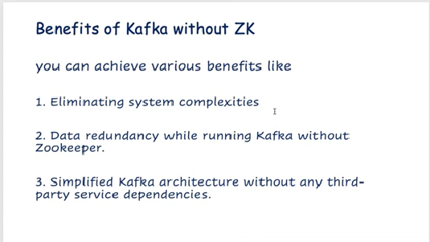



*>docker compose -f docker-compose.yml up -d*

**checking images:**

*>docker images*

*>docker ps*

*>docker exec --it kafka /bin/sh*

