SMARTMINE
Intelligent Mine-Safety Monitoring Rover
Professional Project Description • Rover-Only Prototype
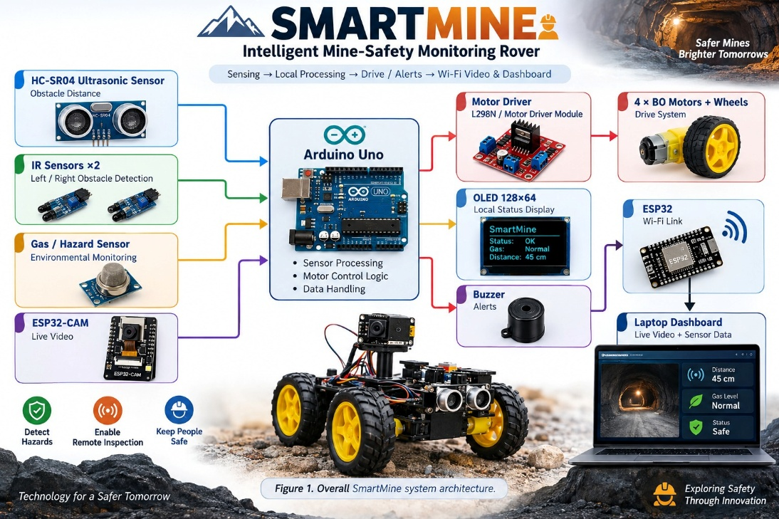
Figure 1. Overall SmartMine system architecture.

1. Executive Summary
SmartMine is a compact, remotely monitored robotic rover designed to support safer inspection of hazardous or difficult-to-access mining environments. The rover combines obstacle detection, environmental sensing, audible and visual alerts, wireless communication, and live camera monitoring in a single mobile platform. The current prototype is intentionally rover-only: four BO geared DC motors drive the wheels, while an Arduino Uno performs local control and an ESP32/ESP32-CAM provide wireless communication and visual monitoring.
The central engineering objective is to keep a person away from potentially unsafe areas during an initial inspection. The rover can approach an area, observe it through the ESP32-CAM, detect nearby obstacles, display status locally, and transmit useful information to a laptop dashboard.

2. Problem Statement
Mining environments can contain uneven ground, confined spaces, obstacles, poor visibility, and potentially hazardous atmospheric conditions. Sending a person into an unfamiliar area for an initial inspection can increase exposure to these hazards. SmartMine addresses this problem by providing a small mobile inspection platform capable of collecting basic sensor and video information remotely.

3. Project Objectives
- Build a stable four-wheel rover using the existing chassis and BO geared motors.
- Detect nearby obstacles using an HC-SR04 ultrasonic sensor and two IR sensors.
- Provide environmental/hazard sensing through a suitable gas or air-quality sensor.
- Provide immediate local warnings using an OLED display and buzzer.
- Add ESP32-CAM live video for visual inspection.
- Use ESP32 Wi-Fi communication to send rover information to a laptop dashboard.
- Create a modular platform that can later support additional sensors and analytics.

4. Hardware Architecture
Component | Role | Interface / Connection | Purpose
Arduino Uno | Main local controller | Digital/analog I/O | Reads sensors and controls rover logic
ESP32 | Wireless controller | Wi-Fi / serial as designed | Communication with laptop/dashboard
ESP32-CAM | Camera subsystem | Wi-Fi | Live visual monitoring
HC-SR04 | Distance sensor | Trigger/Echo | Front obstacle detection
IR sensors ×2 | Proximity detection | Digital | Left/right obstacle awareness
Gas / hazard sensor | Environmental sensing | Analog/digital | Detects selected atmospheric parameter
OLED 128×64 | Local display | I²C | Status, sensor values and warnings
Buzzer | Local alarm | Digital output | Audible warning
Motor driver | Power interface | Arduino control inputs | Drives four BO geared motors
BO geared DC motors ×4 | Drive system | Motor driver outputs | Moves the rover

5. Physical Layout
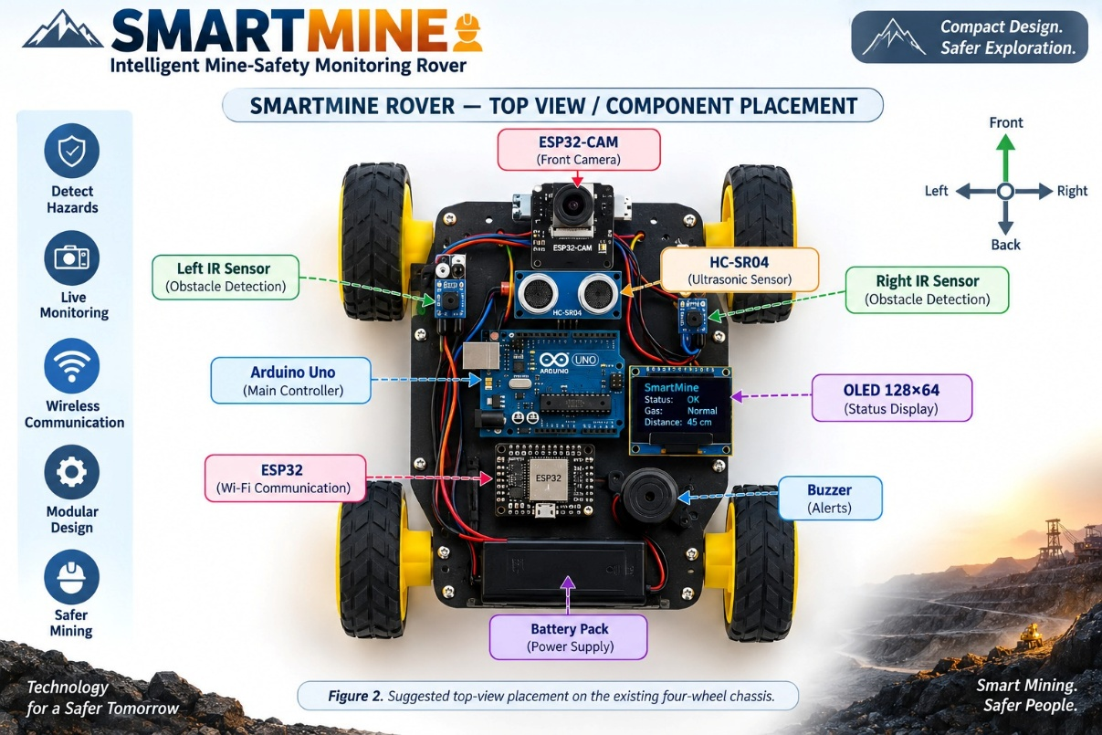
Figure 2. Suggested top-view placement on the existing four-wheel chassis.
The ESP32-CAM should be positioned at the front/top of the chassis with a clear forward field of view. The ultrasonic sensor should face forward and remain unobstructed. The IR sensors can be placed toward the front-left and front-right areas. The controller and power electronics should remain near the center of the chassis to keep wiring short and reduce the chance of mechanical interference.

6. Operating Principle
Power-up: The rover initializes the Arduino, ESP32, ESP32-CAM, display and sensor interfaces.
Sensing: The ultrasonic, IR and environmental sensors continuously collect measurements.
Decision: The Arduino evaluates sensor states and applies programmed movement/alert logic.
Movement: The motor driver supplies the required drive signals to the four BO geared motors.
Local warning: The OLED displays key readings/status and the buzzer provides an audible warning when programmed thresholds are reached.
Visual monitoring: The ESP32-CAM captures the forward scene and provides a Wi-Fi video stream.
Remote monitoring: The ESP32 communicates with the laptop dashboard for telemetry/control functions.

7. Data and Communication Flow
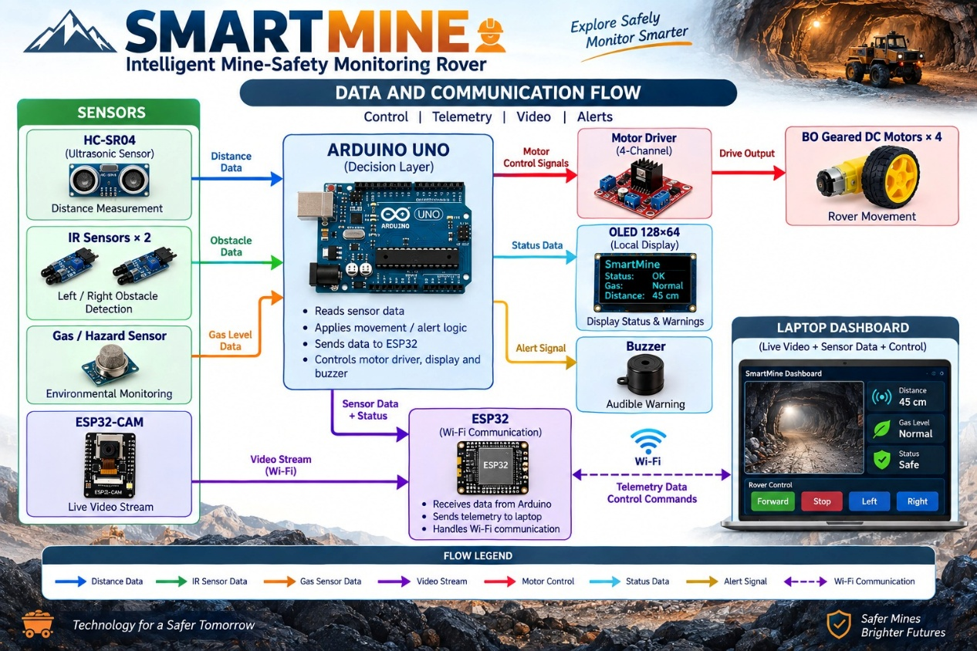
Figure 3. High-level control, telemetry and video flow.

8. ESP32-CAM Integration
The ESP32-CAM is added as the visual subsystem rather than replacing the Arduino. Its primary role is to provide a live view of the rover's surroundings. This is particularly useful because a distance sensor can indicate that an obstacle exists but cannot provide the same visual context as a camera.
- Mount the camera above the front section of the chassis.
- Keep the lens clear of the ultrasonic sensor and chassis structure.
- Use the ESP32-CAM's Wi-Fi capability for the video stream.
- Present the video beside sensor telemetry on the laptop dashboard where practical.
- For future development, captured frames can be processed for visual obstacle or hazard classification.

9. Software Architecture
The software should be organized into separate modules so that sensing, motion control, communication, and display functions can be tested independently.
- Sensor module: reads HC-SR04, IR sensors and the selected gas/environmental sensor.
- Motion module: converts navigation decisions into left/right motor commands.
- Safety module: checks obstacle and hazard conditions and triggers alerts.
- Display module: updates the OLED with sensor values and system state.
- ESP32 communication module: handles wireless commands and telemetry.
- ESP32-CAM module: provides the camera stream.
- Laptop dashboard: displays video, telemetry and alert status; it can later store readings for analysis.

10. Key Features
Feature | Engineering benefit
Four-wheel mobility | Uses the existing geared BO motors and wheels for simple, robust ground movement.
Obstacle awareness | Combines ultrasonic and IR sensing for complementary proximity detection.
Visual inspection | ESP32-CAM adds live video to the sensor-based view of the environment.
Local alerts | OLED and buzzer provide immediate status and warnings on the rover.
Wireless monitoring | ESP32 provides a path to remote telemetry and control.
Modular expansion | The chassis can accept additional sensors, lighting, storage or processing modules.

11. Prototype Testing Plan
- Test each BO motor independently before connecting the complete drivetrain.
- Verify wheel direction and left/right control at low speed.
- Check HC-SR04 distance readings against known distances.
- Test each IR sensor independently and verify its active state.
- Test the OLED and buzzer using simulated sensor conditions.
- Verify ESP32 Wi-Fi communication before integrating dashboard functions.
- Test the ESP32-CAM stream separately and then combine it with telemetry.
- Run integrated tests on a clear, controlled surface before moving to more complex terrain.
- For any future field demonstration, use appropriate adult/teacher supervision and follow the site's safety rules.

12. Expected Output
The completed prototype should demonstrate a four-wheel SmartMine rover that can move under remote/local control, detect nearby obstacles, monitor a selected environmental parameter, issue local warnings, and provide live camera observation through the ESP32-CAM. A laptop dashboard can combine the video feed with sensor values and system status.

13. Future Development
- Add a higher-quality camera or pan/tilt camera mount.
- Introduce data logging for sensor measurements and event timestamps.
- Add computer-vision algorithms for visual obstacle recognition.
- Add map/route visualization for larger test environments.
- Add additional environmental sensors appropriate to the intended mining demonstration.
- Develop a more robust communication link for longer-range controlled testing.
- Add autonomous navigation after reliable manual and sensor-level operation has been demonstrated.

14. Conclusion
SmartMine is a practical robotics platform that combines mobility, sensing, visual monitoring and wireless communication into one rover. The rover-only configuration keeps the prototype mechanically straightforward while still demonstrating the project's core mining-safety concept. The addition of the ESP32-CAM strengthens the system by giving the operator direct visual information alongside sensor data, creating a foundation for future remote inspection and computer-vision capabilities.

SMARTMINE • ONE ROVER • MULTIPLE SENSING MODALITIES • REMOTE VISUAL MONITORING

