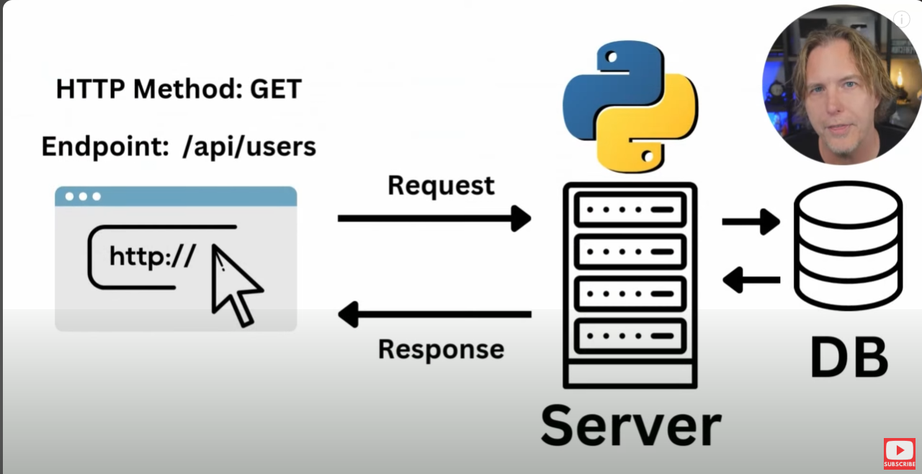

1. Open folder in VS Code
2. Create Virtual Environment
3. Open new terminal
4. There’s difference between Mac/Linux and Window, To use python command in Mac/Linux use ‘py3’ but Window use ‘py’
5. 
6. To activate in Linux, We use ‘source .venv/bin’ but on Window we use ‘source .venv/Scripts/activate’ and press Enter
7. Press Enter again to see (.venv) 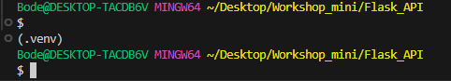
8. Install dependencies:

* Pip install flask
* pip install flask_restful
* pip install flask_sqlalchemy (it is an ORM, ORM is used to talk to database)

1. Type ‘pip freeze > requirements.txt’ to create a requirements doc that lists all dependencies install
2. Type ‘touch .gitignore’ to create .gitignore file
3. 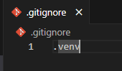
4. Import flask

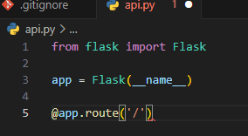

1. For initializing web page

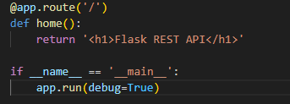

1. py api.py

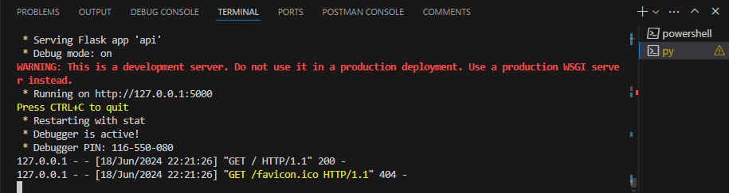

1. import sqlalchemy

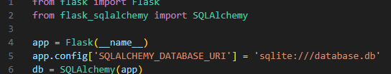

1. Create Data Model

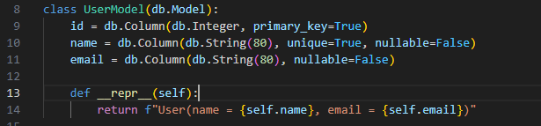

1. Create ‘create_db.py’
2. In create_db.py file import app, db
3. Use app.app_context()method :

db.create_all()

1.  in api.py
2. Use Api by create a variable api = Api(app)

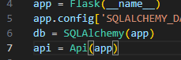

1. Add these to api.py

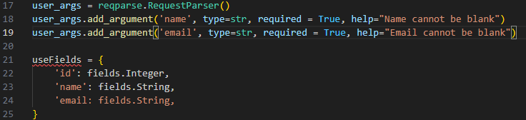

UseFields(in the picture) resemble JSON file