ALU Launchpad
Mobile Application — Implementation Plan
Flutter · Firebase · BLoC · Clean Architecture
Course  Mobile Development | Institution  African Leadership University
Prepared by  Bode | Date  June 2026

1. Project Overview
ALU Launchpad is a mobile application that bridges the gap between ALU students seeking internship experience and student-led startups within the ALU ecosystem. Students struggle to secure internships at established organizations, while student entrepreneurs need support in areas such as software development, design, marketing, and operations.

The platform allows startups to post opportunities and students to discover, filter, and apply for meaningful experiences — all within a verified, ALU-exclusive environment.

1.1 Core Problem
- Students lack access to structured internship pathways within the ALU ecosystem
- Student startups cannot easily recruit skilled peers from their own campus
- No centralized, verified platform exists for ALU-specific internship matching

1.2 Tech Stack
Layer | Technology | Reason
Frontend | Flutter (Dart) | Cross-platform mobile
State Management | BLoC (flutter_bloc) | Stream-based, scalable
Backend | Firebase (Firestore, Auth, Storage) | Real-time, serverless
Navigation | go_router | Declarative routing
Architecture | Feature-first Clean Architecture | Maintainable & testable

2. Features

2.1 Required Features
Feature | Description
Authentication & Onboarding | Email login restricted to @alustudent.com / @alueducation.com domains. Role selection (Student or Startup Founder). Multi-step onboarding to build profile.
Startup Profiles & Verification | Startups register with details (name, domain, description). Admin verifies startup via Firestore flag. Verified badge shown on profile and opportunity cards.
Opportunity Posting | Verified startups post roles with title, description, role type, skills required, duration, and compensation. Posts appear live via Firestore streams.
Opportunity Discovery & Search | Students browse an open feed of opportunities. Search by keyword. Filter by role type, compensation, and duration.
Application Submission | Students apply with a short pitch and optional portfolio link. One application per student per opportunity enforced by Firestore rules.
Real-time Updates | Firestore snapshots() streams power the feed and application status updates without manual refresh.
Firebase Integration | Firestore for all data, Firebase Auth for identity, Firebase Storage for logos and avatars.
State Management | One BLoC per feature domain. Events and States clearly separated. BLoC communicates with repositories, never with Firebase directly.

2.2 Additional Features
Feature | Description
Bookmarking | Students save opportunities with one tap. Stored as a subcollection under users/{uid}/bookmarks. Accessible from the Saved tab.
Recommendation System | Opportunities where skillsRequired overlaps the student's skills array are surfaced at the top of the feed with a Recommended badge. Powered by Firestore arrayContainsAny query.
Portfolio Page | Student profile displays bio, skills, experience entries, and portfolio links. Shared from the same users/{uid} document.
Role Filtering | Filter opportunities by role type: Engineering, Design, Marketing, Operations, Research, Content, Business.

3. Architecture

3.1 Architecture Pattern
The application uses Feature-first Clean Architecture with BLoC for state management. This separates concerns into three layers per feature:

Layer | Responsibility
Presentation | Flutter widgets + BLoC (Events, States, Bloc class). Responsible for UI rendering and dispatching user actions as events.
Domain | Plain Dart entities and abstract repository interfaces. No Flutter or Firebase imports. Defines what the app can do and what data looks like.
Data | Firebase implementations of domain repositories. The only layer that interacts with Firestore, Auth, or Storage.

3.2 Request Flow
- Widget dispatches an Event to the BLoC
- BLoC receives the Event and calls the Repository interface (domain layer)
- FirestoreRepository fetches or writes data to Firebase
- Repository returns an Entity to the BLoC
- BLoC emits a new State
- Widget rebuilds in response to the new State

The BLoC layer never imports Firebase packages directly. It only depends on abstract repository interfaces defined in the domain layer. This means Firebase can be swapped out without touching any BLoC or UI code.

3.3 Folder Structure
lib/
├── core/
│ ├── router/ # go_router configuration
│ ├── theme/ # colors, typography, spacing
│ ├── constants/ # role types, skill list enums
│ └── errors/ # failure classes
├── features/
│ ├── auth/
│ │ ├── data/repositories/ # FirebaseAuthRepository
│ │ ├── data/models/ # UserModel (JSON serialization)
│ │ ├── domain/entities/ # UserEntity (plain Dart)
│ │ ├── domain/repositories/# AuthRepository (abstract)
│ │ └── presentation/ # AuthBloc + screens
│ ├── opportunities/ # same structure
│ ├── applications/ # same structure
│ ├── startups/ # same structure
│ ├── feed/ # discovery, search, recommendations
│ └── bookmarks/ # same structure
└── main.dart

3.4 BLoC Mapping
BLoC | Responsibility
AuthBloc | Login, signup, logout, role detection, onboarding state
StartupBloc | Startup profile creation, verification status, startup data
OpportunityBloc | Post opportunities, edit, close, manage by startup
FeedBloc | Browse feed, search, filter by role/compensation/duration, recommendations
ApplicationBloc | Submit application, track status, view applicant list (startup side)
BookmarkBloc | Save/unsave opportunities, list saved opportunities

4. Database Schema

4.1 Database Choice: Firestore (Non-relational)
Firestore was chosen over a relational database for the following reasons:
- Document-centric access patterns — every screen loads one thing at a time, which maps naturally to Firestore documents
- Real-time is a core requirement — Firestore's snapshots() streams provide this out of the box
- Array-based recommendation logic — matching skillsRequired against skills uses arrayContainsAny, a native Firestore query
- Flexible onboarding — students and founders have different fields; Firestore handles this without schema migrations

Trade-off acknowledged: Firestore makes cross-collection queries more expensive than SQL JOINs. At larger scale, application analytics and cross-startup reporting would benefit from a relational layer. For this project scope, Firestore is the correct choice.

4.2 Collections

users/{uid}
users/{uid}
uid, email, displayName, avatarUrl
role: 'student' | 'founder'
createdAt: timestamp

// Student-only
skills: string[], bio: string, portfolioLinks: string[]
experience: [{ title, organization, duration, description }]

// Founder-only
startupId: string

// Subcollection
bookmarks/{oppId} { opportunityId, savedAt }

startups/{startupId}
startups/{startupId}
startupId, name, description, domain
logoUrl, founderId, teamSize, website
verified: bool // false by default, admin flips to true
verifiedAt: timestamp | null, createdAt: timestamp

opportunities/{oppId}
opportunities/{oppId}
oppId, startupId, title, description
startupName, startupLogoUrl // denormalized for feed display
roleType: 'Engineering'|'Design'|'Marketing'|'Operations'|...
skillsRequired: string[] // matched against student skills
duration, compensation: 'Paid'|'Unpaid'|'Equity'
isOpen: bool, createdAt: timestamp

applications/{appId}
applications/{appId}
appId, opportunityId, startupId, studentId
studentName, studentAvatarUrl // denormalized
pitch: string, portfolioUrl: string
status: 'pending'|'reviewing'|'accepted'|'rejected'
createdAt, updatedAt: timestamp

notifications/{uid}/items/{notifId}
notifications/{uid}/items/{notifId}
message: string
type: 'application_update'|'new_opportunity'
relatedId: string, read: bool, createdAt: timestamp

4.3 Security Rules
Collection | Rule
users | Read/write only if uid matches the authenticated user
startups | Read by all. Write only by the startup founder (uid match)
opportunities | Read by all authenticated users. Write only if startup.verified == true
applications | Write by student (own uid). Read by student (own) or startup (their startupId)
notifications | Read/write scoped to own uid only

5. Implementation Plan

Phase 1 — Setup (Days 1–2)
- Create Flutter project and connect Firebase via FlutterFire CLI
- Add core dependencies: flutter_bloc, firebase_auth, cloud_firestore, firebase_storage, go_router
- Configure folder structure and Firestore security rules

Phase 2 — Auth & Onboarding (Days 3–4)
- Email login restricted to @alustudent.com / @alueducation.com
- Role selection screen, multi-step onboarding for both roles
- AuthBloc manages all auth state globally

Phase 3 — Startup Profiles & Verification (Days 5–6)
- Startup profile screen with logo, description, active opportunities
- Admin Firestore document flips verified: true
- Firestore rules block unverified startups from posting

Phase 4 — Opportunity Feed & Discovery (Days 7–9)
- Live feed powered by Firestore snapshots()
- Search by keyword, filter by role/compensation/duration
- Recommendation via arrayContainsAny on skillsRequired
- Bookmarking to users/{uid}/bookmarks subcollection

Phase 5 — Applications (Days 10–11)
- Student submits pitch + optional portfolio URL
- Startup manages applicant list, updates status in real-time

Phase 6 — Portfolio Page (Day 12)
- Reuses student profile data — no extra data model needed
- Visible on own profile and to startups reviewing applications

Phase 7 — Polish, Report & Demo (Days 13–16)
- UI consistency pass, write technical report, record demo video

6. UI Screen Designs
The following mockups show the planned screens for ALU Launchpad. Each screen was designed around the specific needs of ALU students and startup founders.

6.1 Auth & Onboarding Screens
From left to right: Sign in screen, Role selection, Student onboarding (Step 2 of 3), Startup onboarding (Step 1 of 2).

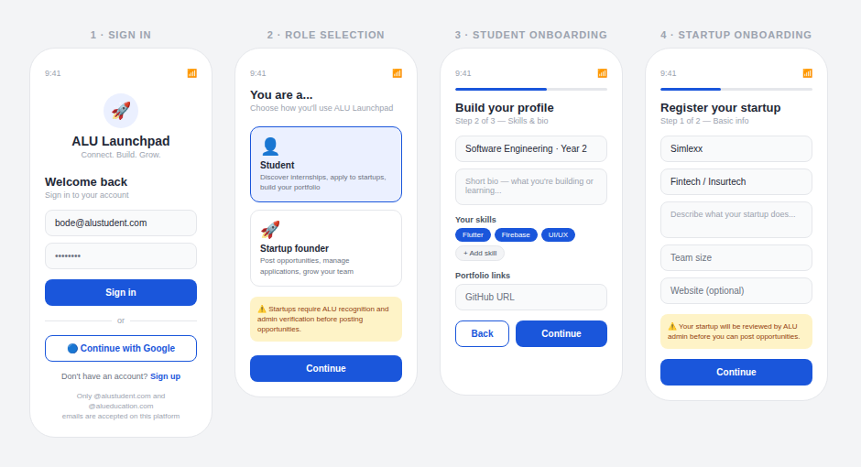

Screen | Key Design Decision
Sign in (Screen 1) | Email/password with Google OAuth. Domain restriction messaging shown below the form. Clear sign-up link for new users.
Role selection (Screen 2) | Student card pre-selected. Warning banner explains admin verification requirement for startups.
Student onboarding (Screen 3) | Progress bar at top. Skill chips for easy multi-select. Portfolio link field for GitHub/LinkedIn.
Startup onboarding (Screen 4) | Orange warning box sets expectation about admin review before posting is enabled.

6.2 Opportunity Feed, Search & Detail Screens
From left to right: Main feed with recommendations, Search and filter screen, Opportunity detail with skill match indicator.

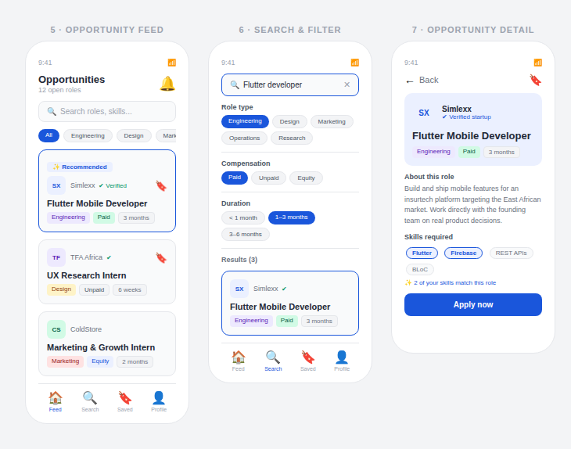

Screen | Key Design Decision
Feed (Screen 5) | Recommended badge on matched opportunities. Horizontal chip row for quick role filtering. Bookmark icon on each card. Bottom navigation for Student role.
Search & filter (Screen 6) | Active search bar with clear button. Stacked filter sections for role, compensation, duration. Results count shown above cards.
Opportunity detail (Screen 7) | Startup branding block with verified badge. Skills section highlights matched skills in accent color with match count. Prominent Apply now CTA.

6.3 Startup Profile, Student Portfolio & Bookmarks
From left to right: Startup profile (founder view), Student portfolio page, Bookmarks and notifications combined screen.

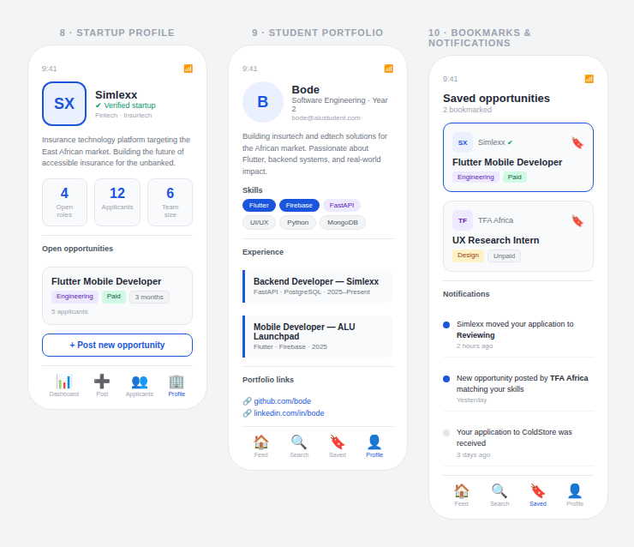

Screen | Key Design Decision
Startup profile (Screen 8) | Stats row (open roles, applicants, team size). Listed opportunities with applicant count. Post new opportunity button. Founder-specific bottom navigation.
Student portfolio (Screen 9) | Avatar initials circle. Skill chips with color coding by type. Left-bordered experience cards for timeline feel. Clickable portfolio links.
Bookmarks & notifications (Screen 10) | Saved opportunities at top. Notification list with unread blue dot and read gray dot indicators. Real-time status update notifications shown.

7. State Management (BLoC)

7.1 Why BLoC
- Stream-based architecture pairs naturally with Firestore real-time snapshots
- Explicit Events and States make data flow traceable and explainable
- BLoC chosen over Cubit for explicit Event classes — easier to document and explain in the demo

7.2 Example: FeedBloc
// Events
abstract class FeedEvent {}
class LoadFeed extends FeedEvent {}
class SearchOpportunities extends FeedEvent { final String query; }
class FilterByRole extends FeedEvent { final String roleType; }

// States
abstract class FeedState {}
class FeedInitial extends FeedState {}
class FeedLoading extends FeedState {}
class FeedLoaded extends FeedState { final List<Opportunity> opportunities; }
class FeedError extends FeedState { final String message; }

// Recommendation logic inside FeedBloc
List<Opportunity> recommended = allOpportunities
.where((opp) => opp.skillsRequired
.any((skill) => currentUser.skills.contains(skill)))
.toList();

8. Startup Verification Strategy

8.1 Domain Gate
Only emails ending in @alustudent.com or @alueducation.com can register. This ensures all users are verified ALU community members before onboarding.

8.2 Admin Approval Flag
- Every new startup is created with verified: false
- Admin Firestore document stores admin UIDs with write access
- Admin flips verified: true after reviewing the startup registration
- Firestore security rules block writes to opportunities/ if startup is not verified
- UI hides the Post opportunity button for unverified startups and shows a Pending verification banner

Using both mechanisms is intentional: domain gating ensures all users are ALU-affiliated, while admin approval ensures only legitimate, recognized startups gain posting privileges.

9. Scalability Considerations
Consideration | Approach
Feature-first architecture | Each feature is self-contained. Adding a new feature means creating a new folder — no existing code is touched.
Repository pattern | Firebase can be swapped for any backend by replacing only the data layer. BLoC and UI code remain unchanged.
Firestore denormalization | Opportunity cards display startup name/logo without extra reads by storing those fields on the opportunity document.
Pagination | Firestore queries use limit() and startAfterDocument() for cursor-based pagination of the feed.
Subcollections for user data | Bookmarks and notifications are subcollections — queries are scoped, secure, and never touch other users' data.

10. Demo Video Guide
The 7–10 minute demo video should cover the following flows in order:

- Student signup with @alustudent.com email → role selection → onboarding (skills, bio, portfolio links)
- Startup founder signup → startup registration → show pending verification banner
- Admin verification flow → startup verified → Post opportunity button unlocked
- Startup posts an opportunity → show it appear live on student's feed (real-time demo)
- Student searches and filters opportunities → open opportunity detail → skill match highlights
- Student applies to an opportunity → startup sees application → startup updates status
- Student sees real-time status update on their application
- Show bookmarking: save an opportunity, view it in the Saved tab
- Explain one BLoC class: show Events, States, and the repository call
- Briefly explain the folder structure and Clean Architecture layers

