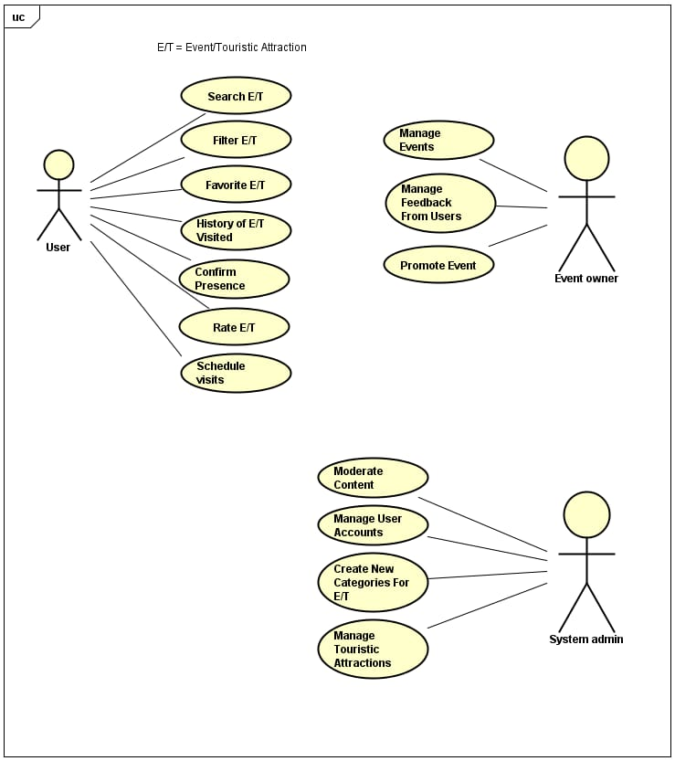

User: has 7 use cases

1- Search by Event / Tourist Attraction in the system database.

2- Filter specific aspects within the search of Events / Tourist Attractions.

3- Favorite Event / Tourist Attraction from the search.

4- List Event History / Tourist Attraction.

5- Confirm attendance at a chosen Event / Tourist Attraction.

6- Rate Event / Tourist Attraction

7- Schedule visit to Event / Tourist Attraction in which the user plans to know

Event Owner: Has 3 use cases.

1- Manage Event/Tourist Attraction registered in the system by the event manager

2-Manage the feedback received by users who rated the Event/Tourist Attraction

3- Promote Your Event/Tourist Attraction

System Admin: Has 4 Use Cases

1- Moderate content registered by the event owner, inspecting the Events/Tourist Attractions

2- Manage Users and Event Owners Account

3- Create new categories for Event/Tourist Attraction, updating filters and categories as needed.

4- Manage the Events/Tourist Attractions registered in the system