Chap_13



After importing openpyxl, it takes in the filename, and returns the data type of the workbook



It contains individual sheet names in a file displayed as a list.



Sheet=wb[‘Sheet1’]



Sheet=wb.active



c_5=sheet[C5].value



Sheet[‘C5’]=’Hello’



xy=coordinate_(‘A4’)

col=column_index(xy[0])

row=row_index(xy[0])



Sheet.max_column: To get maximum number of occupied columns in console.

Sheet.max_row: To get maximum number of occupied rows in console.



col=column_index_from_string(M[0])



produce.name=sheet.cell(column=colNum,column=15).value



produceName in range(A1,G1)

sheet.cell(row=rowNum,column=1).value



wb.save(‘example.xlsx’)



For example,if we need the sum,

Sheet[‘A3’]=’=SUM(A1:A3)’

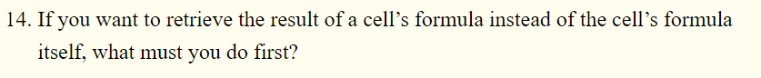

We have to save the formula.

Set the formula in a program then wb.save(‘Formula.xlsx’)



sheet.row_dimensions[1].height=100



Cells.hideColumn(C)



Freezepanes are row or columns which are always visible to the user even if he scrolls down.



seriesObj=openpyxl.chart.Series(refObj,title=’Name’)

ChartObj=openpyxl.chart.BarChart()

ChartObj.title=’Charts’

ChartObject.append(Name)

sheet.add_chart(CharrtObj,’column’)