STOCK MARKET PREDICTION
Documentation for the Capstone project of AI/ML course.

By
BODHISATTVA DASGUPTA

ABSTRACT
This Documentation provides a study on predicting stock prices using Linear Regression, a fundamental machine learning algorithm. The objective is to develop a predictive model that can forecast future stock prices based on historical data. The dataset employed consists of historical Stock prices from various companies, incorporating features such as open, close, high, low prices and trading volumes.
Data preprocessing steps include handling Missing Values.
The Linear Regression model is trained and validated using this cleaned dataset and its performance is evaluated using Mean Squared Error (MSE).

INTRODUCTION
Linear Regression is a straightforward yet powerful tool for identifying relationships between variables. In the context of stock market prediction, it helps in modeling
The relationship between time and stock prices, enabling the prediction of future prices based on historical trends. Its simplicity and interpretability make it an ideal starting point for financial forecasting.
KEY FEATURES:
- Data Collection
- Model Development
- Model Evaluation
- Visualization
- Deployment

PROJECT SYNOPSIS
- DATA PREPARATION
A Dataset was collected from Kaggle. It consisted of 32 companies and the volume of their stock traded everyday for the year 2022. Each row consisted date, High (highest value of the stock on that day), low (lowest value of the stock on that day), Open (Opening value of the stock on that day), Close (Closing Values of the stock on that day) and some other columns (which were of no use in this Project).
The original Dataset:
https://drive.google.com/file/d/1d3bgB4aodpWMW_CJFFejFUBobwSye9Dm/view?usp=drive_link
- DATA CLEANING
To ensure data’s quality and suitability for modeling , the following steps were performed:
Checking data shape: Using ‘df.shape’ to understand dimensions of the dataset.
Handling missing Values: identifying missing values with ‘df.isnull().sum()’ and removing them using ‘df.dropna()’ to maintain data integrity.

- Exploratory Data Analysis
OHLC vizuaization: Implementing Open-High-Low-Close (OHLC) charts to represent stock price movements within a specified period, providing a comprehensive view of market behaviour.
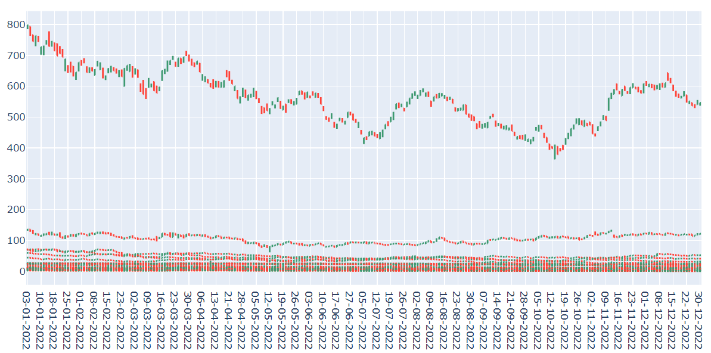

In this graph produced by plotly, the red stock indicates Bearish and the green stocks indicate bullish. If the curser is taken on top of any green or red point, it would provide the full details (date, open, high, low, close) of that particular stock.

- MODEL DEVELOPMENT

DATA SPLITTING: The dataset is divided into training (80%) and testing (20%) splits using ‘train_test_split’

to ensure the model’s ability to generalize to unseen data.

MODEL TRAINING: A linear regression model was developed using ‘LinearRegression’ from scikit_learn.

The training data was used to fit the Linear Regression model, establishing the relationship between the independent variables (open, high, low, volume) and the dependent variable (Close).

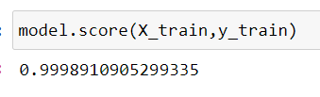

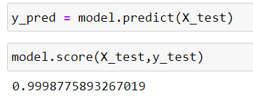

Both the Training and Testing were 99% accurate.
- MODEL EVALUATION

Mean Squared Error (MSE): Calculated using ‘mean_squared_error’ to measure the average squared difference between the predicted and actual stock prices. The MSE was very low.

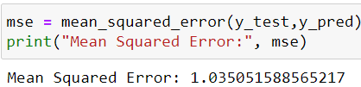
- PREDICTION of a CLOSING PRICES of a NEW DATA

A new data was downloaded from Kaggle:

https://drive.google.com/file/d/19Uisi4GKBz_2uJmajdmipIs2FZ3o64e5/view?usp=sharing

This data consists of the opening price, highest price, lowest price, volume of stocks sold of TISCO everyday in 2023.

We have used the previous model to predict the closing price of stocks of TISCO in 2023.

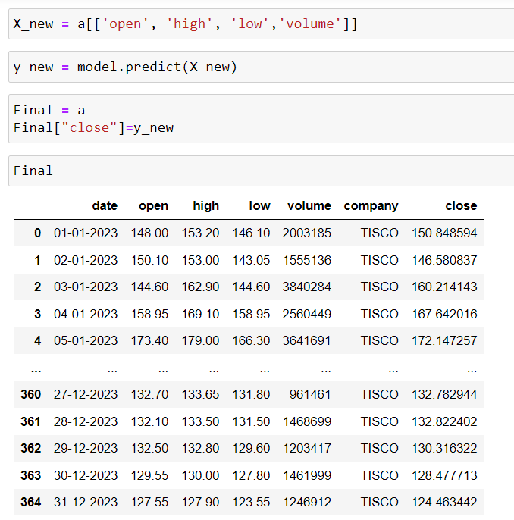

CONCLUSION

This project successfully demonstrates the application of Linear regression for stock market prediction. By meticulously cleaning the data, conducting through EDA, and employing a robust evaluation methodology,

the model provides valuable predictions than can aid an investment decision making. While Linear Regression offers a solid foundation, future work may explore more complex models to further enhance predictive accuracy.

The final predicted dataset:

https://drive.google.com/file/d/11HOBwuLZ6tA_hX6_UDIQGX6dLgwtAC8S/view?usp=drive_link

