ФЕДЕРАЛЬНОЕ ГОСУДАРСТВЕННОЕ АВТОНОМНОЕ ОБРАЗОВАТЕЛЬНОЕ УЧРЕЖДЕНИЕ ВЫСШЕГО ОБРАЗОВАНИЯ  
«РОССИЙСКИЙ УНИВЕРСИТЕТ ТРАНСПОРТА»  
(РУТ (МИИТ))

Институт транспортной техники и систем управления

Кафедра «Управление и защита информации»

ОТЧЁТ  
О ПРАКТИЧЕСКОЙ РАБОТЕ № 3

По дисциплине «Языки программирования»

Выполнил: ст. гр. ТКИ – 241

Боди Итшан

Проверил: к.т.н., доц.

Васильева М. А.

Москва 2024

**Задание:** Повторите задание 2, используя интеллектуальные указатели

**Код программы:**

-------------------------------------------------------------------------

#pragma once

#include <memory>

/*

* @brief Define a struct for the Node of a double linked list.

*/

struct Node

{

int value;

std::shared_ptr<Node> next;

std::weak_ptr<Node> previous;

/*

* @brief Constructor for Node, initializes the Node with a given value.

* @param value The integer with which the Node will be initialized.

*/

Node(int value);

};

#include "Node.h"

Node::Node(int value) : value{ value }, next{ nullptr } {}

**---------------------------------------------------------------------------**

#pragma once

#include <iostream>

#include "Node.h"

#include <initializer_list>

#include <sstream>

/**

* @brief Class DoubleLinkedList.

*/

class DoubleLinkedList {

std::shared_ptr<Node> head;

std::shared_ptr<Node> tail;

std::size_t size;

public:

/**

* @brief Constructs a new empty linked list.

*/

DoubleLinkedList();

/**

* @brief Constructs a new linked list initialized with the elements of the provided initializer list.

* @param lst The initializer list of elements to initialize the linked list with.

*/

DoubleLinkedList(std::initializer_list<int> lst);

/**

* @brief Constructs a new linked list with the same elements as another linked list.

* @param other The linked list to copy the elements from.

*/

DoubleLinkedList(const DoubleLinkedList& other) = default;

/**

* @brief Move constructor for DoubleLinkedList.

* @param other The linked list to move elements from.

*/

DoubleLinkedList(DoubleLinkedList&& other) noexcept = default;

/**

* @brief Destroys the linked list and deallocates the memory used by the nodes.

*/

~DoubleLinkedList();

/**

* @brief Removes all nodes from the linked list.

*/

void clear();

/**

* @brief Checks if the linked list is empty.

* @return true If the linked list is empty.

* @return false If the linked list is not empty.

*/

bool empty() const;

/**

* @brief Returns the number of nodes in the linked list.

* @return size_t The number of nodes in the linked list.

*/

size_t length() const;

/**

* @brief Adds a new node with the given data to the front of the linked list.

* @param data The data to store in the new node.

*/

void push_front(int value);

/**

* @brief Adds a new node with the given data to the back of the linked list.

* @param data The data to store in the new node.

*/

void push_back(int value);

/*

@brief a function which delete a Node in front of List.

*/

void pop_front();

/*

@brief a function which delete a Node in back of List.

*/

void pop_back();

/**

* @brief Returns a reference to the data stored in the node at the given index.

* @param index The index of the node to retrieve the data from.

* @return T& A reference to the data stored in the node at the given index.

* @throws std::out_of_range If the index is out of bounds.

*/

int& operator[](size_t index);

/**

* @brief Returns a string representation of the linked list, with the elements separated by commas and enclosed in square brackets.

* @return std::string The string representation of the linked list.

*/

void print();

/**

* @brief Removes the node at the given index from the linked list.

* @param index The index of the node to remove.

* @throws std::out_of_range If the index is out of bounds.

*/

void remove(size_t index);

/**

* @brief Assignment Operator= for DoubleLinkedList.

* @param other The linked list to copy the elements from.

* @return DoubleLinkedList& A reference to the assigned linked list.

*/

DoubleLinkedList& operator=(const DoubleLinkedList& other) = default;

/**

* @brief Move Assignment Operator= for DoubleLinkedList.

* @param other The linked list to move elements from.

* @return DoubleLinkedList& A reference to the assigned linked list.

*/

DoubleLinkedList& operator=(DoubleLinkedList&& other) noexcept = default;

#include "doubleLinkedList.h"

DoubleLinkedList::DoubleLinkedList()

: head(nullptr), tail(nullptr), size(0) {}

DoubleLinkedList::DoubleLinkedList(std::initializer_list<int> lst)

: DoubleLinkedList() {

for (auto& elem : lst) {

push_back(elem);

}

}

DoubleLinkedList::~DoubleLinkedList() { clear(); }

void DoubleLinkedList::clear() {

while (head) {

head = head->next;

}

tail.reset();

size = 0;

}

bool DoubleLinkedList::empty() const {

return size == 0;

}

size_t DoubleLinkedList::length() const {

return size;

}

void DoubleLinkedList::push_front(int value) {

auto new_node = std::make_shared<Node>(value);

if (head == nullptr)

{

tail = new_node;

}

else

{

head->previous = new_node;

}

new_node->next = head;

head = new_node;

++size;

}

void DoubleLinkedList::push_back(int value) {

auto new_node = std::make_shared<Node>(value);

if (head == nullptr)

{

head = new_node;

}

else

{

tail->next = new_node;

}

new_node->previous = tail;

tail = new_node;

++size;

}

void DoubleLinkedList::pop_front()

{

if (head == nullptr)

{

return;

}

auto temp = head;

head = head->next;

--size;

};

void DoubleLinkedList::pop_back()

{

if (nullptr == this->head)

{

return;

}

auto temp = this->tail;

this->tail = this->tail->previous.lock();

tail->next = nullptr;

--size;

};

int& DoubleLinkedList::operator[](size_t index) {

auto curr = head.get();

for (size_t i = 0; i < index; ++i) {

if (!curr) throw std::out_of_range("Index out of bounds");

curr = curr->next.get();

}

if (!curr) throw std::out_of_range("Index out of bounds");

return curr->value;

}

void DoubleLinkedList::print() {

std::stringstream ss;

if (empty()) {

ss << "[]";

}

else {

ss << "[" << head->value;

auto curr = head->next;

while (curr) {

ss << ", " << curr->value;

curr = curr->next;

}

ss << "]";

}

std::cout << ss.str() << std::endl;

}

void DoubleLinkedList::remove(size_t index) {

if (index == 0)

{

pop_front();

}

else if (index == size - 1)

{

pop_back();

}

else

{

auto temp = head;

std::size_t i = 0;

while (i < index - 1)

{

temp = temp->next;

}

auto to_delete = temp->next;

temp->next = to_delete->next;

--size;

}

}

};



Рисунок 1 – прохождение задач

**Тесты:**

#include <gtest/gtest.h>

#include "DoubleLinkedList.h"

// Test fixture for the DoubleLinkedList class

class DoubleLinkedListTest : public ::testing::Test {

protected:

// Create a linked list object before each test

void SetUp() override {

list = DoubleLinkedList<int>();

}

DoubleLinkedList<int> list;

};

// Test the empty() function

TEST_F(DoubleLinkedListTest, Empty) {

// Verify that the list is initially empty

EXPECT_TRUE(list.empty());

// Add an element to the list

list.push_back(42);

// Verify that the list is not empty after adding an element

EXPECT_FALSE(list.empty());

}

// Test the length() function

TEST_F(DoubleLinkedListTest, Length) {

// Verify that the initial length of the list is zero

EXPECT_EQ(list.length(), 0);

// Add elements to the list

list.push_back(1);

list.push_back(2);

list.push_back(3);

// Verify that the length of the list is updated correctly

EXPECT_EQ(list.length(), 3);

}

// Test the push_front() function

TEST_F(DoubleLinkedListTest, PushFront) {

// Add elements to the front of the list

list.push_front(3);

list.push_front(2);

list.push_front(1);

// Verify that the elements are inserted in the correct order

EXPECT_EQ(list[0], 1);

EXPECT_EQ(list[1], 2);

EXPECT_EQ(list[2], 3);

}

// Test the push_back() function

TEST_F(DoubleLinkedListTest, PushBack) {

// Add elements to the back of the list

list.push_back(1);

list.push_back(2);

list.push_back(3);

// Verify that the elements are inserted in the correct order

EXPECT_EQ(list[0], 1);

EXPECT_EQ(list[1], 2);

EXPECT_EQ(list[2], 3);

}

// Test the operator[] function

TEST_F(DoubleLinkedListTest, OperatorIndex) {

// Add elements to the list

list.push_back(1);

list.push_back(2);

list.push_back(3);

// Verify that the operator[] returns the correct element at each index

EXPECT_EQ(list[0], 1);

EXPECT_EQ(list[1], 2);

EXPECT_EQ(list[2], 3);

}

// Test the remove() function

TEST_F(DoubleLinkedListTest, Remove) {

// Add elements to the list

list.push_back(1);

list.push_back(2);

list.push_back(3);

// Remove the element at index 1

list.remove(1);

// Verify that the element is removed and the list is updated correctly

EXPECT_EQ(list.length(), 2);

EXPECT_EQ(list[0], 1);

EXPECT_EQ(list[1], 3);

}

// Test the to_string() function

TEST_F(DoubleLinkedListTest, ToString) {

// Add elements to the list

list.push_back(1);

list.push_back(2);

list.push_back(3);

// Verify that the string representation is correct

std::string expected = "[1, 2, 3]";

EXPECT_EQ(list.to_string(), expected);

}

// Test the stream insertion operator

TEST_F(DoubleLinkedListTest, StreamInsertion) {

// Add elements to the list

list.push_back(1);

list.push_back(2);

list.push_back(3);

// Create an output stringstream

std::stringstream ss;

// Insert the list into the stringstream

ss << list;

// Verify that the string representation is correct

std::string expected = "[1, 2, 3]";

EXPECT_EQ(ss.str(), expected);

}

int main(int argc, char* argv[]) {

::testing::InitGoogleTest(&argc, argv);

return RUN_ALL_TESTS();

}

**Uml – диаграмма:**

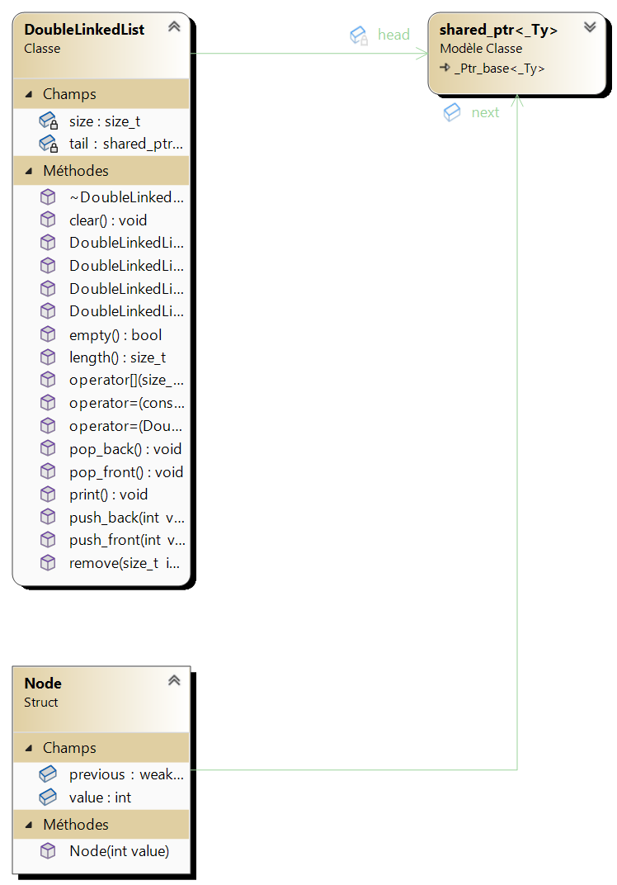

Рисунок 2 – диаграмма проекта



Рисунок 3 – approve задания