SOLAR-BASED SMART RINGING BELL SYSTEM
PANAGUINTINGAN ELEMENTARY SCHOOL • ESP32 & HUB75 MATRIX CONTROLLER
System Architecture, Operational Process Flow & Hardware Visual Documentation
Author: Engineering Pair Team • Target Platform: ESP32-WROOM-32 / LittleFS / FreeRTOS
System Overview & Engineering Scope
This document provides comprehensive technical documentation and process screenshots for the Solar-Based Smart Ringing Bell & HUB75 RGB LED Matrix System. Designed for high reliability in offline school environments, the system features GPS atomic time synchronization, FreeRTOS multi-core task scheduling, LittleFS non-volatile storage, optocoupler-isolated relay actuation, and an offline responsive Web Management Portal hosted directly from ESP32 internal flash memory.

🏠 Page 1: System Authentication, Access & Live Dashboard Process
Process Overview: The ESP32 creates an isolated WiFi SoftAP (SSID: ESP32-Bell-System, IP: 192.168.4.1) requiring zero external internet. Access to the web management console is protected by a secondary SHA-256 session-based authentication layer.
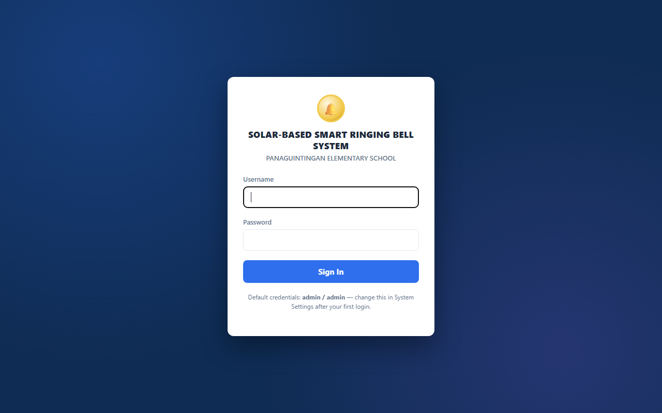
Figure 1.1: Secure Admin Login Portal with SHA-256 session token verification.
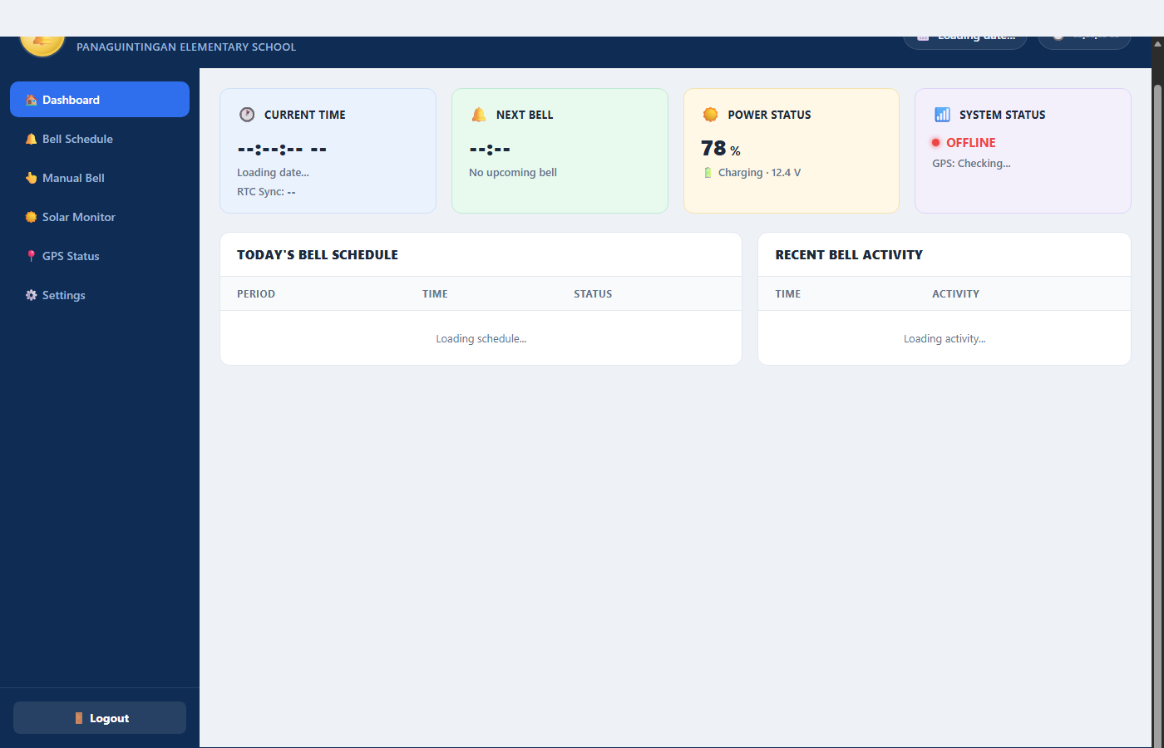
Figure 1.2: Live Web Dashboard displaying Real-Time Clock, Active Period Countdown, and Activity Log.
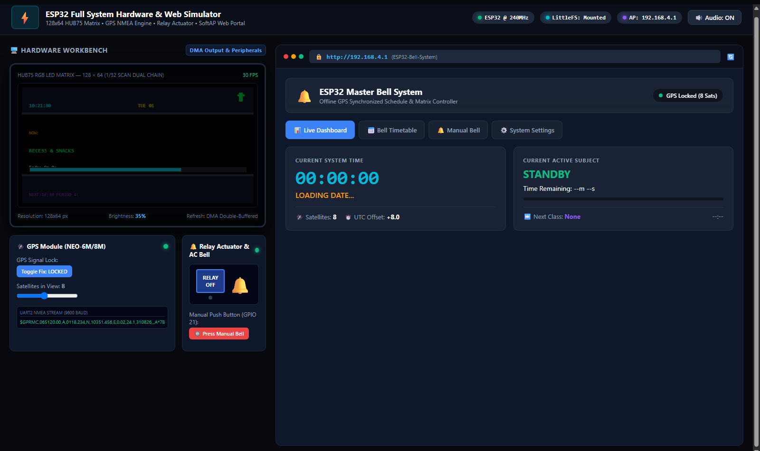
Figure 1.3: Dual System Workbench simulating 128x64 Matrix DMA Output and SoftAP Web Portal.
Detailed Technical Process Breakdown:
- 1. Captive Portal & Security Verification: When users connect to the ESP32 SoftAP and open http://192.168.4.1, WebServerManager::isAuthenticated() intercepts unauthenticated traffic, redirecting to /login.html. Submitting credentials performs client-side validation and dispatches POST /api/login, issuing an 8-hour session token cookie.
- 2. Live 1-Second Telemetry Polling: The dashboard initiates an asynchronous GET /api/status loop every 1,000ms. The response supplies UTC date/time, GPS satellite lock status, active class period metadata, time remaining, and visual progress percentage.
- 3. Dynamic Timetable & Activity Tracking: The dashboard evaluates today's periods against local time, assigning Done, In Session, Next, or Pending status pills per row, while streaming the last 20 bell events from the circular activity buffer.

🛰️ Page 2: GPS Synchronization, Real-Time Clock & Matrix Display Process
Process Overview: Atomic time accuracy is maintained off-grid by continuously parsing NMEA satellite telemetry through hardware UART2, rendering live schedules and clocks onto a high-resolution 128x64 HUB75 RGB LED Matrix via I2S DMA double-buffering.
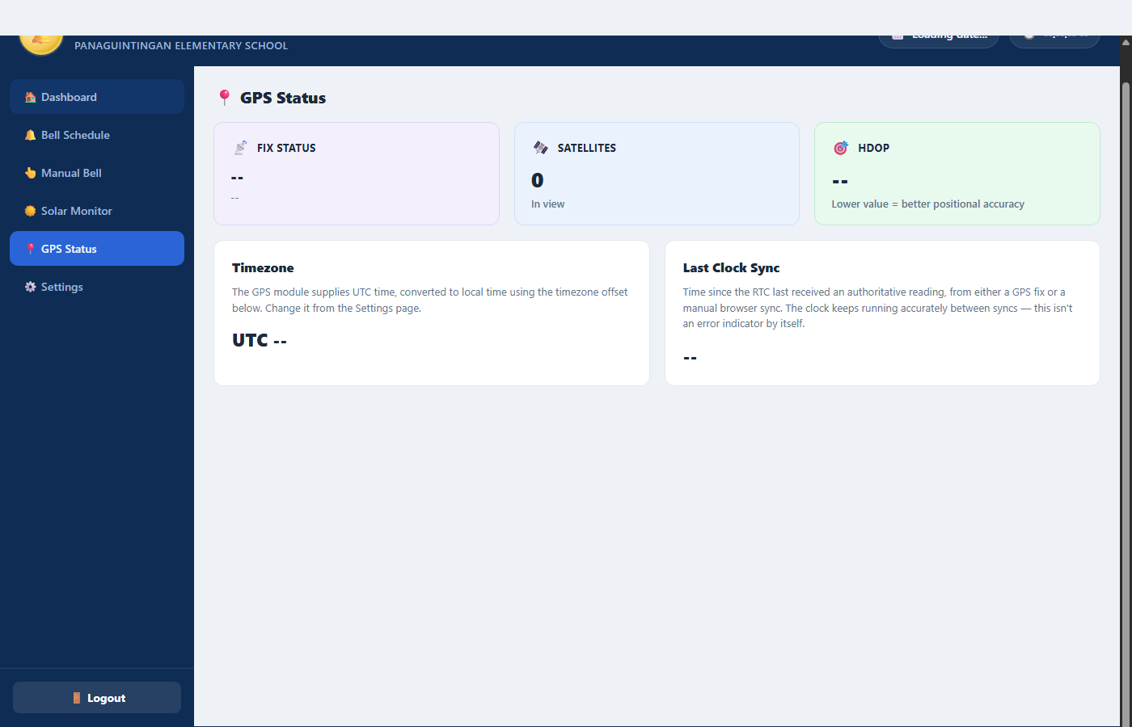
Figure 2.1: GPS Telemetry Panel showing Satellite Lock, HDOP Accuracy, and UTC Timezone.
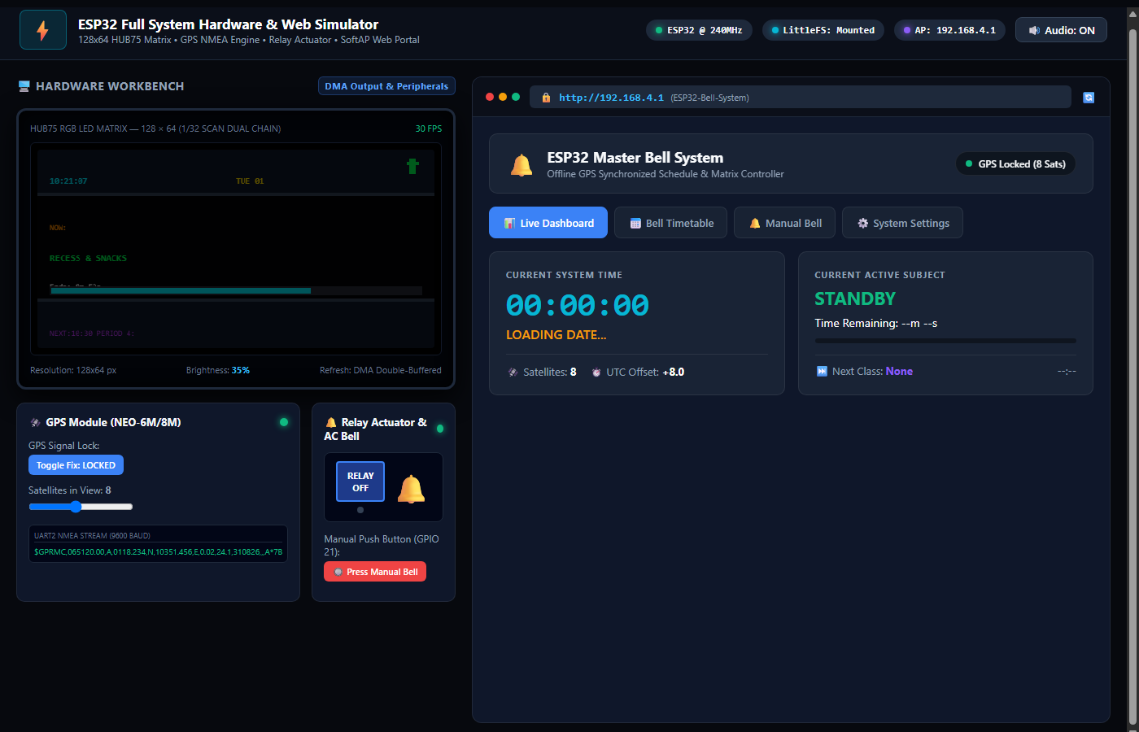
Figure 2.2: 128x64 HUB75 RGB LED Matrix Enclosure with Real-Time Clock and Smooth Marquee Banner.
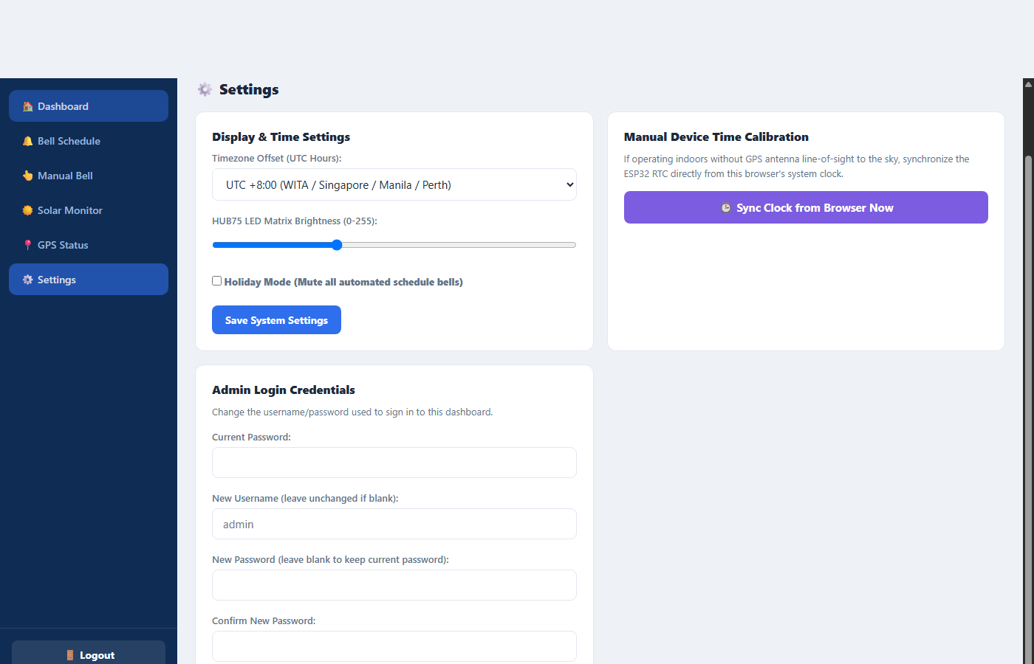
Figure 2.3: Manual Browser-to-ESP32 RTC Calibration interface for indoor commissioning.
Detailed Technical Process Breakdown:
- 1. Satellite Signal Ingestion & NMEA Engine: A NEO-6M/8M GPS receiver interfaces over GPIO 16 (RX) and GPIO 17 (TX) at 9600 baud. GPSManager parses $GPRMC and $GPGGA sentences with TinyGPSPlus, updating the internal hardware RTC upon receiving valid fixes with low HDOP.
- 2. HUB75 I2S DMA Matrix Graphics Pipeline: The 128x64 RGB LED matrix is refreshed at 30+ FPS using ESP32 DMA channels, offloading CPU processing. It displays large digital clock numerals, satellite status dots, and smooth scrolling marquee text for long class names.
- 3. Indoor Time Calibration Fallback: During indoor testing or building installations without clear sky visibility, administrators can click 'Sync Clock from Browser Now', which posts the client's UTC epoch timestamp via POST /api/timesync to synchronize the ESP32 RTC immediately.

📅 Page 3: Automated Bell Scheduling & Flash Memory Persistence Process
Process Overview: School bell schedules are configured through an intuitive weekly timetable editor and stored permanently in non-volatile LittleFS flash memory (/schedules.json), guaranteeing zero data loss during power outages.
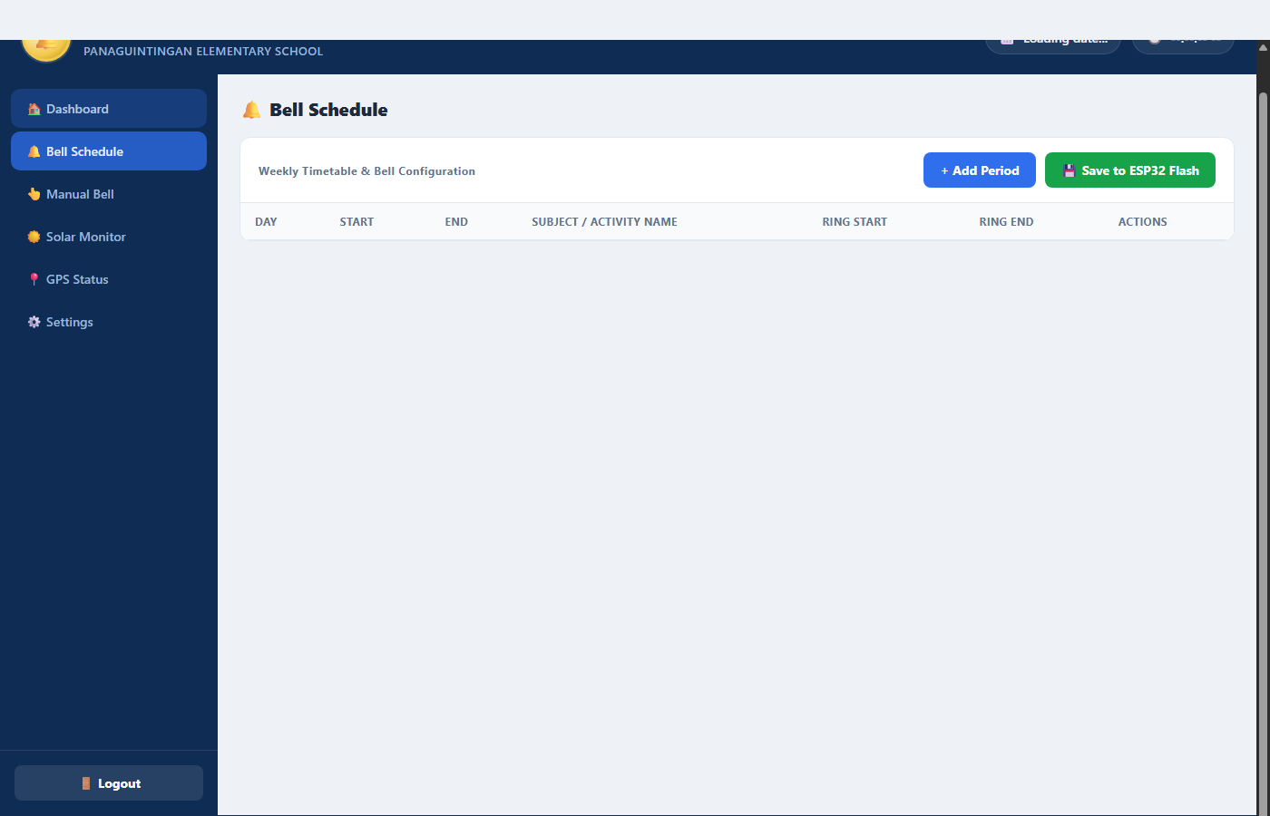
Figure 3.1: Weekly Timetable Configuration Table with Period Start, End & Ring Triggers.
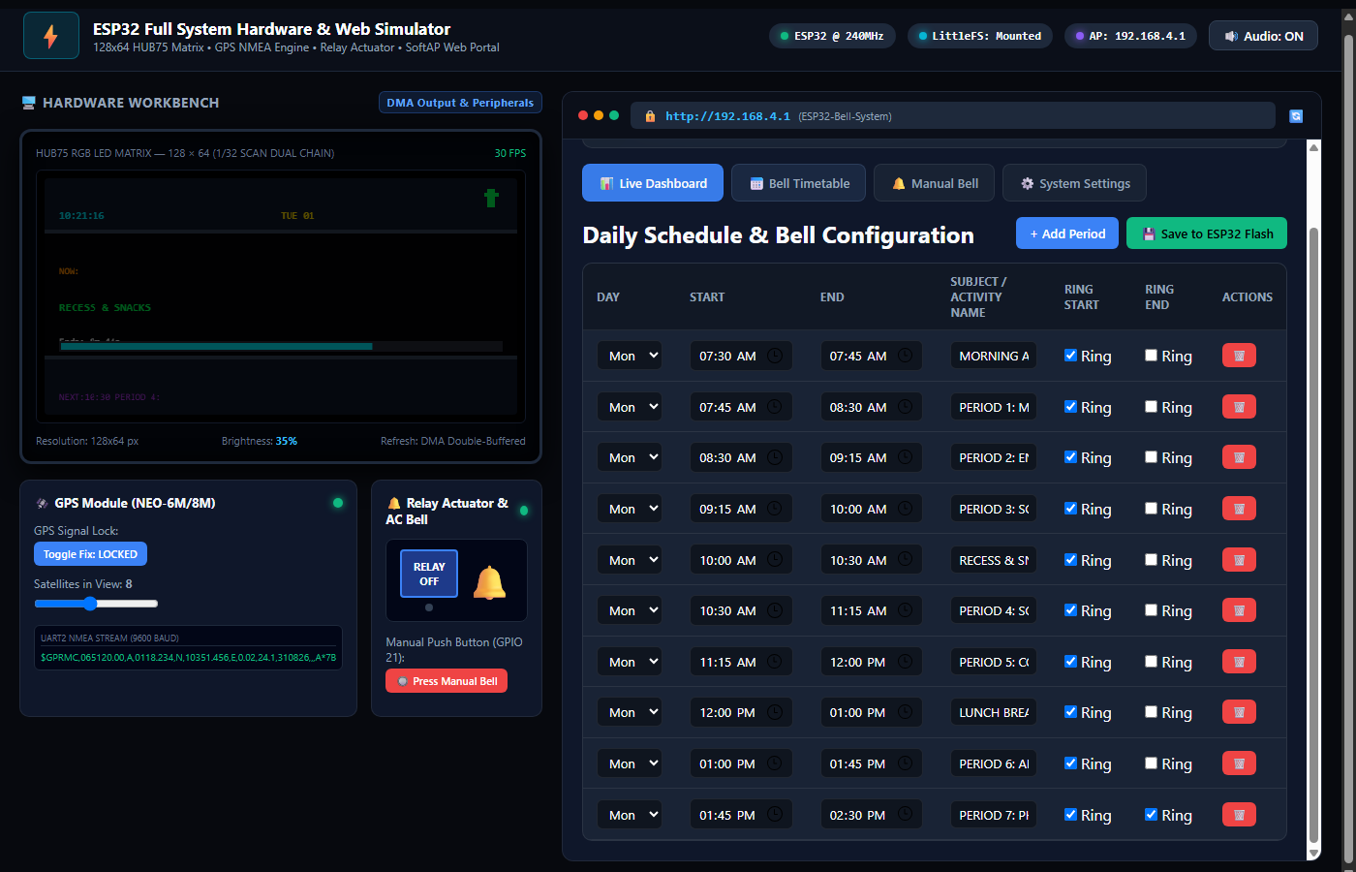
Figure 3.2: Period Creation Form validating Subject Name, recurrence days, and time ranges.
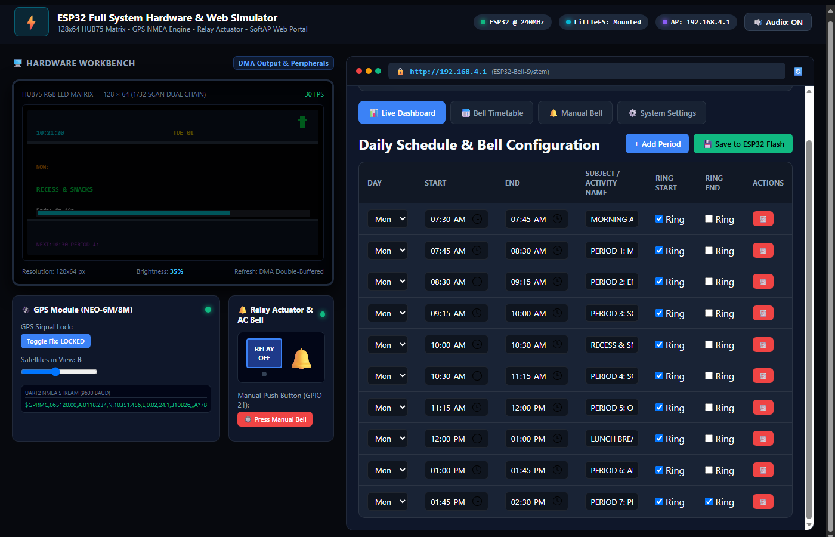
Figure 3.3: LittleFS Non-Volatile Flash Persistence with visual confirmation toast.
Detailed Technical Process Breakdown:
- 1. Timetable Period Configuration: Each period entry supports day filters (Mon-Fri Weekdays, Everyday, or individual days), 24-hour Start and End times, Custom Subject Titles (up to 30 characters), and independent Ring Start and Ring End triggers.
- 2. Comprehensive Form Validation: Both client-side JavaScript (app.js) and firmware C++ (ScheduleManager.cpp) enforce strict data validation: empty subject names and invalid time spans (where end time <= start time) are rejected with descriptive alerts.
- 3. LittleFS Flash Memory Serialization: When saving, the timetable is converted into JSON using ArduinoJson v7 and committed to /schedules.json on the internal flash partition. Schedules are automatically restored upon every boot cycle.

🔔 Page 4: Automated & Manual Bell Actuation & Relay Hardware Process
Process Overview: Bell ringing is actuated via an optocoupler-isolated relay module connected to high-decibel AC or DC school bells. The system provides automated timetable triggering, manual web triggers, front-panel push button override, and instant emergency stop.
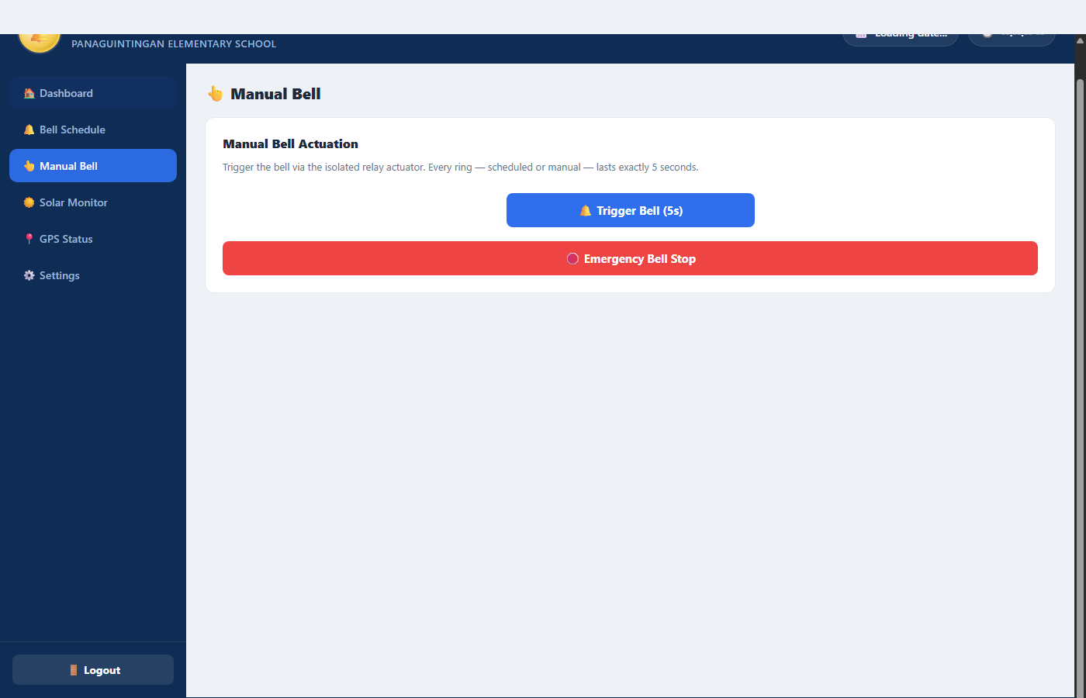
Figure 4.1: Manual Bell Control Interface with Single 5s Ring Trigger and Emergency Stop.
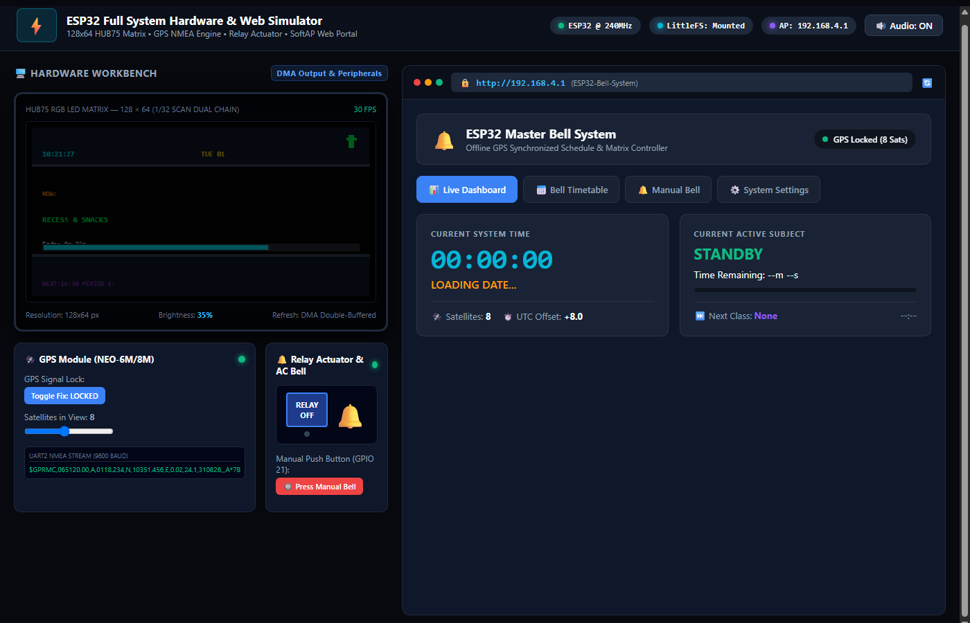
Figure 4.2: Active Ringing Banner Alert with animated indicator and one-click Emergency Stop.
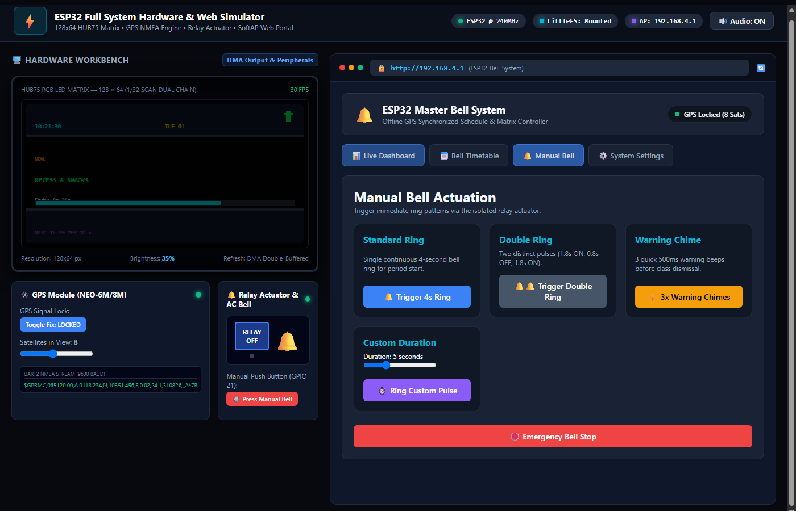
Figure 4.3: Relay Actuator Module Energization, Relay Status LED, and Mechanical Bell Gong.
Detailed Technical Process Breakdown:
- 1. Automated Schedule Execution: ScheduleManager::update() continuously evaluates the current second against configured periods. When a match occurs, it invokes RelayManager::ring(), driving GPIO 22 HIGH for a precise 5-second pulse unless Holiday Mode is active.
- 2. Multi-Source Manual Triggering: Manual rings can be actuated from the Web Portal ('Trigger Bell (5s)', sending POST /api/ring) or by pressing the physical front-panel button wired to GPIO 21 with software debounce protection.
- 3. Isolated Relay Switching & Emergency Abort: The relay circuit electrically isolates the ESP32 3.3V logic from 220V/110V AC or 12V DC bell power lines. Clicking 'Emergency Bell Stop' (POST /api/stop) forces GPIO 22 LOW immediately, aborting any active ring.

☀️ Page 5: Solar Power Monitoring, System Settings & Security Process
Process Overview: The system includes dedicated interfaces for Solar Battery telemetry monitoring, global UTC timezone configuration, LED matrix brightness PWM scaling, Holiday Mode muting, and administrator credential management.
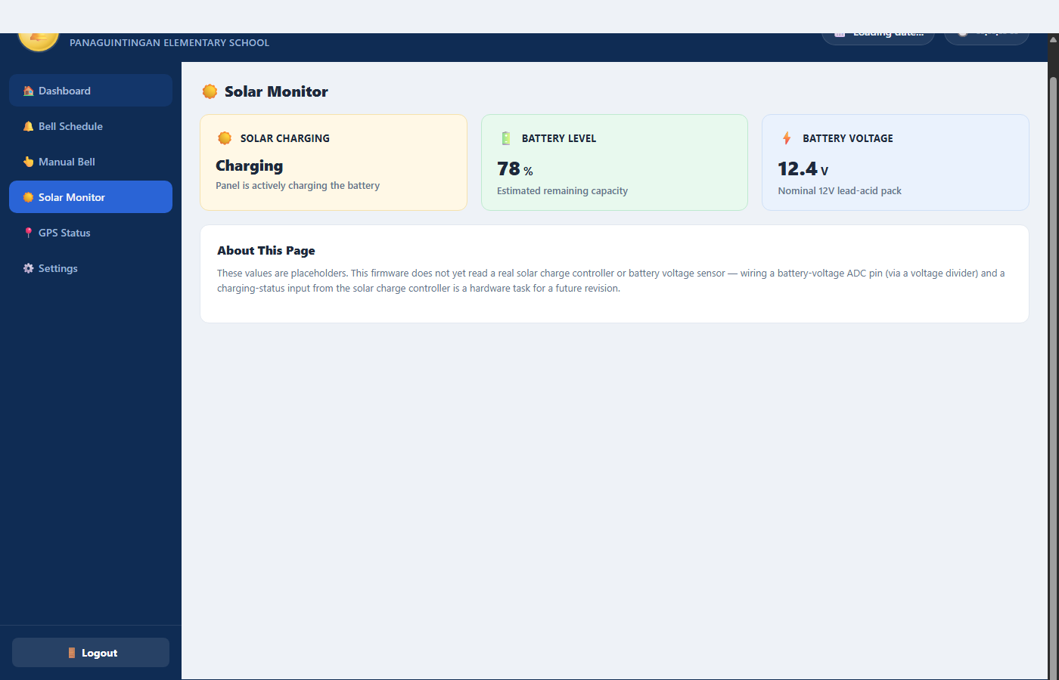
Figure 5.1: Solar Power Telemetry Panel displaying Solar Charging State, Battery Level %, and Voltage.
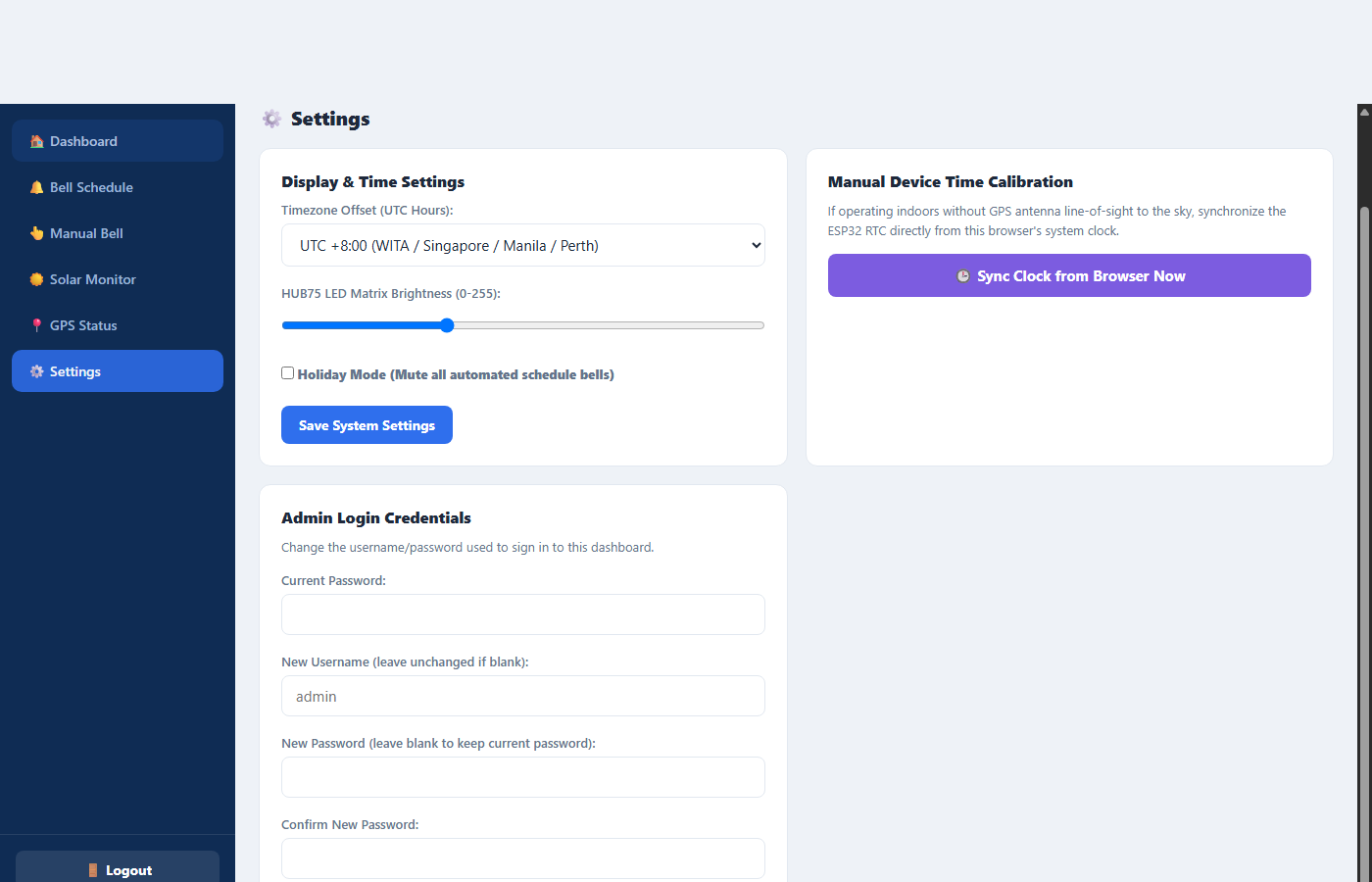
Figure 5.2: System Settings Panel for UTC Timezone Offset, HUB75 Brightness & Holiday Mode.
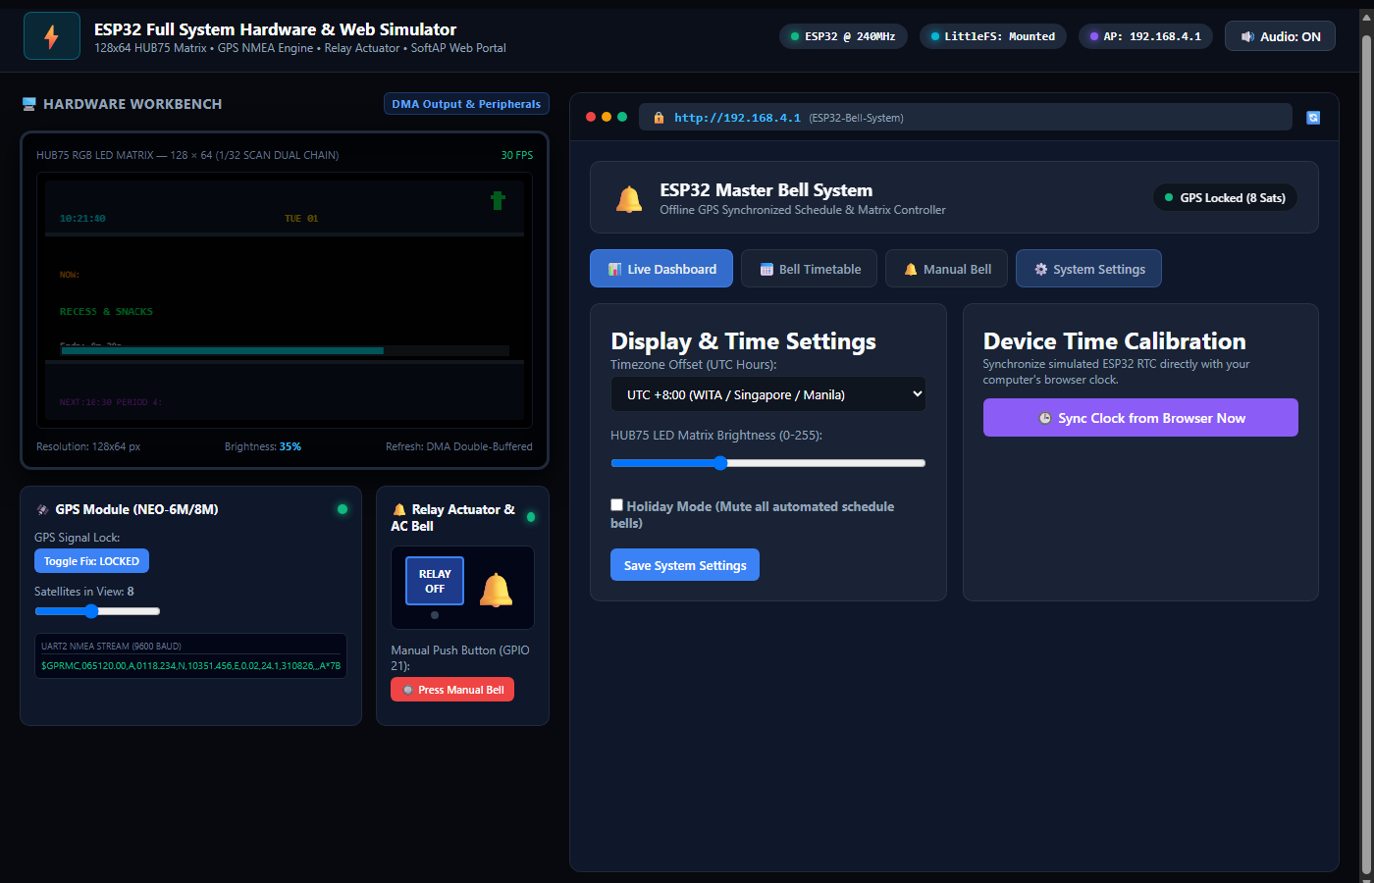
Figure 5.3: Administrator Credential Security Management for username and password updates.
Detailed Technical Process Breakdown:
- 1. Solar Power & Battery Telemetry: The Solar Monitor displays solar panel charging state, estimated battery capacity percentage (e.g., 78%), and 12V lead-acid terminal voltage (12.4V), providing off-grid operational awareness.
- 2. Timezone Offset & LED Brightness Control: Admins can select local UTC offsets (e.g., UTC +8:00 for Manila/Singapore/Perth, UTC +7:00 for Jakarta/Bangkok). The matrix brightness slider (10 to 255) dynamically regulates display PWM for optimal day/night visibility.
- 3. Holiday Mode & Credential Hashing: Enabling Holiday Mode mutes all automated timetable rings during school vacations while preserving the digital clock. The Admin Login Credentials card allows updating credentials with SHA-256 verification stored in /config.json.

🔌 System Hardware Pinout & Architecture Summary
Hardware Subsystem | ESP32 GPIO Pin | Signal / Function | Operating Voltage
NEO-6M/8M GPS Module | GPIO 16 | RX2 (Connects to GPS TX) | 3.3V / 5V VCC
NEO-6M/8M GPS Module | GPIO 17 | TX2 (Connects to GPS RX) | 3.3V / 5V VCC
Relay Actuator Module | GPIO 22 | Digital Output (Relay Control) | 5V VCC / 3.3V Logic
Manual Push Button | GPIO 21 | Digital Input (Active LOW Pull-up) | 3.3V Logic
HUB75 LED Matrix (128x64) | GPIO 25, 26, 27 | R1, G1, B1 (Upper Half RGB) | 5V Matrix VCC / 3.3V Logic
HUB75 LED Matrix (128x64) | GPIO 14, 12, 13 | R2, G2, B2 (Lower Half RGB) | 5V Matrix VCC / 3.3V Logic
HUB75 LED Matrix (128x64) | GPIO 23, 19, 5, 18, 4 | A, B, C, D, E (Row Scan Lines) | 5V Matrix VCC / 3.3V Logic
HUB75 LED Matrix (128x64) | GPIO 15, 32, 33 | LAT, OE, CLK (Timing & Latch) | 5V Matrix VCC / 3.3V Logic
Solar Battery Voltage Divider | GPIO 34 (ADC1_CH6) | Analog Voltage Input (0-3.3V) | 12V Battery via Divider

