SOLAR-BASED SMART RINGING BELL SYSTEM
PANAGUINTINGAN ELEMENTARY SCHOOL • ESP32 & HUB75 MATRIX CONTROLLER
System Architecture, Operational Process Flow & Real Web UI Documentation
Target Hardware: ESP32-WROOM-32 / LittleFS / NEO-6M GPS / HUB75 DMA / Isolated Relay
Executive Engineering Summary
This document provides full technical documentation and real web portal process screenshots for the Solar-Based Smart Ringing Bell & HUB75 RGB LED Matrix Controller. Tailored specifically for Panaguintingan Elementary School, the system operates completely offline without internet or cloud dependencies. Core features include atomic GPS clock synchronization, weekly schedule management, LittleFS non-volatile flash storage, optocoupler-isolated relay bell actuation, and a responsive web dashboard served directly from the ESP32 internal flash memory.

🏠 Page 1: System Authentication, Access & Live Dashboard Process
Process Overview: The ESP32 broadcasts a standalone WiFi SoftAP (SSID: ESP32-Bell-System, IP: 192.168.4.1). Administrative access is secured via a SHA-256 session token authentication gate protecting the live operational dashboard.
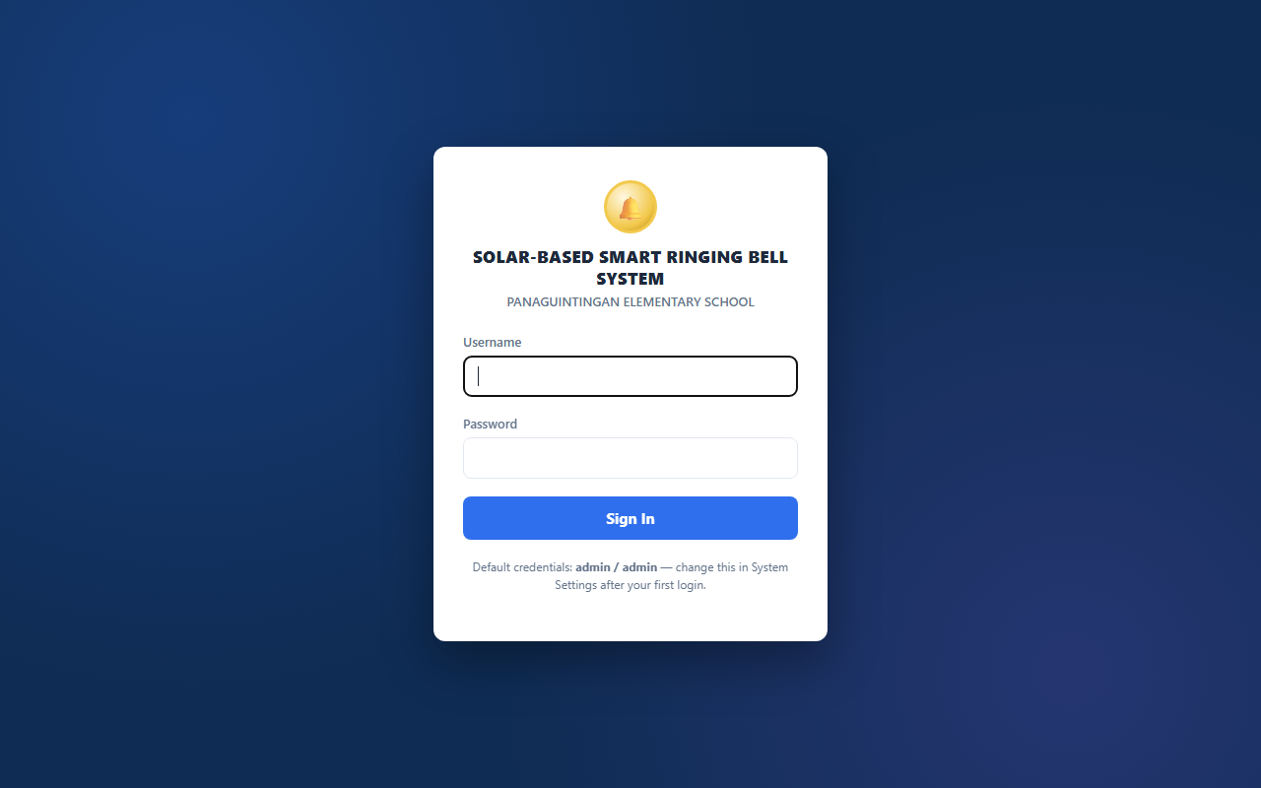
Figure 1.1: Secure Admin Login Portal with SHA-256 password hash verification.
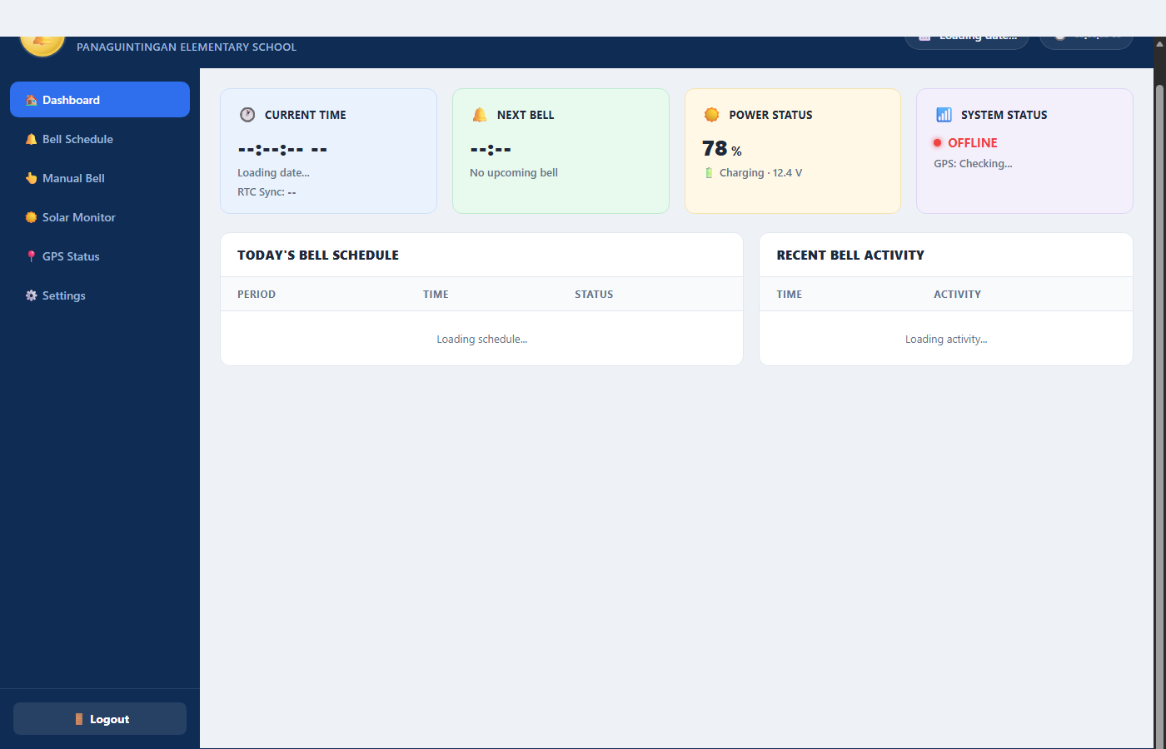
Figure 1.2: Real-Time Status Telemetry Cards displaying Live Clock, Next Bell countdown, Power Status, and System Status.
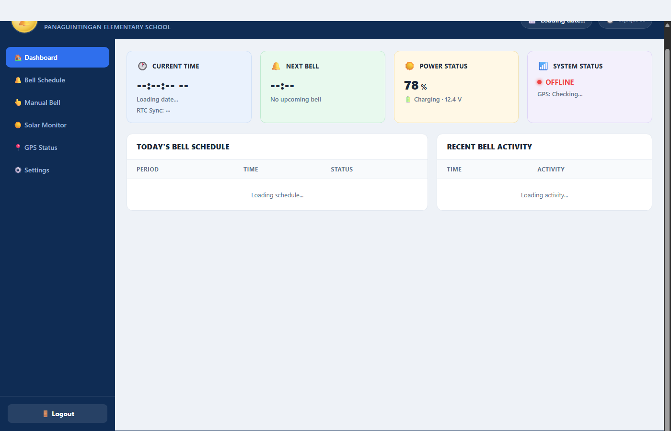
Figure 1.3: Today's Bell Schedule Timetable with period progress indicators and Recent Bell Activity log.
Detailed Technical Process Breakdown:
- 1. SoftAP Captive Portal & Security Verification: Upon connecting to 'ESP32-Bell-System' and navigating to http://192.168.4.1, WebServerManager::isAuthenticated() verifies session validity. Unauthenticated clients are routed to /login.html. Valid login issues an 8-hour HTTP cookie session token.
- 2. Live 1-Second Telemetry Polling Loop: The dashboard initiates an asynchronous GET /api/status request every 1,000ms. The response supplies real-time clock readings, GPS fix status, active subject details, remaining duration, and countdown timer.
- 3. Dynamic Timetable & Circular Activity Log: Today's scheduled periods are continuously evaluated against system time to display live status badges (Done, In Session, Next, Pending). Recent bell events are captured in a non-volatile 20-event circular log.

🛰️ Page 2: GPS Synchronization, Real-Time Clock & Calibration Process
Process Overview: Accurate timekeeping is achieved through atomic GPS satellite time ingestion over hardware UART2, with configurable UTC offsets and direct browser-to-ESP32 RTC calibration for indoor commissioning.
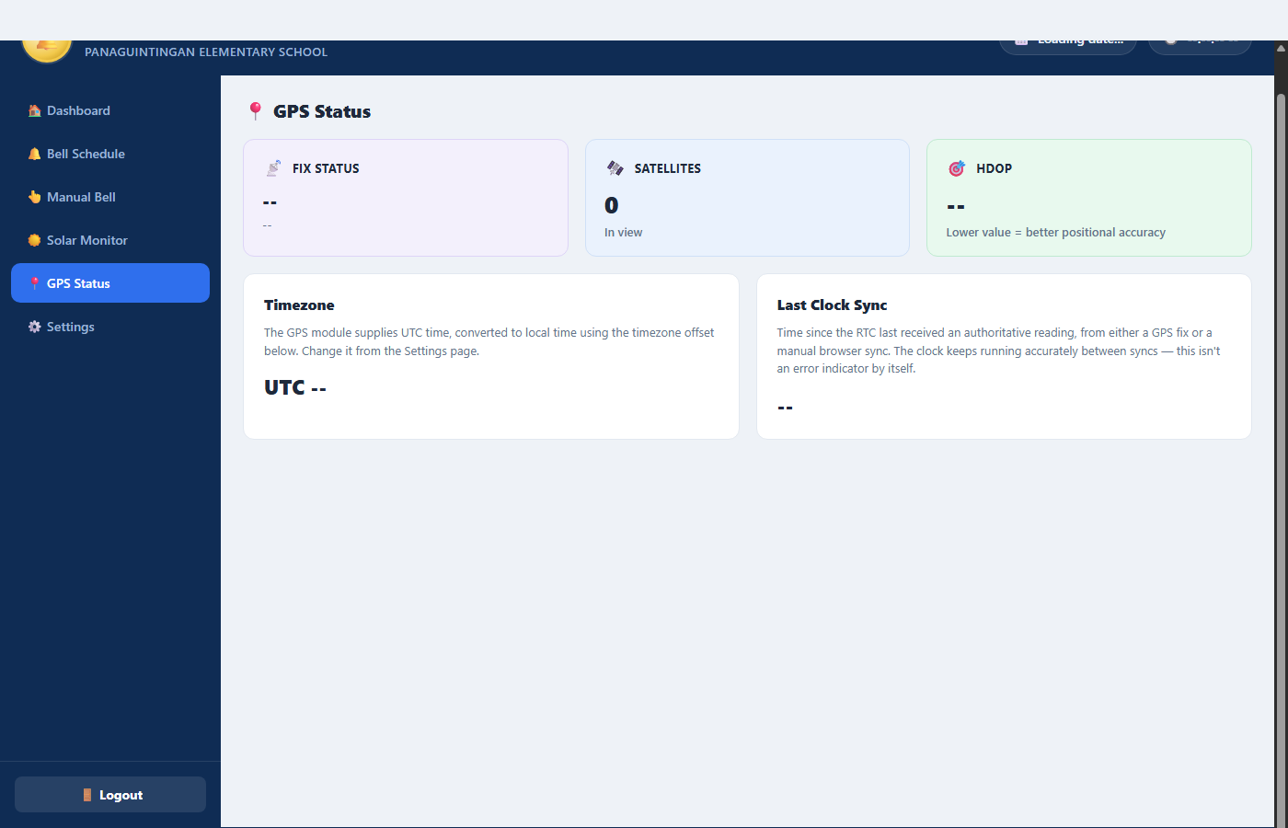
Figure 2.1: GPS Status Dashboard showing Fix Lock status, Satellites in view, and HDOP Precision.
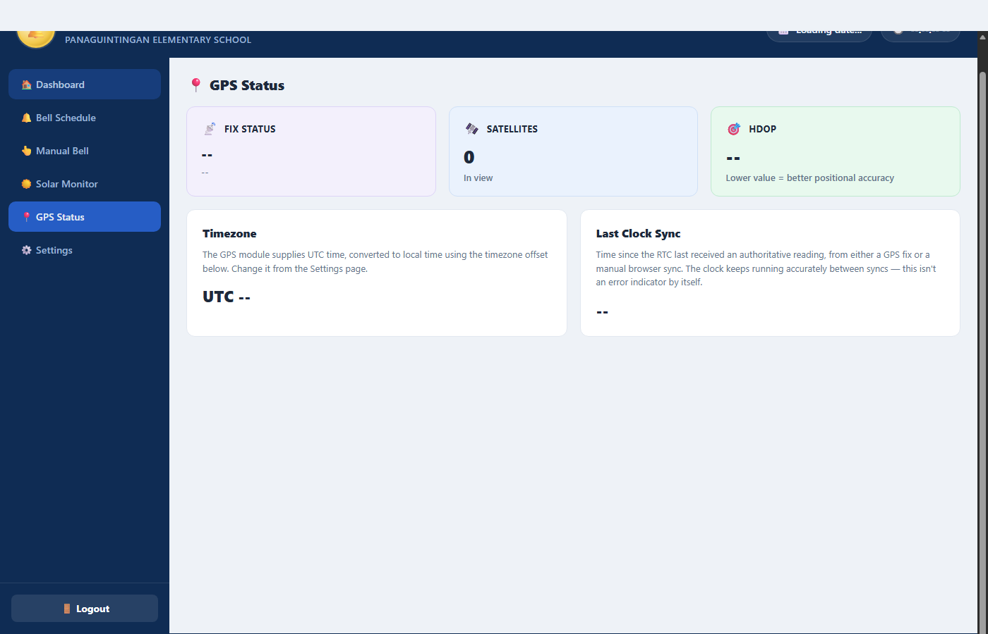
Figure 2.2: Timezone and Last Clock Sync Telemetry display indicating accurate RTC elapsed time.
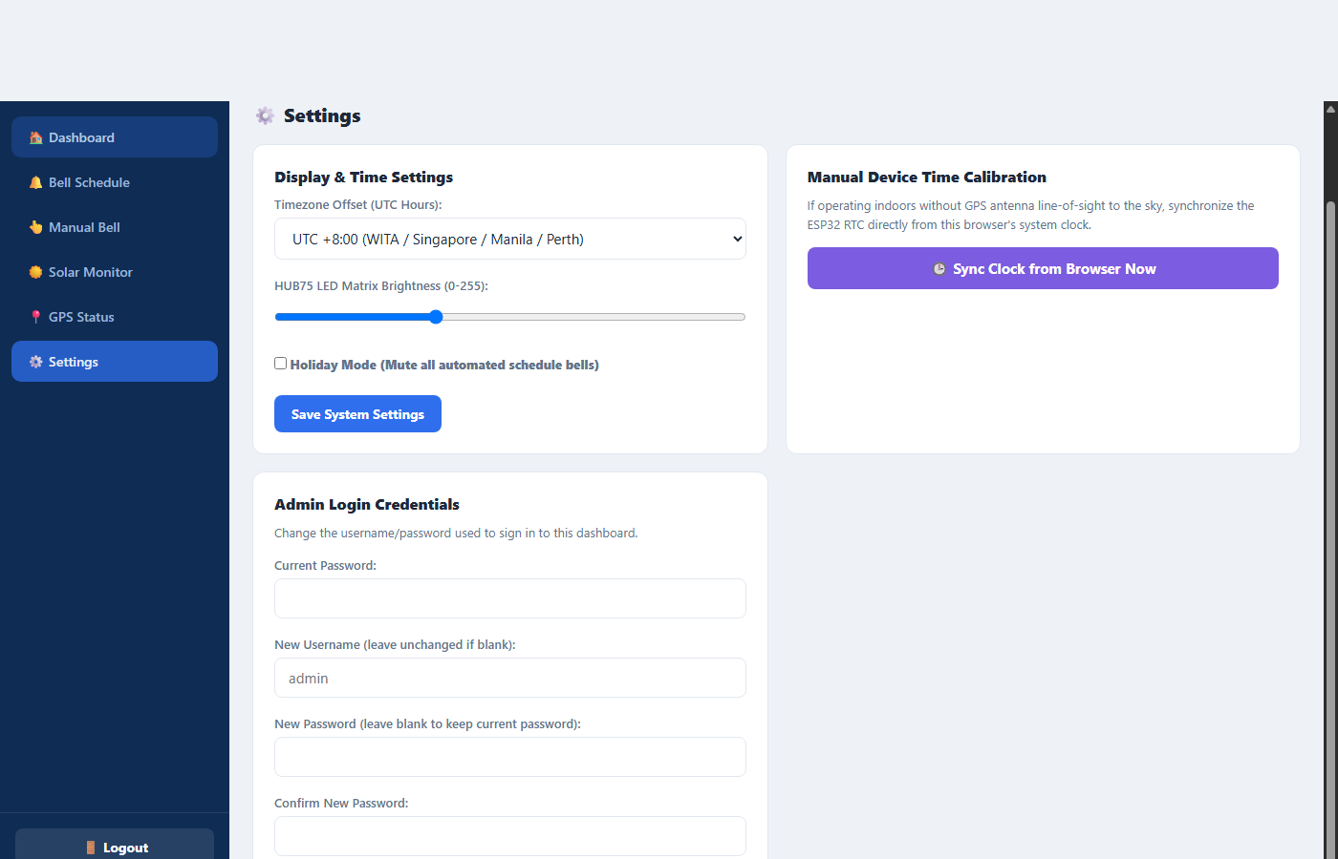
Figure 2.3: Manual Browser-to-ESP32 Clock Calibration interface for indoor setups.
Detailed Technical Process Breakdown:
- 1. Atomic GPS Satellite Time Ingestion: The NEO-6M GPS receiver interfaces with ESP32 UART2 (GPIO 16 RX / GPIO 17 TX) at 9600 baud. GPSManager parses $GPRMC and $GPGGA sentences with TinyGPSPlus, synchronizing the internal RTC when valid fixes with low HDOP are acquired.
- 2. Timezone Offset Application: The system applies a configurable UTC offset (e.g., UTC +8:00 for Manila/Singapore/Perth) directly to UTC timestamps from GPS or manual calibration, updating clock displays instantly across the web portal and HUB75 matrix.
- 3. Indoor Time Calibration Fallback: When commissioning indoors without sky line-of-sight, clicking 'Sync Clock from Browser Now' dispatches POST /api/timesync containing the client device's UTC epoch timestamp, calibrating the ESP32 RTC immediately.

📅 Page 3: Automated Bell Scheduling & Flash Memory Persistence Process
Process Overview: School bell schedules are configured through an intuitive weekly timetable manager and committed permanently to non-volatile LittleFS flash memory (/schedules.json), ensuring seamless operation across power cycles.
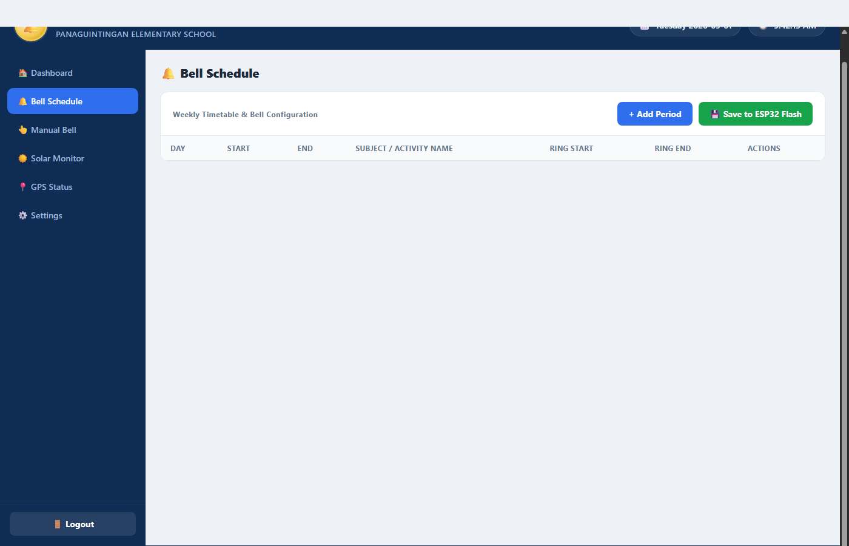
Figure 3.1: Weekly Timetable Configuration Panel with period management controls.
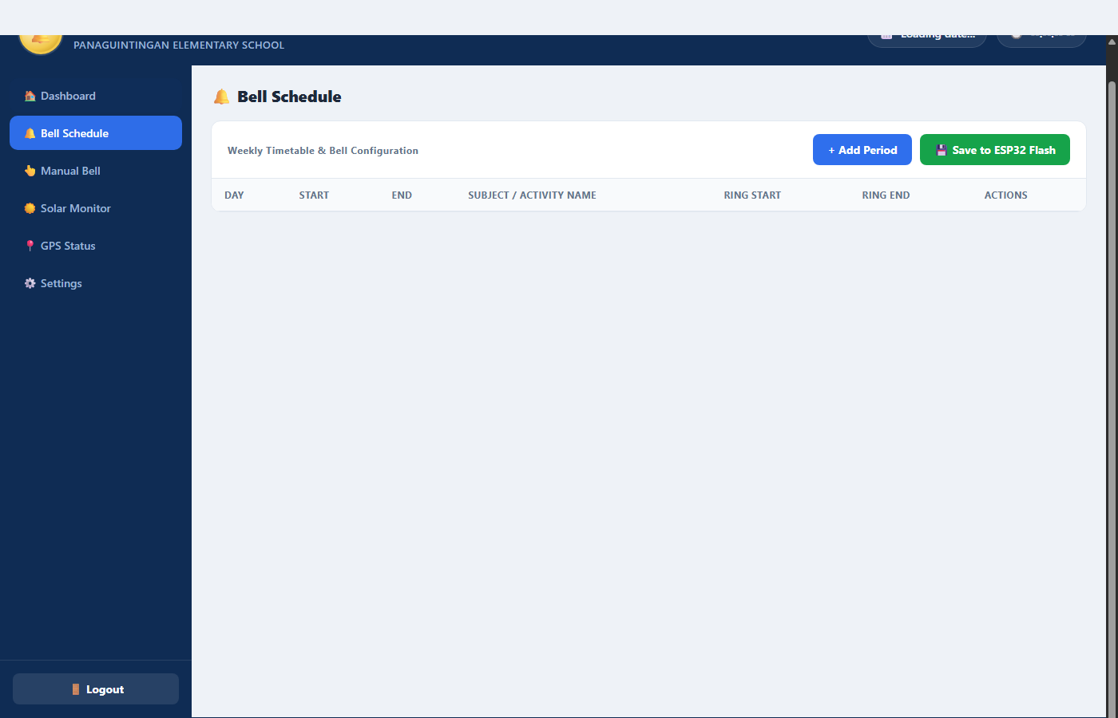
Figure 3.2: Period Rows Editor with Day Selector, Start/End times, and Ring Start/End checkboxes.
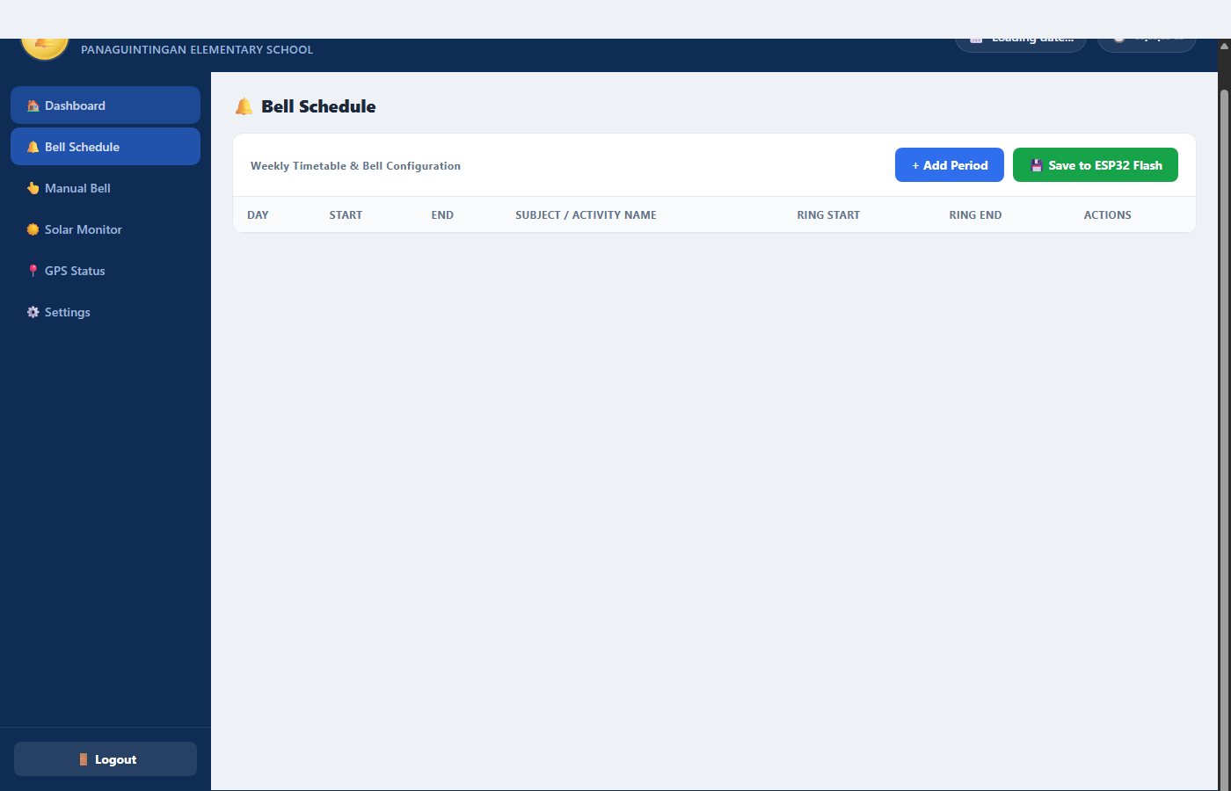
Figure 3.3: LittleFS Flash Persistence action with confirmation notification toast.
Detailed Technical Process Breakdown:
- 1. Flexible Weekly Timetable Management: Administrators configure periods with custom day filters (Mon-Fri Weekdays, Everyday, or specific days), 24-hour Start and End times, Subject Name (e.g., MATHEMATICS, RECESS), and independent Ring Start and Ring End toggles.
- 2. Client & Server Data Validation: To prevent invalid timetable states, both app.js and ScheduleManager.cpp enforce validation: empty subject names and invalid time periods (where end time <= start time) are rejected with descriptive alerts.
- 3. LittleFS Non-Volatile Flash Serialization: Clicking 'Save to ESP32 Flash' serializes the timetable into JSON via ArduinoJson v7 and writes to /schedules.json on the LittleFS partition, preserving configurations across power cycles.

🔔 Page 4: Automated & Manual Bell Actuation & Relay Hardware Process
Process Overview: Bell ringing is actuated via an optocoupler-isolated relay module wired to physical school bells. The system supports automated timetable ringing, web-based manual triggers, physical push buttons, and immediate emergency stop.
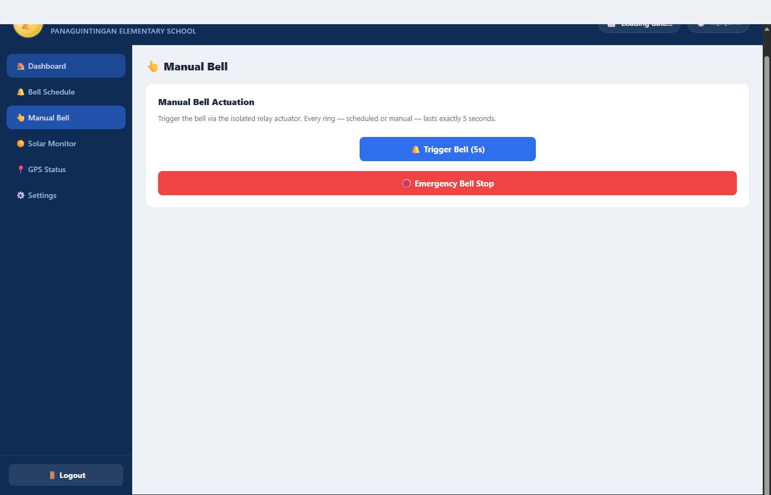
Figure 4.1: Manual Bell Control Interface with Single 5s Trigger Button and Emergency Stop.
Figure 4.2: Active Ringing Warning Banner displayed across the dashboard during bell operation.
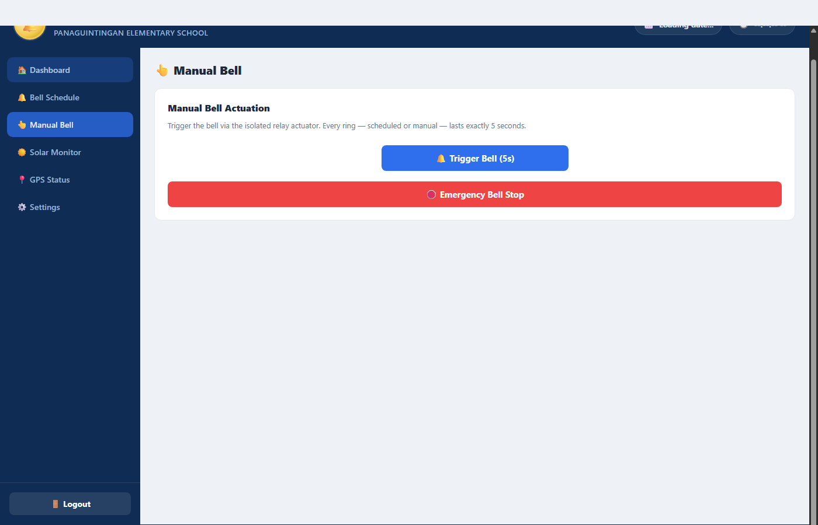
Figure 4.3: Manual Bell Actuation Confirmation Toast with one-click Emergency Abort.
Detailed Technical Process Breakdown:
- 1. Automated Schedule Execution: ScheduleManager continuously compares the current RTC second against configured periods. When a match occurs, RelayManager drives GPIO 22 HIGH for a precise 5-second pulse unless Holiday Mode is active.
- 2. Multi-Channel Manual Triggering: Authorized users can trigger an immediate 5-second ring via the Web Portal ('Trigger Bell (5s)', POST /api/ring) or via the front-panel physical button connected to GPIO 21 with software debounce.
- 3. Optocoupled Relay Isolation & Emergency Abort: The relay module provides optical isolation between the 3.3V ESP32 microcontroller and high-voltage 220V AC or 12V DC bells. Clicking 'Emergency Bell Stop' (POST /api/stop) forces GPIO 22 LOW immediately.

☀️ Page 5: Solar Power Monitoring, System Settings & Security Process
Process Overview: The system incorporates dedicated telemetry for Solar Battery power monitoring, global UTC timezone configuration, LED matrix brightness PWM regulation, Holiday Mode bell muting, and administrator credential management.
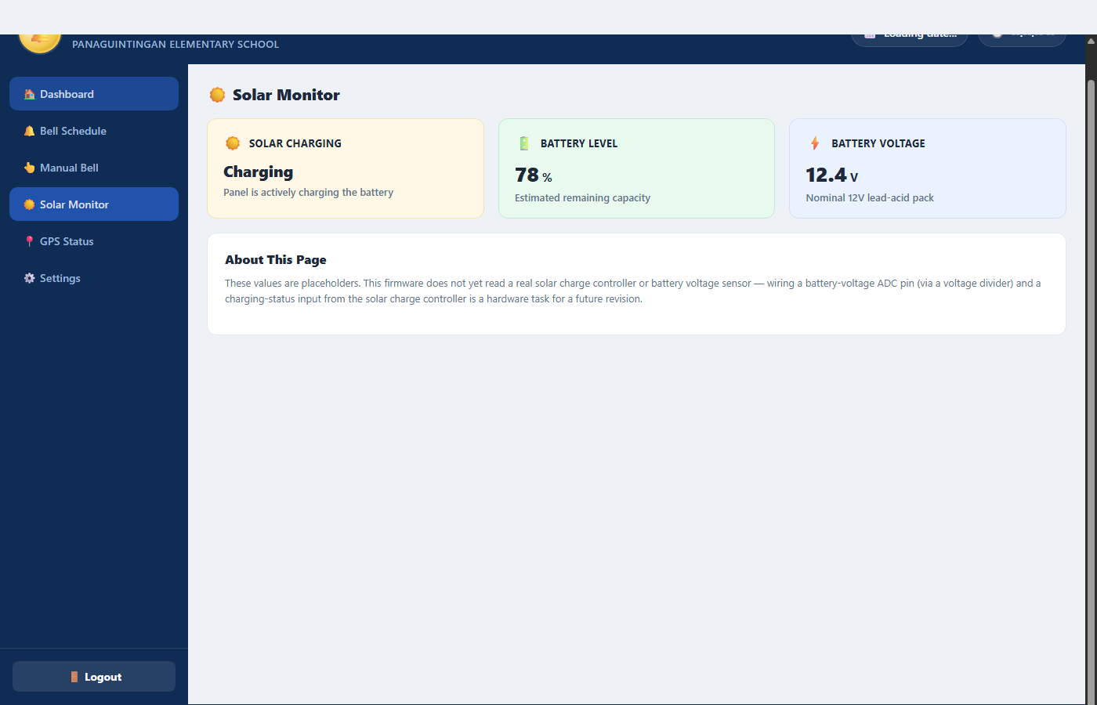
Figure 5.1: Solar Power Telemetry Panel displaying Solar Charging State, Battery Level %, and Voltage.
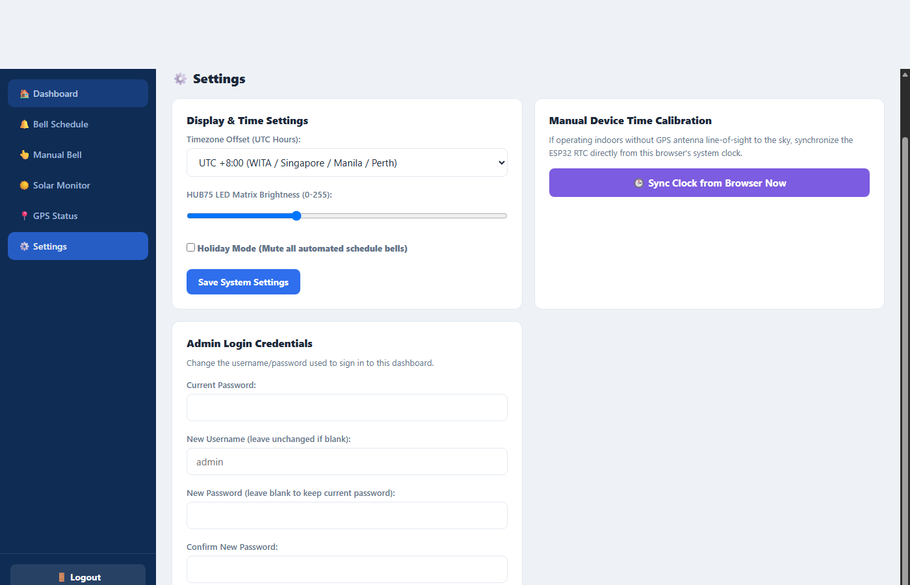
Figure 5.2: System Settings for Timezone Offset, HUB75 Matrix Brightness, and Holiday Mode.
Figure 5.3: Administrator Credential Security Management for username and password updates.
Detailed Technical Process Breakdown:
- 1. Solar Power & Battery Telemetry: The Solar Monitor displays solar panel charging activity, remaining battery capacity percentage (e.g. 78%), and 12V lead-acid terminal voltage (12.4V) for off-grid operational awareness.
- 2. Timezone Offset & LED Brightness Control: Administrators select the regional UTC offset (e.g., UTC +8:00 for Philippines). The matrix brightness slider (10 to 255) adjusts PWM output to ensure optimal readability in various lighting conditions.
- 3. Holiday Mode & Credential Hashing: Holiday Mode mutes automated schedule rings during school breaks while keeping the clock operational. The Admin Login Credentials card updates credentials using SHA-256 hashing stored securely in /config.json.

🔌 System Hardware Pinout & Architecture Summary
Hardware Subsystem | ESP32 GPIO Pin | Signal / Function | Operating Voltage
NEO-6M/8M GPS Module | GPIO 16 | RX2 (Connects to GPS TX) | 3.3V / 5V VCC
NEO-6M/8M GPS Module | GPIO 17 | TX2 (Connects to GPS RX) | 3.3V / 5V VCC
Relay Actuator Module | GPIO 22 | Digital Output (Relay Control) | 5V VCC / 3.3V Logic
Manual Push Button | GPIO 21 | Digital Input (Active LOW Pull-up) | 3.3V Logic
HUB75 LED Matrix (128x64) | GPIO 25, 26, 27 | R1, G1, B1 (Upper Half RGB) | 5V Matrix VCC / 3.3V Logic
HUB75 LED Matrix (128x64) | GPIO 14, 12, 13 | R2, G2, B2 (Lower Half RGB) | 5V Matrix VCC / 3.3V Logic
HUB75 LED Matrix (128x64) | GPIO 23, 19, 5, 18, 4 | A, B, C, D, E (Row Scan Lines) | 5V Matrix VCC / 3.3V Logic
HUB75 LED Matrix (128x64) | GPIO 15, 32, 33 | LAT, OE, CLK (Timing & Latch) | 5V Matrix VCC / 3.3V Logic
Solar Battery Voltage Divider | GPIO 34 (ADC1_CH6) | Analog Voltage Input (0-3.3V) | 12V Battery via Divider

