PowerGuard IoT System Processes
This document provides a visual walkthrough of the main processes within the PowerGuard IoT application.

Page 1: User Onboarding & Authentication
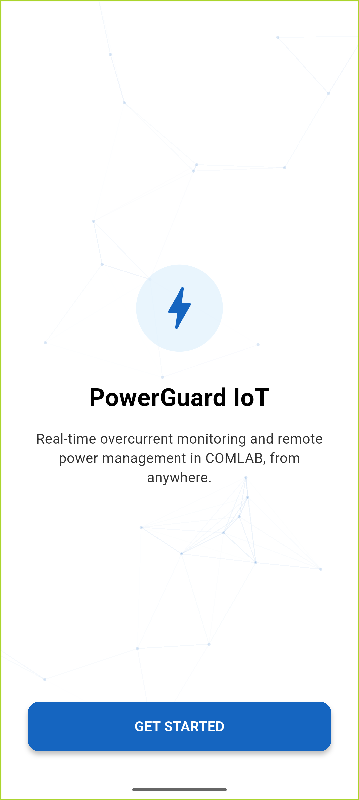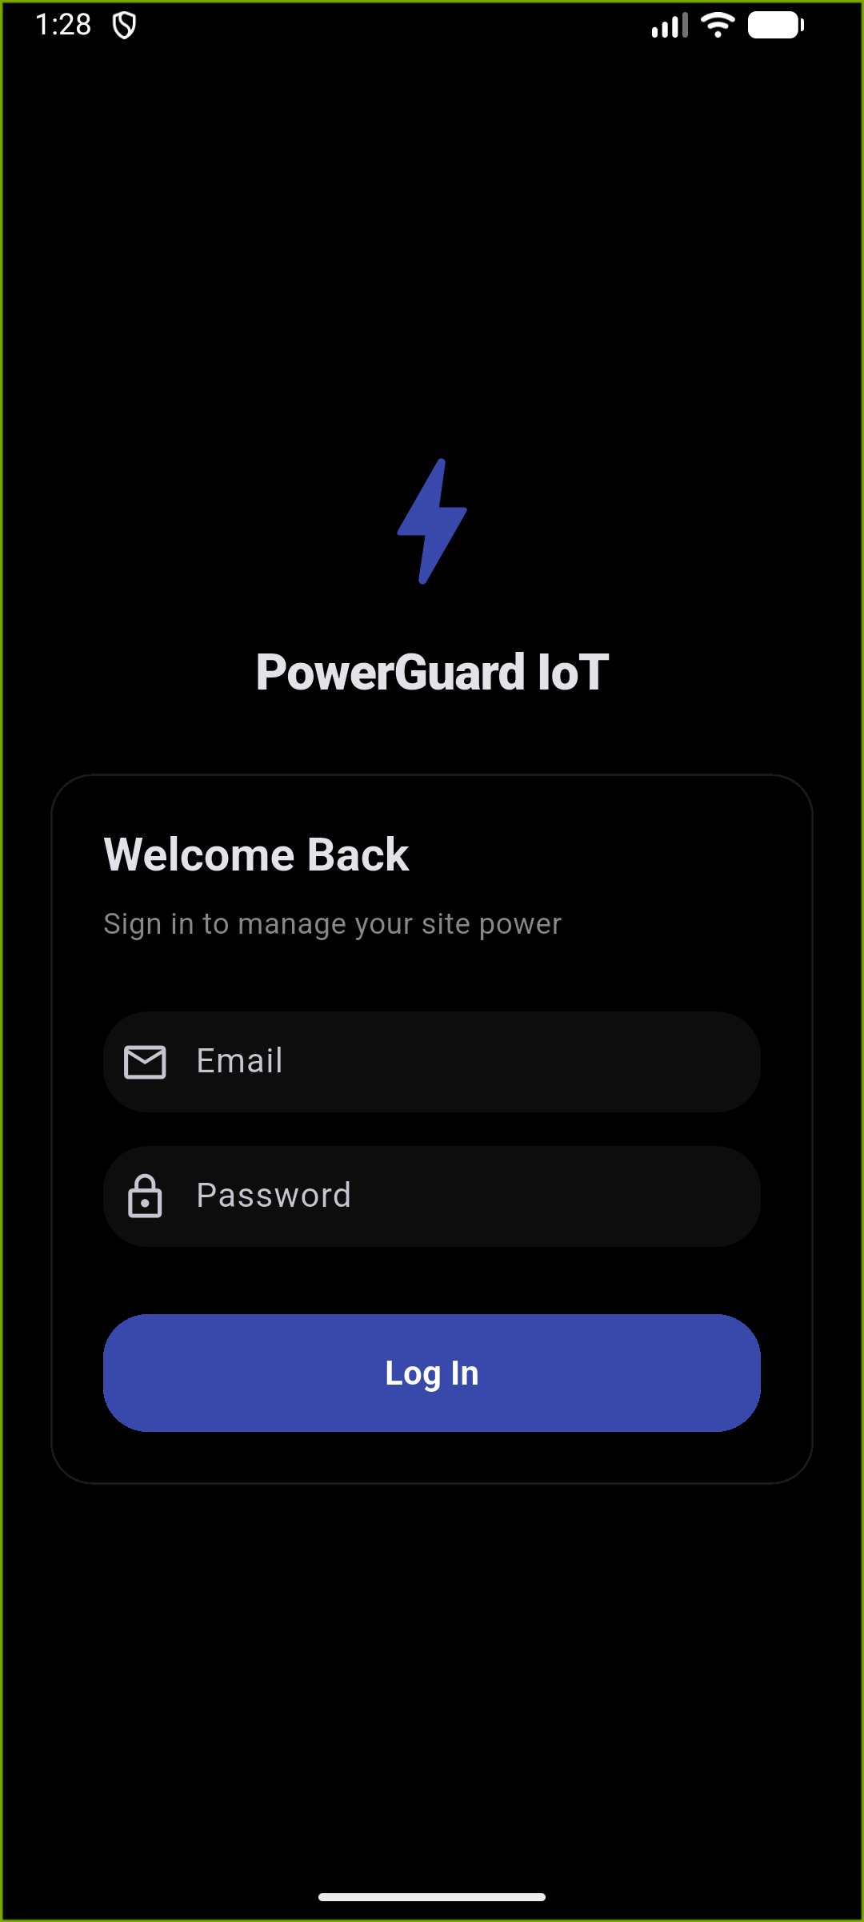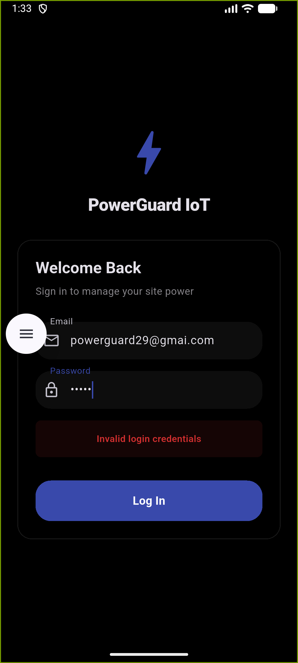
1. Welcome & Value Proposition: Users are greeted with a splash screen.
2. Secure Login: A centralized login screen.
3. Authentication Feedback: Clear feedback during login.

Page 2: Monitoring & Real-time Insights
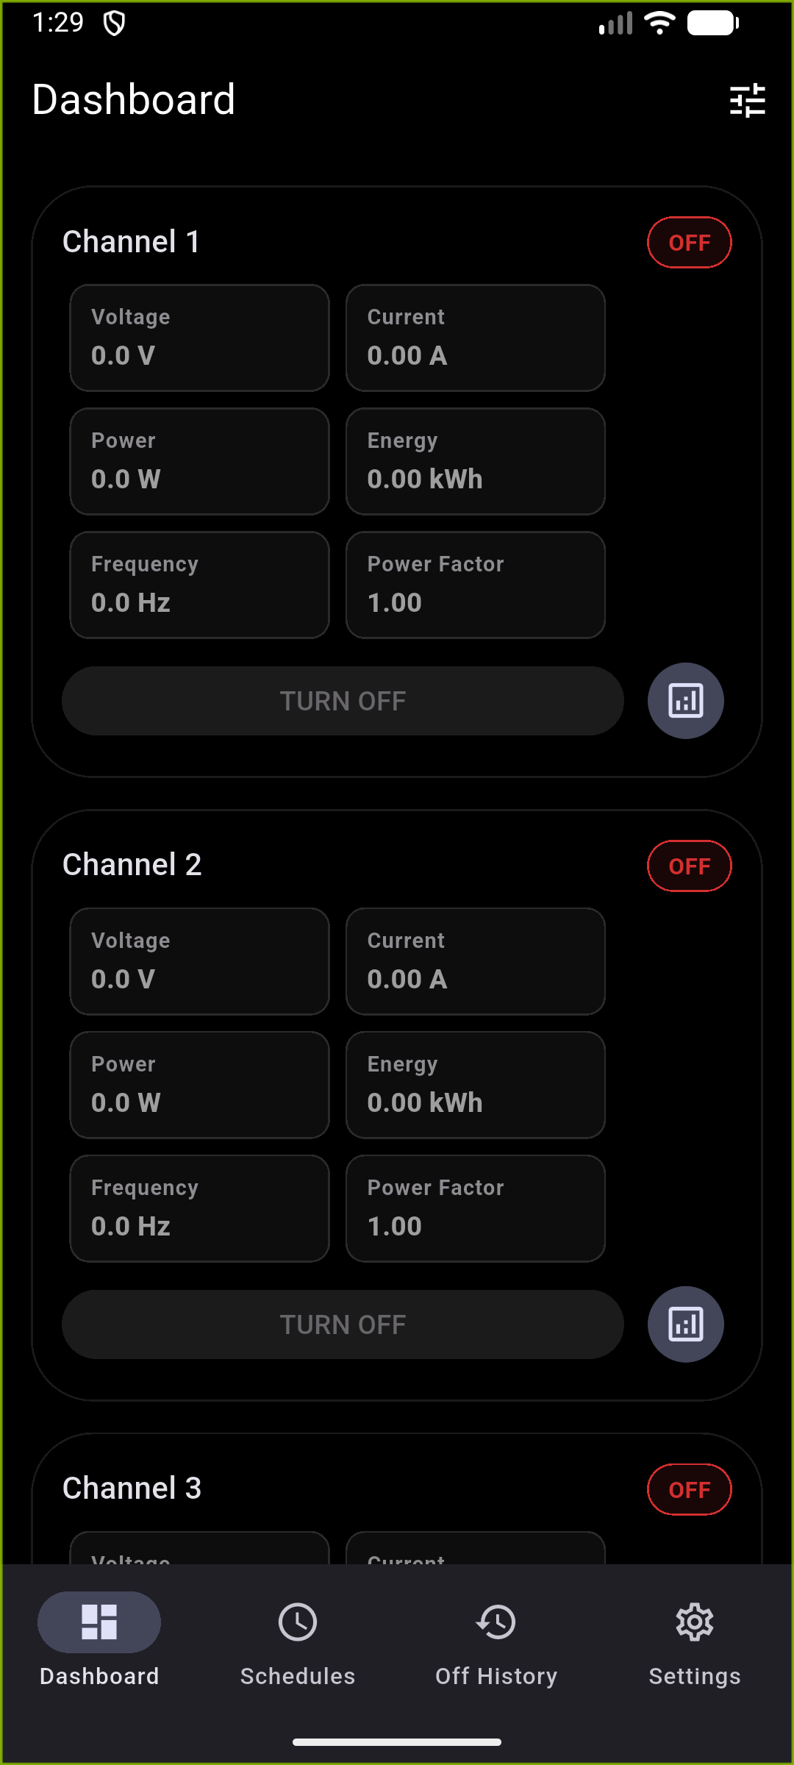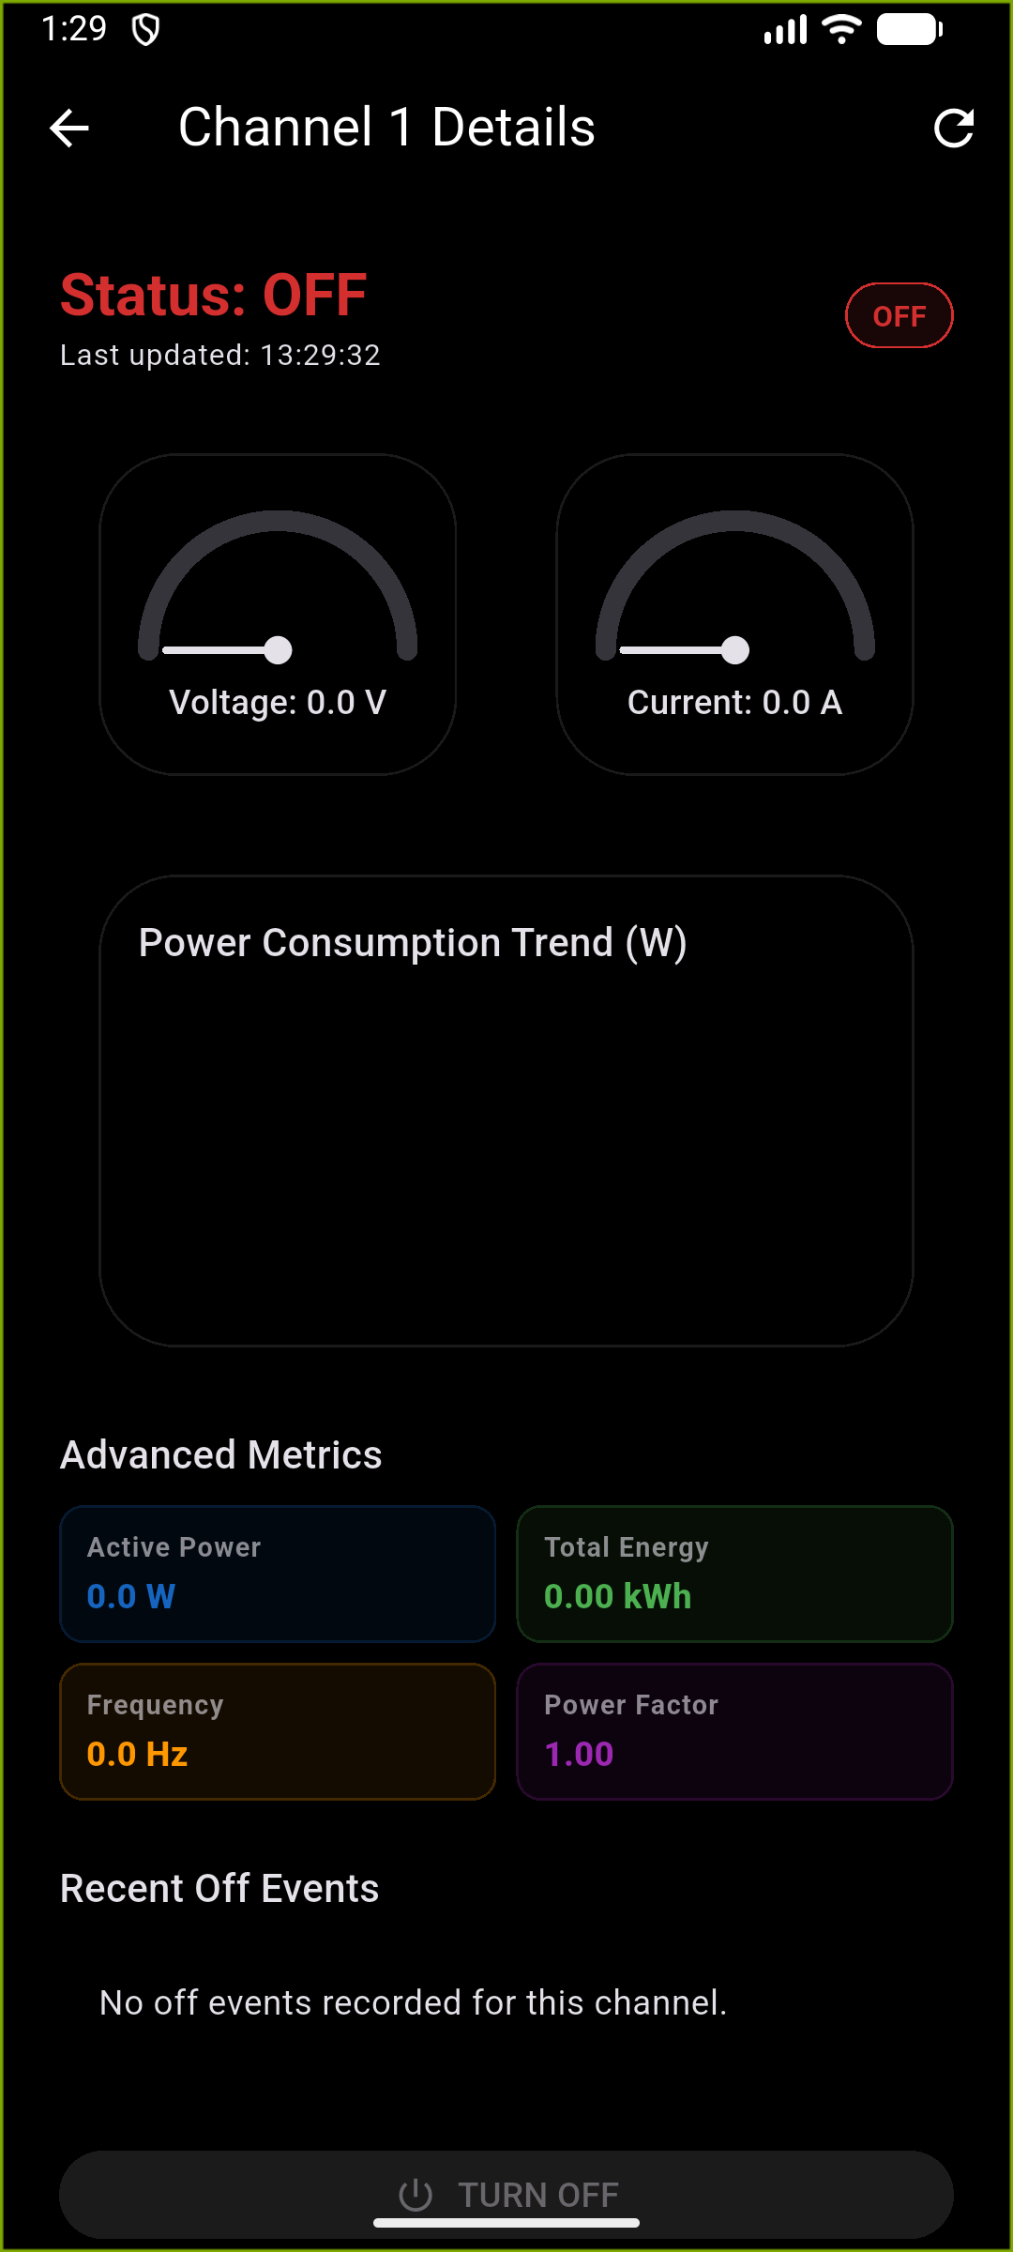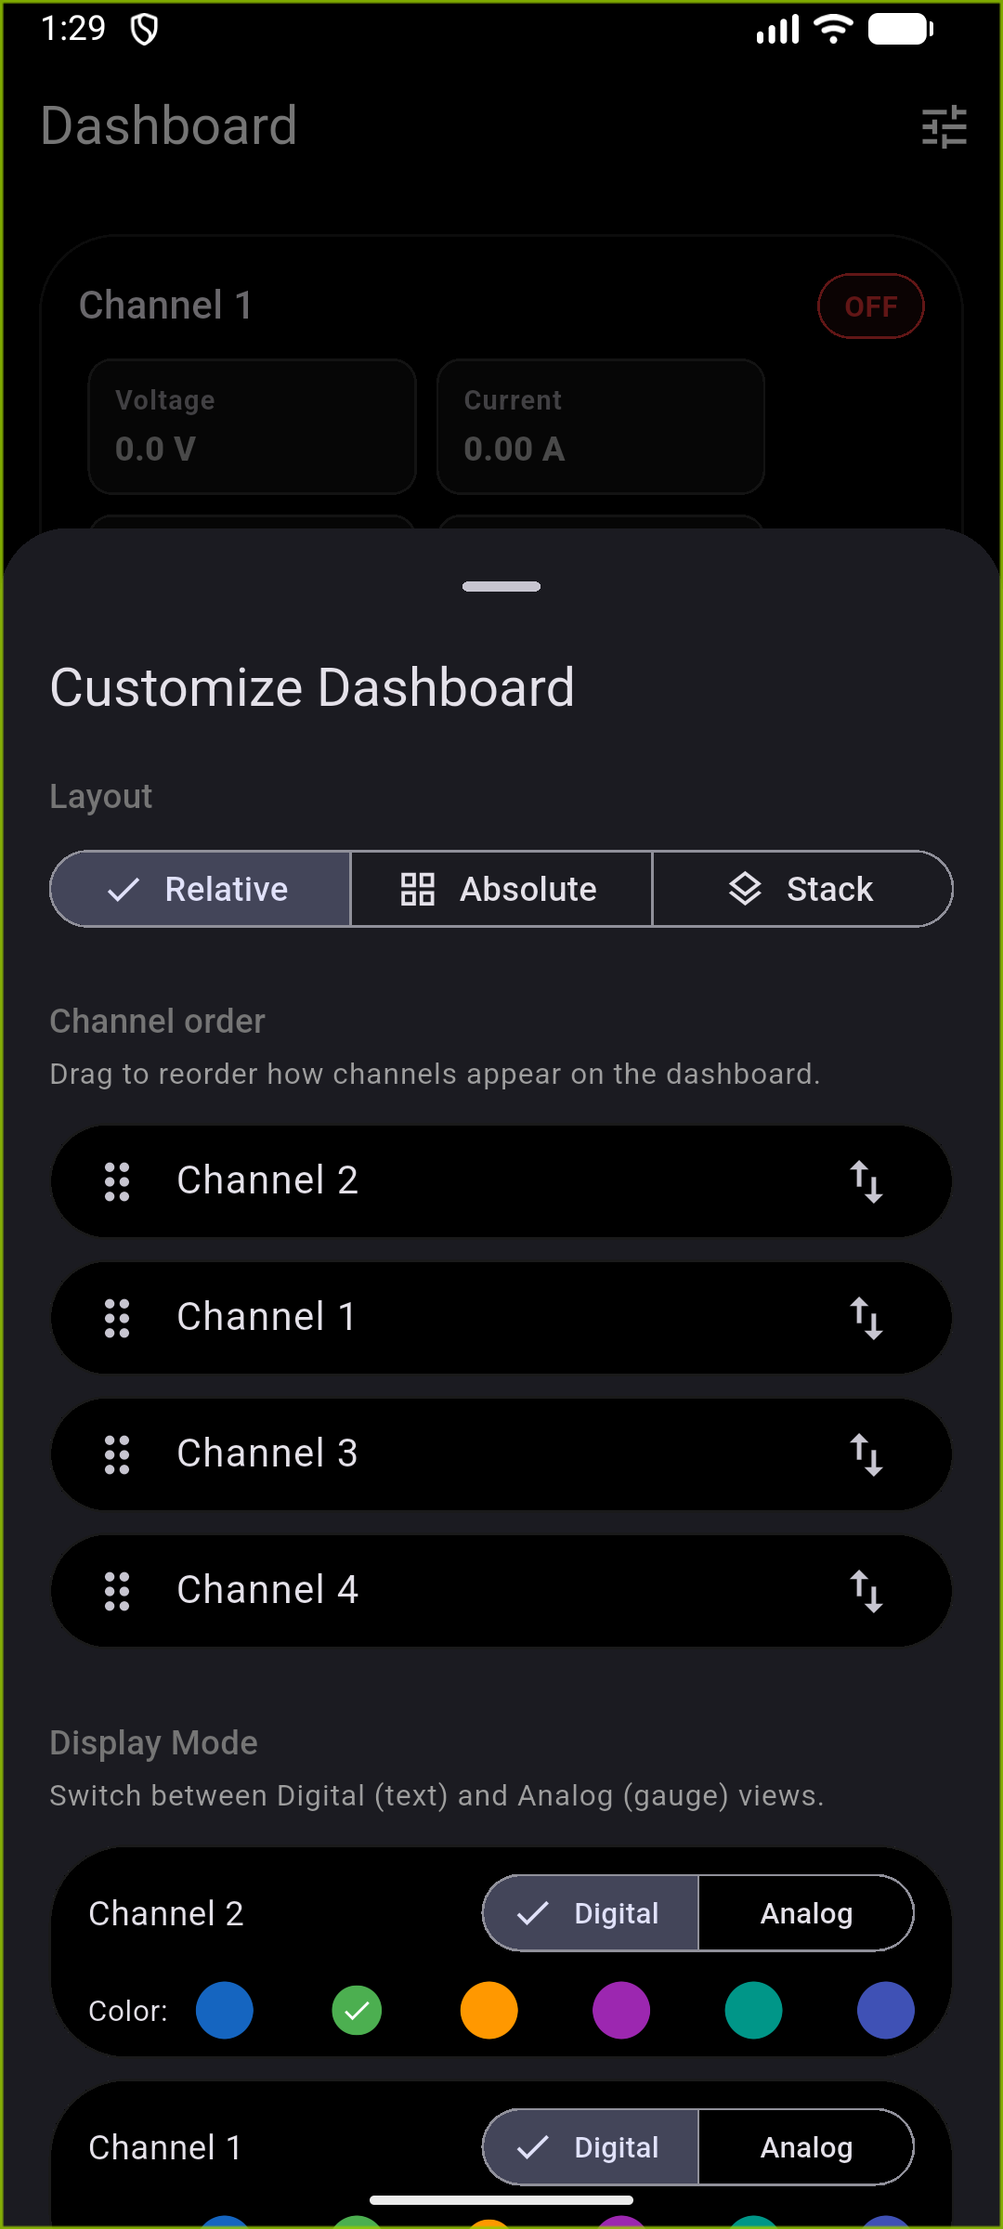
1. Central Dashboard: Overview of all channels.
2. In-depth Analytics: Detailed view with real-time gauges.
3. Layout Customization: Personalize dashboard.

Page 3: Management & System Configuration
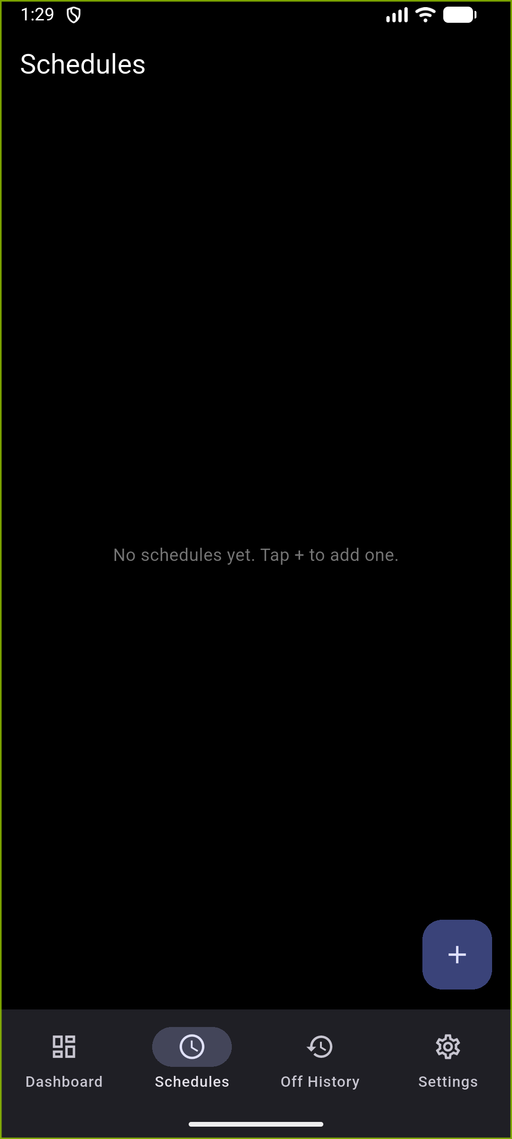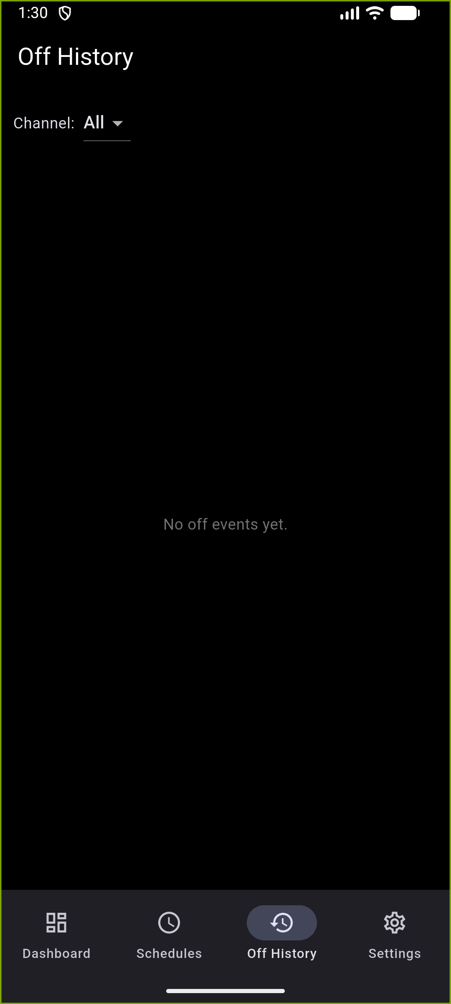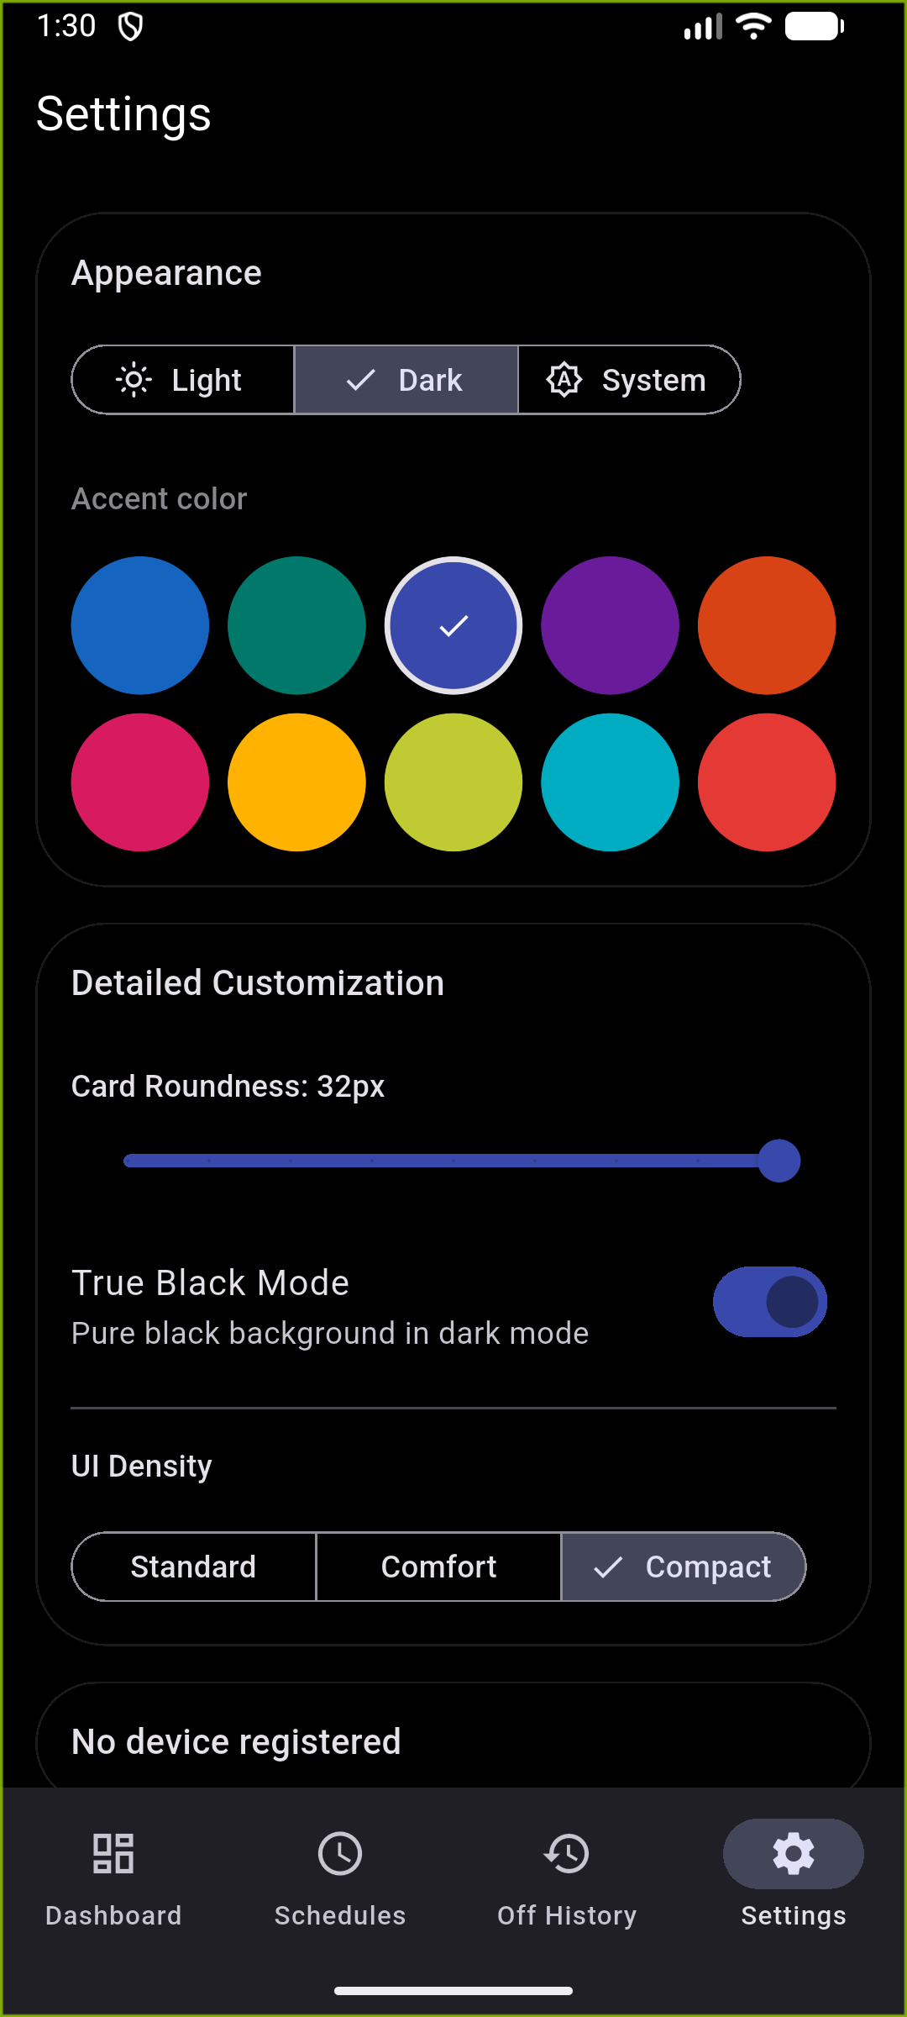
1. Automated Scheduling: Create schedules for energy conservation.
2. Historical Audit: record of every time a channel was powered down.
3. Global Personalization: deep UI customization.

