DOCUMENTATIE

TEMA 2

NUME STUDENT: Bodogae George Stefan
GRUPA: 30424

CUPRINS

Contents
DOCUMENTATIE 1
TEMA 2 1
CUPRINS 2
1. Assignment’s objective 2
2. Analisys, use cases 2
3. Design 3
4. Implementation 3
5. Results 3
6. Conclusions 3
7. Bibliography 3

Assignment’s objective
This assignment’s objective is to implement a queue management application with threads. The main goal is to decrease the waiting time for the clients by assigning them to the queues in an optimal way. Also the application should generate the average waiting time and the peak hour. The secondary goal was learning how to work with threads such that each queue is ran by a separate thread and in this way all the queues are running concurently like in real life. The application was designed with ease of use in mind such that it is easy to setup and run the simulation and also to read the results and to know at each time the average waiting time and the peak hour. The objective in terms of self-development is learning how to manage threads by creating this real-life scenario simulation that needs the ability to run multiple processes at the same time.

Analisys, use cases
In this application, the tasks represent the clients of a shop and the servers represent the queues in which the clients take place. So, each server is ran by a thread that runs concurently with all the other threads so that the simulation of all the queues happens in real time.
When starting the application, the user has to enter data in the following fields: minimal arrival time, maximal arrival time, minimal service time, maximal service time, number of servers (queues), number of tasks (clients) and the simulation time, all in seconds. Below, the user can see at each second which tasks are being processed and which tasks are being removed. Also at each time, the user can see the average waiting time and the peak hour which shows at which hour the waiting time was maximal.
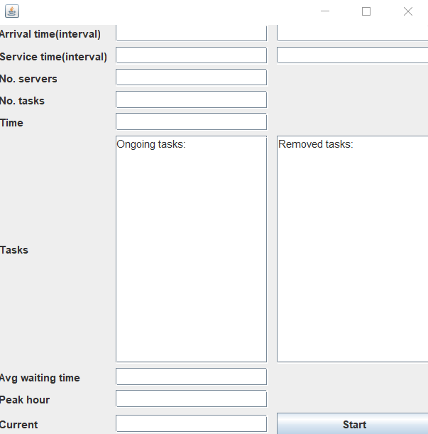

Design
I implemented this application by sorting the classes into packages such that the flow of the program is easy to understand and if further developments are done to the application it is easy to find the place to add/change code. An OOP approach was chosen for this application as it is more eficient to work with classes and methods than working with non-OOP programing tehniques. The classes were divided into packages as follows:
- BussinessLogic package contains: Controller class, Scheduler class, SimulationManager class and TimeStrategy class
- GUI package contains the MainWindow class
- Model package contains Server class and Task class
In the image below, there is the UML diagram of this application which presents the classes with their methods and also the links between classes such that the workflow of the aplication is made clear.
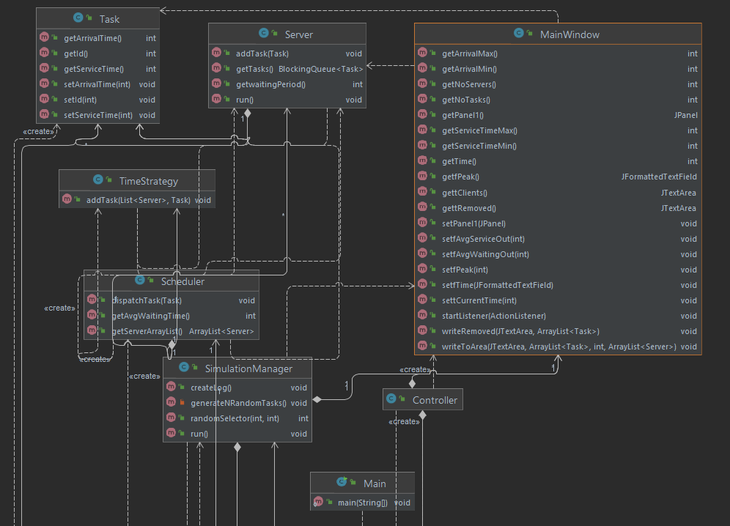

Implementation
The BussinessLogic package contains the classes: Controller, Scheduler, SimulationManager and TimeStrategy. The GUI package contains the class mainWindow and the Model package contains the classes Sever and Task.

The Model package contains:
- The Task class has 3 fields: int id which is the id of the task, int arrivalTime which is the time at which the client arrives and int service time which is the time that the client spends for processing. This class contains a constructor that sets all the fields and also getters and setters for retrieving and changing the fields of the instantiated object. This class was used to instantiate a Task type object that represents the client of the service

- The Server class implements Runnable in order to override the run() method. This class has 2 fields: BlockingQueue<Task> tasks and int waitingPeriod. The constructor of this class sets both its fields in the following way: it sets the tasks field with a new ArrayBlockingQueue of size 1000 and initializes the waitingPeriod field with 0. The addTask method is used to add a task to the tasks BlockingQueue and also calculating the waiting period. The run method takes the next task from the queue and pauses the thread with the current tasks service time and decrements the waiting period. This class is used to instantiate a Server type object that represents a queue of clients, each server being ran by a sepparate thread.

The GUI package contains:
- The MainWindow class extends JFrame and is used to create the the user interface. This class contains labels, a start button to start the simulation and textfields for minimum arrival time, maximum arrival time, minimum service time, maximum service time, number of servers, number of tasks, simulation time, average waiting time, peak hour and current time. It also contains two text areas for printing the status of the servers and tasks at every moment of execution and also for printing the tasks that have been removed from the list. The user interface was designed with ease of use in mind such that is is easy to set up and run a simulation. Also, a goal in designing the user interface was making sure that the results are clearly diplayed and that the user can track the evolution of the servers and tasks in real time.

The BussinessLogic package contains:
- The TimeStrategy class contains the addTask which adds a task to the server with the least waiting time and then sorts the servers list using the SortByWaitingTime method that is implementing Comparator.
- The Scheduler class is mainly used to displatch tasks using the addTask method from the timeStrategy class. This class has 4 fields: ArrayList<Server> serverArrayList, int maxNoServers, int maxTasksPerServer and TimeStrategy timeStrategy. The getAvgWaitingTime class is used to calculate the average waiting time at each moment of execution for letting the clients know what is the approximate time they should wait before it is their turn to be processed. The constructor of this class makes maxNoServers new Server objects and threads, starts a thread with each of them and adds them to the serverArrayList list.
- The SimulationManager class implements runnable and is the central class of the application. it contains the following fields: int arrivalMin, int serviceTimeMin, int noServers, int noTasks, int time, int arrivalMax, int serviceTimeMax, List<Task> taskList, Scheduler scheduler, MainWindow mainWindow. The random selector method receives two integer parameters: a min time and a max time, and generates a random integer between the two provided limits. The generateNRandomTasks method is used to fill the task list with newly created tasks that have random arrival times and service times generated with the randomSelector method. The createLog method is used to generate a text file containing information about the server and task status at each time in the running process of the application. The text area from the user interface contains the same information so for simplicity, this method simply takes all the text from the task text area from the user interface and saves it in the Log.txt file.
- The run method is the principal method of the application, this is th method that brings all the classes together and uses them with logic to get the application running corectly. At first, the peak hour and current time are initialized with 0. Then a timer starts which is adapted to real time by using the Thread.sleep(1000), so that for each second the app actually takes a second in real time to run. Then, for each second the task that has the arrival time equal to the curent time is dispatched using the scheduler and added to the doneTask list which keeps track of the tasks dispatched at each itteration. This method also writes to the two text areas the current tasks that are being handeled and the queue status, and also the removed tasks on the second text area. This method sets the peak hour by comparing the last peak hour with the current waitinf time, if the waiting time is greater, than the peak hour is set to the current time.
- The Controller class implements the action listener for the start button from the user interface. within the actionPerformed method all the user input is gathered: arrivalMin, arrivalMax, serviceTimeMin, serviceTimeMax, noServers, noTasks and time. Then, a SimulationManager type object is created and a thread is started with it. When the thread finishes running, the log is created with the createLog method from the simulationManager class.

Results
The application is running as it should and the waiting time and peak hour are computed correctly. The following image show the application in its running process:
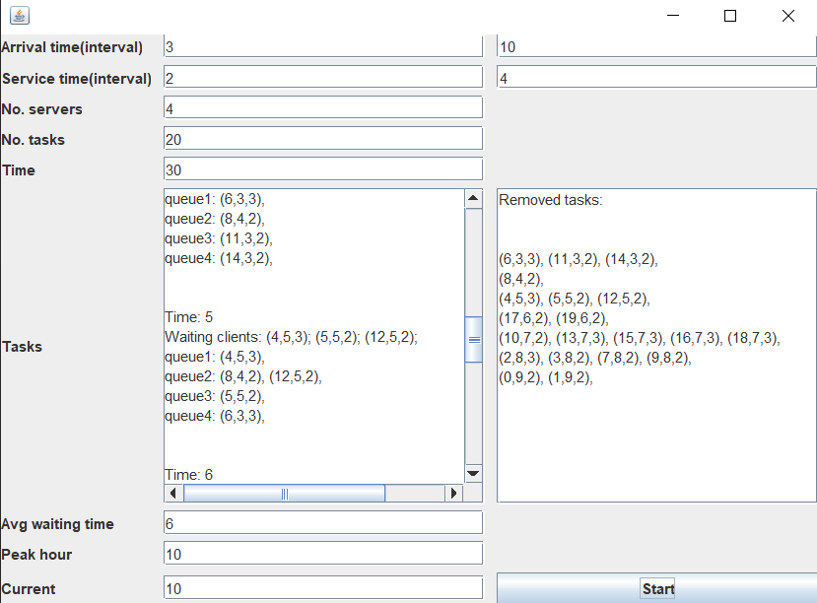
In the following image there is an example of a log file generated as Log.txt after the simulation is finished:
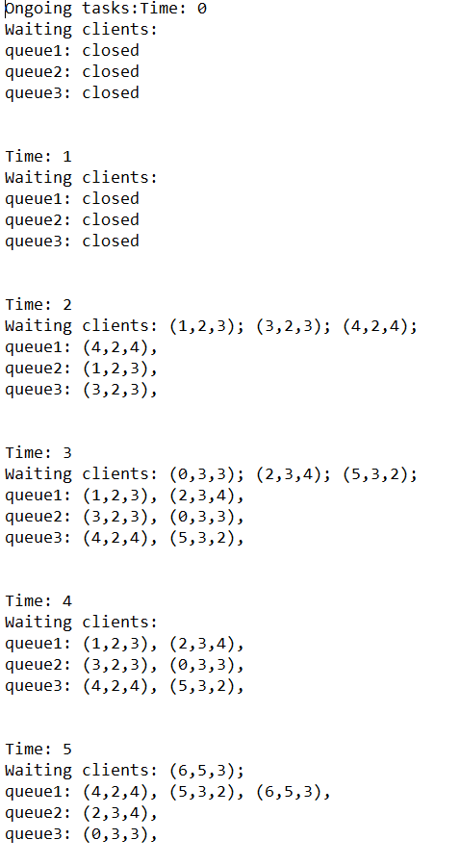
As can be seen from the images above, the clients were assigned to the queue with the least waiting time, and after the tasks were processed, they were removed in batches from the list to optimize the application running time by not having to deal with clients that have already been serviced. The log file is generated based on the waiting clients and queue status at each time and stored in the Log.txt file in the project’s folder.

Conclusions
The final product is an usable program which can be used to simulate a shop or any kind of service that includes queues and people having to wait in queues for certain services. This application can also be used in the real life for letting the clients of a shop know what is the average time of waiting and also what the peak hour is so they know when to come to the shop. This application is also useful for letting the management crew know when they need to add a new operator and how to manage the queues so that the waiting time is minimal and the process of servicing is optimized.
From the process of making this application I learned how to deal with threads and multi threading, and how to implement a real life scenario in a program using threads. The use of threads was really handy in this application because in real life everything happens in the same time, so working with a secvential approach was not the optimal solution becouse the simulation would not have been accurate. In terms of user interface and results seen by the user of the simulation, it would have mostly been the same thing becouse the power of the computer’s processor is enough to compute all the operations so fast that the user would’t notice a difference. However, the aim was to implement a real-life simulation so by using threads this was made possible.

For further developments, this application could include a notification for each client that lets them know how much time they got to wait. Also, there could be implemented a way of adding a new server when the simulation is running and a way orf redistributing the tasks so that the waiting time decreases. This application can easily be paired with a mobile app that lets the users make appointments and assign automatically or recommend times at which the clients should come and take place in the queue. Another way to decreasing the waiting time could be the posibility to migrate tasks from one queue from another is needed and the posibility to postpone users appointments so that they spend the least time possible in the queue. A real-life scenario in which this application could be used is in a tickets shop for trains, where the clients line up in a queue to buy the tickets.

Bibliography

FUNDAMENTAL PROGRAMMING TECHNIQUES (dsrl.eu) – Learning about threads and taking templates of classes to write the code on. This presentation was useful in terms of providing a solid support to write my code and giving the proper theory and knowledge about how threads work.
Java Threads (w3schools.com) – creating and running threads and preventing concurency problems
Runnable (Java Platform SE 7 ) (oracle.com) – java runnable
Multithreading in Java Explained in 10 Minutes - YouTube – learning how to work with threads
Java threads 🧵 - YouTube – learning how to use threads

