Uncertainty in Thermosensory Expectations Enhances an Illusion of Pain

Jesper Fischer Ehmsen1, Niia Nikolova1, Daniel Elmstrøm Christensen1, Leah Banellis1, Malthe Brændholt1, Arthur S. Courtin1, Camilla E. Krænge1, Alexandra G. Mitchell1, Camila Sardeto Deolindo1, Christian Steenkjær1, Melina Vejlø1, Christoph Mathys2, Micah G. Allen1,3,*, Francesca Fardo1,4,*

1Center of Functionally Integrative Neuroscience (CFIN), Department of Clinical Medicine, Aarhus University

2Interacting Minds Center (IMC), Aarhus University, Aarhus, Denmark

3Cambridge Psychiatry, University of Cambridge, United Kingdom

4Danish Pain Research Center, Department of Clinical Medicine, Aarhus University

*Equal contributions

Corresponding author: Francesca Fardo ([francesca@cfin.au.dk](mailto:francesca@cfin.au.dk))

# Abstract

The human brain has a remarkable ability to learn and update its beliefs about the world. Here, we investigate how thermosensory learning shapes our subjective experience of temperature and the misperception of pain in response to harmless thermal stimuli. Through computational modeling, we demonstrate that the brain uses a probabilistic predictive coding scheme to update beliefs about temperature changes based on their uncertainty. We find that these expectations directly modulate the perception of pain in the thermal grill illusion. Quantitative microstructural brain imaging further revealed that individual variability in computational parameters related to uncertaintydriven learning and decision-making is reflected in the microstructure of brain regions such as the precuneus, posterior cingulate gyrus, cerebellum, as well as basal ganglia and brainstem. These findings provide a framework to understand how the brain infers pain from innocuous thermal inputs, with important implications for the etiology of thermosensory symptoms under chronic pain conditions

## Teaser

Computational modeling reveals how uncertainty transforms harmless stimuli into perceptions of pain.

# INTRODUCTION

The ability to adapt to environmental changes and learn in the face of uncertainty is critical for generating precise and flexible responses to a wide range of stimuli. In the context of thermosensation and nociception, such adaptability allows us to effectively detect temperature shifts and avert potential tissue damage, even under conditions of incomplete or ambiguous information. This capability not only is essential for safeguarding our bodily integrity but also facilitates our interaction with an uncertain environment. Here, we report findings demonstrating that thermosensation relies on precision-weighted expectations and that this extends to complex phenomena such as illusory pain, exemplified by the thermal grill illusion (TGI).

Current knowledge of the thermosensory and thermonociceptive systems predominantly revolves around peripheral sensory mechanisms that transduce innocuous and noxious thermal stimuli into neural signals. This includes landmark discoveries like the TRPV1 and TRPM8 receptors (*1*–*3*). Although these bottom-up mechanisms have been extensively studied, less attention has been devoted to how they integrate with top-down expectations to form our subjective experiences of temperature and pain. Perception in these domains is not solely the output of isolated afferent channels but is heavily influenced by prior beliefs and expectations (*4*–*7*). In this context, the TGI presents a striking case in which the simultaneous presentation of innocuous warm and cold stimuli can evoke illusory burning sensations (*8*–*13*). This illusion is fascinating because it cannot be adequately explained by the physical characteristics of the stimuli alone. Instead, it arises from a dynamic interplay between sensory processing and cognitive factors, collectively shaping how temperature and pain are perceived. Although neuroimaging studies have mapped out brain regions involved in the TGI, such as the anterior cingulate cortex,thalamus, cerebellum, hippocampus, and parietal regions (*14*–*16*), the influence of expectations on this phenomenon remains an open and largely underexplored question

Associative learning plays a fundamental role in the perception of pain and its modulation by expectation, enabling the development of adaptive behaviors that protect us from potential harm. Substantial progress has been made in understanding these processes through the computational neuroscience of predictive coding (*17*–*26*) and reinforcement learning (*22*, *27*). For instance, it has been shown that participants learn about painful stimuli in a manner that is consistent with Bayesian principles (*27*, *28*), and pain-prediction errors have been mapped to key brain areas involved in pain-related processing, including the insula and brainstem (*19*, *29*, *30*). A key contribution of this work was the recognition that expectation-related modulation of pain, such as nocebo and placebo effects (*31*–*37*), are grounded in the weighting of pain prediction errors by their uncertainty or inverse precision (*17*, *22*, *38*–*40*). To date, it is unknown if these principles similarly explain innocuous thermosensory perception and illusions of pain. An intriguing possibility is that the TGI may stem from thermosensory predictive coding, where increased uncertainty about upcoming stimulus temperatures enhances the perception of pain.

In this study, we apply computational methods to reveal how expectations and their associated uncertainty influence both innocuous thermosensation and the TGI. We further used highresolution quantitative magnetic resonance imaging (qMRI) to identify how interindividual variations in the brain microstructure are associated with computational fingerprints of thermosensory learning. The brain’s microstructural properties, including variations in myelination and iron concentration, play a crucial role in shaping individual differences in thermosensation and pain perception. Structural variations, particularly within pain-related pathways, likely influence how sensory input is processed and interpreted. Understanding these neurobiological features offers important insights into the mechanisms behind such perceptual differences, enhancing our understanding of the biological factors that contribute to the variability in thermosensory and pain responses among individuals (*41*).

To this aim, we conducted an experiment in 267 participants who completed a probabilistic thermosensory learning (PTL) task, in which we strategically embedded simultaneous cold and warm stimuli to induce the TGI within the learning sequence. This experimental approach offers a comprehensive analysis of the role of expectations in thermosensory learning and provides a unique opportunity to test the hypothesis that the uncertainty of thermal expectations plays a crucial role in the perception of illusory pain. Our results provide a compelling example of how uncertainty contributes to the misinterpretation of non-nociceptive stimuli as painful, offering potential new insights into symptoms of neuropathic and nociplastic pain conditions (*42*, *43*).

# Results

To quantify the relationship between learned expectations and thermosensation, we tested the probabilistic thermal learning task (PTL, Fig 1A) in 267 healthy individuals. The PTL integrates key features of reversal learning tasks in other sensory domains (*44*–*47*), in which participants must dynamically update sensory predictions in response to varying uncertainty. In each PTL trial, participants heard auditory cues consisting of high or low tones that predicted whether the forthcoming stimulus would be cold or warm. Critically, these cue-stimulus pairings shifted unpredictably over time, requiring participants to continuously relearn their associative mappings. Cue-stimulus associations varied according to blocks of longer, more stable periods in which reversals were less likely, and shorter, more variable periods in which transitions occurred more frequently (Fig 1B). Innocuous cool and warm trials were pseudorandomly interspersed with ambiguous stimuli. These ambiguous stimuli were the simultaneous presentation of the same objective temperatures as those used in the innocuous cold and warm trials, in an alternated spatial configuration. This method of stimulus presentation is known to elicit burning pain sensations referred to as the TGI (*8*, *10*). On each trial, participants made a binary prediction response, indicating whether they expected an upcoming cold or warm stimulus. In a subset of trials, they subsequently provided visual analog scale (VAS) ratings reflecting their perceived levels of cold, warm, and burning sensations. This design allowed us to isolate how uncertainty in learned cue-stimulus associations affects the perception of ambiguous thermal stimuli, such as those that produce the TGI. By manipulating the frequency and stability of cue-stimulus reversals, we could precisely quantify how top-down expectations, and their associated uncertainty, modulated the quality and intensity of this pain illusion.

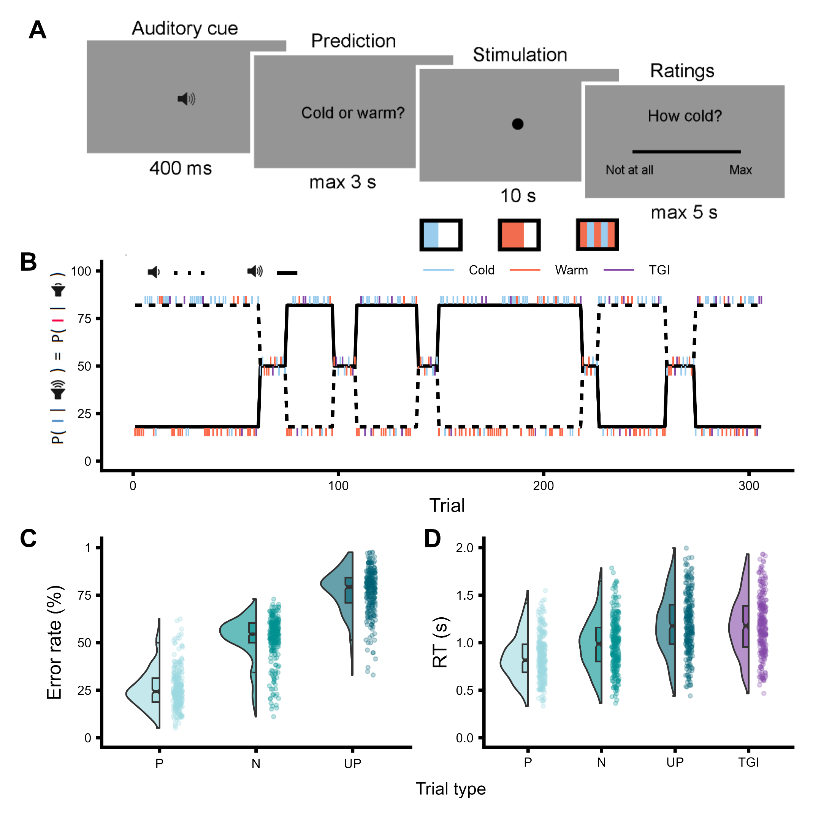

**Fig 1. Thermosensory learning: experimental design and behavioral measures.** **(A)** Trial structure depicting the sequence of events within each trial: auditory cue presentation, prediction of the forthcoming stimulation quality as either cold or warm, delivery of the thermal stimulation (cold, warm or TGI) and VAS ratings of cold, warm and burning sensations. All three ratings were completed for a given stimulus. **(B)** Time-course of cue-stimulus contingencies throughout the experiment, varying across three levels of cue-stimulus association probabilities set at 82%, 50% and 18%. **(C)** Comparison of error rates for participants’ predictions of the forthcoming stimulation quality across predicted (P), neutral (N) and unpredicted (UP) innocuous thermosensory trials. **(D)** Comparison of response times in the trial following predicted (P), neutral (N) and unpredicted (UP) thermosensory stimuli, as well as TGI stimuli, demonstrating post-prediction error slowing.

## *Behavior*

### *Error rates and response times are modulated by thermosensory learning*

To evaluate participants’ learning of cue-stimulus associations, we analyzed error rates for predicted, neutral, and unpredicted innocuous thermosensory stimuli (Fig 1C and table S1). Predicted and unpredicted stimuli were defined based on the participants’ trial-by-trial predictions (i.e., whether they predicted a cold or a warm sensation) in blocks where the nominal probability of a specific cue-stimulus association was 82 and 18%, respectively. Neutral trials referred to non-predictive blocks where a cue predicted a particular stimulus with a 50% probability. This analysis confirmed that the probability of cue-stimulus association robustly modulated expectations such that participants’ prediction accuracy was highest for predicted trials compared to both neutral ( = -1.37, 95% CI = [-1.41; -1.33], p < .0001) and unpredicted trials ( = -2.28, 95% CI = [-2.33; -2.23], p < .0001).

As further evidence of successful learning, we observed post-prediction error slowing, indicated by reduced response times on trials following association violations (Fig 1D and table S2). Our findings showed that response times were increasingly slowed following neutral ( = 0.15, 95% CI = [0.13; 0.16], p < .0001) unpredicted ( = 0.31, 95% CI = [0.3; 0.32], p < .0001), and TGI stimuli ( = 0.34, 95% CI = [0.32; 0.35], p < .0001), compared to predicted stimuli. Together, these results serve as a model-free positive control, confirming that participants effectively learned and incorporated cue-stimulus relationships into their thermosensory predictions.

### **Stimulus-Specific Effects on thermosensory and Burning Ratings**

To evaluate the effectiveness of cold, warm and TGI stimuli, we predicted subjective ratings using generalized linear mixed effects models incorporating a zero-one inflated beta regression approach (Supplementary Note). The TGI is characterized by an enhanced perception of heat and the elicitation of burning sensations when innocuous cold and warm stimuli are combined, which does not occur when these stimuli are applied individually (Fig 2, table S3-5). In line with heat enhancement, TGI stimuli were rated as significantly less cold than innocuous cold stimuli ( = -1.02, 95% CI = [-1.04; -0.99], p < .0001), but warmer than innocuous warm alone ( = 0.18, 95% CI = [0.17; 0.2], p < .0001). Further, in line with the elicitation of illusory pain, the concurrent application of cold and warm stimuli during TGI produced significantly greater burning sensations than when either cold ( = -0.45, 95% CI = [-0.48; -0.43], p < .0001), or warm ( = -0.65, 95% CI = [-0.68; -0.63], p < .0001) were applied individually. Taken together, these findings confirm that innocuous thermosensory stimuli were perceived in a veridical manner, and the TGI manipulation effectively induced illusory heat and burning sensations.

### **Innocuous thermosensation is shaped by expectations**

To investigate the impact of learned expectations on innocuous thermosensory experiences, we analyzed participants’ reported levels of both cold and warm sensations for predicted and unpredicted stimuli (Fig 2B and table S6). For each stimulus, participants provided ratings for factual (e.g., coldness of a cold stimulus) and counterfactual qualities (e.g., warmth of a cold stimulus) of their sensations. We found a robust three-way interaction between the stimulation quality, the participants’ prediction on a trial by trial basis, and the rating type ( = 0.24, 95% CI = [0.17; 0.32], p < .0001). Considering the factual ratings, predicted cold stimuli were rated as colder than predicted warm stimuli ( = -0.09, 95% CI = [-0.12; -0.07], p < .0001), and predicted warm stimuli were rated as warmer than predicted cold stimuli ( = -0.05, 95% CI = [-0.07; -0.03], p < .0001). Conversely, when assessing the counterfactual quality, predicted cold stimuli were rated as less warm compared to predicted warm stimulus ( = 0.06, 95% CI = [0.01; 0.11], p < .05 ), while predicted cold stimuli were not rated differently compared to predicted warm stimuli ( = 0.04, 95% CI = [-0.01; 0.09], p = 0.13). Overall, these results highlight that participants’ thermosensory expectations significantly influenced the perceived intensity of innocuous stimuli.

### **Response times and error rates reflect perceived TGI quality**

We hypothesized that the ambiguous nature of TGI trials would either reinforce or counter cue-stimulus associations, depending on the participants’ perception of TGI as primarily warm or cold. For instance, if a participant associates a high tone with a high probability of experiencing a cold stimulus, and perceives a TGI stimulus as predominantly warm, they might incorrectly infer a reversal has occurred after hearing a high tone and receiving a TGI stimulus, leading to an erroneous prediction in the subsequent trial. Conversely, if a participant perceives the TGI as predominantly cold, the participant’s correct association would be reinforced, leading to increased likelihood of an accurate prediction in the subsequent trial. To evaluate this hypothesis, we assessed each participant’s perceived TGI quality by computing the ratio of perceived coldness to warmth. In general, participants displayed high self-consistency in evaluating their perception of TGI stimuli as predominantly cold or warm (Fig 2C).

Our model confirmed our hypothesis, demonstrating that error rates were significantly influenced by the interaction between cue-stimulus association and perceived TGI quality ( = -1.8, 95% CI = [-2.12; -1.49], p < .0001,Fig 2 and table S7). Specifically, participants were more likely to respond correctly on the subsequent trial when the contingency and the perceived TGI quality matched (i.e., predicting cold and perceiving TGI as predominantly cold) ( = 1.06, 95% CI = [0.85; 1.28], p < .0001). Conversely, participants were more likely to make incorrect responses in the following trial when the contingency and the perceived TGI quality diverged (e.g., predicting warm and perceiving TGI as predominantly cold) ( = -0.74, 95% CI = [-0.97; -0.51], p < .0001). Collectively, in a contingency block that predicted a cold outcome, the odds of making a correct prediction changed substantially depending on whether the TGI was rated as mostly cold vs. warm - a difference amounting to a 17.63 % change in the probability of a correct answer [20.93, 13.82 %]. Complementary effects were observed for response times after TGI stimulation (see Supplementary Results and table S8). In summary, these findings reveal that TGI trials play a crucial role in reinforcing cue-stimulus associations by effectively shaping participants’ thermosensory predictions based on their perceived quality.

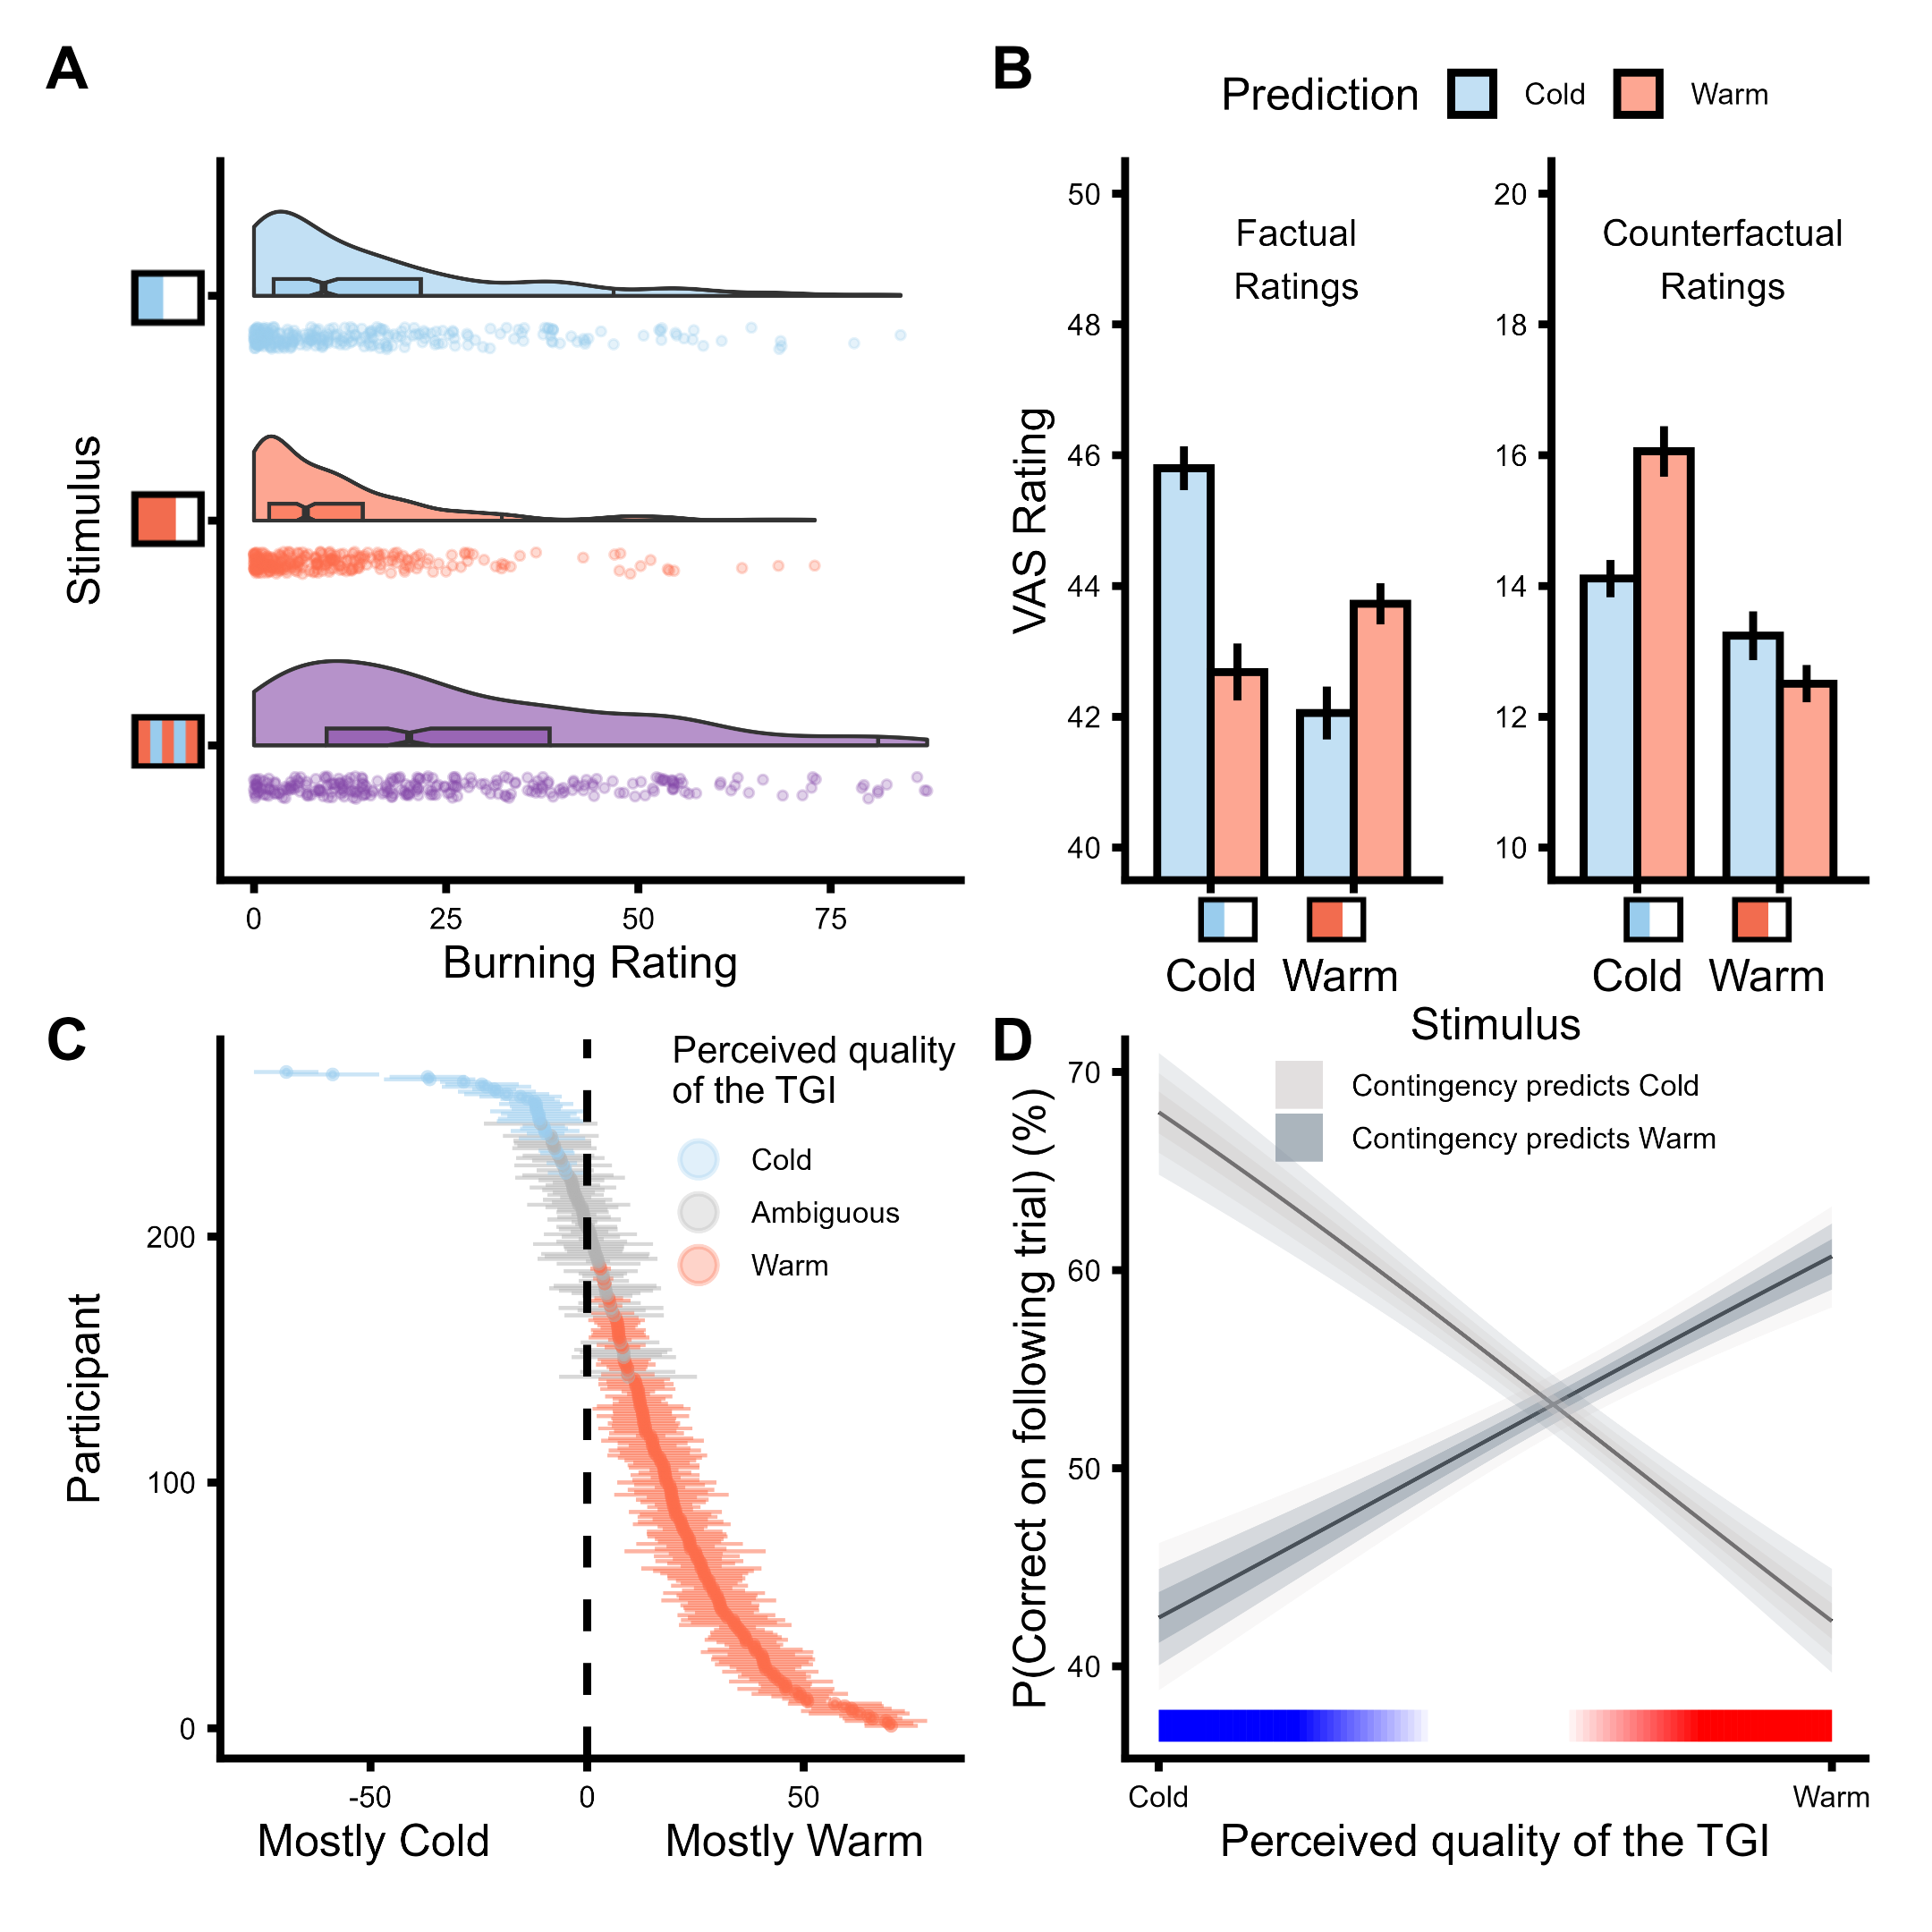

**Fig 2. Thermosensory ratings and TGI perception. A.** VAS burning ratings for cold, warm and TGI stimuli, illustrating a key feature of the TGI as an illusion of pain. **B.** Effects of participants’ expectations on VAS ratings for innocuous cold and warm stimuli, showing that expectations modulated these sensations (mean ± 2 SEM). **C.** Within-subject consistency of TGI perception as mostly cold (blue), ambiguous (gray) or mostly warm (red). Thermal ambiguity in this context signified that participants perceived the TGI trials as equally warm and cold. The y-axis depicts each individual participant, while the x-axis represents the ratio of perceived coldness to warmth for TGI stimuli (mean ± 2 SEM). **D.** The relationship between perceived TGI quality and learning (i.e., error rates in the trials that followed TGI stimulation), demonstrating that TGI trials reinforced cue-stimulus contingencies based on the perceived TGI quality.

### **Computational modeling**

#### **A 2-level Hierarchical Gaussian Filter model best explained thermosensory learning**

We employed the Hierarchical Gaussian Filter (HGF) (*48*, *49*) to analyze learning trajectories across two hierarchical levels of belief (Fig 3). We estimated mean and uncertainty values for beliefs about an upcoming stimulus given a cue (i.e., predictions) and beliefs regarding the strength of cue-outcome associations (i.e., estimations). At the first level (), prediction uncertainty, pertains to uncertainty about immediate outcomes. A low prediction uncertainty indicates high confidence in predicting the forthcoming stimulus based on the given cue, while high prediction uncertainty suggests that the participant has not formed a definite prediction of which outcome is most likely. At the second level (), estimation uncertainty, quantifies the uncertainty surrounding the reliability of cue-outcome relationships. This level of uncertainty influences the rate at which beliefs about cue-outcome associations are updated. Low estimation uncertainty signifies a strong belief in the consistency of the cue-outcome association, requiring considerable contrary evidence for a belief update. In contrast, high estimation uncertainty means that beliefs regarding the cue-outcome relationship are more malleable and can be adjusted more readily upon encountering disconfirming evidence. Prediction and estimation uncertainty are structured hierarchically, meaning that beliefs at one level are dependent on, or informed by, the beliefs at the upper level (Fig 3).

To assess the best-fitting model, while accounting for parameter complexity, we compared the 2-level HGF with other well-known reinforcement learning models, such as Rescorla-Wagner, Sutton K1 and Pearce-Hall (*50*–*53*) using Bayesian model selection (*54*). We found that the 2-level HGF outperformed these models. To validate the robustness of our fitted models, we conducted both parameter and model recovery for the models under consideration (see fig. S1-8). Overall, model comparison and cross-validation demonstrated that thermosensory learning is best captured by Bayesian precision-weighted mechanisms that integrate both prediction and estimation uncertainty.

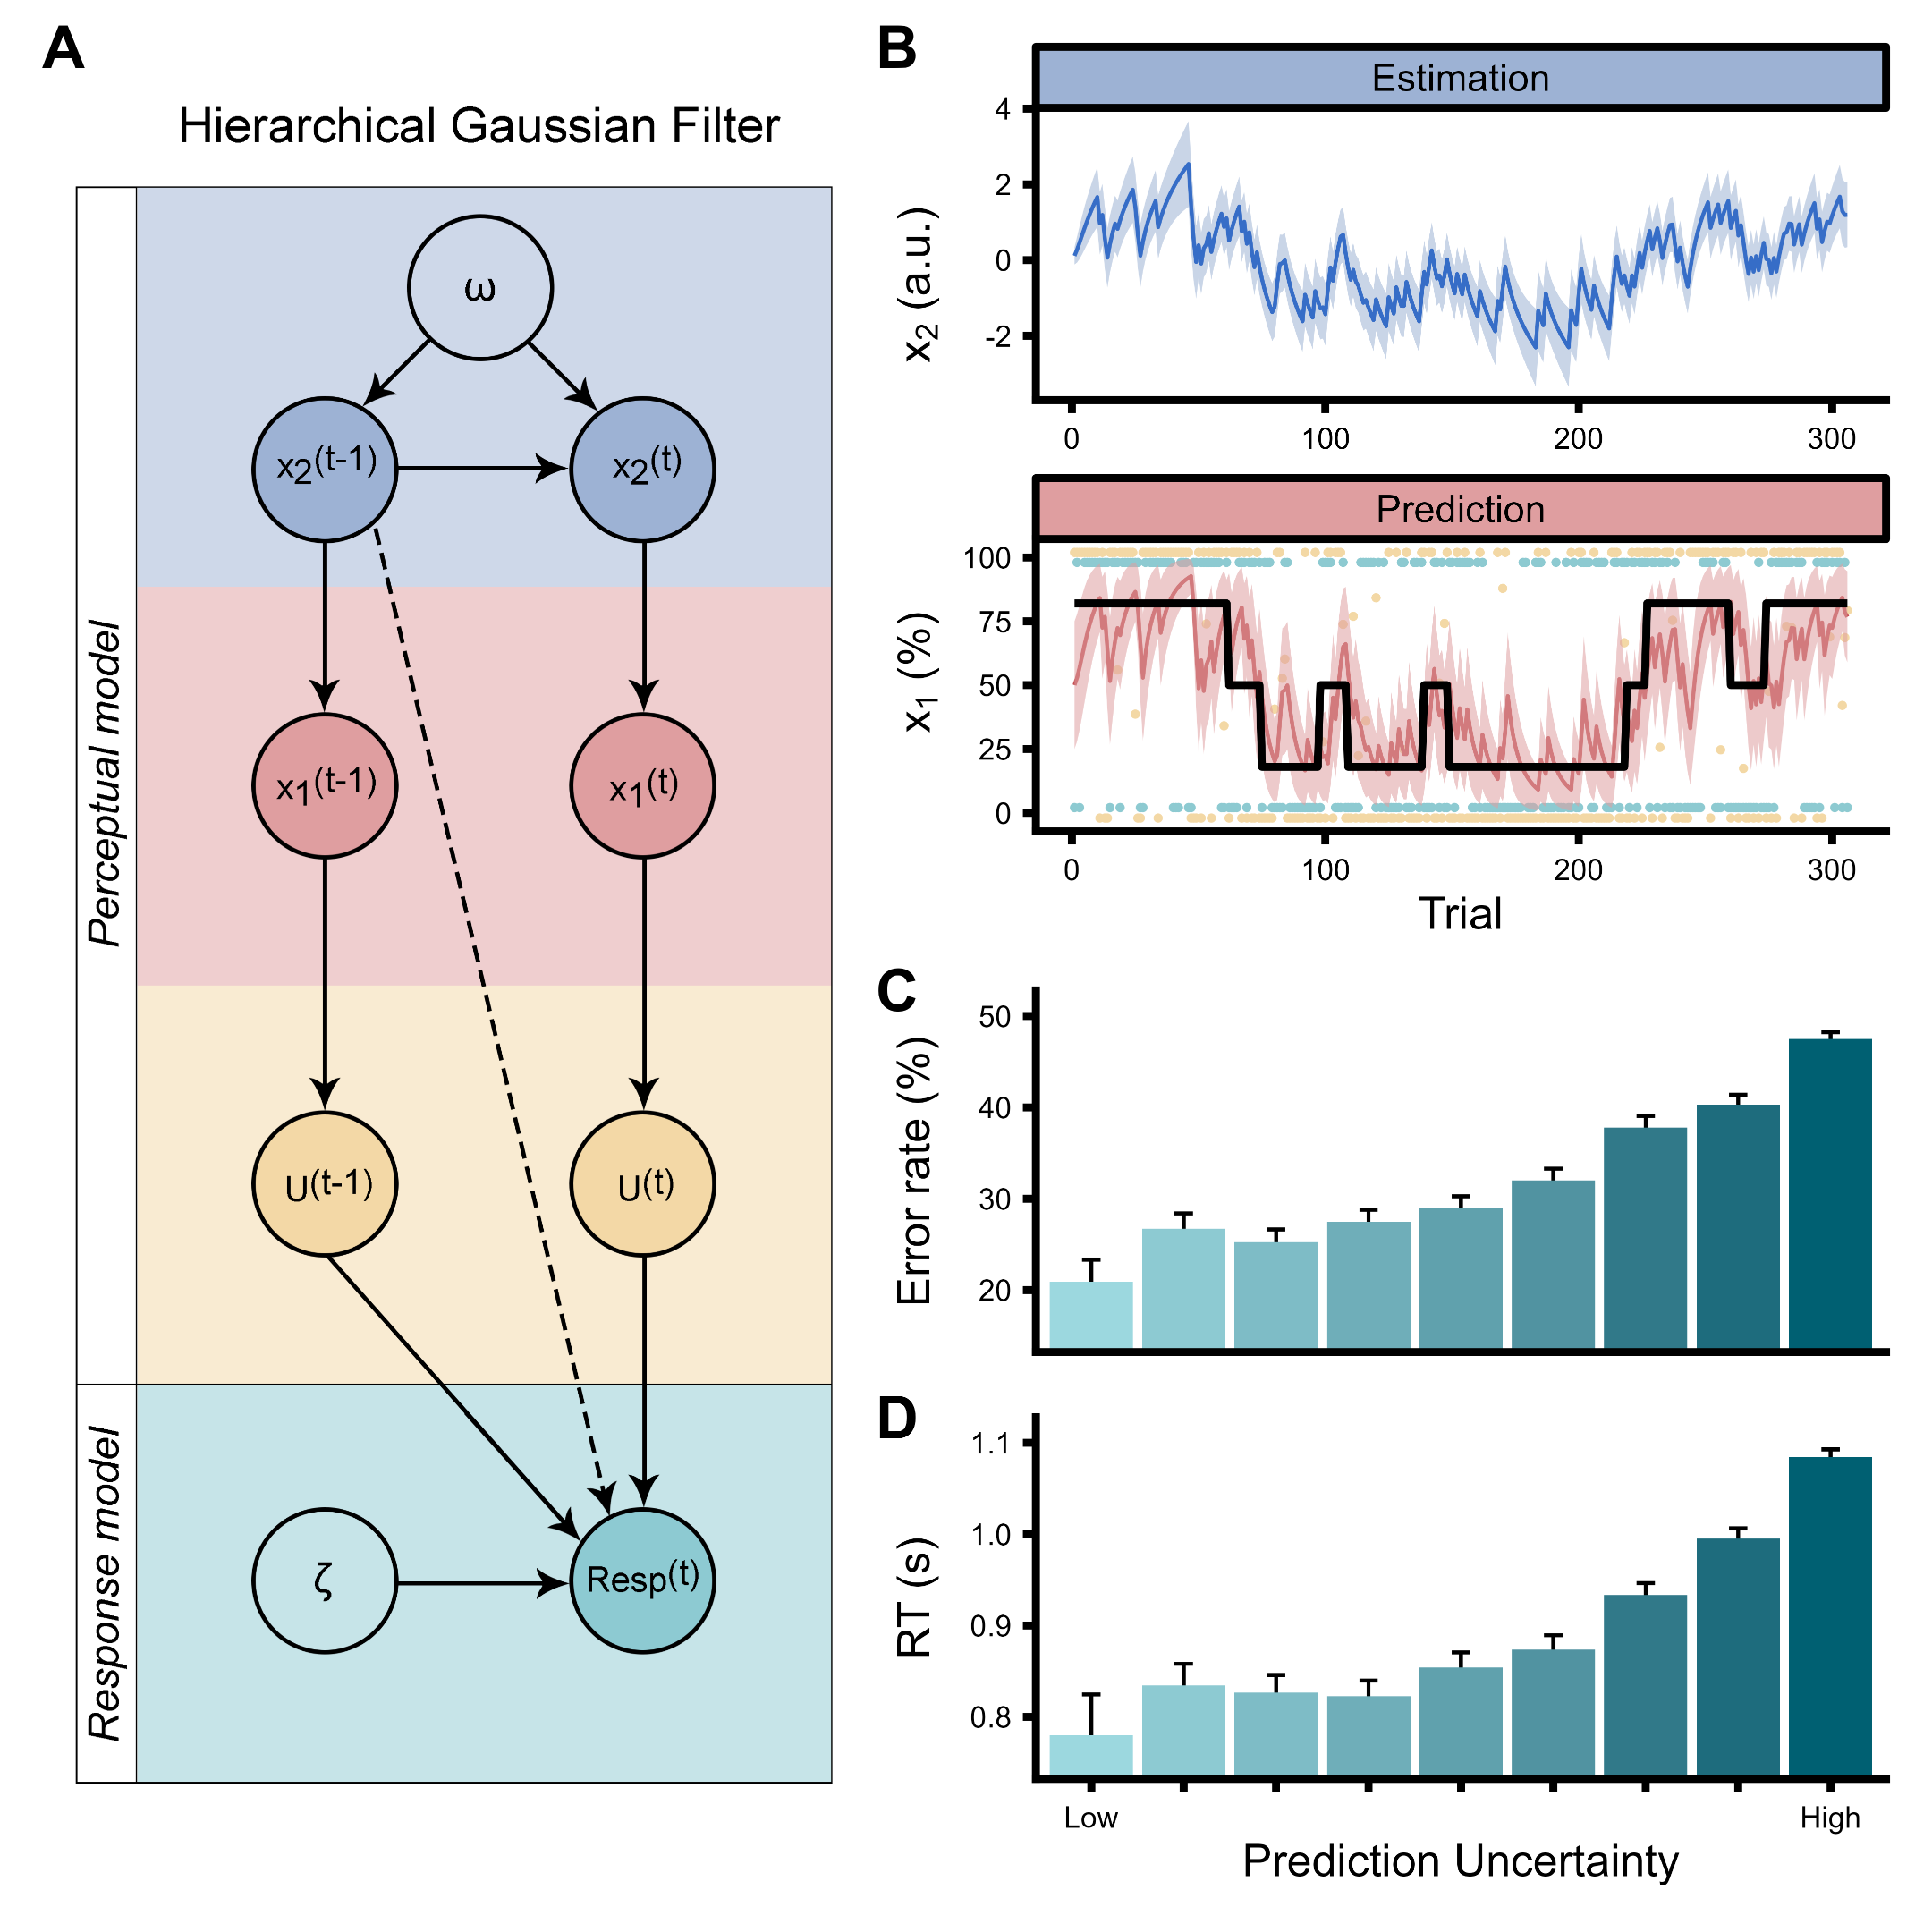

**Fig 3. Computational modeling of thermosensation and illusory pain. A.** Illustration of the Hierarchical Gaussian Filter, and its constituent perceptual and response models. Within the perceptual model, two hierarchical levels of trajectories with uncertainties are defined: prediction () and estimation (). The first level takes the form of a Bernoulli distribution, while the second level evolves in time as a Gaussian random walk with step-size corresponding to the omega () parameter. The response model converts the continually updated perceptual belief to a probability of answering through the inverse decision temperature zeta () through a logistic sigmoid transformation. U are observed values representing the cue-stimulus association mappings, dashed line depicts mediation through model inversion. **B.** Example of a single participants’ prediction and estimation trajectories together with their respective uncertainties. When considering the prediction trajectory, the thick black line represents the actual contingency probabilities. The trial-by-trial participant’s responses (i.e., predictions) are depicted by green points, where the value of one corresponds to the prediction of a cold stimulus and the value of zero corresponds to a prediction of a warm stimulus. The contingency space is represented by yellow dots, where zero values represent low tone-cold and high tone-warm associations and one values represent low tone-warm and high tone-cold associations. Intermediate values represent trials in which the stimulus was simultaneously cold and warm (i.e., TGI). Prediction uncertainty strongly modulated both **C.** error rates and **D.** response times needed to provide a prediction about the upcoming stimulus, validating the response model. Prediction uncertainty is presented here as discretized into nine bins.

#### **Modulation of behavior and perception by uncertainty**

The impact of uncertainty on behavior and subjective experience was assessed using hierarchical regression analyses. At the lower level, involving prediction uncertainty, precise beliefs notably diminished error rates ( = -5.06, 95% CI = [-5.31; -4.8], p < .0001, Fig 3C and table S9) and response times ( = 1.78, 95% CI = [1.72; 1.85], p < .0001, Fig 3D and table S10) when participants predicted the quality of a forthcoming stimulus. This effect was also reflected in heightened VAS ratings for the thermosensory quality consistent with participants’ expectations ( = -0.18, 95% CI = [-0.28; -0.09], p < .0001). Specifically, a stronger belief about a forthcoming cold stimulus resulted in heightened cold ratings ( = 0.15, 95% CI = [0.1; 0.19], p < .0001), but reduced warm ratings ( = -0.09, 95% CI = [-0.13; -0.05], p < .0001, Fig 4A and table S11). Prediction uncertainty also exerted a notable influence on the perceived thermosensory quality of the TGI (Fig 4A and table S11). Here, precise expectations of cold intensified cold ratings ( = 0.16, 95% CI = [0.1; 0.23], p < .0001) and reduced warm ( = -0.17, 95% CI = [-0.22; -0.11], p < .0001), but did not significantly influence burning ratings ( = -0.04, 95% CI = [-0.12; 0.04], p = 0.3) during the illusion. Conversely, precise expectations of warmth heightened both warm and burning sensations, accentuating both heat enhancement and illusory pain components of TGI perception.

The higher-level estimation uncertainty played a more pronounced role in influencing burning sensations within TGI trials ( = 0.04, 95% CI = [0.02; 0.05], p < .0001, Fig 4B and table S12). Whereas precise cold expectations at the lower level were linked to reduced burning sensations, weak or unclear associations between cues and predicted stimuli increased burning ratings compared to both cold ( = -0.12, 95% CI = [-0.14; -0.09], p < .0001) and warm stimuli ( = -0.06, 95% CI = [-0.08; -0.04], p < .0001). This indicated that the illusory pain aspect of the TGI was most intense under conditions of ambiguous cue-stimulus mappings, or high estimation uncertainty. In essence, while lower-level prediction uncertainty predominantly determined whether the TGI was perceived as more cold or warm, the characteristic burning sensation of the TGI was markedly influenced by higher-level estimation uncertainty. These findings elucidate how increased uncertainty regarding forthcoming stimulus temperatures can lead to a distorted perception of innocuous temperatures, manifesting as an aberrant sensation of pain.

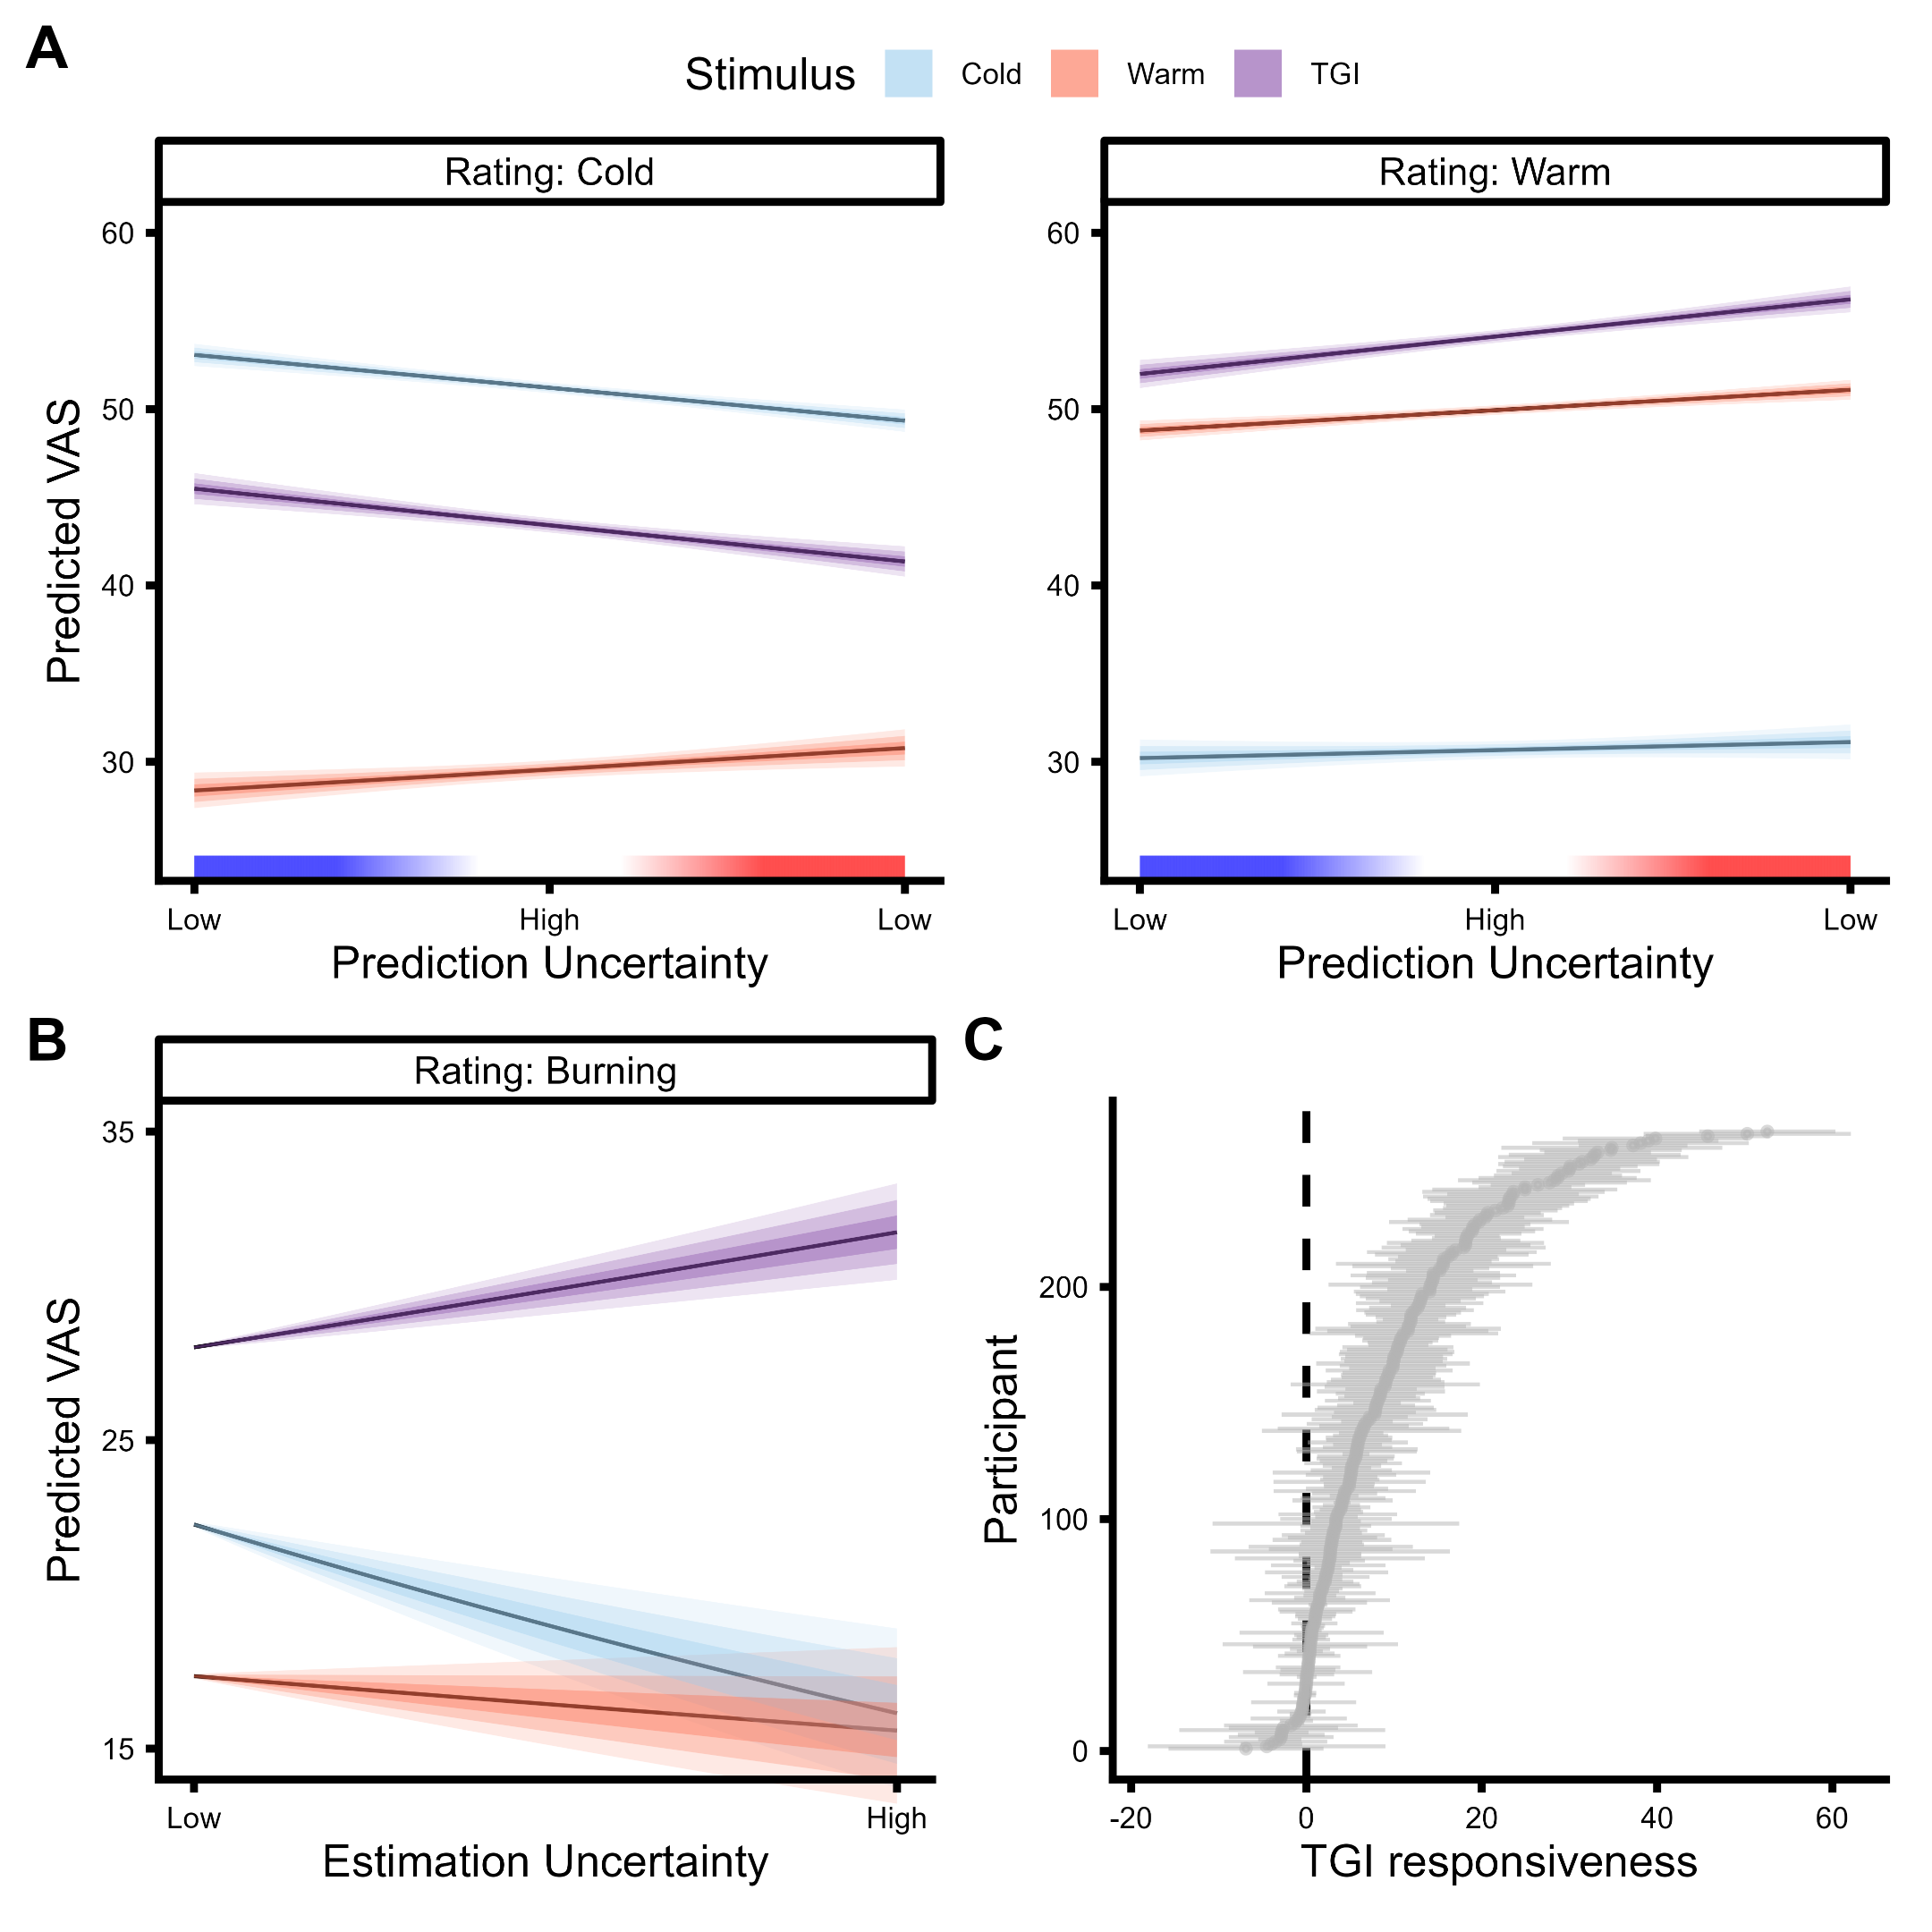

**Fig 4. Effects of prediction and estimation uncertainty on veridical thermosensation and illusory pain. A.** The impact of prediction uncertainty on thermosensory ratings for cold (blue), warm (red) and TGI stimuli (purple). The x-axis represents the precision of the lower-level belief about the forthcoming stimulus. Prediction uncertainty values range from high precision prediction that the stimulus would be warm to high precision predictions that the stimulus would be cold. Intermediate values indicate high prediction uncertainty about the thermal quality of the forthcoming stimulus. The y-axis indicates the predicted VAS ratings (i.e., marginal means) based on ZOIB modeling, separately for cold, warm and burning ratings with the shaded area depicting the 50, 80 and 95% confidence interval on the marginal means. **B.** The impact of estimation uncertainty on TGI perception. The x-axis depicts the varying degree of estimation uncertainty from low to high. The y-axis indicates the predicted burning ratings based on ZOIB modeling, separately for cold (blue), warm (red) and TGI stimuli (purple) with the shaded area depicting the 50, 80 and 95% confidence interval on the marginal means. **C.** Individual differences in TGI responsiveness. The y-axis depicts each individual participant, while the x-axis represents the TGI responsiveness (mean ± 2 SEM), calculated as the discrepancy between burning ratings for TGI stimuli and the highest burning rating for either innocuous cold or warm stimuli. This approach yielded a continuous scale of TGI responsiveness, spanning from negative values indicative of TGI non-responders to positive values representing TGI responders.

### **Cortical myeloarchitecture fingerprints of computational parameters**

We conducted an exploratory investigation of the neurobiological underpinnings of inter-individual variability in computational parameters, by relating omega () reflecting the speed of adaptation to changing conditions or learning; zeta () capturing variability in the decision-making process, also known as decision temperature; UMTI reflecting individual differences in the modulation of TGI burning ratings by high order uncertainty, see Supplementary Text and TGI responsiveness Fig 4D

To this aim, we performed whole-brain voxel-based quantification analyses of Magnetization Transfer (MT), Longitudinal Relaxation Rate (R1) and effective transverse relaxation rate (R2*) weighted maps obtained from 0.8 mm Multi-Parameter Mapping (Table 1-2 and Fig 5). MT and R1 serve as indicators of cortical myeloarchitecture, aiding in the identification of myelination levels in gray matter. R2* is influenced by factors such as iron concentration (*55*, *56*). A benefit of this approach is that the VBQ technique yields quantitative measures of local brain microstructure which are inherently meaningful and comparable across imaging sites or studies, unlike classical volumetric techniques which derive arbitrary signal units (*56*).

Using a Threshold Free Cluster Enhancement (TFCE) approach (*57*), we identified significant correlations between computational parameters and individual variation in iron concentration in cortical, subcortical and brainstem regions. The parameter showed significant positive correlations with iron concentration variability in several key regions (Table 1). These included the right precuneus (5453 voxels, p = .015), right posterior cingulate gyrus (10683 voxels, p = .019), right caudate (3088 voxels, p = .034), and right angular gyrus (1023 voxels, p = .03). These regions, involved in thermosensory associative learning, have been previously linked to uncertainty processing, pain modulation, and cognitive control. The parameter was positively correlated with iron concentrations in several brain regions (Table 2). These included the left lingual gyrus (7717 voxels, p = .018), right cerebellum and brainstem (6037 voxels, p = .028), as well as right precuneus (1290 voxels, p = .039). Further results obtained with a cluster-based inference method also involving UMTI and TGI responsiveness are presented in the supplementary material. These results shed light on the microstructural fingerprints associated with and , enhancing our understanding of the neurobiological underpinnings of decision-making and learning within the context of thermosensation and pain illusions.

**Table 1: Microstructural brain correlates of Omega**

| **Region** | **k** | **p (FWE)** | **TFCE** | **Z value** | **x** | **y** | **z** |
| --- | --- | --- | --- | --- | --- | --- | --- |
| R Precuneus  L Precuneus | 5453 | .015 | 1999 | 3.35 | 4  -5 | -54  -53 | 35  30 |
| R Posterior Cingulate Gyrus  R Precuneus | 10683 | .019 | 1916 | 3.35 | 15  18 | -48  -57 | 4  21 |
| L Precuneus | 2001 | .028 | 1780 | 3.09 | -4  1 | -88  -93 | 30  17 |
| R Angular gyrus  R Middle Temporal Gyrus | 1023 | .03 | 1757 | 3.16 | 51  47 | -59  -50 | 15  11 |
| R Caudate  R Putamen | 3088 | .034 | 1713 | 3.16 | 13  15 | 6  11 | 8  -5 |
| R Superior Temporal Gyrus | 217 | .039 | 1667 | 3.09 | 43  44 | -46  -38 | 12  11 |
| L Middle Frontal Gyrus | 252 | .043 | 1628 | 3.54 | -27 | 59 | 9 |
| R Middle Occipital Gyrus  R Angular Gyrus | 351 | .045 | 1607 | 3.24 | 35  34 | -76  -68 | 45  46 |
| R Superior Parietal Lobule | 155 | .048 | 1589 | 3.24 | 26 | -68 | 44 |

**Table 2: Microstructural brain correlates of Zeta**

| **Region** | **k** | **p (FWE)** | **TFCE** | **Z value** | **x** | **y** | **z** |
| --- | --- | --- | --- | --- | --- | --- | --- |
| L Lingual Gyrus  L Precuneus | 7717 | .018 | 2200 | 3.09 | -19  -8 | -59  -53 | 2  9 |
| R Cerebellum  Brain Stem | 6037 | .028 | 2008 | 3.16 | 10  9 | -55  -46 | -54  -59 |
| L Cerebellum | 3281 | .029 | 2002 | 3.09 | -14  -10 | -67  -55 | -51  -54 |
| L Cerebellum  L Fusiform Gyrus | 1764 | .035 | 1919 | 3.09 | -34  -28 | -46  -43 | -28  -18 |
| R Precuneus | 1290 | .039 | 1880 | 3.16 | 13  8 | -66  -66 | 41  28 |
| R Lingual Gyrus  R Cerebellum | 684 | .042 | 1844 | 3.04 | 13  12 | -41  -37 | -6  -14 |
| R Cerebellum | 260 | .043 | 1829 | 3.16 | 31 | -65 | -23 |
| R Posterior Cingulate Gyrus | 513 | .045 | 1817 | 2.95 | 10 | -48 | 6 |
| L Lingual Gyrus | 336 | .047 | 1798 | 3.04 | -26  -30 | -58  -50 | -4  -5 |

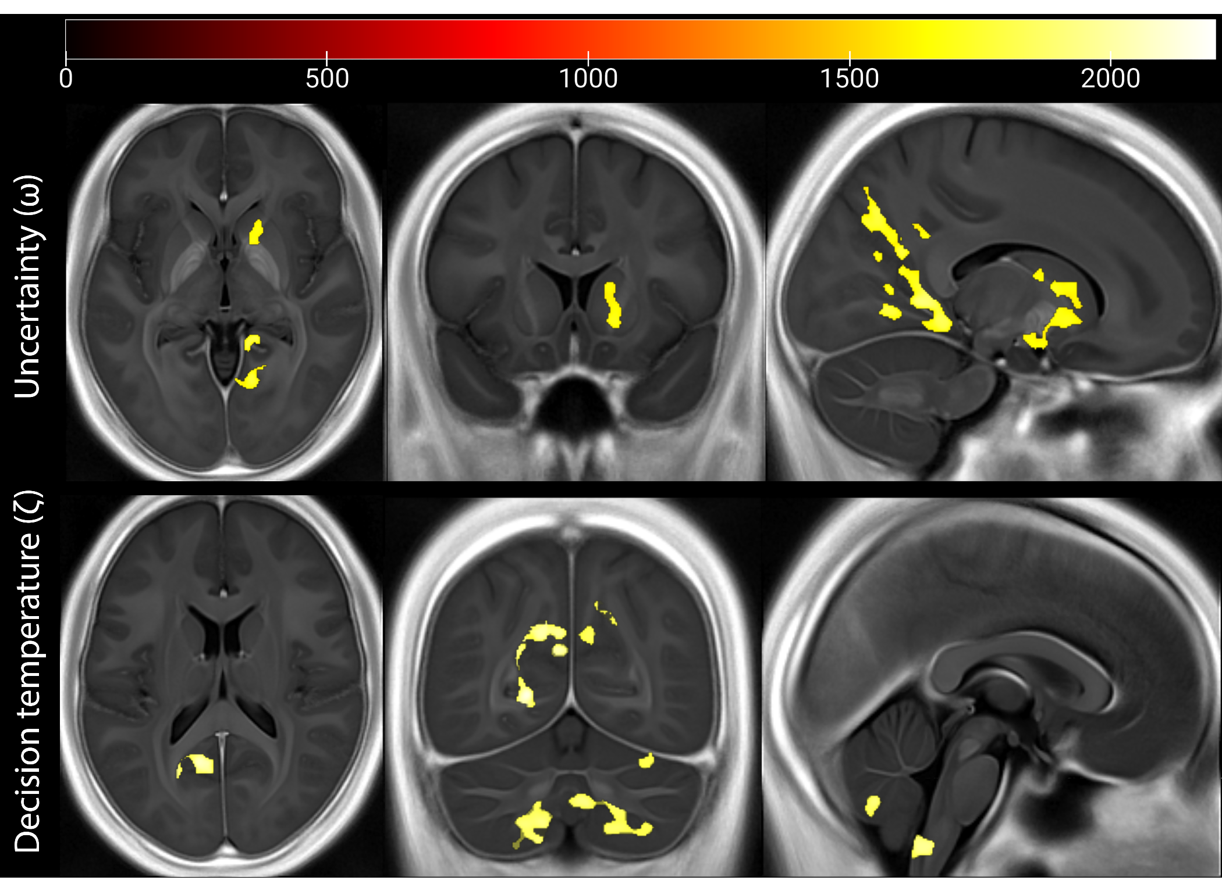

**Fig. 5. Microstructural brain correlates of computational parameters (omega and zeta contrasts).** Using a permutation-based Threshold Free Cluster Enhancement (TFCE) approach, we identified that iron concentrations (as indexed by R2* maps) in specific cortical, subcortical and brainstem regions positively correlated with the learning parameter related to uncertainty (ω or omega) and decision temperature (ζ or zeta). The omega parameter reflects the influence of uncertainty on learning, while the zeta parameter reflects decision temperature. Heat maps and color bars indicate TFCE values. For visualization purposes, the thresholded maps are plotted on the average normalized parametric map across the entire sample. The three columns represent axial, coronal, and sagittal views of the brain, from left to right, respectively.

# Discussion

We demonstrate that bottom-up sensory processes and top-down expectations interact to shape the perception of innocuous thermosensation and the Thermal Grill Illusion (TGI), providing a computational perspective on how the brain’s interpretation of innocuous thermal stimuli can paradoxically lead to pain. Through computational modeling, we have elucidated a mechanistic framework where hierarchical levels of predictions govern both the perceived quality of thermosensory inputs and the intensity of illusory pain. At the lower-level, the immediate predictions about an upcoming sensory stimulus modulate the perceived thermosensory quality. This modulation aligns closely with the predicted outcome, with the degree of influence scaled by the prediction’s uncertainty. In other words, more uncertain predictions result in less pronounced effects on temperature perception. At the higher level, the model encapsulates beliefs about cue-outcome associations, where greater uncertainty in these associations is found to amplify the experience of illusory pain, as evidenced by the increased burning sensations during the Thermal Grill Illusion (TGI). This framework highlights that the perception of pain or burning during the TGI arises from the dynamic interplay between the brain’s sensory processing and its predictive mechanisms.

We further defined computationally-based metrics of thermosensory learning, decision making and TGI responsivity, and related such parameters to brain microstructural properties. Using high-resolution Multi-Parameter Maps indexing myelination and iron concentration, we identified significant relationships between the computational parameters omega (ω) and zeta (ζ), and the iron concentration of brain regions involved in pain modulation, sensory integration, and cognitive control.

The ω parameter, which reflects how uncertainty influences learning, was linked to iron concentration in the posterior cingulate cortex (PCC), precuneus, caudate, and angular gyrus. The PCC is a core hub within the default mode network, involved in integrating sensory, emotional, and cognitive aspects of pain perception (*58*), and plays a role in modulating pain under uncertainty (*59*).

The precuneus integrates self-referential, sensory signals and cognitive processing (*60*), while the caudate and putamen, in the basal ganglia, track prediction errors in reinforcement learning (*61*, *62*). The angular gyrus is a key region for multi-sensory integration (*63*) with a key role in integrating conflicting sensory signals and resolving uncertainty.

The ζ parameter, which reflects individual variability in decision-making (i.e., decision temperature), was associated with iron concentration in the precuneus, cerebellum, and brainstem. The precuneus was implicated in both learning and decision making parameters. This dual involvement supports the idea that it is a critical hub for coordinating cognitive responses to ambiguous thermal stimuli. The cerebellum is traditionally associated with motor control, but it has also been increasingly recognized for its role in cognitive functions and decision-making (*64*). Finally, brainstem regions, such as the subnucleus reticularis dorsalis, modulate pain perception through the descending pain inhibitory pathway (*65*). Together, these findings suggest that microstructural properties, like iron concentration, may influence thermosensory learning and pain perception across the lifespan, with implications for chronic pain, where disruptions in thermosensory processing and learning are often observed (*66*). We also observed correlations of the UMTI parameter with the myelination and iron concentration of the inferior frontal gyrus and basolateral amygdala. These regions have previously been implicated in pain processing (*34*, *35*) or threat detection (*67*), and may play a role in linking top-down learning effects with the magnification of innocuous stimuli into painful percepts, as is the case in the TGI. However, these results did not survive the TCFE-based correction and should be treated with caution pending future replication. In general, our analysis revealed associations between individual computational profiles and the R2* parameter, a marker sensitive to iron concentration in neurons and glia. R2* is responsive to iron accumulation in regions like the substantia nigra and locus coeruleus, which contain neuromelanin, an iron-rich pigment abundant in dopaminergic neurons. While R2* serves as an indirect proxy for iron content rather than directly measuring dopamine neuron activity, previous studies have shown its potential to reflect the integrity of dopaminergic systems, especially in neurodegenerative conditions like Parkinson’s disease (*68*, *69*). The involvement of these iron-rich, dopamine-linked regions suggests that dopaminergic processes may play a role in thermosensory associative learning. Given that iron accumulation generally increases with age and is associated with neurodegeneration, our findings may have implications for how aging affects thermosensory learning and changes in pain sensitivity across the lifespan.

In summary, this study not only refines our understanding of human thermosensation from a Bayesian perspective but also elucidates how uncertainty can underpin the mis-interpretation of harmless stimuli as painful, transforming objectively innocuous stimuli into a subjective experience of pain. Our findings align with the growing body of evidence supporting Bayesian models in pain perception and learning (*27*, *28*) and extend such framework to the domains of thermosensation and thermo-nociceptive illusions.

Unlike previous cue-conditioning studies on nociceptive pain (e.g., (*6*)), our use of the TGI provides information into how the brain’s handling of uncertainty modulates pain perception when sensory inputs are harmless, but ambiguous. Further, the complex interplay between learned expectations and the sensory experience demonstrate that uncertainty computation varies significantly between individuals. By showing that innocuous thermosensation and pain perception can be modulated by learned expectations, our study provides a computational framework that may be used to identify computational profiles that might be linked to an increased vulnerability to chronic pain or specific chronic pain conditions, where pain perception is decoupled from nociceptive inputs. For instance, in neuropathic pain conditions, often marked by nerve damage and resultant sensory disruption, individuals might experience heightened pain due to a misinterpretation of uncertain thermosensory inputs. Alternatively, chronic pain might be a result of the brain’s tendency to maintain its expectation of pain, which is not updated by sensory inputs due to the reduced sensory drive. These scenarios highlight how uncertainty and expectations can shape the experience of pain, as a result of altered bottom-up signaling. Overall, our study offers a computational framework to investigate how individual differences in learning could underlie experiences of chronic pain.

# Online methods

### **Participants**

A total of 273 participants completed a behavioral session of the probabilistic thermosensory learning task (PTL). We excluded 6 participants from the analyses due to missing responses in more than 10% of choices (i.e., predictions) or VAS ratings. The sample included in the behavioral analyses corresponded to 267 (182 female) participants, between the age of 18 and 52 years (mean = 24.5, sd = 4.4). 213 of these participants completed an MRI session, on a separate day, prior to the completion of the PTL task. Both MRI and behavioral sessions were completed within a three-week interval by the same individuals. This research, a subsection of a larger neuroimaging study with a total of 502 participants, involved various imaging, physiological, and cognitive assessments, focusing here on thermosensory learning and quantitative MRI data. Participants provided informed consent prior to the beginning of the study. The project received ethical approval from the Midtjylland Ethics Committee, and was conducted in accordance with the Declaration of Helsinki.

### **Stimuli**

Thermal stimuli were administered via a Thermal Cutaneous Stimulator (TCS) on the non-dominant forearm, allowing for quick and accurate responses with the dominant hand. The total stimulation surface covered 10 , comprising five distinct stimulation zones measuring 7 x 28 mm each. Cold and warm temperatures were individually calibrated, using a procedure that combined the method of limits and method of levels approaches. Innocuous warm stimuli involved three adjacent zones at an average temperature of 39.1 2.8 °C while innocuous cold stimuli consisted of two adjacent zones at an average temperature of 20 6.5 °C. The inactive zones remained at the baseline temperature of 32°C. TGI stimuli used the same temperatures as the innocuous conditions, with three warm and two cold stimuli presented in an alternating spatial pattern. Auditory tones, which served as cues for the forthcoming thermal stimulation, were either a lower tone of 400 Hz or a higher tone of 1600 Hz.

### **Experimental procedure**

The PTL was implemented in Matlab using the psychtoolbox-3 (*70*, *71*), here participants completed 306 trials. Each trial began with a fixation point displayed for a random interval between 1 to 2 seconds. Following this, an auditory tone (either 400 or 1600 Hz) was presented, leading to a prompt for the participant to predict the upcoming thermosensory stimulus. This prediction was a binary choice - ‘cold’ or ‘warm’ - made using the left and right arrow keys, with a response time limit of 3 seconds. The stimulus, lasting 10 seconds, varied between cold (43% of trials), warm (43% of trials), or a combination of both in an alternating pattern to induce Thermal Grill Illusion (TGI), present in 14% of trials. In around 47% of trials, we collected Visual Analog Scale (VAS) ratings from participants to measure their perception of cold, warm, and burning sensations. Each sensation was rated on a separate scale ranging from 0 (no sensation) to 100 (maximum sensation), with these ratings required for approximately 60% of cold and warm trials and all TGI trials. Participants had up to 5 seconds to provide each VAS rating.

The likelihood of cue-stimulus associations was governed by two predetermined sequences, which were counterbalanced across participants. These sequences were designed to create blocks of stimuli where a specific cue had an 82% chance of indicating a particular outcome. However, these cues were subject to unpredictable reversals - at certain points, a cue that previously had an 82% likelihood of predicting one outcome would switch to having only an 18% likelihood of predicting that same outcome. Interspersed between these reversals were blocks of trials in which the association between a cue and a stimulus was at chance level.

### **Statistical modeling**

The modeling of error rates, response times and VAS ratings was conducted using generalized linear mixed effects models using the GAMLSS package (*72*). Error rates were modeled using a binomial distribution with the logit link function, while response times were modeled using a gamma distribution with a logarithmic link function, VAS-ratings were modeled using the zero-one-inflated beta distribution with the logit link function for all parameters (see Supplementary note). For all mixed effects models random intercepts were incorporated for each subject, incorporating random slopes where convergence permitted.

### **Computational modeling**

We compared four computational learning models in MATLAB (R2021a) (*73*): 2-level HGF, Rescorla Wagner, Sutton K1 and Peace hall. To ensure the robustness of all models, we demonstrated acceptable parameter recovery, across a wide range of subject-specific learning parameters, as well as effective model recovery. Results from these analyses, further elaborated in fig. S1-8, ensured that the parameters derived from the models were interpretable and sensible, and facilitated the specification of reasonable parameter ranges for weakly informative priors for all models. For selecting the model that most accurately represented the data from our learning task, we employed a random effects model comparison using the VBA-toolbox (*54*). This analysis indicated that the 2-level HGF was the most appropriate model to describe our data.

The 2-level HGF utilizes variational Bayesian approximation to derive update equations, enabling the estimation of how beliefs across different hierarchical levels evolve over trials (*48*, *49*). The model is structured in two sub-parts known as response and perceptual models (Fig 3). The response model includes observed values, such as the inferred cue-outcome association (U), the participant’s prediction responses (Resp), and the decision temperature parameter zeta (). The perceptual model is organized across two distinct hierarchical levels. At the first level (), the model captures participants’ immediate predictions about upcoming stimuli. These lower-level predictions are assumed to be distributed as a Bernouli random variable where the more extreme values around zero and one signify low prediction uncertainty, while intermediate values (0.5) indicate high uncertainty. The second level () encapsulated predictions about the stability of cue-outcome associations. These higher-level beliefs evolve over time as a Gaussian random walk, with a step size determined by the parameter omega ().

The transition from the second-level to the first-level HGF is governed by a sigmoid transformation, converting the continuous Gaussian-distributed beliefs into Bernoulli-distributed probabilities about immediate outcomes. The sigmoid transformation is formulated as:

Simultaneously, the second-level HGF is updated based on precision-weighted prediction errors computed at the first-level. This update mechanism allows the model to account for confidence in the first-level predictions, adjusting the second-level beliefs accordingly. In cases of higher precision, when the uncertainty weight on prediction errors is low, the model is more likely to maintain its current belief structure. This belief updating is formulated as:

Further on each trial the precision is updated based on the following equation:

Where subscripts represent the level of the HGF, is the mean of the level, is the precision of the level and is the contingency input. In our computational analysis, this inverse precision is referred to as estimation uncertainty, while the first level uncertainty is labeled prediction uncertainty.

### **Multiparameter Mapping**

We used multiparameter mapping (MPM), a well-established quantitative MRI protocol to map percent saturation due to magnetization transfer (MT), longitudinal relaxation rate (R1) and effective transverse relaxation rate (R2*) (*56*, *74*, *75*). Following data acquisition, we applied voxel based quantification (VBQ) (*76*) to relate individual differences in computational parameters of thermosensory learning to patterns of brain microstructure. Identical details about data acquisition and map creation are also reported in a different paper relating individual differences in respiroception to brain microstructure (*77*). Advantages of MPM and VBQ compared to qualitative brain metrics, such as voxel-based morphometry, are improved neurobiological specificity, reproducibility, and identification of biomarkers, as well as longitudinal test-retest reliability (*78*), enhancing our understanding of brain-behavior relations.

### **Data acquisition**

The imaging data were acquired using a 3T MRI scanner (Magnetom Prisma, Siemens healthcare, Erlangen, Germany), with a standard 32-channel radiofrequency (RF) head coil and a body coil. We acquired a set of high-resolution whole brain T1-weighted anatomical images (0.8 mm isotropic) using an MP-RAGE sequence (repetition time=2.2 s, echo time=2.51 ms, matrix size=256×256 × 192voxels, flip angle=8°, in-slice phase-encoding direction = AP, slice encoding direction = LR, read-out direction = HF). Further, we obtained whole-brain images at isotropic 0.8mm resolution using a Multi-Parameter Mapping (MPM) quantitative imaging protocol (*74*). The imaging sequences included three RF and gradient spoiled (using a linear phase increment of 137°) multi-echo 3D fast low angle shot (FLASH) acquisitions and three additional calibration sequences to correct for RF receive bias (*79*). Specifically, the FLASH sequences consisted of magnetization transfer (MT), proton density (PD) and T1 weighting acquisitions. The flip angle was 6° for MT and PD, while 21° for T1-weighted images. MT-weighting used a Gaussian RF pulse 2 kHz off resonance with 4ms duration and a nominal flip angle of 220°. The field of view was 256mm head-foot, 224mm anterior-posterior, and 179mm right-left. We acquired gradient echoes with alternating readout gradient polarity using equidistant echo times ranging from 2.34 to 13.8ms (MT) or 18.4ms (PD and T1), using a readout bandwidth of 490 Hz/pixel. For the MT-weighted acquisition, only 6 echoes were collected to achieve a repetition time (TR) of 25ms for all FLASH volumes. For accelerated data acquisition, we performed partially parallel imaging using the GRAPPA algorithm, with an acceleration factor of 2 in each phase encoded direction and 40 integrated reference lines. All acquisitions had a slab rotation of 30° in the sagittal plane to avoid eye-related motion artifacts in the cortex. The B1 mapping acquisition comprised 11 measurements with the nominal flip angle ranging from 115° to 65° in 5° steps. The total scanning time for the qMRI acquisitions was approximately 26 minutes.

### **Map creation**

We preprocessed all qMRI images using the hMRI toolbox v. 0.5.0 (January 2023) (*80*) and SMP12 (version 12.r7771, Wellcome Trust Centre for Neuroimaging, [http://www.fil.ion.ucl.ac.uk/spm/).](http://www.fil.ion.ucl.ac.uk/spm/), to correct the raw qMRI images for spatial transmit, receive field inhomogeneities and obtain quantitative MT, PD, R1 and R2* estimate maps. Except for enabling the correction for imperfect spoiling (*81*), the hMRI toolbox was configured using the standard settings. Prior to the estimation of these maps, all images were aligned to the MNI standard space. This processing produced four maps, each reflecting different attributes of brain tissue microstructure: an MT saturation map is sensitive to myelin content (*82*, *83*), a PD map representing tissue water content, an R1 map reflecting micro-structural tissue properties such as macromolecule content, local mobility of water molecules iron concentration (also related to myelination) (*80*, *84*), and an R2* map sensitive to tissue iron concentration (*85*). We analyzed three of these maps (MT, R1 and R2*) independently.

We used the unified segmentation approach (*86*) to segment MT saturation maps into probability maps of gray matter (GM), white matter (WM) and cerebrospinal fluid (CSF). For this segmentation, we employed tissue probability maps based on multi-parameter data (*87*), without bias field correction as MT maps do not show significant bias field modulation. Subsequently, GM and WM probability maps were utilized for inter-subject registration using the nonlinear diffeomorphic algorithm DARTEL (*88*). This step enabled the normalization of the derived quantitative maps to MNI space at an isotropic 1 mm resolution. This normalization used the DARTEL template created during registration and participant-specific deformation fields.

The nonlinear registration of the quantitative maps was based on the MT maps, chosen for their high contrast in subcortical structures and a WM-GM contrast in the cortex comparable to that of T1-weighted images (*82*). Finally, tissue-weighted smoothing was applied using a 4 mm full width at half maximum (FWHM) kernel (*76*), to preserve quantitative values. The resulting smoothed, modulated and normalized GM images were used for statistical analyses. For visualization purposes, we generated an average MT map in standard space based on data from 442 individuals, who participated in the Visceral Mind Project. For analysis, we utilized a gray-matter mask that was generated by averaging the smoothed, modulated GM segments, and applying a threshold of p(gray matter) > 0.2.

### **MPM Quality Control**

We implemented a comprehensive set of quality-control (QC) protocols including manual and automated procedures. These included manual scoring of raw image quality at the time of acquisition, automated processing via the Mriqc pipeline (*89*), as well as the application of a specially developed semi-automatic hMRI-vQC pipeline designed for quantitative neuroimaging. We additionally calculated the index of motion degradation using QUQUI (*84*). The automated procedures yielded a variety of quantitative QC metrics including coregistration parameters, standard deviation in the white matter of the R2* maps, SNR and CNR values; these were inspected via boxplots to identify extreme subjects. Following the application of MRIqc, a team of two authors (NN and CS) inspected all raw images and post-processed maps including those flagged by the automated procedure. Images were graded on a scale from 0-3 (unusable to no issues), and any disagreements between the raters were discussed and resolved alongside a third author (MA). In the Visceral Mind Project, 60 out of 502 individuals failed to pass these QC protocols, while in the subsample of the current study no participant was excluded from the voxel-based quantification analyses due to data quality.

### **Voxel Based Quantification Analysis**

We analyzed whole-brain associations between MT at each voxel and thermosensory learning using a multiple linear regression approach known as voxel-based quantification (VBQ). Our key analysis comprised positive and negative t-tests over the computational parameters. We included age, gender and total intracranial volume as nuisance covariates in the regression model, following recommended procedures for computational neuroanatomy (*90*).

To robustly detect clusters of voxels correlated with the computational parameters of interest, we employed Threshold-Free Cluster Enhancement (TFCE) (*57*). Traditional cluster-based methods typically require an arbitrary voxel-wise threshold to define clusters, which can introduce bias or affect sensitivity. TFCE addresses these limitations by continuously enhancing signal from clusters of voxels based on both their spatial extent (size) and height (intensity), without the need for predefined thresholds. This makes TFCE more sensitive to subtle effects while reducing the likelihood of false positives. For our analysis, we applied TFCE using default hyper-parameters, with an extent of E = 0.5 and a height of H = 2. A family-wise error (FWE) cluster-corrected threshold of p < .05 was used within the gray matter mask. To compare the robustness of our results, we also performed a traditional cluster-based correction. This approach utilized a family-wise error (FWE) cluster-corrected threshold of p < .025 (Bonferroni-corrected for two one-tailed tests), based on an inclusion threshold of p < .001 (uncorrected). The results from the traditional cluster-based approach are available in the supplementary material for comparison. All statistical analyses were conducted in SPM12, while anatomical labels were determined using the JuBrain Anatomy Toolbox v. 3.0 (*91*). The group-level statistical maps generated from this study are available at a Neurovault repository (URL will be provided).

### **Maps interpretation**

Multi-Parameter Mapping (MPM) produces quantitative images that allow for detailed examination of brain microstructure. The magnetization transfer (MT) map is particularly sensitive to macromolecular content, especially myelin. MT saturation reflects the exchange of magnetization between free water protons and macromolecule-bound protons, making it a key measure of myelin density and structural integrity within brain tissue (*92*). This makes MT mapping essential for analyzing regions where changes in tissue organization or myelination are relevant. The R1 map, which captures the longitudinal relaxation rate, provides valuable information about tissue composition, water content, and macromolecule presence. Higher R1 values are often linked to increased macromolecule density or reduced water mobility, factors that may correspond to myelination or other structural characteristics in the brain (*74*). As such, R1 complements the information obtained from MT mapping. R2*, or the effective transverse relaxation rate, is highly sensitive to local magnetic field inhomogeneities caused by variations in tissue composition, such as the presence of paramagnetic substances. This makes the R2* map particularly useful for studying tissues rich in substances like iron, as well as myelin (*85*). R2* mapping is frequently applied to analyze regions where these materials are concentrated, such as in the basal ganglia and brainstem (*93*). Together, these maps provide a comprehensive quantitative approach to characterizing brain microstructure, offering more specific and reliable measures of tissue properties than conventional qualitative MRI methods (*56*, *74*, *75*, *78*). MPM thus plays a crucial role in studying individual variations in brain anatomy and their connection to cognitive and sensory processes.

### **Data availability**

Behavioral and modeling data are available at [OSF](https://osf.io/q5z39/). Brain imaging data are available at [add Neurovault link here].

### **Code availability**

All code is available at [Github](https://github.com/Body-Pain-Perception-Lab/Pain-Thermal-Learning.git)

### **Acknowledgements**

This work was supported by the European Research Council under the grants ERC-2020-StG-948838 (FF, JFE, CSD, CEK, AGM) and ERC-2020-StG-948788 (MGA, ASC, MV). We also acknowledge funding from the Lundbeck Foundation under the grants R272-2017-4345 (MGA, LB, MB, NN). CS is supported by a Neuroscience Academy Denmark (NAD) fellowship. Additionally, CM is supported by Wellcome Mental Health Award 226776/Z/22/Z, Independent Research Fund Denmark (DFF) Research Project 3166-00158B, Carlsberg Foundation Young Researcher Fellowship CF21-0439, and Aarhus University Research Foundation Starting Grant AUFF-E-2019-7-10. We thank Tobias Hauser for comments on the study design and draft.

# References

1. M. J. Caterina, M. A. Schumacher, M. Tominaga, T. A. Rosen, J. D. Levine, D. Julius, [The capsaicin receptor: A heat-activated ion channel in the pain pathway](https://doi.org/10.1038/39807). *Nature* **389**, 816–824 (1997).

2. D. D. McKemy, W. M. Neuhausser, D. Julius, [Identification of a cold receptor reveals a general role for TRP channels in thermosensation](https://doi.org/10.1038/nature719). *Nature* **416**, 52–58 (2002).

3. A. M. Peier, A. Moqrich, A. C. Hergarden, A. J. Reeve, D. A. Andersson, G. M. Story, T. J. Earley, I. Dragoni, P. McIntyre, S. Bevan, A. Patapoutian, [A TRP channel that senses cold stimuli and menthol](https://doi.org/10.1016/s0092-8674(02)00652-9). *Cell* **108**, 705–715 (2002).

4. L. Y. Atlas, N. Bolger, M. A. Lindquist, T. D. Wager, [Brain Mediators of Predictive Cue Effects on Perceived Pain](https://doi.org/10.1523/JNEUROSCI.0057-10.2010). *Journal of Neuroscience* **30**, 12964–12977 (2010).

5. H. L. Fields, [How expectations influence pain](https://doi.org/10.1097/j.pain.0000000000001272). *PAIN* **159 Suppl 1**, S3–S10 (2018).

6. M. Jepma, L. Koban, J. van Doorn, M. Jones, T. D. Wager, [Behavioural and neural evidence for self-reinforcing expectancy effects on pain](https://doi.org/10.1038/s41562-018-0455-8). *Nature Human Behaviour* **2**, 838–855 (2018).

7. M. M. Nickel, L. Tiemann, V. D. Hohn, E. S. May, C. Gil Ávila, F. Eippert, M. Ploner, [Temporal–spectral signaling of sensory information and expectations in the cerebral processing of pain](https://doi.org/10.1073/pnas.2116616119). *Proceedings of the National Academy of Sciences* **119**, e2116616119 (2022).

8. A. D. Craig, M. C. Bushnell, [The thermal grill illusion: Unmasking the burn of cold pain](https://doi.org/10.1126/science.8023144). *Science* **265**, 252–255 (1994).

9. F. Fardo, N. B. Finnerup, P. Haggard, [Organization of the Thermal Grill Illusion by Spinal Segments](https://doi.org/10.1002/ana.25307). *Annals of Neurology* **84**, 463–472 (2018).

10. F. Fardo, B. Beck, M. Allen, N. B. Finnerup, [Beyond Labeled Lines: A Population Coding Account of the Thermal Grill Illusion](https://doi.org/10.1016/j.neubiorev.2019.11.017). *Neuroscience and Biobehavioral Reviews* **108**, 472–479 (2020).

11. R. A. Böhme, L. Banellis, M. Vejlø, M. Allen, F. Fardo, The Psychological Construction of Pain: Evidence for No Link Between Mental Health Symptoms and Thermal Pain Thresholds (2024). <https://doi.org/10.31234/osf.io/bc627>.

12. C. Sardeto Deolindo, J. F. Ehmsen, A. S. Courtin, A. G. Mitchell, C. E. Kraenge, N. Nikolova, M. G. Allen, F. Fardo, Assessing Individual Sensitivity to the Thermal Grill Illusion: A Two-Dimensional Adaptive Psychophysical Approach (2024). <https://doi.org/10.1101/2024.03.14.585017>.

13. A. G. Mitchell, J. F. Ehmsen, D. E. Christensen, A. V. Stuckert, P. Haggard, F. Fardo, [Disentangling the spinal mechanisms of illusory heat and burning sensations in the thermal grill illusion](https://doi.org/10.1097/j.pain.0000000000003352). *PAIN* **165**, 2370 (2024).

14. A. Leung, S. Shukla, E. Li, J.-R. Duann, T. Yaksh, [Supraspinal characterization of the thermal grill illusion with fMRI](https://doi.org/10.1186/1744-8069-10-18). *Molecular Pain* **10**, 18 (2014).

15. A. D. Craig, E. M. Reiman, A. Evans, M. C. Bushnell, [Functional imaging of an illusion of pain](https://doi.org/10.1038/384258a0). *Nature* **384**, 258–260 (1996).

16. F. Lindstedt, B. Johansson, S. Martinsen, E. Kosek, P. Fransson, M. Ingvar, [Evidence for Thalamic Involvement in the Thermal Grill Illusion: An fMRI Study](https://doi.org/10.1371/journal.pone.0027075). *PLoS ONE* **6**, e27075 (2011).

17. C. Büchel, S. Geuter, C. Sprenger, F. Eippert, [Placebo analgesia: A predictive coding perspective](https://doi.org/10.1016/j.neuron.2014.02.042). *Neuron* **81**, 1223–1239 (2014).

18. F. Fardo, R. Auksztulewicz, M. Allen, M. J. Dietz, A. Roepstorff, K. J. Friston, [Expectation violation and attention to pain jointly modulate neural gain in somatosensory cortex](https://doi.org/10.1016/j.neuroimage.2017.03.041). *NeuroImage* **153**, 109–121 (2017).

19. S. Geuter, S. Boll, F. Eippert, C. Büchel, [Functional dissociation of stimulus intensity encoding and predictive coding of pain in the insula](https://doi.org/10.7554/eLife.24770). *eLife* **6**, e24770 (2017).

20. A. Tabor, M. A. Thacker, G. L. Moseley, K. P. Körding, [Pain: A Statistical Account](https://doi.org/10.1371/journal.pcbi.1005142). *PLOS Computational Biology* **13**, e1005142 (2017).

21. R. Hoskin, C. Berzuini, D. Acosta-Kane, W. El-Deredy, H. Guo, D. Talmi, [Sensitivity to pain expectations: A Bayesian model of individual differences](https://doi.org/10.1016/j.cognition.2018.08.022). *Cognition* **182**, 127–139 (2019).

22. B. Seymour, F. Mancini, [Hierarchical models of pain: Inference, information-seeking, and adaptive control.](https://doi.org/10.1016/j.neuroimage.2020.117212) *NeuroImage* **222**, 117212 (2020).

23. Y. Song, M. Yao, H. Kemprecos, A. Byrne, Z. Xiao, Q. Zhang, A. Singh, J. Wang, Z. S. Chen, [Predictive coding models for pain perception](https://doi.org/10.1007/s10827-021-00780-x). *Journal of Computational Neuroscience* **49**, 107–127 (2021).

24. A.-L. Eckert, K. Pabst, D. M. Endres, [A Bayesian model for chronic pain](https://www.frontiersin.org/articles/10.3389/fpain.2022.966034). *Frontiers in Pain Research* **3** (2022).

25. J. Kiverstein, M. D. Kirchhoff, M. Thacker, [An Embodied Predictive Processing Theory of Pain Experience](https://doi.org/10.1007/s13164-022-00616-2). *Review of Philosophy and Psychology* **13**, 973–998 (2022).

26. Z. S. Chen, J. Wang, [Pain, from perception to action: A computational perspective](https://doi.org/10.1016/j.isci.2022.105707). *iScience* **26**, 105707 (2023).

27. F. Mancini, S. Zhang, B. Seymour, [Computational and neural mechanisms of statistical pain learning](https://doi.org/10.1038/s41467-022-34283-9). *Nature Communications* **13**, 6613 (2022).

28. D. Mulders, B. Seymour, A. Mouraux, F. Mancini, [Confidence of probabilistic predictions modulates the cortical response to pain](https://doi.org/10.1073/pnas.2212252120). *Proceedings of the National Academy of Sciences* **120**, e2212252120 (2023).

29. M. Roy, D. Shohamy, N. Daw, M. Jepma, G. E. Wimmer, T. D. Wager, [Representation of aversive prediction errors in the human periaqueductal gray](https://doi.org/10.1038/nn.3832). *Nature Neuroscience* **17**, 1607–1612 (2014).

30. S. Fazeli, C. Büchel, [Pain-Related Expectation and Prediction Error Signals in the Anterior Insula Are Not Related to Aversiveness](https://doi.org/10.1523/JNEUROSCI.0671-18.2018). *Journal of Neuroscience* **38**, 6461–6474 (2018).

31. J. D. Levine, N. C. Gordon, H. L. Fields, [The mechanism of placebo analgesia](https://doi.org/10.1016/s0140-6736(78)92762-9). *Lancet* **2**, 654–657 (1978).

32. T. D. Wager, J. K. Rilling, E. E. Smith, A. Sokolik, K. L. Casey, R. J. Davidson, S. M. Kosslyn, R. M. Rose, J. D. Cohen, [Placebo-induced changes in FMRI in the anticipation and experience of pain](https://doi.org/10.1126/science.1093065). *Science* **303**, 1162–1167 (2004).

33. D. D. Price, D. G. Finniss, F. Benedetti, [A comprehensive review of the placebo effect: Recent advances and current thought](https://doi.org/10.1146/annurev.psych.59.113006.095941). *Annual Review of Psychology* **59**, 565–590 (2008).

34. F. Eippert, U. Bingel, E. D. Schoell, J. Yacubian, R. Klinger, J. Lorenz, C. Büchel, [Activation of the opioidergic descending pain control system underlies placebo analgesia](https://doi.org/10.1016/j.neuron.2009.07.014). *Neuron* **63**, 533–543 (2009).

35. F. Eippert, J. Finsterbusch, U. Bingel, C. Büchel, [Direct evidence for spinal cord involvement in placebo analgesia](https://doi.org/10.1126/science.1180142). *Science* **326**, 404 (2009).

36. F. Benedetti, [Placebo effects: From the neurobiological paradigm to translational implications](https://doi.org/10.1016/j.neuron.2014.10.023). *Neuron* **84**, 623–637 (2014).

37. T. D. Wager, L. Y. Atlas, [The neuroscience of placebo effects: Connecting context, learning and health](https://doi.org/10.1038/nrn3976). *Nature Reviews Neuroscience* **16**, 403–418 (2015).

38. D. Anchisi, M. Zanon, [A Bayesian perspective on sensory and cognitive integration in pain perception and placebo analgesia](https://doi.org/10.1371/journal.pone.0117270). *PloS One* **10**, e0117270 (2015).

39. A. Tabor, C. Burr, [Bayesian Learning Models of Pain: A Call to Action](https://doi.org/10.1016/j.cobeha.2018.10.006). *Current Opinion in Behavioral Sciences* **26**, 54–61 (2019).

40. G. Ongaro, T. J. Kaptchuk, [Symptom perception, placebo effects, and the Bayesian brain](https://doi.org/10.1097/j.pain.0000000000001367). *PAIN* **160**, 1–4 (2019).

41. R. Kanai, B. Bahrami, G. Rees, [Human Parietal Cortex Structure Predicts Individual Differences in Perceptual Rivalry](https://doi.org/10.1016/j.cub.2010.07.027). *Current Biology* **20**, 1626–1630 (2010).

42. A. D. Craig, [Can the basis for central neuropathic pain be identified by using a thermal grill?](https://doi.org/10.1016/j.pain.2008.01.022) *PAIN* **135**, 215–216 (2008).

43. F. Adam, P. Jouët, J.-M. Sabaté, S. Perrot, C. Franchisseur, N. Attal, D. Bouhassira, [Thermal grill illusion of pain in patients with chronic pain: A clinical marker of central sensitization?](https://doi.org/10.1097/j.pain.0000000000002749) *PAIN* **164**, 638–644 (2023).

44. H. E. M. den Ouden, J. Daunizeau, J. Roiser, K. J. Friston, K. E. Stephan, [Striatal prediction error modulates cortical coupling](https://doi.org/10.1523/JNEUROSCI.4458-09.2010). *Journal of Neuroscience* **30**, 3210–3219 (2010).

45. S. Iglesias, C. Mathys, K. H. Brodersen, L. Kasper, M. Piccirelli, H. E. M. den Ouden, K. E. Stephan, [Hierarchical prediction errors in midbrain and basal forebrain during sensory learning](https://doi.org/10.1016/j.neuron.2013.09.009). *Neuron* **80**, 519–530 (2013).

46. A. O. de Berker, R. B. Rutledge, C. Mathys, L. Marshall, G. F. Cross, R. J. Dolan, S. Bestmann, [Computations of uncertainty mediate acute stress responses in humans](https://doi.org/10.1038/ncomms10996). *Nature Communications* **7**, 10996 (2016).

47. R. P. Lawson, C. Mathys, G. Rees, [Adults with autism overestimate the volatility of the sensory environment](https://doi.org/10.1038/nn.4615). *Nature Neuroscience* **20**, 1293–1299 (2017).

48. C. Mathys, J. Daunizeau, K. Friston, K. Stephan, [A Bayesian Foundation for Individual Learning Under Uncertainty](https://www.frontiersin.org/articles/10.3389/fnhum.2011.00039). *Frontiers in Human Neuroscience* **5** (2011).

49. C. D. Mathys, E. I. Lomakina, J. Daunizeau, S. Iglesias, K. H. Brodersen, K. J. Friston, K. E. Stephan, [Uncertainty in perception and the Hierarchical Gaussian Filter](https://www.frontiersin.org/articles/10.3389/fnhum.2014.00825). *Frontiers in Human Neuroscience* **8** (2014).

50. R. Rescorla, A. Wagner, A theory of Pavlovian conditioning: The effectiveness of reinforcement and non-reinforcement. *Classical Conditioning: Current Research and Theory* (1972).

51. R. Sutton, Gain Adaptation Beats Least Squares? *In Proceedings of the 7th Yale Workshop on Adaptive and Learning Systems* (1995).

52. J. Li, D. Schiller, G. Schoenbaum, E. A. Phelps, N. D. Daw, [Differential roles of human striatum and amygdala in associative learning](https://doi.org/10.1038/nn.2904). *Nature Neuroscience* **14**, 1250–1252 (2011).

53. S. Zhang, H. Mano, G. Ganesh, T. Robbins, B. Seymour, [Dissociable Learning Processes Underlie Human Pain Conditioning](https://doi.org/10.1016/j.cub.2015.10.066). *Current Biology* **26**, 52–58 (2016).

54. J. Daunizeau, V. Adam, L. Rigoux, [VBA: A Probabilistic Treatment of Nonlinear Models for Neurobiological and Behavioural Data](https://doi.org/10.1371/journal.pcbi.1003441). *PLOS Computational Biology* **10**, e1003441 (2014).

55. R. S. Samson, O. Ciccarelli, C. Kachramanoglou, L. Brightman, A. Lutti, D. L. Thomas, N. Weiskopf, C. a. M. Wheeler-Kingshott, [Tissue- and column-specific measurements from multi-parameter mapping of the human cervical spinal cord at 3 T](https://doi.org/10.1002/nbm.3022). *NMR in Biomedicine* **26**, 1823–1830 (2013).

56. N. Weiskopf, S. Mohammadi, A. Lutti, M. F. Callaghan, [Advances in MRI-based computational neuroanatomy: From morphometry to in-vivo histology](https://doi.org/10.1097/WCO.0000000000000222). *Current Opinion in Neurology* **28**, 313 (2015).

57. S. M. Smith, T. E. Nichols, [Threshold-free cluster enhancement: Addressing problems of smoothing, threshold dependence and localisation in cluster inference](https://doi.org/10.1016/j.neuroimage.2008.03.061). *NeuroImage* **44**, 83–98 (2009).

58. B. A. Vogt, S. Laureys, [Posterior cingulate, precuneal and retrosplenial cortices: Cytology and components of the neural network correlates of consciousness](https://doi.org/10.1016/S0079-6123(05)50015-3). *Progress in Brain Research* **150**, 205–217 (2005).

59. R. Leech, D. J. Sharp, [The role of the posterior cingulate cortex in cognition and disease](https://doi.org/10.1093/brain/awt162). *Brain: A Journal of Neurology* **137**, 12–32 (2014).

60. A. E. Cavanna, M. R. Trimble, [The precuneus: A review of its functional anatomy and behavioural correlates](https://doi.org/10.1093/brain/awl004). *Brain: A Journal of Neurology* **129**, 564–583 (2006).

61. J. P. O’Doherty, P. Dayan, K. Friston, H. Critchley, R. J. Dolan, [Temporal Difference Models and Reward-Related Learning in the Human Brain](https://doi.org/10.1016/S0896-6273(03)00169-7). *Neuron* **38**, 329–337 (2003).

62. J. O’Doherty, P. Dayan, J. Schultz, R. Deichmann, K. Friston, R. J. Dolan, [Dissociable roles of ventral and dorsal striatum in instrumental conditioning](https://doi.org/10.1126/science.1094285). *Science (New York, N.Y.)* **304**, 452–454 (2004).

63. M. L. Seghier, [The angular gyrus: Multiple functions and multiple subdivisions](https://doi.org/10.1177/1073858412440596). *The Neuroscientist: A Review Journal Bringing Neurobiology, Neurology and Psychiatry* **19**, 43–61 (2013).

64. J. D. Schmahmann, [The cerebellum and cognition](https://doi.org/10.1016/j.neulet.2018.07.005). *Neuroscience Letters* **688**, 62–75 (2019).

65. I. Tracey, P. W. Mantyh, [The cerebral signature for pain perception and its modulation](https://doi.org/10.1016/j.neuron.2007.07.012). *Neuron* **55**, 377–391 (2007).

66. A. V. Apkarian, M. N. Baliki, P. Y. Geha, [Towards a theory of chronic pain](https://doi.org/10.1016/j.pneurobio.2008.09.018). *Progress in Neurobiology* **87**, 81–97 (2009).

67. A. S. Fox, J. A. Oler, D. P. M. Tromp, J. L. Fudge, N. H. Kalin, [Extending the amygdala in theories of threat processing](https://doi.org/10.1016/j.tins.2015.03.002). *Trends in neurosciences* **38**, 319–329 (2015).

68. T. K. Steiger, N. Weiskopf, N. Bunzeck, [Iron Level and Myelin Content in the Ventral Striatum Predict Memory Performance in the Aging Brain](https://doi.org/10.1523/JNEUROSCI.3617-15.2016). *Journal of Neuroscience* **36**, 3552–3558 (2016).

69. P. Trujillo, M. A. Aumann, D. O. Claassen, [Neuromelanin-sensitive MRI as a promising biomarker of catecholamine function](https://doi.org/10.1093/brain/awad300). *Brain* **147**, 337–351 (2024).

70. D. H. Brainard, [The Psychophysics Toolbox](https://doi.org/10.1163/156856897X00357). *Spatial Vision* **10**, 433–436 (1997).

71. M. Kleiner, D. Brainard, D. Pelli, A. Ingling, R. Murray, C. Broussard, What’s new in psychtoolbox-3. *Perception* **36**, 1–16 (2007).

72. R. A. Rigby, D. M. Stasinopoulos, [Generalized Additive Models for Location, Scale and Shape](https://www.jstor.org/stable/3592732). *Journal of the Royal Statistical Society. Series C (Applied Statistics)* **54**, 507–554 (2005).

73. *MATLAB version 9.10.0.1613233 (R2021a)* (The Mathworks, Inc., Natick, Massachusetts, 2021).

74. N. Weiskopf, J. Suckling, G. Williams, M. M. Correia, B. Inkster, R. Tait, C. Ooi, E. T. Bullmore, A. Lutti, [Quantitative multi-parameter mapping of R1, PD*, MT, and R2* at 3T: A multi-center validation](https://doi.org/10.3389/fnins.2013.00095). *Frontiers in Neuroscience* **7**, 95 (2013).

75. M. F. Callaghan, P. Freund, B. Draganski, E. Anderson, M. Cappelletti, R. Chowdhury, J. Diedrichsen, T. H. B. Fitzgerald, P. Smittenaar, G. Helms, A. Lutti, N. Weiskopf, [Widespread age-related differences in the human brain microstructure revealed by quantitative magnetic resonance imaging](https://doi.org/10.1016/j.neurobiolaging.2014.02.008). *Neurobiology of Aging* **35**, 1862–1872 (2014).

76. B. Draganski, J. Ashburner, C. Hutton, F. Kherif, R. S. J. Frackowiak, G. Helms, N. Weiskopf, [Regional specificity of MRI contrast parameter changes in normal ageing revealed by voxel-based quantification (VBQ)](https://doi.org/10.1016/j.neuroimage.2011.01.052). *NeuroImage* **55**, 1423–1434 (2011).

77. N. Nikolova, J. F. Ehmsen, L. Banellis, M. Brændholt, M. Vejlø, F. Fardo, M. Allen, Microstructural Brain Correlates of Inter-individual Differences in Respiratory Interoception (2024). <https://doi.org/10.1101/2024.04.08.588519>.

78. N. Aye, N. Lehmann, J. Kaufmann, H.-J. Heinze, E. Düzel, M. Taubert, G. Ziegler, [Test-retest reliability of multi-parametric maps (MPM) of brain microstructure](https://doi.org/10.1016/j.neuroimage.2022.119249). *NeuroImage* **256**, 119249 (2022).

79. D. Papp, M. F. Callaghan, H. Meyer, C. Buckley, N. Weiskopf, [Correction of inter-scan motion artifacts in quantitative R1 mapping by accounting for receive coil sensitivity effects](https://doi.org/10.1002/mrm.26058). *Magnetic Resonance in Medicine* **76**, 1478–1485 (2016).

80. K. Tabelow, E. Balteau, J. Ashburner, M. F. Callaghan, B. Draganski, G. Helms, F. Kherif, T. Leutritz, A. Lutti, C. Phillips, E. Reimer, L. Ruthotto, M. Seif, N. Weiskopf, G. Ziegler, S. Mohammadi, [hMRI—A toolbox for quantitative MRI in neuroscience and clinical research](https://doi.org/10.1016/j.neuroimage.2019.01.029). *NeuroImage* **194**, 191–210 (2019).

81. N. Corbin, M. F. Callaghan, [Imperfect spoiling in variable flip angle T1 mapping at 7T: Quantifying and minimizing impact](https://doi.org/10.1002/mrm.28720). *Magnetic Resonance in Medicine* **86**, 693–708 (2021).

82. G. Helms, B. Draganski, R. Frackowiak, J. Ashburner, N. Weiskopf, [Improved segmentation of deep brain grey matter structures using magnetization transfer (MT) parameter maps](https://doi.org/10.1016/j.neuroimage.2009.03.053). *Neuroimage* **47**, 194–198 (2009).

83. P. Freund, N. Weiskopf, J. Ashburner, K. Wolf, R. Sutter, D. R. Altmann, K. Friston, A. Thompson, A. Curt, [MRI investigation of the sensorimotor cortex and the corticospinal tract after acute spinal cord injury: A prospective longitudinal study](https://doi.org/10.1016/S1474-4422(13)70146-7). *The Lancet. Neurology* **12**, 873–881 (2013).

84. A. Lutti, N. Corbin, J. Ashburner, G. Ziegler, B. Draganski, C. Phillips, F. Kherif, M. F. Callaghan, G. Di Domenicantonio, [Restoring statistical validity in group analyses of motion-corrupted MRI data](https://doi.org/10.1002/hbm.25767). *Human Brain Mapping* **43**, 1973–1983 (2022).

85. C. Langkammer, N. Krebs, W. Goessler, E. Scheurer, F. Ebner, K. Yen, F. Fazekas, S. Ropele, [Quantitative MR Imaging of Brain Iron: A Postmortem Validation Study](https://doi.org/10.1148/radiol.10100495). *Radiology* **257**, 455–462 (2010).

86. J. Ashburner, K. J. Friston, [Unified segmentation](https://doi.org/10.1016/j.neuroimage.2005.02.018). *NeuroImage* **26**, 839–851 (2005).

87. S. Lorio, S. Fresard, S. Adaszewski, F. Kherif, R. Chowdhury, R. S. Frackowiak, J. Ashburner, G. Helms, N. Weiskopf, A. Lutti, B. Draganski, [New tissue priors for improved automated classification of subcortical brain structures on MRI](https://doi.org/10.1016/j.neuroimage.2016.01.062). *NeuroImage* **130**, 157–166 (2016).

88. J. Ashburner, [A fast diffeomorphic image registration algorithm](https://doi.org/10.1016/j.neuroimage.2007.07.007). *NeuroImage* **38**, 95–113 (2007).

89. O. Esteban, D. Birman, M. Schaer, O. O. Koyejo, R. A. Poldrack, K. J. Gorgolewski, [MRIQC: Advancing the automatic prediction of image quality in MRI from unseen sites](https://doi.org/10.1371/journal.pone.0184661). *PLOS ONE* **12**, e0184661 (2017).

90. G. R. Ridgway, S. M. D. Henley, J. D. Rohrer, R. I. Scahill, J. D. Warren, N. C. Fox, [Ten simple rules for reporting voxel-based morphometry studies](https://doi.org/10.1016/j.neuroimage.2008.01.003). *NeuroImage* **40**, 1429–1435 (2008).

91. S. B. Eickhoff, K. E. Stephan, H. Mohlberg, C. Grefkes, G. R. Fink, K. Amunts, K. Zilles, [A new SPM toolbox for combining probabilistic cytoarchitectonic maps and functional imaging data](https://doi.org/10.1016/j.neuroimage.2004.12.034). *NeuroImage* **25**, 1325–1335 (2005).

92. G. Helms, H. Dathe, K. Kallenberg, P. Dechent, [High-resolution maps of magnetization transfer with inherent correction for RF inhomogeneity and T1 relaxation obtained from 3D FLASH MRI](https://doi.org/10.1002/mrm.21732). *Magnetic Resonance in Medicine* **60**, 1396–1407 (2008).

93. M. C. Keuken, P.-L. Bazin, L. Crown, J. Hootsmans, A. Laufer, C. Müller-Axt, R. Sier, E. J. van der Putten, A. Schäfer, R. Turner, B. U. Forstmann, [Quantifying inter-individual anatomical variability in the subcortex using 7 T structural MRI](https://doi.org/10.1016/j.neuroimage.2014.03.032). *NeuroImage* **94**, 40–46 (2014).

### **Supplementary Results**

We investigated how response times were affected in trials subsequent to a thermal grill stimulus. Our findings revealed a significant influence of the interaction between cue-stimulus association and participants’ perception of TGI quality ( = 0.14, 95% CI = [0.07; 0.22], p < .0001). Specifically,when there was a congruence between the predicted temperature (contingency) and the actual perceived TGI quality (e.g., anticipating cold and perceiving the TGI as predominantly cold), participants’ response times on the trial following a TGI stimulus remained unchanged, indicating no post-TGI slowing ( = -0.02, 95% CI = [-0.07; 0.02], p = 0.32). Conversely, when there was a mismatch between the predicted temperature and perceived TGI quality (for instance, expecting warm but perceiving TGI as predominantly cold), participants exhibited slower response times in the subsequent trial ( = 0.12, 95% CI = [0.06; 0.17], p < .0001). Further details can be found in the supplementary tables.

### **Supplementary Note**

#### **Formulation of reported models**

We analyzed three types of responses: (1) binary choices, which determined if a participant predicted a cold or a warm stimulus, (2) response times associated with these binary choices and (3) VAS ratings, which reflected how a received stimulus was perceived by a participant. Here, we detail the probability distribution of each response type, as well as the parameters upon which our regression analysis is based.

To analyze the binary choices, we used the binomial distribution which is given by:

Where is the gamma function, y is the random variable of n successes (restricted to integer values) and is the probability of a given success. Here we parameterize using the logit link function (the inverse sigmoid transformation) .

To analyze response times, we used the gamma distribution given by:

Where is the gamma function, y is the random variable of response times (restricted to positive values), is the mean of the distribution and is the square root of the usual dispersion parameter for a GLM gamma model. is the standard deviation of the defined distribution. Here we parameterize using the logarithmic link function.

To analyze Visual analog scale (VAS) ratings, we used the zero one inflated beta (ZOIB) distribution, which is a mixture of two Bernoulli distributions and one beta distribution, formally given by:

where the probability density function of the beta distribution is given by

In the GAMLSS packages, the parameters are parameterized as follows:

where . All these given parameters , , and are restricted between 0 and 1, and are modelled using the logit link function.

#### **Formulation of the Uncertainty Modulation of TGI Index**

To provide a thorough understanding of the subject specific Uncertainty Modulation index parameter (UMTI), here we present the detailed mathematical formulation of the model. This formulation is written using the lmer syntax, as detailed below.

Considering the number of parameters that have been parameterized, our primary focus in this section is on the mean. However, it is important to note that this approach is equally applicable to the parameters representing the proportion of ones and zeros (i.e., & ). The mathematical description, specifically tailored to address only the mean, is as follows:

Now, we present the structure of the random effects, illustrated through the variance-covariance matrix. Here, we exclude the upper triangle of the matrix to avoid redundancy.

In this analysis, the parameter estimate of interest (i.e., UMTI) is , which is the beta estimate for the j-th participant ID. This estimate specifically denotes the interaction term, which quantifies the degree to which estimation uncertainty influences the participant’s response to the TGI , compared to their response to cold and warm stimuli. Positive values of suggest that a participant exhibits an increased tendency to rate the sensation as more ‘burning’ under TGI stimulus conditions, relative to either cold or warm stimuli, as estimation uncertainty increases. It is important to note that this effect is distinct from the direct stimulus effect of the TGI; it represents the differential impact of estimation uncertainty on burning ratings across stimulus types.

### **Multi-Parameter Mapping**

In our initial analysis, we identified correlations between multi-parameter maps and the computational parameters of interest using a traditional cluster-based inference approach. This approach applied a family-wise error (FWE) cluster-corrected threshold of p < 0.025 (Bonferroni-corrected for two one-tailed tests), with an inclusion threshold of p < 0.001 (uncorrected) within the gray matter mask. The regression model included the computational parameters omega, zeta, and UMTI, along with age, gender, and total intracranial volume (TIV) as nuisance covariates. These results were initially reported in the preprint version of the manuscript (version 1) and are available online (link to be provided).

In response to a reviewer’s suggestion, we updated the model to include TGI responsiveness as an additional regressor of interest. For this updated analysis, we performed both the original traditional cluster-based inference and Threshold-Free Cluster Enhancement (TFCE). Given that TFCE offers key advantages over traditional methods—such as enhanced sensitivity to subtle effects and the avoidance of arbitrary cluster-forming thresholds—we updated the main manuscript’s methods and results sections to reflect the findings obtained using TFCE. Nevertheless, for completeness and comparison, we also provide the results from the traditional cluster-based inference method in an online repository (link to be provided).

### **Supplementary Figures**

To ensure the robustness of our models, we conducted parameter recovery analysis. This analysis revealed that the 3-level Hierarchical Gaussian Filter model and the modified Pearce Hall model could not adequately recover all the parameters governing the learning trajectories. Consequently, these models were not included in neither model comparison nor model selection.

The parameter recovery analysis demonstrated that the 2-level HGF, the Rescorla Wagner, the Sutton k1 and the pearce hall learning models successfully recovered their respective parameters with acceptable precision. However, the 3-level HGF and the modified pearce hall failed to recover particular parameters, making it unsuitable for further analysis in this context. The outcomes of the parameter recovery were then utilized to establish suitable priors for subsequent model recovery analyses. For further details, including comprehensive plots that illustrate the evaluation of the priors used in our simulations, readers are directed to the Shiny app in the GitHub repository linked to this study.

Note we display as the HGF toolbox. All parameters were simulated from a uniform distribution in the range seen in the plot below. Note the parameter-recovery figures for are cropped at y = 30, Few simulations estimated to values above 50 which are not shown in the scatter plot, but included in the correlation coefficient reported in the figure. Priors for each of the models were transformed to obey their constraints, meaning that parameters on the unit interval where sigmoid transformed and positively constrained parameters exponentiated.

#### **Fig S1.**

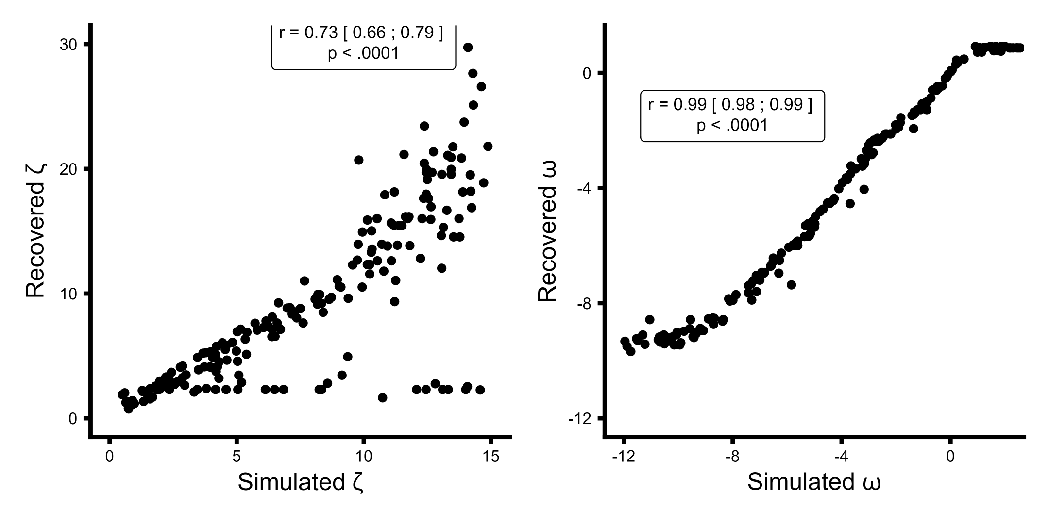

**Parameter recovery analysis of the 2-level Hierarchical Gaussian Filter learning model.** X-axis presenting the simulated values and the y-axis being the estimated / recovered value. Priors for both parameters, and

#### **Fig S2.**

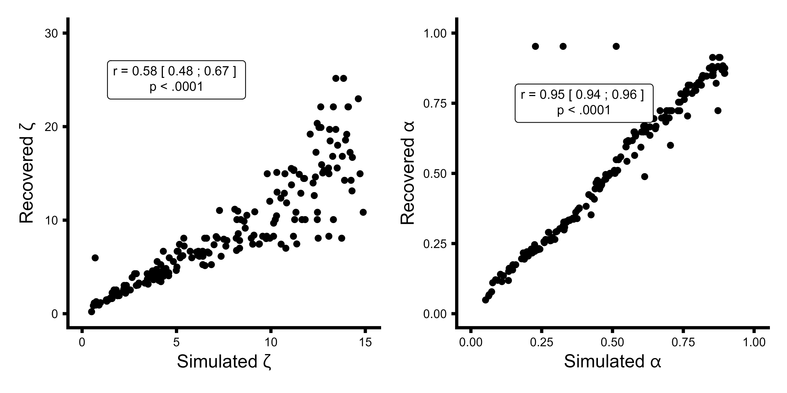

**Parameter recovery analysis of the Rescorla-Wagner learning model.** X-axis presenting the simulated values and the y-axis being the estimated / recovered value. Priors both parameters, and

#### **Fig S3.**

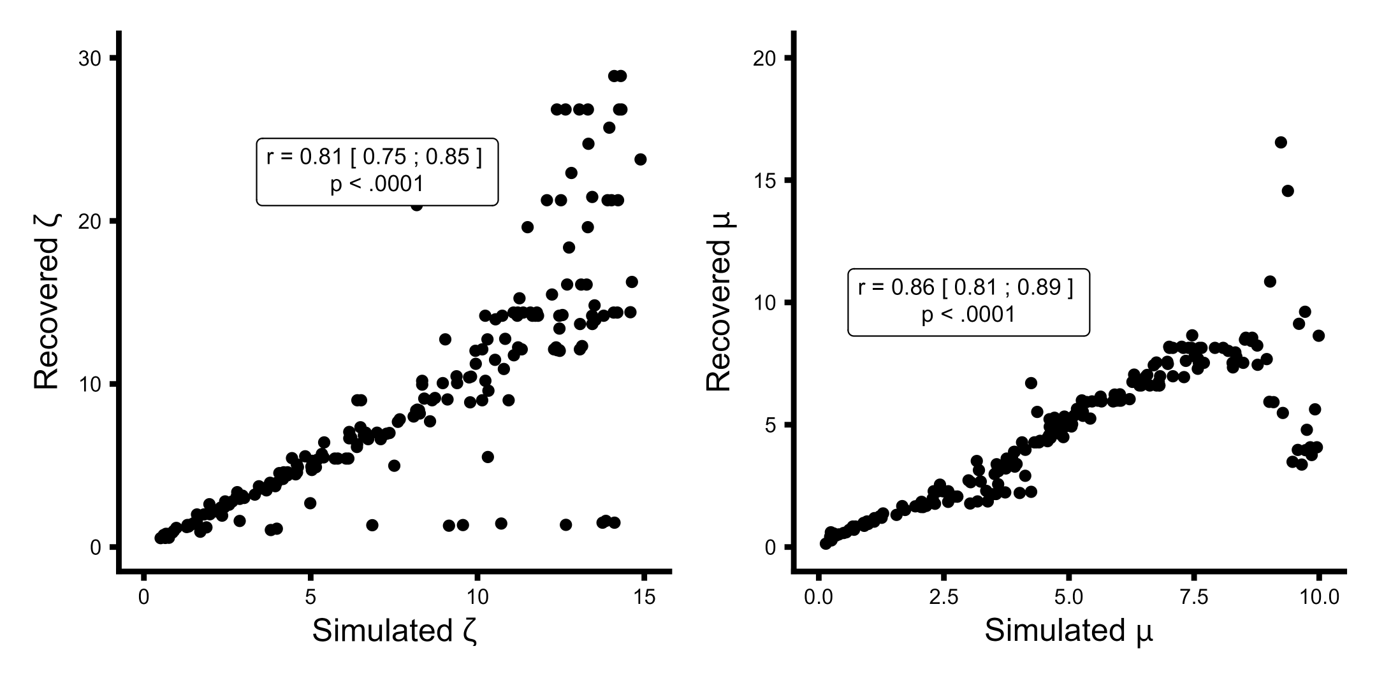

**Parameter recovery analysis of the Sutton K1 learning model.** X-axis presenting the simulated values and the y-axis being the estimated / recovered value. Priors for both parameters, and

#### **Fig S4.**

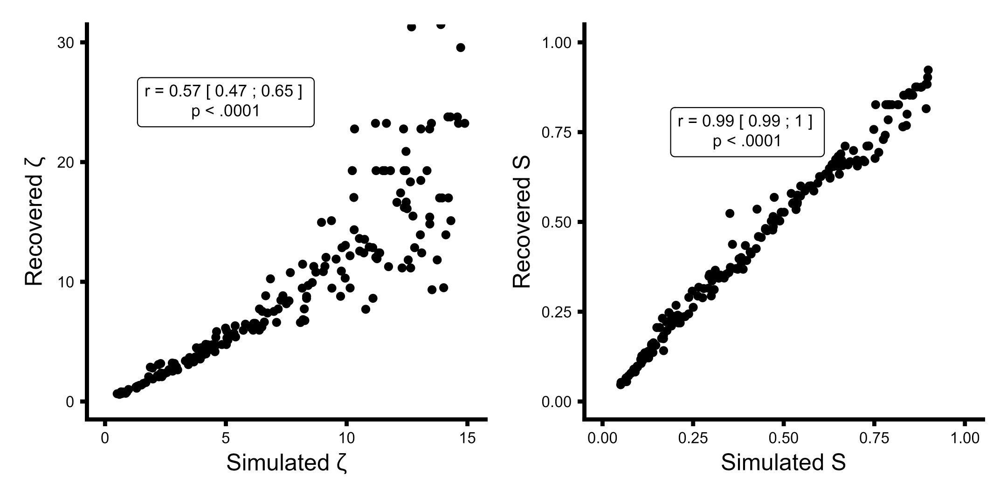

**Parameter recovery analysis of the pearce hall learning model.** X-axis presenting the simulated values and the y-axis being the estimated / recovered value. Priors for both parameters, and .

#### **Fig S5.**

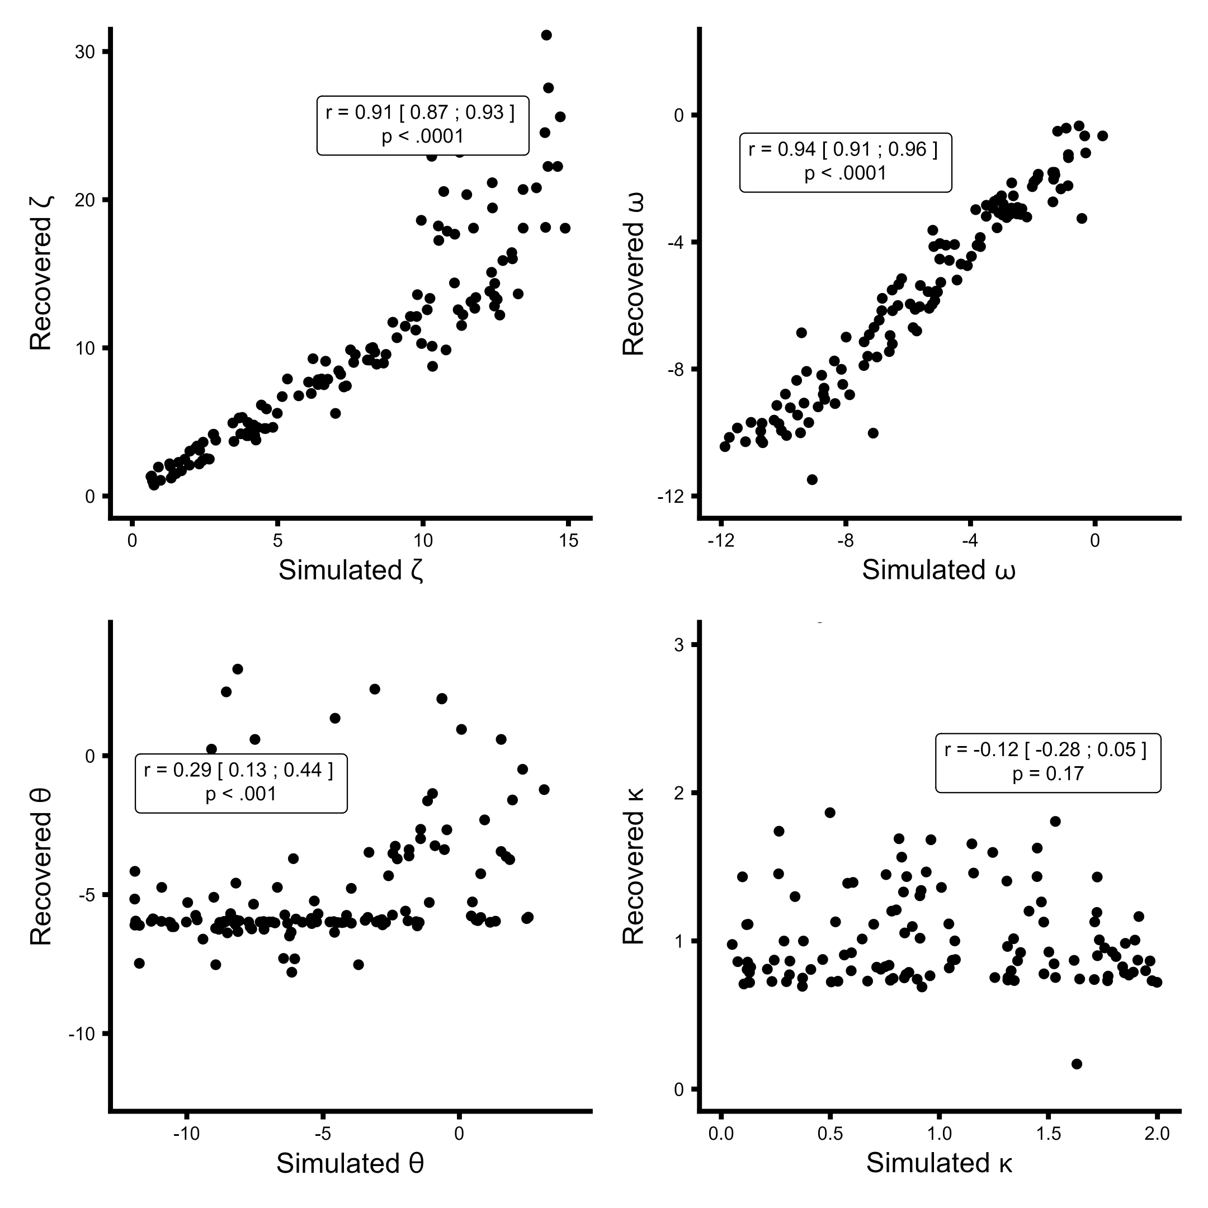

**Parameter recovery analysis of the 3-level Hierarchical Gaussian Filter learning model.** X-axis presenting the simulated values and the y-axis being the estimated / recovered value. Priors for all parameters, and , and . Due to the very poor recovery of the third level parameters i.e.  and the 3-level HGF model was not used in model comparison.

#### **Fig S6.**

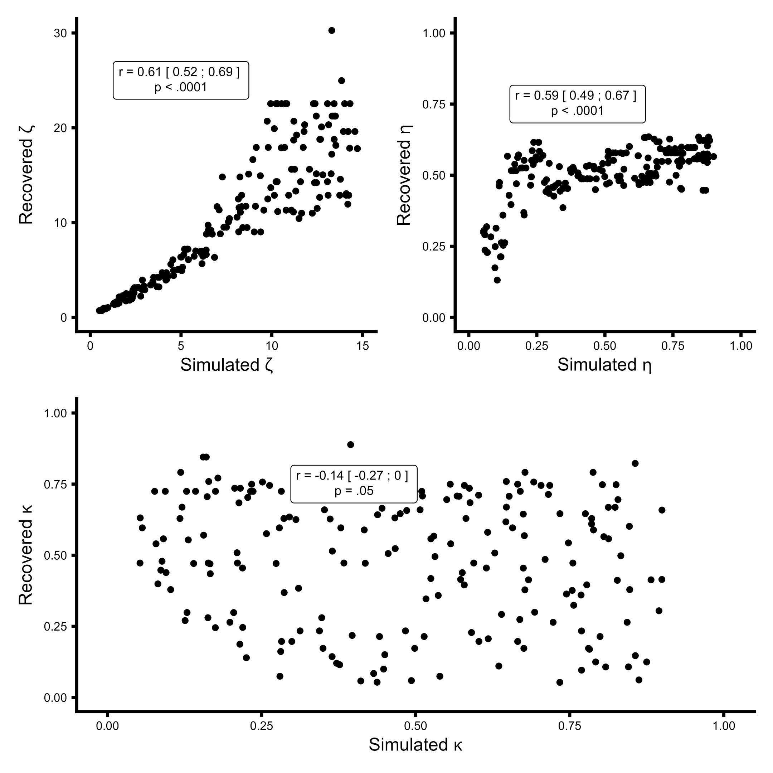

**Parameter recovery analysis of the modified pearce hall learning model.** X-axis presenting the simulated values and the y-axis being the estimated / recovered value. Priors for all parameters, and , . Due to the very poor recovery of the parameters the modified pearce hall model was not used in model comparison.

#### **Fig S7.**

|  | | Simulated |  |  |
| --- | --- | --- | --- | --- |
|  | HGF | RW | Sutton | pearce hall |
| Recovered HGF | 186 | 0 | 35 | 4 |
| Recovered RW | 1 | 195 | 0 | 0 |
| Recovered SU1 | 8 | 0 | 153 | 0 |
| Recovered PH | 5 | 5 | 12 | 196 |

**Model recovery analyses.** Columns are which model was used as the generate model and rows are which model best described the data in log model evidence. As can be seen from the table, the models were distinguishable (i.e., when using a specific generate model, that model would also outperform the other models in most cases), which is evident from the high values of the diagonal of the plot. Priors used for the model recovery: **HGF:** ω ~ N(-4,6) & ζ ~ N(5,2), **Rescorla Wagner:** α ~ N(0,1) & ζ ~ N(5,3), **Sutton k1:** μ ~ N(3,10) & ζ ~ N(5,3) and **Pearce Hall (PH):** S ~ N(0,1) & ζ ~ N(5,3)

#### **Fig S8**

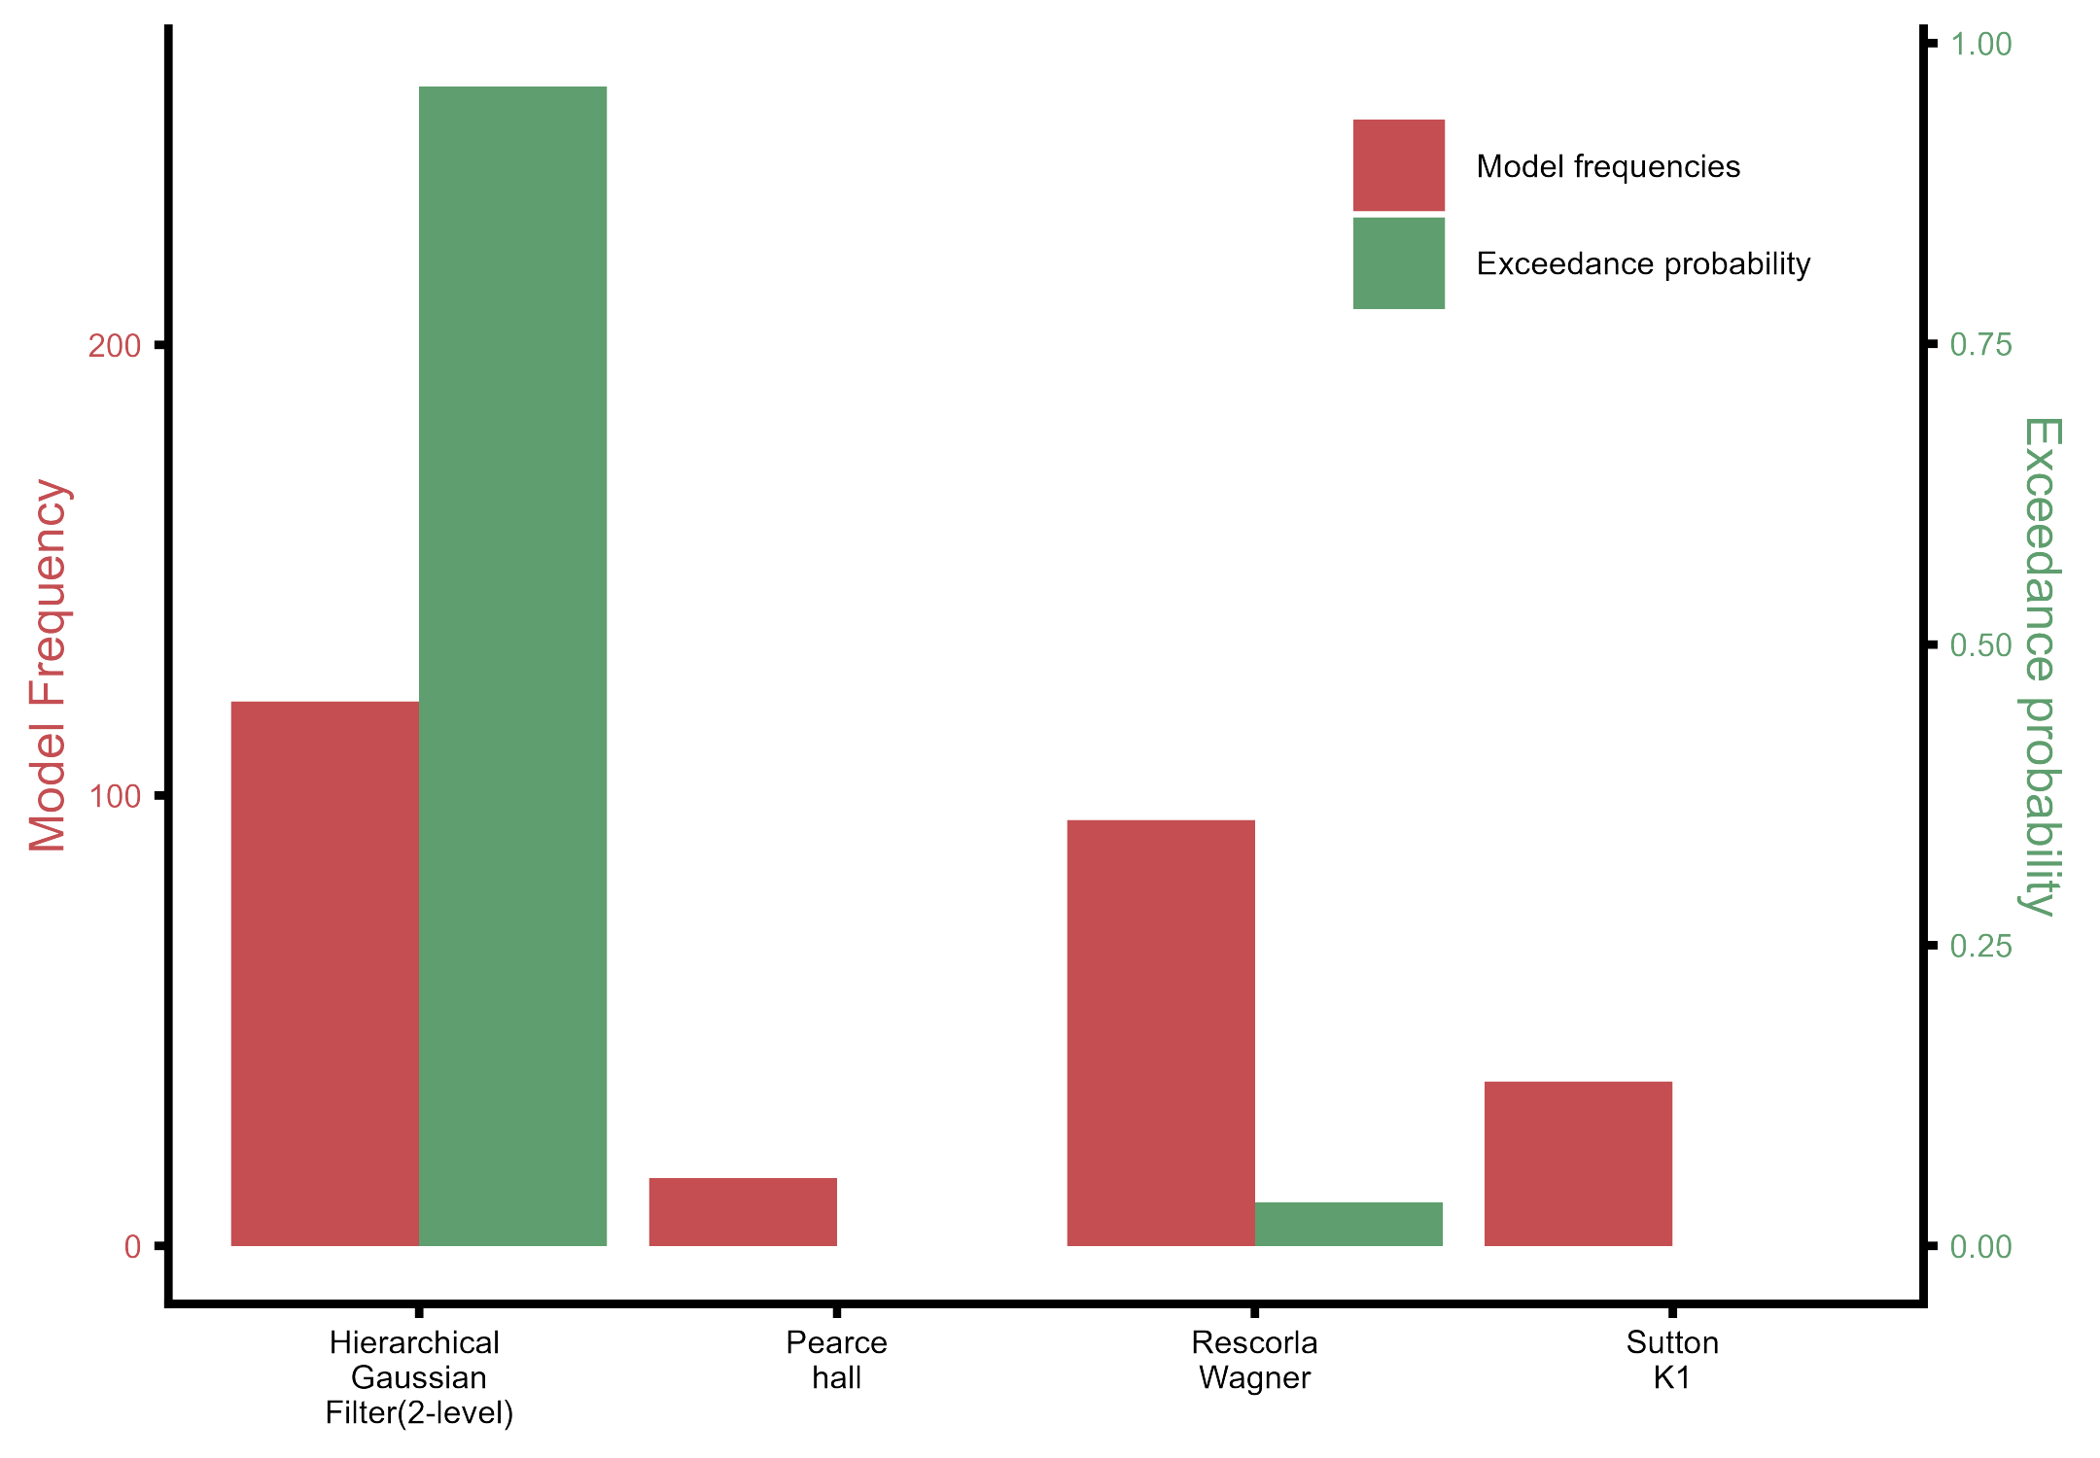

**Model selection analysis using random-effects on log model evidence.** The Hierarchical Gaussian Filter outperformed the fixed learning rate model, Rescorla–Wagner, the variable-learning-rate non-Bayesian model Sutton K1 and the dynamic learning rate based on associability Pearce-Hall.

### **Supplementary Tables**

Table S1. Main effect of expectation on predicting the next stimulus.  
Table S2. Main effect of expectation on Response time of the next stimulus.  
Table S3. Main effect of stimulus on burning ratings.  
Table S4. Main effect of stimulus on cold ratings.  
Table S5. Main effect of stimulus on warm ratings.  
Table S6. Expectation effect of thermosensory ratings.  
Table S7. Effect of perceived TGI given contingency on accuracy on next trial  
Table S8. Effect of perceived TGI given contingency on prediction response time on next trial  
Table S9. Effect of prediction uncertainty on accuracy on current trial  
Table S10. Effect of prediction uncertainty on prediction time on current trial  
Table S11. Effect of belief that the next stimulus will be cold on thermosensory ratings  
Table S12. Effect of estimation uncertainty given stimulus on burning ratings