Disentangling the spinal mechanisms of illusory heat and burning sensations in the Thermal Grill Illusion

2023-07-14

# Abstract

The Thermal Grill Illusion (TGI) is a phenomenon in which the juxtaposition of innocuous warm and cold temperatures elicits a burning sensation, offering a unique window to understand how pain can be perceived in response to harmless stimuli. Much debate has revolved around whether spinal mechanisms are involved in the generation of illusory pain, beyond supraspinal mechanisms. In this study, we investigated the role of the spinal cord in the generation of the TGI, in two independent experiments, involving a total of 80 healthy individuals. We applied heat and cold stimuli on dermatomes, namely areas of skin innervated by a single spinal nerve, mapped onto adjacent or nonadjacent spinal segments. Participants were asked to rate their perceptions of cold, warm, and burning sensations in response to TGI and control stimuli. Our aims were to investigate thermosensory and painful perceptual components of the TGI, as well as spatial features of the TGI that may illuminate processes underlying thermosensory integration in the spinal cord. Our findings revealed that both thermosensory and painful components of TGI perception were modulated similarly, with enhanced warm and burning ratings observed when cold and warm stimuli were confined within the same dermatome. Further, we found no perceptual differences based on the proximal-distal location of the cold stimulus within a single dermatome, but a notable enhancement of the TGI effect when the cold stimulus was associated with a more caudal segmental location along the spinal cord compared to the warm stimulus. These results provide insights into the organisation of the spinal cord in relation to the thermosensory integration and generation of the TGI.

# Introduction

The thermal grill illusion (TGI) is a perceptual phenomenon that challenges conventional understanding of pain perception. It is a sensation of burning heat or pain when harmless cold and warm temperatures are applied to the skin simultaneously (A. D. Craig and Bushnell 1994; A. D. Craig et al. 1996). Despite cold and warm temperatures being individually innocuous, their combination produces a contradictory burning sensation, even so the temperatures are insufficient to activate peripheral nociceptors. The generation of this illusion is thus attributed to central nervous system mechanisms (Fardo et al. 2020). Recent studies have highlighted the involvement of the spinal cord as an initial site contributing to the TGI (Fardo, Finnerup, and Haggard 2018; Harper and Hollins 2017). However, the precise mechanisms underpinning integration of cold and warm thermal afferents in the spinal cord, alongside those responsible for the distinctive burning quality to this illusion, are yet to be elucidated.The TGI is often described as encompassing two distinct perceptual components - an illusion of heat and an illusion of pain Fardo et al. (2020). The illusion of heat, also known as synthetic heat (Fruhstorfer, Harju, and Lindblom 2003; Green 1977, 2002, 2004), refers to non-painful sensations evoked by the thermal grill (Defrin et al. 2008; Kern et al. 2008; 2008; Bouhassira et al. 2005; Adam et al. 2014). The illusion of pain, which is the most recognised aspect of the TGI, is the distinctive burning sensation that accompanies the simultaneous presentation of cold and warm stimuli (A. D. Craig and Bushnell 1994; 1996; Bach et al. 2011). The hallmark of both illusory components is a qualitative change in perception when the cold and warm stimuli are applied concurrently, compared to when they are presented individually. Historically, the thermosensory and painful components of the TGI were explained by distinct spinal and supraspinal mechanisms, respectively. The enhanced perception of heat in TGI was explained by a spinal inhibitory mechanism, drawing from observations in an animal model where simultaneous application of cold and warm temperatures reduced the activity of cold-specific spinal neurons compared to when cold was applied alone (A. D. Craig and Bushnell 1994). Instead, the illusory pain component was ascribed to a disinhibition mechanism at the level of the thalamus, primarily based on the observations of unremitting pain following a thalamic lesion (A. D. Craig and Bushnell 1994; 1998). Recent human studies on TGI provided differing interpretations of the spinal or supraspinal origin of the illusion. Two studies posited that the illusory pain of the TGI depends uniquely on supraspinal mechanisms. This interpretation was based on the observed modulation of the illusion in accordance with a spatiotopic rather than somatotopic representation of the body (Marotta, Ferrè, and Haggard 2015). Further, the illusion remained unaltered during concomitant tactile stimulation, suggesting ineffectiveness of tactile gating - a spinally-mediated process involving inhibition of nociceptive activity by concurrent somatosensory activity (Ferrè et al. 2018). Counter to this perspective, other research endorsed a spinal contribution to the TGI. These studies demonstrated that the illusion varied depending on whether cold and warm stimuli were applied to dermatomes mapped either onto adjacent or non-adjacent spinal segments (Fardo, Finnerup, and Haggard 2018). Participants perceived the stimulation more veridically, consistently with a reduction in TGI perception, when warm or cold stimuli triggered more widespread activity along the spinal cord, corroborating the hypothesis that the spinal cord is an initial site of thermosensory integration underlying TGI. Further support for spinal mechanisms comes from research demonstrating that both noxious heat and the TGI were comparably reduced by conditioned pain modulation in humans. This suggests a similar influence of descending modulation, irrespective of whether the painful sensation was triggered by potentially harmful (noxious) or harmless (innocuous) stimuli (Harper and Hollins 2017). These findings collectively challenge a purely supraspinal hypothesis of the painful component of the TGI and indicate the relevance of spinal mechanisms in the manifestation of both illusory heat and pain within the TGI. In this paper our objective was twofold. Firstly, we directly investigated the hypothesis that thermosensory and burning components of the TGI experience are mediated by spinal mechanisms in humans, by manipulating the location of the stimuli within and across dermatomes. Our past work using a similar manipulation involved measuring the experience of the TGI using a temperature matching task (Fardo, Finnerup, and Haggard 2018), which provides a composite measure of TGI perception, reflecting both thermosensory and burning components. Here, to probe possible distinctions between the two qualitative components of the TGI, we measured subjective indices of TGI perception using three independent visual analog scale (VAS) ratings of perceived cold, warm and burning sensations. Secondly, we investigated spatial order effects associated with the integration of cold and warm sensory information at the dermatome (skin) and segmental (i.,e., spine) levels. At the dermatome level, we used body-related coordinates to define proximal (towards the elbow) and distal (towards the wrist) locations. At the spinal level, we used segment-related coordinates to define more rostral (towards the head) and more caudal (towards the lower back) locations. Given the organisation of the spinal cord along a rostral-caudal axis, where each dermatome is represented across multiple spinal segments through the Lissauer tract, this study aimed to glean indirect insights into the spinal mechanisms underpinning thermosensory integration and the generation of the TGI.

# Results and discussion

The Thermal Grill Illusion (TGI) is characterised by two key phenomena: thermosensory enhancement and illusory pain. Thermosensory enhancement refers to an amplified perception of heat or cold when cold and warm stimuli are simultaneously applied, as opposed to when each stimulus is presented individually or paired with a neutral temperature. Notably, the majority of individuals experience an intensification of heat rather than cold (Fardo et al. 2020). Illusory pain, on the other hand, denotes the perception of a burning sensation elicited by the pairing of warm and cold stimuli, an experience that is largely absent or significantly diminished when each stimulus is presented alone or combined with a neutral temperature. Thus, indicators of a stronger TGI are heightened warm and burning ratings, coupled with reduced cold ratings. To investigate thermosensory and burning components of the TGI, participants received pairs of temperatures on their forearms and were asked to quantify the levels of cold, warmth, and burning they experienced during each stimulation. These stimuli consisted of either cold-warm pairs (TGI stimuli), which potentially evoked an illusion of heat and pain, or control stimuli that involved pairing a cold or a warm stimulus of identical temperature as in the TGI condition with a baseline temperature of 30°C (non-TGI stimuli). All stimulation pairs were presented at a fixed distance on the skin, either within the same dermatome or across dermatomes that mapped onto non-adjacent spinal segments. In doing so, the stimuli elicited cold-related and warm-related neural activity that was either more focal or more widespread along the spinal cord. For each stimulation, participants reported their ratings using three sequential VAS scales ranging from 0, indicating the lack of a sensation, to 100, indicating an extreme sensation. For each instance of stimulation, participants were guided to focus their reporting on the sensations originating from a specific thermode. While the participants were unaware, this location corresponded to either the colder stimulus (Exp. 1) or the warmer stimulus (Exp. 2) of the paired temperatures. VAS ratings were analysed using zero-inflated beta regressions.

## Thermosensory and burning components of TGI perception are spinally mediated

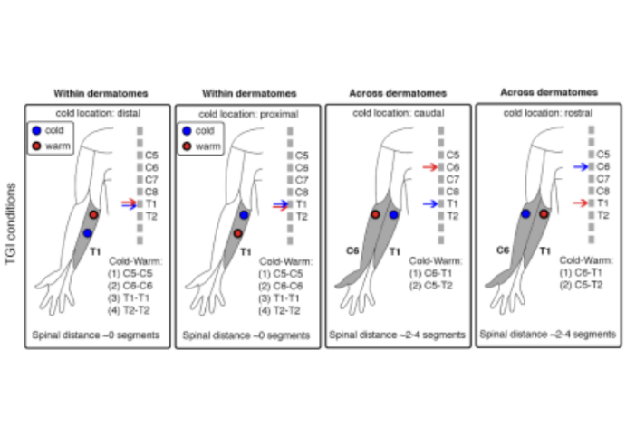

Four experimental conditions depicting an exemplar cold and warm thermode placement within and across dermatomes. Within dermatomes, the relative location of the cold thermode was proximal or distal. Across dermatomes, the relative location of the corresponding spinal segments was rostral or caudal.

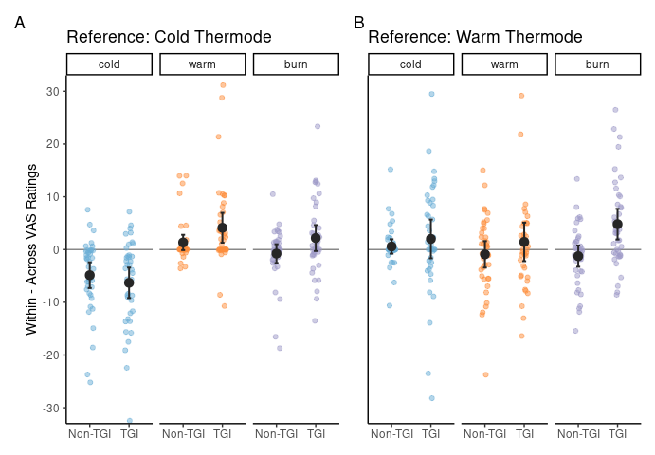

Difference in VAS ratings between within and across dermatome conditions for each type of stimulation (Non-TGI and TGI) in each VAS rating quality (cold, warm and burning). Positive values represent higher ratings within dermatomes, negative values represent higher ratings across dermatomes. Small dots are individual means, large dots are population means for each condition and error bars are 95% confidence intervals.

In keeping with the unique heat and burning features of TGI, our results exhibited a more robust TGI when stimuli were confined within dermatomes compared to when applied across dermatomes, corresponding to non-adjacent spinal segments (Fig. 2). We investigated this difference in subjective cold / warm and burning ratings with a two by two interaction of manipulation (control / TGI) and dermatome (within / across). Results showed that participants reported a stronger reduced experience of cold, when the stimulus was presented within determatomes compared to across in the TGI condition compared to the control condition when the reference thermode was cold (experiment 1), but not when the reference thermode was warm (experiment 2) (Exp. 1: = -0.15, p < .01; Exp. 2: = 0.08, p = 0.28) The percept of warm showed no siginifcant interaction with either thermode as reference (Exp. 1: = -0.03, p = 0.77; Exp. 2: = 0.07, p = 0.16) The percept of burning showed no statistical significant interaction with the reference being cold, but a strong interaction when the reference thermode was warm (Exp.1: = 0.06, p = 0.54; Exp. 2 = 0.21, p < .001) These findings not only corroborated earlier results regarding the segmental organisation of the TGI (Fardo, Finnerup, and Haggard 2018) but also suggested that both the thermosensory enhancement and illusory pain components of the illusion are modulated at the spinal cord level. These findings are consistent with previous results on the modulation of heat and pain ratings of TGI stimuli by conditioned pain modulation (Harper and Hollins 2017). All together these results support the role of spinal processes in the generation of distinct perceptual aspects of the TGI.

## Undetected proximodistal bias in TGI

Previous research demonstrated a phenomenon known as distal inhibition, wherein heat pain ratings tend to increase when a participant evaluates a more distal compared to a more proximal stimulus among two warm stimuli presented on the forearm (A. Quevedo and Coghill 2004; A. S. Quevedo and Coghill 2007). In our study, we sought to investigate whether this effect of distal inhibition would also influence TGI perception within a single dermatome (Fig. 3). We tested this effect with a two way interaction between condition (control / TGI) and the location of the cold thermode when it was placed within dermatome (distal / proximal) Results showed no statistical significant interaction effect for the cold ratings in both experiments: (Exp. 1: = 0.08, p = 0.3; Exp. 2: = -0.10, p = 0.34) Neither a statistically significant effect for warm watings (Exp1: = -0.19, p = 0.14; Exp 2: = 0.00, p = 0.96) and also not for burning ratings (Exp1: = -0.15, p = 0.29; Exp 2: = 0.06, p = 0.49)

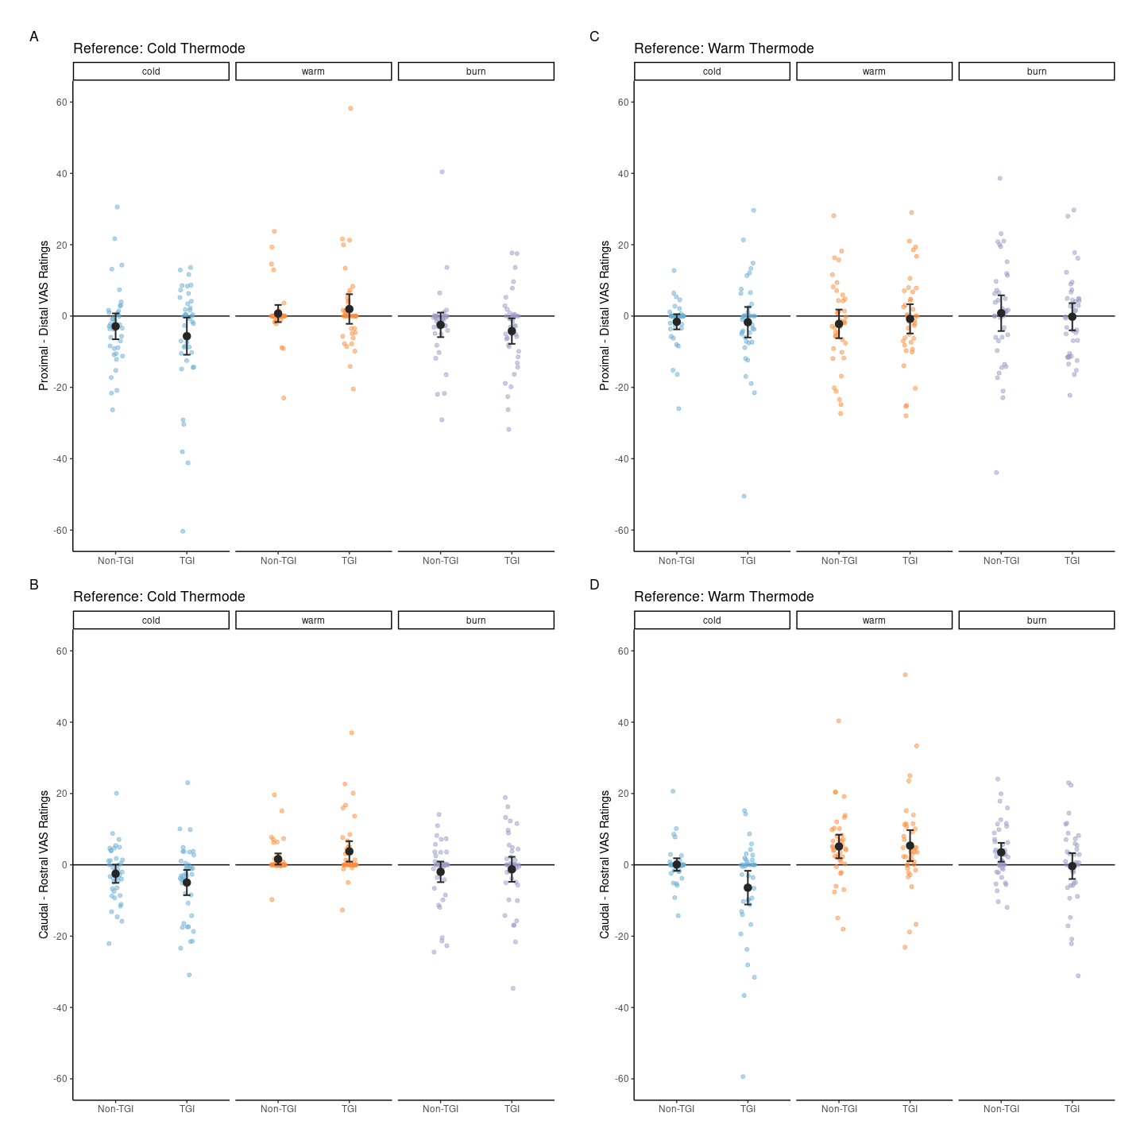

Difference in VAS ratings between the two dermatome conditions. The top panel shows the difference between proximal and distal cold afferent locations (within dermatomes) and the bottom panel shows the difference between rostral and caudal cold afferent locations, relative to warm, across stimulation type (Non-TGI, TGI) and VAS rating quality (cold, warm and burning). Small points show data from each participant, large dots are means across trials for each condition, and error bars show 95% confidence intervals.

## Directional effects in inter-segmental sensory integration

A main objective of this study was assessing spatial order effects along the rostrocaudal axis at the spinal level. We delivered an equal number of trials in which the cold stimulus was applied on a dermatome that mapped more rostrally or caudally compared to the warm or neutral stimuli. Like the previous analysis we investigated this relationship with a two way interaction here with the rostral - caudal axis being investigated. Results showed no statistical significant interaction effect for the cold ratings in the first experiment, but a statistically significant interaction when the reference thermode was warm: (Exp. 1: = -0.10, p = 0.19; Exp. 2: = -0.23, p < .05 ) No statistically significant effect for warm watings (Exp1: = 0.06, p = 0.65; Exp 2: = 0.01, p = 0.94) and also not for burning ratings (Exp1: = -0.05, p = 0.61; Exp 2: = -0.14, p = 0.1)

The results indicated a notably enhanced TGI effect when the cold stimulus induced more caudal activity within the spinal cord, as depicted in Figure 3. These findings were consistent across both experiments for thermosensory ratings, albeit with minor deviations that corresponded with the particular stimulation quality being assessed. The observed enhancement of warmth perception in Experiment 2 could be ascribed to the participants’ assessment of the warmer thermode as opposed to the colder one of Experiment 1. For burning ratings, significant results were seen in Experiment 2, but not in Experiment 1. One possible reason for this discrepancy could be the relatively low power in Experiment 1, as the power analysis was specifically focused on thermosensory ratings. Alternatively, assessing the warmer thermode might be a more accurate method for measuring TGI perception.

## Spinal organisation and TGI perception

The complexities of spinal neuroanatomy provide insightful perspectives concerning the two main findings of these experiments: (1) enhanced heat and burning sensations when cold-warm thermosensory integration takes place more focally within the spinal cord, and (2) discernible directional inter-segmental effects when distinct cold and warm stimuli elicited broader activity along the spinal cord. Small primary afferents, responsible for mediating temperature and pain sensations, split into ascending and descending branches that cover one to two segments before they enter the dorsal horn (Kerr 1975; Lamotte 1977). This pattern forms the Lissauer’s tract, a structure hypothesised to regulate sensory transmission to the dorsal horn and influence spinal receptive field size (Wall, Lidierth, and Hillman 1999).

Additionally, the endings of small primary afferents within the superficial laminae of the dorsal horn form synapses with both propriospinal neurons and projection neurons that target supraspinal structures known to significantly influence TGI perception (A. D. Craig et al. 1996; Lindstedt et al. 2011; Leung et al. 2014 + any other neuroimaging studies of the TGI).

Evidence from animal studies shows that propriospinal neurons, confined within the spinal cord, exhibit bidirectional collateral branches along the rostrocaudal plane (Saywell et al. 2011; Skinner et al. 1989). These connections shape the network of interneurons that modulates sensory information delivered to the dorsal horn (Todd 2010; Peirs and Seal 2016).

Our finding of enhanced TGI perception with cold-warm stimuli applied within dermatomes might reflect the combined effects of the Lissauer’s tract’s short rostrocaudal span (comprising one to two segments, consistent with a single dermatome’s boundary) and the characteristics of spinal circuits. These circuits, created by propriospinal neurons, may promote sensory integration within a spinal receptive field while simultaneously inhibiting activity in adjacent fields. This mechanism aligns with the concept of lateral inhibition, a ubiquitous process in sensory processing seen across both the peripheral and central nervous systems, and multiple sensory modalities, including thermoception and nociception (Békésy 1962; A. S. Quevedo et al. 2017; Adamczyk et al. 2021). Further, our observation that spatial factors, such as the more caudal localisation of cold activity relative to warm activity in the spinal cord, influences TGI perception, suggests possible neuroanatomical and functional asymmetries. This could mean a greater number of ascending fibres than descending fibres carrying thermosensory information in the Lissauer’s tract, an uneven distribution of ascending and descending collaterals of propriospinal neurons (Anatomical Hypotheses), or varying effects of inter-segmental inhibition along the rostrocaudal axis (Functional Hypothesis). Additional research is needed to illuminate the specific anatomical and functional features of the spinal cord that resulted in the observed effects of this study.

# Conclusion

Illusions in the thermo-nociceptive system can be leveraged to improve our understanding of mechanisms contributing to pain perception. Here, we presented results supporting the notion that the spinal cord plays a crucial role in the integration and processing of thermal information, contributing to the perception of both thermosensory enhancement and the illusory pain within the TGI. Additionally, we reported findings on directional inter-segmental effects in spinal integration underlying TGI. Further research is needed to elucidate the neuroanatomical and functional properties of the spinal cord, as well as the intricate interplay between supraspinal and spinal processes, that give rise to TGI perception.

# Methods

## Participants

The study entailed two separate experiments, collectively involving 80 healthy volunteers. The sample consisted of 27 females and 13 males, mean age = 25.38 years old (SD = 4.67, range = 18 - 36) in Experiment 1, and 25 females and 14 males and 1 non-binary (Female at birth), mean age = 25.73 years old (SD = 4.12, range = 21 - 39), in Experiment 2. The research methodology complied with the principles set forth in the Declaration of Helsinki and received ethical approval from the Institutional Review Board (IRB) at the Danish Neuroscience Center, Aarhus University, Denmark. Prior to commencing the study, all participants were fully informed about the procedures and provided their voluntary consent.

## Stimuli and procedure

All thermal stimuli were delivered using two NTE-3 Thermal Sensitivity Testers (PhysiTemp Instruments LLC) controlled by PhysiTemp NTE-3 software (version 5.4b). The procedure involved measurements of heat and cold pain thresholds, calibration of cold-warm temperature pairs eliciting TGI, and an experimental task where TGI and non-TGI stimuli were applied on dermatomes that mapped onto adjacent or non-adjacent spinal segments. To measure cold and heat pain thresholds, we gradually adjusted the temperature of one thermode until the participant indicated an experience of pain by pressing a stop button or reached the maximum temperature cut-offs of 5ºC or 50ºC. We calibrated TGI stimuli by identifying a cold-warm temperature pair based on specific criteria: (1) consistently eliciting a burning sensation of at least 15 on a scale ranging from 0 to 100, (2) consistently avoiding a burning sensation (less than 15) when the cold-neutral (Exp. 1) or warm-neutral (Exp. 2) stimuli were presented, (3) both cold and warm temperatures falling within the innocuous range based on individual cold and heat pain thresholds. For pain threshold measurements and TGI calibration, we positioned the probes within a single dermatome. To address our experimental questions, we presented the calibrated TGI stimuli, as well as cold-neutral (Exp. 1) or warm-neutral (Exp. 2) non-TGI stimuli using two thermodes. In non-TGI stimuli the cold or warm temperatures were set to match the temperature used for TGI stimulation, but paired with a neutral temperature set at 30ºC. The two thermodes were positioned on the internal surface of either forearm, with a constant spacing value between 4 and 5 cm in each direction, depending on the participant’s forearm size. The positioning of the thermodes was either within the same dermatome (i.e., C6 and T1) or across dermatomes mapped onto non-adjacent spinal segments (i.e. C6 - T1). Further, we manipulated the spatial arrangement of the temperature pairs, by systematically presenting an equal number of trials where the cold thermode was applied on a proximal or distal location within a dermatome, or was applied on a dermatome that mapped onto a rostral or caudal segment along the spinal cord. We based the demarcation of the dermatome boundaries on the American Spinal Injury Association (ASIA) map (Fardo et al., 2018) and positioned the thermodes in relation to standard anatomical landmarks. Proximo-distal coordinates referred to locations on the skin closer to the elbow or the wrist, whereas rostral-caudal coordinates referred to spinal segments closer to the head or the lower back. The possible spatial arrangements corresponded to the four conditions depicted in Figure 1. The order of the stimuli (TGI vs. non-TGI), the dermatome condition (within vs. across) and the relative placement of the colder temperature (proximal vs. distal or rostral vs. caudal) were pseudo-randomised and counterbalanced between participants. During each trial, the experimenter positioned two thermodes, mounted on a stand using two independent clamps, on the participant’s skin for 10 seconds. An auditory cue (300Hz, 100ms) indicated the end of the stimulation period, after which the experimenter removed the thermodes from the participant’s skin. Participants then rated the most intense cold, warm or burning sensation they perceived during the stimulation period using three separated computerised VAS scales. VAS scales were presented one at a time on a computer screen and appeared as a horizontal line, anchored at 0, representing no sensation (e.g., no burning), and 100, signifying an extreme sensation (e.g., extreme burning). The order of the three VAS scales was randomised across trials. For each scale, participants provided their responses using the arrow keys on a keyboard and rated the intensity of their sensations from a specific location (labeled ‘A’ or ‘B’), based on the experimenter’s instruction. Unbeknown to the participant, this location systematically corresponded to either the colder temperature (Exp. 1) or the warmer temperature (Exp. 2). Participants had max 8 seconds to provide each rating, and if they did not complete a rating within the allowed timeframe, the trial was repeated. Following the completion of the last of the three VAS ratings, we presented a 200 ms fixation dot. Each thermode configuration was tested three consecutive times, on three different skin locations. An auditory tone of 500Hz lasting 100ms was played to indicate to the experimenter when to rearrange the thermode configuration to stimulate different dermatomes depending on a pseudo-randomisation order. Each of the four experimental conditions was repeated 12 times, with both the right and left forearms stimulated, and a minimum of five trials between the re-stimulation of the same skin location. This ensured that the same skin locations were not stimulated consecutively to minimise carry-over effects. Experiments 1 and 2 were conducted in two independent groups of participants and followed exactly the same procedure except for two elements. In Experiment 1, participants rated the sensations localised underneath the colder thermode, and the non-TGI stimuli corresponded to cold-neutral pairs. In Experiment 2, participants rated the sensations localised underneath the warmer thermode, and the non-TGI stimuli corresponded to warm-neutral pairs.

## Sample size

An initial pilot study informed the pre-registered calculation of the sample size. To test the directional TGI hypothesis with 95% power and detect an effect size of .12 or greater, we determined that we needed a minimum number of 32 TGI-responsive participants. We defined TGI-responders as those individuals for whom the median burning ratings for TGI stimuli significantly exceeded 0. Non-responders were individuals that did not meet this criterion when tested with the max cold-warm temperatures allowed in the experiment. The predefined cut-off for TGI stimulation was (xx-xx). In Experiment 1, recruitment continued until we achieved the target of 32 TGI-responsive participants. We verified this criterion every 10 participants, resulting in a total sample size of 40 participants. In Experiment 2, we stopped recruitment once we collected data from 40 participants. This decision was based on meeting both required criteria: (1) matching the sample size of Exp. 1 for consistency, and (2) achieving the minimum requirement of 32 TGI-responsive participants as determined by the power analysis.

## Data analyses

We re-scaled data from cold, warm and burning VAS ratings from their original values to a range of 0 to 1. Following re-scaling, we applied zero-inflated mixed-effects beta regression models separately for each set of VAS ratings. In these models, we incorporated three fixed effects. These included the type of stimulation (non-TGI vs. TGI), the dermatome condition (within the same dermatome vs. across different dermatomes) and the spatial positioning of the cold or neutral thermode (proximal vs. distal within dermatomes; rostral vs. caudal across dermatomes). These choices allowed us to assess the individual and interactive effects of these three factors on VAS ratings. Further, we added random intercepts to our models to account for between-subject variability and the effects of repeated measures. The variables introduced as random intercepts included the participant ID, the counterbalancing order and the trial number. The choices of the zero-inflated approach and the use of beta regressions were necessitated by the specific distribution of VAS ratings. The beta distribution is suitable for modelling VAS rating data, as they are proportional in nature. Additionally, the zero-inflation was needed due to the presence of an excess number of zero values in specific ratings and conditions. Specifically, we anticipated an overrepresentation of zero values for thermosensory ratings that were counterfactual to the objective stimulation quality (i.e., cold ratings of warm stimuli and warm ratings of cold stimuli) and burning ratings of non-TGI stimuli. The latter stimuli were designed to not elicit an illusion or trigger a weaker illusion as compared to the TGI stimuli. We carried out the statistical analyses using the ‘glmmTMB’ package in R (version 1.1.7), and statistical significance was set at p < .05. The experimental procedure, power analyses to determine sample size and statistical approach were preregistered for both [Experiment 1](https://osf.io/4xcn5/) and [Experiment 2](https://osf.io/dhg8u/). All data and code for the analysis are available in the [github repository](https://github.com/Body-Pain-Perception-Lab/tgi-spinal/tree/Markdown-manuscript), ensuring the reproducibility of our findings.

# Authors contributions

Author contributions listed alphabetically according to [CRediT taxonomy](https://credit.niso.org):

* Conceptualization: DEC, JFE, FF, PH, AGM.
* Data curation: JEF, AGM.
* Formal analysis: JFE, FF, AGM.
* Funding acquisition: FF.
* Investigation: DEC, JFE, AGM.
* Methodology: DEC, JFE, FF, AGM, AVS.
* Project administration: FF, AGM.
* Resources: FF, AGM.
* Software: JFE, FF, AGM.
* Supervision: FF, AGM.
* Visualization: FF, AGM.
* Writing – original draft: FF, AGM.
* Writing – review & editing: FF, AGM. (+ others who will provide feedback)

# Acknowledgements

We would like to thank XXX for their help with participant recruitment and data collection. This study was supported by a European Research Council Starting Grant (ERC-2020-StG-948788).

# References

Adam, Frédéric, Pascal Alfonsi, Delphine Kern, and Didier Bouhassira. 2014. “Relationships Between the Paradoxical Painful and Nonpainful Sensations Induced by a Thermal Grill.” *PAIN* 155 (12): 2612. <https://doi.org/10.1016/j.pain.2014.09.026>.

Adamczyk, Wacław M., Tibor M. Szikszay, Tiffany Kung, Gabriela F. Carvalho, and Kerstin Luedtke. 2021. “Not as "Blurred" as Expected? Acuity and Spatial Summation in the Pain System.” *Pain* 162 (3): 794–802. <https://doi.org/10.1097/j.pain.0000000000002069>.

Bach, Patrick, Susanne Becker, Dieter Kleinböhl, and Rupert Hölzl. 2011. “The Thermal Grill Illusion and What Is Painful about It.” *Neuroscience Letters* 505 (1): 31–35. <https://doi.org/10.1016/j.neulet.2011.09.061>.

Békésy, G. V. 1962. “Lateral Inhibition of Heat Sensations on the Skin.” *Journal of Applied Physiology* 17 (6): 1003–8. <https://doi.org/10.1152/jappl.1962.17.6.1003>.

Bouhassira, Didier, Delphine Kern, Jean Rouaud, Emilie Pelle-Lancien, and Françoise Morain. 2005. “Investigation of the Paradoxical Painful Sensation (‘Illusion of Pain’) Produced by a Thermal Grill.” *PAIN* 114 (1): 160. <https://doi.org/10.1016/j.pain.2004.12.014>.

Craig, A. D. (Bud). 1998. “A New Version of the Thalamic Disinhibition Hypothesis of Central Pain.” *Pain Forum* 7 (1): 1–14. <https://doi.org/10.1016/S1082-3174(98)70004-2>.

Craig, A. D., and M. C. Bushnell. 1994. “The Thermal Grill Illusion: Unmasking the Burn of Cold Pain.” *Science (New York, N.Y.)* 265 (5169): 252–55. <https://doi.org/10.1126/science.8023144>.

Craig, A. D., E. M. Reiman, A. Evans, and M. C. Bushnell. 1996. “Functional Imaging of an Illusion of Pain.” *Nature* 384 (6606): 258–60. <https://doi.org/10.1038/384258a0>.

Defrin, Ruth, Anat Benstein-Sheraizin, Adva Bezalel, Ofira Mantzur, and Lars Arendt-Nielsen. 2008. “The Spatial Characteristics of the Painful Thermal Grill Illusion☆.” *PAIN* 138 (3): 577. <https://doi.org/10.1016/j.pain.2008.02.012>.

Fardo, Francesca, Brianna Beck, Micah Allen, and Nanna Brix Finnerup. 2020. “Beyond Labeled Lines: A Population Coding Account of the Thermal Grill Illusion.” *Neuroscience and Biobehavioral Reviews* 108 (January): 472–79. <https://doi.org/10.1016/j.neubiorev.2019.11.017>.

Fardo, Francesca, Nanna Brix Finnerup, and Patrick Haggard. 2018. “Organization of the Thermal Grill Illusion by Spinal Segments.” *Annals of Neurology* 84 (3): 463–72. <https://doi.org/10.1002/ana.25307>.

Ferrè, E. R., G. D. Iannetti, J. A. van Dijk, and P. Haggard. 2018. “Ineffectiveness of Tactile Gating Shows Cortical Basis of Nociceptive Signaling in the Thermal Grill Illusion.” *Scientific Reports* 8 (April): 6584. <https://doi.org/10.1038/s41598-018-24635-1>.

Fruhstorfer, Heinrich, Eva-Liz Harju, and Ulf F. Lindblom. 2003. “The Significance of A-Delta and C Fibres for the Perception of Synthetic Heat.” *European Journal of Pain (London, England)* 7 (1): 63–71. <https://doi.org/10.1016/s1090-3801(02)00056-3>.

Green, Barry G. 1977. “Localization of Thermal Sensation: An Illusion and Synthetic Heat.” *Perception & Psychophysics* 22 (4): 331–37. <https://doi.org/10.3758/BF03199698>.

———. 2002. “Synthetic Heat at Mild Temperatures.” *Somatosensory & Motor Research* 19 (2): 130–38. <https://doi.org/10.1080/08990220220220131524>.

———. 2004. “Temperature Perception and Nociception.” *Journal of Neurobiology* 61 (1): 13–29. <https://doi.org/10.1002/neu.20081>.

Harper, D. E., and M. Hollins. 2017. “Conditioned Pain Modulation Dampens the Thermal Grill Illusion.” *European Journal of Pain (London, England)* 21 (9): 1591–601. <https://doi.org/10.1002/ejp.1060>.

Kern, Delphine, Emilie Pelle-lancien, Virginie Luce, and Didier Bouhassira. 2008. “Pharmacological Dissection of the Paradoxical Pain Induced by a Thermal Grill.” *PAIN* 135 (3): 291. <https://doi.org/10.1016/j.pain.2007.12.001>.

Kern, Delphine, Frédéric Plantevin, and Didier Bouhassira. 2008. “Effects of Morphine on the Experimental Illusion of Pain Produced by a Thermal Grill.” *PAIN* 139 (3): 653. <https://doi.org/10.1016/j.pain.2008.07.001>.

Kerr, Frederick W. L. 1975. “Neuroanatomical Substrates of Nociception in the Spinal Cord.” *PAIN* 1 (4): 325. <https://doi.org/10.1016/0304-3959(75)90072-X>.

Lamotte, Carole. 1977. “Distribution of the Tract of Lissauer and the Dorsal Root Fibers in the Primate Spinal Cord.” *Journal of Comparative Neurology* 172 (3): 529–61. <https://doi.org/10.1002/cne.901720308>.

Leung, Albert, Shivshil Shukla, Eric Li, Jeng-Ren Duann, and Tony Yaksh. 2014. “Supraspinal Characterization of the Thermal Grill Illusion with fMRI.” *Molecular Pain* 10 (January): 1744-8069-10-18. <https://doi.org/10.1186/1744-8069-10-18>.

Lindstedt, Fredrik, Bo Johansson, Sofia Martinsen, Eva Kosek, Peter Fransson, and Martin Ingvar. 2011. “Evidence for Thalamic Involvement in the Thermal Grill Illusion: An FMRI Study.” *PloS One* 6 (11): e27075. <https://doi.org/10.1371/journal.pone.0027075>.

Marotta, Angela, Elisa Raffaella Ferrè, and Patrick Haggard. 2015. “Transforming the Thermal Grill Effect by Crossing the Fingers.” *Current Biology* 25 (8): 1069–73. <https://doi.org/10.1016/j.cub.2015.02.055>.

Peirs, Cedric, and Rebecca P. Seal. 2016. “Neural Circuits for Pain: Recent Advances and Current Views.” *Science* 354 (6312): 578–84. <https://doi.org/10.1126/science.aaf8933>.

Quevedo, A., and R. Coghill. 2004. “Psychophysics/Hyperalgesia: Spatial Interactions Between Multiple Painful Stimuli.” *The Journal of Pain* 5 (3): S32. <https://doi.org/10.1016/j.jpain.2004.02.094>.

Quevedo, Alexandre S., and Robert C. Coghill. 2007. “An Illusion of Proximal Radiation of Pain Due to Distally Directed Inhibition.” *The Journal of Pain* 8 (3): 280–86. <https://doi.org/10.1016/j.jpain.2006.09.003>.

Quevedo, Alexandre S., Carsten Dahl Mørch, Ole K. Andersen, and Robert C. Coghill. 2017. “Lateral Inhibition During Nociceptive Processing.” *PAIN* 158 (6): 1046. <https://doi.org/10.1097/j.pain.0000000000000876>.

Saywell, S. A., T. W. Ford, C. F. Meehan, A. J. Todd, and P. A. Kirkwood. 2011. “Electrophysiological and Morphological Characterization of Propriospinal Interneurons in the Thoracic Spinal Cord.” *Journal of Neurophysiology* 105 (2): 806–26. <https://doi.org/10.1152/jn.00738.2010>.

Skinner, R. D., R. Nelson, M. Griebel, and E. Garcia-Rill. 1989. “Ascending Projections of Long Descending Propriospinal Tract (LDPT) Neurons.” *Brain Research Bulletin* 22 (2): 253–58. <https://doi.org/10.1016/0361-9230(89)90050-6>.

Todd, Andrew J. 2010. “Neuronal Circuitry for Pain Processing in the Dorsal Horn.” *Nature Reviews. Neuroscience* 11 (12): 823–36. <https://doi.org/10.1038/nrn2947>.

Wall, Patrick D., Malcolm Lidierth, and Peter Hillman. 1999. “Brief and Prolonged Effects of Lissauer Tract Stimulation on Dorsal Horn Cells.” *PAIN®* 83 (3): 579–89. <https://doi.org/10.1016/S0304-3959(99)00170-0>.