**International School**

**Capstone Project 2**

CMU-SE 451

**Architecture Design**

**Version 1.1**

**Date: 22nd May, 2021**

**Food Care**

**Submitted by**

Huynh Dac Vinh  
 Tran Quoc Trung

Ton That Minh Huy

Dang Van Duan

**Approved by**

**Proposal Review Panel Representative:**

NameSignature Date

**Capstone Project 2-Mentor:**

Name Signature Date

**Dang Viet Hung**

**PROJECT INFORMATION**

|  |  |  |  |
| --- | --- | --- | --- |
| **Project acronym** | FC | | |
| **Project Title** | Food Care | | |
| **Start Date** | 01 Mar, 2021 | **End Date** | 25 May, 2021 |
| **Lead Institution** | International School, Duy Tan University | | |
| **Project Mentor** | Ph.D Hung, Dang Viet | | |
| **Scrum master / Project Leader & contact details** | Vinh, Huynh Dac  Email: dacvinh98@gmail.com  Tel: 0347191925 | | |
| **Partner Organization** |  | | |
| **Project Web URL** |  | | |
| **Team members** | Name | Email | Tel |
| 1 | Vinh, Huynh Dac | dacvinh98@gmail.com | 0347191925 |
| 2 | Trung, Tran Quoc | quoctrung.tran210@gmail.com | 0935420530 |
| 3 | Huy, Ton That Minh | tonthatminhh@gmail.com | 0935432561 |
| 4 | Duan, Dang Van | dangvanduan755@gmail.com | 0769710126 |

REVISION HISTORY

|  |  |  |  |  |
| --- | --- | --- | --- | --- |
| **Version** | **Date** | **Comments** | **Author** | **Approval** |
| 1.0 | 02/03/2021 | Initial Release | C2SE.18 team |  |
| 1.1 | 22/05/2021 | Final | Vinh, Huynh Dac |  |
|  |  |  |  |  |

**Document Approval**

The following signatures are required for approval of this document

|  |  |  |
| --- | --- | --- |
| **Mentor** | Dang Viet Hung | Date: |
| **Scrum Master** | Huynh Dac Vinh | Date: |
| **Product Owner** | Tran Quoc Trung | Date: |
| **Team Member** | Ton That Minh Huy | Date: |
| **Team Member** | Dang Van Duan | Date: |

**Contents**

**1. Introduction** 2

**1.1. Purpose** 2

**2. Project Overview** 2

**2.1. Business needs** 2

**2.2. Proposed solution** 2

**2.3. Business drivers** 2

**2.4. Project goal** 2

**3. Architectural drivers** 3

**3.1. Functional requirements** 3

**3.2. Business constraints** 15

**3.3. Technical constraints** 15

**3.4. Quality Attribute** 16

**3.5. Context Diagram** 18

**4. C&C view** 19

**5. Module view** 21

**6. Allocation view** 23

# **1. Introduction**

## **1.1. Purpose**

This document will cover the following information:

- Brief description of the project: project overview, business goals, general constrains about technical and business problems.

- Architectural drivers: functional requirements, quality attributes and constraints.

- Architecture presented by various architecture view types: Component and Connect tor view, Module view, Allocation view

# **2. Project Overview**

## **2.1. Business needs**

- Helping users to access Food Care system easily.

- Helping users to manage their nutrition in the most convenient way.

- Help users find effective, effective diets that are safe for themselves quickly.

- Help users to have reasonable suggestions from the system

- Help users experience the most effective system.

## **2.2. Proposed solution**

C2SE.18-_Proposal_v1.0

## **2.3. Business drivers**

Based on the business needs and business solution our team decides to make a Food Care.

## **2.4. Project goal**

- The goal of project is to build the Food Care:

- Access to the system, enter information about yourself according to the required system and get a recommendation of a diet suitable for you.

- Provide information to the user about the right nutrition and diet.

- Search for new dishes or diets.

- Users can build their own dining menu.

- Ensuring the safety and effectiveness of each diet for each participant.

# **3. Architectural drivers**

## **3.1. Functional requirements**

Ref to User story

**Use Case Entities**

|  |  |
| --- | --- |
| ID | E01 |
| Title | User |
| Description | People who use the system for building their diet |
| Provides Assumptions | Provide personal information |
| Requires Assumptions | Already have an account |
| Identified Use Cases | US1-US22 |

|  |  |
| --- | --- |
| ID | E02 |
| Title | Admin |
| Description | Admin who is the system administrator |
| Provides Assumptions | Admin is the management of the entire system |
| Requires Assumptions | Already have an account |
| Identified Use Cases | US23-US27 |

**Operational Use Cases**

|  |  |
| --- | --- |
| ID | UC01 |
| Title | Login |
| Description | Click on Login to access into system by their account |
| Entities Involved | E01: User, E03: Admin |
| Preconditions | 1. Connected to the network  2. You must have an account |
| Primary Flow | 1. User clicks [Login] button on Bar menu to open login form. 2. User inputs data value on [Email or Phone Number] textbox and [Password] textbox or user can login with [Facebook/Twitter/Google].  3. User clicks on [Login] button.  4. System validates [Email or Phone Number] and password.  5. User visits on Home Page. |
| Post conditions | After successful login, the user will have access to the homepage |
| Alternate Flows | - In step 4 of the Primary Flow, if [Email or Phone Number] or password is incorrect.  1. The system will prompt user “input wrong email, phone number or password”.  2. User clicks ok to continue. If [Email or Phone Number] and password are correct, continue to step 5. |

|  |  |
| --- | --- |
| ID | UC02 |
| Title | Logout |
| Description | Click on Logout to exit website |
| Entities Involved | E01: User, E03: Admin |
| Preconditions | Successfully logged in the website |
| Primary Flow | 1. User click [Logout] button on [Account Setting] menu bar.  2. System checks and closes account. Return Home page. |
| Post conditions |  |
| Alternate Flows | In step 2 of the Primary Flow, if the system has a problem, it will show error messages. |

|  |  |
| --- | --- |
| ID | UC03 |
| Title | Register |
| Description | User can register as a Seller and Buyer |
| Entities Involved | E01: User |
| Preconditions | Connected to network |
| Primary Flow | 1. Access the website  2. Registration function selection  3. User enter personal information  4. The system will check information |
| Post conditions | In step 4 on primary flow: If the system is valid, you have successfully registered |
| Alternate Flows | If the test system is not valid, you must enter the information from the beginning. |

|  |  |
| --- | --- |
| ID | UC04 |
| Title | Reset password |
| Description | Users recover the password for their account, so that they can access their account in case they forget their password. |
| Entities Involved | E01: User |
| Preconditions | 1.Successfully logged in the website  2.User already has an account |
| Primary Flow | 1. The user has navigated to the login page  2. Click to [Forgot password] option  3. Entered a valid email to receive a link for password recovery 4. The system sent the link to the entered email  5. The user received the link via the email  6. The user navigated through the link received in the email  7. The system enables the user to set a new password |
| Post conditions | The message will be sent after the system has processed it |
| Alternate Flows | In step 1 of the Primary Flow, if authorization is invalid then the system shows the error messages.  In the step 2,3,4,5,6,7 on primary flow: if the system have a problem, it will show error messages. |

|  |  |
| --- | --- |
| ID | UC05 |
| Title | Change password |
| Description | User click on change password on menu of website |
| Entities Involved | E01: User |
| Preconditions | Successfully logged in the website |
| Primary Flow | 1. User clicks [Change Password] button on [Account Settings] menu bar.  2. System checks and returns Change Password Page.  3. User inputs into [Old Password], [New password], and [Repeat New Password] field.  4. Click [Save Change] button. |
| Post conditions |  |
| Alternate Flows | - In step 3 of the Primary Flow, if one of fields is invalid then the system shows the error messages.  - In step 4 of the Primary Flow, if the system has a problem, it will show error messages. |

|  |  |
| --- | --- |
| ID | UC06 |
| Title | Edit profile |
| Description | Click on Edit Profile to modify information of account |
| Entities Involved | E01: User |
| Preconditions | Successfully logged in the website |
| Primary Flow | 1. Diners click on [My Profile] button on [Account Settings] menu bar. System goes to My Profile form.  2. Diners click [Edit Profile] button.  3. Diners enter the data value on relevant field to edit.  4. Diners click [Save Change] button. |
| Post conditions | The message will be sent after the system has processed it |
| Alternate Flows | - In step 3 of the Primary Flow, if one of fields is invalid then the system shows the error messages.  - In step 4 of the Primary Flow, if the system has a problem, it will show error messages. |

|  |  |
| --- | --- |
| ID | UC07 |
| Title | Filter Food |
| Description | Users filter food by title, and food type |
| Entities Involved | E01: User |
| Preconditions | Successfully logged in the website |
| Primary Flow | 1. Users click on [Filter] button.  2. Users select food type, title to filter  3. Users clicks on [Apply Filter] button.  4. System checks and returns the list of posts matching the properties in the filter. |
| Post conditions |  |
| Alternate Flows | In step 4 of the Primary Flow, system shows a message failure if it did not find the post matching the properties in the filter. |

|  |  |
| --- | --- |
| ID | UC8 |
| Title | Search Food |
| Description | User enter title to search the food which user want to see |
| Entities Involved | E01: User |
| Preconditions | Successfully logged in the website |
| Primary Flow | 1. Users enter post’s title on Search box.  2. Users press enter or click on the suggestion list of the title under Search box.  3. System checks and returns the post with the same this title. |
| Post conditions |  |
| Alternate Flows | In step 3 of the Primary Flow, system showing a message failure if it did not find the post matching the input |

|  |  |
| --- | --- |
| ID | UC9 |
| Title | View Food’s Details |
| Description | User can check a specific food with its properties |
| Entities Involved | E01: User |
| Preconditions | 1. Login successfully to the website |
| Primary Flow | 1. Go to “All Food” page  2. Click to a food |
| Post conditions | Food’s Properties will be shown |
| Alternate Flows |  |

|  |  |
| --- | --- |
| ID | UC10 |
| Title | Add food to favorite |
| Description | User add food to favorite list too check again later and receive recommended food based on that |
| Entities Involved | E01: User |
| Preconditions | Successfully logged in the website |
| Primary Flow | 1. Go to “All Food” page 2. Click add icon on the food card |
| Post conditions |  |
| Alternate Flows |  |

|  |  |
| --- | --- |
| ID | UC11 |
| Title | Add food to menu |
| Description | User can add food to their menu |
| Entities Involved | E01: User |
| Preconditions | Successfully logged in the website |
| Primary Flow | 1. Go to “All Food” page  2. Click add to menu icon or drag food to menu |
| Post conditions | Added food show up on the menu |
| Alternate Flows |  |

|  |  |
| --- | --- |
| ID | UC12 |
| Title | Remove food from menu |
| Description | User can remove added food from their menu |
| Entities Involved | E01: User |
| Preconditions | Successfully logged in the website |
| Primary Flow | 1. Open menu. 2. Click remove icon on food or drag out |
| Post conditions | Food is removed from menu |
| Alternate Flows |  |

|  |  |
| --- | --- |
| ID | UC13 |
| Title | Create Food collection |
| Description | User can create collection to save food for later use |
| Entities Involved | E01: User |
| Preconditions | Successfully logged in the website |
| Primary Flow | 1. Go to collection page 2. Click add collection button 3. Enter required fields and click create |
| Post conditions | New collection shown up on the page |
| Alternate Flows |  |

|  |  |
| --- | --- |
| ID | UC14 |
| Title | Add food to collection |
| Description | User can add new food to exist collection |
| Entities Involved | E01: User |
| Preconditions | Successfully logged in the website |
| Primary Flow | 1. Go to All Food page 2. Click add to collection icon 3. Choose a collection 4. Click add |
| Post conditions |  |
| Alternate Flows |  |

|  |  |
| --- | --- |
| ID | UC15 |
| Title | Remove Food from collection |
| Description | User can remove food from collection |
| Entities Involved | E01: User |
| Preconditions | Successfully logged in the website |
| Primary Flow | 1. Go to collection page 2. Click one collection 3. Click remove icon on food |
| Post conditions |  |
| Alternate Flows |  |

|  |  |
| --- | --- |
| ID | UC16 |
| Title | View Collection |
| Description | User can view their collection’s properties |
| Entities Involved | E01: User |
| Preconditions | Successfully logged in the website |
| Primary Flow | 1. Go to collection page 2. Click a collection 3. Collection’s properties shown up |
| Post conditions |  |
| Alternate Flows |  |

|  |  |
| --- | --- |
| ID | UC17 |
| Title | View Favorite food |
| Description | User can view their favorite list |
| Entities Involved | E01: User |
| Preconditions | Successfully logged in the website |
| Primary Flow | 1. Click on favorite on navigation bar |
| Post conditions | User’s favorite list will show up |
| Alternate Flows |  |

|  |  |
| --- | --- |
| ID | UC18 |
| Title | Remove favorite food |
| Description | User can remove a food from their favorite list |
| Entities Involved | E01: User |
| Preconditions | Successfully logged in the website |
| Primary Flow | 1. Go to favorite page 2. Click a remove button on food |
| Post conditions | The message will be sent after the system has processed it |
| Alternate Flows |  |

|  |  |
| --- | --- |
| ID | UC19 |
| Title | Create Food |
| Description | User can create their customized Food |
| Entities Involved | E01: User |
| Preconditions | Successfully logged in the website |
| Primary Flow | 1. Click new Food button 2. Enter required fields |
| Post conditions | New Food will be show on custom list |
| Alternate Flows |  |

|  |  |
| --- | --- |
| ID | UC20 |
| Title | Update custom food |
| Description | User can update their custom food |
| Entities Involved | E01: User |
| Preconditions | Successfully logged in the website |
| Primary Flow | 1. Click on custom food 2. Click edit 3. Enter data to fields 4. Click update |
| Post conditions |  |
| Alternate Flows |  |

|  |  |
| --- | --- |
| ID | UC21 |
| Title | Delete custom food |
| Description | User con delete their custom food |
| Entities Involved | E01: User |
| Preconditions | Successfully logged in the website |
| Primary Flow | 1. Click delete button on custom food |
| Post conditions |  |
| Alternate Flows |  |

|  |  |
| --- | --- |
| ID | UC22 |
| Title | Receive recommended menu |
| Description | User can receive recommended menu based on their provided information |
| Entities Involved | E01: User |
| Preconditions | Successfully logged in the website |
| Primary Flow | Click Recommend button |
| Post conditions | The recommended menu will be shown |
| Alternate Flows |  |

|  |  |
| --- | --- |
| ID | UC23 |
| Title | Add new food |
| Description | Admin can add food to the system |
| Entities Involved | E03: Admin |
| Preconditions | Successfully logged in the website as an admin |
| Primary Flow | 1. Click Add food 2. Enter required fields 3. Click create |
| Post conditions | New food will be shown on list |
| Alternate Flows |  |

|  |  |
| --- | --- |
| ID | UC24 |
| Title | Update Food |
| Description | Admin can update Food information |
| Entities Involved | E03: Admin |
| Preconditions | Successfully logged in the website as an admin |
| Primary Flow | 1. Click a food 2. Click edit button  3. Enter updated information 4. Click update |
| Post conditions | New information will be shown |
| Alternate Flows |  |

|  |  |
| --- | --- |
| ID | UC25 |
| Title | View all food |
| Description | Admin can view all public food |
| Entities Involved | E03: Admin |
| Preconditions | Successfully logged in the website as an admin |
| Primary Flow | 1. Go to food manage page |
| Post conditions | All food will be shown |
| Alternate Flows |  |

|  |  |
| --- | --- |
| ID | UC26 |
| Title | View User list |
| Description | Admin can view all users in the system |
| Entities Involved | E03: Admin |
| Preconditions | Successfully logged in the website as an admin |
| Primary Flow | 1. Click manage button |
| Post conditions | All the users will be shown |
| Alternate Flows |  |

|  |  |
| --- | --- |
| ID | UC27 |
| Title | Ban user |
| Description | Admin can remove users from the system |
| Entities Involved | E03: Admin |
| Preconditions | Successfully logged in the website as an admin |
| Primary Flow | 1. Click manage button 2. Click remove on a user |
| Post conditions |  |
| Alternate Flows |  |

## **3.2. Business constraints**

• Project runs from March 1, 2021 to May 29, 2021.

• The project will be completed in 91 days (1560 hours) with 4 members.

• Product follows Mentor's requirement.

## **3.3. Technical constraints**

Technical to develop

• Language: JavaScript (ECMAScript 6), HTML5, CSS3

• Framework: Express JS, ReactJs

• Operating system: Linux(Ubuntu:1804), Windows 10 Pro

• Develop tool: Sublime Text, Visual Studio Code

• Database Management: Mongo DB Platform: Node JS:8.0 or upper

• Web browsers: Google Chrome

• Operation systems: Linux, Windows

## **3.4. Quality Attribute**

- Usability: When users visit our site, they are very interested in the usability of the site is good: the interface of the site is friendly, easy to use, simple website and everyone understands.

|  |  |
| --- | --- |
| **Quality Attributes**: Usability | **ID**: QA01 |
| **Stimulus** | Want to feel comfortable and easy to use with the user interface |
| **Source(s) of the stimulus** | Administrator and Users |
| **Relevant environmental conditions** | The system is running in normal time |
| **Architectural elements** | User interface |
| **System response** | System supports the help for user |
| **Response measure(s)** | Users can use system easily in the first time |

*Table 1: Quality Attributes: Usability*

- Performance: The speed of response of the system is something that site users are very interested in. When they use the function of viewing nutrition information, the results returned to them will be very fast and they will be excited about using our site.

|  |  |
| --- | --- |
| **Quality Attributes**: Performance | **ID**: QA02 |
| **Stimulus** | The user wants to suggest a dish in the menu |
| **Source(s) of the stimulus** | Users |
| **Relevant environmental conditions** | During the system running |
| **Architectural elements** | The System. |
| **System response** | System should responses resources simultaneously when new check logs are taken. |
| **Response measure(s)** | Users should take less than 3s to receive new changes to website resources. |

*Table 2: Quality Attributes: Performance*

- Performance: The speed of response of the system is something that site users are very interested in. When they use to get the notifications of their posts function the results returned to them will be very fast and they will be excited about using our site.

|  |  |
| --- | --- |
| **Quality Attributes**: Performance | **ID**: QA03 |
| **Stimulus** | Users want to get the notifications of their posts |
| **Source(s) of the stimulus** | Users |
| **Relevant environmental conditions** | During the system running |
| **Architectural elements** | The System. |
| **System response** | User can receive the notifications from the website |
| **Response measure(s)** | Users only take less than 3 seconds to receive notifications from the website after new effects appear from their activities |

*Table 3: Quality Attributes: Performance*

- Security: The user's information needs to be secure, in order to avoid the theft of important personal information they do not want others to know User accounts should be kept secure with information such as personal information.

|  |  |
| --- | --- |
| **Quality Attributes**: Security | **ID**: QA04 |
| **Stimulus** | User who’s the contract has expired access the system. |
| **Source(s) of the stimulus** | Administrator |
| **Relevant environmental conditions** | During using process. |
| **Architectural elements** | Network, the system. |
| **System response** |  |
| **Response measure(s)** | User can only see the events but cannot make any changes. |

*Table 4: Quality Attributes: Security*

- Security: Nutrition information needs to be much and complete, with high accuracy, information provided by the user needs to be accurate in order for the system to provide a suitable and accurate diet.

|  |  |
| --- | --- |
| **Quality Attributes**: Security | **ID**: QA05 |
| **Stimulus** | The user wants all information provided by the system to be highly accurate. |
| **Source(s) of the stimulus** | Administrator |
| **Relevant environmental conditions** | During the system running |
| **Architectural elements** | System Database, Server |
| **System response** |  |
| **Response measure(s)** | The system gets information from transparent and reliable information sources |

*Table 5: Quality Attributes: Security*

- Reliability: When users use the site and provide personal information to the site, they now need to trust the site not to sell their information to third parties.

|  |  |
| --- | --- |
| **Quality Attributes**: Reliability | **ID**: QA06 |
| **Stimulus** | User want to update information |
| **Source(s) of the stimulus** | System and Users |
| **Relevant environmental conditions** | The system is in run time |
| **Architectural elements** | User interface |
| **System response** | System will be update information for user |
| **Response measure(s)** | The process updates less than 2 seconds |

*Table 6: Quality Attributes: Reliability*

## **3.5. Context Diagram**

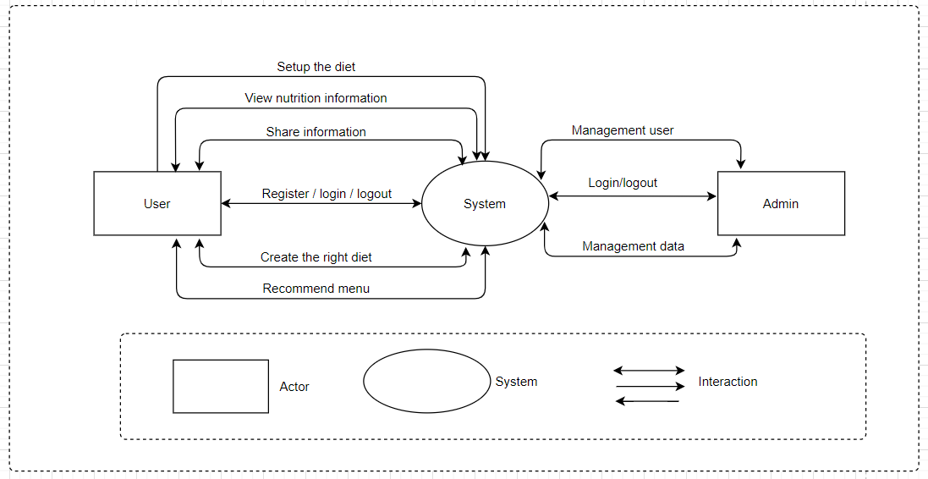

*Figure 1: System Context Diagram*

# **4. C&C view**

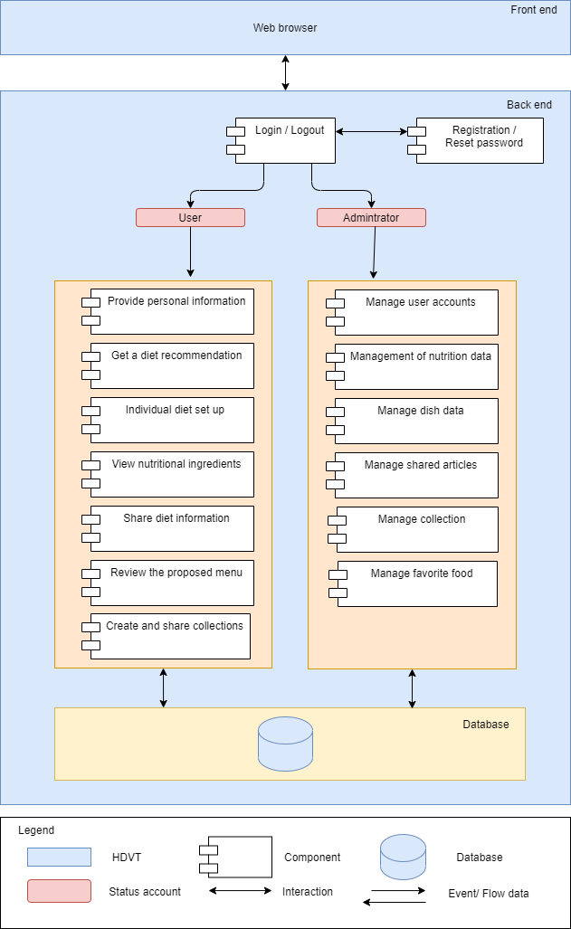We mainly used C&C view to argue and reason about architectural properties, quality attribute requirements, and functional requirements that the system must adhere to.

*Figure 2: Connector & Component View Diagram*

Prose

To process and authorize request from user, all packages are tied up together to authorize the association between user and data (Data Authorization Layer). All requests come from users firstly processed by middleware, it will determine user is authenticated to the system or not. Then, controllers can handle the business logic. All data access logic is controlled by repository to handle all the data access logics with the association of criteria layers to filter data of users that they can be retrieved. Finally, depending on endpoints, data will be responded to Database.

Role and Responsibility

|  |  |
| --- | --- |
| Component login/logout | Only when users log in can use the system's functions |
| Component registration/  reset password | Users register an account to use the system or renew a password to log into the system. |
| Status account | Represents usable objects in the system |
| Odm | Convert the object to JSON type in the database |
| Block Component 1 | Shows specific functions of user objects used in the system |
| Block Component 2 | Shows the functions and objects of users and sales objects that can be used together in the system. |
| Block component 3 | Represents the functionality that the sales object can be used in the system |
| Block component 4 | Represents the functionality that the admin object can use on the system |

# **5. Module view**

*Figure 3: Model View Diagram*

Prose

First, the index package's job is to configure and launch the program. In order to process and authorize requests from users, all packets are linked together to allow for association between the user and the data (Data Authorization Layer). All requests coming from the user are handled by the Route first, which contains the URL file of the user accessing the system. Then, this information is sent to the Controller, in the Controller there are methods to control (clean) the information. And Controller also connects to Lang to determine the language that the user is using. If there is something to be processed into the DB, it sends the information to the service. The service continues to process and send to the Model to get the data from the DB. Then, the information is sent back to the Service - Controller. Next, Controller sends this information to View. View accepts them and Public (contains CSS, JS, Font ...) to output hypertext content (HTML).

This information (HTML) is sent back to the Controller and exported to the user.

Role and Responsibility

|  |  |
| --- | --- |
| View | View receives data from Controller and Public to output hypertext content. This information is sent back to the Controller and exported to the user. |
| Route | It is a device on the network that connects, routes and transports the URL data files of the user accessing it |
| Config | Install the system configuration |
| Public | Store profiles, images, decorations, and effects in the UI of the system |
| Controller | Define methods support to call data from client. Appends with the processing language to determine which language the user is using. And responsibility interact with services to get data. |
| Validation | Constraint the data syntax when it is passed to the system |
| Lang | Switching the language and definition of system messages |
| Service | Responsibility to get request from controller after that interact with real-time database to handle business logic and return data result.  And then, get result and return to component package. Component will handle data and show for client |
| Index | The file that runs the system's source code |
| Model | Defined objects to handle business logic. |
| Node module | As a 3rd library running on Node JS platform, we can use the available libraries to operate the system more optimally. |

# **6. Allocation view**

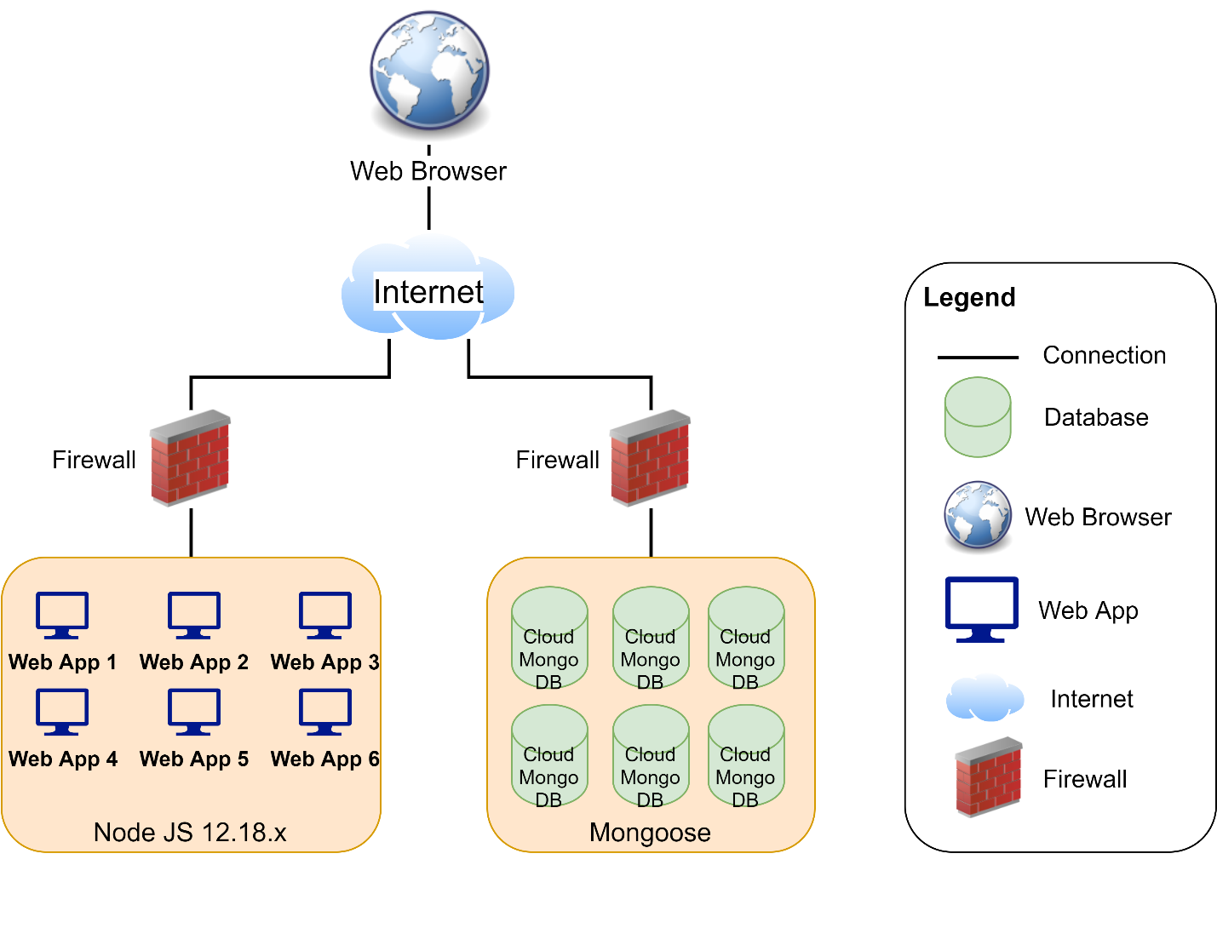

*Figure 4: Allocation View Diagram*

Prose

Client will use web browser (Apple Safari, Google Chrome, and so on) to access to the system. It required internet network if you use external link. Once you did access to the website, the Node JS environment will be processed handle, then the Express app connect to the Cloud Mongo DB through Internet to interact database between user and system. Any transaction between user and system will be implemented on Mongo DB.