**International School**

**Capstone Project 2**

CMU-SE 451

**Proposal**

**Version 1.1**

**Date: 22nd May, 2021**

**Food Care**

**Submitted by**

Huynh Dac Vinh  
 Tran Quoc Trung

Ton That Minh Huy

Dang Van Duan

**Approved by**

**Proposal Review Panel Representative:**

NameSignature Date

**Capstone Project 2-Mentor:**

Name Signature Date

**Dang Viet Hung**

**PROJECT INFORMATION**

|  |  |  |  |
| --- | --- | --- | --- |
| **Project acronym** | FC | | |
| **Project Title** | Food Care | | |
| **Start Date** | 01 Mar, 2021 | **End Date** | 25 May, 2021 |
| **Lead Institution** | International School, Duy Tan University | | |
| **Project Mentor** | Ph.D Hung, Dang Viet | | |
| **Scrum master / Project Leader & contact details** | Vinh, Huynh Dac  Email: dacvinh98@gmail.com  Tel: 0347191925 | | |
| **Partner Organization** |  | | |
| **Project Web URL** |  | | |
| **Team members** | Name | Email | Tel |
| 1 | Vinh, Huynh Dac | dacvinh98@gmail.com | 0347191925 |
| 2 | Trung, Tran Quoc | quoctrung.tran210@gmail.com | 0935420530 |
| 3 | Huy, Ton That Minh | tonthatminhh@gmail.com | 0935432561 |
| 4 | Duan, Dang Van | dangvanduan755@gmail.com | 0769710126 |

REVISION HISTORY

|  |  |  |  |  |
| --- | --- | --- | --- | --- |
| **Version** | **Date** | **Comments** | **Author** | **Approval** |
| 1.0 | 02/03/2021 | Initial Release | C2SE.18 team |  |
| 1.1 | 22/05/2021 | Final | Vinh, Huynh Dac |  |
|  |  |  |  |  |

**Document Approval**

The following signatures are required for approval of this document

|  |  |  |
| --- | --- | --- |
| **Mentor** | Dang Viet Hung | Date: |
| **Scrum Master** | Huynh Dac Vinh | Date: |
| **Product Owner** | Tran Quoc Trung | Date: |
| **Team Member** | Ton That Minh Huy | Date: |
| **Team Member** | Dang Van Duan | Date: |

**Contents**

**1. Introduction** 5

**2. Problem Definition** 5

**3. Current Status of Art** 5

**4. Engineering Approach** 6

**4.1. System Context Overview** 6

**4.2. System Context Description** 6

**4.3. Technical Proposal** 7

**4.3.1. Technical to develop the system:** 7

**4.3.2. Supported Environment:** 7

**5. Tasks and Deliverables** 8

**6. Project Management** 9

**6.1. Cost/Budget for Project** 9

**6.2. Tentative Schedule** 10

**7. Project Constraints** 11

**8. Conclusion** 13

**9. References** 13

**10. Attachment:** 13

# **1. Introduction**

Food Care is a system that allows users to build, adjust their own diet plan with the available food while having the nutrition calculated. Users will also receive a warning if the chosen one does not match their body’s needs.

The system will also recommend a diet for users based on their information and target. Users can also adjust the given diet plan with their favorite food and the nutrition will be re-calculated.

Users can provide feedback for the meal, food, or the combination of them, which will help the system give a more precise suggestion next time.

# **2. Problem Definition**

Currently, there are many different diets for different body conditions, and most of them are unofficial, so it is hard to find, and gather the most accurate one.

In some cases, a person needs to avoid specific ingredients, such as food allergy, or religious reasons, so each meal must be broken down apart and have many labels.

The system needs various amounts of food in order to give users different options, so the meal will not be repeated.

The information about each meal needs to be entered and calculated carefully in order to give users the most accurate nutrition they absorb.

# **3. Current Status of Art**

Up till now, there are many websites or app about the auction system online such as:

⦁ **CookPad**: This is an application that allows users to share the dishes users know with others. Others will rate and react to the food you share. Users can save these recipes and practice later.

This application is very good for the community, but it does not indicate the nutritional components of each dish, does not calculate the number of nutrients needed by the body for each person. It's more like a social network sharing recipe than a website that tailors and organizes a suitable diet.

⦁ **MyNetDiary**: This is a great app that allows users to track their weight changes through a diet that you organize yourself or an app that organizes for you. It also shows calories from each meal as well as calculates to balance calorie intake and consumption appropriately.

MyNetDiary has many outstanding features, but unfortunately, those features require a pretty high fee. For those who do not spend a lot of time thinking about what they will eat tonight to have stable health, paying such a large sum is not feasible. Therefore, the range of users using the application will be limited.

With Food Care, users are free to build their own meals or receive a suggested one and adjust them based on their hobbies and habits. In any case, the nutrition will always be calculated and users will be given a warning if the meal does not meet the requirements for nutritional content.

The system will also provide stores to buy the cooked meal in case users are too busy to prepare and cook.

# **4. Engineering Approach**

## **4.1. System Context Overview**

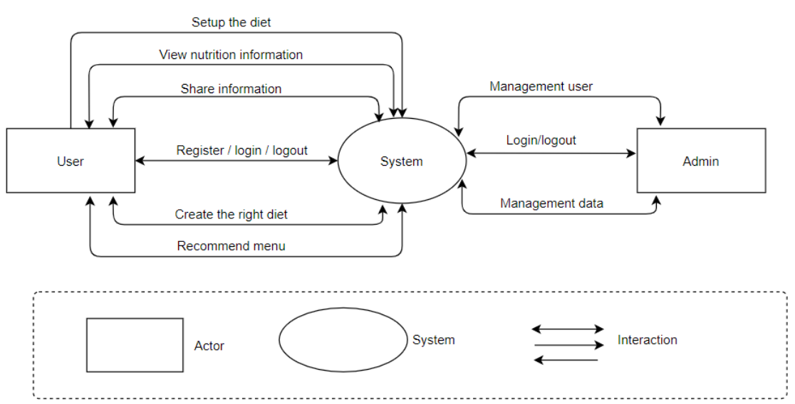

## **4.2. System Context Description**

The User, they can:

- Register an account, log in to the system, and log out of the system.

- Setup their diet by themselves.

- Search for food, view its information

- Build their own menu.

- Get the recommended menu from the system.

- Enter, view, update their information.

- Get recommended stores for the food.

- Provide feedback for menu/ food.

The Admin, they can:

- Log in, log out to the system.

- Manage User (active, deactivate).

- Manage food (add, delete, adjust).

## **4.3. Technical Proposal**

### **4.3.1. Technical to develop the system:**

Operating System: Linux (Ubuntu:1804), Windows 10 Pro

Development Tools: Visual Studio Code, Sublime Text, Git,

Robo3T Version Control System: GitHub

Language: JavaScript (ECMAScript 6), HTML5,

CSS3 Framework: Express JS

Database: MongoDB

Platform: Node Js:8.0 or upper

### **4.3.2. Supported Environment:**

Operating System: Linux, Windows, Android

Web browsers: Chrome, Coc Coc, Microsoft Edge

# **5. Tasks and Deliverables**

|  |  |  |  |  |
| --- | --- | --- | --- | --- |
| **No** | **Phase** | **Task Description** | **Deliverables** | **Responsible** |
| 1 | Product Planning | - Scrum Master to make a new product planning document.    + Environmental Landscape    + Product Requirement    + Specification Requirement    + Value Proposition | - Fundamental document for product.    + Proposal    + Project Plan  - To provide all functions. | Product Owner |
| 2 | Specification & Features | - Scrum Master to share Project planning deck to each function.  - Make a detail specification and features for product | - Project approval deck  - Functional Requirement deck    + User Story    + Architecture Document    + Database Document   + Product Backlog | Product Owner, Scrum Master, Development Team |
| 3 | Design & Development | - Development Team to develop a project following the Scrum Process  - Preparing a backend infrastructure to operate new product  - Making Product | - Development plan    + Sprint Backlog    + Test Plan  - Product | Product Owner,  Development Team |
| 4 | Testing & Deployment | - Development Team testing  - Beta Trials  - Preparing to produce the product | - Development Team test report     + Test Report Document  - Packaging/ Delivery Plan | Product Owner,  Development Team |

# **6. Project Management**

## **6.1. Cost/Budget for Project**

|  |  |  |  |  |
| --- | --- | --- | --- | --- |
| **NO** | **Criteria** | **Price (USD)** | **Amount** | **Total (USD)** |
| 1 | Working hour | $2.5 | 1560 | $3900 |
| 2 | 3rd services | $200 | 1 | $200 |
| **Total cost** | | | | $4100 |

|  |  |  |
| --- | --- | --- |
| Description | Amount | Unit |
| Number of members | 4 | Person |
| Number of working hours per day | 6 | Hour |
| The cost of working per hour per person | 2.5 | Dollar |
| The duration of the project | 3 | Month |
| The number of working days | 65 | Day |
| The cost for 3rd services | 200 | USD |

- Explain:

+ Amount of working hours = 4 members * 4 hours * 65 days.

- Overall:

+ Resource: 4 people

+ Budget: $4100

+ Time: The project must be completed within 3 months

+ Are: Vietnam

**6.2. Tentative Schedule**

**Schedule**

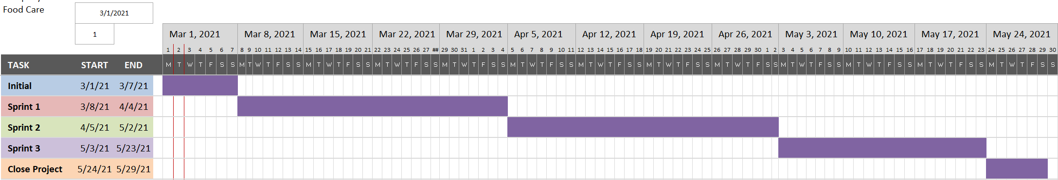

**Scrum Process**

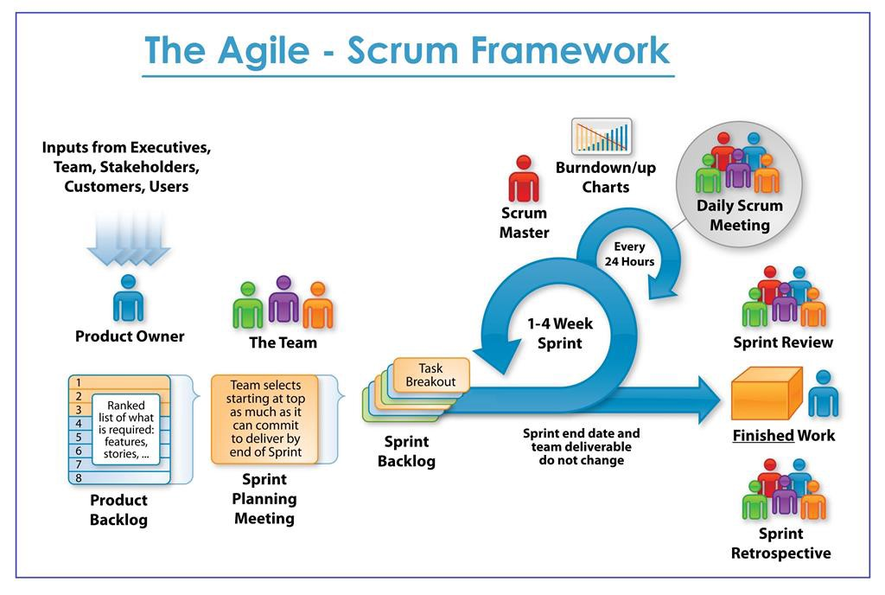

- Scrum is an iterative and incremental agile software development framework for managing software projects and product or application development.

- Scrum focuses on project management institutions where it is difficult to plan ahead.

- Mechanisms of empirical process control, where feedback loops that constitute the core management technique are used as opposed to traditional command-and-control management.

- Its approach to planning and managing projects is by bringing decision-making authority to the level of operation properties and certainties.

- Benefit of the methodology:

+ Project can respond easily to change.

+ Problems are identified early.

+ Customers get the most beneficial work first.

+ Work done will better meet the customer’s needs.

+ Improved productivity.

+ Ability to maintain a predictable schedule for delivery.

|  |  |
| --- | --- |
| **Full Name** | **Position** |
| Dang Viet Hung | Mentor |
| Huynh Dac Vinh | Scrum master/ Developer |
| Tran Quoc Trung | Product owner/ Developer |
| Ton That Minh Huy | Developer/ Tester |
| Dang Van Duan | Developer/ Tester |

# **7. Project Constraints**

|  |  |  |
| --- | --- | --- |
| **Constraint** | **Constraints Description** | **Guidelines for Acceptance** |
| **Economic** | Developer’s salary, hosting service, tax, cooperation fee, marketing fee.  Later on, we can make money from providing ads from the store or suggest the one sell the food. | Elements for consideration are design costs, production costs, maintenance costs, operating costs, and sales price |
| **Environmental** | -People these days have paid too much attention to working and making money, some really want to have a good diet but they do not have enough time for it. That the reason why we want to create this system, which allows user to have their own diet based on their need.  -This system may change the way people use their meals in certain locations, so the price of specific food may rise. That may lead to goods imbalance. The good side is people will have healthy eating without putting too much time into planning and calculation. -We focus on 3 group of people: people who want a healthy and diversity diet, people who want to build shape, and people who need to follow specific diet (vegetarian, allergy) | Impact of the design on the environment as well as impact of the environment (e.g. temperature range, humidity, vibration, electromagnetic interference immunity, and shock) on the design should be considered. Design for recycling and design to use recycled materials should also be considered |
| **Ethical** | Users’ id will be encrypted, food will be labeled with specific requirements, not with id. | Ethical considerations can be broad. Areas that are typically addressed include intellectual property, reverse- engineering, privacy, security, and the conflict between cost and safety |
| **Public health, safety, and welfare** | The food information might be too large to gather and have to verify its correctness. There are too many diets for each target, and not all of them are official.  Food, and meal in the system must be strictly censored. The one provided by the stores must have quality assurance by the store itself. | Includes safety standards as well as impact of the design on users (for example, electrical or physical hazards) |
| **Social and Global** | Users will receive diets tailored to specific requirements. | Addresses aspects such as benefits, risks, the man-machine interface, the acceptance of products by the intended user or by society at large, global and socially responsible engineering. |
| **Cultural** | In some cultures, people will either refer to cook by themselves or eat out, they also have different eating habits.  We will provide local stores rather than one which too far away. | Which cultural characteristics could influence the approach?  How do the design from different cultures differ? |
| **Sustainability** | With the design, the system can be easily expanded with more food and stores, we can also provide a platform for users to share their diet and give advice to others.  On the other hand, there are many systems with similar ideas on the market, they have various numbers of meals as well as recipes. But our one supports a wide range of users with different needs. | Refers to sustainability of resources, including material, energy, supplies, manufacturing techniques, personnel, operation, and the need for additional infrastructure, as well as sustainability of the design including reliability, lifetime, durability, reusability, maintainability. |

# **8. Conclusion**

- Food Care is a system for anyone who wants a healthy diet, or for a specific purpose, or simply wants to diversify their daily meals. It focuses on convenience, targets each user’s requirement, and evolves by itself.

- We build the system using JavaScript and its framework.

- App support will be available after the web is ready.

# **9. References**

• Software Development Standards for the Guidance and Control Software Project (https://sw-eng.larc.nasa.gov/)

• General Software Coding Standards and Guidelines (https://www.nws.noaa.gov/oh/hrl/developers_docs/General_Software_Standar ds.pdf)

• Scrum and best practices

(https://docs.microsoft.com/en-us/azure/devops/boards/sprints/best-practices-scrum?view=azure-devops)

• The Scrum Guide (https://www.scrum.org/resources/scrum-guide)

o The ISO/IEC & IEEE/EIA Standard 12207, IEEE standards: IEEE-829, IEEE-1008, IEEE-1012

o Requirement

# **10. Attachment:**

DESCRIPTION OF PRODUCT REQUIREMENTS FORM

#### **DESCRIPTION OF PRODUCT REQUIREMENTS**

Group: HDVT

Project: FoodCare – Diet Building System

Date: Mar 6th, 2021

**I. Short description of product ideas (less than 7 statements)**

|  |
| --- |
| -This project are being proposed to build a website platform that can provide nutrition with the right dishes for those in need of improving health and body fitness. Developed the 'unknow' website to search for dishes by suggesting the activities of each person to filter out the most relevant information, to solve the problem of searching for information manually and contribute to meeting the needs of users.  -Help users find and share information about the recipes or nutrition of each dish, solving the problem that users have to search for information that is not highly accurate, has consistency and information vague. ‘Unknow’ helps users to manage their food scientifically and the results it brings to each person's health. |

**II. Requirements**

|  |  |
| --- | --- |
| High-level Functional Requirements | 1. Provide nutrition according to the condition of all subjects (food, diets,...). |
| 2. Evaluate the change in body condition over the proposed time. |
| 3. Provide complete information of raw materials in pe dish |
| 4. Gather data collected from the subject's assessment. |
| 5. Detailed statistics to suggest more new dishes through subjects that have applied the diet. |

|  |  |
| --- | --- |
| Quality Attributes Requirements  (example related to issues: Ease  Use, Easy to Like, Easy to Learn, Easy to Understand, Easy to Buy / Yes, ...) | 1. Easy to use |
| 2. Easy to practice |
| 3. Easy to understand |
| 4. Easy to find |
| 5. Easy to statistics |

|  |  |
| --- | --- |
| Operation Requirements  (related to issues: Speed, Accuracy, Performance, Stability, Load Resistance, Scalability, Safety, ...) | 1. Ensure to overcome the overload problem of the system |
| 2. Ensuring the reliability of the system |
| 3. Ensuring the security of the system |
| 4. Ensuring the high stability of the system |
| 5. Ensuring the scalability of the system |

|  |  |
| --- | --- |
| Environment & Operation Requirements  (related to issues: physical impacts on the environment, interact with relevant or existing systems, conditions for product commercialization, ...) | 1. Use on Website platform |
| 2. Conditions for product commercialization |
| 3. Interact with relevant or existing systems |
| 4. Physical impacts on the environment |
| 5. Using Website platform on browser applications available on smartphones |

|  |  |
| --- | --- |
| Requirements for Maintenance & Support | 1. Easy to maintain source code |
| 2. Easy to expand source code |
| 3. Documentation specific description |
| 4. Notes clearly in source code |

|  |  |
| --- | --- |
| Security/ Safety Requirements  (related to issues: conditions of use / access to products, personal freedom, inspection, ...) | 1. Information security for users |
| 2. Define the correctness and transparency of the formula |
| 3. Data and content must be clear and sourced |
| 4. Anti network attacks, altering data |

|  |  |
| --- | --- |
| Culture Requirements | 1. Distinguishing content for humans on each continent |
| 2. Meet strict diets |

|  |  |  |
| --- | --- | --- |
| Evaluate the complexity of engineering problems |  | 1. Involving wide-ranging or conflicting technical issues |
|  | 2. Having no obvious solution |
|  | 3. Addressing problems not encompassed by current standards and codes |
| x | 4. Involving diverse groups of stakeholders |
| x | 5. Including many component parts or sub-problems |
|  | 6. Involving multiple disciplines |
|  | 7. Having significant consequences in a range of contexts |

|  |  |  |
| --- | --- | --- |
| Standard requirements | x | 1. Code standard. (GNU, Oracle standard for Java, ..,) |
| x | 2. Design standard. (design patterns, object-oriented analysis and design,…). |
|  | 3. IEEE (1058, 1540, 830, 1016, 829, 1012, 1008) |
|  | 4. ISO/IEC/IEEE 12207:2017 (TCVN 10539:2014); ISO/IEC 25051:2006(TCVN 10540:2014); |
|  | 5. Other standards. (related to specific topics) |



**International School**

**Capstone Project 2**

CMU-SE 451

**Project Plan**

**Version 1.4**

**Date:** **25th May 2021**

**Food Care**

**Submitted by**

Huynh Dac Vinh

Dang Van Duan

Tran Quoc Trung

Ton That Minh Huy

**Approved by**

**Proposal Review Panel Representative:**

NameSignature Date

**Capstone Project 2-Mentor:**

Name Signature Date

**Dang Viet Hung**

**PROJECT INFORMATION**

|  |  |  |  |
| --- | --- | --- | --- |
| **Project acronym** | FC | | |
| **Project Title** | Food Care | | |
| **Start Date** | 01 Mar, 2021 | **Start Date** | 25 May, 2021 |
| **Lead Institution** | International School, Duy Tan University | | |
| **Project Mentor** | Ph.D Hung, Dang Viet | | |
| **Scrum master / Project Leader & contact details** | Vinh, Huynh Dac  Email: dacvinh98@gmail.com  Tel: 0347191925 | | |
| **Partner Organization** |  | | |
| **Project Web URL** |  | | |
| **Team members** | Name | Email | Tel |
| 1 | Vinh, Huynh Dac | dacvinh98@gmail.com | 0347191925 |
| 2 | Trung, Tran Quoc | quoctrung.tran210@gmail.com | 0935420530 |
| 3 | Huy, Ton That Minh | tonthatminhh@gmail.com | 0935432561 |
| 4 | Duan, Dang Van | dangvanduan755@gmail.com | 0769710126 |

REVISION HISTORY

|  |  |  |  |  |
| --- | --- | --- | --- | --- |
| **Version** | **Date** | **Comments** | **Author** | **Approval** |
| 1.0 | 29/3/2021 | Initial Release | C2SE.18 team |  |
| 1.1 | 25/4/2021 | Updated Release | Dang Van Duan |  |
| 1.2 | 4/5/2021 | Updated Release | Tran Quoc Trung |  |
| 1.3 | 12/5/2021 | Updated Release | Ton That Minh Huy |  |
| 1.4 | 25/5/2021 | Final | Huynh Dac Vinh |  |
|  |  |  |  |  |

**Document Approval**

The following signatures are required for approval of this document

|  |  |  |
| --- | --- | --- |
| **Mentor** | Dang Viet Hung | Date: |
| **Scrum Master** | Huynh Dac Vinh | Date: |
| **Product Owner** | Tran Quoc Trung | Date: |
| **Team member** | Ton That Minh Huy | Date: |
| **Team member** | Dang Van Duan | Date: |

**TABLE OF CONTENTS**

1. PROJECT OVERVIEW 6
   1. Project Description 6
   2. Scope and Purpose 6
   3. Assumptions and Constraints 6
   4. Project Objectives 7
   5. Critical Dependencies 8
   6. Project Risk 8
2. PROJECT DEVELOPMENT APPROACH 9
   1. Project Process 9
   2. Requirement Change Management 9
   3. Product Integration Strategy 9
   4. Quality Management 10
   5. Unit Testing Strategy 12
   6. Integration Testing Strategy 13
   7. System Testing Strategy 13
3. ESTIMATE 14
   1. Size 14
   2. Effort 14
   3. Schedule 15
   4. Resource 17
   5. Infrastructure 17
   6. Training Plan 18
   7. Finance 18
4. PROJECT ORGANIZATION 20
   1. Organization Structure 20
   2. Project Team 20
   3. External Interfaces 22
5. COMMUNICATION & REPORTING 25
6. CONFIGURATION MANAGEMENT 27
7. SECURITY ASPECTS 28

# PROJECT OVERVIEW

## *Project Description*

|  |  |  |  |
| --- | --- | --- | --- |
| **Project code** | HDVT | **Contract type** | Internal Project |
| **Customer** | Teacher | **2nd Customer** | University |
| **Project Level** | Group | **Project rank** | A |
| **Group** | C2.SE18 | **Division** |  |
| **Project Type** | External | **Project Manager/ Scrum master** | Huynh Dac Vinh |
| **Project Category** | Captone2 | **Business domain** | Application |
| **Application type** | Website |  |  |

## *Scope and Purpose*

* Food Care is a system which allows users to build, adjust their own diet plan with the available food while having the nutrition calculated. User will also receive a warning if the chosen one do not match their body’s need.
* The system will also recommend diet for users that based on their information and target. Users can also adjust the given diet plan with their favorite food and the nutrition will be re-calculate.
* Users can provide feedback for the meal, food, or the combination of them, which will help the system give a more precise suggestion next time.

## *Assumptions and Constraints*

|  |  |  |
| --- | --- | --- |
| **No** | **Description** | **Note** |
| **Assumptions** | | |
| 1 | Provide nutrition according to the condition of all subjects (food, diets, ...) | Scope |
| 2 | Provide all ingredients information in the dish, the interface must be clear and easy to use | External Interfaces |
| 3 | Suggest the same menu for people with similar tastes and needs | Scope |
| **Constraints** | | |
| 1 | All sprint tasks must be completed as soon as possible before the sprint deadline | Schedule |
| 2 | Information security for users and Anti network attacks, altering data | Security |
| 3 | Define the correctness and transparency of the formula, Data and content must be clear and sourced | Safety |

## *Project Objectives*

* + 1. **Standard Objectives**

|  |  |  |  |  |
| --- | --- | --- | --- | --- |
| **Metrics** | **Unit** | **Committed** | **Re-committed** | **Note** |
| Start Date | 01-03-2021 |  |  |  |
| End Date | 25-5-2021 |  |  |  |
| Duration | 85 days |  |  |  |
| Maximum Team Size | 4 Persons |  |  |  |
| Billable Effort | 6 hours/ 5days/ 1 Month |  |  |  |
| Calendar effort | 6 hours/ 5days/ 1 Month |  |  |  |
| Effort Usage | 6 hours/ 5days/ 1 Month |  |  |  |

* + 1. **Specific Objectives**

Functional goals:

* + Works correctly
  + Don’t have conflict
  + Correct to the requirement

Strategic goals:

* + Satisfactory requirement documents
  + Bringing knowledge and health to users
  + Provide income for developers

Business goals:

* + Income is based on effort

Quality goals

* + Correct to the requirement

Organizational goals

* + Update later

Other goals

* + Update later

## *Critical Dependencies*

|  |  |  |  |
| --- | --- | --- | --- |
| **No** | **Dependency** | **Expected delivery date** | **Note** |
| 1 | Does not depend on another project |  |  |

## *Project Risk*

|  |  |  |  |  |
| --- | --- | --- | --- | --- |
| **Risk** | **Description** | **Probability** | **Impact** | **Mitigation Strategy** |

|  |  |  |  |  |
| --- | --- | --- | --- | --- |
| **Estimates of project planning** | The plan may be delayed for the initial estimate of the project. | 1 | 1 | Analysis and assessment of the scale.  Reduce requirements. |
| **Not enough knowledge to implement the project** | Members' knowledge may or may not be consistent with their expertise | 2 | 2 | Spend more time for learning and training. |
| **Requirements** | Important requirements may be missing from the formal requirements specification. | 3 | 3 | Try to ensure to get as much of the requirements before we start development. |
| **Estimated project schedule** | Programming Languages and technology | 3 | 2 | Experience sharing used to reduce the research time. |
| **Technical processes** | The standard procedure cannot meet the requirements of specific solutions.  The new process may be required.  The process can be improved and more efficient. | 2 | 3 | Analysis of requirements and processes to ensure appropriate levels.  If the new process is needed, we need to evaluate this response has improved over the old process. |
| **Network** | Block by Limited Bandwidth | 4 | 4 | Upgrade transmission line network |
| **Time** | Project implementation period is too short, so our team cannot complete this project in a short time.  During project implementation, our team learns and has more work to do, our team cannot focus all their time to carry out this project. | 4 | 5 | Reduce time and increase individual personal time working in their stay on the 7th day and Sunday. |
| **Project Management** | Project management systems may not be sufficient to support the requirements of the project | 1 | 4 | Discuss with the group to offer solutions and consistent accuracy. |

# PROJECT DEVELOPMENT APPROACH

## *Technical Process*

## *Reasons for selecting*

This is the first time the whole group has worked together, with not much experience, and will surely encounter many difficulties in the development process. As for the traditional model we are not allowed to make mistakes but for our scrum it allows us to make mistakes, through each sprint we will discuss, test and adjust to work better.

Scrum process is a flexible development model so in this project we think it is suitable for workflow creation and communication among members.

## *Agile Methodology*

**Definition**:

* Agile methodology is a type of project management process, mainly used for software development, where demands and solutions evolve through the collaborative effort of self-organizing and cross-functional teams and their customers. It is a collection of principles that value adaptability and flexibility. Agile aims to provide better responsiveness to changing business needs and focuses on enabling teams to deliver in workable increments.

**Process:**

* **Concept**: Projects are envisioned and prioritized
* Inception: Team members are identified, funding is put in place, and initial environments and requirements are discussed
* Iteration/Construction: The development team works to deliver working software based on iteration requirements and feedback
* Release: QA (Quality Assurance) testing, internal and external training, documentation development, and final release of the iteration into production
* Production: Ongoing support of the software
* Retirement: End-of-life activities, including customer notification and migration

**Manifesto:**

* When the IT industry talks about the Scrum framework, It's also often we hear the term "Agile Scrum" along the same lines as "Scrum". It led some of us in the industry to think and look for differences between the terms "Agile Scrum" and "Scrum".
* We have discovered a better way to develop the software by doing it and helping others to do it.
* Individuals and interactions rather than processes and tools;
* Software that runs better is full documentation;
* Collaborate with customers rather than negotiate contracts;
* Respond to changes rather than stick to the plan.

**2.1.2.1. Scrum Process**

**Scrum Process**

* Scrum is an iterative and incremental agile software development framework for managing software projects and product or application development.
* Scrum focuses on project management institutions where it is difficult to plan ahead.
* Mechanisms of empirical process control, where feedback loops that constitute the core management technique are used as opposed to traditional command-and-control management.
* Its approach to planning and managing projects is by bringing decision-making authority to the level of operation properties and certainties.
* Scrum has three roles: product owner, scrum master and the development team members.

**Benefit of the methodology:**

* Project can respond easily to change.
* Problems are identified early.
* Customer gets most beneficial work first.
* Work done will better meet the customer’s needs.
* Improved productivity.
* Ability to maintain a predictable schedule for delivery.

## *Quality Management*

* + 1. **Estimates of Defects to be detected**

**Pre-release review defects**

|  |  |  |
| --- | --- | --- |
| **Process** | **Planned found by review** | **Actual found by review** |
| **Requirement** | 10 | 5 |
| **Design** | 10 | 20 |
| **Coding** | 40 | 20 |
| **Other** | 15 | 10 |
| Total | 75 | 55 |

**Pre-release test defects**

|  |  |  |
| --- | --- | --- |
| **Process** | **Planned found by review** | **Actual found by review** |
| **Requirement** | 10 | 5 |
| **Design** | 10 | 20 |
| **Coding** | 40 | 20 |
| **Other** | 15 | 10 |
| Total | 75 | 55 |

* + 1. **Measurements Program**

|  |  |
| --- | --- |
| **Strategy** | **Expected Benefits** |
| Do defect prevention using the standard defect prevention guidelines and process; use standards developed in ABC for coding. | 10–20% reduction in defect injection rate and about 2% improvement in productivity |
| Group review of program specs for first few/logically complex use cases.  Group review of design docs/first time-generated code by project leader, developer, and one consultant. | Improvement in quality as overall defect removal efficiency will improve; some benefits in productivity as defects will be detected early |
| Introduction of RUP methodology and implementing the project in iterations. Milestone analysis and defect prevention exercise will be done after each Iteration. | Approximately 5% reduction in defect injection rate and 1% improvement in overall productivity |

**2.2.3 Quality Control**

|  |  |  |  |
| --- | --- | --- | --- |
| **Review Item** | **Type of Review** | **Reviewer** | **When** |
| Project plan  Project schedule  CM Plan | Group review Group review  One-person review | Huynh Dac Vinh  Tran Quoc Trung  Ton That Minh Huy  Dang Van Duan | End of Initiation stage |
| Business analysis and requirements specification document, Use Case catalog | Group review | Huynh Dac Vinh  Tran Quoc Trung | 90% |
| Design document, object model | Group review | Huynh Dac Vinh  Tran Quoc Trung  Ton That Minh Huy  Dang Van Duan | End of 90% design |
| Stage plans | One-person review | Huynh Dac Vinh  Tran Quoc Trung | Beginning of each stage |
| Complex/first specs incl. diagramstime test generated cases, program interactive | Group review | Huynh Dac Vinh  Tran Quoc Trung  Ton That Minh Huy  Dang Van Duan | End of detailed design |
| Code | Group review | Huynh Dac Vinh  Tran Quoc Trung  Ton That Minh Huy  Dang Van Duan | After coding for first few programs |

**2.2.4 Measurements Program**

|  |  |  |  |
| --- | --- | --- | --- |
| **Data to be collected** | **Purpose** | **Responsible** | **When** |
| Size: No. of KLOC// FP |  | PM/SM | At the end of stages |
| Effort: No. person-day |  | Team members | Daily |
| Quality: No. defects detected |  | Reviewer, Tester | Right after the review/test |
| Schedule |  | PM/SM | Weekly and at the end of stages |

## *Unit Testing Strategy*

**Completion criteria:**

Completion criteria are stated to for two purposes:

* Identify acceptance criteria for product quality.
* Identify when the testing is successfully executed

A clear statement of completion criteria should include the following items:

* Function, behavior, or condition being measured
* Method of measurement

Criteria or degree of conformance to measurement

**Special considerations:**

This section should identify any influences or dependencies, which may impact or influence the test effort described in the test strategy. Influences might include:

Human resources (such as availability or need for non-test resources to support / participate in test)

Constraints, (such as equipment limitations or availability, or the need / lack of special equipment)

Special requirements, such as test scheduling or access to systems

Testing may be stopped when:

* It becomes unproductive
* It requires a certain coverage
* It requires a certain number of errors to be found
* Schedule time runs out

## *Integration Testing Strategy*

Using Big Bang Testing for an Integration testing approach in which all the components or modules are integrated together at once and then tested as a unit. This combined set of components is considered as an entity while testing. If all of the components in the unit are not completed, the integration process will not execute.

## *System Testing Strategy*

Participating in test cases of each function created in the test case document assesses whether the functions created by the programmers meet the set criteria or not and checks the integrity of the system

# ESTIMATION

## *Size*

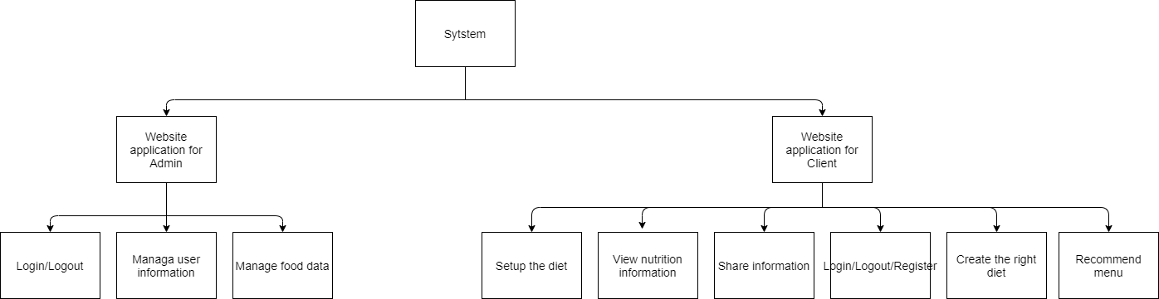

**3.2 Effort**

The Effort estimation is documented in Sprint Backlog

|  |  |  |  |  |  |  |  |  |
| --- | --- | --- | --- | --- | --- | --- | --- | --- |
| **Activity/Process** | **Total budgeted Effort Usage (pd)** | **Total % budgeted Effort Usage (%)** | **Stage 1/ Sprint 1** | | **Stage 2/ Sprint 2** | | **Stage 3 / sprint 3** | |
| **No.** | **%** | **No.** | **%** | **No.** | **%** |
| Requirement | 100 | 2.6% | 100 | 3.3% | 100 | 3.3% | 0 | 0% |
| Design | 800 | 20.5% | 300 | 7.7% | 350 | 9% | 150 | 3.8% |
| Coding | 1700 | 43.6% | 500 | 12.8% | 400 | 10.3% | 800 | 20.5% |
| Unit Testing | 150 | 3.9% | 50 | 1.3% | 50 | 1.3% | 50 | 1.3% |
| Testing | 400 | 10.2% | 100 | 2.6% | 100 | 2.6% | 200 | 5.1% |
| Deployment | 100 | 2.6% | 0 | 0% | 0 | 0 | 100 | 2.6% |
| Support for Acceptance Test | 90 | 2.3% | 30 | 0.8% | 30 | 0.8% | 30 | 0.8% |
| Project Planning | 90 | 2.3% | 30 | 0.8% | 30 | 0.8% | 30 | 0.8% |
| Project monitoring | 90 | 2.3% | 30 | 0.8% | 30 | 0.8% | 30 | 0.8% |
| Quality Assurance | 80 | 2.1% | 30 | 0.8% | 30 | 0.8% | 30 | 0.8% |
| Training | 300 | 7.6% | 100 | 2.6% | 100 | 2.6% | 100 | 2.6% |
| Total | 3900$ | 100% |  |  |  |  |  |  |

## *3.3. Schedule*

**3.3.1. Project Milestone & Deliverables**

|  |  |  |  |  |
| --- | --- | --- | --- | --- |
| No | Milestones | Time | Product | Delivery |
| 1. | Initial | 01/03/2021 | Proposal document  Project Plan  User Story  Product Backlog  Architecture Design | Bringing many new ideas for the project, building the project structure more and more carefully |
| 2. | Development | 08/03/2021 | Database Design |  |
| 2.1 | Sprint1 | 08/03/2021 | Test Plan | Design, code login/logout/register UI and API for User |
| 2.2 | Sprint2 | 05/04/2021 | Test Case | - Design, code menu, add, remove food UI and API for User,  - Give ways to fix the process and affordable way of working for each member |
| 2.3 | Sprint3 | 03/05/2021 | Sprint Backlog, Meeting Document | Make Dashboard for Admin |
| 3. | Final Release | 29/05/2021 | Reflection Document | Evaluate the ability of each member |

**3.3.2.** **Work Breakdown Structure**

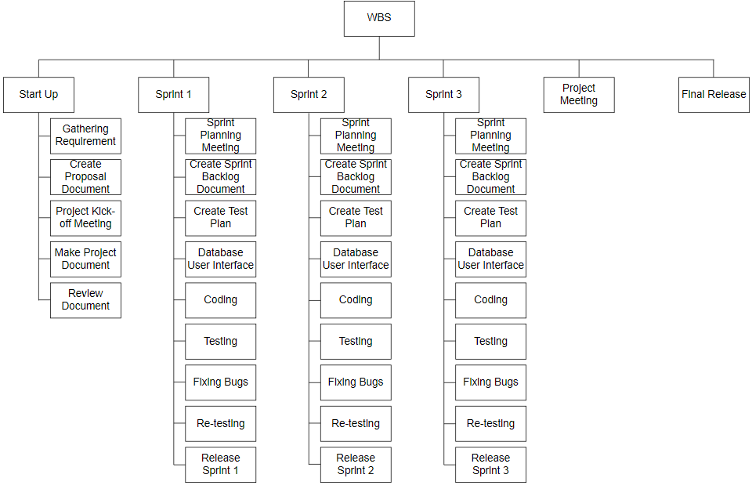

**3.3.3 Detailed Schedule**

|  |  |  |  |  |  |
| --- | --- | --- | --- | --- | --- |
| **No.** | **Task Name** | **Duration (Days)** | **Start** | **Finish** | **Assign to** |
| **1.** | **Initial** | 5 | 1/3 | 7/3 | All members |

|  |  |  |  |  |  |
| --- | --- | --- | --- | --- | --- |
|  |  |  |  |  |  |

|  |  |  |  |  |  |
| --- | --- | --- | --- | --- | --- |
| **2** | **Development** | 80 | 8/3 | 28/5 | All members |
| 2.1 | Sprint 1 | 28 | 8/3 | 4/4 | All members |

|  |  |  |  |  |  |
| --- | --- | --- | --- | --- | --- |
|  |  |  |  |  |  |

|  |  |  |  |  |  |
| --- | --- | --- | --- | --- | --- |
| 2.2 | Sprint 2 | 28 | 5/4 | 2/5 | All members |

|  |  |  |  |  |  |
| --- | --- | --- | --- | --- | --- |
|  |  |  |  |  |  |

|  |  |  |  |  |  |
| --- | --- | --- | --- | --- | --- |
| 2.3 | Sprint 3 | 21 | 3/5 | 23/5 | All members |

|  |  |  |  |  |  |
| --- | --- | --- | --- | --- | --- |
|  |  |  |  |  |  |

|  |  |  |  |  |  |
| --- | --- | --- | --- | --- | --- |
| **3** | **Close project** | 5 | 24/5 | 29/5 | All members |
|  | **Duration** | 90 | 1/3 | 29/5 | All members |

**3.3.4 Project Schedule**

|  |  |  |  |  |
| --- | --- | --- | --- | --- |
| **No** | **Activity** | **Start date** | **Responsible** | **Note** |
| **Defect Prevention** | | | | |
|  | Sprint 1 | 08/03/2021 |  |  |
|  | Sprint 2 | 05/04/2021 |  |  |
|  | Sprint 3 | 03/05/2021 |  |  |
| **Quality Control** | | | | |
|  | Review: Work Product 1 | 17/04/2021 |  |  |
|  | Review: Work Product 2 | 29/04/2021 |  |  |
| **Project Tracking** | | | | |
|  | Stage name milestone review meeting | 17/04/2021 |  |  |
|  | Stage name milestone review meeting | 29/04/2021 |  |  |
| **QA** | | | | |
|  | Final Inspection: Deliverable 1 | 01/06/2021 |  |  |
|  | Final Inspection: Deliverable 2 | 02/06/2021 |  |  |
|  | Baseline audit: Startup | 04/06/2021 |  |  |
|  | Baseline audit: Wrap-up |  |  |  |

## *Resource*

Specified as in the section *Project Team*

## *3.5* *Infrastructure*

|  |  |  |  |
| --- | --- | --- | --- |
| **Work/Product** | **Purpose** | **Expected Availability by** | **Note** |
| **Development Environment** | | | |
| NT Server | Operating System | Initiation stage |  |
| Mainframe | Operating System |  |  |
| Win NT | Operating System |  |  |
| DB2 | DBMS |  |  |
| Java Script | Development language for Web interface |  |  |
| Python | Development language for data collection |  |  |
| **Hardware & Software** | | | |
| 1GB space on server |  |  |  |
| Rational Rose | Design |  |  |
| **Other Tools** | | | |
| CVS | Source version control | Definition stage |  |
| Unit | Unit Test | Construction stage |  |
| DMS | Defect logging and tracking | Definition stage |  |
| Timesheet | Effort logging | Initiation stage |  |
| FI | Project management tool | Initiation stage |  |
| MS Project | Task tracking | Initiation stage |  |

## *Training Plan*

|  |  |  |  |
| --- | --- | --- | --- |
| **Training Area** | **Participants** | **When, Duration** | **Waiver Criteria** |
| Technical | | | |
| React JS framework | Huynh Dac Vinh | 14 days | If already trained |
| Python language | Ton That Minh Huy |  |  |
| Node JS framework | Tran Quoc Trung, Dang Van Duan | 14 days | If already trained |
| Business domain | | | |
| Banking | Huynh Dac Vinh | 7 days |  |
| Process | | | |
| Quality system | Huynh Dac Vinh | 3 hrs | If already trained |
| Configuration management | Huynh Dac Vinh | 2 hrs | If already trained for  python. For others, on-the- job training |
| Group review | Huynh Dac Vinh | 4 hrs | If already trained |
| Defect prevention |  | 4.5 hrs | Mandatory |
| React Js | Ton That Minh Huy  Huynh Dac Vinh | 8 hrs | If already trained |
| Connect Firebase | Ton That Minh Huy  Huynh Dac Vinh  Tran Quoc Trung  Dang Van Duan | 8 hrs | Mandatory |
| NodeJS | Tran Quoc Trung  Dang Van Duan | 8 hrs | Mandatory |

## *Finance*

|  |  |  |  |  |
| --- | --- | --- | --- | --- |
| **No.** | **Criteria** | **Price (USD)** | **Amount** | **Total (USD)** |
| 1 | Working hour | $2.5 | 1560 | $3900 |
| 2 | 3rd services | $200 | 1 | $200 |
|  | | | **Total** | $4100 |

**Table 2: Cost Description**

|  |  |  |
| --- | --- | --- |
| **Description** | **Amount** | **Unit** |
| Number of members | 4 | Person |
| Number of working-day per week | 6 | Hour |
| Number of working-hour per week | 2.5 | Dollar |
| The cost per member per week | 3 | Month |
| The duration of the project | 65 | Day |
| The number of working days | 200 | USD |

* **Explain:**
* Amount of working hours = 4 members * 4 hours * 65 weeks.
* **Overall**:
* Resource: 4 peoples
* Budget: $4100
* Time: The project must be completed within 3 months
* Area: Vietnam

|  |  |  |  |  |  |
| --- | --- | --- | --- | --- | --- |
| **Item** | **Total Budget ($)** | **% Budget** | **SPRINT 1** | **SPRINT 2** | **SPRINT 3** |
| Purchases (COST) | 4100 | 100% | 1367 | 1367 | 1367 |
| Team building | 0 | 0 | 0 | 0 | 0 |
| Tools | 0 | 0 | 0 | 0 | 0 |
| Travel costs | 0 | 0 | 0 | 0 | 0 |
| Training | 0 | 0 | 0 | 0 | 0 |
| Review activities | 0 | 0 | 0 | 0 | 0 |
| Other | 0 | 0 | 0 | 0 | 0 |
| Total | 4100 | 100 | 0 | 0 | 0 |

# PROJECT ORGANIZATION

## Organization Structure

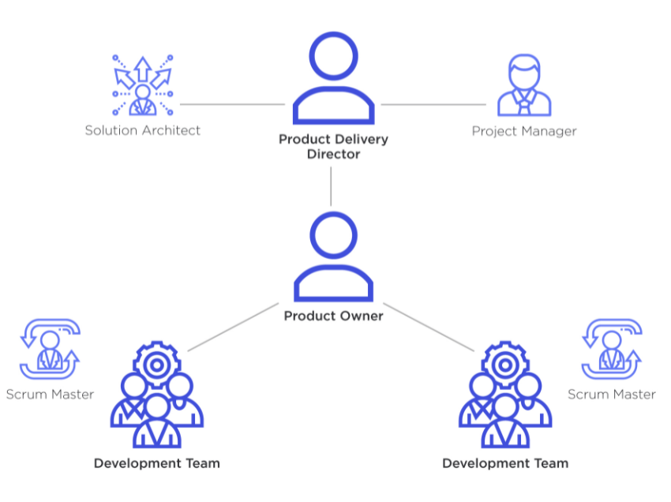

## *Project* *Team*

|  |  |  |
| --- | --- | --- |
| **Role** | **Responsibility** | **Name** |

|  |  |  |
| --- | --- | --- |
| **Scrum Master** | * Communicate the value of Scrum * Teach the organization on Scrum to maximize business value * Attend all Scrum meetings * Preserve the integrity and spirit of the Scrum framework * Maintain the focus of the Team and facilitate efforts to resolve them * Serve as a coach and mentor to members of the Team * Respectfully hold the Team, Product Owner and Stakeholders accountable for their commitments * Continually work with the Team and business to find and implement improvements * As a timekeeper * Record team meeting   Make the Team aware of impediments | Vinh, Huynh Dac |
| **Product Owner** | - A spokesperson for the customer and needs to represent them | Trung, Tran Quoc |
| **Developer** | - Responsible for quality  - Responsible for delivering the potentially shippable product of the Application each sprint  - Report progress based on the remaining time  - Self-organized  - Owns the Sprint backlog | All  members |
| **Tester** | * Do the Test plan * Creation of test designs, test processes, test cases and test data. * Carry out testing as per the defined procedures. * Graph the results and make sure people know when test results decline. * Prepare all reports related to software testing carried out. * Analysis and evaluate the Test result. * Ensure that all tested related work is carried out as per the defined standards and procedures. | All Members |
| **Mentor** | * Guide on the process. * Monitoring all activities of the Team. * Help with anything. * Reviews project documents   - Reviews product | Viet Hung Dang, Ph.D |

# COMMUNICATION & REPORTING

***Communication Methodology.***

|  |  |  |  |
| --- | --- | --- | --- |
| **Audience/Attendees** | **Topic/ Deliverable** | **Frequency** | **Method** |
| **Mentor and Team member** | | Project Progress Review | Weekly | Zoom Meeting, Face to Face |
| **Team Member** | | Project Progress Review and Daily Meeting | Daily | Email, Facebook, Zoom Meeting, Slack |

**Communication and Report.**

|  |  |  |  |
| --- | --- | --- | --- |
| **Audience / Attendees** | **Topic / Deliverable** | **Frequency** | **Method** |
| Scrum Master, Members | Daily meeting | Daily | Face to Face / Zoom Meeting / Facebook Chat / Slack |
| Scrum Master, Members | Sprint Planning Meeting | When starting a sprint | Face to face / Zoom Meeting |
| Scrum Master, Members, Mentor | Sprint Review Meeting | When finishing a sprint | Face to face / Zoom Meeting |
| Scrum Master, Members | Sprint Retrospective | When the sprint review finish | Face to face/ Zoom Meeting |
| Scrum Master, Members | Individual Meeting | When need | Face to face / Message / |
| Scrum Master, Members, Mentor | Working report, review problems | Once a week | Face to face / Facebook Chat / Slack |

# CONFIGURATION MANAGEMENT

Refer to the CM plan or insert here the contents of the CM plan as appropriated

# SECURITY ASPECTS

* Use authentication to ensure user data integrity
* Encrypting user data to avoid stolen data, decrypting data is also extremely difficult, takes a lot of computational resources and takes a lot of time.
* Do not disclose important documents to the outside

**REFERENCES**

* Provide a complete list of all documents and other sources of information referenced in this Plan.
* Identify each referenced document by title, report number, date, author and publishing organization.
* Identify other referenced sources of information, such as electronic files, using unique identifiers such as path/name, date and version number.

### DEFINITIONS AND ACRONYMS

Define, or provide references to documents or annexes containing the definition of all terms and acronyms required to properly understand this Plan.

|  |  |  |
| --- | --- | --- |
| **Acronym** | **Definition** | **Note** |
| PM | Project Manager |  |
| PTL | Project Technical Leader |  |
| QA | Quality Assurance Officer |  |
| CC | Infrastructure Configuration Controller |  |
| DV | Developer |  |
| URD | User Requirement Document |  |
| SRS | Software Requirement Specification |  |
| ADD | Architecture Design Document |  |
| DDD | Detail Design Document |  |
| TP | Test Plan |  |
| TC | Test Case |  |
| SC | Source Code |  |
| CM | Configuration Management |  |
| CSCI | Computer Software Configuration Items |  |
| CI | Configuration Item |  |
| CCB | Change Control Board |  |
| UI | User Interface |  |
| NE | Node express |  |
| CSV | Comma Separated Values |  |
| Axios | HTTP client |  |
| JWT | JSON Web Token |  |
| Heroku | Cloud Application Platform |  |
| Mongoose | a MongoDB object modeling tool |  |
| WC | Web crawling |  |
| WS | Web Scraping |  |

**International School**

**Capstone Project 2**

CMU-SE 451

**Sprint Backlog**

**Version 1.1**

**Date: 22nd May, 2021**

**Food Care**

**Submitted by**

Huynh Dac Vinh  
 Tran Quoc Trung

Ton That Minh Huy

Dang Van Duan

**Approved by**

**Proposal Review Panel Representative:**

NameSignature Date

**Capstone Project 2-Mentor:**

Name Signature Date

**Dang Viet Hung**

**PROJECT INFORMATION**

|  |  |  |  |
| --- | --- | --- | --- |
| **Project acronym** | FC | | |
| **Project Title** | Food Care | | |
| **Start Date** | 01 Mar, 2021 | **End Date** | 25 May, 2021 |
| **Lead Institution** | International School, Duy Tan University | | |
| **Project Mentor** | Ph.D Hung, Dang Viet | | |
| **Scrum master / Project Leader & contact details** | Vinh, Huynh Dac  Email: dacvinh98@gmail.com  Tel: 0347191925 | | |
| **Partner Organization** |  | | |
| **Project Web URL** |  | | |
| **Team members** | Name | Email | Tel |
| 1 | Vinh, Huynh Dac | dacvinh98@gmail.com | 0347191925 |
| 2 | Trung, Tran Quoc | quoctrung.tran210@gmail.com | 0935420530 |
| 3 | Huy, Ton That Minh | tonthatminhh@gmail.com | 0935432561 |
| 4 | Duan, Dang Van | dangvanduan755@gmail.com | 0769710126 |

REVISION HISTORY

|  |  |  |  |  |
| --- | --- | --- | --- | --- |
| **Version** | **Date** | **Comments** | **Author** | **Approval** |
| 1.0 | 22/05/2021 | Final | Vinh, Huynh Dac |  |
|  |  |  |  |  |

**Document Approval**

The following signatures are required for approval of this document

|  |  |  |
| --- | --- | --- |
| **Mentor** | Dang Viet Hung | Date: |
| **Scrum Master** | Huynh Dac Vinh | Date: |
| **Product Owner** | Tran Quoc Trung | Date: |
| **Team Member** | Ton That Minh Huy | Date: |
| **Team Member** | Dang Van Duan | Date: |

**Sprint 1**

|  |  |  |  |  |  |  |
| --- | --- | --- | --- | --- | --- | --- |
| **No.** | **Task** | **Responsible**  **person** | **Status** | **Estimate (hours)** | **Start Date** | **End Date** |
|  | Create Sprint 1 Backlogs | All member | done | 20 | 3/9/2021 | 3/10/2021 |
|  | Create Database for Sprint 1 | Trung, Huy | done | 18 | 3/10/2021 | 3/12/2021 |
|  | Create Test Plan for Sprint 1 | Duan | done | 8 | 3/11/2021 | 3/14/2021 |
|  | Design register UI (user) | Huy | done | 3 | 3/17/2021 | 3/17/2021 |
|  | Code register UI (user) | Vinh | done | 5 | 3/13/2021 | 3/19/2021 |
|  | Code register API (user) | Trung | done | 8 | 3/27/2021 | 3/28/2021 |
|  | Create test cases for register (user) | Trung | done | 3 | 3/21/2021 | 3/21/2021 |
|  | Test register (user) | Duan | done | 3 | 4/3/2021 | 4/3/2021 |
|  | Design login UI (user) | Huy | done | 3 | 3/17/2021 | 3/17/2021 |
|  | Code login UI (user) | Trung | done | 4 | 3/27/2021 | 3/27/2021 |
|  | Code login API (user) | Trung,Vinh | done | 9 | 3/23/2021 | 3/24/2021 |
|  | Create test cases for login (user) | Trung | done | 4 | 3/20/2021 | 3/20/2021 |
|  | Test login (user) | Vinh | done | 3 | 4/3/2021 | 4/3/2021 |
|  | Code logout API | Trung | done | 7 | 3/19/2021 | 3/20/2021 |
|  | Create test cases for logout | Duan | done | 1 | 4/3/2021 | 4/4/2021 |
|  | Test logout | Vinh |  | 2 | 3/17/2021 | 3/18/2021 |
|  | Design change password UI (user) | Huy | done | 3 | 3/24/2021 | 3/25/2021 |
|  | Code change password UI (user) | Huy |  | 4 | 3/25/2021 | 3/25/2021 |
|  | Code change password API (user) | Trung | done | 6 | 3/25/2021 | 3/26/2021 |
|  | Create test cases for change password (user) | Duan | done | 3 | 4/1/2021 | 4/1/2021 |
|  | Test change password (user) | Huy | done | 3 | 4/4/2021 | 4/4/2021 |
|  | Design reset password UI (user) | Vinh | done | 3 | 3/18/2021 | 3/19/2021 |
|  | Code reset password UI (user) | Huy | done | 3 | 3/16/2021 | 3/16/2021 |
|  | Code reset password API (user) | Trung | done | 6 |  |  |
|  | Create test cases for reset password (user) | Duan | done | 4 | 3/31/2021 | 4/1/2021 |
|  | Test reset password (user) | Duan | done | 2 |  |  |
|  | Design profile page UI | Vinh | done | 7 | 3/20/2021 | 3/21/2021 |
|  | Code profile page UI | Huy | done | 9 | 3/20/2021 | 3/23/2021 |
|  | Code profile page API | Vinh, Trung | done | 8 | 4/1/2021 | 4/2/2021 |
|  | Create test cases for profile page | Duan |  | 4 | 3/29/2021 | 3/29/2021 |
|  | Test profile page | Duan | done | 4 | 3/17/2021 | 4/3/2021 |
|  | Design edit profile UI | Vinh | done | 3 | 3/15/2021 | 3/15/2021 |
|  | Code edit profile UI | Huy |  | 6 | 4/1/2021 | 4/1/2021 |
|  | Code edit profile API | Trung | done | 9 | 3/31/2021 | 4/2/2021 |
|  | Create test cases for edit profile | Duan |  | 3 | 4/2/2021 | 4/2/2021 |
|  | Test edit profile | trung |  | 4 | 4/4/2021 | 4/4/2021 |
|  | Design filter food UI | Huy, Vinh | done | 12 | 3/22/2021 | 3/24/2021 |
|  | Code filter food UI | Vinh, Huy |  | 9 |  |  |
|  | Code filter food API | Trung | done | 10 | 3/22/2021 | 3/24/2021 |
|  | Create test cases for filter food | Duan |  | 4 | 4/2/2021 | 4/2/2021 |
|  | Test filter food | Trung |  | 6 |  |  |
|  | Design search food UI | Huy | done | 4 | 4/3/2021 | 4/3/2021 |
|  | Code search food UI | Vinh |  | 6 |  |  |
|  | Code search food API | Trung | done | 7 |  |  |
|  | Create test cases for search food | Vinh |  | 4 | 4/3/2021 | 4/3/2021 |
|  | Test search food | Duan |  | 4 | 4/4/2021 | 4/4/2021 |
|  | Design food's details UI | Vinh, Huy | done | 10 |  |  |
|  | Code food's details UI | Vinh |  | 8 |  |  |
|  | Code food's details API | Trung |  | 6 |  |  |
|  | Create test cases for food's details | Duan |  | 3 | 3/31/2021 | 3/31/2021 |
|  | Test food's details | Huy |  | 3 |  |  |
|  | Design add to favorite UI | Vinh | done | 3 | 3/30/2021 | 3/30/2021 |
|  | Code add to favorite UI | Huy |  | 3 |  |  |
|  | Code add to favorite API | Trung | done | 5 |  |  |
|  | Create test cases for add to favorite | Duan |  | 3 | 3/31/2021 | 3/31/2021 |
|  | Test add to favorite | Vinh |  | 3 |  |  |
|  | Design favorite list UI | Huy | done | 8 |  |  |
|  | Code favorite list UI | Vinh |  | 6 |  |  |
|  | Code favorite list API | Trung | done | 5 |  |  |
|  | Create test cases for favorite list | Duan |  | 2 | 4/1/2021 | 4/1/2021 |
|  | Test favorite list | Vinh |  | 3 |  |  |
|  | Design remove favorite food UI | Vinh | done | 3 | 3/28/2021 | 3/28/2021 |
|  | Code remove favorite food UI | Huy |  | 3 |  |  |
|  | Code remove favorite food API | Trung | done | 7 |  |  |
|  | Create test cases for remove favorite food | Duan |  | 3 | 3/31/2021 | 3/31/2021 |
|  | Test remove favorite food | Huy |  | 2 | 4/3/2021 | 4/3/2021 |
|  | Design create custom food UI | Vinh | done | 7 | 4/3/2021 | 4/4/2021 |
|  | Code create custom food UI | Huy |  | 4 |  |  |
|  | Code create custom food API | Trung |  | 7 |  |  |
|  | Create test cases for create custom food | Huy |  | 4 | 4/4/2021 | 4/4/2021 |
|  | Test create custom food | Duan |  | 4 |  |  |
|  | Design update custom food UI | Vinh | done | 4 | 4/4/2021 | 4/4/2021 |
|  | Code update custom food UI | Huy |  | 3 |  |  |
|  | Code update custom food API | Trung | done | 6 |  |  |
|  | Create test cases for update custom food | Duan | done | 4 | 4/4/2021 | 4/4/2021 |
|  | Test update custom food food | Duan | done | 5 | 4/3/2021 | 4/3/2021 |
|  | Design remove custom food UI | Huy | done | 3 | 4/3/2021 | 4/3/2021 |
|  | Code remove custom food UI | Vinh | done | 3 | 4/3/2021 | 4/3/2021 |
|  | Code remove custom food API | Trung | done | 9 | 4/3/2021 | 4/3/2021 |
|  | Create test cases for remove custom food list | Duan | done | 3 | 4/3/2021 | 4/3/2021 |
|  | Test remove custom food | Vinh | done | 3 | 4/2/2021 | 4/2/2021 |
|  |  |  |  | 419 |  |  |

|  |  |  |  |  |  |  |  |  |  |  |  |  |  |  |  |
| --- | --- | --- | --- | --- | --- | --- | --- | --- | --- | --- | --- | --- | --- | --- | --- |
| **Milestone** | 8/3 | 9/3 | 10/3 | 11/3 | 12/3 | 13/3 | 14/3 | 15/3 | 16/3 | 17/3 | 18/3 | 19/3 | 20/3 | 21/3 | 22/3 |
| **Actual time remaining**  **(hours)** | 419 | 411 | 396 | 386 | 379 | 375 | 369 | 366 | 359 | 351 | 348 | 339 | 322 | 315 | 304 |
| **Estimated Time**  **(hours)** | 404.  05 | 389.  1 | 374.  15 | 359.  2 | 344.25 | 329.3 | 314.35 | 299.4 | 284.  45 | 269.  5 | 254.  55 | 239.  6 | 224.  65 | 209.  7 | 194.  75 |
| **Actual time**  **(hours)** | 8 | 15 | 10 | 7 | 11 | 4 | 6 | 3 | 7 | 8 | 3 | 9 | 17 | 7 | 11 |

|  |  |  |  |  |  |  |  |  |  |  |  |  |  |
| --- | --- | --- | --- | --- | --- | --- | --- | --- | --- | --- | --- | --- | --- |
| **Milestone** | 23/3 | 24/3 | 25/3 | 26/3 | 27/3 | 28/3 | 29/3 | 30/3 | 31/3 | 1/4 | 2/4 | 3/4 | 4/4 |
| **Actual time remaining**  **(hours)** | 295 | 286 | 276 | 273 | 265 | 258 | 254 | 251 | 238 | 224 | 205 | 186 | 157 |
| **Estimated Time**  **(hours)** | 179.  8 | 164.  85 | 149.  9 | 134.  95 | 120 | 105.  05 | 90.  1 | 75.  15 | 60.  2 | 45.  25 | 30.  3 | 15.35 | 0 |
| **Actual time**  **(hours)** | 9 | 9 | 8 | 3 | 8 | 7 | 4 | 3 | 13 | 14 | 19 | 19 | 29 |

**Sprint 2**

|  |  |  |  |  |  |  |  |  |
| --- | --- | --- | --- | --- | --- | --- | --- | --- |
| **No.** | | **Task** | **Responsible**  **person** | | **Status** | **Estimate (hours)** | **Start Date** | **End Date** |
| 1 | Create Sprint 2 Backlogs | | | All member | done | 20 | 4/6/2021 | 4/7/2021 |
| 2 | Create Database for Sprint 2 | | | Trung, Huy | done | 20 | 4/18/2021 | 4/24/2021 |
| 3 | Create Test Plan for Sprint 2 | | | Duan | done | 5 | 4/8/2021 | 4/8/2021 |
| 4 | Design menu UI | | | Vinh, Huy | done | 12 |  |  |
| 5 | Code menu UI | | | Huy | done | 10 | 4/30/2021 | 5/2/2021 |
| 6 | Code menu API | | | Trung | done | 8 | 5/1/2021 | 5/2/2021 |
| 7 | Design test cases for menu | | | Vinh | done | 5 | 5/2/2021 | 5/2/2021 |
| 8 | Test menu | | | Duan | done | 4 |  |  |
| 9 | Design collection UI | | | Vinh | done | 8 | 4/19/2021 | 4/20/2021 |
| 10 | Code collection UI | | | Huy | done | 7 | 4/27/2021 | 4/28/2021 |
| 11 | Code collection API | | | Trung | done | 6 | 4/27/2021 | 4/27/2021 |
| 12 | Design test cases for collection | | | Vinh | done | 3 | 4/10/2021 | 4/10/2021 |
| 13 | Test collection | | | Duan | done | 3 | 4/27/2021 | 4/28/2021 |
| 14 | Design collection's details UI | | | Huy | done | 6 | 4/11/2021 | 4/11/2021 |
| 15 | Code collection's details UI | | | Vinh | done | 7 | 4/25/2021 | 4/26/2021 |
| 16 | Code collection's details API | | | Trung | done | 6 | 4/13/2021 | 4/14/2021 |
| 17 | Design test cases for collection's details | | | Huy | done | 4 | 4/18/2021 | 4/18/2021 |
| 18 | Test collection's details | | | Duan | done | 2 | 4/16/2021 | 4/16/2021 |
| 19 | Design create collection UI | | | Vinh | done | 6 | 4/17/2021 | 4/17/2021 |
| 20 | Code create collection UI | | | Huy | done | 6 |  |  |
| 21 | Code create collection API | | | Vinh | done | 5 | 5/1/2021 | 5/1/2021 |
| 22 | Design test cases for create collection | | | Duan | done | 3 | 4/30/2021 | 4/30/2021 |
| 23 | Test create collection | | | Huy | done | 2 | 5/2/2021 | 5/2/2021 |
| 24 | Design add food to collection UI | | | Vinh | done | 5 | 4/19/2021 | 4/19/2021 |
| 25 | Code add food to collection UI | | | Huy | done | 3 | 4/24/2021 | 4/24/2021 |
| 26 | Code add food to collection API | | | Trung | done | 4 | 4/24/2021 | 4/24/2021 |
| 27 | Design test cases for add food to collection | | | Vinh | done | 3 | 4/19/2021 | 4/19/2021 |
| 28 | Test add food to collection | | | Duan | done | 2 | 5/2/2021 | 5/2/2021 |
| 29 | Design remove food from collection UI | | | Huy | done | 5 | 4/20/2021 | 4/20/2021 |
| 30 | Code remove food from collection UI | | | Vinh | done | 4 | 4/20/2021 | 4/20/2021 |
| 31 | Code remove food from collection API | | | Huy | done | 5 | 4/21/2021 | 4/21/2021 |
| 32 | Design test cases for remove food from collection | | | Huy | done | 5 | 4/29/2021 | 4/29/2021 |
| 33 | Test remove food from collection | | | Duan | done | 3 | 4/30/2021 | 4/30/2021 |
| 34 | Design request to public food UI | | | Vinh |  | 7 |  |  |
| 35 | Code request to public food UI | | | Huy |  | 5 |  |  |
| 36 | Code request to public food API | | | Trung | done | 4 | 4/13/2021 | 4/13/2021 |
| 37 | Design test cases for request to public food | | | Huy |  | 4 |  |  |
| 38 | Test request to public food | | | Duan |  | 3 |  |  |
| 39 | Design list requested food UI | | | Vinh | done | 5 | 4/12/2021 | 4/12/2021 |
| 40 | Code list requested food UI | | | Huy |  | 4 |  |  |
| 41 | Code list requested food API | | | Trung |  | 6 | 4/13/2021 |  |
| 42 | Design test cases for list requested  food | | | Duan | done | 4 | 4/13/2021 | 5/1/2021 |
| 43 | Test list requested food | | | Vinh | done | 5 | 5/2/2021 | 5/2/2021 |
| 44 | Design withdraw requested food  UI | | | Huy | done | 6 |  |  |
| 45 | Code withdraw requested food UI | | | Vinh | done | 4 | 4/22/2021 | 4/22/2021 |
| 46 | Code withdraw requested food  API | | | Trung | done | 5 | 4/21/2021 | 4/21/2021 |
| 47 | Design test cases for withdraw  requested food | | | Duan | done | 3 | 4/22/2021 | 4/22/2021 |
| 48 | Test withdraw requested food | | | Trung | done | 2 | 4/23/2021 | 4/23/2021 |
| 49 | Code reset password API (user) | | | Vinh | done | 6 | 5/2/2021 | 5/2/2021 |
| 50 | Test reset password (user) | | | Duan | done | 2 | 5/2/2021 | 5/2/2021 |
| 51 | Code filter food UI | | | Huy, Vinh | done | 10 | 4/26/2021 | 4/27/2021 |
| 52 | Test filter food | | | Duan | done | 6 | 4/27/2021 | 4/27/2021 |
| 53 | Code search food UI | | | Vinh |  | 6 |  |  |
| 54 | Code search food API | | | Trung | done | 7 | 4/15/2021 | 4/25/2021 |
| 55 | Test search food | | | Duan |  | 4 |  |  |
| 56 | Code food's details UI | | | Huy | done | 8 | 4/9/2021 | 4/26/2021 |
| 57 | Code food's details API | | | Trung | done | 6 | 4/24/2021 | 4/24/2021 |
| 58 | Test food's details | | | Duan | done | 3 | 5/1/2021 | 5/1/2021 |
| 59 | Code add to favorite UI | | | Huy | done | 3 | 4/8/2021 | 4/8/2021 |
| 60 | Code add to favorite API | | | Trung | done | 5 | 4/29/2021 | 4/30/2021 |
| 61 | Test add to favorite | | | Vinh | done | 3 | 4/28/2021 | 4/28/2021 |
| 62 | Design favorite list UI | | | Huy | done | 8 | 4/27/2021 | 4/28/2021 |
| 63 | Code favorite list UI | | | Vinh | done | 6 |  |  |
| 64 | Code favorite list API | | | Trung | done | 5 | 4/27/2021 | 4/27/2021 |
| 65 | Test favorite list | | | Duan | done | 3 | 4/27/2021 | 4/27/2021 |
| 66 | Code remove favorite food UI | | | Huy | done | 3 | 4/29/2021 | 4/29/2021 |
| 67 | Code remove favorite food API | | | Vinh | done | 7 | 4/26/2021 | 5/1/2021 |
| 68 | Test remove favorite food | | | Duan | done | 2 | 5/2/2021 | 5/2/2021 |
| 69 | Code create custom food UI | | | Vinh | done | 4 | 4/7/2021 | 4/7/2021 |
| 70 | Code create custom food API | | | Trung | done | 7 | 4/8/2021 | 4/9/2021 |
| 71 | Test create custom food | | | Duan | done | 4 | 4/17/2021 | 4/17/2021 |
| 72 | Code update custom food UI | | | Huy | done | 3 | 4/19/2021 | 4/19/2021 |
| 73 | Code update custom food API | | | Vinh | done | 6 | 4/22/2021 | 4/23/2021 |
| 74 | Test update custom food food | | | Trung | done | 5 | 4/24/2021 | 4/24/2021 |
| 75 | Design remove custom food UI | | | Vinh | done | 3 | 4/25/2021 | 4/25/2021 |
| 76 | Code remove custom food UI | | | Huy | done | 3 | 4/30/2021 | 4/30/2021 |
| 77 | Code remove custom food API | | | Trung | done | 9 | 4/27/2021 | 4/28/2021 |
| 78 | Test remove custom food | | | Duan | done | 3 | 5/1/2021 | 5/1/2021 |
|  | |  |  | |  | 414 |  |  |

|  |  |  |  |  |  |  |  |  |  |  |  |  |  |
| --- | --- | --- | --- | --- | --- | --- | --- | --- | --- | --- | --- | --- | --- |
| **Milestone** | 5/4 | 6/4 | 7/4 | 8/4 | 9/4 | 10/4 | 11/4 | 12/4 | 13/4 | 14/4 | 15/4 | 16/4 | 17/4 |
| **Actual time remaining**  **(hours)** | 414 | 406 | 390 | 378 | 366 | 363 | 357 | 352 | 345 | 342 | 339 | 337 | 327 |
| **Estimated Time**  **(hours)** | 399.  23 | 384.  46 | 369.  69 | 354.  92 | 340.  15 | 325.  38 | 310.  61 | 295.  84 | 281.  07 | 266.  3 | 251.  53 | 236.  76 | 221.  99 |
| **Actual time(hours)** | 8 | 16 | 12 | 12 | 12 | 3 | 6 | 5 | 7 | 3 | 3 | 2 | 10 |

|  |  |  |  |  |  |  |  |  |  |  |  |  |  |  |  |
| --- | --- | --- | --- | --- | --- | --- | --- | --- | --- | --- | --- | --- | --- | --- | --- |
| **Milestone** | 18/4 | 19/4 | 20/4 | 21/4 | 22/4 | 23/4 | 24/4 | 25/4 | 26/4 | 27/4 | 28/4 | 29/4 | 30/4 | 1/5 | 2/5 |
| **Actual time remaining**  **(hours)** | 317 | 302 | 289 | 279 | 270 | 256 | 232 | 218 | 200 | 169 | 150 | 140 | 124 | 98 | 73 |
| **Estimated Time**  **(hours)** | 207.  22 | 192.45 | 177.  68 | 162.  91 | 148.  14 | 133.  37 | 118.6 | 103.  83 | 89.  06 | 74.  29 | 59.  52 | 44.  75 | 29.  98 | 15.  21 | 0 |
| **Actual time(hours)** | 10 | 15 | 13 | 10 | 9 | 14 | 24 | 14 | 18 | 31 | 19 | 10 | 16 | 26 | 25 |

**Sprint 3**

|  |  |  |  |  |  |  |
| --- | --- | --- | --- | --- | --- | --- |
| 1 | Create Sprint 3 Backlogs | All member | done | 16 | 5/4/2021 | 5/5/2021 |
| 2 | Create Database for Sprint 3 | Trung, Vinh | done | 18 | 5/6/2021 | 5/8/2021 |
| 3 | Create Test Plan for Sprint 3 | All member | done | 9 | 5/7/2021 | 5/8/2021 |
| 4 | Test delete food | Trung | done | 2 | 5/23/2021 | 5/23/2021 |
| 5 | Design receive recommended food UI | Vinh | done | 8 | 5/19/2021 | 5/22/2021 |
| 6 | Code receive recommended food UI | Huy | done | 6 | 5/21/2021 | 5/21/2021 |
| 7 | Code receive recommended food API | Trung,Vinh | done | 28 | 5/5/2021 | 5/21/2021 |
| 8 | Create test cases for receive recommended food | Duan | done | 7 | 5/21/2021 | 5/22/2021 |
| 9 | Test receive recommended food | Huy | done | 6 | 5/22/2021 | 5/22/2021 |
| 10 | Design request to public food UI | Vinh | done | 7 | 5/19/2021 | 5/19/2021 |
| 11 | Code request to public food UI | Huy | done | 5 | 5/18/2021 | 5/18/2021 |
| 12 | Design test cases for request to public food | Duan | done | 4 | 5/22/2021 | 5/22/2021 |
| 13 | Test request to public food | Trung | done | 3 | 5/23/2021 | 5/23/2021 |
| 14 | Code list requested food UI | Vinh | done | 4 | 5/23/2021 | 5/23/2021 |
| 15 | Code list requested food API | Trung | done | 6 | 5/16/2021 | 5/20/2021 |
| 16 | Code search food UI | Huy | done | 6 | 5/20/2021 | 5/20/2021 |
| 17 | Test search food | Duan | done | 4 | 5/21/2021 | 5/21/2021 |
|  |  |  |  | 139 |  |  |

|  |  |  |  |  |  |  |  |  |  |  |  |
| --- | --- | --- | --- | --- | --- | --- | --- | --- | --- | --- | --- |
| **Milestone** | 3/5 | 4/5 | 5/5 | 6/5 | 7/5 | 8/5 | 9/5 | 10/5 | 11/5 | 12/5 | 13/5 |
| **Actual time remaining**  **(hours)** | 139 | 131 | 121 | 117 | 105 | 94 | 94 | 88 | 88 | 88 | 88 |
| **Estimated Time**  **(hours)** | 335.24 | 318.48 | 301.72 | 284.96 | 268.2 | 251.44 | 234.68 | 217.92 | 201.16 | 184.4 | 167.64 |
| **Actual time(hours)** | 8 | 10 | 10 | 4 | 12 | 11 | 0 | 6 | 0 | 0 | 0 |

|  |  |  |  |  |  |  |  |  |  |  |
| --- | --- | --- | --- | --- | --- | --- | --- | --- | --- | --- |
| **Milestone** | 14/5 | 15/5 | 16/5 | 17/5 | 18/5 | 19/5 | 20/5 | 21/5 | 22/5 | 23/5 |
| **Actual time remaining**  **(hours)** | 88 | 88 | 77 | 77 | 65 | 56 | 45 | 26 | 9 | 0 |
| **Estimated Time**  **(hours)** | 150.88 | 134.12 | 117.36 | 100.6 | 83.84 | 67.08 | 50.32 | 33.56 | 16.8 | 0 |
| **Actual time(hours)** | 0 | 0 | 11 | 0 | 12 | 9 | 11 | 19 | 17 | 9 |

**International School**

**Capstone Project 2**

CMU-SE 451

**Product Backlog**

**Version 1.1**

**Date: 22nd May, 2021**

**Food Care**

**Submitted by**

Huynh Dac Vinh  
 Tran Quoc Trung

Ton That Minh Huy

Dang Van Duan

**Approved by**

**Proposal Review Panel Representative:**

NameSignature Date

**Capstone Project 2-Mentor:**

Name Signature Date

**Dang Viet Hung**

**PROJECT INFORMATION**

|  |  |  |  |
| --- | --- | --- | --- |
| **Project acronym** | FC | | |
| **Project Title** | Food Care | | |
| **Start Date** | 01 Mar, 2021 | **End Date** | 25 May, 2021 |
| **Lead Institution** | International School, Duy Tan University | | |
| **Project Mentor** | Ph.D Hung, Dang Viet | | |
| **Scrum master / Project Leader & contact details** | Vinh, Huynh Dac  Email: dacvinh98@gmail.com  Tel: 0347191925 | | |
| **Partner Organization** |  | | |
| **Project Web URL** |  | | |
| **Team members** | Name | Email | Tel |
| 1 | Vinh, Huynh Dac | dacvinh98@gmail.com | 0347191925 |
| 2 | Trung, Tran Quoc | quoctrung.tran210@gmail.com | 0935420530 |
| 3 | Huy, Ton That Minh | tonthatminhh@gmail.com | 0935432561 |
| 4 | Duan, Dang Van | dangvanduan755@gmail.com | 0769710126 |

REVISION HISTORY

|  |  |  |  |  |
| --- | --- | --- | --- | --- |
| **Version** | **Date** | **Comments** | **Author** | **Approval** |
| 1.0 | 05/03/2021 | Initial Release | C2SE.18 team |  |
| 1.1 | 22/05/2021 | Final | Vinh, Huynh Dac |  |
|  |  |  |  |  |

**Document Approval**

The following signatures are required for approval of this document

|  |  |  |
| --- | --- | --- |
| **Mentor** | Dang Viet Hung | Date: |
| **Scrum Master** | Huynh Dac Vinh | Date: |
| **Product Owner** | Tran Quoc Trung | Date: |
| **Team Member** | Ton That Minh Huy | Date: |
| **Team Member** | Dang Van Duan | Date: |

**Contents**

**1. Introduction** 2

**1.1. Purpose** 2

**1.2. Scope** 2

**1.3. References** 2

**2. Product Backlog** 3

**2.1. Product Backlog Specification** 3

**3. Constraint** 7

**4. Stakeholders Summary** 7

# **1. Introduction**

The agile product backlog in Scrum is a prioritized features list, containing short descriptions of all functionality desired in the product. When applying Scrum, it’s not necessary to start a project with a lengthy, upfront effort to document all requirements. Typically, a Scrum team and its product owner begin by writing down everything they can think of for agile backlog prioritization. This agile product backlog is almost always more than enough for a first sprint. The Scrum product backlog is then allowed to grow and change as more is learned about the product and its clients.

## **1.1. Purpose**

- Provide a prioritized features list, containing a short description of all functionality desired in the product.

- Lists everything that the product owner and Scrum team feels should be included in the software they are developing.

## **1.2. Scope**

- Display a list of roles: User, Admin

- Write all the user’s requirements.

- Lists some main functions of the website.

- Short description of all the functionality desired in the product.

- Given the priority of each feature and function of the product.

## **1.3. References**

|  |  |  |
| --- | --- | --- |
| **No** | **Reference** | **Note** |
| 1 | <http://agilebench.com/blog/the-product-backlog-for-agile-teams> | How to create product backlog |
| 2 | <http://www.mountaingoatsoftware.com/agile/scrum/product-backlog/example/> | Product Backlog Example |

# **2. Product Backlog**

## **2.1. Product Backlog Specification**

Priority and Estimates

Priorities are set from 1 to 5.

- The maximum/highest priority is 5

- The minimum priority is 1

- Priorities of some user stories can be the same with others

- If a user story has dependencies, it must have lower priority than its dependencies

|  |  |  |  |  |  |  |
| --- | --- | --- | --- | --- | --- | --- |
| **ID** | **Theme** | **As a/an** | **I want to** | **So that** | **Prior** | **Est.** |
| PB01 | Login | Admin | Login to the system as admin | I can manage information | 3 | 25 |
| PB02 | Change password | Admin | Change my account's password | I can keep it secure or make it easier to remember | 4 | 35 |
| PB03 | Logout | Admin | Logout to the system | I can stop using the system. I can log in later when I want to use system on next time | 1 | 10 |
| PB04 | View All User | Admin | View all the user in the system | I can manage users and take action if needed | 4 | 90 |
| PB05 | Ban User | Admin | Ban a user in the system | I can prevent a user from using the system | 4 | 145 |
| PB06 | View All Foods | Admin | View all food in the system | I can manage foods and take action on them | 2 | 55 |
| PB07 | Approve Food | Admin | Approve a requested food | I can add user's custom food to the public | 1 | 10 |
| PB08 | Create Food | Admin | Create new food | I can add more food to the system | 4 | 34 |
| PB09 | Edit Food | Admin | Edit food's information | I can update the correctness of food in the system | 4 | 23 |
| PB10 | Delete Food | Admin | Remove food | I can remove incorrect food from the system | 4 | 24 |

*Table 1: Product Backlog Specification (Admin)*

|  |  |  |  |  |  |  |
| --- | --- | --- | --- | --- | --- | --- |
| **ID** | **Theme** | **As a/an** | **I want to** | **So that** | **Prior** | **Est.** |
| PB01 | Register | User | Create an account | I will be ready to use the system | 3 | 25 |
| PB02 | Login | user | Login to system | I can access the features of the system | 4 | 35 |
| PB03 | Logout | User | Logout of the system | I can stop using the system | 1 | 10 |
| PB04 | Change Password | User | Change account's password | I can update my password to remember easier | 4 | 90 |
| PB05 | Reset Password | User | Reset my password | Access to my account when forget password | 4 | 145 |
| PB06 | Edit Profile | User | Update nmy information | I can change the information as needed | 2 | 55 |
| PB07 | Filter Food | User | View Food with specific properties | I can choose the most suitable food | 1 | 10 |
| PB08 | Search Food | User | Find the Food by its name | I can look for a specific food | 2 | 16 |
| PB09 | View Food's Details | User | View Food's information | I can know all about the food | 5 | 23 |
| PB10 | Add To Favorite | User | Add a food to favorite list | I can save my favorite food | 4 | 20 |
| PB11 | Remove From Favorite | User | Remove a food from favorite list | I can remove the food I don't like | 3 | 14 |
| PB12 | View Favorite List | User | View all my favorite food | I can choose which one I like to eat | 2 | 19 |
| PB13 | Add Food To Menu | User | Add a food to my meal plan | I can plan and prepare for the meal better | 2 | 14 |
| PB14 | Remove Food From Menu | User | Remove a food from meal plan | I can plan and prepare for the meal better | 2 | 15 |
| PB15 | View Menus | User | View all foods in my menu | I can evaluate my menu and adjust them | 5 | 18 |
| PB16 | Create Collection | User | Create a food collection | I can store food based on theme | 4 | 23 |
| PB17 | Add Food To Collection | User | Add food to a created collection | I can add suitable food to a collection for later use | 3 | 22 |
| PB18 | Remove Food From Collection | User | Renice food from a created collection | I can remove a food that no longer fit that collection | 3 | 12 |
| PB19 | Remove Collection | User | Remove a created collection | I can remove a collection that I don't need | 3 | 12 |
| PB20 | View Collections | User | View all of my collection | I can manage my food collection | 3 | 10 |
| PB21 | View Collection's Detail | User | View all foods in a collection | I can know what food is belong to that collection | 4 | 12 |
| PB22 | Create Custom Food | User | Create my own food | I can create a food haven't existed in the system | 2 | 23 |
| PB23 | Update Custom Food | User | Update my own food | I can update the correctness of my customed food | 2 | 20 |
| PB24 | Remove Custom Food | User | Remove my created food | I can remove my food that no longer needed | 2 | 22 |
| PB25 | Receive Recommended Menu | User | Receive a recommended meal | I can save time planning meal and have a diversity menu | 5 | 55 |
| PB26 | Request To Public Food | User | Request my food to be public | I can share my recipe with other people | 1 | 15 |
| PB27 | View List Requested Foods | User | View all of my requested food | I can manage my application | 1 | 18 |
| PB28 | Withdraw Requested Foods | User | Withdraw a requested food | I can update its information and apply later | 1 | 12 |

*Table 2: Product Backlog Specification (User)*

# **3. Constraint**

|  |  |
| --- | --- |
| **Constraint** | **Condition** |
| **Time** | Project completion time limit in 3 months so time to complete project be restricted |
| **People constraint** | 4 people working together to finish the project |
| **Requirements** | According to Product owner’s Requirements |

*Table 3: Constraint*

# **4. Stakeholders Summary**

|  |  |  |
| --- | --- | --- |
| **Name** | **Description** | **Role** |
| **Product Owner** | The Person who gives the Requirement | Provide information to develop the website. Make the decision to accept and implement the project, do the unit test |
| **Scrum Master** | This is the stakeholder who leading, manage the website development Team | Controlling, managing, monitoring, make sure the project complete on time, within budget, according to plan and according to requirements |
| **Requirement Analyzer** | This is a stakeholder that works with the Analysts to correctly translate requests or needs into requirements to be used for design | Specifies the details of one or more parts of the website’s functionality by describing one or the aspects of the requirements,  This will include functional and non-functional |
| **Software Architect** | This is a stakeholder that is primary for leading the website development | Responsible for the software architecture, which includes the key technical decisions that constrain the overall design for the project |
| **Coder** | This is a stakeholder that programs the software | Implement the project |

*Table 4: Stakeholders Summary*

**International School**

**Capstone Project 2**

CMU-SE 451

**User Story**

**Version 1.2**

**Date: 22nd May, 2021**

**Food Care**

**Submitted by**

Huynh Dac Vinh  
 Tran Quoc Trung

Ton That Minh Huy

Dang Van Duan

**Approved by**

**Proposal Review Panel Representative:**

NameSignature Date

**Capstone Project 1-Mentor:**

Name Signature Date

**Dang Viet Hung**

**PROJECT INFORMATION**

|  |  |  |  |
| --- | --- | --- | --- |
| **Project acronym** | FC | | |
| **Project Title** | Food Care | | |
| **Start Date** | 01 Mar, 2021 | **End Date** | 25 May, 2021 |
| **Lead Institution** | International School, Duy Tan University | | |
| **Project Mentor** | Ph.D Hung, Dang Viet | | |
| **Scrum master / Project Leader & contact details** | Vinh, Huynh Dac  Email: dacvinh98@gmail.com  Tel: 0347191925 | | |
| **Partner Organization** |  | | |
| **Project Web URL** |  | | |
| **Team members** | Name | Email | Tel |
| 1 | Vinh, Huynh Dac | dacvinh98@gmail.com | 0347191925 |
| 2 | Trung, Tran Quoc | quoctrung.tran210@gmail.com | 0935420530 |
| 3 | Huy, Ton That Minh | tonthatminhh@gmail.com | 0935432561 |
| 4 | Duan, Dang Van | dangvanduan755@gmail.com | 0769710126 |

REVISION HISTORY

|  |  |  |  |  |
| --- | --- | --- | --- | --- |
| **Version** | **Date** | **Comments** | **Author** | **Approval** |
| 1.0 | 05/03/2021 | Initial Release | C2SE.18 team |  |
| 1.1 | 20/03/2021 | Fix conflict content | Vinh, Huynh Dac |  |
| 1.2 | 22/05/2021 | Final | Vinh, Huynh Dac |  |
|  |  |  |  |  |

**Document Approval**

The following signatures are required for approval of this document

|  |  |  |
| --- | --- | --- |
| **Mentor** | Dang Viet Hung | Date: |
| **Scrum Master** | Huynh Dac Vinh | Date: |
| **Product Owner** | Tran Quoc Trung | Date: |
| **Team Member** | Ton That Minh Huy | Date: |
| **Team Member** | Dang Van Duan | Date: |

**Contents**

**1. User Stories of Food Care** 4

**1.1. User Stories for User** 4

1.1.1. Login

1.1.2. Register

1.1.3. Logout

1.1.4. Edit profile

1.1.5. Change password

1.1.6 Reset password

1.1.7 Filter food

1.1.8 Search food

1.1.9 View food's details

1.1.10 Add to favorite

1.1.11 Remove from favorite

1.1.12 View favorite list

1.1.13 Add food to menu

1.1.14 Remove food from menu

1.1.15 View menus

1.1.16 Create collection

1.1.17 Add food to collection

1.1.18 Remove food from collection

1.1.19 Remove collection

1.1.20 View collections

1.1.21 View collection's detail

1.1.22 Create custom food

1.1.22 Create custom food

1.1.23 Update custom food

1.1.24 Remove custom food

1.1.25 Receive recommended menu

1.1.26 Request to public food

1.1.27 View list requested foods

1.1.28 Withdraw requested foods

**1.2. User Stories for Admin** 15

1.2.1. Login

1.2.2. Change password

1.2.3. Logout

1.2.4. View all user

1.2.5. Ban user

1.2.6. View all foods

1.2.7. Approve food

1.2.8. Create food

1.2.9. Edit food

1.2.10. Delete food

**2. System Architecture** 19

**3. Product Backlog** 19

**4. References** 19

# **1. User Stories of Food Care**

## **1.1. User Stories for User**

1.1.1. Login

|  |
| --- |
| Login |
| As a user  I want to login so that I can use the function of the system. |
| Acceptance Criteria:  - User can log into the system by enter valid email and password in right fields - Generate failure or success messages when processing  - Show the error messages when the value is invalid |

1.1.2. Register

|  |
| --- |
| Register |
| As a user  I want to register for an account so that I can access the system. |
| Acceptance Criteria:  - User can register account by click [Sign up] button. After that, input email, password and then click on [Register] button.  - Account is successfully created when user input correctly value on fields.  - Generate failure or success messages when processing.  - Show the error messages when value is invalid. |

1.1.3. Logout

|  |
| --- |
| Logout |
| As a user  I want to logout of the system so that I can stop using the system when I click on Log out button and I can log in later. |
| Acceptance Criteria:  - User can logout of the system when User click on [Logout] button.  - When user logout success, the web site will auto redirect to homepage for user. |

1.1.4. Edit profile

|  |
| --- |
| Edit profile |
| As a user  I want to update my information in the system so that I can update my new information. |
| Acceptance Criteria:  - User can update their information in the system when User click on [Update] button.  - When user click on [Update] button and they can update new profile.  - Show the error messages when the value is invalid. |

1.1.5. Change password

|  |
| --- |
| Change password |
| As a user  I want to change account's password in the system so that I can update my new password. |
| Acceptance Criteria:  - User can change new password of the system when they click on [Change password] button  - When user change password success, the website will auto redirect to page login for user login account by new password.  - Show the error messages when the value is invalid.  - When user click on [Change password] button and they can update new password |

1.1.6 Reset password

|  |
| --- |
| Reset password |
| As a user  I want to reset my password in the system so that I can access to my account when I forget password. |
| Acceptance Criteria:  - User can take password of the system when User click on [Forgot password] button.  - User must input their email to take new password.  - When user click on [Forgot password] button and they can recover my password.  - Show the error messages when the value is invalid. |

1.1.7 Filter food

|  |
| --- |
| Filter food |
| As a user  I want to view food with specific properties from the system so that I can choose the most suitable food. |
| Acceptance Criteria:  - User can find foods of the system when User click on [Filter] button  - Filter help user looked for foods an easier way.  - User can filter foods in the system.  - When user click on [Filter] button and they can find most suitable foods. |

1.1.8 Search food

|  |
| --- |
| Filter food |
| As a user  I want to find the food by its name from system so that I can look for a specific food. |
| Acceptance Criteria:  - User can find a food of the system when User input food name and click on [Search] button.  - Searching help user look for specific food. an easier way.  - User can look for a food that they need in the system.  - When user input food name and click on [Search] button from that they can look for specific food. |

1.1.9 View food's details

|  |
| --- |
| View food's details |
| As a user  I want to view food's information from the system so that I can know all about the food in the system. |
| Acceptance Criteria:  - User can see food’s detail from the system when User click on [Image] of food  - When user click on [Image] of a food and they can see ingredients into that food. |

1.1.10 Add to favorite

|  |
| --- |
| Add to favorite |
| As a user  I want to add foods into my favorite food into the system so that I can save my favorite food in the system when I click on Save button and I can storage foods. |
| Acceptance Criteria:  - User can add foods into list favorite food of the system when User click on [Save] button  - When user was click on [Save] button, [Save] button status was transfer to [Saved] button and if user click again that button, foods will remove from list favorite food |

1.1.11 Remove from favorite

|  |
| --- |
| View food's details |
| As a user  I want to remove a food from favorite list from the system so that I can remove the food I don't like. |
| Acceptance Criteria:  - User can remove food in their favorite food from the system when User click on [Remove] of a food.  - User can filter foods that they don’t like.  - When user click on [Remove] of a food and they can delete that food from their favorite food. |

1.1.12 View favorite list

|  |
| --- |
| View food's details |
| As a user  I want to view all my favorite food from the system so that I can choose which one I like to eat. |
| Acceptance Criteria:  - User can see foods in their favorite food from the system when User click on [My favorite list] of a food.  - User can manage foods.  - When user click on [My favorite list] and user can look for foods they need or delete that food from my favorite food. |

1.1.13 Add food to menu

|  |
| --- |
| View food's details |
| As a user  I want to add a food to my meal plan in the system so that I can plan and prepare for the meal better. |
| Acceptance Criteria:  - User can add foods into their dish from the system when User click on [Add food] of a food.  - When user add some foods into their dish then total nutrition of that meal may be change.  - User can plan and prepare for the meal better.  - User can select more food in their meals.  - When user click on [Add food] and they can mix and diversify their meals more. |

1.1.14 Remove food from menu

|  |
| --- |
| View food's details |
| As a user  I want to remove a food from meal plan from the system so that I can plan and prepare for the meal better. |
| Acceptance Criteria:  - User can remove foods in their dish from the system when User click on [remove food] of a food.  - When user remove some foods into their dish then total nutrition of that meal may be change.  - User can filter some foods that they don’t like in their meals.  - When user click on [Remove food] and they can delete and simplify their meal more. |

1.1.15 View menus

|  |
| --- |
| View menus |
| As a user  I want to view all foods in my menu from the system so that I can evaluate my menu and adjust them |
| Acceptance Criteria:  - User can see all foods in menu food from the system when User click on [Menu food] of a food.  - User can manage foods.  - When User click on [Menu food] and they can evaluate their menu or adjust them. |

1.1.16 Create collection

|  |
| --- |
| View menus |
| As a user  I want to create a food collection from the system so that I can store food based on theme |
| Acceptance Criteria:  - User can create their collection from the system when User click on [Create collection] of a food.  - User can manage foods in their collection and adjust them.  - When user click on [Create collection] and they can manage all foods in their collection or adjust them. |

1.1.17 Add food to collection

|  |
| --- |
| Add food to collection |
| As a user  I want to add food to a created collection in the system so that I can add suitable food to a collection for later use. |
| Acceptance Criteria:  - User can add foods into their collection from the system when User click on [Add collection].  - User can manage and store foods in their collection and adjust them.  - When user click on [Add collection] button and they can store foods. |

1.1.18 Remove food from collection

|  |
| --- |
| Remove food from collection |
| As a user  I want to remove foods in my collection from the system so that I can remove a food that no longer fit that collection. |
| Acceptance Criteria:  - User can remove foods in their collection from the system when User click on [Remove collection].  - User can remove many collections at once.  - User can filter some foods that they don’t like in their collection  - When user click on [Remove collection] and remove a food that no longer fit that collection. |

1.1.19 Remove collection

|  |
| --- |
| View collections |
| As a user  I want to remove a created collection in the system so that I can remove a collection that I don't need. |
| Acceptance Criteria:  - User can remove their collections from the system when User click on [Remove my collection] button.  - User can remove more other collection to manage food become easier.  - When user click on [Remove my collection] and they can remove that collection. |

1.1.20 View collections

|  |
| --- |
| View collections |
| As a user  I want to view all of my collection from the system so that I can manage my food collection. |
| Acceptance Criteria:  - User can manage their collection from the system when User click on [My collection] button.  - When user click on [My collection] and they can view their collection. |

1.1.21 View collection's detail

|  |
| --- |
| View collections |
| As a user  I want to view all foods in a collection from the system so that I can know what food is belong to that collection. |
| Acceptance Criteria:  - User can see detail their collections from the system when User click on [More detail] button.  - User can know which dishes are main dishes and which are side dishes in the collection.  - When user click on [More detail] and user can see all foods in their collection. |

1.1.22 Create custom food

|  |
| --- |
| Create custom food |
| As a user  I want to create my own food into the system so that I can create a food haven't existed in the system. |
| Acceptance Criteria:  - User can create custom food from the system when User click on [Custom food] button.  - User can create food for them or everyone, help they find the food that suits them better.  - When user click on [Custom food] and they can create new foods for them or everyone. |

1.1.23 Update custom food

|  |
| --- |
| Update custom food |
| As a user  I want update my own food in the system so that I can update the correctness of my customized food. |
| Acceptance Criteria:  - User click on [Update custom food] and they can adjust some ingredients is more suitable for that dish  - User make more diversify for their food |

1.1.24 Remove custom food

|  |
| --- |
| Remove custom food |
| As a user  I want to remove custom food in the system so that I can remove my food that no longer needed. |
| Acceptance Criteria:  - User click on [Remove custom food] and they can manage and filter some foods that they don’t need |

1.1.25 Receive recommended menu

|  |
| --- |
| Remove custom food |
| As a user  I want to be recommended menu in the system so that I can save more time planning meal and have a diversity menu |
| Acceptance Criteria:  - User can be recommended menu when they click [Recommend menu] button and they will be recommended menu food follow their profile before  - User can be recommended menu.  - When User click [Recommend menu] button and they must be input all your favorite food so that the system can recommend the most suitable menu for them. |

1.1.26 Request to public food

|  |
| --- |
| Request to public food |
| As a user  I want to request my food to be public in the system so I can share my recipe with other people. |
| Acceptance Criteria:  - User can request to public food when they click [Request food] button and they can be received reviews from other persons.  - Request to public food, help share recipe to everyone. |

1.1.27 View list requested foods

|  |
| --- |
| View list requested foods |
| As a user  I want to view all of my requested food from the system so I can manage my application. |
| Acceptance Criteria:  - User can view all of my requested food when they click [My request] button and they can be received response from the system. |

1.1.28 Withdraw requested foods

|  |
| --- |
| View list requested foods |
| As a user  I want to withdraw a requested food in the system so I can update its information and apply later. |
| Acceptance Criteria:  - User can withdraw a requested food when they click [withdraw requested] button and they can update new request and request later. |

## **1.2. User Stories for Admin**

1.2.1. Login

|  |
| --- |
| Login |
| As an admin  I want to access to the system by my account so that I can use the system with my role |
| Acceptance Criteria:  - Admin can login into system when admin input correctly User name value, password value and log in.  - Generate failure or success messages when processing.  - Show the error messages when value is invalid. |

1.2.2. Change password

|  |
| --- |
| Change password |
| As an admin  I want to change my password regularly so that I can keep it secure or make it easier to remember. |
| Acceptance Criteria:  - Admin input correct current password, new password, confirm password and save.  - Generate failure or success messages when processing.  - Show the error messages when value is invalid. |

1.2.3. Logout

|  |
| --- |
| Logout |
| As an admin  I want to logout system so that I can stop using system. I can log in later when I want to use system on next time. |
| Acceptance Criteria:  - Admin can logout system when admin click on [Logout] button. |

1.2.4. View all user

|  |
| --- |
| View all user |
| As an admin  I want to view all the user in the system so that I can manage users and take action if needed |
| Acceptance Criteria:  - View staff detail information: role, email, password, Full  name, email and shift log.  - Generate failure or success messages when processing.  - Show the error messages when value is invalid. |

1.2.5. Ban user

|  |
| --- |
| Ban user |
| As an admin  I want to Ban a user in the system so that I can prevent a user from using the system. |
| Acceptance Criteria:  - I can ban account when user violate the terms in “Term of service” page.  - Admin ban the account by clicking on [Ban] button  - Show the messages “Do you want to do this? “Yes or No”  - Clicking “Yes” to ban, “No” to cancel. |

1.2.6. View all foods

|  |
| --- |
| View all foods |
| As an admin  I want to view all food in the system so that I can manage foods and take action on them. |
| Acceptance Criteria:  - Admin can control the quantity of food and the composition of each dish and have the conditions to manage them. |

1.2.7. Approve food

|  |
| --- |
| Approve food |
| As an admin  I want to approve a requested food so that I can add user's custom food to the public |
| Acceptance Criteria:  - Admin have list requests was sent from user and check it. - Admin can delete or refuse requests that are not related to food and health issues for users  - Show the messages “Do you want to active this? “Yes or No”  - Clicking “Yes” to active that request, “No” to cancel. |

1.2.8. Create food

|  |
| --- |
| Create food |
| As an admin  I want to create new food so that I can add more food to the system. |
| Acceptance Criteria:  - Admin can create more food so that help the web site more diversity. - Help user have more selection  - To create new food, admin must input detail of a food and public that food on the web site. |

1.2.9. Edit food

|  |
| --- |
| Edit food |
| As an admin  I want to edit food's information so that I can update the correctness of food in the system. |
| Acceptance Criteria:  - Admin can edit data of a food so that update new profile it. - Show the messages “Do you want to edit this? “Update or Cancel”  - Clicking “Update” to change new profile that food, “Cancel” to cancel. |

1.2.10. Delete food

|  |
| --- |
| Delete food |
| As an admin  I want to remove food so that I can remove incorrect food from the system. |
| Acceptance Criteria:  - Admin can delete foods, if they realize it's no longer necessary or it is not suitable with user.  - Show the messages “Do you want to delete this? “Delete or Cancel”  - Clicking “Update” to delete that food, “Cancel” to cancel. |

# **2. System Architecture**

Reference to Architecture – Design v1.1 document

# **3. Product Backlog**

Reference to Product Backlog v1.1 document

# **4. References**

[1]. Scrum Process: A gentle introduction - https://scrumguides.org/

[2]. Scrum Guide - https://scrumguides.org/scrum-guide.html

[3]. https://en.wikipedia.org/wiki/Scrum_(software_development)

**International School**

**Capstone Project 2**

CMU-SE 451

**Architecture Design**

**Version 1.1**

**Date: 22nd May, 2021**

**Food Care**

**Submitted by**

Huynh Dac Vinh  
 Tran Quoc Trung

Ton That Minh Huy

Dang Van Duan

**Approved by**

**Proposal Review Panel Representative:**

NameSignature Date

**Capstone Project 2-Mentor:**

Name Signature Date

**Dang Viet Hung**

**PROJECT INFORMATION**

|  |  |  |  |
| --- | --- | --- | --- |
| **Project acronym** | FC | | |
| **Project Title** | Food Care | | |
| **Start Date** | 01 Mar, 2021 | **End Date** | 25 May, 2021 |
| **Lead Institution** | International School, Duy Tan University | | |
| **Project Mentor** | Ph.D Hung, Dang Viet | | |
| **Scrum master / Project Leader & contact details** | Vinh, Huynh Dac  Email: dacvinh98@gmail.com  Tel: 0347191925 | | |
| **Partner Organization** |  | | |
| **Project Web URL** |  | | |
| **Team members** | Name | Email | Tel |
| 1 | Vinh, Huynh Dac | dacvinh98@gmail.com | 0347191925 |
| 2 | Trung, Tran Quoc | quoctrung.tran210@gmail.com | 0935420530 |
| 3 | Huy, Ton That Minh | tonthatminhh@gmail.com | 0935432561 |
| 4 | Duan, Dang Van | dangvanduan755@gmail.com | 0769710126 |

REVISION HISTORY

|  |  |  |  |  |
| --- | --- | --- | --- | --- |
| **Version** | **Date** | **Comments** | **Author** | **Approval** |
| 1.0 | 02/03/2021 | Initial Release | C2SE.18 team |  |
| 1.1 | 22/05/2021 | Final | Vinh, Huynh Dac |  |
|  |  |  |  |  |

**Document Approval**

The following signatures are required for approval of this document

|  |  |  |
| --- | --- | --- |
| **Mentor** | Dang Viet Hung | Date: |
| **Scrum Master** | Huynh Dac Vinh | Date: |
| **Product Owner** | Tran Quoc Trung | Date: |
| **Team Member** | Ton That Minh Huy | Date: |
| **Team Member** | Dang Van Duan | Date: |

**Contents**

**1. Introduction** 3

**1.1. Purpose** 3

**2. Project Overview** 3

**2.1. Business needs** 3

**2.2. Proposed solution** 3

**2.3. Business drivers** 3

**2.4. Project goal** 3

**3. Architectural drivers** 4

**3.1. Functional requirements** 4

**3.2. Business constraints** 15

**3.3. Technical constraints** 15

**3.4. Quality Attribute** 16

**3.5. Context Diagram** 18

**4. C&C view** 19

**5. Module view** 21

**6. Allocation view** 22

# **1. Introduction**

## **1.1. Purpose**

This document will cover the following information:

- Brief description of the project: project overview, business goals, general constrains about technical and business problems.

- Architectural drivers: functional requirements, quality attributes and constraints.

- Architecture presented by various architecture view types: Component and Connect tor view, Module view, Allocation view

# **2. Project Overview**

## **2.1. Business needs**

- Helping users to access Food Care system easily.

- Helping users to manage their nutrition in the most convenient way.

- Help users find effective, effective diets that are safe for themselves quickly.

- Help users to have reasonable suggestions from the system

- Help users experience the most effective system.

## **2.2. Proposed solution**

C2SE.18-_Proposal_v1.0

## **2.3. Business drivers**

Based on the business needs and business solution our team decides to make a Food Care.

## **2.4. Project goal**

- The goal of project is to build the Food Care:

- Access to the system, enter information about yourself according to the required system and get a recommendation of a diet suitable for you.

- Provide information to the user about the right nutrition and diet.

- Search for new dishes or diets.

- Users can build their own dining menu.

- Ensuring the safety and effectiveness of each diet for each participant.

# **3. Architectural drivers**

## **3.1. Functional requirements**

Ref to User story

**Use Case Entities**

|  |  |
| --- | --- |
| ID | E01 |
| Title | User |
| Description | People who use the system for building their diet |
| Provides Assumptions | Provide personal information |
| Requires Assumptions | Already have an account |
| Identified Use Cases | US1-US22 |

|  |  |
| --- | --- |
| ID | E02 |
| Title | Admin |
| Description | Admin who is the system administrator |
| Provides Assumptions | Admin is the management of the entire system |
| Requires Assumptions | Already have an account |
| Identified Use Cases | US23-US27 |

**Operational Use Cases**

|  |  |
| --- | --- |
| ID | UC01 |
| Title | Login |
| Description | Click on Login to access into system by their account |
| Entities Involved | E01: User, E03: Admin |
| Preconditions | 1. Connected to the network  2. You must have an account |
| Primary Flow | 1. User clicks [Login] button on Bar menu to open login form. 2. User inputs data value on [Email or Phone Number] textbox and [Password] textbox or user can login with [Facebook/Twitter/Google].  3. User clicks on [Login] button.  4. System validates [Email or Phone Number] and password.  5. User visits on Home Page. |
| Post conditions | After successful login, the user will have access to the homepage |
| Alternate Flows | - In step 4 of the Primary Flow, if [Email or Phone Number] or password is incorrect.  1. The system will prompt user “input wrong email, phone number or password”.  2. User clicks ok to continue. If [Email or Phone Number] and password are correct, continue to step 5. |

|  |  |
| --- | --- |
| ID | UC02 |
| Title | Logout |
| Description | Click on Logout to exit website |
| Entities Involved | E01: User, E03: Admin |
| Preconditions | Successfully logged in the website |
| Primary Flow | 1. User click [Logout] button on [Account Setting] menu bar.  2. System checks and closes account. Return Home page. |
| Post conditions |  |
| Alternate Flows | In step 2 of the Primary Flow, if the system has a problem, it will show error messages. |

|  |  |
| --- | --- |
| ID | UC03 |
| Title | Register |
| Description | User can register as a Seller and Buyer |
| Entities Involved | E01: User |
| Preconditions | Connected to network |
| Primary Flow | 1. Access the website  2. Registration function selection  3. User enter personal information  4. The system will check information |
| Post conditions | In step 4 on primary flow: If the system is valid, you have successfully registered |
| Alternate Flows | If the test system is not valid, you must enter the information from the beginning. |

|  |  |
| --- | --- |
| ID | UC04 |
| Title | Reset password |
| Description | Users recover the password for their account, so that they can access their account in case they forget their password. |
| Entities Involved | E01: User |
| Preconditions | 1.Successfully logged in the website  2.User already has an account |
| Primary Flow | 1. The user has navigated to the login page  2. Click to [Forgot password] option  3. Entered a valid email to receive a link for password recovery 4. The system sent the link to the entered email  5. The user received the link via the email  6. The user navigated through the link received in the email  7. The system enables the user to set a new password |
| Post conditions | The message will be sent after the system has processed it |
| Alternate Flows | In step 1 of the Primary Flow, if authorization is invalid then the system shows the error messages.  In the step 2,3,4,5,6,7 on primary flow: if the system have a problem, it will show error messages. |

|  |  |
| --- | --- |
| ID | UC05 |
| Title | Change password |
| Description | User click on change password on menu of website |
| Entities Involved | E01: User |
| Preconditions | Successfully logged in the website |
| Primary Flow | 1. User clicks [Change Password] button on [Account Settings] menu bar.  2. System checks and returns Change Password Page.  3. User inputs into [Old Password], [New password], and [Repeat New Password] field.  4. Click [Save Change] button. |
| Post conditions |  |
| Alternate Flows | - In step 3 of the Primary Flow, if one of fields is invalid then the system shows the error messages.  - In step 4 of the Primary Flow, if the system has a problem, it will show error messages. |

|  |  |
| --- | --- |
| ID | UC06 |
| Title | Edit profile |
| Description | Click on Edit Profile to modify information of account |
| Entities Involved | E01: User |
| Preconditions | Successfully logged in the website |
| Primary Flow | 1. Diners click on [My Profile] button on [Account Settings] menu bar. System goes to My Profile form.  2. Diners click [Edit Profile] button.  3. Diners enter the data value on relevant field to edit.  4. Diners click [Save Change] button. |
| Post conditions | The message will be sent after the system has processed it |
| Alternate Flows | - In step 3 of the Primary Flow, if one of fields is invalid then the system shows the error messages.  - In step 4 of the Primary Flow, if the system has a problem, it will show error messages. |

|  |  |
| --- | --- |
| ID | UC07 |
| Title | Filter Food |
| Description | Users filter food by title, and food type |
| Entities Involved | E01: User |
| Preconditions | Successfully logged in the website |
| Primary Flow | 1. Users click on [Filter] button.  2. Users select food type, title to filter  3. Users clicks on [Apply Filter] button.  4. System checks and returns the list of posts matching the properties in the filter. |
| Post conditions |  |
| Alternate Flows | In step 4 of the Primary Flow, system shows a message failure if it did not find the post matching the properties in the filter. |

|  |  |
| --- | --- |
| ID | UC8 |
| Title | Search Food |
| Description | User enter title to search the food which user want to see |
| Entities Involved | E01: User |
| Preconditions | Successfully logged in the website |
| Primary Flow | 1. Users enter post’s title on Search box.  2. Users press enter or click on the suggestion list of the title under Search box.  3. System checks and returns the post with the same this title. |
| Post conditions |  |
| Alternate Flows | In step 3 of the Primary Flow, system showing a message failure if it did not find the post matching the input |

|  |  |
| --- | --- |
| ID | UC9 |
| Title | View Food’s Details |
| Description | User can check a specific food with its properties |
| Entities Involved | E01: User |
| Preconditions | 1. Login successfully to the website |
| Primary Flow | 1. Go to “All Food” page  2. Click to a food |
| Post conditions | Food’s Properties will be shown |
| Alternate Flows |  |

|  |  |
| --- | --- |
| ID | UC10 |
| Title | Add food to favorite |
| Description | User add food to favorite list too check again later and receive recommended food based on that |
| Entities Involved | E01: User |
| Preconditions | Successfully logged in the website |
| Primary Flow | 1. Go to “All Food” page 2. Click add icon on the food card |
| Post conditions |  |
| Alternate Flows |  |

|  |  |
| --- | --- |
| ID | UC11 |
| Title | Add food to menu |
| Description | User can add food to their menu |
| Entities Involved | E01: User |
| Preconditions | Successfully logged in the website |
| Primary Flow | 1. Go to “All Food” page  2. Click add to menu icon or drag food to menu |
| Post conditions | Added food show up on the menu |
| Alternate Flows |  |

|  |  |
| --- | --- |
| ID | UC12 |
| Title | Remove food from menu |
| Description | User can remove added food from their menu |
| Entities Involved | E01: User |
| Preconditions | Successfully logged in the website |
| Primary Flow | 1. Open menu. 2. Click remove icon on food or drag out |
| Post conditions | Food is removed from menu |
| Alternate Flows |  |

|  |  |
| --- | --- |
| ID | UC13 |
| Title | Create Food collection |
| Description | User can create collection to save food for later use |
| Entities Involved | E01: User |
| Preconditions | Successfully logged in the website |
| Primary Flow | 1. Go to collection page 2. Click add collection button 3. Enter required fields and click create |
| Post conditions | New collection shown up on the page |
| Alternate Flows |  |

|  |  |
| --- | --- |
| ID | UC14 |
| Title | Add food to collection |
| Description | User can add new food to exist collection |
| Entities Involved | E01: User |
| Preconditions | Successfully logged in the website |
| Primary Flow | 1. Go to All Food page 2. Click add to collection icon 3. Choose a collection 4. Click add |
| Post conditions |  |
| Alternate Flows |  |

|  |  |
| --- | --- |
| ID | UC15 |
| Title | Remove Food from collection |
| Description | User can remove food from collection |
| Entities Involved | E01: User |
| Preconditions | Successfully logged in the website |
| Primary Flow | 1. Go to collection page 2. Click one collection 3. Click remove icon on food |
| Post conditions |  |
| Alternate Flows |  |

|  |  |
| --- | --- |
| ID | UC16 |
| Title | View Collection |
| Description | User can view their collection’s properties |
| Entities Involved | E01: User |
| Preconditions | Successfully logged in the website |
| Primary Flow | 1. Go to collection page 2. Click a collection 3. Collection’s properties shown up |
| Post conditions |  |
| Alternate Flows |  |

|  |  |
| --- | --- |
| ID | UC17 |
| Title | View Favorite food |
| Description | User can view their favorite list |
| Entities Involved | E01: User |
| Preconditions | Successfully logged in the website |
| Primary Flow | 1. Click on favorite on navigation bar |
| Post conditions | User’s favorite list will show up |
| Alternate Flows |  |

|  |  |
| --- | --- |
| ID | UC18 |
| Title | Remove favorite food |
| Description | User can remove a food from their favorite list |
| Entities Involved | E01: User |
| Preconditions | Successfully logged in the website |
| Primary Flow | 1. Go to favorite page 2. Click a remove button on food |
| Post conditions | The message will be sent after the system has processed it |
| Alternate Flows |  |

|  |  |
| --- | --- |
| ID | UC19 |
| Title | Create Food |
| Description | User can create their customized Food |
| Entities Involved | E01: User |
| Preconditions | Successfully logged in the website |
| Primary Flow | 1. Click new Food button 2. Enter required fields |
| Post conditions | New Food will be show on custom list |
| Alternate Flows |  |

|  |  |
| --- | --- |
| ID | UC20 |
| Title | Update custom food |
| Description | User can update their custom food |
| Entities Involved | E01: User |
| Preconditions | Successfully logged in the website |
| Primary Flow | 1. Click on custom food 2. Click edit 3. Enter data to fields 4. Click update |
| Post conditions |  |
| Alternate Flows |  |

|  |  |
| --- | --- |
| ID | UC21 |
| Title | Delete custom food |
| Description | User con delete their custom food |
| Entities Involved | E01: User |
| Preconditions | Successfully logged in the website |
| Primary Flow | 1. Click delete button on custom food |
| Post conditions |  |
| Alternate Flows |  |

|  |  |
| --- | --- |
| ID | UC22 |
| Title | Receive recommended menu |
| Description | User can receive recommended menu based on their provided information |
| Entities Involved | E01: User |
| Preconditions | Successfully logged in the website |
| Primary Flow | Click Recommend button |
| Post conditions | The recommended menu will be shown |
| Alternate Flows |  |

|  |  |
| --- | --- |
| ID | UC23 |
| Title | Add new food |
| Description | Admin can add food to the system |
| Entities Involved | E03: Admin |
| Preconditions | Successfully logged in the website as an admin |
| Primary Flow | 1. Click Add food 2. Enter required fields 3. Click create |
| Post conditions | New food will be shown on list |
| Alternate Flows |  |

|  |  |
| --- | --- |
| ID | UC24 |
| Title | Update Food |
| Description | Admin can update Food information |
| Entities Involved | E03: Admin |
| Preconditions | Successfully logged in the website as an admin |
| Primary Flow | 1. Click a food 2. Click edit button  3. Enter updated information 4. Click update |
| Post conditions | New information will be shown |
| Alternate Flows |  |

|  |  |
| --- | --- |
| ID | UC25 |
| Title | View all food |
| Description | Admin can view all public food |
| Entities Involved | E03: Admin |
| Preconditions | Successfully logged in the website as an admin |
| Primary Flow | 1. Go to food manage page |
| Post conditions | All food will be shown |
| Alternate Flows |  |

|  |  |
| --- | --- |
| ID | UC26 |
| Title | View User list |
| Description | Admin can view all users in the system |
| Entities Involved | E03: Admin |
| Preconditions | Successfully logged in the website as an admin |
| Primary Flow | 1. Click manage button |
| Post conditions | All the users will be shown |
| Alternate Flows |  |

|  |  |
| --- | --- |
| ID | UC27 |
| Title | Ban user |
| Description | Admin can remove users from the system |
| Entities Involved | E03: Admin |
| Preconditions | Successfully logged in the website as an admin |
| Primary Flow | 1. Click manage button 2. Click remove on a user |
| Post conditions |  |
| Alternate Flows |  |

## **3.2. Business constraints**

• Project runs from March 1, 2021 to May 29, 2021.

• The project will be completed in 91 days (1560 hours) with 4 members.

• Product follows Mentor's requirement.

## **3.3. Technical constraints**

Technical to develop

• Language: JavaScript (ECMAScript 6), HTML5, CSS3

• Framework: Express JS, ReactJs

• Operating system: Linux(Ubuntu:1804), Windows 10 Pro

• Develop tool: Sublime Text, Visual Studio Code

• Database Management: Mongo DB Platform: Node JS:8.0 or upper

• Web browsers: Google Chrome

• Operation systems: Linux, Windows

## **3.4. Quality Attribute**

- Usability: When users visit our site, they are very interested in the usability of the site is good: the interface of the site is friendly, easy to use, simple website and everyone understands.

|  |  |
| --- | --- |
| **Quality Attributes**: Usability | **ID**: QA01 |
| **Stimulus** | Want to feel comfortable and easy to use with the user interface |
| **Source(s) of the stimulus** | Administrator and Users |
| **Relevant environmental conditions** | The system is running in normal time |
| **Architectural elements** | User interface |
| **System response** | System supports the help for user |
| **Response measure(s)** | Users can use system easily in the first time |

*Table 1: Quality Attributes: Usability*

- Performance: The speed of response of the system is something that site users are very interested in. When they use the function of viewing nutrition information, the results returned to them will be very fast and they will be excited about using our site.

|  |  |
| --- | --- |
| **Quality Attributes**: Performance | **ID**: QA02 |
| **Stimulus** | The user wants to suggest a dish in the menu |
| **Source(s) of the stimulus** | Users |
| **Relevant environmental conditions** | During the system running |
| **Architectural elements** | The System. |
| **System response** | System should responses resources simultaneously when new check logs are taken. |
| **Response measure(s)** | Users should take less than 3s to receive new changes to website resources. |

*Table 2: Quality Attributes: Performance*

- Performance: The speed of response of the system is something that site users are very interested in. When they use to get the notifications of their posts function the results returned to them will be very fast and they will be excited about using our site.

|  |  |
| --- | --- |
| **Quality Attributes**: Performance | **ID**: QA03 |
| **Stimulus** | Users want to get the notifications of their posts |
| **Source(s) of the stimulus** | Users |
| **Relevant environmental conditions** | During the system running |
| **Architectural elements** | The System. |
| **System response** | User can receive the notifications from the website |
| **Response measure(s)** | Users only take less than 3 seconds to receive notifications from the website after new effects appear from their activities |

*Table 3: Quality Attributes: Performance*

- Security: The user's information needs to be secure, in order to avoid the theft of important personal information they do not want others to know User accounts should be kept secure with information such as personal information.

|  |  |
| --- | --- |
| **Quality Attributes**: Security | **ID**: QA04 |
| **Stimulus** | User who’s the contract has expired access the system. |
| **Source(s) of the stimulus** | Administrator |
| **Relevant environmental conditions** | During using process. |
| **Architectural elements** | Network, the system. |
| **System response** |  |
| **Response measure(s)** | User can only see the events but cannot make any changes. |

*Table 4: Quality Attributes: Security*

- Security: Nutrition information needs to be much and complete, with high accuracy, information provided by the user needs to be accurate in order for the system to provide a suitable and accurate diet.

|  |  |
| --- | --- |
| **Quality Attributes**: Security | **ID**: QA05 |
| **Stimulus** | The user wants all information provided by the system to be highly accurate. |
| **Source(s) of the stimulus** | Administrator |
| **Relevant environmental conditions** | During the system running |
| **Architectural elements** | System Database, Server |
| **System response** |  |
| **Response measure(s)** | The system gets information from transparent and reliable information sources |

*Table 5: Quality Attributes: Security*

- Reliability: When users use the site and provide personal information to the site, they now need to trust the site not to sell their information to third parties.

|  |  |
| --- | --- |
| **Quality Attributes**: Reliability | **ID**: QA06 |
| **Stimulus** | User want to update information |
| **Source(s) of the stimulus** | System and Users |
| **Relevant environmental conditions** | The system is in run time |
| **Architectural elements** | User interface |
| **System response** | System will be update information for user |
| **Response measure(s)** | The process updates less than 2 seconds |

*Table 6: Quality Attributes: Reliability*

## **3.5. Context Diagram**

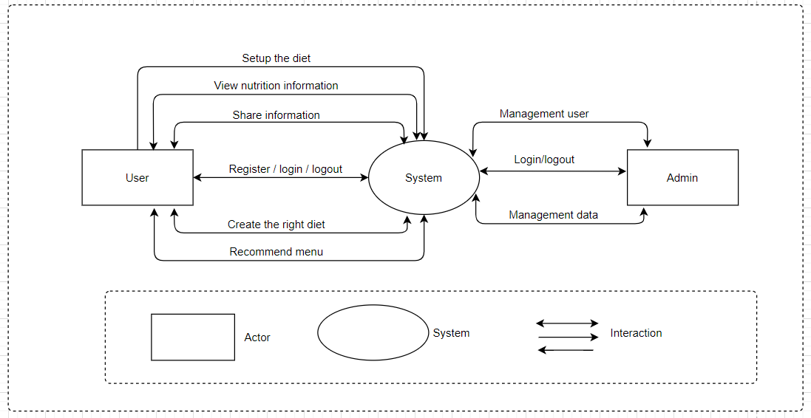

*Figure 1: System Context Diagram*

# **4. C&C view**

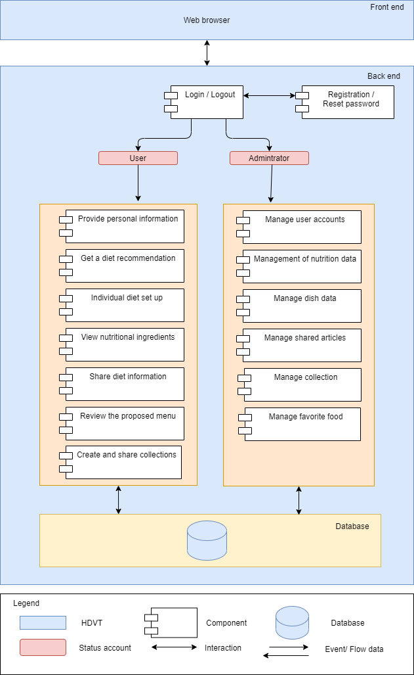We mainly used C&C view to argue and reason about architectural properties, quality attribute requirements, and functional requirements that the system must adhere to.

*Figure 2: Connector & Component View Diagram*

Prose

To process and authorize request from user, all packages are tied up together to authorize the association between user and data (Data Authorization Layer). All requests come from users firstly processed by middleware, it will determine user is authenticated to the system or not. Then, controllers can handle the business logic. All data access logic is controlled by repository to handle all the data access logics with the association of criteria layers to filter data of users that they can be retrieved. Finally, depending on endpoints, data will be responded to Database.

Role and Responsibility

|  |  |
| --- | --- |
| Component login/logout | Only when users log in can use the system's functions |
| Component registration/  reset password | Users register an account to use the system or renew a password to log into the system. |
| Status account | Represents usable objects in the system |
| Odm | Convert the object to JSON type in the database |
| Block Component 1 | Shows specific functions of user objects used in the system |
| Block Component 2 | Shows the functions and objects of users and sales objects that can be used together in the system. |
| Block component 3 | Represents the functionality that the sales object can be used in the system |
| Block component 4 | Represents the functionality that the admin object can use on the system |

# **5. Module view**

*Figure 3: Model View Diagram*

Prose

First, the index package's job is to configure and launch the program. In order to process and authorize requests from users, all packets are linked together to allow for association between the user and the data (Data Authorization Layer). All requests coming from the user are handled by the Route first, which contains the URL file of the user accessing the system. Then, this information is sent to the Controller, in the Controller there are methods to control (clean) the information. And Controller also connects to Lang to determine the language that the user is using. If there is something to be processed into the DB, it sends the information to the service. The service continues to process and send to the Model to get the data from the DB. Then, the information is sent back to the Service - Controller. Next, Controller sends this information to View. View accepts them and Public (contains CSS, JS, Font ...) to output hypertext content (HTML).

This information (HTML) is sent back to the Controller and exported to the user.

Role and Responsibility

|  |  |
| --- | --- |
| View | View receives data from Controller and Public to output hypertext content. This information is sent back to the Controller and exported to the user. |
| Route | It is a device on the network that connects, routes and transports the URL data files of the user accessing it |
| Config | Install the system configuration |
| Public | Store profiles, images, decorations, and effects in the UI of the system |
| Controller | Define methods support to call data from client. Appends with the processing language to determine which language the user is using. And responsibility interact with services to get data. |
| Validation | Constraint the data syntax when it is passed to the system |
| Lang | Switching the language and definition of system messages |
| Service | Responsibility to get request from controller after that interact with real-time database to handle business logic and return data result.  And then, get result and return to component package. Component will handle data and show for client |
| Index | The file that runs the system's source code |
| Model | Defined objects to handle business logic. |
| Node module | As a 3rd library running on Node JS platform, we can use the available libraries to operate the system more optimally. |

# **6. Allocation view**

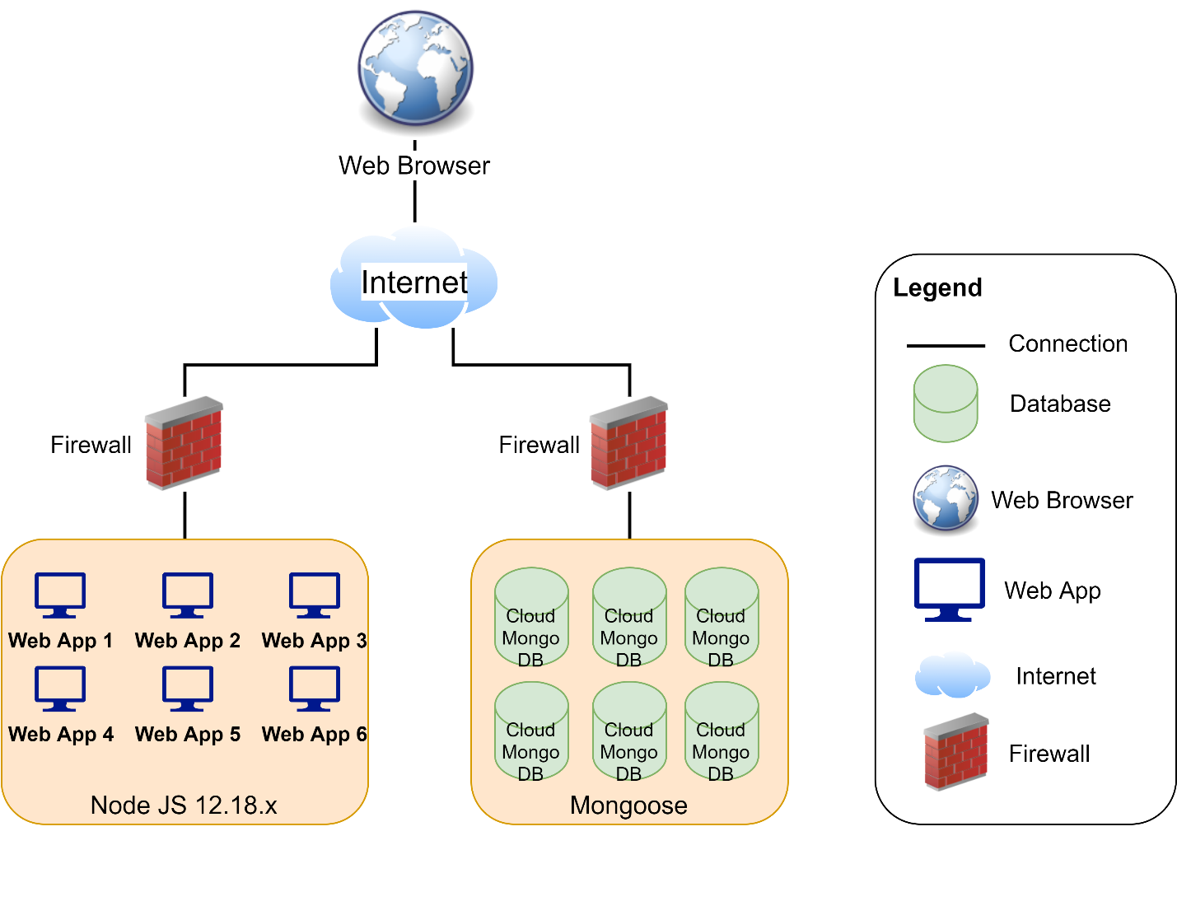

*Figure 4: Allocation View Diagram*

Prose

Client will use web browser (Apple Safari, Google Chrome, and so on) to access to the system. It required internet network if you use external link. Once you did access to the website, the Node JS environment will be processed handle, then the Express app connect to the Cloud Mongo DB through Internet to interact database between user and system. Any transaction between user and system will be implemented on Mongo DB.

**International School**

**Capstone Project 2**

CMU-SE 451

**Database Design**

**Version 1.4**

**Date: 22nd May, 2021**

**Submitted by**

Huynh Dac Vinh  
 Tran Quoc Trung

Ton That Minh Huy

Dang Van Duan

**Approved by**

**Proposal Review Panel Representative:**

NameSignature Date

**Capstone Project 2-Mentor:**

Name Signature Date

**Dang Viet Hung**

**PROJECT INFORMATION**

|  |  |  |  |
| --- | --- | --- | --- |
| **Project acronym** | FC | | |
| **Project Title** |  | | |
| **Start Date** | 01 Mar, 2021 | **End Date** | 25 May, 2021 |
| **Lead Institution** | International School, Duy Tan University | | |
| **Project Mentor** | Ph.D Hung, Dang Viet | | |
| **Scrum master / Project Leader & contact details** | Vinh, Huynh Dac  Email: dacvinh98@gmail.com  Tel: 0347191925 | | |
| **Partner Organization** |  | | |
| **Project Web URL** |  | | |
| **Team members** | Name | Email | Tel |
| 1 | Vinh, Huynh Dac | dacvinh98@gmail.com | 0347191925 |
| 2 | Trung, Tran Quoc | quoctrung.tran210@gmail.com | 0935420530 |
| 3 | Huy, Ton That Minh | tonthatminhh@gmail.com | 0935432561 |
| 4 | Duan, Dang Van | dangvanduan755@gmail.com | 0769710126 |

REVISION HISTORY

|  |  |  |  |  |
| --- | --- | --- | --- | --- |
| **Version** | **Date** | **Comments** | **Author** | **Approval** |
| 1.0 | 02/03/2021 | Initial Release | C2SE.18 team |  |
| 1.1 | 12/03/2021 | Update for sprint 1 | Trung, Tran Quoc |  |
| 1.2 | 10/04/2021 | Update for sprint 2 | Trung, Tran Quoc |  |
| 1.3 | 13/05/2021 | Update for sprint 3 | Trung, Tran Quoc |  |
| 1.4 | 22/05/2021 | Final | Vinh, Huynh Dac |  |
|  |  |  |  |  |

**Document Approval**

The following signatures are required for approval of this document

|  |  |  |
| --- | --- | --- |
| **Mentor** | Dang Viet Hung | Date: |
| **Scrum Master** | Huynh Dac Vinh | Date: |
| **Product Owner** | Tran Quoc Trung | Date: |
| **Team Member** | Ton That Minh Huy | Date: |
| **Team Member** | Dang Van Duan | Date: |

**Contents**

**1.** **Introduction:** 2

**1.1.** Purpose: 2

**1.2.** Goal: 2

**1.3.** Scope: 2

**1.4.** Definitions, Acronyms and Abbreviations: 2

**2.** **Database Design for Sprint 1:** 4

**2.1.** Schema Overview: 4

**2.2.** Entity Relationship Diagram: 4

**2.3.** Table Diagram: 6

**2.4.** Detail 6

**2.4.1.** Users: 6

**2.4.2.** Foods 7

**2.4.3.** probabilityofUser 8

**3.** **Database Design for Sprint 2:** 11

**3.1.** Schema Overview: 11

**3.2.** Entity Relationship Diagram: 11

**3.3.** Table Diagram: 13

**3.4.** Detail 13

**3.4.1.** Users: 13

**3.4.2.** Foods 14

**3.4.3.** ProbabilityofUser 15

**3.4.4.** Menus 17

**4.** **Database Design for Sprint 3:** 18

**4.1.** Schema Overview: 18

**4.2.** Entity Relationship Diagram: 19

**4.3.** Table Diagram: 20

**4.4.** Detail 21

**4.4.1.** Users: 21

**4.4.2.** Foods 21

**4.4.3.** Tokens 23

**4.4.4.** Collections 23

**4.4.5.** Favorites 23

**4.4.6.** Menus 24

# **Introduction:**

## Purpose:

Place information system’s database design document describes the structure of the database and file structure of the system. The database Design document will introduce all attributes of the System that will help developers and testers base on this design to implement and test.

## Goal:

To create the most accurate database for the system.

## Scope:

* This Database Design Document provides the basic for the Food Care Database design.
* It defines the Database which will support the “Food Care” Data Model.
* “Food Care” uses the No-SQL as MongoDB to store the data. Each Schema could be a table or be a field in the other table

## Definitions, Acronyms and Abbreviations:

|  |  |  |
| --- | --- | --- |
| **Abbreviations** | **Description** | **Comment** |
| PK | Primary | Use to indicate a file is a Primary key in a schema |
| FC | FoodCare – Diet Building System | Project title |
| R | Randomized | Randomized |
| CT | Current_Timestamp | On update Current_Timestamp |

# **Database Design for Sprint 1:**

## Schema Overview:

|  |  |  |
| --- | --- | --- |
| **No** | **Schema name** | **Short Description** |
| 1 | users | This table contains the information about users |
| 2 | foods | This table contains the information about the listed foods on the system |
| 3 | nutrients | This table contains the nutrient information of each ingredient |
| 4 | menus | This table contains the menu information of each user |

## Entity Relationship Diagram:

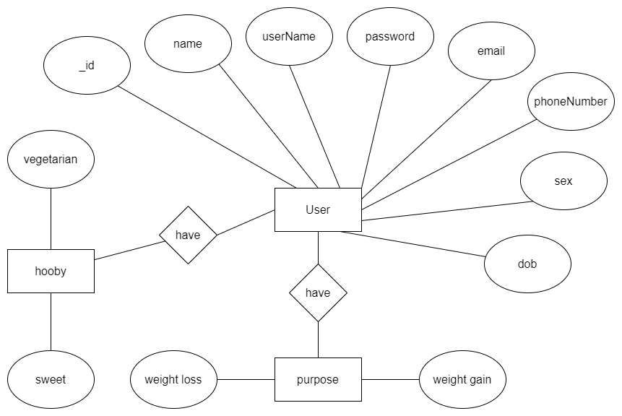

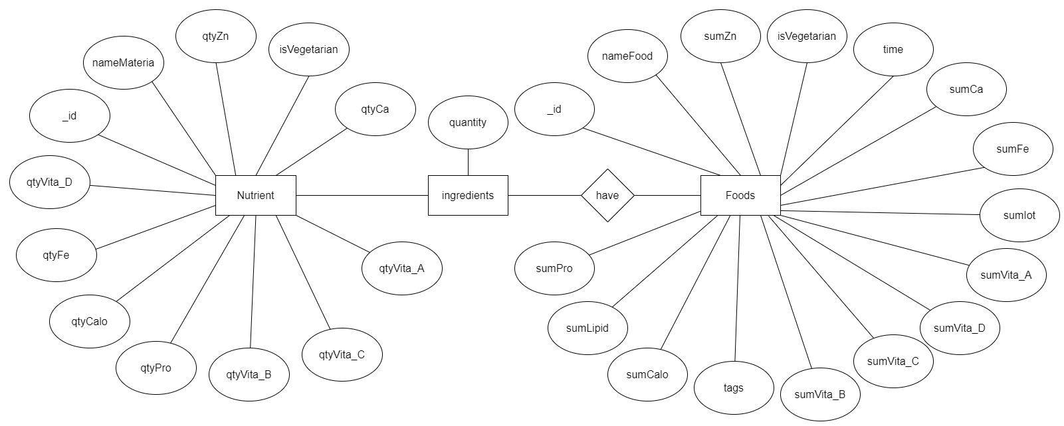

## Table Diagram:

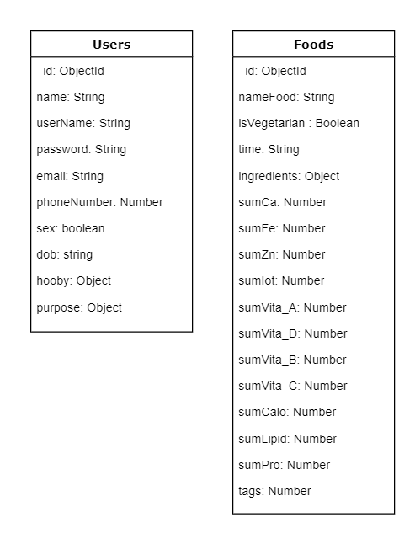

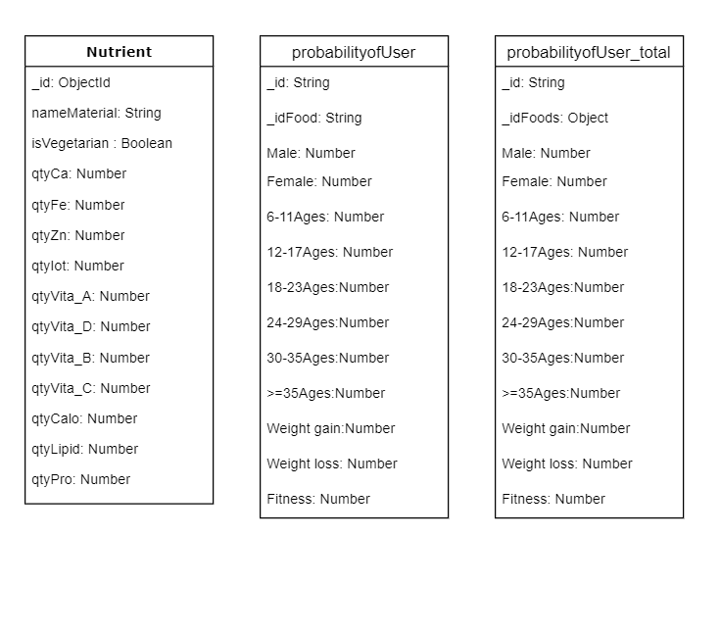

## Detail

### Users:

**This includes the attribute:**

**users**

|  |  |  |  |  |  |
| --- | --- | --- | --- | --- | --- |
| **Attributes** | **Datatype** | **Null** | **Key** | **Default** | **Extra** |
| _id | string | not | PK |  | R |
| name | string |  |  |  |  |
| userName | string |  |  |  |  |
| Password | string | not |  |  |  |
| email | string | not |  |  |  |
| phoneNumber | string |  |  |  |  |
| sex | boolean |  |  |  |  |
| dob | string |  |  |  |  |
| hooby | number |  |  |  |  |
| purpose | object |  |  |  |  |

### Foods

**This includes the attribute:**

**Foods**

|  |  |  |  |  |  |
| --- | --- | --- | --- | --- | --- |
| **Attributes** | **Datatype** | **Null** | **Key** | **Default** | **Extra** |
| _id | string | not | PK |  | R |
| nameFood | string | not |  |  |  |
| isVegetarian | boolean |  |  |  |  |
| Time | string |  |  |  |  |
| ingredients | object |  |  |  |  |
| sumCa | number |  |  |  |  |
| sumFe | number |  |  |  |  |
| sumZn | number |  |  |  |  |
| sumIot | number |  |  |  |  |
| sumVita_A | number |  |  |  |  |
| sumVita_D | number |  |  |  |  |
| sumVita_B | string |  |  |  |  |
| sumVita_C | number |  |  |  |  |
| sumCalo | number |  |  |  |  |
| sumLipid | number |  |  |  |  |
| sumPro | number |  |  |  |  |
| tags | number |  |  |  |  |

**Nutrient**

|  |  |  |  |  |  |
| --- | --- | --- | --- | --- | --- |
| **Attributes** | **Datatype** | **Null** | **Key** | **Default** | **Extra** |
| __id | string | not | PK |  | R |
| nameMaterial | string | not |  |  |  |
| isVegetarian | boolean |  |  |  |  |
| Time | string |  |  |  |  |
| ingredients | object |  |  |  |  |
| qtyCa | number |  |  |  |  |
| qtyFe | number |  |  |  |  |
| qtyZn | number |  |  |  |  |
| qtyIot | number |  |  |  |  |
| qtyVita_A | number |  |  |  |  |
| qtyVita_D | number |  |  |  |  |
| qtyVita_B | string |  |  |  |  |
| qtyVita_C | number |  |  |  |  |
| qtyCalo | number |  |  |  |  |
| qtyLipid | number |  |  |  |  |
| qtyPro | number |  |  |  |  |

### probabilityofUser

**This includes the attribute:**

**probabilityofUser**

|  |  |  |  |  |  |
| --- | --- | --- | --- | --- | --- |
| **Attributes** | **Datatype** | **Null** | **Key** | **Default** | **Extra** |
| _id | string | not | PK |  | R |
| _idFood | string | not |  |  |  |
| Male | number | not |  |  |  |
| Female | number | not |  |  |  |
| 6-11Ages | number | not |  |  |  |
| 12-17Ages | number | not |  |  |  |
| 18-23Ages | number | not |  |  |  |
| 24-29Ages | number | not |  |  |  |
| 30-35Ages | number | not |  |  |  |
| >=35Ages | number | not |  |  |  |
| Weight gain | number | not |  |  |  |
| Weight loss | number | not |  |  |  |
| Fitness | number | not |  |  |  |

**probabilityofUser_total**

|  |  |  |  |  |  |
| --- | --- | --- | --- | --- | --- |
| **Attributes** | **Datatype** | **Null** | **Key** | **Default** | **Extra** |
| _id | string | not | PK |  | R |
| _idFood | string | not |  |  |  |
| Male | number | not |  |  |  |
| Female | number | not |  |  |  |
| 6-11Ages | number | not |  |  |  |
| 12-17Ages | number | not |  |  |  |
| 18-23Ages | number | not |  |  |  |
| 24-29Ages | number | not |  |  |  |
| 30-35Ages | number | not |  |  |  |
| >=35Ages | number | not |  |  |  |
| Weight gain | number | not |  |  |  |
| Weight loss | number | not |  |  |  |
| Fitness | number | not |  |  |  |

# **Database Design for Sprint 2:**

## Schema Overview:

|  |  |  |
| --- | --- | --- |
| **No** | **Schema name** | **Short Description** |
| 1 | users | This table contains the information about users |
| 2 | foods | This table contains the information about the listed foods on the system |
| 3 | nutrients | This table contains the nutrient information of each ingredient |
| 4 | menus | This table contains the menu information of each user |

## Entity Relationship Diagram:





## Table Diagram:

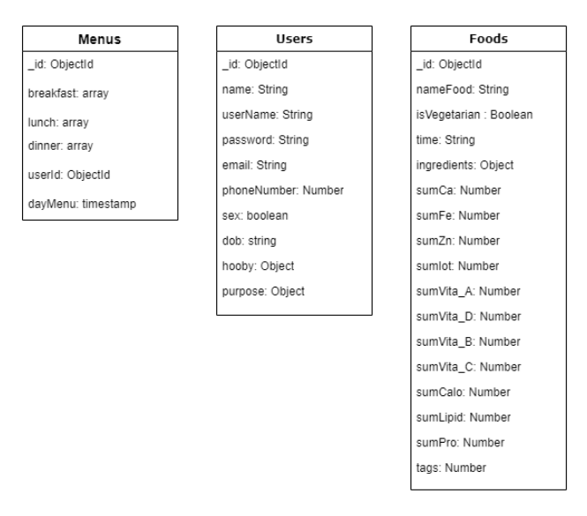



## Detail

### Users:

**This includes the attribute:**

**users**

|  |  |  |  |  |  |
| --- | --- | --- | --- | --- | --- |
| **Attributes** | **Datatype** | **Null** | **Key** | **Default** | **Extra** |
| _id | string | not | PK |  | R |
| name | string |  |  |  |  |
| userName | string |  |  |  |  |
| Password | string | not |  |  |  |
| email | string | not |  |  |  |
| phoneNumber | string |  |  |  |  |
| sex | boolean |  |  |  |  |
| dob | string |  |  |  |  |
| hooby | number |  |  |  |  |
| purpose | object |  |  |  |  |

### Foods

**This includes the attribute:**

**Foods**

|  |  |  |  |  |  |
| --- | --- | --- | --- | --- | --- |
| **Attributes** | **Datatype** | **Null** | **Key** | **Default** | **Extra** |
| _id | string | not | PK |  | R |
| nameFood | string | not |  |  |  |
| isVegetarian | boolean |  |  |  |  |
| Time | string |  |  |  |  |
| ingredients | object |  |  |  |  |
| sumCa | number |  |  |  |  |
| sumFe | number |  |  |  |  |
| sumZn | number |  |  |  |  |
| sumIot | number |  |  |  |  |
| sumVita_A | number |  |  |  |  |
| sumVita_D | number |  |  |  |  |
| sumVita_B | string |  |  |  |  |
| sumVita_C | number |  |  |  |  |
| sumCalo | number |  |  |  |  |
| sumLipid | number |  |  |  |  |
| sumPro | number |  |  |  |  |
| tags | number |  |  |  |  |

**Nutrient**

|  |  |  |  |  |  |
| --- | --- | --- | --- | --- | --- |
| **Attributes** | **Datatype** | **Null** | **Key** | **Default** | **Extra** |
| __id | string | not | PK |  | R |
| nameMaterial | string | not |  |  |  |
| isVegetarian | boolean |  |  |  |  |
| Time | string |  |  |  |  |
| ingredients | object |  |  |  |  |
| qtyCa | number |  |  |  |  |
| qtyFe | number |  |  |  |  |
| qtyZn | number |  |  |  |  |
| qtyIot | number |  |  |  |  |
| qtyVita_A | number |  |  |  |  |
| qtyVita_D | number |  |  |  |  |
| qtyVita_B | string |  |  |  |  |
| qtyVita_C | number |  |  |  |  |
| qtyCalo | number |  |  |  |  |
| qtyLipid | number |  |  |  |  |
| qtyPro | number |  |  |  |  |

### ProbabilityofUser

**This includes the attribute:**

**probabilityofUser**

|  |  |  |  |  |  |
| --- | --- | --- | --- | --- | --- |
| **Attributes** | **Datatype** | **Null** | **Key** | **Default** | **Extra** |
| _id | string | not | PK |  | R |
| _idFood | string | not |  |  |  |
| Male | number | not |  |  |  |
| Female | number | not |  |  |  |
| 6-11Ages | number | not |  |  |  |
| 12-17Ages | number | not |  |  |  |
| 18-23Ages | number | not |  |  |  |
| 24-29Ages | number | not |  |  |  |
| 30-35Ages | number | not |  |  |  |
| >=35Ages | number | not |  |  |  |
| Weight gain | number | not |  |  |  |
| Weight loss | number | not |  |  |  |
| Fitness | number | not |  |  |  |

**probabilityofUser_total**

|  |  |  |  |  |  |
| --- | --- | --- | --- | --- | --- |
| **Attributes** | **Datatype** | **Null** | **Key** | **Default** | **Extra** |
| _id | string | not | PK |  | R |
| _idFood | string | not |  |  |  |
| Male | number | not |  |  |  |
| Female | number | not |  |  |  |
| 6-11Ages | number | not |  |  |  |
| 12-17Ages | number | not |  |  |  |
| 18-23Ages | number | not |  |  |  |
| 24-29Ages | number | not |  |  |  |
| 30-35Ages | number | not |  |  |  |
| >=35Ages | number | not |  |  |  |
| Weight gain | number | not |  |  |  |
| Weight loss | number | not |  |  |  |
| Fitness | number | not |  |  |  |

### Menus

**This includes the attribute:**

**Menu**

|  |  |  |  |  |  |
| --- | --- | --- | --- | --- | --- |
| **Attributes** | **Datatype** | **Null** | **Key** | **Default** | **Extra** |
| _ id | ObjectId | not | PK |  | R |
| _breakfast | Array | not |  |  |  |
| lunch | Array | not |  |  |  |
| dinner | Array | not |  |  |  |
| userId | String | not |  |  |  |
| Date | Date | not |  |  |  |

# **Database Design for Sprint 3:**

## Schema Overview:

|  |  |  |
| --- | --- | --- |
| **No** | **Schema name** | **Short Description** |
| 1 | users | This table contains the information about users |
| 2 | foods | This table contains the information about the listed foods on the system |
| 3 | menus | This table contains the menu information of each user |
| 4 | tokens | This table contains tokens for login verification |
| 5 | collections | This table contains the food collections of the users |

## Entity Relationship Diagram:

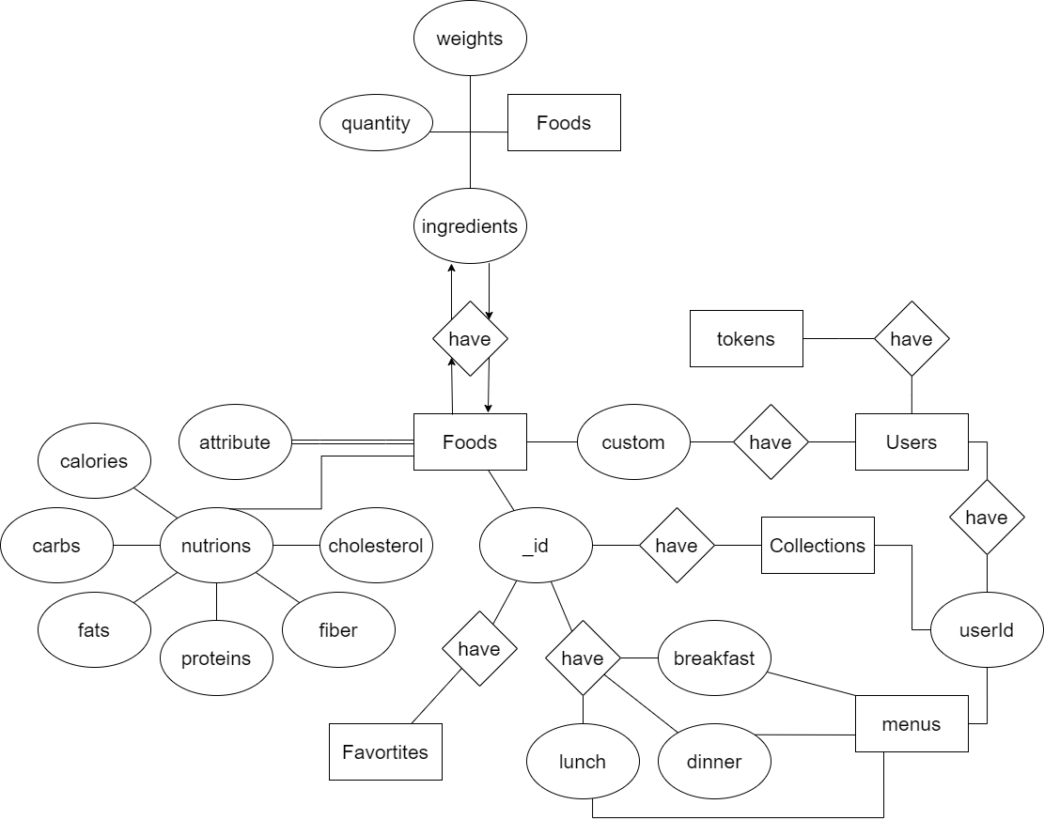

## Table Diagram:

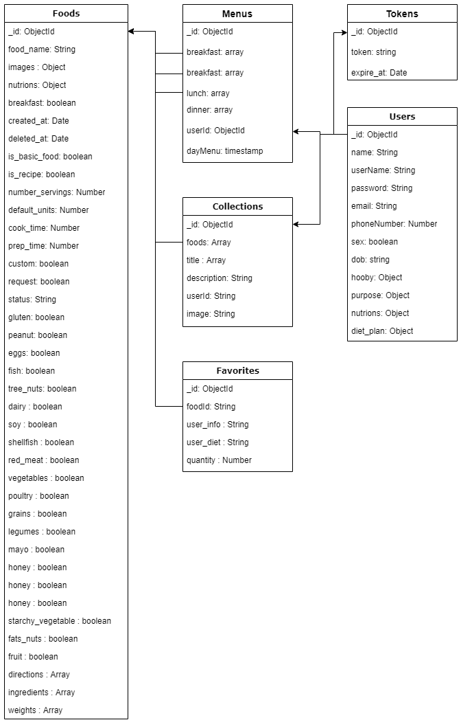

## Detail

### Users:

**This includes the attribute:**

**users**

|  |  |  |  |  |  |
| --- | --- | --- | --- | --- | --- |
| **Attributes** | **Datatype** | **Null** | **Key** | **Default** | **Extra** |
| _id | string | not | PK |  | R |
| name | string |  |  |  |  |
| userName | string |  |  |  |  |
| Password | string | not |  |  |  |
| email | string | not |  |  |  |
| phoneNumber | string |  |  |  |  |
| sex | boolean |  |  |  |  |
| dob | string |  |  |  |  |
| hooby | number |  |  |  |  |
| purpose | object |  |  |  |  |

### Foods

**This includes the attribute:**

**Foods**

|  |  |  |  |  |  |
| --- | --- | --- | --- | --- | --- |
| **Attributes** | **Datatype** | **Null** | **Key** | **Default** | **Extra** |
| _id | ObjectId | not | PK |  | R |
| id | number | not |  |  |  |
| food_name | string |  |  |  |  |
| images | object |  |  |  |  |
| nutrions | object |  |  |  |  |
| breakfast | boolean |  |  |  |  |
| created_at | Date |  |  |  |  |
| deleted_at | Date |  |  |  |  |
| is_basic_food | boolean |  |  |  |  |
| is_recipe | boolean |  |  |  |  |
| number_servings | number |  |  |  |  |
| default_units | number |  |  |  |  |
| cook_time | number |  |  |  |  |
| prep_time | number |  |  |  |  |
| custom | boolean |  |  |  |  |
| request | boolean |  |  |  |  |
| status | string |  |  |  |  |
| gluten | boolean |  |  |  |  |
| peanut | boolean |  |  |  |  |
| eggs | boolean |  |  |  |  |
| fish | boolean |  |  |  |  |
| tree_nuts | boolean |  |  |  |  |
| dairy | boolean |  |  |  |  |
| soy | boolean |  |  |  |  |
| shellfish | boolean |  |  |  |  |
| red_meat | boolean |  |  |  |  |
| vegetables | boolean |  |  |  |  |
| poultry | boolean |  |  |  |  |
| grains | boolean |  |  |  |  |
| legumes | boolean |  |  |  |  |
| mayo | boolean |  |  |  |  |
| honey | boolean |  |  |  |  |
| starchy_vegetables | boolean |  |  |  |  |
| fats_nuts | boolean |  |  |  |  |
| fruit | boolean |  |  |  |  |
| directions | Array |  |  |  |  |
| ingredients | Array |  |  |  |  |
| weights | Array |  |  |  |  |

### Tokens

**This includes the attribute:**

**Tokens**

|  |  |  |  |  |  |
| --- | --- | --- | --- | --- | --- |
| **Attributes** | **Datatype** | **Null** | **Key** | **Default** | **Extra** |
| _id | ObjectId | not | PK |  | R |
| token | string | not |  |  |  |
| expire_at | Date | not |  |  |  |

### Collections

**This includes the attribute:**

**Collections**

|  |  |  |  |  |  |
| --- | --- | --- | --- | --- | --- |
| **Attributes** | **Datatype** | **Null** | **Key** | **Default** | **Extra** |
| _ id | ObjectId | not | PK |  | R |
| foods | Array | not |  |  |  |
| title | Array | not |  |  |  |
| description | Array | not |  |  |  |
| userId | String | not |  |  |  |
| image | String | not |  |  |  |

### Favorites

**This includes the attribute:**

**Favorites**

|  |  |  |  |  |  |
| --- | --- | --- | --- | --- | --- |
| **Attributes** | **Datatype** | **Null** | **Key** | **Default** | **Extra** |
| _ id | ObjectId | not | PK |  | R |
| foodId | String | not |  |  |  |
| user_info | String | not |  |  |  |
| user_diet | String | not |  |  |  |
| quantity | number | not |  |  |  |

### Menus

**This includes the attribute:**

**Menu**

|  |  |  |  |  |  |
| --- | --- | --- | --- | --- | --- |
| **Attributes** | **Datatype** | **Null** | **Key** | **Default** | **Extra** |
| _ id | ObjectId | not | PK |  | R |
| breakfast | Array | not |  |  |  |
| lunch | Array | not |  |  |  |
| dinner | Array | not |  |  |  |
| userId | String | not |  |  |  |

**International School**

**Capstone Project 2**

CMU-SE 451

**User Interface Design**

**Version 1.2**

**Date: 25nd May, 2021**

**Food Care**

**Submitted by**

Huynh Dac Vinh  
 Tran Quoc Trung

Ton That Minh Huy

Dang Van Duan

**Approved by**

**Proposal Review Panel Representative:**

NameSignature Date

**Capstone Project 2-Mentor:**

Name Signature Date

**Dang Viet Hung**

**PROJECT INFORMATION**

|  |  |  |  |
| --- | --- | --- | --- |
| **Project acronym** | FC | | |
| **Project Title** | Food Care | | |
| **Start Date** | 01 Mar, 2021 | **End Date** | 25 May, 2021 |
| **Lead Institution** | International School, Duy Tan University | | |
| **Project Mentor** | Ph.D Hung, Dang Viet | | |
| **Scrum master / Project Leader & contact details** | Vinh, Huynh Dac  Email: dacvinh98@gmail.com  Tel: 0347191925 | | |
| **Partner Organization** |  | | |
| **Project Web URL** |  | | |
| **Team members** | Name | Email | Tel |
| 1 | Vinh, Huynh Dac | dacvinh98@gmail.com | 0347191925 |
| 2 | Trung, Tran Quoc | quoctrung.tran210@gmail.com | 0935420530 |
| 3 | Huy, Ton That Minh | tonthatminhh@gmail.com | 0935432561 |
| 4 | Duan, Dang Van | dangvanduan755@gmail.com | 0769710126 |

REVISION HISTORY

|  |  |  |  |  |
| --- | --- | --- | --- | --- |
| **Version** | **Date** | **Comments** | **Author** | **Approval** |
| 1.0 | 10/3/2021 | Initial Release | Ton That Minh Huy |  |
| 1.1 | 20/4/2021 | Updated document | Ton That Minh Huy |  |
| 1.2 | 25/5/2021 | Updated document | Ton That Minh Huy |  |
|  |  |  |  |  |

**Document Approval**

The following signatures are required for approval of this document

|  |  |  |
| --- | --- | --- |
| **Mentor** | Dang Viet Hung | Date: |
| **Scrum Master** | Huynh Dac Vinh | Date: |
| **Product Owner** | Tran Quoc Trung | Date: |
| **Team Member** | Ton That Minh Huy | Date: |
| **Team Member** | Dang Van Duan | Date: |

**Contents**

**1. Introduction:** 3

**1.1. Purpose** 3

**1.2. Scope:** 3

**2. List of User Interface for Sprint:** 3

**3. Describe User Interface for All** 5

**3.1. UI-01: Home page** 5

**3.2. UI-02: Login** 6

**3.3. UI-03: Register** 7

**3.4. UI-04: Update profile user** 8

**3.5. UI-05: Change password** 10

**3.6. UI-06: Browse food** 11

**3.7. UI-07: Profile (Edit status profile)** 12

**3.8. UI-08: Preferences (Meal & Layout)** 14

**3.9. UI-9: Preferences (Rate foods)** 15

**3.10. UI-10: Preferences (Diet & Nutrition)** 16

**3.11. UI-11: Preferences (Nutrition Profile Options)** 17

**3.12. UI-12: Preferences (Meal & Layout)** 18

**3.13. UI-13: Preferences (Add meals to the weekly planner)** 19

**3.14. UI-14: Preferences (Meal Settings)** 20

**3.15. UI-15: Collections** 21

**3.16. UI-16: Detail of collection** 22

**3.17. UI-17: Dashboard (Manage users)** 23

**3.18. UI-18: Dashboard (Manage foods)** 24

# **1. Introduction:**

## **1.1. Purpose**

This document describes the user interface of Food Care

## **1.2. Scope:**

Overview of the stages and modules of the software

Create complete interfaces, and describe them clearly

# **2. List of User Interface for Sprint:**

|  |  |  |  |
| --- | --- | --- | --- |
| Roles | User Interface ID | UI Name | Description |
| All | UI-01 | Homepage | The screen is used for showing all information about the system. |
| All | UI-02 | Login | The screen is used for login into the system. |
| User | UI-03 | Register | The screen is used for user register account into the system. |
| User | UI-04 | Edit profile | The screen is used for user edit profile into the system. |
| User | UI-05 | Change password | The screen is used for user change password account into the system. |
| User | UI-06 | Browse food | The screen is used to show list foods |
| User | UI-07 | Edit status profile | The screen is used for user edit status profile into the system. |
| User | UI-08 | Preferences (Meal & Layout) | The screen is used for user edit user’s meal into the system. |
| User | UI-09 | Preferences (Rate foods) | The screen is used for user rate foods into the system. |
| User | UI-010 | Preferences (Diet & Nutrition) | The screen is used for user select Diet type into the system. |
| User | UI-011 | Preferences (Nutrition Profile Options) | The screen is used for user add new Diet into the system. |
| User | UI-012 | Preferences (Meal & Layout) | The screen is used for user edit user’s meal into the system. |
| User | UI-013 | Preferences (Add meals to the weekly planner) | The screen is used for user add new meal into the system. |
| User | UI-014 | Preferences (Meal Settings) | The screen is used for user update meal into the system. |
| User | UI-015 | Collections | The screen is used for user see all collections into the system. |
| User | UI-016 | Detail of collection | The screen is used for user see collection’s detail into the system. |
| Admin | UI-017 | Dashboard (Manage users) | The screen is used for admin manage user into the system. |
| Admin | UI-018 | Dashboard (Manage foods) | The screen is used for admin manage foods into the system. |

# **3. Describe User Interface for All**

## **3.1. UI-01: Home page**

*Figure 1: Homepage*

|  |  |  |  |  |
| --- | --- | --- | --- | --- |
| **From** | **Condition** | **Null** | **Control Type** | **Target** |
| 1 | View |  | Section | Display homepage |

## **3.2. UI-02: Login**

*Figure 2: Login*

5

6

4

3

2

1

|  |  |  |  |  |
| --- | --- | --- | --- | --- |
| **From** | **Condition** | **Null** | **Control Type** | **Target** |
| 1 | Input |  | Textbox | Input user’s email |
| 2 | Input |  | Textbox | Input user’s password |
| 3 | Click |  | Link | Click to go register page |
| 4 | Click |  | Link | Click to go forgot password page |
| 5 | Click |  | Link | Click to agree remember login section |
| 6 | Click |  | Button | Click to login into the homepage |

## **3.3. UI-03: Register**

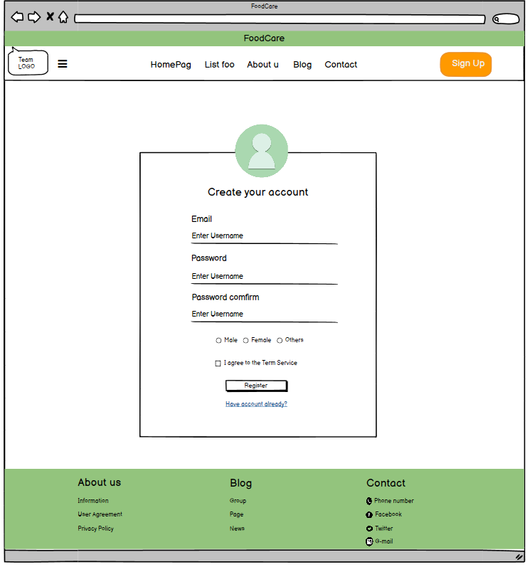

7

6

5

4

3

2

1

*Figure 3: Register*

|  |  |  |  |  |
| --- | --- | --- | --- | --- |
| **From** | **Condition** | **Null** | **Control Type** | **Target** |
| 1 | Input |  | Read only | Input user’s email |
| 2 | Input |  | Textbox | Input user’s password |
| 3 | Input |  | Textbox | Input user’s re-password |
| 4 | Click |  | Button | Click to agree term of service |
| 5 | Click |  | Link | Click to go to login page |
| 6 | Click |  | Button | Click to complete register |
| 7 | Click |  | Radio | Click to select sex |

## **3.4. UI-04: Update profile user**

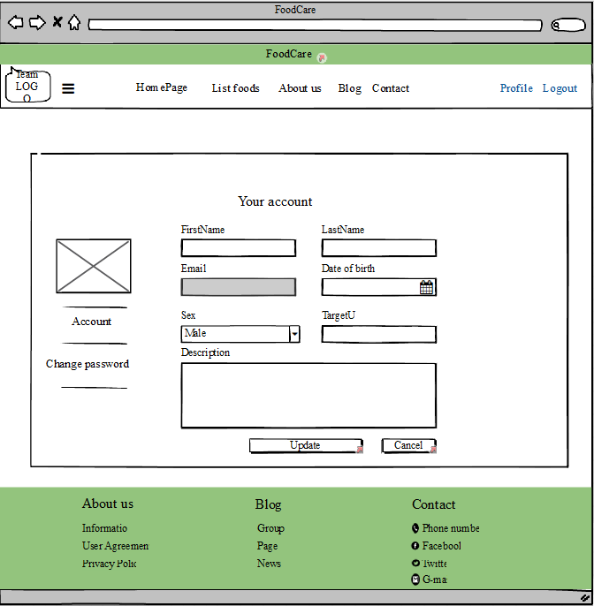

dd/mm/yyyy

12

11

10

2

1

6

3

4

7

9

8

5

*Figure 4: Edit profile user’s*

|  |  |  |  |  |
| --- | --- | --- | --- | --- |
| **From** | **Condition** | **Null** | **Control Type** | **Target** |
| 1 | Input |  | Read only | Input user’s email |
| 2 | Input |  | Textbox | Input user’s first name |
| 3 | Input |  | Textbox | Input user’s last name |
| 4 | Input |  | Select | Click to select date of birth |
| 5 | Input |  | Textbox | Input user’s date of birth |
| 6 | Combo box |  | Textbox | Click to select gender (male/female) |
| 7 | Input |  | Text area | User’s description |
| 8 | Click |  | Button | Click to cancel update profile |
| 9 | Click |  | Button | Click to save update profile |
| 10 | View |  | Section | View picture of user’s |
| 11 | Click |  | Link | Redirect user’s profile |
| 12 | Click |  | Link | Redirect user’s change password |

## **3.5. UI-05: Change password**

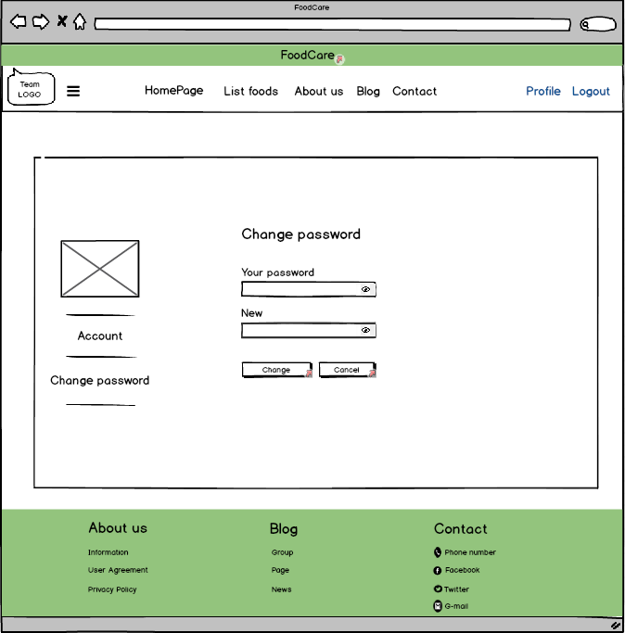

8

7

6

5

4

3

2

1

*Figure 5: Change password*

|  |  |  |  |  |
| --- | --- | --- | --- | --- |
| **From** | **Condition** | **Null** | **Control Type** | **Target** |
| 1 | Input |  | Textbox | Input user’s old password |
| 2 | Input |  | Textbox | Input user’s new password |
| 3 | Click |  | Button | Click to cancel change password |
| 4 | Click |  | Button | Click to save new password |
| 5 | View |  | Section | View picture of user’s |
| 6 | Click |  | Link | Redirect user’s profile |
| 7 | Click |  | Link | Redirect user’s change password |
| 8 | Click |  | Button | View password of user’s |

## **3.6. UI-06: Browse food**

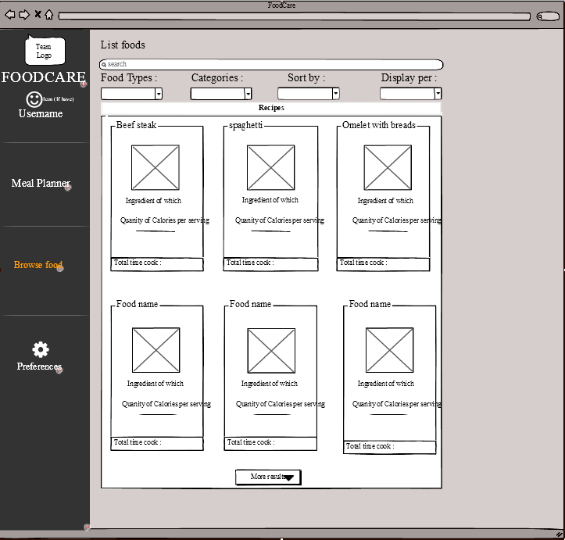

1

5

4

3

2

*Figure 6: Browse food*

|  |  |  |  |  |
| --- | --- | --- | --- | --- |
| **From** | **Condition** | **Null** | **Control Type** | **Target** |
| 1 | Click |  | Link | Click select option |
| 2 | Input |  | Textbox | Input food name |
| 3 | Combo box |  | Textbox | Click to select filter |
| 4 | View |  | Section | View details of food |
| 5 | Button |  | Textbox | Click to show more foods |

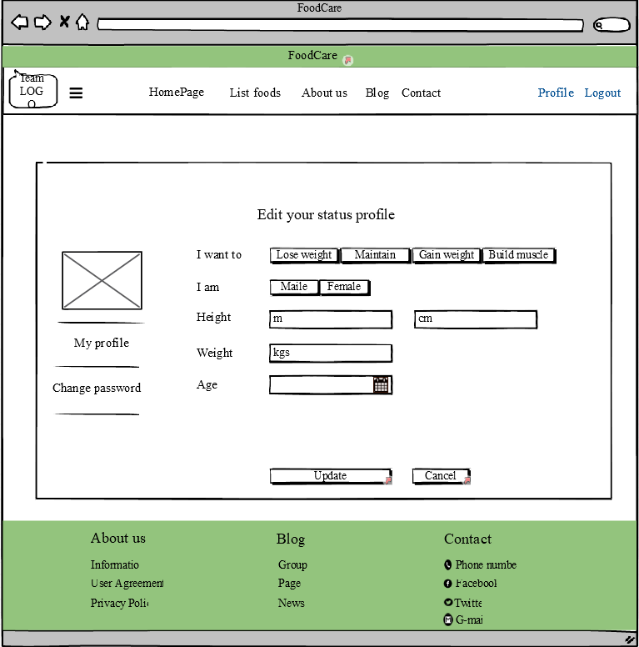

## **3.7. UI-07: Profile (Edit status profile)**

*Figure 7: Meal planner*

3

7

8

6

5

4

2

1

|  |  |  |  |  |
| --- | --- | --- | --- | --- |
| **From** | **Condition** | **Null** | **Control Type** | **Target** |
| 1 | Button |  | Select | Click select option |
| 2 | Button |  | Select | Click to select sex |
| 3 | Input |  | TextBox | Input your height(unit : m) |
| 4 | Input |  | TextBox | Input your height(unit : cm) |
| 5 | Input |  | TextBox | Input your weight(unit : kgs) |
| 6 | Input |  | Select | Click to select date of birth |
| 7 | Button |  | Select | Click to cancel update profile |
| 8 | Button |  | Select | Click to update profile |

## **3.8. UI-08: Preferences (Meal & Layout)**

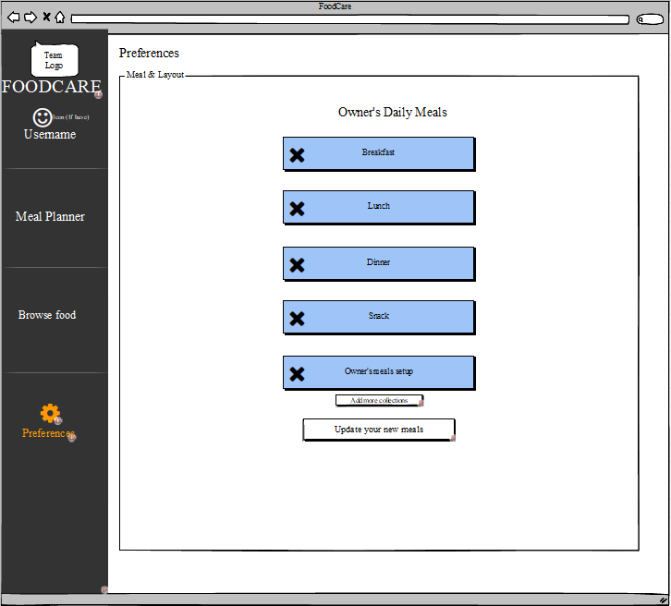

4

3

2

1

*Figure 8: Meal & Layout*

|  |  |  |  |  |
| --- | --- | --- | --- | --- |
| **From** | **Condition** | **Null** | **Control Type** | **Target** |
| 1 | Click |  | Link | Click select option |
| 2 | Click |  | Button | Click to delete your option |
| 3 | Click |  | Button | Click to add more your option |
| 4 | Click |  | Button | Click to update your option |

## **3.9. UI-9: Preferences (Rate foods)**

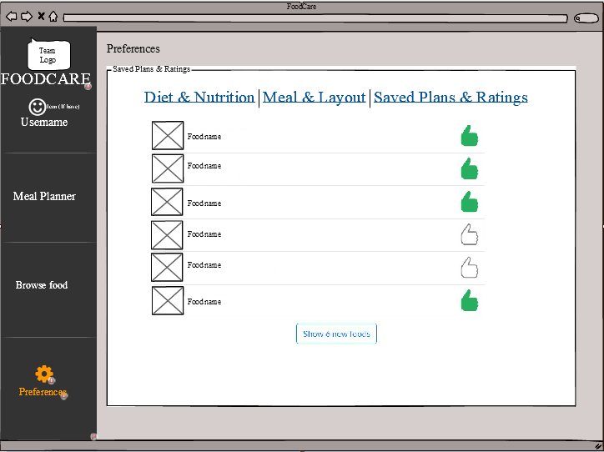

1

2

4

33

*Figure 9: Rate foods*

|  |  |  |  |  |
| --- | --- | --- | --- | --- |
| **From** | **Condition** | **Null** | **Control Type** | **Target** |
| 1 | Click |  | Link | Click select option |
| 2 | Click |  | Select | Click to select your favourite food |
| 3 | Click |  | Button | Click to show more foods |
| 4 | Click |  | TextBox | Click to show foods has been evaluated |
| 5 | View |  | Image | View food’s image |

## **3.10. UI-10: Preferences (Diet & Nutrition)**

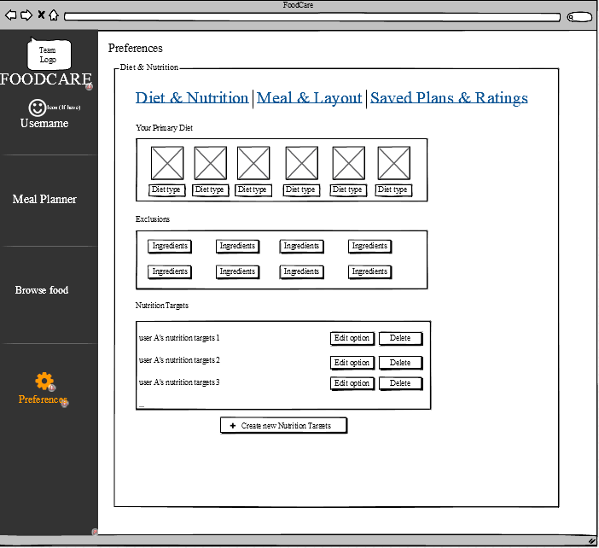

6

4

5

3

2

1

*Figure 10: Diet & Nutrition*

|  |  |  |  |  |
| --- | --- | --- | --- | --- |
| **From** | **Condition** | **Null** | **Control Type** | **Target** |
| 1 | Click |  | Link | Click select option |
| 2 | Click |  | Select | Click to select Diet type |
| 3 | Click |  | Select | Click to select ingredients |
| 4 | Click |  | Button | Click to delete nutrition target |
| 5 | Click |  | Button | Click to edit nutrition target |
| 5 | Click |  | Modal | Click to add new nutrition target |

## **3.11. UI-11: Preferences (Nutrition Profile Options)**

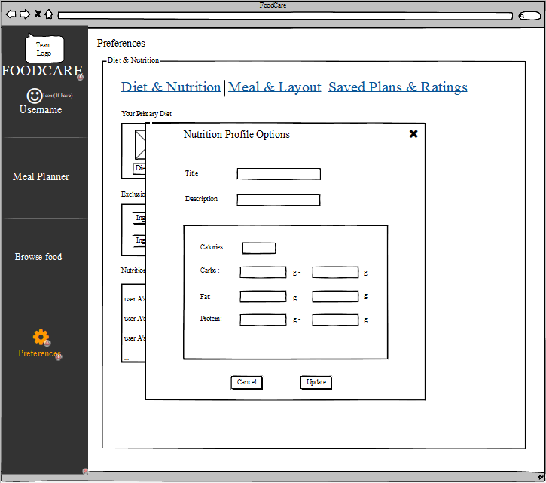

9

7

8

6

5

4

3

2

1

*Figure 11: Nutrition Profile Options*

|  |  |  |  |  |
| --- | --- | --- | --- | --- |
| **From** | **Condition** | **Null** | **Control Type** | **Target** |
| 1 | Input |  | TextBox | Input nutrition title |
| 2 | Input |  | TextBox | Input nutrition description |
| 3 | Input |  | TextBox | Input calories ingredient |
| 4 | Input |  | TextBox | Input cabs ingredient |
| 5 | Input |  | TextBox | Input fats ingredient |
| 6 | Input |  | TextBox | Input protein ingredient |
| 7 | Click |  | Button | Click to update new nutrition target |
| 8,9 | Click |  | Button | Click to close new nutrition target modal |

## **3.12. UI-12: Preferences (Meal & Layout)**

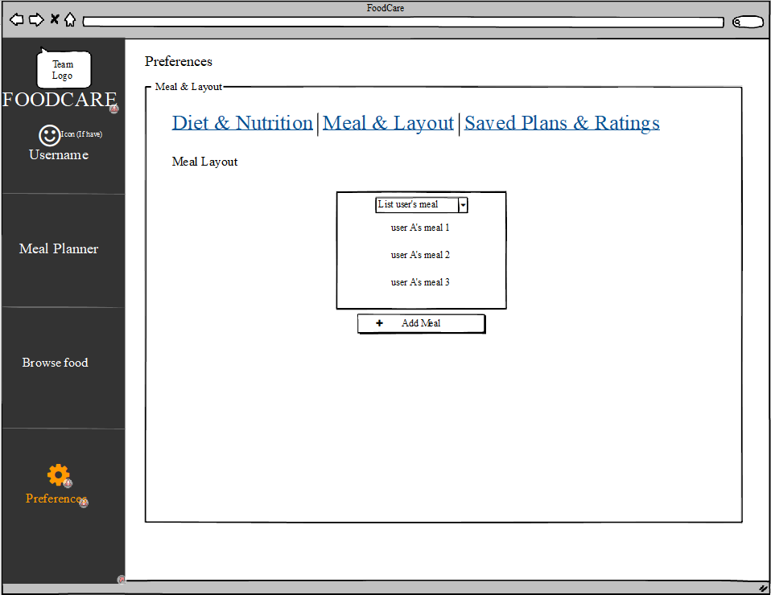

3

22

1

*Figure 12****:*** *Meal & Layout*

|  |  |  |  |  |
| --- | --- | --- | --- | --- |
| **From** | **Condition** | **Null** | **Control Type** | **Target** |
| 1 | Click |  | Link | Click select option |
| 2 | Click |  | Dropdown | Click to show list user’s meal |
| 3 | Click |  | Button | Click to show add new meal modal |

## **3.13. UI-13: Preferences (Add meals to the weekly planner)**

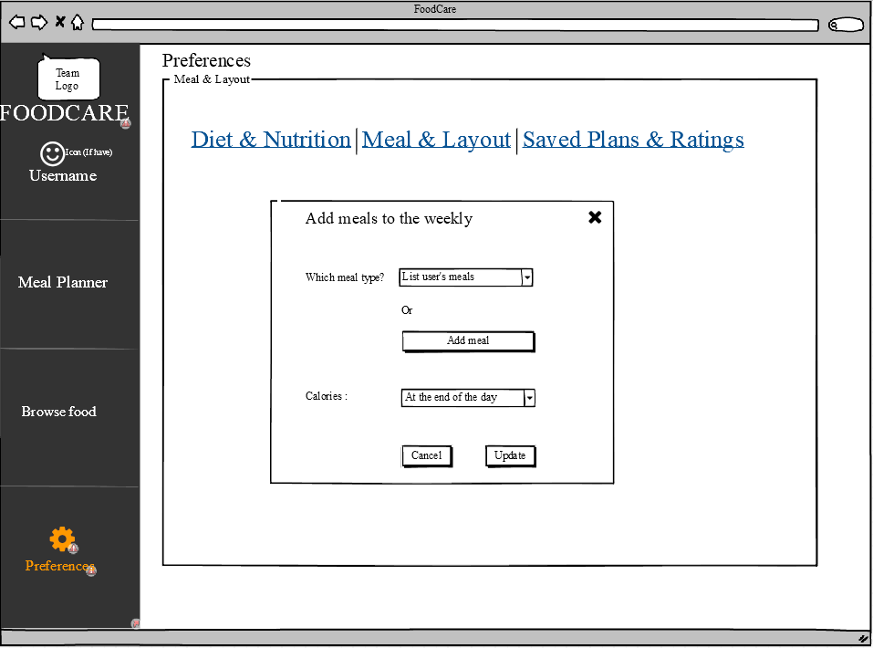

7

6

5

4

3

2

1

*Figure 13: Add meals to the weekly planner*

|  |  |  |  |  |
| --- | --- | --- | --- | --- |
| **From** | **Condition** | **Null** | **Control Type** | **Target** |
| 1 | Click |  | Link | Click select option |
| 2 | Click |  | Dropdown | Click to show list user’s meal |
| 3 | Click |  | Button | Add new user’s meal |
| 4 | Click |  | Dropdown | Click to select the day |
| 5 | Click |  | Button | Click to update new user’s meal |
| 6,7 | Click |  | Button | Click to close add meal modal |

## **3.14. UI-14: Preferences (Meal Settings)**

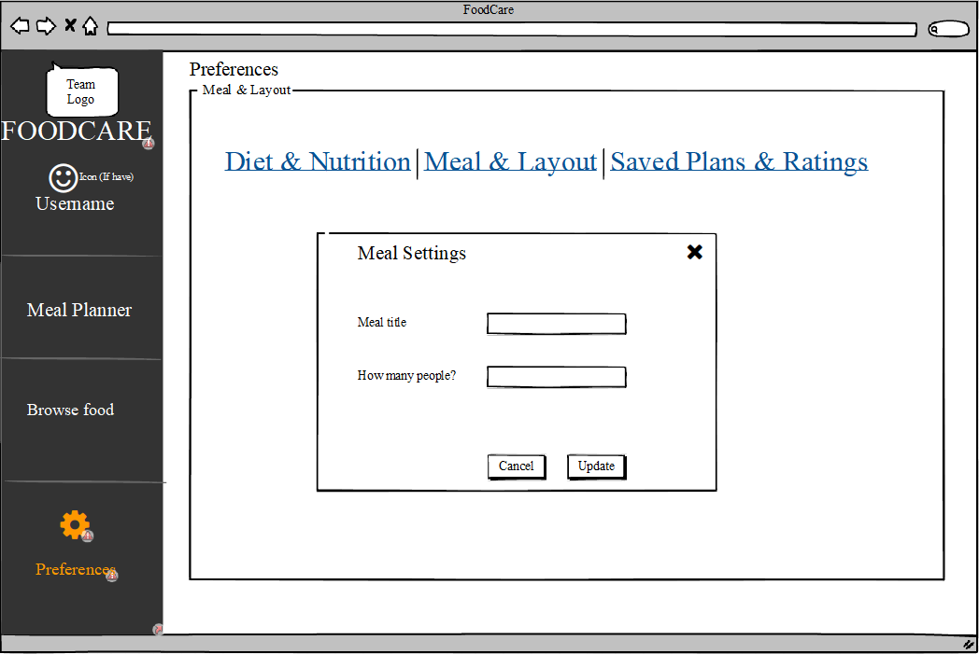

6

55

4

3

2

1

*Figure 14: Meal Settings*

|  |  |  |  |  |
| --- | --- | --- | --- | --- |
| **From** | **Condition** | **Null** | **Control Type** | **Target** |
| 1 | Click |  | Link | Click select option |
| 2 | Input |  | TextBox | Input meal title |
| 3 | Input |  | TextBox | Input quantity person |
| 4 | Click |  | Button | Click to update meal setting |
| 5,6 | Click |  | Button | Click to close meal setting modal |

## **3.15. UI-15: Collections**

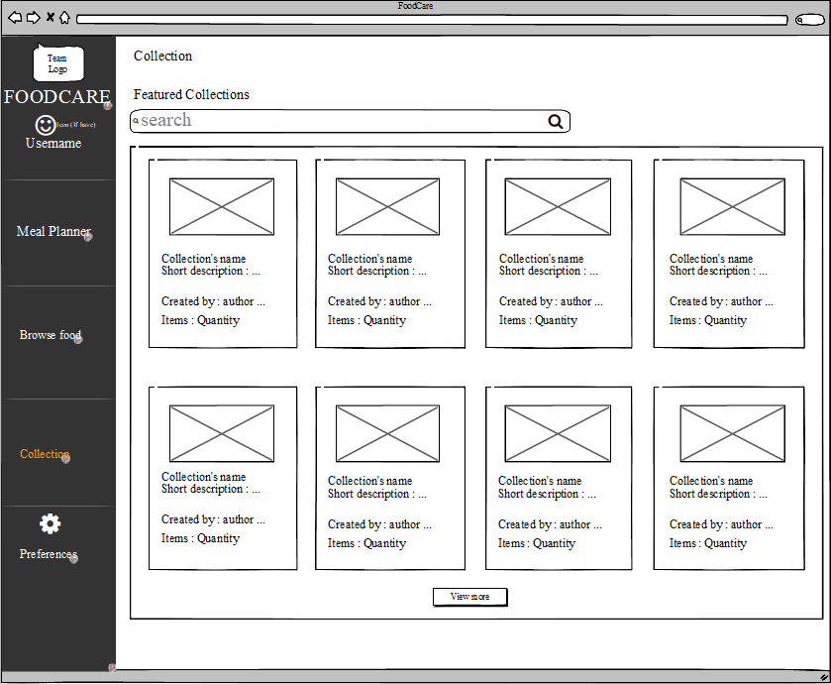

2

3

4

1

*Figure 15: Collections*

|  |  |  |  |  |
| --- | --- | --- | --- | --- |
| **From** | **Condition** | **Null** | **Control Type** | **Target** |
| 1 | Input |  | TextBox | Input collection need to find |
| 2 | Click |  | Button | Click to query collection need to find |
| 3 | View |  | Selection | Show recommended collections |
| 4 | Click |  | Butoon | Click to view more collection |

## **3.16. UI-16: Detail of collection**

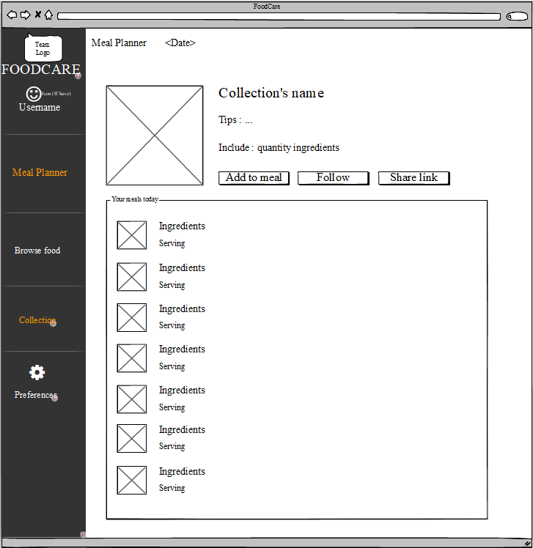

8

7

6

5

4

33

2

1

*Figure 16: Detail of collection*

|  |  |  |  |  |
| --- | --- | --- | --- | --- |
| **From** | **Condition** | **Null** | **Control Type** | **Target** |
| 1 | View |  | Label | Show collection’s thumbnail |
| 2 | View |  | Label | Show collection’s name |
| 3 | View |  | Label | Show collection’s tips |
| 4 | View |  | Label | Show collection’s quantity ingredients |
| 5 | Click |  | Button | Add more meal |
| 6 | Click |  | Button | Follow that collection |
| 7 | Click |  | Button | Share information of collection |
| 8 | View |  | Label | Show all ingredients of collection |

## **3.17. UI-17: Dashboard (Manage users)**

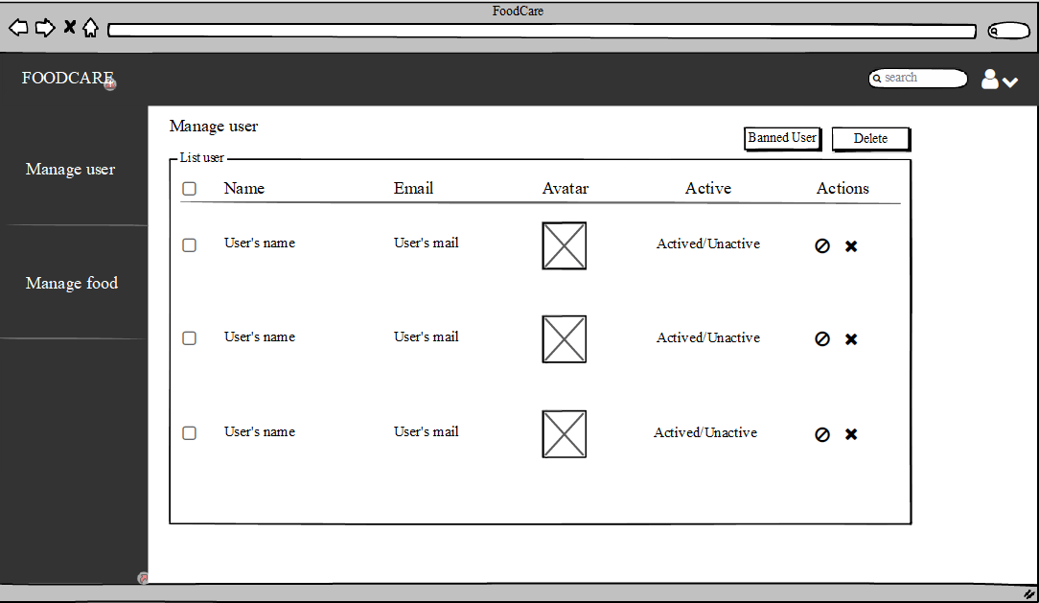

10

9

78

8

6

2

5

4

33

1

*Figure 17: Manage users*

|  |  |  |  |  |
| --- | --- | --- | --- | --- |
| **From** | **Condition** | **Null** | **Control Type** | **Target** |
| 1 | Click |  | Button | Click to ban user accounts |
| 2 | Click |  | Button | Click to delete user accounts |
| 3 | View |  | Column | Show user’s name column |
| 4 | View |  | Column | Show user’s email list |
| 5 | View |  | Column | Show user’s avatar list |
| 6 | View |  | Column | Show user’s status list |
| 7 | Click |  | Button | Click to ban a user list |
| 8 | Click |  | Button | Click to delete a user account |
| 9 | Click |  | Select | Click to select user account |
| 10 | Click |  | Button | Click to show admin profile |

## **3.18. UI-18: Dashboard (Manage foods)**

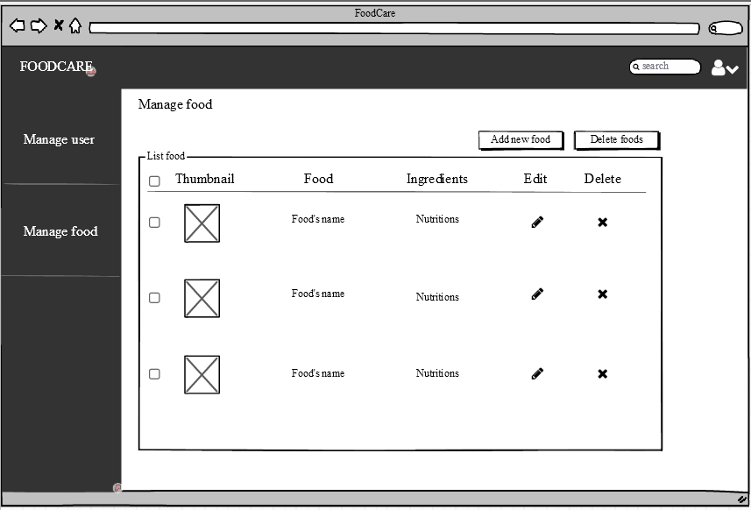

9

3

8

7

6

5

44

2

1

*Figure 18: Manage foods*

|  |  |  |  |  |
| --- | --- | --- | --- | --- |
| **From** | **Condition** | **Null** | **Control Type** | **Target** |
| 1 | Click |  | Button | Click to add new food |
| 2 | Click |  | Button | Click to delete foods |
| 3 | View |  | Column | Show food’s thumbnail list |
| 4 | View |  | Column | Show food’s name list |
| 5 | View |  | Column | Show food’s ingredients list |
| 6 | View |  | Column | Click to edit a food |
| 7 | Click |  | Button | Click to delete a food |
| 8 | Click |  | Button | Click to select foods |
| 9 | Click |  | Select | Click to show admin profile |

3

**International School**

**Capstone Project 2**

CMU-SE 451

**Code Standard**

**Version 1.0**

**Date: 22nd May, 2021**

**Food Care**

**Submitted by**

Huynh Dac Vinh  
 Tran Quoc Trung

Ton That Minh Huy

Dang Van Duan

**Approved by**

**Proposal Review Panel Representative:**

NameSignature Date

**Capstone Project 2-Mentor:**

Name Signature Date

**Dang Viet Hung**

**PROJECT INFORMATION**

|  |  |  |  |
| --- | --- | --- | --- |
| **Project acronym** | FC | | |
| **Project Title** | Food Care | | |
| **Start Date** | 01 Mar, 2021 | **End Date** | 25 May, 2021 |
| **Lead Institution** | International School, Duy Tan University | | |
| **Project Mentor** | Ph.D Hung, Dang Viet | | |
| **Scrum master / Project Leader & contact details** | Vinh, Huynh Dac  Email: dacvinh98@gmail.com  Tel: 0347191925 | | |
| **Partner Organization** |  | | |
| **Project Web URL** |  | | |
| **Team members** | Name | Email | Tel |
| 1 | Vinh, Huynh Dac | dacvinh98@gmail.com | 0347191925 |
| 2 | Trung, Tran Quoc | quoctrung.tran210@gmail.com | 0935420530 |
| 3 | Huy, Ton That Minh | tonthatminhh@gmail.com | 0935432561 |
| 4 | Duan, Dang Van | dangvanduan755@gmail.com | 0769710126 |

REVISION HISTORY

|  |  |  |  |  |
| --- | --- | --- | --- | --- |
| **Version** | **Date** | **Comments** | **Author** | **Approval** |
| 1.1 | 22/05/2021 | Final | Vinh, Huynh Dac |  |
|  |  |  |  |  |

**Document Approval**

The following signatures are required for approval of this document

|  |  |  |
| --- | --- | --- |
| **Mentor** | Dang Viet Hung | Date: |
| **Scrum Master** | Huynh Dac Vinh | Date: |
| **Product Owner** | Tran Quoc Trung | Date: |
| **Team Member** | Ton That Minh Huy | Date: |
| **Team Member** | Dang Van Duan | Date: |

**Contents**

**1. Introduction:** 3

**2. Purpose of coding standards and best practices:** 3

**3. How to follow the standards across the team:** 3

**4. ES6 Features:** 4

**5. Indentation:** 5

**6. Comments:** 6

**7. Variable Declarations:** 6

**8. Operators and comparison:** 6

**9. Control statements:** 7

**10. Strings:** 7

**11. Conditionals:** 7

**12. Functions and objects:** 7

**13. Arrays** 9

**14. Error handling** 9

**15. REFERENCES** 10

# **1. Introduction:**

Anybody can write code. With a few months of programming experience, you can write 'working applications'. Making it work is easy, but doing it the right way requires more work, than just making it work. Believe it, the majority of the programmers write 'working code', but not ‘good code'. Writing 'good code' is an art and you must learn and practice it.

Everyone may have different definitions for the term ‘good code’. In my definition, the following are the characteristics of a good code.

● Reliable

● Maintainable

● Efficient

Most of the developers are inclined towards writing code for higher performance, compromising reliability, and maintainability. But considering the long term ROI (Return On Investment), efficiency and performance come below reliability and maintainability. If your code is not reliable and maintainable, you (and your company) will be spending a lot of time identifying issues, trying to understand code, etc. throughout the life of your application.

# **2. Purpose of coding standards and best practices:**

To develop reliable and maintainable applications, you must follow coding standards and best practices.

The naming conventions, coding standards, and best practices described in this document are compiled from our own experience and by referring to various MDN and Google guidelines.

Several standards exist in the programming industry. None of them are wrong or bad and you may follow any of them. What is more important is, selecting one standard approach and ensuring that everyone is following it.

# **3. How to follow the standards across the team:**

If you have a team of different skills and tastes, you are going to have a tough time convincing everyone to follow the same standards. The best approach is to have a team meeting and develop your own standards document. You may use this document as a template to prepare your document.

Distribute a copy of this document (or your coding standard document) well ahead of the coding standards meeting. All members should come to the meeting prepared to discuss the pros and cons of the various points in the document. Make sure you have a manager present in the meeting to resolve conflicts.

Discuss all points in the document. Everyone may have a different opinion about each point, but at the end of the discussion, all members must agree upon the standard you are going to follow. Prepare a new standards document with appropriate changes based on the suggestions from all of the team members. Print copies of it and post it in all workstations.

After you start the development, you must schedule code review meetings to ensure that everyone is following the rules. 3 types of code reviews are recommended:

1. Peer review – another team member reviews the code to ensure that the code follows the coding standards and meets requirements. This level of review can include some unit testing also. Every file in the project must go through this process.

2. Architect review – the architect of the team must review the core modules of the project to ensure that they adhere to the design and there are no “big” mistakes that can affect the project in the long run.

3. Group review – randomly select one or more files and conduct a group review once a week. Distribute a printed copy of the files to all team members 30 minutes before the meeting. Let them read and come up with points for discussion. In the group review meeting, use a projector to display the file content on the screen. Go through every section of the code and let every member give their suggestions on how that piece of code can be written in a better way. (Don’t forget to appreciate the developer for the good work and also make sure he does not get offended by the “group attack”!).

# **4. ES6 Features:**

JavaScript ES6 brings new syntax and new awesome features to make your code more modern and more readable. It allows you to write less code and do more. ES6 introduces us to many great features like arrow functions, template strings, class destruction, Modules… and more.

1. Const and Let

const is a new keyword in ES6 for declaring variables. const is more powerful than var. Once used, the variable can’t be reassigned. In other words, it’s an immutable variable except when it is used with objects.

This is really useful for targeting the selectors. For example, when we have a single button that fires an event, or when you want to select an HTML element in JavaScript, use const instead of var. This is because var is ‘hoisted’. It’s always preferable to use const when you don't want to reassign the variable.

let can be reassigned and take new value. It creates a mutable variable.

let is the same as const in that both are blocked-scope. It means that the variable is only available within its scope.

2. Arrow functions

The arrow function is really awesome and makes your code more readable, more structured, and looks like modern code.

Template Literals

Template literals or template strings are pretty cool. We don’t have to use the plus (+) operator to concatenate strings, or when we want to use a variable inside a string.

3. Default parameters

In JavaScript, function parameters default to undefined. However, it's often useful to set a different default value. This is where default parameters can help.

In the past, the general strategy for setting defaults was to test parameter values in the function body and assign a value if they are undefined.

4. Array and object destructing

Destruction makes the assignment of the values of an array or object to the new variable easier.

With ES5, we have to assign each value to each variable. With ES6, we just put our values within curly brackets to get any property of the object.

5. Import and export

Using import and export in your JavaScript application makes it more powerful. They allow you to create separate and reusable components.

6. Promises

Promises are a new feature of ES6. It’s a method to write asynchronous code. It can be used when, for example, we want to fetch data from an API, or when we have a function that takes time to be executed. Promises make it easier to solve the problem.

7. Rest parameter and Spread operator

The rest parameters are used to get the argument of an array and return a new array.

The spread operator has the same syntax as the rest parameter, but the spread operator takes the Array itself and not just the arguments. We can use the Spread parameter to get the values of an Array, instead of using a for loop or any other method.

8. Classes

Classes are the core of object-oriented programming (OOP). They make your code more secure and encapsulated. Using classes gives your code a nice structure and keeps it oriented.

# **5. Indentation:**

The unit of indentation is four spaces. Use of tabs should be avoided because (as of this writing in the 21st Century) there still is not a standard for the placement of tab stops. The use of spaces can produce a larger file size, but the size is not significant over local networks, and the difference is eliminated by minification.

# **6. Comments:**

Be generous with comments. It is useful to leave information that will be read at a later time by people (possibly yourself) who will need to understand what you have done. The comments should be well-written and clear, just like the code they are annotating. An occasional nugget of humor might be appreciated. Frustrations and resentments will not.

Comments must be kept up-to-date. Erroneous comments can make programs even harder to read and understand.

Make comments meaningful. Focus on what is not immediately visible. Don't

waste the reader's time with stuff like:

i = 0; // Set i to zero.

Generally, use line comments. Save block comments for formal documentation.

# **7. Variable Declarations:**

1. Variable naming

For variable names use lowerCamelCasing and use concise, human-readable, semantic names where appropriate.

let playerScore = 0;

let speed = distance / time;

2. Declaring variables

When declaring variables and constants, use the let and const keywords, not var.

If a variable will not be reassigned, prefer const:

const myName = 'Chris';

console.log(myName);

# **8. Operators and comparison:**

Ternary operators:

Ternary operators should be put on a single line:

let status = (age >= 18) ? 'adult' : 'minor';

Use strict equality:

Always use strict equality and inequality.

name === 'Chris';

age !== 25;

Use shortcuts for boolean tests

Use shortcuts for boolean tests — use x and !x, not x === true and x === false.

# **9. Control statements:**

There should be no space between a control statement keyword and its opening parenthesis.

There should be a space between the parentheses and the opening curly brace.

if(iceCream) {

alert('Woo hoo!');

}

# **10. Strings:**

Use template literals

let myName = 'Chris';

console.log(`Hi! I'm ${myName}!`);

Use textContent, not innerHTML

When inserting strings into DOM nodes, use Node.textContent:

let text = 'Hello to all you good people';

const para = document.createElement('p');

para.textContent = text;

# **11. Conditionals:**

When loops are required, feel free to choose an appropriate loop out of the available ones (for, for...of, while, etc.) Just make sure to keep the code as understandable as possible.

When using for/for...of loops, make sure to define the initializer properly, with a let keyword:

let cats = ['Athena', 'Luna'];

for(let i of cats) {

console.log(i);

}

# **12. Functions and objects:**

1. Function naming

For function names use lowerCamelCasing and use concise, human-readable, semantic names where appropriate.

function sayHello() {

alert('Hello!');

};

2. Defining functions

Where possible, use the function declaration to define functions over function expressions:

function sum(a, b) {

return a + b;

}

When using anonymous functions inside a method that requires a function as a parameter, it is acceptable (although not required) to use an arrow function to make the code shorter and cleaner.

let sum = (a, b) => {

return a + b;

}

3. Creating objects

Use literals — not constructors — for creating general objects (i.e., when classes are not involved):

let myObject = {};

4. Object classes

class Person {

constructor(name, age, gender) {

this.name = name;

this.age = age;

this.gender = gender;

}

greeting() {

console.log(`Hi! I'm ${this.name}`);

};

}

Use extends for inheritance:

class Teacher extends Person {

...

}

5. Object naming

When defining an object class (as seen above), use UpperCamelCasing (also known as PascalCasing) for the class name, and lowerCamelCasing for the object property and method names.

When defining an object instance, either a literal or via a constructor, use lowerCamelCase for the instance name:

let hanSolo = new Person('Han Solo', 25, 'male');

let hanSolo = {

name: 'Han Solo',

age: 25,

gender: 'male'

}

# **13. Arrays**

Creating arrays

Use literals — not constructors — for creating arrays:

let myArray = [ ];

Adding to an array

When adding items to an array, use push(), not direct assignment. Given the following array:

const pets = [];

# **14. Error handling**

If certain states of your program throw uncaught errors, they will halt execution and potentially reduce the usefulness of the example. You should therefore catch errors using a try...catch block:

try {

console.log(results);

}

catch(e) {

console.error(e);

}

# **15. REFERENCES**

Freecodecamp. (2020, December 14). *JavaScript ES6 — write less, do more*. Retrieved from https://www.freecodecamp.org/news/write-less-do-more-with-javascript-es6-5fd4a8e50ee2/

MDN. (2020, December 14). *Javascript_guidelines*. Retrieved from https://developer.mozilla.org/en-US/docs/MDN/Guidelines/Code_guidelines/JavaScript

**International School**

**Capstone Project 2**

CMU-SE 451

**Test Plan**

**Version 1.4**

**Date: 25nd May, 2021**

**Food Care**

**Submitted by**

Huynh Dac Vinh  
 Tran Quoc Trung

Ton That Minh Huy

Dang Van Duan

**Approved by**

**Proposal Review Panel Representative:**

NameSignature Date

**Capstone Project 2-Mentor:**

Name Signature Date

**Dang Viet Hung**

**PROJECT INFORMATION**

|  |  |  |  |
| --- | --- | --- | --- |
| **Project acronym** | FC | | |
| **Project Title** | Food Care | | |
| **Start Date** | 01 Mar, 2021 | **End Date** | 25 May, 2021 |
| **Lead Institution** | International School, Duy Tan University | | |
| **Project Mentor** | Ph.D Hung, Dang Viet | | |
| **Scrum master / Project Leader & contact details** | Vinh, Huynh Dac  Email: dacvinh98@gmail.com  Tel: 0347191925 | | |
| **Partner Organization** |  | | |
| **Project Web URL** |  | | |
| **Team members** | Name | Email | Tel |
| 1 | Vinh, Huynh Dac | dacvinh98@gmail.com | 0347191925 |
| 2 | Trung, Tran Quoc | quoctrung.tran210@gmail.com | 0935420530 |
| 3 | Huy, Ton That Minh | tonthatminhh@gmail.com | 0935432561 |
| 4 | Duan, Dang Van | dangvanduan755@gmail.com | 0769710126 |

REVISION HISTORY

|  |  |  |  |  |
| --- | --- | --- | --- | --- |
| **Version** | **Date** | **Comments** | **Author** | **Approval** |
| 1.0 | 02/03/2021 | Initial Release | Duan, Dang Van |  |
| 1.1 | 12/03/2021 | Update for sprint 1 | Duan, Dang Van |  |
| 1.2 | 10/04/2021 | Update for sprint 2 | Duan, Dang Van |  |
| 1.3 | 13/05/2021 | Update for sprint 3 | Duan, Dang Van |  |
| 1.4 | 22/05/2021 | Final | Vinh, Huynh Dac |  |
|  |  |  |  |  |

**Document Approval**

The following signatures are required for approval of this document

|  |  |  |
| --- | --- | --- |
| **Mentor** | Dang Viet Hung | Date: |
| **Scrum Master** | Huynh Dac Vinh | Date: |
| **Product Owner** | Tran Quoc Trung | Date: |
| **Team Member** | Ton That Minh Huy | Date: |
| **Team Member** | Dang Van Duan | Date: |

**Contents**

**1. Introduction:** 3

**1.1. Purpose:** 3

**1.2. References:** 3

**1.3. Background information:** 3

**1.4. Scope of testing:** 3

**1.5. Risk list:** 4

**2. Requirements for test** 4

**2.1. Test items:** 4

**3.1. Entry Criteria** 9

**3.2. Exit Criteria** 9

**4. Test strategy** 9

**4.1. Test stages:** 9

**4.2. Tools** 10

**5. Resource** 10

**5.1. Human Resource** 10

**6. Test Milestone** 10

# **1. Introduction:**

A test plan is a detailed software verification document that provides specifics on how the validate will test all aspects of the software design. This test plan document contains a description of test cases to be written for each function, and a description of the testing platform to be used.

## **1.1. Purpose:**

The purpose of the Test Plan is to define, schedule and monitor the test execution. It supports the following objectives:

* Provide a list of test functions.
* List the Requirements for Test.
* Describe the testing strategies to test functions.
* Identify the required resources and schedule the Test execution

## **1.2. References:**

|  |  |  |
| --- | --- | --- |
| **No.** | **Reference** | **Document Information** |
| 1 | Test plan Template | Test plan template of Hung from mentor |
| 2 | Proposal | C2SE.18-Proposal_Ver.1.1 |
| 3 | Product Backlog | C2SE.18-ProductBacklog_Ver.1.0 |
| 4 | Project Plan | C1SE.18-ProjectPlan_Ver.1.0 |

## **1.3. Background information:**

As introduced in the Proposal document, there are many things all the members in the team must do. However, the project duration is 3 months. This project has a scope to meet the time constraint.

## **1.4. Scope of testing:**

This Test Plan is for release TEST PLAN FOR SECURE Food Care – Diet Building System. The Test Plan defines the unit, system testing approach. The test scope includes the following:

* Testing of all functions, application performance and use cases requirements listed in the Product Backlog document
* Quality requirements and fit “Food Care system” metrics
* End-to-end testing of “Food Care system” Platform

## **1.5. Risk list:**

|  |  |  |  |
| --- | --- | --- | --- |
| **No.** | **Risk** | **The plan for corrective** | **The level of influence** |
| **1** | **Time** | Work overtime on Sunday | High |
| **2** | **Experience** | Experience sharing used to reduce the research time. | Medium |

# **2. Requirements for test**

## **2.1. Test items:**

The following list describes the features that will be tested:

|  |  |  |  |
| --- | --- | --- | --- |
| **No** | **Function** | **Type test case** | **Note** |
| **1** | **Sprint1** |  |  |
| 1.1 | Design test case for " Register" | User interface, Function Test |  |
| 1.2 | Design test case for "Login for user " | User interface, Function Test |  |
| 1.3 | Design test case for "Logout " | User interface, Function Test |  |
| 1.4 | Design test case for " Change password" | User interface, Function Test |  |
| 1.5 | Design test case for "Reset password " | User interface, Function Test |  |
| 1.6 | Design test case for " Edit profile" | User interface, Function Test |  |
| 1.7 | Design test case for "Filter food " | User interface, Function Test |  |
| 1.8 | Design test case for "Search food " | User interface, Function Test |  |
| 1.9 | Design test case for "View food detail " | User interface, Function Test |  |
| 1.10 | Design test case for "Add food favorite list " | User interface, Function Test |  |
| 1.11 | Design test case for "View favorite list " | User interface, Function Test |  |
| 1.12 | Design test case for "Remove food favorite list" | User interface, Function Test |  |
| 1.13 | Design test case for "Create custom food" | User interface, Function Test |  |
| 1.14 | Design test case for " Update custom food" | User interface, Function Test |  |
| 1.15 | Design test case for "Remove custom food " | User interface, Function Test |  |
| 1.16 | Test " Register" | User interface, Function Test |  |
| 1.17 | Test "Login for user " | User interface, Function Test |  |
| 1.18 | Test "Logout " | User interface, Function Test |  |
| 1.19 | Test " Change password" | User interface, Function Test |  |
| 1.20 | Test "Reset password " | User interface, Function Test |  |
| 1.21 | Test " Edit profile" | User interface, Function Test |  |
| 1.22 | Test "Filter food " | User interface, Function Test |  |
| 1.23 | Test "Search food " | User interface, Function Test |  |
| 1.24 | Test "View food detail " | User interface, Function Test |  |
| 1.25 | Test "Add food favorite list " | User interface, Function Test |  |
| 1.26 | Test "View favorite list " | User interface, Function Test |  |
| 1.27 | Test "Remove food favorite list" | User interface, Function Test |  |
| 1.28 | Test "Create custom food" | User interface, Function Test |  |
| 1.29 | Test " Update custom food" | User interface, Function Test |  |
| 1.30 | Test "Remove custom food " | User interface, Function Test |  |
| **2** | **Sprint2** |  |  |
| 2.1 | Design test case for "Add food menu " | User interface, Function Test |  |
| 2.2 | Design test case for " Remove food to menu" | User interface, Function Test |  |
| 2.3 | Design test case for "view collection " | User interface, Function Test |  |
| 2.4 | Design test case for "Create collection " | User interface, Function Test |  |
| 2.5 | Design test case for "Remove collection " | User interface, Function Test |  |
| 2.6 | Design test case for "Add to collection " | User interface, Function Test |  |
| 2.7 | Design test case for "Remove food collection " | User interface, Function Test |  |
| 2.8 | Design test case for "Request to public food " | User interface, Function Test |  |
| 2.9 | Design test case for "List requested food " | Admin interface, Function Test |  |
| 2.10 | Design test case for "Withdraw requested food " | Admin interface, Function Test |  |
| 2.11 | Test "Add food menu " | User interface, Function Test |  |
| 2.12 | Test "view collection " | User interface, Function Test |  |
| 2.13 | Test "Create collection " | User interface, Function Test |  |
| 2.14 | Test "Remove collection " | User interface, Function Test |  |
| 2.15 | Test "Add to collection " | User interface, Function Test |  |
| 2.16 | Test "Remove food collection " | User interface, Function Test |  |
| 2.17 | Test "request to public food " | User interface, Function Test |  |
| 2.18 | Test "List requested food " | Admin interface, Function Test |  |
| 2.19 | Test "Withdraw requested food " | Admin interface, Function Test |  |
| **3** | **Sprint3** |  |  |
| 3.1 | Design test case for "Login for admin " | Admin interface, Function Test |  |
| 3.2 | Design test case for " Change password" | Admin interface, Function Test |  |
| 3.3 | Design test case for "View all users " | Admin interface, Function Test |  |
| 3.4 | Design test case for "Ban user " | Admin interface, Function Test |  |
| 3.5 | Design test case for "View all food " | Admin interface, Function Test |  |
| 3.6 | Design test case for "Approve food " | Admin interface, Function Test |  |
| 3.7 | Design test case for "Create food" | Admin interface, Function Test |  |
| 3.8 | Design test case for "Update food " | Admin interface, Function Test |  |
| 3.9 | Design test case for "Delete food " | Admin interface, Function Test |  |
| 3.10 | Design test case for "Receive recommended menu" | Admin interface, Function Test |  |
| 3.11 | Test "Login for admin " | Admin interface, Function Test |  |
| 3.12 | Test "Change password " | Admin interface, Function Test |  |
| 3.13 | Test "view all users " | Admin interface, Function Test |  |
| 3.14 | Test "ban user " | Admin interface, Function Test |  |
| 3.15 | Test "View all food " | Admin interface, Function Test |  |
| 3.16 | Test "Approve food " | Admin interface, Function Test |  |
| 3.17 | Test "Create food " | Admin interface, Function Test |  |
| 3.18 | Test "Update food " | Admin interface, Function Test |  |
| 3.19 | Test "delete food " | Admin interface, Function Test |  |
| 3.20 | Test "Receive recommended menu" | Admin interface, Function Test |  |

**(*) Team acronym– F: Team name**

**3. Test Cycle Entry and Exit Criteria**

## **3.1. Entry Criteria**

* All test hardware platforms must have been successfully installed, configured, and functioning properly.
* All the necessary documentation, design, and requirements information should be available that will allow testers to operate the system and judge the correct behavior.
* Proper test cases are available.
* The test environment such as, lab, hardware, software, and system administration support should be ready.

## **3.2. Exit Criteria**

* All test cases have been run.
* A certain level of requirements coverage has been achieved.
* No high priority or severe bugs are left outstanding.
* All high-risk areas have been fully tested, with only minor residual risks left outstanding.
* The schedule has been achieved.

# **4. Test strategy**

## **4.1. Test stages:**

|  |  |  |  |
| --- | --- | --- | --- |
| **Test Types** | **Test Stages** | | |
| **Unit** | **Integration** | **Acceptance** |
| Functional Tests | X | X | X |
| User Interface | X | X | X |
| Reliability   * Integrity * Structure | X | X |  |

## **4.2. Tools**

|  |  |  |  |
| --- | --- | --- | --- |
| **Purpose** | **Tool** | **Vendor** | **Version** |
| Microsoft Excel is used to write Test Plans and Test Cases. | Microsoft Excel 2016 | Microsoft |  |
| Selenium IDE is a Firefox add-on developed originally by Shinya Kasatani as a way to use the original Selenium Core without having to copy Selenium Core onto the server | Selenium | Selenium Open Source |  |

# **5. Resource**

## **5.1. Human Resource**

|  |  |  |
| --- | --- | --- |
| **The role** | **Resource** | **Specific responsibilities** |
| Tester |  | Executes the tests. Responsibilities include:   * Execute test suites * Log results * Analyze and recover from test failures * Document incidents |

# **6. Test Milestone**

|  |  |  |
| --- | --- | --- |
| Milestone Task | Date Start | Date Finish |
| Test plan and test case for Sprint 1 | 08 Mar | 02 Apr |
| Test plan and test case for Sprint 2 | 05 Apr | 28 Apr |
| Test plan and test case for Sprint 3 | 03 May | 22 May |

**International School**

**Capstone Project 2**

CMU-SE 451

**Test Plan**

**Version 1.4**

**Date: 25nd May, 2021**

**Testcase Sprint 1**

**Submitted by**

Huynh Dac Vinh  
 Tran Quoc Trung

Ton That Minh Huy

Dang Van Duan

**Approved by**

**Proposal Review Panel Representative:**

NameSignature Date

**Capstone Project 2-Mentor:**

Name Signature Date

**Dang Viet Hung**

**PROJECT INFORMATION**

|  |  |  |  |
| --- | --- | --- | --- |
| **Project acronym** | FC | | |
| **Project Title** | Food Care | | |
| **Start Date** | 01 Mar, 2021 | **End Date** | 25 May, 2021 |
| **Lead Institution** | International School, Duy Tan University | | |
| **Project Mentor** | Ph.D Hung, Dang Viet | | |
| **Scrum master / Project Leader & contact details** | Vinh, Huynh Dac  Email: dacvinh98@gmail.com  Tel: 0347191925 | | |
| **Partner Organization** |  | | |
| **Project Web URL** |  | | |
| **Team members** | Name | Email | Tel |
| 1 | Vinh, Huynh Dac | dacvinh98@gmail.com | 0347191925 |
| 2 | Trung, Tran Quoc | quoctrung.tran210@gmail.com | 0935420530 |
| 3 | Huy, Ton That Minh | tonthatminhh@gmail.com | 0935432561 |
| 4 | Duan, Dang Van | dangvanduan755@gmail.com | 0769710126 |

REVISION HISTORY

|  |  |  |  |  |
| --- | --- | --- | --- | --- |
| **Version** | **Date** | **Comments** | **Author** | **Approval** |
| 1.0 | 02/03/2021 | Initial Release | Duan, Dang Van |  |
|  |  |  |  |  |

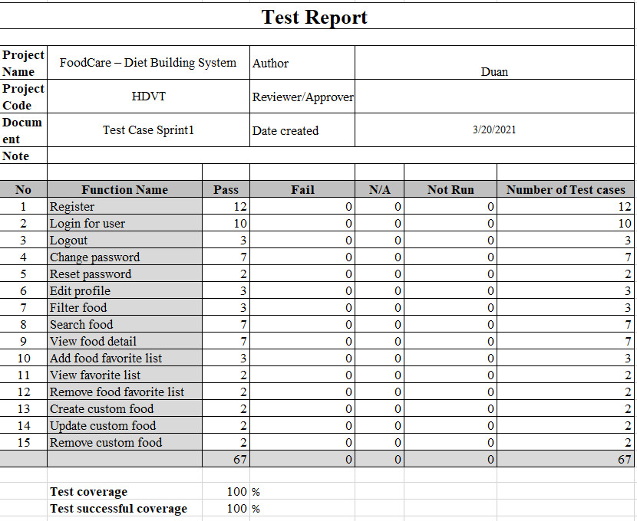

**International School**

**Capstone Project 2**

CMU-SE 451

**Test Plan**

**Version 1.4**

**Date: 25nd May, 2021**

**Testcase Sprint 2**

**Submitted by**

Huynh Dac Vinh  
 Tran Quoc Trung

Ton That Minh Huy

Dang Van Duan

**Approved by**

**Proposal Review Panel Representative:**

NameSignature Date

**Capstone Project 2-Mentor:**

Name Signature Date

**Dang Viet Hung**

**PROJECT INFORMATION**

|  |  |  |  |
| --- | --- | --- | --- |
| **Project acronym** | FC | | |
| **Project Title** | Food Care | | |
| **Start Date** | 01 Mar, 2021 | **End Date** | 25 May, 2021 |
| **Lead Institution** | International School, Duy Tan University | | |
| **Project Mentor** | Ph.D Hung, Dang Viet | | |
| **Scrum master / Project Leader & contact details** | Vinh, Huynh Dac  Email: dacvinh98@gmail.com  Tel: 0347191925 | | |
| **Partner Organization** |  | | |
| **Project Web URL** |  | | |
| **Team members** | Name | Email | Tel |
| 1 | Vinh, Huynh Dac | dacvinh98@gmail.com | 0347191925 |
| 2 | Trung, Tran Quoc | quoctrung.tran210@gmail.com | 0935420530 |
| 3 | Huy, Ton That Minh | tonthatminhh@gmail.com | 0935432561 |
| 4 | Duan, Dang Van | dangvanduan755@gmail.com | 0769710126 |

REVISION HISTORY

|  |  |  |  |  |
| --- | --- | --- | --- | --- |
| **Version** | **Date** | **Comments** | **Author** | **Approval** |
| 1.0 | 02/04/2021 | Initial Release | Duan, Dang Van |  |
|  |  |  |  |  |

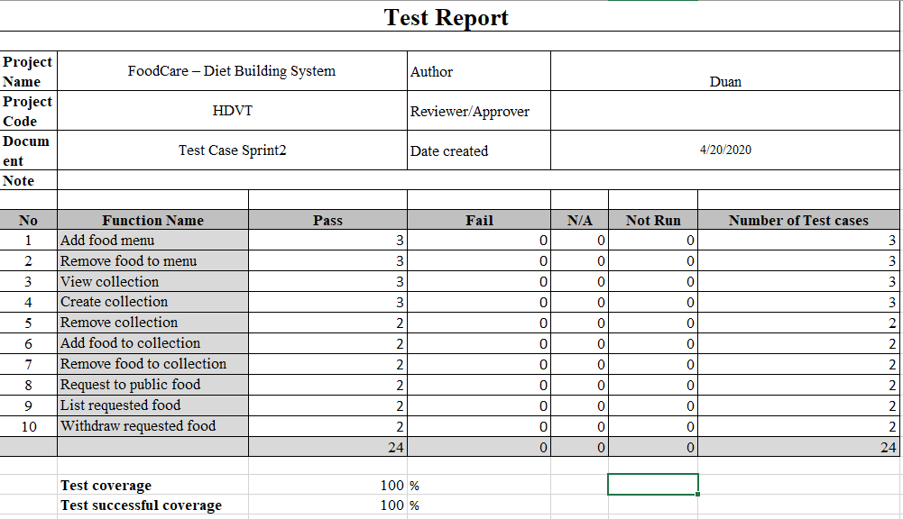

**International School**

**Capstone Project 2**

CMU-SE 451

**Test Plan**

**Version 1.4**

**Date: 25nd May, 2021**

**Testcase Sprint 3**

**Submitted by**

Huynh Dac Vinh  
 Tran Quoc Trung

Ton That Minh Huy

Dang Van Duan

**Approved by**

**Proposal Review Panel Representative:**

NameSignature Date

**Capstone Project 2-Mentor:**

Name Signature Date

**Dang Viet Hung**

**PROJECT INFORMATION**

|  |  |  |  |
| --- | --- | --- | --- |
| **Project acronym** | FC | | |
| **Project Title** | Food Care | | |
| **Start Date** | 01 Mar, 2021 | **End Date** | 25 May, 2021 |
| **Lead Institution** | International School, Duy Tan University | | |
| **Project Mentor** | Ph.D Hung, Dang Viet | | |
| **Scrum master / Project Leader & contact details** | Vinh, Huynh Dac  Email: dacvinh98@gmail.com  Tel: 0347191925 | | |
| **Partner Organization** |  | | |
| **Project Web URL** |  | | |
| **Team members** | Name | Email | Tel |
| 1 | Vinh, Huynh Dac | dacvinh98@gmail.com | 0347191925 |
| 2 | Trung, Tran Quoc | quoctrung.tran210@gmail.com | 0935420530 |
| 3 | Huy, Ton That Minh | tonthatminhh@gmail.com | 0935432561 |
| 4 | Duan, Dang Van | dangvanduan755@gmail.com | 0769710126 |

REVISION HISTORY

|  |  |  |  |  |
| --- | --- | --- | --- | --- |
| **Version** | **Date** | **Comments** | **Author** | **Approval** |
| 1.0 | 25/05/2021 | Initial Release | Duan, Dang Van |  |
|  |  |  |  |  |

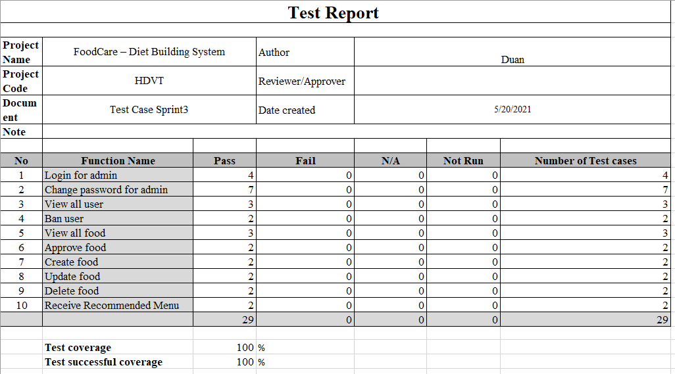

**International School**

**Capstone Project 2**

CMU-SE 451

**Meeting**

**Version 1.1**

**Date: 22nd May, 2021**

**Food Care**

**Submitted by**

Huynh Dac Vinh  
 Tran Quoc Trung

Ton That Minh Huy

Dang Van Duan

**Approved by**

**Proposal Review Panel Representative:**

NameSignature Date

**Capstone Project 2-Mentor:**

Name Signature Date

**Dang Viet Hung**

**PROJECT INFORMATION**

|  |  |  |  |
| --- | --- | --- | --- |
| **Project acronym** | FC | | |
| **Project Title** | Food Care | | |
| **Start Date** | 01 Mar, 2021 | **End Date** | 25 May, 2021 |
| **Lead Institution** | International School, Duy Tan University | | |
| **Project Mentor** | Ph.D Hung, Dang Viet | | |
| **Scrum master / Project Leader & contact details** | Vinh, Huynh Dac  Email: dacvinh98@gmail.com  Tel: 0347191925 | | |
| **Partner Organization** |  | | |
| **Project Web URL** |  | | |
| **Team members** | Name | Email | Tel |
| 1 | Vinh, Huynh Dac | dacvinh98@gmail.com | 0347191925 |
| 2 | Trung, Tran Quoc | quoctrung.tran210@gmail.com | 0935420530 |
| 3 | Huy, Ton That Minh | tonthatminhh@gmail.com | 0935432561 |
| 4 | Duan, Dang Van | dangvanduan755@gmail.com | 0769710126 |

REVISION HISTORY

|  |  |  |  |  |
| --- | --- | --- | --- | --- |
| **Version** | **Date** | **Comments** | **Author** | **Approval** |
| 1.0 | 02/03/2021 | Initial Release | C2SE.18 team |  |
| 1.1 | 22/05/2021 | Final | Duan, Dang Van |  |
|  |  |  |  |  |

**Document Approval**

The following signatures are required for approval of this document

|  |  |  |
| --- | --- | --- |
| **Mentor** | Dang Viet Hung | Date: |
| **Scrum Master** | Huynh Dac Vinh | Date: |
| **Product Owner** | Tran Quoc Trung | Date: |
| **Team Member** | Ton That Minh Huy | Date: |
| **Team Member** | Dang Van Duan | Date: |

**MEETING**

|  |  |  |  |  |
| --- | --- | --- | --- | --- |
| **Meeting Information** | | | | |
| Product | Food Care | | | |
| Subject | First meeting | | | |
| Location | Coffee store at 76 Phan Dang Luu street | | | |
| Date and Time | Date | Start Time | | End Time |
|  | 01/03/2020 | 18:00:00 | | 21:00:00 |
| Attendees | * Huynh Dac Vinh * Dang Van Duan * Ton That Minh Huy * Tran Quoc Trung | |  | |
| Related Documents |  | | | |
| **Content** | | | | |
| * Introduce member * Giving ideas for Capstone 2 project * Provide tools for project programming * Proposal to create an online survey | | | | |
| **Result Items** | | | | |
| * Plan to do DCS project * Plan meeting and how Scrum process work * Divide task for work | | | | |

|  |  |  |  |  |
| --- | --- | --- | --- | --- |
| **Meeting Information** | | | | |
| Product | Food Care | | | |
| Subject | Kick off sprint 1 | | | |
| Location | Room 201, 03 Quang Trung | | | |
| Date and Time | Date | Start Time | | End Time |
|  | 02/03/2020 | 10:00:00 | | 11:00:00 |
| Attendees | * Huynh Dac Vinh * Dang Van Duan * Ton That Minh Huy * Tran Quoc Trung | | **Mentor**  Dang Viet Hung | |
| Related Documents |  | | | |
| **Content** | | | | |
| * Introduce member * Proposing team project ideas to mentor * Come up with realistic options * Get ideas and suitable implementation methods for your project from a mentor | | | | |
| **Result Items** | | | | |
| * Plan to do DCS project * Plan meeting and how Scrum process work * Divide task for work | | | | |

|  |  |  |  |  |
| --- | --- | --- | --- | --- |
| **Meeting Information** | | | | |
| Product | Food Care | | | |
| Subject | Team meeting | | | |
| Location | Coffee store at 76 Phan Dang Luu street | | | |
| Date and Time | Date | Start Time | | End Time |
|  | 04/03/2020 | 18:00:00 | | 20:00:00 |
| Attendees | * Huynh Dac Vinh * Dang Van Duan * Ton That Minh Huy * Tran Quoc Trung | |  | |
| Related Documents |  | | | |
| **Content** | | | | |
| * Provide solutions for the project when applied in practice * Outline construction and design the structure of the website | | | | |
| **Result Items** | | | | |
| * Construction and design of website * Provide solutions and practice * Divide task for work | | | | |

|  |  |  |  |  |
| --- | --- | --- | --- | --- |
| **Meeting Information** | | | | |
| Product | Food Care | | | |
| Subject | Report to mentor | | | |
| Location | Room 201, 03 Quang Trung | | | |
| Date and Time | Date | Start Time | | End Time |
|  | 05/03/2021 | 10:00:00 | | 11:00:00 |
| Attendees | * Huynh Dac Vinh * Dang Van Duan * Ton That Minh Huy * Tran Quoc Trung | | **Mentor**  Dang Viet Hung | |
| Related Documents |  | | | |
| **Content** | | | | |
| * Update Proposal document * Team work skill * User Story Document * Project Plan Document * Product Backlog Document * Create User Stories, create Sprint Backlog Document | | | | |
| **Result Items** | | | | |
| * Completed Proposal * Idea about interface, and database * Divide task for work | | | | |

|  |  |  |  |  |
| --- | --- | --- | --- | --- |
| **Meeting Information** | | | | |
| Product | Food Care | | | |
| Subject | Report to mentor | | | |
| Location | Room 201, 03 Quang Trung | | | |
| Date and Time | Date | Start Time | | End Time |
|  | 07/03/2021 | 10:00:00 | | 11:00:00 |
| Attendees | * Huynh Dac Vinh * Dang Van Duan * Ton That Minh Huy * Tran Quoc Trung | | **Mentor**  Dang Viet Hung | |
| Related Documents |  | | | |
| **Content** | | | | |
| * Update User story document * Update Plan document * Update Create User Stories * Learn about Bayesian knowledge from mentors to apply to the recommender algorithm | | | | |
| **Result Items** | | | | |
| * Error about few the function * Update the function * Divide task for work | | | | |

|  |  |  |  |  |
| --- | --- | --- | --- | --- |
| **Meeting Information** | | | | |
| Product | Food Care | | | |
| Subject | Start Sprint 1 | | | |
| Location | Room 201, 03 Quang Trung | | | |
| Date and Time | Date | Start Time | | End Time |
|  | 08/03/2021 | 10:00:00 | | 11:00:00 |
| Attendees | * Huynh Dac Vinh * Dang Van Duan * Ton That Minh Huy * Tran Quoc Trung | | **Mentor**  Dang Viet Hung | |
| Related Documents |  | | | |
| **Content** | | | | |
| * Review User Story, Plan document, User Stories Document. * Give examples of Bayesian methods to mentors * Learn more about how to recommend dishes through the above method. | | | | |
| **Result Items** | | | | |
| * Start sprint 1 * Guide to Product Backlog * Give schedule for work will do | | | | |

|  |  |  |  |  |
| --- | --- | --- | --- | --- |
| **Meeting Information** | | | | |
| Product | Food Care | | | |
| Subject | Team meeting | | | |
| Location | ZOOM (Meeting online) | | | |
| Date and Time | Date | Start Time | | End Time |
|  | 12/03/2020 | 18:00:00 | | 20:00:00 |
| Attendees | * Huynh Dac Vinh * Dang Van Duan * Ton That Minh Huy * Tran Quoc Trung | |  | |
| Related Documents |  | | | |
| **Content** | | | | |
| * Design UI for website * Create appropriate fields for project data of project | | | | |
| **Result Items** | | | | |
| * Design interface document * Database design document * Create diagram database | | | | |

|  |  |  |  |  |
| --- | --- | --- | --- | --- |
| **Meeting Information** | | | | |
| Product | Food Care | | | |
| Subject | Team meeting | | | |
| Location | Google meet (Meeting online) | | | |
| Date and Time | Date | Start Time | | End Time |
|  | 15/03/2020 | 18:00:00 | | 20:00:00 |
| Attendees | * Huynh Dac Vinh * Dang Van Duan * Ton That Minh Huy * Tran Quoc Trung | |  | |
| Related Documents |  | | | |
| **Content** | | | | |
| * Complete proposal document * Add new data to the sample database | | | | |
| **Result Items** | | | | |
| * Proposal document * Database design document | | | | |

|  |  |  |  |  |
| --- | --- | --- | --- | --- |
| **Meeting Information** | | | | |
| Product | Food Care | | | |
| Subject | Show Sprint 1 | | | |
| Location | Room 201, 03 Quang Trung | | | |
| Date and Time | Date | Start Time | | End Time |
|  | 17/03/2021 | 10:00:00 | | 11:00:00 |
| Attendees | * Huynh Dac Vinh * Dang Van Duan * Ton That Minh Huy * Tran Quoc Trung | | **Mentor**  Dang Viet Hung | |
| Related Documents |  | | | |
| **Content** | | | | |
| * Give the tasks to be implemented in sprint 1 * Learn about machine learning from mentor * Refer to the formulas of Bayes Theorem from mentor * Build user interface and server | | | | |
| **Result Items** | | | | |
| * Sprint 1 * Guide to Product Backlog * Interface and server of user * Give schedule for work will do | | | | |

|  |  |  |  |  |
| --- | --- | --- | --- | --- |
| **Meeting Information** | | | | |
| Product | Food Care | | | |
| Subject | Show full version proposal document | | | |
| Location | Room 201, 03 Quang Trung | | | |
| Date and Time | Date | Start Time | | End Time |
|  | 24/03/2021 | 10:00:00 | | 11:00:00 |
| Attendees | * Huynh Dac Vinh * Dang Van Duan * Ton That Minh Huy * Tran Quoc Trung | | **Mentor**  Dang Viet Hung | |
| Related Documents |  | | | |
| **Content** | | | | |
| * Submit the proposal to the mentor for reference * Training real-world processing by bayes theorem with mentor | | | | |
| **Result Items** | | | | |
| * Show proposal * Training bayes theorem | | | | |

|  |  |  |  |  |
| --- | --- | --- | --- | --- |
| **Meeting Information** | | | | |
| Product | Food Care | | | |
| Subject | Release Sprint 1 | | | |
| Location | Library Room, 03 Quang Trung | | | |
| Date and Time | Date | Start Time | | End Time |
|  | 25/03/2021 | 16:00:00 | | 17:00:00 |
| Attendees | * Huynh Dac Vinh * Dang Van Duan * Ton That Minh Huy * Tran Quoc Trung | | **Mentor**  Dang Viet Hung | |
| Related Documents |  | | | |
| **Content** | | | | |
| * Release Sprint 1 * Update Product Backlog, Sprint Backlog * Update User Story, Test case for sprint 1 | | | | |
| **Result Items** | | | | |
| * Demo authentication * Completed Sprint 1 | | | | |

|  |  |  |  |  |
| --- | --- | --- | --- | --- |
| **Meeting Information** | | | | |
| Product | Food Care | | | |
| Subject | Come up with new ideas for the project | | | |
| Location | Room 201, 03 Quang Trung | | | |
| Date and Time | Date | Start Time | | End Time |
|  | 31/03/2021 | 10:00:00 | | 11:00:00 |
| Attendees | * Huynh Dac Vinh * Dang Van Duan * Ton That Minh Huy * Tran Quoc Trung | | **Mentor**  Dang Viet Hung | |
| Related Documents |  | | | |
| **Content** | | | | |
| * Use Bayes' theorem to process how the food menu for each person * Use NoSQL to store and define database | | | | |
| **Result Items** | | | | |
| * Bayes' theorem process in project * Use NoSQL | | | | |

|  |  |  |  |  |
| --- | --- | --- | --- | --- |
| **Meeting Information** | | | | |
| Product | Food Care | | | |
| Subject | Team meeting | | | |
| Location | Coffee store at 76 Phan Dang Luu street | | | |
| Date and Time | Date | Start Time | | End Time |
|  | 02/04/2020 | 18:00:00 | | 20:00:00 |
| Attendees | * Huynh Dac Vinh * Dang Van Duan * Ton That Minh Huy * Tran Quoc Trung | |  | |
| Related Documents |  | | | |
| **Content** | | | | |
| * Practice crawl sample data from food websites * Build server and interface on hosting | | | | |
| **Result Items** | | | | |
| * Sample data * Server and interface online for user * Divide task for work | | | | |

|  |  |  |  |  |
| --- | --- | --- | --- | --- |
| **Meeting Information** | | | | |
| Product | Food Care | | | |
| Subject | Start Sprint 2 | | | |
| Location | Room 201, 03 Quang Trung | | | |
| Date and Time | Date | Start Time | | End Time |
|  | 05/04/2021 | 15:00:00 | | 16:15:00 |
| Attendees | * Huynh Dac Vinh * Dang Van Duan * Ton That Minh Huy * Tran Quoc Trung | | **Mentor**  Dang Viet Hung | |
| Related Documents |  | | | |
| **Content** | | | | |
| * Review Plan document | | | | |
| **Result Items** | | | | |
| * Start sprint 2 * Update Plan document * Give schedule for work will do | | | | |

|  |  |  |  |  |
| --- | --- | --- | --- | --- |
| **Meeting Information** | | | | |
| Product | Food Care | | | |
| Subject | Update Sprint 2 | | | |
| Location | Room 201, 03 Quang Trung | | | |
| Date and Time | Date | Start Time | | End Time |
|  | 12/04/2021 | 15:00:00 | | 16:15:00 |
| Attendees | * Huynh Dac Vinh * Dang Van Duan * Ton That Minh Huy * Tran Quoc Trung | | **Mentor**  Dang Viet Hung | |
| Related Documents |  | | | |
| **Content** | | | | |
| * Provide solutions for functionality in sprint 2 | | | | |
| **Result Items** | | | | |
| * Sprint 2 * Update product backlog document * Update user story document | | | | |

|  |  |  |  |  |
| --- | --- | --- | --- | --- |
| **Meeting Information** | | | | |
| Product | Food Care | | | |
| Subject | Team meeting | | | |
| Location | Coffee store at 76 Phan Dang Luu street | | | |
| Date and Time | Date | Start Time | | End Time |
|  | 14/04/2020 | 18:00:00 | | 20:00:00 |
| Attendees | * Huynh Dac Vinh * Dang Van Duan * Ton That Minh Huy * Tran Quoc Trung | |  | |
| Related Documents |  | | | |
| **Content** | | | | |
| * Add new functionality to users in sprint 2 * Update product backlog * Update user story | | | | |
| **Result Items** | | | | |
| * Sprint 2 * Product backlog document * User story document | | | | |

|  |  |  |  |  |
| --- | --- | --- | --- | --- |
| **Meeting Information** | | | | |
| Product | Food Care | | | |
| Subject | Show functions in Sprint 2 | | | |
| Location | Room 201, 03 Quang Trung | | | |
| Date and Time | Date | Start Time | | End Time |
|  | 19/04/2021 | 15:00:00 | | 16:15:00 |
| Attendees | * Huynh Dac Vinh * Dang Van Duan * Ton That Minh Huy * Tran Quoc Trung | | **Mentor**  Dang Viet Hung | |
| Related Documents |  | | | |
| **Content** | | | | |
| * Submit function in sprint 2 * Add functionality needed in sprint 2 from mentor | | | | |
| **Result Items** | | | | |
| * To do sprint 2 * Update product backlog * Update user story | | | | |

|  |  |  |  |  |
| --- | --- | --- | --- | --- |
| **Meeting Information** | | | | |
| Product | Food Care | | | |
| Subject | Update sprint 2 | | | |
| Location | Room 201, 03 Quang Trung | | | |
| Date and Time | Date | Start Time | | End Time |
|  | 26/04/2021 | 15:00:00 | | 16:15:00 |
| Attendees | * Huynh Dac Vinh * Dang Van Duan * Ton That Minh Huy * Tran Quoc Trung | | **Mentor**  Dang Viet Hung | |
| Related Documents |  | | | |
| **Content** | | | | |
| * Provide solutions for sprint 2 * Build user interface and server | | | | |
| **Result Items** | | | | |
| * Interface and server of user * Update sprint 2 * Update database and UI design document | | | | |

|  |  |  |  |  |
| --- | --- | --- | --- | --- |
| **Meeting Information** | | | | |
| Product | Food Care | | | |
| Subject | Release Sprint 2 | | | |
| Location | Room 201, 03 Quang Trung | | | |
| Date and Time | Date | Start Time | | End Time |
|  | 29/04/2021 | 16:00:00 | | 17:15:00 |
| Attendees | * Huynh Dac Vinh * Dang Van Duan * Ton That Minh Huy * Tran Quoc Trung | | **Mentor**  Dang Viet Hung | |
| Related Documents |  | | | |
| **Content** | | | | |
| * Release Sprint 2 * Update Product Backlog, Sprint Backlog * Update User Story, Test case for sprint 2 | | | | |
| **Result Items** | | | | |
| * Demo of the functionalities * Plan to work overtime finish task sprint 2 * Divide task for work | | | | |

|  |  |  |  |  |
| --- | --- | --- | --- | --- |
| **Meeting Information** | | | | |
| Product | Food Care | | | |
| Subject | Start Sprint 3 | | | |
| Location | Room 201, 03 Quang Trung | | | |
| Date and Time | Date | Start Time | | End Time |
|  | 03/05/2021 | 16:00:00 | | 17:00:00 |
| Attendees | * Huynh Dac Vinh * Dang Van Duan * Ton That Minh Huy * Tran Quoc Trung | | **Mentor**  Dang Viet Hung | |
| Related Documents |  | | | |
| **Content** | | | | |
| * Review document * Release Sprint 2 | | | | |
| **Result Items** | | | | |
| * Start sprint 3 * Update document * Give schedule for work will do | | | | |

|  |  |  |  |  |
| --- | --- | --- | --- | --- |
| **Meeting Information** | | | | |
| Product | Food Care | | | |
| Subject | Show functions in Sprint 3 | | | |
| Location | Room 201, 03 Quang Trung | | | |
| Date and Time | Date | Start Time | | End Time |
|  | 06/05/2021 | 16:00:00 | | 17:00:00 |
| Attendees | * Huynh Dac Vinh * Dang Van Duan * Ton That Minh Huy * Tran Quoc Trung | | **Mentor**  Dang Viet Hung | |
| Related Documents |  | | | |
| **Content** | | | | |
| * Submit function in sprint 3 * Add functionality needed in sprint 3 from mentor | | | | |
| **Result Items** | | | | |
| * To do sprint 3 * Update product backlog * Update user story | | | | |

|  |  |  |  |  |
| --- | --- | --- | --- | --- |
| **Meeting Information** | | | | |
| Product | Food Care | | | |
| Subject | Update Sprint 3 | | | |
| Location | Room 201, 03 Quang Trung | | | |
| Date and Time | Date | Start Time | | End Time |
|  | 10/05/2021 | 16:00:00 | | 17:00:00 |
| Attendees | * Huynh Dac Vinh * Dang Van Duan * Ton That Minh Huy * Tran Quoc Trung | | **Mentor**  Dang Viet Hung | |
| Related Documents |  | | | |
| **Content** | | | | |
| * Provide solutions for sprint 3 * Build user interface and server | | | | |
| **Result Items** | | | | |
| * Interface and server of user * Update sprint 3 * Update database and UI design document | | | | |

|  |  |  |  |  |
| --- | --- | --- | --- | --- |
| **Meeting Information** | | | | |
| Product | Food Care | | | |
| Subject | Team meeting | | | |
| Location | Coffee store at 76 Phan Dang Luu street | | | |
| Date and Time | Date | Start Time | | End Time |
|  | 11/04/2020 | 18:00:00 | | 20:00:00 |
| Attendees | * Huynh Dac Vinh * Dang Van Duan * Ton That Minh Huy * Tran Quoc Trung | |  | |
| Related Documents |  | | | |
| **Content** | | | | |
| * Complete new functionality to users in sprint 3 * Update product backlog * Update user story | | | | |
| **Result Items** | | | | |
| * Sprint 3 * Product backlog document * User story document | | | | |

|  |  |  |  |  |
| --- | --- | --- | --- | --- |
| **Meeting Information** | | | | |
| Product | Food Care | | | |
| Subject | Generate additional ideas for sprint 3 | | | |
| Location | Google meet (Meeting online) | | | |
| Date and Time | Date | Start Time | | End Time |
|  | 17/05/2021 | 10:00:00 | | 11:00:00 |
| Attendees | * Huynh Dac Vinh * Dang Van Duan * Ton That Minh Huy * Tran Quoc Trung | | **Mentor**  Dang Viet Hung | |
| Related Documents |  | | | |
| **Content** | | | | |
| * Update Sprint 3 * Update Product Backlog, Sprint Backlog * Update User Story, Test case for sprint 3 | | | | |
| **Result Items** | | | | |
| * Demo of the functionalities * Plan to work overtime finish task sprint 3 * Divide task for work | | | | |

|  |  |  |  |  |
| --- | --- | --- | --- | --- |
| **Meeting Information** | | | | |
| Product | Food Care | | | |
| Subject | Team meeting | | | |
| Location | Coffee store at 76 Phan Dang Luu street | | | |
| Date and Time | Date | Start Time | | End Time |
|  | 10/04/2020 | 18:00:00 | | 20:00:00 |
| Attendees | * Huynh Dac Vinh * Dang Van Duan * Ton That Minh Huy * Tran Quoc Trung | |  | |
| Related Documents |  | | | |
| **Content** | | | | |
| * Edit functions suitable for users in sprint 3 * Update product backlog * Update user story | | | | |
| **Result Items** | | | | |
| * Sprint 3 * Product backlog document * User story document | | | | |

|  |  |  |  |  |
| --- | --- | --- | --- | --- |
| **Meeting Information** | | | | |
| Product | Food Care | | | |
| Subject | Release Sprint 3 | | | |
| Location | Google meet (meeting online) | | | |
| Date and Time | Date | Start Time | | End Time |
|  | 20/05/2021 | 16:00:00 | | 17:15:00 |
| Attendees | * Huynh Dac Vinh * Dang Van Duan * Ton That Minh Huy * Tran Quoc Trung | | **Mentor**  Dang Viet Hung | |
| Related Documents |  | | | |
| **Content** | | | | |
| * Release Sprint 3 * Update Product Backlog, Sprint Backlog * Update User Story, Test case for sprint 3 | | | | |
| **Result Items** | | | | |
| * Demo of the functionalities * Plan to work overtime finish task sprint 3 * Divide task for work | | | | |

|  |  |  |  |  |
| --- | --- | --- | --- | --- |
| **Meeting Information** | | | | |
| Product | Food Care | | | |
| Subject | Release product | | | |
| Location | Google meet (meeting online) | | | |
| Date and Time | Date | Start Time | | End Time |
|  | 24/05/2021 | 15:30:00 | | 16:30:00 |
| Attendees | * Huynh Dac Vinh * Dang Van Duan * Ton That Minh Huy * Tran Quoc Trung | | **Mentor**  Dang Viet Hung | |
| Related Documents |  | | | |
| **Content** | | | | |
| * Release Product * Review all documents | | | | |
| **Result Items** | | | | |
| * Demo web * Plan to fix bugs * Divide task for work | | | | |

|  |  |  |  |  |
| --- | --- | --- | --- | --- |
| **Meeting Information** | | | | |
| Product | Food Care | | | |
| Subject | Release Product | | | |
| Location | Google meet (meeting online) | | | |
| Date and Time | Date | Start Time | | End Time |
|  | 27/05/2021 | 15:00:00 | | 16:15:00 |
| Attendees | * Huynh Dac Vinh * Dang Van Duan * Ton That Minh Huy * Tran Quoc Trung | | **Mentor**  Dang Viet Hung | |
| Related Documents |  | | | |
| **Content** | | | | |
| * Release Website * Review all documents | | | | |
| **Result Items** | | | | |
| * Demo Website | | | | |

**International School**

**Capstone Project 2**

CMU-SE 451

**Retrospective Meetings**

**Version 1.0**

**Date: 27nd May, 2021**

**Food Care**

**Submitted by**

Huynh Dac Vinh  
 Tran Quoc Trung

Ton That Minh Huy

Dang Van Duan

**Approved by**

**Proposal Review Panel Representative:**

NameSignature Date

**Capstone Project 2-Mentor:**

Name Signature Date

**Dang Viet Hung**

**PROJECT INFORMATION**

|  |  |  |  |
| --- | --- | --- | --- |
| **Project acronym** | FC | | |
| **Project Title** | Food Care | | |
| **Start Date** | 01 Mar, 2021 | **End Date** | 25 May, 2021 |
| **Lead Institution** | International School, Duy Tan University | | |
| **Project Mentor** | Ph.D Hung, Dang Viet | | |
| **Scrum master / Project Leader & contact details** | Vinh, Huynh Dac  Email: dacvinh98@gmail.com  Tel: 0347191925 | | |
| **Partner Organization** |  | | |
| **Project Web URL** |  | | |
| **Team members** | Name | Email | Tel |
| 1 | Vinh, Huynh Dac | dacvinh98@gmail.com | 0347191925 |
| 2 | Trung, Tran Quoc | quoctrung.tran210@gmail.com | 0935420530 |
| 3 | Huy, Ton That Minh | tonthatminhh@gmail.com | 0935432561 |
| 4 | Duan, Dang Van | dangvanduan755@gmail.com | 0769710126 |

REVISION HISTORY

|  |  |  |  |  |
| --- | --- | --- | --- | --- |
| **Version** | **Date** | **Comments** | **Author** | **Approval** |
| 1.0 | 27/05/2021 | Final | Huy, Ton That Minh |  |
|  |  |  |  |  |

**Document Approval**

The following signatures are required for approval of this document

|  |  |  |
| --- | --- | --- |
| **Mentor** | Dang Viet Hung | Date: |
| **Scrum Master** | Huynh Dac Vinh | Date: |
| **Product Owner** | Tran Quoc Trung | Date: |
| **Team Member** | Ton That Minh Huy | Date: |
| **Team Member** | Dang Van Duan | Date: |

|  |  |  |  |
| --- | --- | --- | --- |
| **Retrospective Meeting Information** | | | |
| **Product** | Food Care | | |
| **Subject** | Retrospective meeting after Sprint 1 | | |
| **Location** | Coffee store at 76 Phan Van Luu street | | |
| **Date and Time** | *Date* | *Start Time* | *End Time* |
|  | 04 Apr 2021 | 8:00 PM | 11:00 PM |
| **Attendees** | * Huynh Dac Vinh * Tran Quoc Trung * Dang Van Duan * Ton That Minh Huy | | |
| **Related documents** | Sprint backlog 1 | | |
| **Content** | | | |
| * Discussed and identified   + (WWW) What Went Well: Good things that we did in previous sprint   + (IBI) Even Better If: Things we did that can be improved.   + What things to improve and how to do it in the next sprint | | | |
| **Result Items** | | | |
| * List of WWW (What Went Well)   + Analysis is required   + Write completed documents on schedule * List of IBI (Even Better If)   + Focus more on design and code * List of things to improve, and how, in the next sprint   + Must quickly set up a project (github, nodejs project, ...) | | | |

|  |  |  |  |
| --- | --- | --- | --- |
| **Retrospective Meeting Information** | | | |
| **Product** | Food Care | | |
| **Subject** | Retrospective meeting after Sprint 2 | | |
| **Location** | Google Meet (Meeting online) | | |
| **Date and Time** | *Date* | *Start Time* | *End Time* |
|  | 02 May 2021 | 8:00 AM | 11:00 AM |
| **Attendees** | * Huynh Dac Vinh * Tran Quoc Trung * Dang Van Duan * Ton That Minh Huy | | |
| **Related documents** | Sprint backlog 2 | | |
| **Content** | | | |
| * Discussed and identified   + (WWW) What Went Well: Good things that we did in previous sprint   + (IBI) Even Better If: Things we did that can be improved.   + What things to improve and how to do it in the next sprint | | | |
| **Result Items** | | | |
| * List of WWW (What Went Well)   + Complete the designs, write the user interface code on schedule * List of IBI (Even Better If)   + Change the way of managing the work that the project team is doing * List of things to improve, and how, in the next sprint   + Focus more on the back-end to keep pace | | | |

|  |  |  |  |
| --- | --- | --- | --- |
| **Retrospective Meeting Information** | | | |
| **Product** | Food Care | | |
| **Subject** | Retrospective meeting after Sprint 3 | | |
| **Location** | Google Meet (Meeting online) | | |
| **Date and Time** | *Date* | *Start Time* | *End Time* |
|  | 23 May 2021 | 8:00 AM | 11:00 AM |
| **Attendees** | * Huynh Dac Vinh * Tran Quoc Trung * Dang Van Duan * Ton That Minh Huy | | |
| **Related documents** | Sprint backlog 3 | | |
| **Content** | | | |
| * Discussed and identified   + (WWW) What Went Well: Good things that we did in previous sprint   + (IBI) Even Better If: Things we did that can be improved.   + What things to improve and how to do it in the next sprint | | | |
| **Result Items** | | | |
| * List of WWW (What Went Well)   + Complete the designs, write the user interface code on schedule * List of IBI (Even Better If)   + Focus more on the back-end * List of things to improve, and how, in the next sprint   + Focus more on the back-end to keep pace | | | |